National Strategy to Achieve Gender Equality | Discussion Paper
National Strategy to Achieve Gender Equality Consultations

Contents
1. Vision 3
2. Have your say 4
3. Where are we heading? 5
4. The current state of gender equality in Australia 5
4.1 We have not achieved economic equality for women 5
4.2 Women bear the burden of care 10
4.3 Women experience high levels of gendered violence 13
4.4 Sex and gender impact our health, and our access to health services 14
4.5 Women are underepresented in leadership and decision making 16
4.6 Gendered factors combine and impact us across our lives 18
4.7 Stereotypes are holding us back 20
5. Measuring progress 21
6. More information and accessing support 22

- Vision
Over the years, Australia has made great progress towards gender equality including through implementation of the Sex Discrimination Act 1984, establishing the Workplace Gender Equality Agency (WGEA), introducing paid parental leave, and introducing a National Plan to End Violence against Women and Children. We have also seen support for gender equality increasing over time, with research showing most Australians now support gender equality. However, there is also evidence that in a number of areas progress is slowing or stalled. It is clear that gender inequality is not only holding women back, but is a brake on our progress as a country.
The National Strategy to Achieve Gender Equality (the Strategy) will guide whole of community action to help make Australia one of the best countries in the world for equality between women and men. It is an important mechanism to elevate and prioritise actions that will achieve gender equality.
We know that government plays an important role – the Strategy will help us identify where Australian government effort should be focused. But we also know that government acting alone cannot achieve gender equality – we need to work together across government, business and communities, and in schools, universities, TAFEs and work places.
The Government wants to understand the Australian community’s vision for gender equality and support a conversation about the priorities and actions to get us there, and how we could work together to achieve this.
Gender equality

Gender equality means people have equal rights, responsibilities and opportunities, regardless of gender. Throughout the paper there will be a strong focus on women and girls, as the group that disproportionately experience the negative impacts of gender inequality, however gender equality benefits all people.
Gender inequality can be exacerbated by other forms of exclusion and disadvantage including those related to age, First Nations heritage, cultural and linguistic background, migration status, disability, gender identity and sexuality, as well as socio-economic status.
- Have your say
This discussion paper has been developed to support discussion and reflection on gender equality in Australia to inform the Strategy. It is designed as a standalone document to inform you on the current situation of gender equality in Australia on a general level. You may like to read additional strategy consultation summaries from Phase One Consultations, to see what issues have been raised by previous consultations.
You can use this paper to have discussions within your organisation, workplace, sporting organisation, home, school or with your networks. There are prompts embedded across the paper to help guide your discussion and any response you may wish to make. You can chose where to focus your discussion – you might like to concentrate on the vision for a gender equal Australia or you might like to engage with some or all of the issues explore in section 4 – it’s up to you.
Organisations or groups wishing to respond to this paper can do so using the online form for organisations. Individuals are encouraged to complete the online survey.
The paper draws on a range of resources. If you would like to do further reading, you may like to start with these resources, especially the October 2022-23 Women’s Budget Statement. You can find out more about the strategy.
This paper discusses issues which may be distressing. A list of support services is included at page 19.
Should you have further questions, please email OFWEngagement@pmc.gov.au.

- Where are we heading?
In many ways, we are clear on what the challenges are – this paper provides an overview of the key issues and statistics that show the status of gender equality in Australia and where we might focus our effort. But we also want the strategy to provide a vision we can work towards and support a conversation about why gender equality is important for this country and what it could mean for us to get there.

Prompts

What would a gender equal Australia mean for you, your family, and community?
What should be the role of government, business and the community in achieving gender equality?
What are your priorities for achieving gender equality in Australia?
Consider the above prompts in your responses and as you reflect on each section below.
- The current state of gender equality in Australia

4.1 We have not achieved economic equality for women
This section explores some of the factors that contribute to women’s economic inequality. Over their lifetimes, women are more likely to earn less than men, are less likely to advance as far in their careers as men, and tend to accumulate less superannuation than men. On average, women tend to retire earlier than men. The cumulative effect of these factors can have negative impacts later in life, particularly for women who go through a relationship breakdown or divorce.
Single mothers can face particularly acute challenges in relation to workforce participation and financial security that can have significant impacts for their lifetime earnings and retirement incomes.
Women migrants tend to have weaker economic outcomes than migrants who are men, and the gender gap in labour force participation is also higher among migrants when compared with the Australian general population.

Gender pay gap
Gender pay gaps are an internationally established measure of women’s position in the economy in comparison to men. Australia’s national gender pay gap measures the difference between the average weekly ordinary time earnings (i.e. base salaries) of women and men working full-time. The gender pay gap is sometimes misunderstood to be two people being paid differently for the same work or work of the same value. However, this is a matter of equal pay, which is protected by legislation.
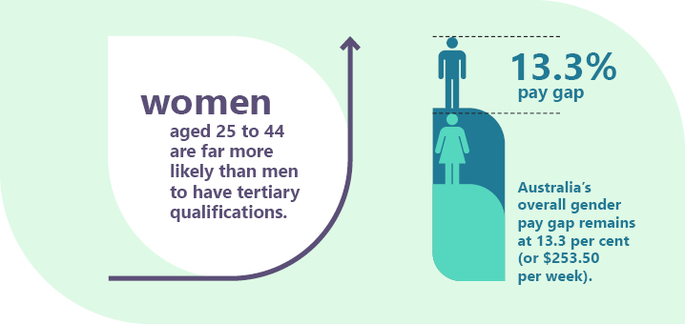
Australian women are among the most highly educated in the world. Girls are more likely than boys to complete Year 12 education, and women aged 25 to 44 are far more likely than men to have tertiary qualifications. However, this has not translated into better economic outcomes for women – Australia’s overall gender pay gap remains at 13.3 per cent (or $253.50 per week), and graduate gender pay gaps favour men in most fields of study.
Almost 40 per cent of workers under 40 do not agree women and men are treated equally in their workplace, have the same chance for promotion, are listened to equally or are paid the same for work in similar roles. Women are more likely to identify gender inequality than men, and there has been little change in gendered perceptions of equality at work between 2017–2022.

Workforce participation and occupational segregation
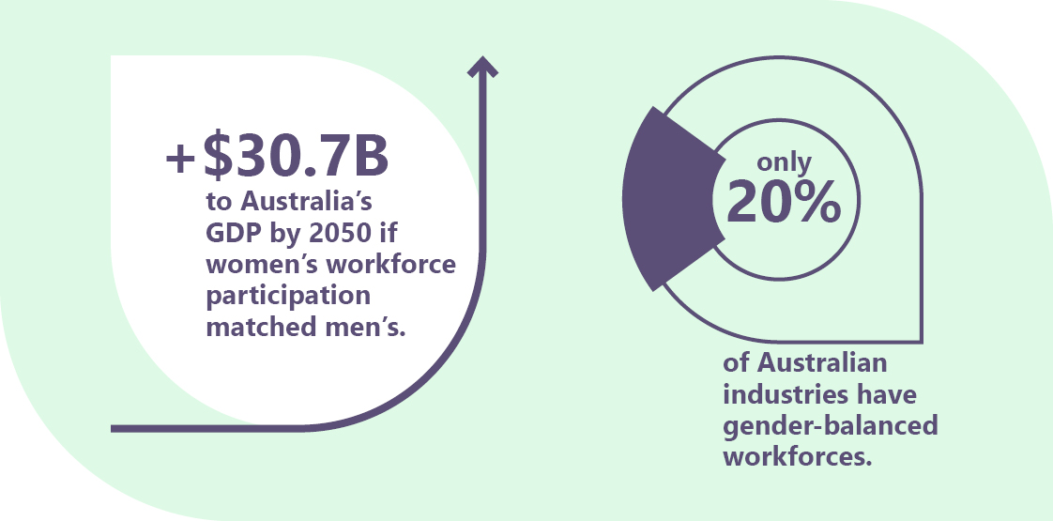
The underrepresentation of women in the workforce has a great impact on the Australian economy – if women’s participation matched men’s, Australia’s GDP would increase by $30.7 billion, or 8.7 per cent to $353 billion by 2050 and create an additional 1 million full-time equivalent workers with post-school qualifications. While labour force participation is near record highs, it is still lower for women than men. This is due to a combination of factors, including the gender segregated nature of the Australian workforce, the undervaluation of female dominated work, and women taking significant time of out the workforce for child care - underrepresentation of women can have a significant impact on the economy.
Australia has some of the most gender-segregated occupations, as well as some of the most gendered division of labour among Organisation of Economic Development and Cooperation (OECD) member countries. Less than half of Australian industries have gender-balanced workforces (at least 40 per cent women and 40 per cent men).
Gendered occupations have persisted over the past 20 years, with the proportion of women in traditionally female-dominated industries increasing. Women continue to be concentrated in Health Care and Social Assistance as well as Education and Training. Men are more likely to be found in Mining, Electricity, Gas, Water and Waste Services, Construction, and Manufacturing.
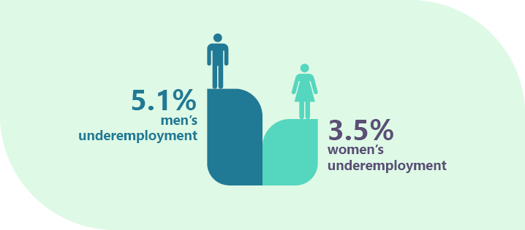
Women’s unemployment is at 3.5 per cent, one of the lowest levels on record, and the participation rate is 62.1 per cent, among the highest on record. However, the women’s underemployment rate (7.3 per cent) remains significantly higher than men’s (5.1 per cent). In Australia, working women are also more than twice as likely to be in part-time work as working men and are more likely to be in casual employment. Part-time and casual work provides flexibility to manage unpaid caring roles. However, casual jobs can also be less secure and lower paid with less opportunity for career progression.
Further information and key gender statistics can be found in the 2022 Jobs and Skills Summit – Issues Paper on the Treasury website.

Workplace sexual harassment
Workplace sexual harassment is driven by power disparities, particularly gender inequality. Other forms of discrimination can also drive sexual harassment. Almost 2 in every 5 women experienced sexual harassment at work between 2013 and 2018, while 1 in 4 men experienced harassment. First Nations people, people with disability and LGBTIQ+ people are more likely to have experienced sexual harassment. Most sexual harassment in the workplace is not formally reported.
Male-dominated workplaces have a higher prevalence of sexual harassment. This is due to a range of factors, including an unequal gender ratio, senior leadership that is predominantly male, and women performing roles that are considered ‘atypical’ for women.
It is estimated that workplace sexual harassment cost the Australian economy $2.6 billion in lost productivity. International research has also indicated that the financial impacts of workplace sexual harassment are felt more acutely by women, as they are more likely than men to make lateral moves or take pay cuts in response to experiences of harassment.

Prompt

What are the underlying challenges for women’s economic equality that the strategy could address?

4.2 Women bear the burden of care
While there have been changes in traditional caring roles, with increasing numbers of women entering the workforce and more gender balance in care-particularly parenting-roles, women are still overwhelmingly responsible for care. In December 2021, 54 per cent of families reported the main person looking after children was a woman, and 40 per cent of families reported equal sharing of responsibility. Only 4 per cent of families reported that a man usually or always looks after the children. Even in these cases, when asked “who plans/coordinates child activities”, it was usually or always a woman (78 per cent of the time). 79.9 per cent of one parent families are single mothers.
These patterns of care are generally driven by social and economic structures that reflect and reinforce gendered care norms that frame women as primary caregivers, not just for children, but also for ageing parents and people with disability. The uptake of parental leave, both Government and employer-provided, is profoundly gendered with an overwhelming number of people taking primary carers leave being women, and those taking secondary carers leave being men. This pattern continues for other forms of care – in 2021 more than twice as many women than men received the Carer Payment.
In Australia the health and care workforces are highly feminised. The predominance of women in these workforces is strongly driven by gender norms and further contributes to a gender pay gap in Australia, resulting from casual, part-time work arrangements and the low pay within the sector. These factors continue to support the stereotype that care is ‘women’s work’ or work which can be done in the home and not paid. Stereotypes also hold that care work is something women do for the love of it rather than money or recognition. These stereotypes can also mean that men who do care work face discrimination about their ability to do their job.
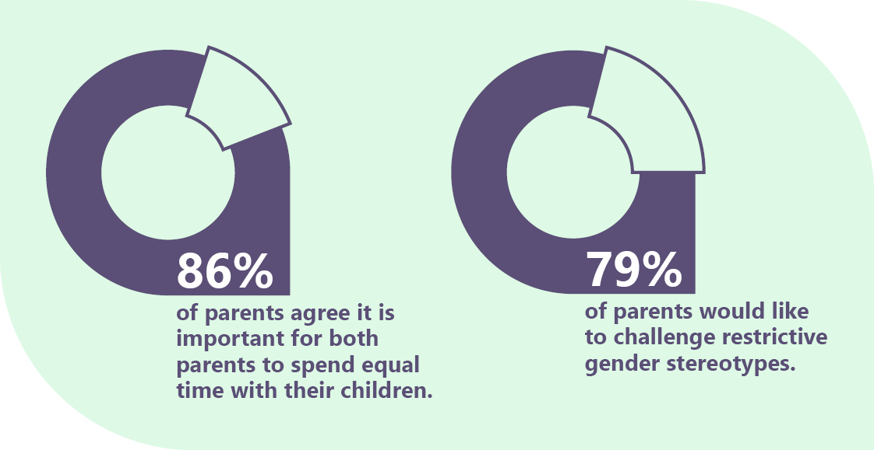
Studies have shown paid parental leave provisions and flexible work practices are amongst the most effective policies to encourage greater participation of men in caregiving and greater equality in household dynamics. Current trends in the availability and uptake of flexible working arrangements, particularly part-time and remote work, are highly gendered. This reflects current patterns of care. Women make up 67 per cent of part-time workers and are nearly three times more likely to use a flexible working arrangements to manage caring responsibilities than their partners (80 per cent compared to 28 per cent). There is evidence that people who use flexible working arrangements are penalised and offered fewer opportunities for advancement, training or professional development. Unless flexible working is established in a gender-equitable way and accessible to all employees, flexible work polices can inadvertently reinforce gender gaps in the access and accumulation of skills, opportunities and experience.
Women are underrepresented in leadership roles and overrepresented in casual, part time and fixed-term roles. These roles can provide flexibility to manage caring responsibilities, but are frequently lower-paid and insecure. Research shows that difficulties reconciling work and unpaid care can lead to ‘occupational downgrading’, where women choose roles below their skill levels and accept poorer conditions.
Although many parents’ priorities and aspirations in relation to caring for children have changed significantly over recent decades, but parental leave arrangements have been slow to keep up with these changes, and gendered stereotypes and expectations in the way that we work can limit take up of leave arrangements when they are available. It may also leave parents feeling they may not have the choice to care differently, including fathers who are not supported to take on care roles.
Workplaces benefit from strategies supporting all employees to better manage family and caring responsibilities. Employer-provided paid parental leave is a crucial element in supporting women to stay in the workforce. Female managers are twice as likely to return to work if their employer provides 13 or more weeks of paid parental leave. Companies with formal support policies for flexible work increased their share of part-time female managers by 7.5 percentage points.
Women in Australia face a ‘motherhood penalty’, in which mothers experience a significant financial setback due to both reduced working hours and time out of the workforce. Women’s earnings are reduced by an average of 55 per cent in the first five years of parenthood. This penalty continues through the first decade after childbirth. While women face penalties in the workforce for parental responsibilities, men are rewarded. Indeed, men experience a “fatherhood premium” of approximately 7.3 per cent.
Research by the Grattan Institute using data from the 2017 HILDA Survey estimated that an average 25 year old woman with children will earn around $2 million less over her lifetime than an average 25 year old man with children, and nearly $1 million less than an average woman without children.

Prompt

What are the underlying challenges in the way we value and allocate care that the strategy could address?

4.3 Women experience high levels of gendered violence
Gender inequality is a driver of violence against women. Women in Australia continue to be disproportionally impacted by family, domestic and sexual violence. On average, one women is killed by an intimate partner every 10 days. Violence against women and girls is a manifestation of inequality and discrimination based on gender, race and other power imbalances. It is rooted in historically unequal power relations that view women and girls as subordinate to men and boys. While women and girls across Australia are unsafe, we will not be able to achieve gender equality.
Some cohorts of women are more likely to experience violence in their lifetimes including First Nations women and women with a disability. Women who identify as lesbian or bisexual experience higher rates of sexual violence than heterosexual women, while trans people report higher rates of sexual assault than the general population, and trans women of colour report higher rates of assault by strangers. A woman is also more likely to experience violence at particular life stages, such as while pregnant or while separating from a partner. Women are also disproportionally targeted by technology-facilitated gender based violence (TFGBV). Examples of TFGBV include online sexist hate speech, online sexual harassment, technology-facilitated coercive control, image-based abuse, gendered online misinformation and disinformation, and digital misogyny.
There are significant economic costs resulting from violence. Gender based violence costs Australia $26 billion a year. Gendered financial abuse is estimated to cost $10.9 billion a year – with $5.7 billion of that cost borne directly by victims.
In October 2022, the Government launched the National Plan to End Violence against Women and Children 2022-2032 (National Plan) to ensure that communities are safe for all women and children. The National Plan sets out a 10-year national framework for ending gender-based violence and will guide Commonwealth, state and territory actions on prevention, early intervention, response, and recovery and healing to help break the cycle of violence and support victim-survivors. Practical actions to implement the National Plan will be outlined in two underpinning five-year Action Plans and a dedicated Aboriginal and Torres Strait Islander Action Plan.
The Government is working in partnership with First Nations communities, through the Aboriginal and Torres Strait Islander Advisory Council, to develop an Aboriginal and Torres Strait Islander Action Plan under the recently released National Plan, to be released in 2023.
The Action Plan will address the immediate safety needs of Aboriginal and Torres Strait Islander families and communities. It will provide the foundations needed for longer-term change through the development of a standalone First Nations National Plan.
The Government is also taking ongoing action to stop sexual harassment at work by implementing all the recommendations from the Respect@Work Report.

Prompt

Australia has a National Plan to End Violence Against Women and Children – how could the strategy contribute to ending violence and supporting the Plan?

4.4 Sex and gender impact our health, and our access to health services
Gender can be a significant determinant of different health experiences and outcomes; understanding these differences is essential to improving outcomes and quality of life for all people in Australia.
At all stages of life, women are at greater risk of ill health than men. Women live longer on average than men, experience chronic health conditions at higher rates and experience poor mental health at higher rates. Women also have specific sexual and reproductive health needs that change over their lives, these can also impact or exacerbate other health conditions. Aboriginal and Torres Strait Islander women experience higher rates of comorbid conditions, including diabetes, breast, cervical and ovarian cancers than non-indigenous women.
Women and girls in socioeconomically disadvantaged and marginalised group continue to experience poorer health outcomes than the general population. Women who experience family and intimate partner violence are more likely to report poor mental health, physical function and general health than other women.
Growing evidence has shown that systemic issues in healthcare delivery and medical research mean women often suffer poorer health outcomes. Women disproportionately experience delayed diagnosis, overprescribing, and a failure to properly investigate symptoms. Symptoms of a heart attack, for example, are less likely to be recognised in women than in men. Women are less likely than men to receive appropriate treatment for heart disease, and rates of cardiovascular disease are 1.5 times higher for women in remote areas than in urban areas.
There are a range of intersecting factors, including discrimination, stigma, poor health literacy, lack of accessible and culturally appropriate services, gender norms, socio-economic disadvantage, geographic location and residency status that can act as barrier both to help seeking behaviours and receiving timely and appropriate health care. This also contributes to poorer health outcomes across some populations, including First Nations people, rural and remote communities, migrants and refugees, LGBTQI+ people and people with disabilities.
Additional barriers are often experienced by First Nations women and girls where poorer health outcomes are experienced due to the ongoing effects of intergenerational trauma and limited access to culturally safe health care.
Harmful gender norms also contribute to increased health risks for men and boys including, for example, where men are less likely to seek health care and more likely to undertake harmful use of drugs and alcohol.
The Government has established a National Women’s Health Advisory Council to guide the delivery of the National Women’s Health Strategy 2020-30. The Council will focus on a range of concerns, especially health system bias and barriers to health equity for women and girls.

Prompt

Australia has a National Women’s Health Strategy supported by an Advisory Council – how should the National Strategy for Achieving Gender Equality support this effort and reflect the role of health and wellbeing in achieving gender equality?

4.5 Women are underepresented in leadership and decision making
Men are typically over represented in management and leadership roles across most industries. This is particularly the case in mining, construction, utilities and manufacturing. Even in female-dominated industries, men are still more likely to occupy more senior positions.
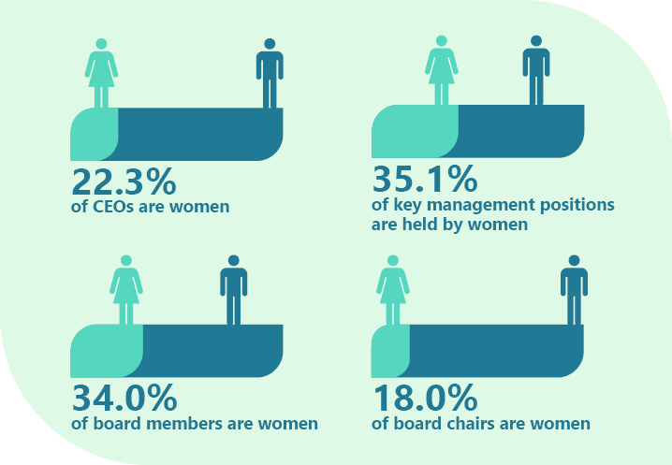
Women remain under-represented in all key decision-making roles across almost all industries in the Australian workforce comprising only: 22.3 per cent of CEOs, 35.1 per cent of key management positions, 34 per cent of board members, and 18 per cent of board chairs.
The prevalence of technology facilitated gender based violence can also seriously impact professional lives (eSafety, 2022). The disrespect and abuse women experience online can be a barrier to using digital spaces to promote business interests or hold visible leadership positions.
The Australian Public Service (APS) has demonstrated that targeted gender equality strategies are an effective way to promote more women into senior leadership positions, with the proportion of women in senior executive roles in the APS increasing from 26.8 per cent in 2001 to 52 per cent in 2022.
The Government is also working to improve women’s representation on Government boards and advisory bodies, through setting measurable gender balance targets and bi-annual reporting on these targets.
At June 2022, women held 51.4 per cent of Australian Government Board positions, up from 33.4 per cent in 2009 when targets were first introduced. Building from this success, there is a need to now focus on boosting representation on boards in those areas of the Government that are highly segregated, and increasing the number of women in Chair and Deputy Chair leadership positions.
In the 47th Australian Parliament, women hold 44.4 per cent of seats across both chambers. This is made up by 38.4 per cent of seats in the House of Representatives, and 56.6 per cent in the Senate. This includes 10 women in Cabinet (43.5 per cent), which is the largest number of women to ever hold positions in an Australian Cabinet.
Women account for 41.9 per cent of overall positions in State and Territory Parliaments in Australia. Six of the eight State and Territory Parliaments are gender balanced, with women and men each holding at least 40 per cent of positions. These are the Australian Capital Territory Legislative Assembly, the Northern Territory Legislative Assembly, the Parliament of Western Australia, the Parliament of South Australia, the Parliament of Victoria and the Parliament of Tasmania.

Prompt

What do you think are the main challenges to achieving gender equal leadership and representation?

4.6 Gendered factors combine and impact us across our lives
The factors outlined in this paper impact us across the life course. They can be experienced in different ways at different times, and the impacts can accumulate over a life time.
Financial insecurity, for example, can impact a woman’s decision or options to leave a violent relationship. Violence can have devastating health impacts and diminish a woman’s capacity to participate in the workforce and progress in her career. Certain women’s health issues – such as endometriosis and menopause – can affect workforce participation. Time out of the workforce and the gender pay gap can have a cumulative impact on women’s lifetime earnings, with considerable implications for older women, including for retirement incomes.
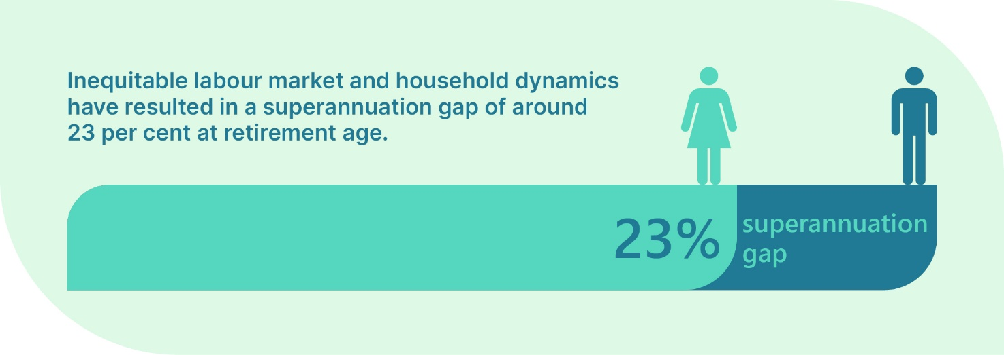
Inequitable labour market and household dynamics have resulted in a superannuation gap of around 23 per cent at retirement age. At 60–64 years-old, men have $181,000 in superannuation, while women have $140,000.

Housing and Infrastructure

Australia’s infrastructure and housing environment tend to be designed from an assumption that women and men have the same needs. However, the combination of the factors explored in this paper often result in particular challenges and needs for women in this area.
Housing is critical infrastructure, with access to affordable, safe and secure long-term housing delivering significant economic and social benefits. Housing is a key enabler of improved education and retirement outcomes, workforce participation, economic equality, safety, health and wellbeing. For those impacted by family and domestic violence, housing is key for their ability to leave and recover. Research has shown 25 per cent of women who wanted to leave a violent partner were unable to due to a lack of financial support.
Australian’s are facing many household pressures, with rising rental costs and supply pressures that have built up over many years. Many women face additional challenges of finding safe and secure long-term housing. This is particularly evident for single women who don’t have the economic security of a dual income relationship, and who are most likely to become homeless. The cumulative impacts of gender inequality, including the gender pay gap and family and domestic violence, result in many women being at increased risk of housing insecurity. Women are less likely to own a property than men. Many people on low incomes spend a large share of their income on rent, there is rising demand for social housing, with more people seeking help from homelessness services, and more people being turned away.
Violence against women also has significant ramifications for women’s economic equality, with a 2011 national domestic violence and the workplace survey finding that 48 per cent of women who had experienced violence saying that it reduced their capacity to attend work. Victims and survivors of sexual violence are up to 45 per cent more likely to experience high levels of financial stress than those who have not experienced sexual violence. KPMG modelling also estimates that nationally the cost of violence against women and their children is $26 billion each year, with victim-survivors bearing approximately 50 per cent of that cost.
Many women experiencing violence can also face a stark choice to stay in a relationship where violence is occurring or escalating, or to leave the relationship but face ongoing financial hardship, homelessness or poverty. There can be a range of reasons why women stay or leave, including because they want to try to work things out. Having no money or nowhere else to go are some of the reasons women identify for leaving a violent relationship, only to return to it later.

Prompts

What are critical factors that exacerbate gendered disadvantage over the life course?
Are there issues you (or your organisation or community group) would address first? Are there issues that should be addressed together?

4.7 Stereotypes are holding us back
Consciously and subconsciously we all hold beliefs about what men and women, boys and girls should do, or can do. These beliefs are also called gender norms and are often expressed as stereotypes that represent or classify women and men in simplified ways. We are all familiar with stereotypes such as those that frame girls and women as good at cooking, housework and looking after people, and less good at maths, leading or sport, or those which frame boys and men as good at sport, fixing and building things, and leading, but less good at caring, or showing emotion.
We are all exposed to gender norms and stereotypes from the day we are born. These stereotypes inform everything from toys to marketing, from which chores boys and girls do and how much pocket money they receive to who gets selected for leadership positions. When gender norms or stereotypes create barriers to individual’s choices or opportunities they lead to different outcomes over our lives and reinforce gender gaps. Although messages about gender vary across cultural, geographic, and socioeconomic groups, gender norms and stereotypes persist across all of Australia’s populations.
Evidence indicates that gendered stereotypes and norms are at the core of key gender equality challenges, including occupational gender segregation, the feminisation and undervaluing of care work, the under representation of women in STEM fields, the under representation of women in leadership and decision making, and gender based violence. If Australia abandoned prescriptive gender norms that constrain men and women educational and work choices, the Australian economy would grow by $47 billion by 2040 and $163 billion by 2050.

Prompt

In what areas are stereotypes a key barrier to achieving gender equality?
- Measuring progress
Research, data collection and the understanding of the various ways that sex, gender, age, First Nations heritage, race, ethnicity, migration status, disability and other demographics interact is complex and evolving. The existing evidence base and data collections have many limitations in this respect and in some cases, demographic information is not always available in a statistically relevant way.
These gaps in data constrain our analysis of what life is like for diverse women, men and non-binary people in Australia. The Government is working to map and better use its data holdings, especially to support gender impact analysis for government decision making, and to shine a light on where progress is slow and more effort needed. This effort is critical to making the invisible visible and surfacing the reality of women’s lives so that policies can respond. Data is also critical for measuring progress and holding ourselves accountable for achieving impact.
The Strategy will help identify where we can focus these efforts, as well as identify what targets we could set ourselves, what indicators of success we should monitor and how we could report this.
Limitations of the Data

In this discussion paper we have used the best data available to demonstrate the state of gender equality in Australia, however we acknowledge that in some cases this is imperfect or does not properly represent the experience of many in Australia. We are seeking to overcome these limitations as best possible by consulting broadly and with a diverse range of people in Australia. In your response to this paper, please feel free to use the terminology that best describes you and your experience so we can understand the words that best resonate with the community when developing the Strategy.

Prompts
When building the evidence base and assessing progress, where should we focus?

What accountability and reporting mechanisms would you prioritise?
- More information and accessing support
We acknowledge that people reading this paper may have lived experience relating to issues detailed in the discussion paper. Discussions about gender inequality and discrimination can be distressing for many in our community. If you would like to speak to someone for support, national counselling and referral services are available:
- 1800RESPECT – confidential information, counselling and support service for people impacted by sexual assault, domestic or family violence and abuse. 1800 737 732 or www.1800respect.org.au * Lifeline – counselling services for anyone at any time. 13 11 14 or www.lifeline.org.au
- Beyond Blue – information and referral for depression and anxiety. 1300 224 636 or www.beyondblue.org.au
- MensLine Australia – telephone and online support, information and referral service to help men with relationship and other problems. 1300 789 978 or www.mensline.org.au
- QLife – anonymous and free LGBTI peer support and referral or people in Australia wanting to talk about sexuality, identity, gender, bodies, feeling or relationships. 1800 184 527 or www.qlife.org.au
- 13YARN – national support line for Aboriginal and Torres Strait Islander people in crisis. 13 92 76 or www.13yarn.org.au
- Arafmi – support for family, friends and carers of people with mental illness. 1300 554 660 or www.arafmi.com.au

The Sex Discrimination Act 1984 is available at: www.legislation.gov.au
The National Plan to End Violence against Women and Children 2022–2032 is available at: www.dss.gov.au
National Community Attitudes towards Violence against Women Survey (NCAS), 2017
Women's Budget Statement October 2022-23 p. 33
Women's Budget Statement October 2022-23 p. 29
For further information: ACARA (Australian Curriculum, Assessment and Reporting Authority) (n.d.) ‘2021 Apparent retention rates from Year 10 to Year 12’, Key Performance Measures for Schooling in Australia, accessed on 20 September 2022.
For further information: WGEA (n.d.) Gender pay gap data, accessed on 7 March 2023; Social Research Centre (2021) 2021 Graduate outcomes survey, Quality Indicators of Learning and Teaching, October 2021, p 7-8.
University of Sydney Gender dynamics in the post pandemic future of work March 2023.
Equity Economics (2021) Back of the pack – How Australia’s parenting policies are failing women and our economy, December 2021, p 9 and CEW (Chief Executive Women) (2002) Addressing Australia's critical skill shortages: Unlocking women's economic participation, Sydney.
Deloitte Access Economics (2022) Breaking the norms: Unleashing Australia’s economic potential, Report prepared in partnership with Australians Investing in Women, November 2022.
WGEA (2022) Australia’s gender equality scorecard 2020–21, Sydney, February 2022.
Women's Budget Statement October 2022-23 p.54
Women's Budget Statement October 2022-23 p.54
Deloitte Access Economics, The economic costs of sexual harassment in the workplace, March 2020
Australian Institute of Family Studies 2022 Conference Proceedings (paperlessevents.com.au)
For further information: Our Watch (2018) Challenging gender stereotypes in the early years: the power of parents, Melbourne.
Deloitte Access Economics Breaking the norms: Unleashing Australia’s economic potential, Report prepared in partnership with Australians Investing in Women, November 2022.
Deloitte Access Economics, (2022) Breaking the norms: Unleashing Australia’s economic potential, Report prepared in partnership with Australians Investing in Women, November 2022
CEW and Bain & Company, Equitable Flexibility.
CEW and Bain & Company, Equitable Flexibility.
Hegewisch and JC Gornick, ‘The impact of work-family policies on women’s employment: a review of research from OECD countries’, Community, Work and Family, 2011, 14(2):119–138, doi.org/10.1080/13668803.2011.571395.
R Cassells and A Duncan, Gender Equity Insights 2019: Breaking through the glass ceiling, Bankwest Curtin Economics Centre, 2019.
Bahar E, Bradshaw N, Deutscher N and Montaigne M (2022) Children and the Gender Earnings Gap, Treasury Round Up, October 2022.
D Wood, K Griffiths and O Emslie, Cheaper childcare: A practical plan to boost female workforce participation, Grattan Institute, 2020.
A joint state and territory Government Initiative, National Plan to End Violence against Women and Children 2022-2032, (2022) P 32, accessed on 14 February. The National Plan is available at: www.dss.gov.au
KPMG, The cost of violence against women and their children in Australia – Final Report, KPMG, 2016.
Deloitte Access Economics (2022) The cost of financial abuse in Australia, Commonwealth Bank of Australia, accessed on 7 March 2023.
The Respect@Work Report can be found at: www.humanrights.gov.au
National Women’s Health Strategy 2020–2030 | Australian Government Department of Health and Aged Care p.11
National Women’s Health Strategy 2020–2030 | Australian Government Department of Health and Aged Care p.11
WGEA (Workplace Gender Equality Agency) (2022) Australia’s gender equality scorecard 2021–22, Sydney, December 2022.
Ibid.
Office for Women (2022) Gender Balance on Australian Government Boards report 2021-22
APH, (2023) Gender composition of Australian parliaments by party: a quick guide
Australian Tax Office (ATO) (2022) ‘Taxation Statistics 2019-20: Individual Statistics, ATO website, accessed on 25 August 2022.
Summers A (2022) The Choice of Violence or Poverty
Productivity Commission (2022) In Need of Repair: The National Housing and Homelessness Agreement, p 2.
L McFerran, Safe at home, safe at work? National domestic violence and the workplace survey, University of New South Wales, 2011.
The Commonwealth of Australia, 2022-23 Women’s Budget Statement, Budget October 2022-23.
Deloitte Access Economics (2022) Breaking the norms: Unleashing Australia’s economic potential, Report prepared in partnership with Australians Investing in Women, November 2022 p. 2
Westpac Kids and Money report 13-15 2023
University of Queensland: Hands up for Gender Equality p. 10
Deloitte Access Economics (2022) Breaking the norms:, November 2022 p. 2

