National Review of Quarantine

The Hon Scott Morrison MP
Prime Minister
Chair, National Cabinet
Parliament House
CANBERRA ACT 2600

Dear Prime Minister

On 23 July 2021, the National Cabinet commissioned a second review of quarantine arrangements in Australia. This report provides the observations and recommendations of the review.
The review considered the recommendations of the first review into national quarantine and found that they had been implemented in whole or part by all states and territories.
The review team engaged with all jurisdictions and Australian Government agencies to consider current arrangements. Due to lockdown restrictions, the review team could not conduct site inspections. Instead, the review is based on documentation provided by all states. Supplementing this desktop review, interviews were conducted via videoconferences with representatives from all states.
The review team also engaged with a number of non-government stakeholders, including from the health, business and aviation sectors. Finally, the review team sought feedback from individuals who had experienced quarantine through semi-structured interviews.
As principal reviewer I was assisted by key review team members Graeme Head AO, Professor Peter Collignon AM and Professor Andrew Wilson. Members of the review team undertook discussions with other experts on public health and infectious diseases to inform development of the report and the proposed risk framework.
I would also like to acknowledge the work of the secretariat who assisted the review team ably led by Richard Aitken from the Department of the Prime Minister and Cabinet.
Australia is at a cross roads in its management of the COVID-19 pandemic. Quarantine has been a crucial part of Australia’s success and will continue to play a role under the National Plan to transition Australia’s National COVID-19 Response. Changes to quarantine arrangements including increased use of home quarantine during the forthcoming stages of the National Plan and the reopening of our borders will play an important role in the transition back to a full-speed economy and the return to a more normal life for all Australians.
Yours sincerely
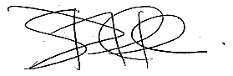

Adj. Professor Jane Halton AO PSM
12 October 2021

Table of Contents
1 Executive Summary 5
1.1 Recommendations 8
1.2 Principles 9
1.3 Risk-based framework 9
2 Australian quarantine – 18 months of operation 10
2.1 First National Review of Hotel Quarantine 10
2.2 COVID-19 cases in quarantine 11
2.3 Transmission events 12
2.3.1 Transmission events in quarantine facilities 13
2.3.2 Transmission events in the wider quarantine system 14
2.4 Quarantine capacity 14
2.4.1 Demand for international travel 17
2.5 Domestic Travellers 18
2.6 Changes in the epidemiological context 18
2.6.1 The Delta variant 18
2.6.2 Incubation period 19
2.6.3 Case numbers 20
2.6.4 Vaccination rates 21
2.7 Modelling and future plans 25
2.7.1 National Plan to transition Australia’s National COVID-19 Response 26
3 Operation of the current quarantine system 27
3.1 Governance 28
3.1.1 The role of the National Cabinet and AHPPC 28
3.1.2 State and territory arrangements 29
3.2 Information Sharing 31
3.2.1 Information sharing on best practice 31
3.2.2 Data sharing about passenger movements 32
3.2.3 Data sharing on capacity 32
3.3 Mitigating transmission risk 32
3.3.1 End-to-end passenger journey 33
3.3.2 Ventilation and airflow 34
3.3.3 Testing for COVID-19 34
3.3.4 Assurance mechanisms 35
3.3.5 Infection prevention and control (IPC) 36
3.3.6 Management of COVID-19 positive cases 36
3.4 Workforce 37
3.4.1 Vaccination requirements for staff 37
3.4.2 Testing requirements 38
3.4.3 Single site employment 38
3.5 Quarantine locations 39
3.5.1 Purpose-built quarantine 40
3.5.2 Hotel quarantine 42
3.5.3 Home quarantine 44
3.6 Home quarantine trials 45
3.7 Quarantine exemptions 46
3.8 Quarantine requirements for different arrivals 46
3.8.1 Airline crew 47
3.8.2 Maritime crew 48
3.8.3 Foreign diplomats 49
3.8.4 Government officials 50
3.8.5 Seasonal workers / industry-led solutions 50
3.8.6 Sporting teams and associated personnel 51
3.8.7 International students 52
3.8.8 Compassionate alternatives 53
3.8.9 Domestic quarantine 53
3.9 Mental health and wellbeing 54
4 Future quarantine arrangements 55
4.1 Development of a risk-based framework 58
4.2 Current context 59
4.2.1 Prevalence of COVID-19 in Australia 59
4.2.2 Objectives under the National Plan 59
4.2.3 Current quarantine trials 60
4.3 Immediate priorities 60
4.4 A stepped down approach 61
4.5 Different types of quarantine 62
4.5.1 Mitigating risk 63
4.6 Implementation issues 65
4.6.1 Vaccine requirements 65
4.6.2 Duration of quarantine 66
4.6.3 Testing 69
4.6.3.1 New types of testing 69
4.6.4 Compliance monitoring 70
4.6.5 Transport to quarantine and location risk 71
4.7 System capacity 72
4.7.1 Current quarantine capacity 72
4.7.2 Future quarantine capacity 73
4.7.3 Impacts of quarantine capacity and duration 73
4.7.4 Emergency capacity 74
4.8 Information sharing 74
4.8.1 Pre-arrival quarantine planning 75
4.8.2 Outbound travel 75
4.9 Airport limitations 76
4.9.1 Travel pathways 76
4.10 Specific cohorts 77
4.10.1 Domestic quarantine requirements 77
4.10.2 Industry-led solutions 78
4.10.3 Appropriate regulation 78
4.11 Variants of concern 78
4.12 Prevalence of COVID-19 79
4.13 International alignment of quarantine requirements 80
4.14 Health system capacity 80
5 Conclusion 81
Attachments 82
Attachment 1 Terms of reference 83
Attachment 2 Implementation of the first National Review of Hotel Quarantine recommendations 84
Attachment 3 National Plan to transition Australia’s National COVID-19 Response 87
Attachment 4 Transmission events 88
Attachment 5 Ventilation and airflow 91
Attachment 6 International experience 93
Attachment 7 AHPPC statements on quarantine to 16 September 2021 97
Attachment 8 The costs of quarantine 100
Attachment 9 Hierarchy of controls 103
Attachment 10 Customer experience in quarantine 105
Attachment 11 Testing arrangements 110
Attachment 12 Other risk mitigations 116
Attachment 13 Remote monitoring 119
Attachment 14 Vaccination certification and authentication 121
Attachment 15 Establishing a risk-based framework 123
Attachment 16 Cumulative effects of travel restrictions and quarantine requirements 125
Attachment 17 Vaccines 127

1 Executive Summary
In January 2020, as early stories began to emerge of a new and worrying coronavirus circulating in China, ‘quarantine’ was a term largely from the history books. Some Australians had heard of the ‘Spanish’ flu and knew of the quarantine stations used to isolate arrivals over 100 years ago. Most Australians had no or very limited awareness of modern uses for quarantine other than for animals.
Some eighteen months into the COVID-19 pandemic, quarantine is well-established as a crucial element of the public health response protecting Australia and Australians. The nature, uses of and risks posed by quarantine are also the subject of everyday conversation, political interest, academic inquiry and media analysis.
In the absence of widespread immunity providing protection against the health effects of COVID-19, limiting the entry and spread of the virus has been a key public health objective. In addition to other non-pharmaceutical interventions (NPIs), mandatory quarantine has played a key role in Australia’s public health response for both domestic and international travellers.
The Australian quarantine system was stood up quickly in response to the immediate threat from COVID-19 – from a standing start to fully operational over a weekend – following a decision at the National Cabinet on 28 March 2020. This was done to meet immediate needs: keep COVID-19 out of Australia, manage case numbers in the community and flatten the epidemiological curve of new cases to help preserve life and provide time to prepare the public health and hospital system response. There was no best practice quarantine handbook and arrangements were developed on a state-by-state basis.
In that context, and in the absence of large-scale dedicated facilities, hotels became the mainstay of the quarantine system for international travellers and have been a key part of Australia’s health response to COVID-19. Since 28 March 2020, when mandatory quarantine commenced, approximately 452,550 international air arrivals have been through the system. A large but unknown number of domestic travellers have also undertaken mandatory hotel quarantine as they have moved from state to state.
In common with a small number of countries, Australia has had remarkable success in managing COVID-19. Our island nation status, early decisions to manage arrivals and prompt and effective action by public health officials together with widespread public cooperation have been key to this success.
Control of the border was an early and crucial element in the response to COVID-19. By preventing the uncontrolled entry of the virus, Australia has not experienced the widespread and devastating waves of infection relative to those seen in most comparable countries.
However, this has required limits to hitherto unquestioned freedoms enjoyed by Australians. These include caps imposed on the number of international arrivals and restrictions on departures as the capacity of the hotel quarantine system is limited.
During the early stages of the pandemic in Australia, and following the effective suppression of the virus, the use of quarantine as a principal defence against COVID-19 was key to Australia’s success. In this context the need for a well-functioning quarantine system has been crucial.
Following a number of transmission events between COVID-19 positive arrivals and quarantine workers, the first National Review of Hotel Quarantine (the first review) was commissioned by the National Cabinet. The review report was released on 23 October 2020 after quarantine arrangements had been in place for seven months. At that time, understanding of COVID-19 and its variants, how to contain the virus, and best practice quarantine arrangements were evolving. While vaccine development had commenced, the time required to develop vaccinations and prospects of success were unknown.
The first review focussed on infection prevention and control, continuous improvement and traveller experience. In line with this review’s Terms of Reference (Attachment 1), the quarantine systems in all jurisdictions have been examined. Overall, this review finds that the quarantine system has improved since the first review. States and territories (states) have implemented improved governance arrangements and greatly improved infection prevention and control (IPC) measures, including improved ventilation.
The six recommendations from the first review have all been implemented in full or in part (Attachment 2). This has included a risk-based approach in respect of some arrivals. Quarantine-free travel between Australia and New Zealand in at least one direction has operated for most of the last 12 months (quarantine-free travel from New Zealand started on 16 October 2020 while the two-way travel bubble started on 19 April 2021 before being suspended on 23 July 2021).
Much has changed since the first review. The pandemic has caused millions of deaths around the world. COVID-19 is now endemic in most countries including parts of Australia. A number of variants of the original COVID-19 virus have emerged, with the current highly infectious Delta variant spreading rapidly around the world and becoming dominant in Australia. It is widely understood that there is no immediate prospect that the virus can be eliminated.
Importantly, and despite concerted public health effort, there are now significant outbreaks of the Delta variant in a number of Australian jurisdictions. Cases are no longer coming primarily from overseas but from within Australia. This has led to sustained lockdowns and domestic border closures. Quarantine and isolation are also now used to respond to community outbreaks, protecting individuals and the wider community by limiting the spread of COVID-19.
With endemic COVID-19, control of the international border is no longer the principal mechanism for COVID-19 control and management in Australia. It is one of the tools available and depends on the context in which it is used.
The consequences of border closures and lockdowns for individuals, families, businesses, academic institutions, the economy (including labour shortages) and national wellbeing are being felt widely.
More hopefully there are now multiple effective vaccines available globally and rollout across the Australian community is well underway. Vaccination rates are increasing rapidly and offer the chance for more day-to-day freedoms as available vaccines are very effective in preventing transmission, severe disease and death. Modelling by the Doherty Institute and others demonstrates that once 70 and 80 per cent vaccination coverage levels are achieved the burden from the spread of COVID-19 on the Australian hospitals system can be managed with lower levels of restrictions on daily individual and community activity in conjunction with effective test, trace, isolate and quarantine (TTIQ) regimes and public health system measures.
In Australia, quarantine options are being expanded to include construction of purpose-built facilities and home quarantine is being trialled in a number of states. Continuous improvement and assurance systems have been widely implemented. More is known about modes of transmission, including the importance of ventilation. Testing technology has improved.
This review comes at a time of increased complexity. There are more quarantine options, travellers and Australians are increasingly vaccinated, and improved and more flexible testing arrangements are available to provide assurance and early detection of infectivity. The risk of COVID-19 developing in recent international arrivals during their quarantine period given pre-departure testing and vaccination is very low, indeed lower than the risk of endemic COVID-19 in at least two states.
The national environment is also more complex with ongoing community transmission of COVID-19 being present in some but not all Australian jurisdictions. While being an international traveller was a good proxy for risk at the start of the pandemic, we now need better ways to determine risk and consequential quarantine requirements.
It is in this context that the National Cabinet has agreed to a re-opening plan in four phases under the National Plan to transition Australia’s National COVID-19 Response (the National Plan, which is at Attachment 3). It is also in this broader context that the National Cabinet commissioned this review on 23 July 2021.
The review is structured in three main sections:
- System performance over the previous 18 months including what has changed since the first review, vaccine rollout, the emergence of the Delta variant and implementation of the first review’s recommendations;
- Current system operations, including risk mitigations to prevent COVID-19 transmission events in the context of phase A of the National Plan; and
- Future use of quarantine, and implementation issues, during phases B-D including the need for a framework that can support increased quarantine capacity and manage transmission risks.

Recommendations
All governments must work towards a future where quarantine requirements are the exception rather than the norm while still ensuring managed quarantine can be scaled up quickly to meet future challenges including to prevent the introduction of new variants of concern.
In this context, in line with the National Plan and the five COVID-19 quarantine principles proposed in this report, the review recommends:
Recommendation 1. The Australian Health Protection Principal Committee should maintain national principles for good practice in managed quarantine. State and territory authorities, including Auditors-General, should review their respective jurisdiction’s compliance with these principles. During the course of the pandemic, the National Cabinet should be provided with regular updates on the quarantine system and compliance with these principles.
Recommendation 2. All governments should commit to improved and timely information sharing, including the establishment of a common quarantine dataset so that quarantine capacity and allocations can be determined. The dataset would include the total number of quarantine places, usage and incorporate forecast arrivals into quarantine.
Recommendation 3. All governments should reference current National Plan settings and the COVID-19 quarantine principles outlined in this report when considering requirements for travellers to undertake quarantine.
Recommendation 4. All governments should commit to urgent work to forecast and publish managed quarantine capacity and projected arrivals based on increased arrivals caps and altered quarantine requirements. This will provide certainty and enable airlines, businesses and Australians seeking to return to plan their travel.
Recommendation 5. The National Cabinet should agree to:
- The five COVID-19 quarantine principles;
- A risk-based quarantine framework that stratifies travellers based on risk factors; and
- A staged approach to step down quarantine requirements in line with the National Plan.
Recommendation 6. States and territories should immediately commence stepping down quarantine requirements by phasing out the use of managed quarantine for interstate travellers and introducing home quarantine where feasible for low-risk fully vaccinated Australians and residents returning from overseas.
Recommendation 7. Quarantine requirements should be proportionate to risk so that home quarantine or quarantine-free options are used as the usual practice while managed quarantine, including purpose-built and hotel quarantine facilities, is used where necessary.
Recommendation 8. States and territories should apply risk mitigations when implementing new models of quarantine. The least restrictive quarantine option should be preferred, including quarantine-free options for low-risk cohorts.
Recommendation 9. All governments should work together towards a future where quarantine requirements become the exception rather than the norm while ensuring managed quarantine can be scaled up quickly to meet future challenges including to prevent the introduction of new variants of concern.

Principles
This review also proposes the following five key COVID-19 quarantine principles to underpin the use and nature of pandemic quarantine going forward:
Principle 1. Quarantine requirements are determined and applied consistent with the context, including: the National Plan; vaccination rates; relevant epidemiology, including the burden of disease and prevalence of COVID-19 in the community; the emergence of new variants and variants of concern; and the community’s risk tolerance.
Principle 2. Quarantine requirements are determined using a consistent risk-based framework that assesses the relative transmission risk posed by the individual.
Principle 3. Quarantine requirements are routinely reviewed in light of new developments and modified in a staged way to increase the ability for travel to and from Australia and between jurisdictions.
Principle 4. Quarantine settings are proportionate to relative transmission risk with the least restrictive setting for a given risk profile preferred.
Principle 5. Quarantine capacity is readily scalable so that appropriate facilities are designed to be available at short notice to respond to the possible emergence of new variants of concern or to assist in managing significant COVID-19 outbreaks.

Risk-based framework
The review also recommends a risk-based framework to reposition use of the quarantine system in light of the phases of the National Plan, increased understanding of COVID-19 and its variants and the impact of COVID-19 vaccinations.
Under phase A of the National Plan, the core objective of quarantine has been to eliminate/minimise community transmission preventing the importation of the virus. Under phases B-D of the National Plan, quarantine is one (but not the most consequential) of the mitigations available to manage the impact of COVID-19. The use of quarantine – for whom, when, where and for how long – should be determined as part of a wider strategy to manage the burden of disease.
This report sets out a framework for the use of quarantine as one of the risk mitigations available to manage COVID-19. Importantly, this provides options to gradually reopen the economy to the wider world.
Quarantine requirements and options that can accommodate new and changing circumstances, while still being proportionate to risks, will be needed. This should include a greater diversity of quarantine models which can minimise community transmission when needed while providing capacity that can be scaled up to support the path back to a full⁻speed economy. Economic and social objectives as well as broader health objectives, including the mental health of those quarantined, must be considered.
In order to achieve the full benefits of greater flexibility that will come from the later phases of the National Plan, which will coincide with greater numbers of international arrivals, attention must be paid to implementation arrangements. Constraints around key services such as testing must not become limiting factors.

2 Australian quarantine – 18 months of operation
The Commonwealth Government declared the COVID-19 pandemic on 27 February 2020. On 27 March 2020, the Government announced incoming travellers were required to undertake 14 days of supervised quarantine in a designated facility at their port of entry. The period of quarantine was agreed as an outer limit of the likely incubation period for 99 per cent of cases with the original Wuhan strain.
States established hotel quarantine at short notice and scaled up these services in response to the public health emergency. They enacted complementary legislation, public health orders and associated declarations, and established quarantine arrangements concentrated mainly in the capital cities of Australia.
The system has proven largely successful in protecting Australia from many of the impacts of COVID-19 by controlling the entry of COVID-19 at the border and preventing its spread into the Australian community.

First National Review of Hotel Quarantine
As a consequence of a number of early transmission events, the National Cabinet commissioned a review of hotel quarantine. This review focussed on infection prevention and control, assurance systems and customer experience.
The first review made six recommendations which were accepted by the National Cabinet on 23 October 2020. All recommendations have been implemented in full or in part. The six recommendations were:
- States should embed end-to-end assurance mechanisms and look to continuously improve hotel quarantine
- Information on the quarantine system should be easy to access by travellers
- People in quarantine should have access to timely decision-making and review processes
- Options for new models of quarantine should be developed for consideration by the National Cabinet including a risk assessment of these options and an analysis of traveller suitability
- The National Cabinet should consider exempting low risk cohorts, such as travellers from New Zealand, from mandatory quarantine
- The Australian Government should consider a national facility for quarantine to be used for emergency situations, emergency evacuations or urgent scalability

Since the first review, a number of states have conducted significant reviews of their quarantine systems. These include the Review of Western Australia’s Hotel Quarantine Arrangements published on 26 February 2021, and the Victorian COVID-19 Hotel Quarantine Inquiry, delivered on 21 December 2020. Both of these reviews set out clear recommendations to improve quarantine arrangements in these two jurisdictions.
Other reviews have been established in relation to specific incidents. For example, Queensland established a Joint Agency review of the COVID-19 infection of a hotel worker. Other jurisdictions have conducted similar reviews of individual incidents.
Importantly, all states have worked to improve their systems based on experience, good practice and the changing COVID-19 pandemic context. They have all incorporated assurance mechanisms in their governance and appropriate oversight in respect of infection prevention and control.
There have been improved testing protocols for both quarantine and transport staff and travellers. There have also been significant improvements in ventilation. More recently there have been requirements that workers be vaccinated.
The objective of the quarantine system over the previous 18 months has been to limit, and preferably prevent, the importation of COVID-19 and hence spread within the community. This broadly equates to phase A of the National Plan agreed by the National Cabinet on 6 August 2021.
Notwithstanding the significant improvements achieved in the delivery of quarantine services, the system has faced new challenges. System performance should be assessed in the context of these changes and the new challenges presented by COVID-19 both in Australia and globally. It also needs to be seen in the context of the phases of the agreed National Plan.

COVID-19 cases in quarantine
Between 28 March 2020 and 27 September 2021, 452,550 travellers (excluding airline crew and travellers under the New Zealand travel bubble) arrived in Australia by air flight. Almost all these travellers completed 14 days of mandatory quarantine in a managed facility. Of these individuals, approximately 4,000 have tested positive to COVID-19, representing around 1 per cent of the total.
More recent arrivals have a lower rate of COVID-19 positivity reflecting the implementation of new mitigations, such as pre-flight testing and vaccination of travellers.
Table 1 – International arrivals and overseas acquired cases since 28 March 2020 (as at 27 September 2021)
Cumulative to date
Total air arrivals into Australia | 452,550
Estimated overseas acquired cases among air arrivals | 4,350
Estimated positivity among total air arrivals | 1.0 per cent
Past 28 Days (30 August 2021 to 26 September 2021)
Total air arrivals into Australia | 20,134
Estimated overseas acquired cases among air arrivals | 64
Estimated positivity among total air arrivals | 0.3 per cent
Source: Department of Health, Australian Border Force
To put the potential for returning travellers to pose an infection risk to the community in the context of the current Australian COVID-19 outbreaks, on 5 September 2021, of the 1487 cases in New South Wales (NSW), only two were identified in the hotel quarantine system. That means that just 0.13 per cent of the cases diagnosed in NSW on that day originated overseas.
There has been significant discussion about whether the quarantine system has been effective and whether the appropriate measure of effectiveness should be the rate of transmission events per positive COVID-19 case or per arrival. On either measure, it is clear that this rate is no more than one per cent and that the quarantine system has been effective.

Transmission events
The objective of quarantine over the last 18 months has been to prevent the spread of COVID-19 from infected travellers to others in the community. This can occur through the infection of quarantine workers or through the infection of other travellers who, following release, in turn infect others. In the absence of widespread vaccination, any transmission event has had the potential to cause significant outbreaks with consequent health, economic and social outcomes.

Transmission events in quarantine facilities
Despite significant improvements in quarantine systems, there have been ongoing transmission events. These have been particularly affected by the new Delta variant of COVID-19 (see section 2.6.1).
As at 6 October 2021, 27 transmission events have been detected within mandatory quarantine facilities since the start of pandemic. The 27 transmission events occurred across NSW, Queensland, South Australia, Victoria and Western Australia.
There were more transmission events in quarantine facilities in the first nine months of 2021 than across 2020. 19 of the 27 transmission events occurred in 2021 and the majority of these (16 of 19) were identified to have a variant of concern. Attachment 4 lists all these events in more detail.
States reported to the review team on their approaches to continuous improvement and how they incorporate learnings from incident reviews into their quarantine processes.
States have reviewed each transmission event and have implemented improvements to respond to identified system and infrastructure weaknesses. This has included improved ventilation (see Attachment 5), the adoption of new systems such as remote compliance monitoring and improved IPC training.
Figure 1 – Transmission events in quarantine facilities
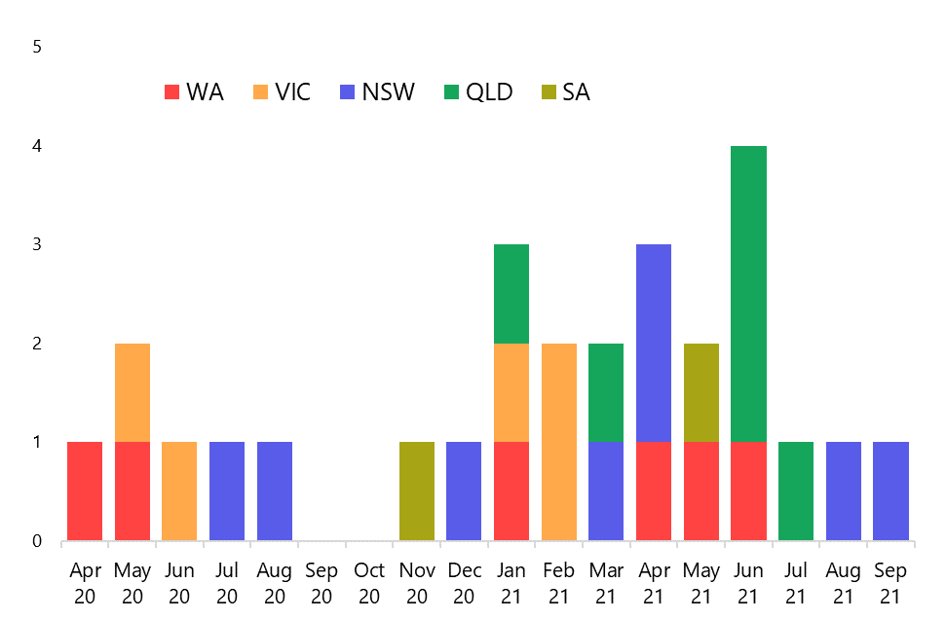
It is important to note that transmission events are not inevitable.
No transmission events have occurred in the Centre for National Resilience (Howard Springs) facility, Tasmanian hotel quarantine or the Special Health Accommodation Hotels operated by NSW Health (noting Figure 1 shows transmission events in NSW Police-managed hotel quarantine). Further, no transmission events have occurred from the Australian Capital Territory’s (ACT) home or managed quarantine program, which has identified and managed over 100 positive cases. There have also been no transmission events in the COVID-19 Quarantine Victoria (CQV)-operated Victorian quarantine system since the implementation of improved ventilation, vaccination of essential workers, and other infection control and prevention standards.
This highlights the significant impact the physical layout of managed quarantine, such as the distributed ‘camp style’ facility used at Howard Springs, has in decreasing the risk of transmission. It also underscores that quarantine can be provided effectively in apartment style accommodation – including with opening windows and balconies – if the hierarchy of controls and IPC processes in place are comprehensive and are implemented meticulously.
However, these services are expensive to provide and have limited capacity to deliver quickly at scale.

Transmission events in the wider quarantine system
The 27 transmission events do not include transmission events outside quarantine facilities but within the quarantine system (this encompasses travel to and from the quarantine facility).
These other transmission events include cases linked to transport, such as the NSW Berala cluster (December 2020) which was linked to a patient transport worker who acquired their infection transporting COVID-19 positive travellers. It also includes the large and ongoing NSW Sydney Metropolitan outbreak (June 2021) which was linked to air crew transport.
Quick action by governments, public health officials and citizens have contained most of these outbreaks although some have resulted in prolonged lockdowns. The lockdowns have come at a huge cost to the lives, health and livelihoods of individuals, families and businesses.
The review acknowledges that steps have been taken to address identified weaknesses in systems, public health orders and compliance since the first review. That said, it is undeniable that the current COVID-19 outbreaks in NSW, Victoria and the ACT have their origins in transmission events involving the transport of international flight crew, representing a gap in Australia’s defences against COVID-19 which has since been rectified.

Quarantine capacity
Delivery of high-quality managed quarantine is a resource-intensive and expensive business. It requires high levels of expert staff and systems to manage and monitor service delivery. In many instances this includes the use of finite resource such as police and health care workers. Suitable sites for delivery, particularly of hotel quarantine, are also limited.
As a consequence of these factors, there have been marked limits on the number of arrivals into Australia even when taking into account periods when travel ‘in the bubble’ between Australia and New Zealand has been permitted.
Arrival numbers can be broadly classified into travellers who arrive as: part of the regular arrival caps agreed by the National Cabinet; ad hoc repatriation arrivals agreed between the Commonwealth and relevant jurisdictions; above cap arrivals approved by the states, ‘travel bubble’ arrivals and categories of arrivals such as aircrew, maritime workers and ad hoc charter flights which occur as part of transport and maritime industry operations.
It is difficult to quantify the total for each category, but Figure 2 demonstrates that while there was a spike in arrivals from April to early July 2021, arrival numbers have been very limited.
In fact, arrivals are at a 30-year low.
Figure 2 – weekly air arrivals into Australia from 20 March 2020 to 5 September 2021
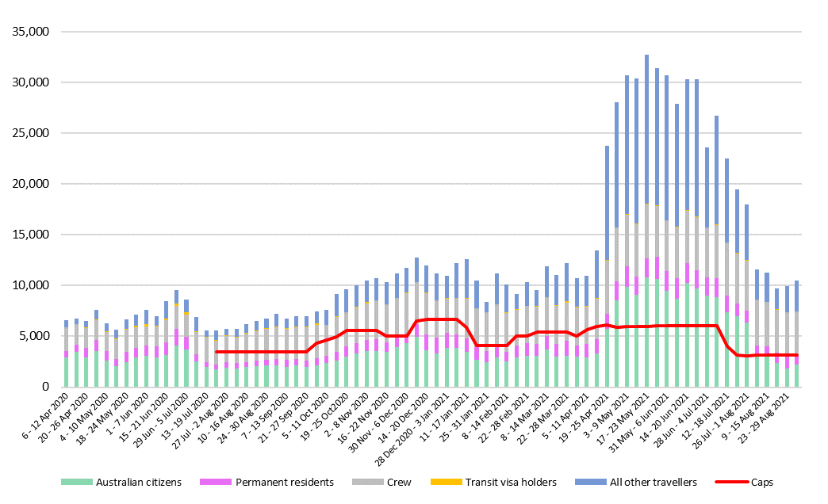
Source: Australian Border Force
Figure 3 provides a snapshot view of arrival data over a one-week period when the travel bubble was in operation from New Zealand to Australia. The vast majority of arrivals were from New Zealand, followed by Singapore, United States of America (United States) and Japan.
Figure 3 –Top Australian citizen air arrival origin countries (one week snapshot 26 July 2021 to 1 August 2021)
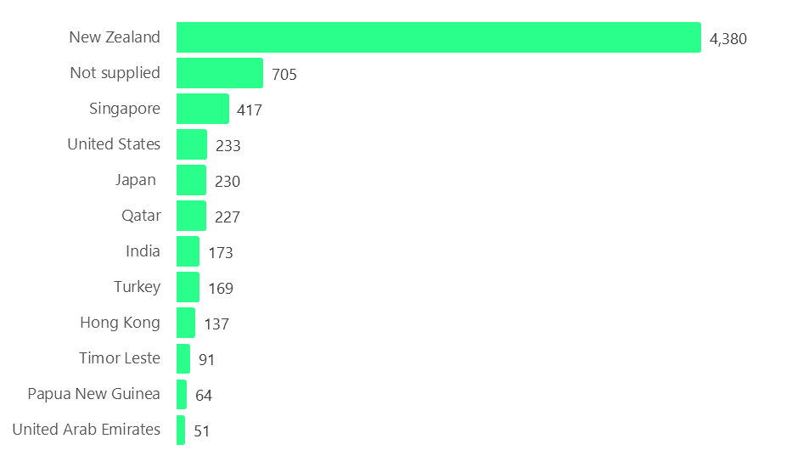
Source: Australian Border Force
In order to manage quarantine arrangements, the National Cabinet first agreed on 10 July 2020 to the imposition of air arrival caps on passengers flying into Australia. Arrival caps have applied since then at varying levels, at the request of state governments. Subsequently, and consistent with the recommendations of the first review, there was also an expansion of capacity at the Centre for National Resilience in Howard Springs from March 2021. The facility was expanded from 850 to 2,000 beds.
The current caps for Queensland, Victoria, Western Australia and South Australia reflect the agreement by the National Cabinet on 2 July 2021 – in response to the increased risk associated with the Delta variant – to temporarily halve the caps to ease the pressure on state and territory quarantine facilities. The cap for NSW was reduced by a further 50 per cent from 8 September 2021.
It is important to note that arrival caps (see table 2) do not represent the totality of arrivals given they exclude some arrivals such as air crew.
Table 2 – Caps on air arrivals into Australia as at 22 September 2021
Jurisdiction | Arrival cap  (per week)
New South Wales | 756
Queensland | 500 +150 surge
Victoria | 500
Western Australia | 265
South Australia | 265

Arrangements for air arrivals into Tasmania, the ACT and the Northern Territory depend on the Commonwealth and state governments working together to manage specific arrivals and repatriation flights.

Demand for international travel
As at 27 August 2021, around 49,800 people were registered through the Department of Foreign Affairs and Trade as being overseas and wishing to return home. Notwithstanding a high number of repatriations in the intervening period, this number is little changed from the first review. The capacity of the hotel quarantine system and the arrivals caps limit the return of these Australians. They also impede travel into Australia from other cohorts including international students, skilled migrants, business travellers and tourists. Necessary arrivals also impact the number of other arrivals including cohorts such as recent humanitarian evacuees from Afghanistan and seasonal workers who have arrived ‘over cap’ – see part two for further information.
Demand for international travel is likely to increase as the pressure builds to address labour shortages and as more people are double vaccinated. While demand may not return to pre-pandemic levels for some time, annual arrivals into Australia have been trending up for decades, so the gap between existing arrival numbers and expected demand is significant. Annual arrivals peaked in 2019 when there were 21,618,800 arrivals into Australia. This equates to around 400,000 arrivals per week on average.
Figure 4 – Arrivals into Australia from 1976 - 2020 (million)

Source: Overseas arrivals and departures data from the ABS released on 13 July 2021
The broader constraints of limited quarantine capacity and the need to get exemptions to travel both domestically and overseas have had flow-on effects as many Australians have been unable to undertake travel for work or compassionate reasons. These constraints have impacted individuals, households, families, communities and businesses.
While almost universal application of a requirement for arrivals to undertake mandatory 14-day quarantine has been a necessary step in the first part of pandemic management, the personal costs have been significant. Quarantine capacity limits have also had significant impacts on the economy and society as well as on individuals. Griffith University academics have quantified that Australia’s closed border is costing the economy $36.5 million per day in the tourism and international student sectors alone.
These limits and consequent impacts have been a feature of what can now be classified as phase A of the National Plan.

Domestic Travellers
While originally intended to accommodate returning international travellers, quarantine requirements were extended to also accommodate domestic travellers following the closure of some internal borders.
The number of domestic travellers requiring quarantine has been a factor in determining the number of international arrivals at various points over the last 18 months. With closed internal borders, quarantining of returning or relocating residents and isolation of transit passengers has been a requirement of a number of jurisdictions.
Domestic quarantine of individuals travelling internally in Australia is managed in a number of ways by jurisdictions. While some states have chosen, based on risk appetite, to use existing managed hotel services for all or some of these domestic groups, others have developed wider options including home quarantine or self-isolation models. Most jurisdictions have a risk-based system linked to domestic border policies and interstate arrivals. Eligibility is usually determined by where an individual has been over the previous 14 days.
Table 3 – home quarantine total numbers by jurisdiction
Jurisdiction | Time Period | Total home quarantine
Western Australia | 6 April 2020 to 1 August 2021 | 175,232
Northern Territory | 16 March 2020 to 1 August 2021 | 16,687
Victoria | 3 January 2021 to 7 August 2021 | 130,802
Tasmania | 13 July 2020 to 22 August 2021 | 23,908
Australian Capital Territory | 1 March 2020 to 1 August 2021 | 16,842
Source: state data
Jurisdictions have also used quarantine capacity to manage COVID-19 positive cases and close contacts in local outbreaks. This serves to limit the spread of COVID-19 to the wider community. While most close contacts are managed in home quarantine arrangements, some individuals require managed hotel facilities to quarantine or isolate when they cannot do so safely at their own home.

Changes in the epidemiological context

The Delta variant
COVID-19 variants of the virus have been observed since the onset of the pandemic. Some of these variants are classified as variants of interest and some as variants of concern. Variants of concern have different properties from the strain of the virus that was originally identified which can make them a greater threat to human health, either due to their increased transmissibility and/or likelihood of causing severe disease or death.
The Delta variant was first identified in India in October 2020. Within months, it had been identified in 98 countries, becoming the dominant variant in more than a dozen of those countries. The Delta variant is estimated to be 40 to 60 per cent more transmissible than the Alpha strain and almost twice as transmissible as the original strain. Table 4 below shows the reproduction number of the Delta variant is between five and eight, which means that on average, one contagious person with the Delta variant will infect between five and eight unimmunised people in the absence of NPIs and vaccination.
Table 4 – Reproduction number of COVID-19, variants and other viruses
Ebola | 2
Original SARS-CoV-2 virus | 2.4-2.6
SARS-CoV-2 Alpha | 4-5
SARS-CoV-2 Delta | 5-8
Measles | 18
Source: University of New South Wales, Lancet
The higher transmissibility of the Delta variant has meant the systems and controls in the quarantine system have needed to be significantly upgraded. This has included implementation of upgrades to ventilation and IPC.
This high level of transmissibility has proven challenging for public health systems around the world. A number of countries that had successfully contained outbreaks of earlier variants have struggled or failed to contain Delta. While the spread of the Delta variant can be minimised with NPIs/vaccination and TTIQ, sustained and total elimination is highly unlikely.

Incubation period
The incubation period of the Delta variant may be shorter than that of the original Wuhan strain (four days vs five to six). There is one published study that supports this, and a number of clinicians report their experience as consistent with the study. Conversely, the review has heard from epidemiologists who believe this is an artefact of improved vigilance/testing/reporting.
This is relevant when considering necessary periods of quarantine particularly in a risk-based framework.

Case numbers
As at 8 October 2021, over 236.7 million cases of COVID-19 and over 4.8 million deaths have been reported worldwide. In Australia, there have been 122,552 confirmed cases and 1,405 deaths.
Australia is currently in a third ‘wave’ of COVID-19 (Figure 5). The first two waves occurred before the first review and were followed by an extended period, in the warmer months, of few or no cases. Rapid lockdowns and intense public health action were able to manage intermittent cases that were caused by quarantine transmission events. As a consequence, Australia has among the lowest COVID-19 case and death rates of Organisation for Economic Cooperation and Development (OECD) countries (see Attachment 6).
In June 2021, there were outbreaks in several states involving the Delta variant. These outbreaks have continued and, since then, there have been other outbreaks and resulting lockdown restrictions in several states.
Unlike the first wave of the pandemic in Australia which was characterised by most cases originating overseas, the current wave is almost exclusively being driven by local transmission, following importation from overseas.
Figure 5 – Daily new COVID-19 cases internationally and in Australia
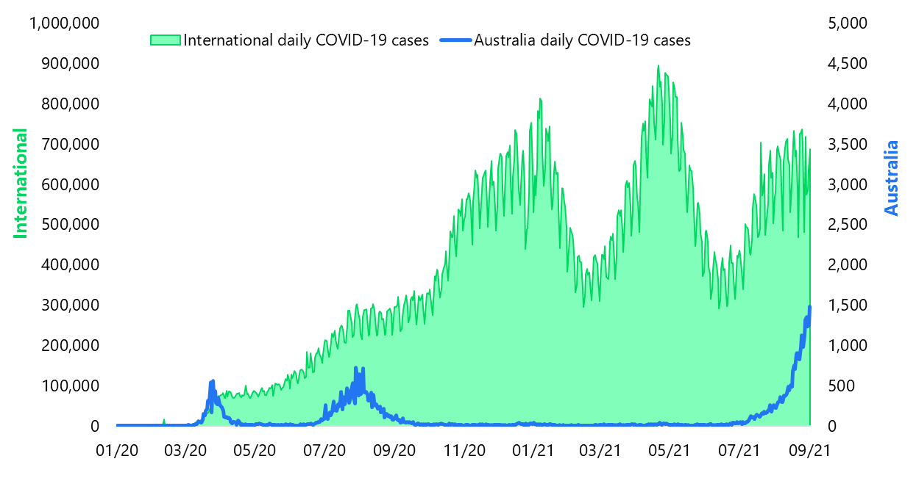
Source: WHO Coronavirus Dashboard

Globally case numbers continue to increase as part of a third wave of cases with cases rising in all OECD countries.
Figure 6 – Daily new COVID-19 deaths internationally and in Australia
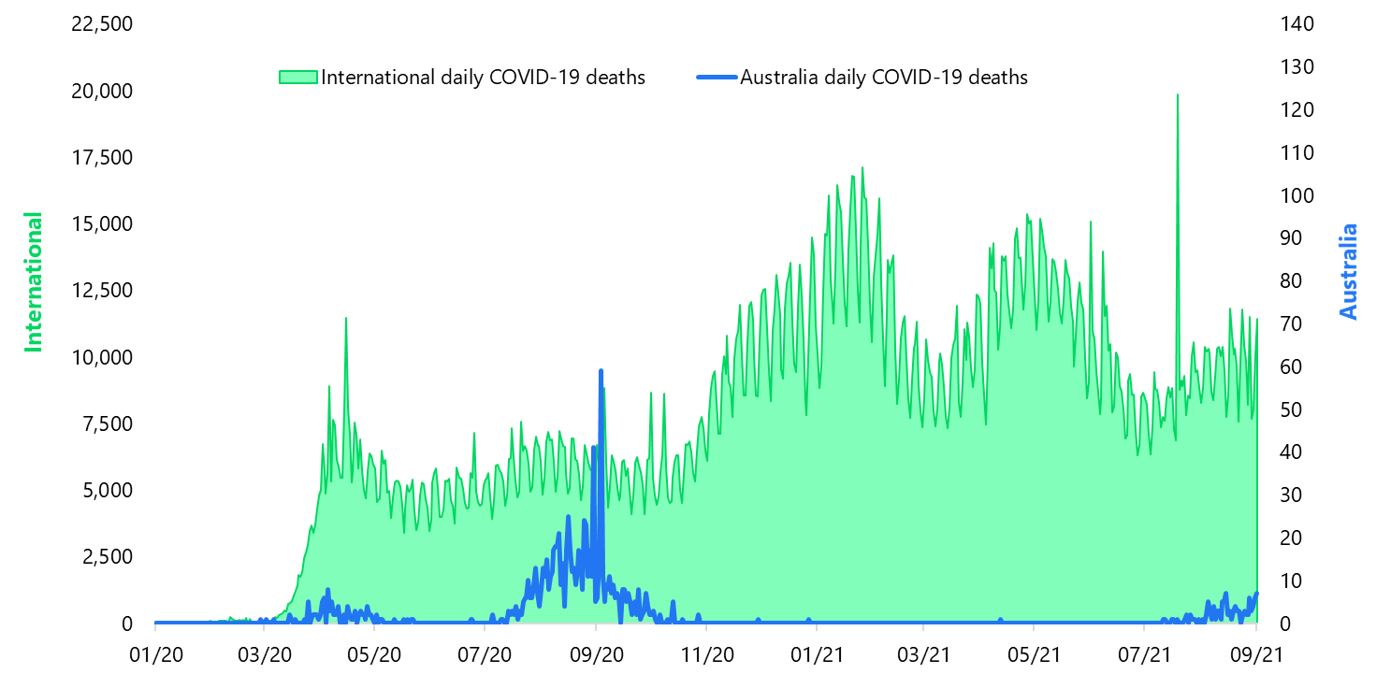
Source: WHO Coronavirus Dashboard

Consistent with international experience, the advent of endemic COVID-19 in a number of Australian jurisdictions has required a combination of vigorous TTIQ and vaccine uptake to help minimise the health impacts of an outbreak. As a consequence, in jurisdictions with sustained outbreaks we have seen a change in the use of quarantine and isolation to include outbreak management as local residents who are unable to isolate at home and/or their close contacts are required to enter managed quarantine.
Unlike the first two waves of COVID-19, the impact of vaccination can now be seen in lower death and severe disease which reinforces the evidence that vaccines are highly effective in combating the effects of the virus.

Vaccination rates
A welcome change in the context of COVID-19 management has been the development, approval and deployment of effective vaccines.
As at 9 October 2021, 12,770,641 people representing 61.9% of people over 16 are fully vaccinated. 16,953,597 people have had at least one dose – that represents 82.2% of people over the age of 16, but with variations between states.
Vaccine coverage ranged from a high of more than 95 per cent first dose and second dose of 72.8 per cent in the ACT to a low of 68.4 per cent first dose in Northern Territory and second dose of 51.7 per cent in WA. This means that, as at 9 October 2021, four states have already achieved the 80 per cent level for first doses (ACT, NSW, Victoria and Tasmania) outlined in the National Plan and a further two states, (South Australia and Queensland) have achieved the 70 per cent level for first doses.
Projections indicate that, nationally, Australia is likely to hit the 70 per cent double vaccinated target by late October 2021 and the 80 per cent target by mid-November 2021.
Figure 7 – vaccination rollout in Australia (as at 10 October 2021)
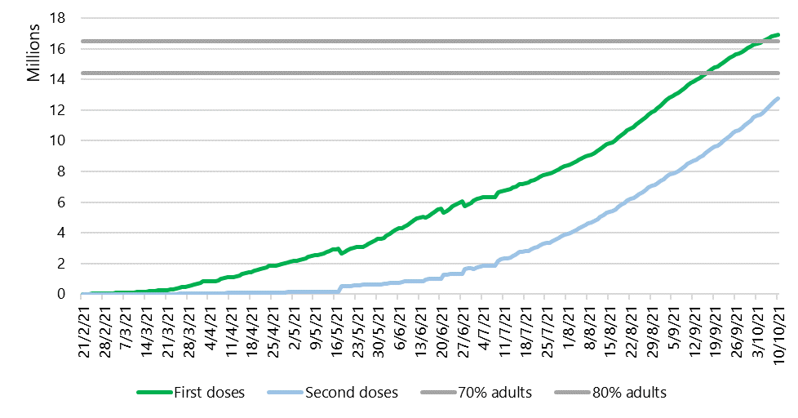
Source: Department of Health

Australian vaccination rates were relatively lower than other OECD countries but now compare well. By November 2021, when 80 per cent of the Australian adult population is projected to be fully vaccinated, Australia will be at the forefront of global vaccine uptake.
Figure 8 – Share of the total population fully vaccinated against COVID-19 (as at 3 October 2021)
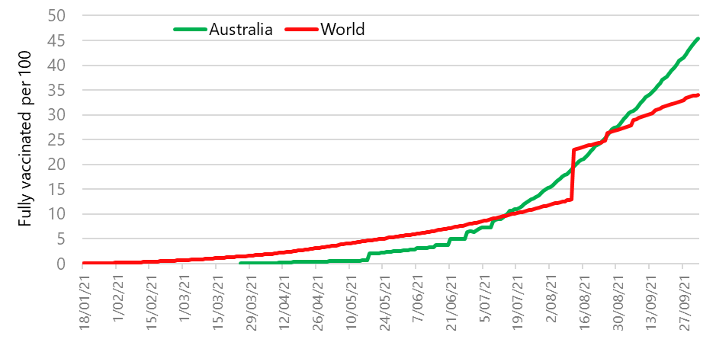
Source: Australian Bureau of Statistics, Our World in Data, Covid-19 Data
As international vaccination rates increase, a larger proportion of travellers arriving in Australia are now vaccinated. Vaccination information is collected from travellers before they depart for Australia through completion of the Australia Travel Declaration (ATD). The ATD collects a range of self-declared information to help governments determine quarantine arrangements and assist with contact tracing follow up if required. The ATD is not currently mandatory for all travellers and does not need to be filled out by air crew. The review understands that work is underway to develop options to collect the necessary health data that can support risk assessments for quarantine purposes.
Figure 9 – Weekly arrivals into Australia by vaccination status*
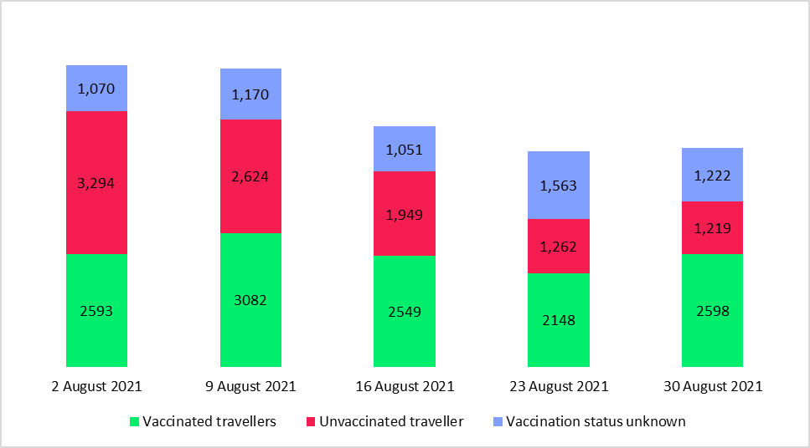
Source: Australian Border Force *(Includes all vaccinations and all dose amounts)
The vaccination status of arrivals is shown in Figure 9. These travellers have arrived in Australia from all over the world.
Vaccination data has been collected from international arrivals to Victoria which demonstrates the increasing trend towards more vaccinated arrivals. However, the small number of arrivals make it hard to project what the likely profile of arrivals would be in the event the current arrival caps were relaxed. There remains significant demand for travel including from countries where vaccine access has been limited.
Figure 10 - Weekly vaccinated air arrivals into Victoria

Source: Victorian Government
The ATD also collects information on the vaccine type. A number of these are approved or recognised by the Therapeutic Goods Administration, a number are also approved by other comparable regulatory authorities, and some have an Emergency Use Licence (EUL) issued by the WHO.
Figure 11 - At least one dose vaccinated by top five countries and top 3 vaccine types for air arrivals into Australia between 9 and 15 August 2021

Source: Australian Border Force
Figure 12 - At least one dose vaccinated by top vaccine type (from the top five countries) for air arrivals into Australia between 9 and 15 August 2021

Source: Australian Border Force

Modelling and future plans
As a novel coronavirus, little was known about the specific attributes of COVID-19 at the onset of the pandemic in early 2020. Consequently, Australia’s early response to COVID-19 was founded on well-established public health knowledge about the management of infectious disease. This included both population and country-wide measures as well as location and context-specific infection prevention and control practices. These broad principles informed the first national review of quarantine.
Since that time a significant body of knowledge has developed about all aspects of COVID-19, its attributes and management. This knowledge has led to improved treatment regimes. It has also been both an adjunct to and the basis for public health judgements, decisions and advice to the public and governments.
The knowledge and data now available enable many policy choices to be made based on evidence. In some instances, this data also enables modelling of different options. It also enables the assessment of risks.
While future variations in the virus cannot be reliably predicted, other aspects of the management and progress of the pandemic can now be modelled. Several modelling exercises have been commissioned by the National Cabinet to inform decision-making. This includes the Doherty Institute’s modelling of the likely impact of vaccines on transmission potential of the Alpha strain of COVID-19. This was reported to the National Cabinet in early June 2021.
Following this, further modelling was undertaken by the Doherty Institute to inform vaccination coverage thresholds to safely transition through the phases of the National Plan, focusing on the Delta variant as the ‘base case’ strain. This formed the basis of the 70 and 80 per cent thresholds announced in the National Plan in late July 2021. Iterations of this modelling have been presented to the National Cabinet, including further sensitivity analysis. Quarantine (as part of TTIQ) continues to play a role in the regime outlined in this modelling. Effective implementation of TTIQ measures underpins the achievement of the modelled outcomes outlined in the Doherty Institute modelling.
The Doherty Institute has also been commissioned to work through more detailed situational analysis to inform the management of COVID-19 in phases A, B and C. This includes a specific modelling package focused on border measures, arrivals pathways and quarantine in the context of revised risk tolerance. Preliminary findings from this new modelling confirm the feasibility of home quarantine and shorter quarantine duration in the next phases of the National Plan, with appropriate compliance mechanisms in place.
In addition, some states have commissioned separate modelling to guide their decision-making. For example, the Victorian Roadmap to Deliver the National Plan (released on 19 September 2021) is informed by Burnet Institute modelling, which is set against COVID-19 thresholds including hospitalisation rates and the vaccination targets already set out in the National Plan. The Burnet Institute is also delivering modelling to inform the NSW Government response.

National Plan to transition Australia’s National COVID-19 Response
On 6 August 2021, the National Cabinet agreed to an updated four-step National Plan. The National Plan takes into account COVID-19 modelling from the Doherty Institute and economic analysis from the Commonwealth Department of Treasury. The National Plan has four phases which set out the policy settings that would apply in line with national vaccination rates. The phases progressively ease restrictions in line with these increased vaccination rates.
Figure 13 – National Plan to Transition Australia’s National COVID-19 Response

Phase B of the National Plan is triggered when vaccination rates are at 70 per cent of the eligible population aged 16 and over fully vaccinated while phase C commences at 80 per cent fully vaccinated.
In future phases of the National Plan beyond phase A, the objective of the public health response evolves to minimising serious illness rather than eliminating community transmission. In phase D of the National Plan, COVID-19 will be managed consistently with other infectious diseases.
In all four phases of the National Plan, quarantine may still be required for, at least, high-risk inbound travel. The phases of the National Plan will inform appropriate quarantine settings. In phase A, where vaccination rates remain below 70 per cent in Australia, the existing quarantine system, including the trial of home quarantine is appropriate.
Once vaccination rates reach the 70 per cent threshold for the population aged over 16 years, phase B is triggered. Phase B calls for proportionate quarantine to minimise the risk of COVID-19 entering the community. This includes the restoration of inbound caps at previous levels for unvaccinated returning travellers and larger caps for vaccinated travellers. In this phase, vaccinated Australians returning from international travel could be permitted to use alternatives to hotel or other quarantine facilities, including at-home quarantine. This could be extended for households, families and industry groups.
During phase C, when vaccination rates reach the 80 per cent of the population aged over 16 years, the National Plan notes that there would not be any cap on vaccinated returning Australians. This phase could also see the increased entry of student, economic and humanitarian visa holders.
In phase D, the National Plan calls for a shift away from a suppression strategy to a management strategy. As part of this management strategy, the National Plan suggests that focus should shift away from case numbers and towards rates of serious illness and hospitalisation as the more appropriate way to guide Australia’s health response. This aligns with the approach to management of other infectious diseases.
This national review of quarantine has been undertaken in the context of the plan agreed by the National Cabinet. It also takes account of the different circumstance of the states regarding outbreaks and vaccination rates.

3 Operation of the current quarantine system
The objective of quarantine to date has been to reduce the spread of COVID-19 from international travellers and minimise or eliminate the risk of community transmission. This is in line with phase A of the National Plan.
Since the beginning of the pandemic international travel (with the exception of to/from New Zealand) has been a good proxy for the relative risk of having contracted COVID-19. While rates of COVID-19 in arrivals have fluctuated it has, until recently, been higher than the background rate of COVID-19 in the community. Control of COVID-19 at the border has therefore been a key defence in protecting the Australian community from COVID-19. Low or no COVID-19 infection within the community meant the consequences of any importation and subsequent community transmission was potentially severe. As a result, 14-day quarantine for all arrivals has been applied with few exceptions.
Current quarantine settings, informed by experience and continuous improvement have delivered well on the key objectives set in respect of customer experience, IPC and continuous improvement

Governance

The role of the National Cabinet and AHPPC
The National Cabinet was established on 13 March 2020 for the purpose of ensuring a consistent and coordinated Australian response to the COVID-19 pandemic. On 15 March 2020, the National Cabinet agreed that for the purposes of decision-making in relation to the pandemic, the Australian Health Protection Principal Committee (AHPPC) and the National Coordination Mechanism would be its primary advisory bodies.
The AHPPC is led by the Commonwealth’s Chief Medical Officer and comprises the chief health and medical officers from each jurisdiction. It is also guided by the expert advice of the Communicable Diseases Network Australia (CDNA), the Public Health Laboratory Network (PHLN) and the Infection Control Expert Group (ICEG). All three groups have multi-jurisdictional memberships.
The Australian Technical Advisory Group on Immunisation (ATAGI) advises the Minister for Health on the National Immunisation Program and other immunisation issues.
In December 2020, the AHPPC published the first version of the National Managed Quarantine Principles, providing nationally agreed guiding principles to set benchmarks for hotel quarantine programs across Australia. The goal of the AHPPC principles is to drive national consistency in Australia’s quarantine efforts, while remaining flexible for jurisdictions to achieve a robust hotel quarantine program tailored to their local requirements. The principles cover end-to-end best practice arrangements, governance, infection prevention and control, risk minimisation, managed quarantine site selection and health and mental health.
On 14 April 2021, AHPPC published its statement on continuous learning in managed quarantine for international arrivals, which sets out AHPPC recommendations for quality assurance, review and continuous improvement in managed quarantine.
The AHPPC’s National Managed Quarantine Principles include guidelines on site selection for managed quarantine. Facilities to be used for managed quarantine must be selected against criteria that meet requirements for health, safety and wellbeing, as outlined by AHPPC and its expert sub-committees and jurisdictional requirements.
The provision of this guidance and the learnings of all jurisdictions has provided a solid foundation for current quarantine systems.
A full list of AHPPC guidance issued about the operation of quarantine is at Attachment 7. This guidance is not in a consolidated form making it hard to access. In this context the review recommends:
1 The Australian Health Protection Principal Committee should maintain national principles for good practice in managed quarantine. State and territory authorities, including Auditors-General, should review their respective jurisdiction’s compliance with these principles. During the course of the pandemic, the National Cabinet should be provided with regular updates on the quarantine system and compliance with these principles.

State and territory arrangements
On 27 March 2020, the National Cabinet agreed that state and territory governments would be responsible for the management of quarantine systems in their jurisdictions. Since then, hotel quarantine has been implemented and enforced under relevant state and territory legislation.
When considering best practice, the first review noted that emergency management operations provide the necessary framework for appropriate accountability and clear line of sight for operations. They are multidisciplinary but well-integrated, and include open lines of communication, and collective and consultative decision-making that incorporates all perspectives. This approach limits opportunities for fractured decision-making or blurred accountability.
These attributes feature in the current approaches to governance of quarantine systems in most jurisdictions, although states have adopted a variety of governance models to oversee their quarantine systems. Table 5 provides a high-level summary of who is responsible for quarantine arrangements in different jurisdictions.
Table 5 – Summary of lead quarantine agency in Australian jurisdictions
New South Wales | NSW Police, NSW Health and Sydney Local Health District with an interagency governance steering committee meeting held fortnightly.
Victoria | The Victorian Department of Health. COVID-19 Quarantine Victoria manages quarantine facilities which it operates in partnership with other agencies such as Victoria Police.
Queensland | Multi-agency arrangements led by Queensland Health
Western Australia | Oversight and responsibility for quarantine rests with WA Health. The State Health Incident Coordination Centre manages the quarantine centres, but is accountable to WA Health.
South Australia | Department for Health and Wellbeing
Tasmania | Departments of Health, Communities and Tasmania Police
Australian Capital Territory | ACT Health Directorate
Northern Territory | Territory Controller (Commissioner for Police)
Source: information provided by states and territories
Across all jurisdictions, health departments, police departments and emergency management coordinators have prominent roles. Some jurisdictions, including NSW and Tasmania, have adopted arrangements where accountability for quarantine is shared between health and police departments.
The costs of quarantine are borne by both governments and the people in quarantine (see Attachment 8).
Where governance arrangements are shared, it is critical to have clearly defined responsibilities and processes to coordinate actions and decision-making. For example, in NSW, the State Emergency Operation Controller (NSW Police) is accountable for the hotel quarantine system, with most quarantine hotels managed by NSW Police. The quarantine system is managed in close partnership with NSW Health, who operate a smaller number of Special Health Accommodation Hotels.
However, there are agreed roles and responsibilities in place, including agreed processes to transfer guests from a NSW Police-administered hotel to Special Health Accommodation if the guest tests positive to COVID-19 or is identified to require additional health support for other conditions during the quarantine period.
Clear governance arrangements are also crucial at the facility level, and it is important that those structures are linked to the broader governance arrangements that apply in the jurisdiction.
For example, in the Northern Territory, the Executive Directors of the Centre for National Resilience in Howard Springs and the Alice Springs Quarantine Facility are responsible for the operations of the facilities. The leadership at the facilities are accountable to the Northern Territory Emergency Operations Centre, overseen by the Territory Controller (the Commissioner for Police). A daily situation report is provided to the Emergency Operations Centre, covering data, key work, forecasting and risks. The leadership of the facilities also report to the Hazard Management Authority Lead, being the Department of Health and the Chief Health Officer.
Victoria’s establishment of a dedicated quarantine agency, CQV, is unique. Formed in late 2020, CQV has overall responsibility for the Victorian COVID-19 Accommodation Program. The CQV Commissioner & State Controller is directly accountable to the Minister for Police. Health, enforcement and operational expertise is embedded in the executive structure of CQV, responding to a key recommendation of the Victorian Hotel Quarantine Inquiry.
The Department of Health remains the control agency with primary responsibility for managing the overall response to the COVID-19 pandemic health emergency, and the roles and responsibilities of CQV and the Department of Health are clearly delineated in a memorandum of understanding.
Governance arrangements within states have matured and are now fit-for-purpose.

Information Sharing
Information sharing between jurisdictions remains an area for further improvement.
States collect large amounts of information and data on their own quarantine systems. This information can be related to health practices but also operational delivery, meal services and staffing. Some jurisdictions report improved collection of data across their systems which can then be integrated into performance and compliance frameworks.
However, there is no single source of quarantine data in Australia. This can present challenges for national analysis or when swift sharing of information across jurisdictions is required. Jurisdiction data is also not well-integrated with relevant data from Commonwealth agencies, such as international arrivals data from the Department of Home Affairs.
There is an opportunity to improve jurisdictional and Commonwealth information and data sharing. To date, this has occurred on an ad-hoc and as needed basis. For example, data may be shared between jurisdictions via the Commonwealth Department of Health’s National Incident Centre. This may occur for reasons including a case connected to hotel quarantine who has travelled interstate.
Enhanced information sharing may support better quarantine and post-quarantine operational decisions. The review team understands initial discussions have already commenced to develop a common dataset led by the Department of Health through the AHPPC to identify the number of people in quarantine and the type of contact they are in quarantine for, as well as strategies and capacity for testing.

Information sharing on best practice
As quarantine is managed by individual states, there can be differences in practice. This includes health practices but also general operational delivery.
All jurisdictions are continuously learning from operating their own quarantine systems. The review team notes that, since the first report, there is more variation in how states approach some aspects of their quarantine arrangements and there is a greater variety of approaches to quarantine being implemented across Australia. Although some variation may be warranted to fit local circumstances, it is vital that lessons are shared so that best practice is achieved nationally. The quarantine system continues to evolve in response to new challenges and with the benefit of new scientific knowledge about COVID-19 and its transmission.
It is important there are avenues to effectively share learnings so best practice can be adopted as quickly as possible. Following its endorsement of a ‘Continuous Improvement Framework for Managed Quarantine’, the AHPPC commenced weekly quarantine discussions. This provides opportunity for jurisdictions, through their Chief Health Officers, to regularly discuss emerging evidence and quarantine issues and share key quarantine updates.

Data sharing about passenger movements
Enhanced data sharing between jurisdictions could positively impact other measures such as additional testing requirements following discharge from quarantine (e.g., day 16 testing). At present, there are challenges to follow-up and implement post-quarantine testing when a person travels to another state or territory. Receiving jurisdictions rely on the declaration of the arriving person or the sharing of ad-hoc information via the National Incident Centre. Enhanced jurisdictional data sharing on quarantine exits would help enhance post-quarantine testing compliance, help assure the overall national integrity of quarantine, and provide the opportunity to evaluate the utility of post-quarantine testing.

Data sharing on capacity
Enhanced jurisdictional and Commonwealth data sharing relevant to quarantine capacity should be implemented. This includes sharing information on the purpose of quarantine entry (return home, work) and destination to help clarify national quarantine supply and demand issues. Enhanced sharing could assist national transparency on all-source demand for quarantine, and inform quarantine capacity utilisation. To further this aim, the review recommends that:
2 All governments should commit to improved and timely information sharing, including the establishment of a common quarantine dataset so that quarantine capacity and allocations can be determined. The dataset would include the total number of quarantine places, usage and incorporate forecast arrivals into quarantine.

Mitigating transmission risk
Mitigation of transmission risk requires the implementation of layers of control across a customer’s journey through quarantine. It also requires attention to all parts of the quarantine system.
Risk mitigations being implemented by states are outlined in Figure 14. This model, which derives from widely understood multi-factor risk models including in aviation and hospitals does not follow the customer journey through the quarantine process. Instead, it structures mitigations around where they fall on the hierarchy of controls, in which the strongest controls eliminate the risks.
This structured systems approach to thinking in respect of the risks in and from quarantine represent a notable maturing of the management of quarantine.
Figure 14 – Model of protections and the hierarchy of controls
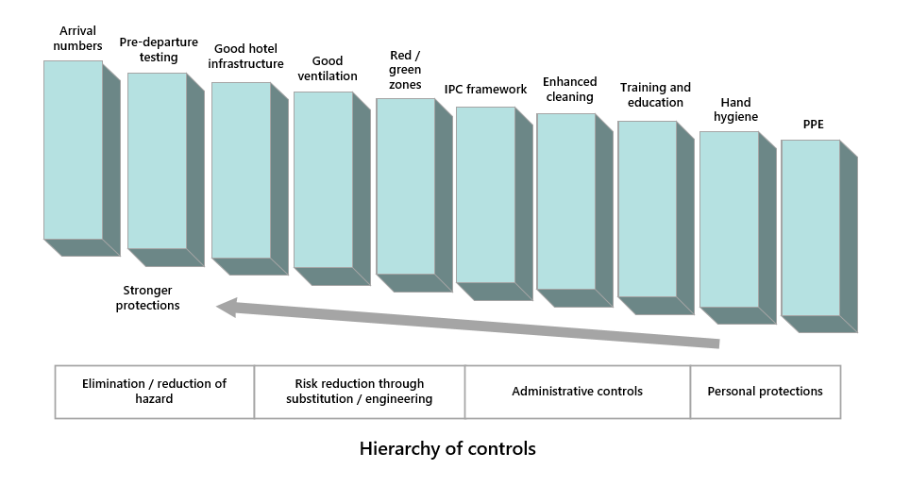
Documents examined by the review team demonstrate jurisdictions have adapted their quarantine systems to implement these layers of control, which provide much greater combined protection to minimise overall risks.
The hierarchy of controls endorsed by AHPPC forms the basis of understanding Australia’s infection prevention control (IPC) framework. It sets out five components that categorise the features of the hierarchy from most effective to least effective:
- Elimination
- Substitution
- Engineering controls
- Administrative controls
- Personal Protective Equipment.
All jurisdictions appear to implement some form of IPC framework based on this hierarchy of controls – seeking to eliminate risks where possible then working down the hierarchy of controls (see Attachment 9).
Since the first review, the review team has noted a focus on upgrades to COVID-19 testing, ventilation and assurance mechanisms.

End-to-end passenger journey
COVID-19 transmission risks must be mitigated within quarantine facilities. However, the quarantine facility is not the only part of the quarantine system that presents risks of transmission.
The integrity of the end-to-end quarantine journey is fundamental to the successful operation of the quarantine system. While the operation of the quarantine system has been largely successful, a single transmission event to the community can have significant consequences. The current NSW COVID-19 outbreak is linked to the infection of a limousine driver who transported international flight crew. This demonstrates that good practice within quarantine systems must consider the end-to-end quarantine journey, not just the activity within quarantine facilities, and seek to mitigate risks at every stage in order to avoid outbreaks. Attachment 10 sets out some of the key considerations associated with an individual’s journey through the quarantine system.

Ventilation and airflow
A focus on airflow and improving ventilation has been necessitated by the increased transmissibility of the Delta variant, as well as earlier transmission events within quarantine where transmission to staff in corridors and to travellers housed in hotels rooms has occurred near an infected guest (often in the opposite room with simultaneous door openings).
Several reviews focussing on ventilation and airflow considerations have been conducted, including the Review of Management of Variants of Concern of COVID-19 in Hotel Quarantine Settings in Victoria published on 11 March 2021. In Western Australia, it also includes the Ventilation review of quarantine hotels published on 28 April 2021. This review noted that ‘[i]deally accommodation rooms should be negative/neutral pressure to corridors to assist in containment of small droplets and aerosols within rooms.’
In response jurisdictions have implemented a number of IPC and ventilation upgrades to their quarantine facilities or discontinued use of some facilities where upgrades were not possible.
It is noteworthy that the controls used across the states are not consistent. For example, the approach to ventilation, room configuration, presence or absence of windows that open, and air filters all vary. Both Western Australia and Victoria have undertaken significant IPC and ventilation upgrades, including discontinuing the use of some hotels or hotel rooms.
Western Australia employs a ‘zipper model’ in hotels, even for rooms that are negatively pressured to the corridors, whereby the rooms opposite in a corridor are not occupied at the same time, removing the risk of cross corridor transmission. Victoria has developed specific ventilation standards for quarantine hotels and have undertaken remediation works (where necessary) to establish negative room pressure in individual quarantine rooms. Ventilation and airflow standards have been applied across the quarantine program in Victoria, including within the resident transport system from the airport.

Testing for COVID-19
The reverse transcription polymerase chain reaction (RT-PCR) diagnostic test is the current gold standard for confirming an acute SARS-CoV-2 infection in Australia and globally and is the main testing modality used in quarantine. While rapid antigen testing is yet to be widely used in Australia, it was announced in late September 2021 that at-home rapid antigen testing would be available from 1 November 2021, subject to individual tests being approved as safe and effective by the TGA. This is welcome and is discussed further at Attachment 11.
All jurisdictions have testing regimes in place for international arrivals, which is appropriate given that testing is one of the most important risk mitigations.
Current national guidelines state that a minimum, testing should occur on day 0-2 and then on day 10-14 of hotel quarantine, with results to be received prior to release from quarantine. Exact arrangements depend on state and territory protocols, with a number of jurisdictions conducting tests at a higher frequency.
Significant changes in the testing regime have occurred over the last 18 months. This has focussed on both guests and staff. Testing is discussed further in part four of the report in terms of how it can be used to support reduced quarantine duration, especially if conducted frequently.
Most jurisdictions have implemented additional testing of international travellers once they leave quarantine since the first review. This follows AHPPC advice that all international travellers should get tested at days 16 or 17 following quarantine, if there have been potential exposure sources within the quarantine facility, regardless of whether they have symptoms. This has presented some challenges, such as when an arrival travels to another state or territory from where quarantine was located.
Widespread daily testing of quarantine workers is also now in place. This is designed to ensure that any transmission event is identified quickly in order to manage the impact on and transmission in the community.
It is noteworthy that Victoria undertakes prospective contact tracing of all staff and visitors to quarantine facilities to speed the process of contact tracing should this be required.

Assurance mechanisms
All jurisdictions have implemented end-to-end assurance mechanisms. Consistent with good practices, these mechanisms report and record incidents and are the basis for improvement and learning.
Some jurisdictions routinely publicly report on transmission events from quarantine. Other jurisdictions internally report on breaches of protocol that could result in a transmission event. Some jurisdictions, such as Victoria and Queensland, conduct root-cause analysis of incidents. This approach defines the problem, determines root causes and then implements necessary solutions. Victoria also conducts regular compliance, assurance, performance and audit activities across every aspect of the quarantine program to identify, escalate and resolve incidents and acquit continuous improvement opportunities. These activities are supported by data and incident monitoring and reporting systems.
It is critical that learnings can be shared across jurisdictions. AHPPC has regular discussions on quarantining, including transmission events from quarantine. This provides Chief Health Officers with an opportunity to discuss best practice in terms of quarantine. However, not all Chief Health Officers are responsible for their jurisdiction’s quarantine system so consideration should be given to establishing other forums to allow learnings to be shared across jurisdictions.

Infection prevention and control (IPC)
All jurisdictions now have IPC policies and frameworks for their quarantine systems and these appear to be supported by comprehensive IPC training and assurance mechanisms. Some jurisdictions also demonstrate additional monitoring of quarantine operations, including through audits and assurance processes conducted by external experts.
At a national level, the AHPPC developed National Principles for Infection Prevention and Control in Quarantine. These were developed after considering reviews into managed quarantine and the causes of SARS-CoV-2 transmission events. The principles provide a baseline for national consistency across IPC aspects including PPE, airflow and ventilation, and managing high-risk individuals.
A number of jurisdictions are taking additional precautions to reduce the risk of transmission between quarantine workers. In addition to vaccination and testing requirements, some jurisdictions, including Western Australia, have implemented requirements for staff to work at a single quarantine site only.

Management of COVID-19 positive cases
The review notes some differences across jurisdictions in terms of where they manage COVID-19 positive cases.
In South Australia, individuals who test positive to COVID-19 in quarantine are moved within 24 hours to dedicated medi-hotels. Depending on their health assessment, they may be admitted through the hospital pathway to the dedicated tertiary COVID-19 hospital. Similarly, in NSW, positive cases are transferred to Special Health Accommodation (i.e. a medi-hotel facility managed by the Department of Health) while in Victoria, positive cases are transferred to Health Hotels or Complex Care Hotels managed by Alfred Health.
In Queensland, individuals who test positive in hotel quarantine are transferred to a COVID-19 designated hospital for treatment. During local outbreaks in Queensland, some stable COVID-19 patients may be provided virtual care in their home if suitable.

Workforce
The end-to-end passenger journey requires a significant number and range of services and staff required to deliver effective quarantine outcomes safely. These staff are at an increased risk from COVID-19 transmission from infectious international arrivals. All quarantine workers have a key role in helping mitigate transmission risks.
The variety of staff who support the quarantine system include:
- Workers in the airport environment, such as ground staff, baggage handlers and those delivering health screening services;
- Transportation workers, like those driving passengers from the airport to the quarantine facility;
- Workers at the quarantine facility, including those delivering hotel, health, cleaning and security services; and
- Workers supporting the quarantine facilities, such as contractors, delivery drivers and waste removal staff.
These workers as well as other travellers in quarantine facilities are at the highest risk of contracting COVID-19 through transmission from infectious travellers.

Vaccination requirements for staff
Vaccinations, regular testing and correct use of PPE are the primary mechanisms to protect quarantine workers as well as reduce the risk of transmission and incursion of the virus into the community from managed quarantine.
On 28 June 2021, the National Cabinet endorsed AHPPC advice to require vaccinations and testing for quarantine workers including those involved in transportation. Quarantine workers in NSW, Queensland, South Australia, Tasmania and Western Australia, are required by law, mostly through state-based public health directions, to be vaccinated against COVID-19. Victoria introduced a mandatory vaccination policy on 7 April 2021, requiring all quarantine workers (employees and contractors) to be vaccinated. From 25 August 2021, all quarantine workers are only able to commence work in a frontline role after they have had their second dose at least 7 days prior to commencing active duty. Vaccination status is verified through the digitally enabled site entry and exit system for all members of the workforce.
The ACT and the Northern Territory do not currently have public health directions, but report achieving very high vaccination coverage for their quarantine workers. While there are some variations across jurisdictions in terms of workers captured by the requirements, generally, quarantine workers, transportation and airport workers all require vaccination.
Businesses whose activities intersect with the quarantine process are also increasingly implementing their own vaccination requirements. For example, the Qantas Group announced vaccination requirements for employees as part of its commitment to safety. Frontline employees – including cabin crew, pilots and airport workers – will need to be fully vaccinated by 15 November 2021 and the remainder of employees by 31 March 2022.
Greater consistency in vaccination requirements for quarantine workers would better support a consistent and high-quality national quarantine system.

Testing requirements
In addition to the testing of international arrivals, since February 2021, daily testing of quarantine workers has been implemented nationally in response to the increased risk posed by COVID-19 variants of concern. Routine testing is a strategy aimed at the early detection of any transmission to quarantine workers. In June 2021, the AHPPC recommended extending this requirement to all workers directly and indirectly involved in managed quarantine. This was in response to transmission events and includes workers involved in transport of quarantined individuals. States have responsibility for determining the most appropriate testing methodology for screening that suits their epidemiology, testing capacity and established workflows.

Single site employment
To reduce transmission risk, some jurisdictions require that quarantine workers are only employed at a single quarantine site. However, these rules vary across jurisdictions and types of roles.
For example, in Western Australia, a public health direction stipulates that quarantine facility workers cannot work in other roles or at more than one quarantine centre. Under public health directions in Victoria, quarantine hotel employers must not require or permit a worker to perform work at more than one hotel quarantine premises unless it is not practicable. In NSW, Sydney Local Health District Special Health Accommodation staff work exclusively at those locations.
In the Northern Territory, a quarantine worker who works at a quarantine facility must not work at another workplace.
Having requirements on single-site employment can represent good practice because it serves as an effective way to limit a transmission event from having larger impacts (i.e. transmission will not occur between an individual and multiple sets of colleagues or quarantine sites).
Having these requirements also make pre-emptive contact tracing easier. Some jurisdictions conduct pre-emptive contact tracing for quarantine workers to support expeditious contact tracing if transmission occurs. In Victoria, this is required under public health directions. Information such as contact details is collected for the worker and of any person with whom the worker ordinarily resides.

Quarantine locations
A number of different quarantine types are now used across the country; these are set out at Figure 15. While quarantine in hotels and purpose-built facilities continues to be a mainstay for international arrivals, alternative arrangements are also being increasingly employed particularly for domestic cases required to quarantine.
This broader range of quarantine types directly reflects improved knowledge about the management of quarantine and, in some states, the need to quarantine or isolate a significant number of local residents.
Each quarantine type has inherent risks some of which are more amenable to mitigation than others. While risks can be mitigated in all quarantine locations these may have costs and/or present implementation challenges. Attachment 12 sets out some of the available risk mitigations that are applied by states in more detail.
Figure 15 – Quarantine types and available mitigations
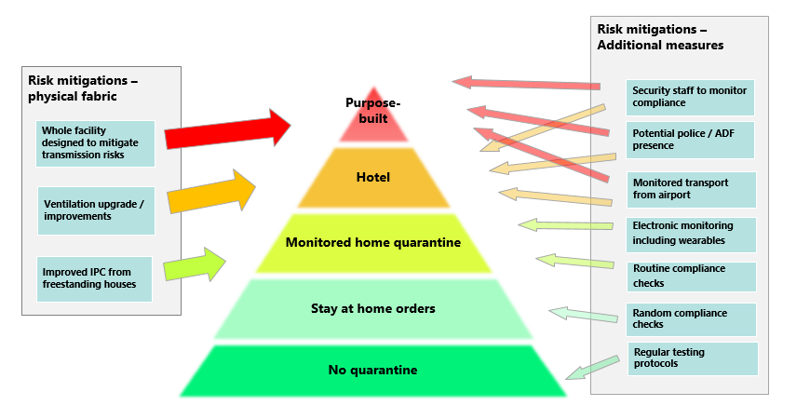
Quarantine can be undertaken in any location where the effective isolation of a person can be achieved. Compared to the time of the first review, there is a greater variety of quarantine types being used in Australia. This reflects a more complex environment that requires a range of suitable locations capable of dealing with an increased number of people needing to quarantine, most of whom are not returned travellers.
Purpose-built facilities will be constructed in some jurisdictions, having been specifically designed to mitigate transmission risks and accommodate high-risk cases. In phase A of the National Plan, hotels are a mainstay for international arrivals, noting some hotels are superior to others, having been upgraded or already able to meet necessary ventilation and air-flow requirements. Home quarantine has also been used extensively by some jurisdictions for domestic purposes (e.g. returning interstate arrivals) and home quarantine trials are underway for international arrivals and are expected to become the majority of quarantine arrangements from phase C of the National Plan.
The different quarantine types employed in Australia provide a range of options, with each option offering different features some of which inherently help mitigate transmission. As noted in Figure 15, the physical fabric / underlying infrastructure of the quarantine location also affects the available mitigations to minimise transmission risk.

Purpose-built quarantine
On 23 October 2020, the Commonwealth Government established the Centre for National Resilience at Howard Springs through a bilateral agreement with the Northern Territory government. Since 3 May 2021, the Centre has been increasing capacity to support up to 2,000 returning Australians each fortnight.
The Centre for National Resilience at Howard Springs was not purpose-built for quarantine but shares many of the features of a recommended purpose-built facility. This includes cabin-style accommodation which provides improved infrastructure with better ventilation and improved satisfaction levels for residents while maintaining an environment to effectively deliver services and strong infection prevention and control practices. Each room has its own veranda providing guests with an outdoor space contributing to customer satisfaction and more positive wellbeing outcomes for many. To date, there have been no transmission events within or from the Centre.
In June 2021, the Commonwealth entered into a Memorandum of Understanding with the State of Victoria to establish a dedicated quarantine facility in Victoria (Mickleham). The Commonwealth, through the Department of Finance, has worked with Victoria to design the facility, leveraging lessons learned from operation of the Howard Springs facility to ensure the new purpose-built facility meets best practice quarantine and infection prevention and control guidance.
While noting the success of the Howard Springs facility in containing the spread of COVID-19, the facility in Victoria is being specifically designed for quarantine, where the Howard Springs facility’s origin as mining accommodation necessitated retrofitting to meet quarantine requirements. These purpose-built facilities will feature key enhancements including ventilation design to prevent the risk of air flow between independently occupied rooms and any potential virus transmission; purpose-built modular accommodation units to reduce the possibility of physical contact between neighbouring residents; and improvements to logistics and site-layouts to optimise guest and staff flows.
The Commonwealth has also entered into Memoranda of Understanding with the Queensland Government to establish a dedicated quarantine facility in Brisbane (Pinkenba) and with the Western Australian Government to establish a facility in Perth (Bullsbrook). The designs for Victoria are being used as the basis for these projects.
The Commonwealth assessed all locations for purpose-built facilities against published Key Assessment Criteria to ensure their appropriateness for quarantine. Key considerations include that proposed facilities should be in close proximity (within approximately one hour vehicle transport) to a tertiary hospital; be near to an international airport taking regularly scheduled commercial international passenger flights; be for use by all Australians; and represent value for money. Importantly, facilities are also required to meet detailed health requirements, including guidance outlined by the AHPPC and its sub-committees, and be comprised of self-contained units and non-communal amenities to support effective infection prevention and control.
Figure 16 – Image of purpose-built facilities
Figure 17 – Image of purpose-built facilities

Hotel quarantine
Hotels have been the mainstay of Australia’s quarantine system and have provided a significant amount of quarantine accommodation for international arrivals, largely in capital cities. This provides close proximity to airports and tertiary hospitals. It also supports recruitment of the necessary workforce required to facilitate hotel quarantine management.
There is no single source of complete hotel quarantine data. Data in Table 6 were provided by jurisdictions and include hotel quarantine numbers for international arrivals and domestic purposes.
Table 6 – Numbers in hotel quarantine (international and domestic)
Jurisdiction | Time Period | Total hotel quarantine
New South Wales | 1 March 2020 to 31 July 2021 | 238,622
Victoria | 28 March 2020 –1 August 2021 | 69,664
Queensland | March 2020 to 6 August 2021 | 130,573
Western Australia | March 2020 to 2 August 2021 | 63,059
South Australia | March 2020 to July 2021 | 30,887
Northern Territory | 16 March 2020 to 1 August 2021 | 26,849
Tasmania | 3 April 2020 to 30 July 2021 | 11,724
Australian Capital Territory | 1 March 2020 to 1 August 2021 | 3,119
Source: data provided by states

Unlike purpose-built facilities, hotels were not designed for quarantine purposes or to reduce COVID-19 transmission risks. While this does mean that not all possible risk mitigations can be fully implemented, it has not prevented the establishment of a robust hotel quarantine system that implements many significant risk mitigations.
Since the first review, jurisdictions have conducted significant reviews and investigations of their hotel quarantine systems, implemented recommendations and applied learnings from incidents or transmission events.
Some jurisdictions have discontinued use of some hotels or hotel rooms. For example, Western Australia and Victoria, after conducting ventilation reviews on their quarantine systems, have closed hotels or hotel rooms for quarantine purposes if they do not meet the adopted ventilation and airflow criteria.
Most jurisdictions have multiple hotel quarantine facilities. Many jurisdictions have hotels dedicated for airline or maritime crew. South Australia has a hotel dedicated to Australian Defence Force travellers. Western Australia has a hotel dedicated to seasonal workers and a hotel dedicated to international flight crew.
Some jurisdictions also have dedicated hotels for COVID-19 positive cases. For example, in NSW, most overseas arrivals undertake quarantine in hotels overseen by police. If they test positive for COVID-19 but do not require hospitalisation, they are moved to Special Health Accommodation, which is operated by NSW Health. Special Health Accommodation is also used to quarantine overseas arrivals with more complex medical or mental health concerns and people who cannot safely self-isolate in the community. There have been no transmission events associated with Special Health Accommodation in NSW.

Home quarantine
To date, home quarantine has been used sparingly for international arrivals in Australia. Home quarantine offers the individual the comfort of their own home and can reduce the transmission risk to quarantine workers and other returned travellers. Home quarantine is used extensively across Australia for domestic purposes. This includes domestic interstate arrivals who need to quarantine in response to a jurisdiction’s domestic border restrictions.
Home quarantine requires alternative forms of compliance monitoring and coordination of the required health, transport and social services. In addition, some homes may not be suitable due to location, shared access or living spaces.
In June 2020, the AHPPC considered the ongoing requirement to quarantine international travellers. This included an option to include part of the time in home quarantine. At that time, the AHPPC concluded that risk of COVID-19 in travellers returning from many countries was increasing, reinforcing the importance of managed quarantine as a protection measure and consequently recommended that all international travellers continue to undertake 14 days quarantine in a supervised hotel.
While it has not been a mainstream option for international arrivals, there are examples of home quarantine for some international arrival cohorts. For example, most jurisdictions have granted a small number of exemptions from hotel quarantine to allow home quarantine for exceptional reasons, including medical reasons. Exact numbers are unknown.
In the ACT, home quarantine has been routinely used for returning diplomats and official travellers. The ACT’s home quarantine program has been successful, with no transmission events to the community. The ACT’s home quarantine program requires a risk assessment to determine suitability of the individual and their home. Accommodation is assessed for suitability in terms of access, rubbish disposal and facilities. The arrangements also feature health and social services, and police services to monitor compliance.
Access to home quarantine for domestic arrivals often depends on a jurisdiction’s risk assessment of where the individual has been over the previous 14 days. For example, for individuals travelling interstate to Western Australia, access to home quarantine can vary depending on where they have travelled from. Travel from jurisdictions assessed as ‘extreme risk’, ‘high risk’ or ‘medium risk’ is not permitted unless approved. If approved, travel from jurisdictions assessed as ‘extreme risk’ requires quarantine at a government hotel quarantine facility; and travel from jurisdictions assessed as ‘medium risk’ or ‘low risk’ require self-quarantine at a suitable facility (including home arrangements). Travel from jurisdictions assessed as ‘very low risk’ do not require quarantine.
Victoria also has a travel permit system that allocates all locations in Australia to a zone type. Individuals who have been in an ‘extreme risk’ zone cannot enter Victoria without an exemption, and if approved must quarantine for 14 days; individuals who have been in a ‘red’ zone must also quarantine for 14 days; individuals who have been in an ‘orange’ zone must isolate until they get a negative test result; and individuals who have been in a ‘green’ zone require a permit to enter Victoria.
Home-base quarantine has also been used extensively by jurisdictions to manage close contacts in local outbreaks. Many Australians have also been subject to stay-at-home orders in response to lockdowns due to local outbreaks.

Home quarantine trials
Several jurisdictions have commenced home quarantine trials that apply home quarantine arrangements more broadly to new cohorts.
On 8 September 2021, Victoria announced it would commence trials of home quarantine initially to support around 200 Victorian residents who are currently located on the NSW side of the border. NSW is currently assessed as an ‘extreme’ zone and individuals cannot enter without an exemption. This has since progressed with new rules from 30 September 2021 that allow Victorian residents currently in NSW to return to Victoria provided that they are fully vaccinated, have received a negative COVID-19 test 72 hours prior to travel and complete 14 days home quarantine on return.
Queensland recently began trialling technology to support home quarantine for close contacts and boarding school students returning from schools in interstate hotspots. To support this, the Queensland Chief Health Officer issued the Use of Technology to Support Home Quarantine Direction pursuant to the Public Health Act 2005 (Qld). Queensland have also just commenced, from 11 October 2021, a home quarantine trial for Queensland residents returning from interstate hotspots.
In August 2021, South Australia launched a home quarantine trial. While the trial commenced with interstate arrivals, it will progress to include international arrivals who have been fully vaccinated in Australia and who have arrived from low and medium-risk countries. An important aspect of South Australia’s trial is the use of geolocation and facial recognition software to monitor compliance. Monitoring compliance can be resource intensive with door checking by police services or by telephone check-ins. For any scaling of home quarantine, a technology solution is therefore vital.
The Commonwealth Government is working with the South Australian Government to ensure this technology is available to all jurisdictions. More detail on South Australia’s use of technology in its home quarantine trial is at Attachment 13.
In addition to home quarantine trials for domestic travellers, trials are also underway for international arrivals. On 17 September 2021, NSW announced a home quarantine pilot for vaccinated international arrivals. The pilot will trial a seven-day home quarantine program for around 175 people, including airline crew and NSW residents. The pilot will use a mobile phone app based on South Australian technology. The app uses geolocation and facial recognition technology to monitor isolation compliance.

Quarantine exemptions
The first review recommended that exemptions to mandatory quarantine be considered for low-risk cohorts, such as travellers from New Zealand. On 19 April 2021, the Australian and New Zealand governments fulfilled a commitment for two-way quarantine-free travel when New Zealand removed its requirement for eligible travellers from Australia to quarantine on arrival. This followed Australia’s decision to allow quarantine-free travel from New Zealand on 16 October 2020.
From 19 April 2021, all travellers who have been in either Australia or New Zealand for 14 days can travel by air between Australia and New Zealand quarantine-free, without the need to apply for a travel exemption. Approximately 25,000 people arrived in Australia from New Zealand from 16 October 2020 to 18 April 2021, and around 230,000 people travelled in each direction from 19 April 2021 until late July when New Zealand suspended quarantine-free travel from Australia.
These arrangements can be paused or amended at short notice in response to the COVID-19 situation and outbreaks in either country, including by individual Australian state and territory jurisdictions.
On 23 July 2021, quarantine-free travel from Australia to New Zealand was suspended. The New Zealand Government suspended quarantine-free travel from Australia for a further eight weeks from 24 September 2021, to be reviewed in mid-November 2021. Australia paused quarantine-free travel from New Zealand on 18 August 2021 but this is due to be reviewed on 12 October 2021.
Quarantine-free travel between Australia and New Zealand in at least one direction has operated for most of the last 12 months. While the safe travel zone is subject to suspensions, its implementation represents a successful example of how similar quarantine-free arrangements can be extended into the future.

Quarantine requirements for different arrivals
Australia’s quarantine system has accommodated very large numbers of people since the start of the pandemic. Although most international arrivals have been subject to mandatory 14-day quarantine in a hotel or facility, there are a number of groups with different risk profiles who have been subject to alternative arrangements. This includes airline and maritime crew, seasonal workers, diplomats and a small number of international students. It also includes a large number of Australians quarantined for domestic reasons, for example when travelling interstate and being subject to domestic border restrictions.
Quarantine requirements have varied for these different cohorts, which can be appropriate given their varying circumstances. The existence of different cohorts who may require bespoke quarantine approaches will continue into the future.

Airline crew
Early in the pandemic, the AHPPC recognised that some industry workers should be exempt from 14-day quarantine requirements when entering Australia, including airline crew.
The airline industry plays a vital role in Australia. Between 30 March 2020 and 5 September 2021, there were nearly one million (949,941) air arrivals into Australia. Over one quarter of these (268,468) were airline crew. This includes crew on freight aircraft. Airline crew may only stay a short time in Australia before their next international flight and are counted above set quarantine caps.
For international aircrew, AHPPC recommends that:
- Red zone flight crew must quarantine for 14 days after arrival, or until their next international flights;
- International flight crew undergo a COVID-19 test every 7 days in Australia, or be tested on arrival in Australia, as directed by jurisdictions; and
- Green zone flight crew are exempt from all quarantine requirements.
While these are national recommendations, state and territory governments who manage quarantine may apply additional requirements including with testing. The relevant jurisdiction also has discretion of what type of quarantine is required for flight crew.
Quarantine type can depend on whether the crew member is a local resident of the jurisdiction, in which case home quarantine arrangements may be agreed. For crew members who are not local residents, the AHPPC issued advice in December 2020 stating quarantine in a managed facility is recommended. This advice was provided after transmission events associated with aircrew.
At present, jurisdictions such as NSW, Victoria and Queensland allow crew who are local residents to quarantine at their home under certain conditions. All other crew are required to quarantine in a managed quarantine facility, often at a dedicated aircrew hotel.
The journey for aircrew once they disembark in Australia generally involves a process of health screening, testing, transport between the airport and quarantine location and quarantine. Jurisdictions, such as NSW, have set out requirements around this process. This includes detailed guidelines for transportation providers.
In NSW, aircrew who are not NSW-based residents are accommodated in aircrew specific hotels and receive health and welfare support on request. Aircrew are tested upon arrival at the airport, then again at day 7 and day 12. Aircrew are required to quarantine for 14 days if they are exiting into the community.
Figure 18 – Week-on-week crew arrivals and total arrivals from week commencing 30 March 2020 through to week commencing 30 August 2021
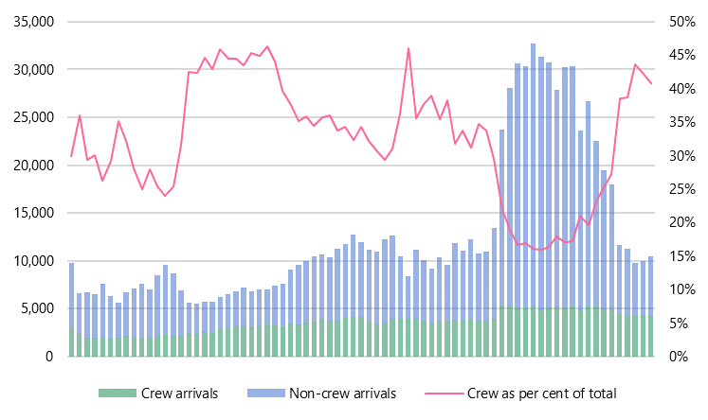
Source: Australian Border Force data

Maritime crew
Port facilities are a critical entry point into Australia for purposes including trade. Between 30 March 2020 and 31 July 2021, there were 507,063 maritime crew arrivals into Australia.
Maritime crew (excluding cruise ships and non-commercial vessels) are another industry group the AHPPC recognised should be exempt from 14-day quarantine requirements when entering Australia. Like airline crew, maritime crew are counted above caps.
Exact quarantine arrangements are subject to state and territory directions and may include mandatory quarantine in managed accommodation or self-quarantine in the crew’s accommodation on the vessel. There may be quarantine requirements for maritime crew disembarking a vessel in Australia. There may also be quarantine requirements for international maritime crew arriving in Australia (via aircraft) for 14 days at the point of arrival.
The Department of Health provides a COVID-19 information sheet for the marine industry that outlines general requirements. Maritime crew still need to be aware of the relevant state and territory requirements before arrival.
The journey for maritime crew generally involves a process of health screening, testing, transport between the airport and quarantine location and quarantine. It is important staff working around this journey are supported with protective measures to reduce COVID-19 risk.

Foreign diplomats
Foreign diplomats have the same requirement as other travellers to quarantine for 14 days on arrival in Australia. However, consistent with Australia’s legal obligations adopted in domestic law, exemptions are made so that foreign diplomats and their dependants holding subclass 995 visas undertake can quarantine at their place of residence, instead of at a government-managed quarantine facility, where circumstances allow. Final approval rests with the relevant state health authority.
Over 2,700 foreign diplomats and their dependants have quarantined in Australia (both at home or private accommodation and in government-managed quarantine facilities) since the start of the pandemic. The Department of Foreign Affairs and Trade facilitates arrangements with relevant state health authorities to ensure the diplomats’ arrival, transport and quarantine arrangements comply with all relevant public health requirements.
Foreign diplomats are asked to comply with state and territory requirements, including testing and compliance measures. The ACT reports there have been a small number of positive cases among foreign diplomats in Australia, but there have been no community transmission events.

Government officials
Some jurisdictions support alternative quarantine arrangements for government officials and their dependants who are returning from official government travel. These are officials travelling on an Australian Government-issued Official or Diplomat passport when completing official travel. Reasons for travel may include: official delegation travel, returning from a posting or approved leave. Government officials are included above caps.
NSW, Victoria, South Australia, Queensland and Western Australia require most government officials to quarantine in a government-managed facility. The ACT considers applications for government officials to quarantine at home. However, a number of requirements must be met, including proof of residence and that the quarantine premises are suitable for quarantine purposes. Government officials quarantining in the ACT often arrive at Sydney airport. These individuals are required by NSW Health to undertake an entry test and enter hotel quarantine until returning a negative result. There are also strict requirements around transportation providers to transit between the NSW hotel quarantine location and the ACT.
The ACT has managed quarantine for over 900 government officials, and over 400 of these were in home quarantine arrangements. The ACT also regularly receives Commonwealth delegations returning from international travel, travelling via Royal Australian Air Force aircraft. The ACT is working with the Australian National University and the Department of Home Affairs to establish a long-term process for receiving these flights going forward.
Australia and New Zealand have agreed a process to allow each other’s officials (including family members) to receive a border exemption and access to quarantine in the other’s country, in order to access ‘green zone’ flights. This process only applies to travellers for whom there is no other practical route home – for example, from Samoa, Tonga, Cook Islands and Niue for Australians and from other Pacific island countries and Timor-Leste for New Zealanders.

Seasonal workers / industry-led solutions
A number of jurisdictions have managed overseas agricultural workers participating in the Australian Government Pacific Labour Scheme (PLS) or Seasonal Worker Program (SWP) under different quarantine arrangements. These programs offer employers in the agriculture sector access to a workforce where there is not enough local Australian labour to meet seasonal demand. Workers are recruited from locations such as Vanuatu, Tonga and Samoa – countries which currently do not have any COVID-19 cases.
Queensland is currently operating an On-Farm Quarantine Arrangement for Pacific Islander workers recruited under the PLS and SWP by approved employers (with an approved on-farm quarantine application form by Queensland Health) in Queensland. These arrangements allow employees to work while quarantining in accommodation ‘on-farm’. The arrangements must meet requirements determined by the Queensland Chief Health Officer, including a testing regime. While the Queensland Department of Health is responsible for the assessment of the application, the local Hospital and Health Service and Public Health Unit may provide feedback on the application or undertake a site inspection to inform the Queensland Health assessment of the application. Once the application is evaluated by the relevant health and law enforcement authorities, a recommendation is made to the Chief Health Officer for consideration.
In Western Australia, seasonal workers quarantine in a dedicated quarantine hotel. Western Australia officials noted in interviews that there was some differentiation in quarantine arrangements compared to other international arrivals as this is a vaccinated cohort arriving from countries with no COVID-19. This includes differences around hotel ventilation requirements and compliance monitoring.
Tasmania and Victoria have concluded an arrangement which saw Tasmania quarantine seasonal workers from the Pacific Islands, in return for the Victorian Government assuming responsibility for Tasmania’s commitment to assisting Australians returning from overseas. As of 7 September 2021, Tasmania has quarantined over 2,300 international seasonal workers in hotel facilities.

Sporting teams and associated personnel
Bespoke quarantine arrangements have also applied to some sportspeople and sporting events. These arrangements are subject to decisions by state governments and are generally funded by industry.
For example, in Victoria sportspeople and support staff who participated in the 2021 Australian Open were accommodated in hotel quarantine with some limited modifications to permit training. This was funded by Tennis Australia.
Queensland permitted some major Australian sporting codes to put in place alternative quarantine arrangements where domestic border restrictions apply. These arrangements were funded by the sporting codes and typically operate at the same or to a higher standard of quarantine and security than government-nominated accommodation, and the chosen accommodation is not from within government-run quarantine stock. To apply for the alternative quarantine arrangements, Queensland Health requires a quarantine management plan, approved by the Queensland Chief Health Officer, which has equivalent COVID-19 risk management strategies to those required at government quarantine hotels.
In NSW, bespoke hotel quarantine programs are considered, usually for professional sporting groups who have a requirement to undertake training while in quarantine. At a minimum, groups must prepare an alternate quarantine proposal, including a COVID-safety health plan, security management plan, and a COVID-safety travel plan. Plans are then submitted to the NSW Government where various agencies, including NSW Health, enforcement and operational experts, review and agree the COVID-safety model. If agreed with operational agencies, all alternate quarantine proposals must be approved by the relevant NSW ministers. Once operationalised, NSW Police provides surveillance and monitoring of the quarantine facility against the approved plan and NSW Health provides advice on monitoring and testing pathways.

International students
A number of jurisdictions have trialled or are proposing to trial alternative quarantine models for returning international students. Prior to the most recent Delta outbreak over June to October 2021, NSW announced a pilot scheme for 250 international students to be flown into Sydney on charter flights every fortnight. Under the scheme, students would quarantine in converted and specifically approved student accommodation. The plan was endorsed by the Commonwealth Government in June 2021. NSW is now working on the implementation of its plan, with the first students expected to arrive before the end of 2021.
In addition, South Australia is also implementing their international student arrival plan approved by the Commonwealth Government in June 2021. The scheme is for 160 overseas students at a time to quarantine at flight school accommodation at Parafield Airport before returning to university campuses in South Australia.
Victoria has also recently announced its international student arrival plan, which has been submitted to the Commonwealth Government for approval. The Commonwealth Government will continue to work closely with all jurisdictions on planning for international student arrivals.
To 17 September 2021, only 63 tertiary international students have returned to Australia since the onset of the pandemic. This includes a small cohort of students from China, Hong Kong, Vietnam, Japan and Indonesia who arrived in the Northern Territory in November 2020 and quarantined at the Howard Springs facility for 14 days.
Universities Australia’s submission to this review calls for consideration of a scaled-up model where larger cohorts undergo quarantine overseen by universities and conducted in on-campus facilities. It also calls for more purpose-built student accommodation for quarantine of targeted cohorts. Further, the submission highlights that international students are a ‘low-risk cohort with credibility as COVID-safe citizens’ and are strong candidates to undertake quarantine outside hotels.

Compassionate alternatives
States have supported alternative quarantine arrangements for compassionate reasons on a case-by-case basis. These decisions are often on an exceptional basis and are small in number. For example, in Victoria between 7 December 2020 and 2 August 2021, there were only 96 approved applications to vary mandatory quarantine and complete quarantine in an alternate location for medical or compassionate reasons. Documentation considered by the review show that states have appropriate decision-making processes that assess the balance of risk to individuals and the communities, include evidentiary requirements, and set out clear responsibility for decision-making.

Domestic quarantine
A significant proportion of quarantine in Australia is completed for domestic purposes. Domestic quarantine is managed across different types of accommodation, such as home quarantine and managed quarantine, including hotel quarantine and quarantine in purpose-built facilities.
Domestic quarantine is currently used due to domestic border policies requiring quarantine of interstate arrivals. Quarantine and home isolation are also used extensively by jurisdictions to manage close contacts in local outbreaks.
Many Australians have also been subject to stay-at-home orders due to local outbreaks. Stay-at-home orders are usually less strict than quarantine because exposure risk is deemed to be lower than a close contact or person from a COVID-19 affected area.
In some states, domestic interstate travellers are a small minority of those placed in managed quarantine. For example, in NSW between 1 March 2020 and 31 July 2021, 225,441 people undertook quarantine in police-managed hotel quarantine (209,032 people were international arrivals and 16,409 people were domestic travellers). A further 13,181 people entered Special Health Accommodation (‘medi-hotels’).
In other states, domestic interstate travellers represent the majority of people placed in managed quarantine. For example, in Tasmania between 3 April 2020 and 30 July 2021, 11,724 people were managed in hotel quarantine. 2,187 were international arrivals and 9,537 were domestic arrivals (around 81 per cent of the total).

Mental health and wellbeing
As was observed in the first review, mandatory 14-day quarantine can be a challenging experience for individuals. In this context, jurisdictions have paid significant attention to the need for mental health, social and emotional support. In December 2020, the Commonwealth Department of Health issued advice on mental health screening, assessment and support during COVID-19 quarantine. The advice was prepared by Dr Ruth Vine, Deputy Chief Medical Officer for Mental Health, Commonwealth Department of Health, and Christine Morgan, Chief Executive Officer, National Mental Health Commission. Additionally, the AHPPC published updated National Principles for Managed Quarantine on 2 September 2021, which highlighted the need for proactive mental support for individuals in quarantine.
This type of support is particularly necessary for vulnerable people and those with pre-existing health conditions. The review has heard from several individuals about how their experience of 14 days hotel quarantine had a significant impact on their mental health.
The first review emphasised the need to recognise the psychological impacts of quarantine and individual psychosocial vulnerabilities to limit the negative health effects of quarantine. It recommended that comprehensive health screenings and wellbeing assessments be conducted at the start of quarantine to identify all health needs of returned travellers. Good practice health screening includes assertive assessments for mental health concerns, particularly with use of validated mental health assessment tools.
These systems are now entrenched and are a core component of the service offering.
All jurisdictions now complete a mental health assessment as part of an initial health screening, either at the port of arrival, at the quarantine location, or both. Regular health and welfare checks are now conducted in every jurisdiction during customers’ quarantine period. Since the first review, some jurisdictions have also made comprehensive activities and entertainment programs available to customers.
In addressing the wellbeing needs of people in quarantine, great care needs to be taken to understand how those needs might differ across the community. For instance, the review team saw evidence of jurisdictions specifically addressing issues of relevance to Aboriginal and Torres Strait Islander peoples, people from culturally and linguistically diverse (CALD) backgrounds and people with disability. Some jurisdictions incorporated requirements for all service providers involved in quarantine to ensure equitable treatment of all cohorts, with bespoke requirements in relation to CALD, LGBTQIA+, and residents with disability.
More information on customer mental health and wellbeing is at Attachment 10.
This review has surveyed a number of people who have undertaken quarantine in Australia, including in hotels in Sydney, Melbourne, the Gold Coast, Cairns and the Howard Springs Facility in the Northern Territory. Individuals that have been subject to home quarantine in several jurisdictions were also interviewed.
Through these interviews, most individuals said that although the quarantine experience was challenging, the conditions were acceptable. Many also indicated that they had a suitable location to undertake quarantine at home and that this would have been their preferred option.
This review has also sought details regarding complaints about the quarantine experience through consultation with the Australian Human Rights Commission (HRC) and the Commonwealth Ombudsman.

4 Future quarantine arrangements
In common with just a small number of countries, Australia has had remarkable success in managing COVID-19. As an island nation, early decisions to manage arrivals and prompt and effective action by public health officials, together with widespread public cooperation, have been key to this success.
Control of the border, including restrictions on departures, was an early and crucial element in the response to COVID-19. By preventing uncontrolled entry of the virus, Australia has avoided the widespread and devastating waves of infection seen in most other countries.
These measures have required sometimes significant limits on the personal freedoms enjoyed by Australians. It has also impacted Australia’s economy, tourism and higher education sectors and our migration programs: arrivals into Australia last year were the lowest for 30 years.
During the early stages of the pandemic in Australia, and following the effective suppression of the virus, the use of quarantine as a principal defence against COVID-19 was key to Australia’s success. The aim of quarantine was to keep COVID-19 out of the country (or State) and, in this context, the need for a high-performing quarantine system was crucial to averting a public health crisis like those experienced in many other parts of the world.
Pleasingly, the recommendations of the first national review of quarantine have all been implemented in whole or part. As outlined in Parts 1, 2 and 3 of this report, the quality of quarantine delivered in Australia has significantly improved over the last 18 months. The knowledge and improved systems that have delivered this outcome provide a solid foundation for the next phases (B-D) of the National Plan, and a different approach to quarantine.
The context in which quarantine now operates has changed. Vaccination rollout and uptake in Australia has gathered significant momentum since the middle of the year: several states have reached the Phase B threshold of the National Plan, with 82.2 per cent of Australians over the age of 16 years now vaccinated with at least one dose. If this momentum continues, 80 percent (phase C) of Australians over the age of 16 years are likely to be fully vaccinated by mid-November.
Community transmission is well-established in some parts of Australia, particularly NSW and Victoria (27,484 total cases in Australia when the first review was completed, compared with 113,411 as at 4 October 2021, most of which have occurred in the outbreaks associated with the Delta variant entering the country in June 2021).
Travellers to Australia are also increasingly likely to have been vaccinated, and work is well advanced to enable travellers to be able to prove their vaccination status when entering Australia (see Attachment 14).
Therefore, while TTIQ remains a crucial part of managing COVID-19, the balance between each element has changed. Quarantine will continue to play an important role but should be seen as part of the hierarchy of controls available to decision-makers. See Figure 19.
Figure 19 – Model of protections and the hierarchy of controls
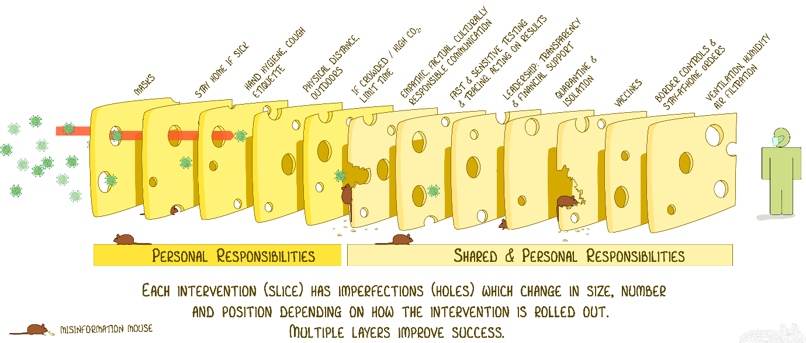
Source: Ian Mackay
Community expectations have also changed. Many Australians believe that, with high levels of vaccination being achieved across the country, there will be a reduction in the number of restrictions imposed upon their customary levels of freedom. There is significant pent-up demand for travel and expectations of increased freedom over the coming Australian summer.
The Australian community has broadly supported the Australian quarantine system over the last 18 months. However, in these changed circumstances, community support for future quarantine arrangements will demand that requirements are proportionate and consistent with perceived levels of threat. This changing community sentiment will influence compliance with quarantine arrangements and will inform risk tolerance across the states.
Quarantine arrangements must be adapted to respond to this changing context. These adaptations will include changes to who is quarantined, when they are quarantined, the setting in which they are quarantined and the duration of that quarantine.
The ‘ordinary traveller’ – a fully vaccinated individual with a pre-departure negative PCR test who is not travelling from a country with the presence of new COVID-19 variants of concern (i.e. subject to a country alert) – should be subject to no quarantine requirements in the later phases of the National Plan. See Figure 20.
Figure 20 – possible future quarantine pathway – ordinary traveller
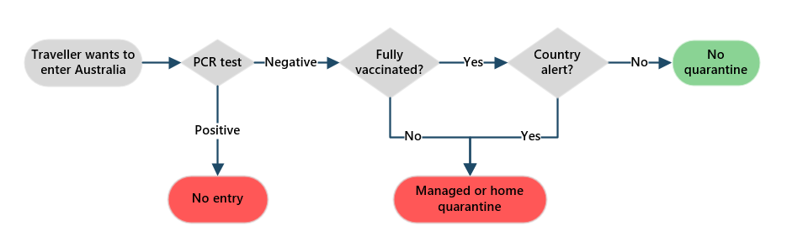
As each phase is reached in the National Plan, new risk-based and less stringent quarantine arrangements must be implemented smoothly, enabling increased travel, greater freedoms and economic activity.
A risk-based framework based on both the epidemiological context and evidence will be important to manage this stepped approach.
This review proposes five key COVID-19 quarantine principles to underpin the use and nature of pandemic quarantine going forward:
- Quarantine requirements are determined and applied consistent with the context, including: the National Plan; vaccination rates; relevant epidemiology, including the burden of disease and prevalence of COVID-19 in the community; the emergence of new variants and variants of concern; and the community’s risk tolerance.
- Quarantine requirements are determined using a consistent risk-based framework that assesses the relative transmission risk posed by the individual.
- Quarantine requirements are routinely reviewed in light of new developments and modified in a staged way to increase the ability for travel to and from Australia and between jurisdictions.
- Quarantine settings are proportionate to relative transmission risk with the least restrictive setting for a given risk profile preferred.
- Quarantine capacity is readily scalable so that appropriate facilities are designed to be available at short notice to respond to the possible emergence of new variants of concern or to assist in managing significant COVID-19 outbreaks.

Development of a risk-based framework
Part 2 of this review outlined the expanded use of different types of quarantine including for outbreak management. In view of the changing context and progress towards latter phases of the National Plan the review recommends the development of a risk-based framework to guide decision-making in relation to the use of quarantine. This should encompass whether someone has to quarantine, where they should quarantine and how long they should quarantine for.
The framework should govern the use and operations of quarantine and be developed and adopted by all jurisdictions. This can be adapted to the phase of the National Plan as well as the prevailing context in individual states including consideration of the prevalence of COVID-19 and risk tolerance (see Attachment 15).
A risk-based framework is also needed in the context of phases B-D of the National Plan to enable decisions about who should quarantine, where, and for how long. An assessment tool should be developed which takes into account the country of origin and the risk of a new variant of concern, vaccination status of the traveller, the risk of transmission associated with different types of quarantine, and available risk mitigations.
Inputs to the risk assessment need to be carefully considered so that the risk-based framework accurately gauges risks, and the overall approach is comprehensive and fit-for-purpose.
There are a number of considerations that affect the reliability of the quarantine risk assessments, including country risk assessments and vaccination certification.
This risk-based framework may be applied differently in individual jurisdictions based on local circumstances. This is more likely in the short term as some states are COVID-19-free and others have COVID-19 outbreaks. In these circumstances, Australian jurisdictions have already demonstrated different risk appetites for re-opening and the use of alternative quarantine modalities.
While individual states can apply risk-based quarantine in different ways, a core level of national consistency is needed as Australian travellers and businesses require certainty about what sort of quarantine requirements will apply.
In time the requirement to quarantine should be applied consistently across Australia using a risk-based framework for both domestic and international travellers.

Current context

Prevalence of COVID-19 in Australia
Decisions relating to quarantine are influenced by the higher prevalence of COVID-19 in Australia and the high levels of vaccination in the Australian community. These two changed circumstances mean that there is a lower impact of any single transmission event and more transmission risk from overseas arrivals can be tolerated.
One transmission event in a COVID-19-free Australia is highly significant whereas one transmission event into a COVID-19-endemic Australia is much less significant. Currently, we are closer to this latter case in several jurisdictions – over recent weeks, daily case numbers have numbered in the thousands on days when there have been no overseas-acquired cases of COVID-19. For instance, in NSW, up to 8pm 3 October 2021, there were 9,020 active COVID-19 cases that were acquired within the state while 6 were from interstate and only 14 were from overseas.

Objectives under the National Plan
In phases B-D of the National Plan, the objective of the public health response will evolve to minimise serious illness rather than to eliminate community transmission. More COVID-19 transmission risk can be tolerated because COVID-19 will be endemic, but more Australians will be vaccinated so the likely impact of any transmission event will also be reduced.
By phase D of the National Plan, quarantine requirements will be relatively light touch and there will have been significant normalisation of travel arrangements with managed quarantine largely confined to high-risk international travellers. Potential spread of any new variants of concern may also be a factor but this will depend on the epidemiological context.
This shift in approach is possible because the risk of COVID-19 transmission is reduced by widespread vaccination. Other TTIQ measures may still be needed, as outlined in the Doherty Institute modelling.
There will be key decision points associated with each stage of the National Plan. Figure 21 provides a representation of how requirements could evolve over time for those in the same risk categories. In light of the importance of the National Plan in dictating quarantine settings, the review recommends that:
3 All governments should reference current National Plan settings and the COVID-19 quarantine principles outlined in this report when considering requirements for travellers to undertake quarantine.

Figure 21 – Potential quarantine requirements in future phases of the National Plan
National Plan phase  ———————————  Risk assessment | Phase C | Phase D
Green* | Stepped down quarantine requirements including no quarantine requirements for some cohorts | No quarantine requirements
Red* | 7 to 14-day quarantine in managed quarantine or at home | 7 to 14-day quarantine in managed quarantine or at home.
*The appropriate quarantine type within these bands will depend on the broader context, including whether the individual is an international or domestic traveller and whether they are travelling from a ‘high’/’extreme’ risk country.

Current quarantine trials
As set out in Part 2, trials are underway in South Australia and NSW to assess a revised approach to implementing home quarantine. These will evaluate monitoring technology and compliance, effects of shorter quarantine duration and the viability of different types of accommodation for home quarantine.
These trials build on the existing experience of operating home quarantine, including high levels of compliance, and modelling on the relative risk of seven days of quarantine compared to 14 days of quarantine.
While home quarantine in suitable premises does not eliminate the risk of transmission events, these risks can be managed and minimised by the use of remote compliance monitoring and testing regimes. Testing regimes used post-quarantine can also be used to further mitigate risk.

Immediate priorities
Transition to phase B of the National Plan (which has already occurred in some jurisdictions) brings expectations about lifting of international arrival caps and the introduction of new quarantine requirements for vaccinated residents. In this context it is imperative that quarantine system design and arrangements can accommodate significantly larger numbers of travellers. Immediate attention should be paid to the capacity required to deliver testing, compliance checking and support to significantly higher caseloads of returning residents.
Clarity about these requirements including eligibility criteria will be important. Communication with (prospective) travellers will be crucial to enhance their understanding and to manage their expectations. Notwithstanding efforts made by all jurisdictions, confusion about existing quarantine and testing arrangements is still evident.
The review notes that existing arrivals caps have prevented tens of thousands of Australians from returning home (see section 2.4.1). As a priority, urgent work, including in the areas outlined below, should be undertaken to enable smooth implementation of the changed arrangements foreshadowed in the National Plan.
In implementing a stepped down approach to quarantine, particular attention should be paid to forecasting quarantine requirements. While some types of quarantine should be scaled back over the medium term, it will be difficult to scale some current options back up in the event this is needed. In this context, urgent work should be done to forecast arrivals and capacity. This will enable service providers and travellers, particularly Australians overseas wishing to return, to make travel plans with confidence. In order to achieve this, the review recommends:
4 All governments should commit to urgent work to forecast and publish managed quarantine capacity and projected arrivals based on increased arrivals caps and altered quarantine requirements. This will provide certainty and enable airlines, businesses and Australians seeking to return to plan their travel.
Attention should also be paid to the logistics required to process significantly larger volumes of travellers through airports in order to facilitate arrivals and to limit transmission risk between ‘red’ and ‘green’ pathways (see section 4.6).
In the early stages of this transition, evidence from trials of home quarantine, including compliance, should be applied and a staged approach to implementation should be adopted. Appropriate risk mitigations (see section 3.3) should also be applied. Evidence about compliance will be particularly important in determining the appropriate form of quarantine and implementation arrangements.

A stepped down approach
As Australia progresses through the phases of the National Plan, states should commence stepping down quarantine requirements promptly. A phased or ‘stepped down’ approach to managing risk and quarantine requirements as part of the National Plan is set out in Figure 22.

Figure 22 – stepped down risk mitigations in phases of the National Plan
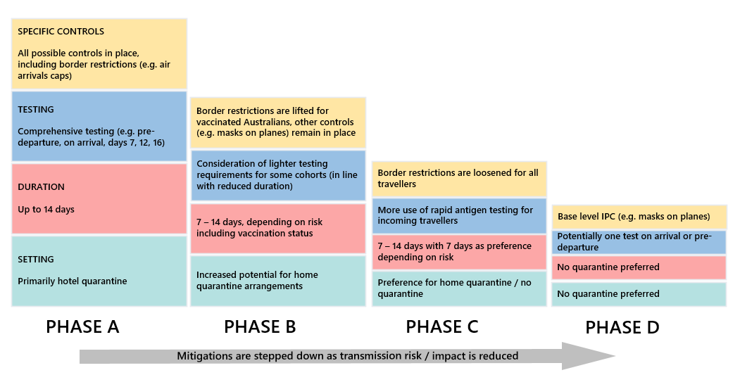
These stepped down requirements, alongside the COVID-19 quarantine principles and the risk-based quarantine framework should all be core parts of the future quarantine system.
As such, the review recommends that:
5 The National Cabinet should agree to:
- The five COVID-19 quarantine principles;
- A risk-based quarantine framework that stratifies travellers based on risk factors; and
- A staged approach to step down quarantine requirements in line with the National Plan.

Phasing out the use of managed quarantine for interstate travellers should be an immediate priority. Domestic quarantine requirements have had serious economic and social impacts on Australians (see Attachment 16). Jurisdictions should also introduce home quarantine arrangements for low-risk fully vaccinated Australians and residents returning from overseas. This aligns with this review’s recommendations that the least restrictive option should be preferred and home quarantine or quarantine-free options should be the usual practice.
In this context, the review recommends that:
6 States and territories should immediately commence stepping down quarantine requirements by phasing out the use of managed quarantine for interstate travellers and introducing home quarantine where feasible for low-risk fully vaccinated Australians and residents returning from overseas.

Different types of quarantine
The range of quarantine options available is broader now than in the initial stages of the pandemic. Figure 15 in Part 2 depicts the range of available quarantine settings and the controls that attach to each of these. Each type of setting can play a role in future quarantine arrangements. Over time the use of hotels will diminish as a proportion of cases in quarantine.
For individuals who present a significant relative risk and require quarantine, an appropriate setting to meet the needs of the individual should be chosen according to the five COVID-19 quarantine principles. Different quarantine settings provide for different types of risk and levels of risk controls. These should be applied having regard to the individual’s risk profile.
Some quarantine settings, such as quarantine in a purpose-built facility, are better able to mitigate transmission risks, especially for high-risk travellers and in respect of variants of concern. As we move through the phases of the National Plan, using different quarantine settings to a greater extent, including home quarantine, becomes more viable. Use of home quarantine in the United Kingdom may be informative – unvaccinated travellers arriving from non-red list (high risk) countries undertake home quarantine for 10 days. They must also satisfy COVID-19 testing requirements pre-departure and on days 2 and 8. Fully vaccinated travellers do not undertake quarantine but must take a test on day 2.
There are also other variables that can change the effectiveness of certain types of quarantine. For example, preliminary results from Doherty modelling indicates that where there are high or very high levels of compliance, home quarantine can reduce transmission risk to a similar degree to managed quarantine.
The National Plan proposes that at phase B, inbound international passenger caps are restored to previous levels for unvaccinated returning travellers and to higher levels for those who are vaccinated (with no caps to be in place by phase C). The National Plan also proposes that vaccinated Australians returning from international travel should be permitted to use alternatives to hotel or purpose-built quarantine facilities, including home quarantine where this is suitable. These proposed arrangements are appropriate given that, in every instance, quarantine requirements should be proportionate to risk. The review recommends that:
7 Quarantine requirements should be proportionate to risk so that home quarantine or quarantine-free options are used as the usual practice while managed quarantine, including purpose-built and hotel quarantine facilities, is used where necessary.
Some risk mitigations can be applied independent of the quarantine setting, while others are built into the physical fabric of the location. This means that some types of quarantine are better able to mitigate transmission risk because there are more and more effective types of risk mitigations available.

Mitigating risk
Interventions applied as part of, or ancillary to, the quarantine process can be used to reduce the transmission risk presented by each individual. This includes existing interventions like polymerase chain reaction (PCR) testing before travel. Other interventions can also reduce risks, including basic principles of IPC correctly followed, such as compulsory mask wearing, as well as application of additional testing protocols such as rapid antigen testing as appropriate.
All types of mitigations may have a role but it is important to implement mitigations in line with what is appropriate in all the circumstances. Total traveller numbers, quarantine compliance, vaccination status, available risk mitigations and origin of travel will be material to successful implementation of new arrangements. In order to ensure risk mitigations are applied appropriately, the review recommends that:
8 States and territories should apply risk mitigations when implementing new models of quarantine. The least restrictive quarantine option should be preferred, including quarantine-free options for low-risk cohorts.
Appropriate risk mitigations should be considered for all travellers and for all forms of quarantine. While mitigations should be considered in a proportionate way, all the diverse levels should be considered so that a comprehensive picture of risk can be formed and appropriate mitigations can be applied. Table 7 sets out these levels of risk, the risk factors and possible mitigations.
Table 7 – risk categories and possible mitigations
Source of risk |  | Risk factor | Mitigation
Individual risk |  | Vaccination status | Vaccination, vaccination certification
 |  | Pre-departure testing result | Testing protocols
 |  | Individual predisposition to compliance | Technology, wearables, compliance checks
Country of origin risk |  | New variants of concern | Monitoring international environment
Travel risk |  | Mode of arrival (air, maritime) | Specific travel pathways (“green”, “red”)
 |  | Transit locations | Travel plan assessment
 |  | Passenger mix | Travel plan assessment, plane sewage surveillance
 |  | Ability to transfer home from port of arrival | Transport arrangement assessment
Quarantine location and type | Home quarantine | Residence type (i.e. freestanding house or non-shared access apartment) | Home suitability assessment
 |  | Family status and living arrangements | Living arrangement assessment
 | Hotel or purpose-built quarantine | Risk of transmission and/or breach | IPC protocol, ventilation improvements
Risk mitigation should be applied in a proportionate manner and consistent with the evidence. Some base-level risk mitigations should be universal and apply to all incoming travellers.
For example, pre-departure testing (likely PCR in the short-term at least) should continue to be a requirement for all incoming travellers. Masks should also be worn by all people travelling to Australia on flights and at Australian airports when required by local authorities. This continues the requirements for masks on flights and in airports introduced on 22 January 2021. All incoming travellers should also be encouraged to practice good hygiene and physical distancing and follow any local public health rules. This should apply to all travellers, regardless of cohort.
Specific consideration will need to be given to risk rating of families with children who cannot currently be vaccinated. Infection with COVID-19 Delta variant is more common in children than the original strain and while most infections in young children are relatively mild, they can and have been the source of infections to others.

Implementation issues
Successful transition to a post-COVID-19 world as outlined in the National Plan will be facilitated by early attention to key implementation/logistical issues during phases B-D. These include in respect of decision-making and how risk mitigations are applied to travellers, including testing methods and compliance measures. It also includes challenges such as scalability and system capacity.

Vaccine requirements
Recognition of vaccination status will be an important part of risk assessment for arrivals. Vaccination is one of the most effective way to protect against infectious diseases. Being vaccinated reduces the risk of developing COVID-19 and transmitting it to someone else. It also significantly lowers the risk of requiring hospital care or death.
Vaccines vary in terms of their efficacy and safety (see Attachment 17). In Australia, the Therapeutic Goods Administration is responsible for assessing all COVID-19 vaccines before they can be used in Australia. At 15 September 2021, there were four provisional registrations for the COVID-19 vaccine in Australia: Comirnaty (Pfizer), Vaxzevria (AstraZeneca), Spikevax (Moderna) and COVID-19 Vaccine Janssen (Janssen-Cilag), noting the Janssen vaccine is not included in Australia’s COVID-19 vaccination program.
The TGA also recognises Coronavac (Sinovac) and Covishield (AstraZeneca/Serum Institute of India). This recognition was based on assessments of individual review of published data and in certain cases of regulatory information provided to the TGA in confidence. However, this recognition does not constitute Australian regulatory approval, meaning these vaccines are not approved for administration within Australia.
In order to speed the inclusion of vaccines to be recognised for travel and risk assessment purposes, consideration should be given to extending recognition to vaccines approved by a regulatory authority considered comparable to the TGA. Currently, the TGA considers the following countries or groups of countries as having comparable regulatory authorities: Canada, Japan, Singapore, Switzerland, the United Kingdom, the United States and the European Union.
This would provide three categories of accepted vaccines: vaccines approved or recognised by the TGA, vaccines approved by a comparable overseas regulator, and, vaccines that do not meet either of these conditions.
At the time of this report, there were no vaccines available for children under the age of 12 years. This is likely to change in the next 12 months.

Duration of quarantine
Recommendations for two-week quarantine periods have been based on the upper bounds of the incubation period (the period of time from exposure to development of symptoms) for COVID-19, the mean of which is estimated to be 6 days. This was considered explicitly when, early in the pandemic, the AHPPC was asked to review the advice on quarantine duration and noted that the median incubation period for the then strain of COVID-19 was 4.9 – 7 days, with a range of 14 days. By comparison, one scientific study shows the Delta variant has an average incubation period of four days.
While a longer quarantine is relatively more effective than a shorter duration, a shorter duration of quarantine involves less risk when the probability of infection on arrival is low. There are also additional risk mitigations that can apply to support reduced duration of quarantine. Indeed, preliminary results from Doherty Institute modelling shows that compliance with quarantine requirements has a more important impact than quarantine duration.
Reducing the duration of hotel and home quarantine in line with the reduced transmission risks of some travellers is appropriate given recent modelling available to the review and real-world data. Interim modelling from the Doherty Institute shows that a vaccinated infected traveller in hotel quarantine for 7 days poses a similar risk to the community to an unvaccinated infected traveller in hotel quarantine for 14 days. This modelling also shows that with perfect (i.e. 100 per cent) compliance, home quarantine poses a lesser risk to the community compared to hotel quarantine partly because the likelihood of a quarantine worker being exposed to the quarantining traveller is greatly reduced.
Real-world data from NSW indicates that a shorter quarantine duration can capture approximately 90 per cent of potentially infectious cases. This does not account for the fact that further testing after 7 days could further reduce risk to the community.
Reducing quarantine duration will also increase quarantine capacity and improve the quarantine experience for individuals. This is already being implemented in the NSW home quarantine trial, which commenced on 17 September 2021.
Real-world data indicates that a shorter quarantine duration can be highly effective. Data from NSW for the period from 1 July 2021 to 30 September 2021 clearly indicates that quarantine of a shorter duration (such as seven days) would have removed the vast majority of transmission risk from international arrivals.
Figure 23 reveals that from 1 July 2021 to 30 September 2021, of the 39,419 individuals in quarantine in NSW, 104 individuals tested positive within the first seven days of quarantine and 15 individuals tested positive to COVID-19 after the first seven days. Advice received from NSW indicates that, since routine day 16 testing was introduced, the majority of the day 15 and day 16 positive cases represent persistently PCR-positive cases who likely contracted COVID-19 weeks or months previously and did not represent active cases.
Figure 23 – positive tests by day of quarantine across 39,419 individuals in NSW quarantine (from 1 July 2021 – 30 September 2021)
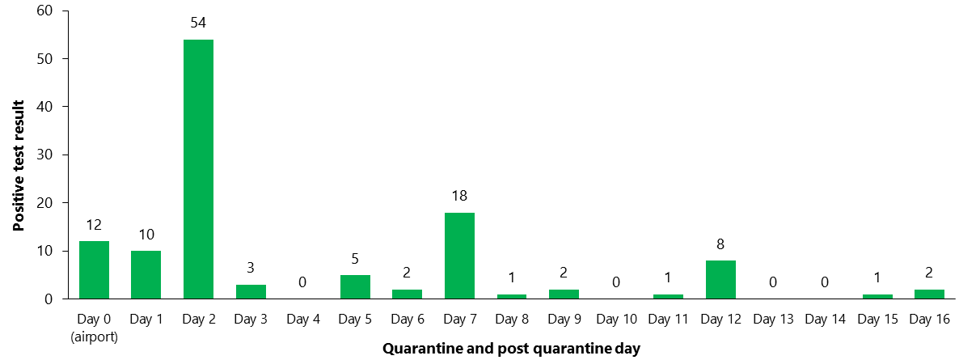
Source: NSW Government
Table 8 shows that 0.30 per cent of total individuals in quarantine in NSW tested positive to COVID-19 over July, August and September 2021. Only 0.04 per cent of individuals tested positive after the first seven days. Given vaccination reduces the risks of both contracting and transmitting COVID-19, positivity rates and therefore overall transmission risk are likely to be even lower in fully vaccinated cohorts (see Attachment 17).
Table 8 – positivity rate across 39,419 individuals in NSW quarantine
(from 1 July 2021 – 30 September 2021)
 | Number of individuals | Positivity rate (of total individuals)
Positive tests within the first 7 days | 104 | 0.26 per cent
Positive tests after the first seven days | 15 | 0.04 per cent
Total individuals in quarantine | 39,419 | 0.30 per cent
Source: NSW Government
Over the same period of time from 1 July 2021 to 30 September 2021, there were over 57,000 locally acquired COVID-19 cases diagnosed in NSW. This means that there were more locally acquired COVID-19 cases in NSW than overseas travellers in quarantine.
While there have been some cases where an individual appears to have transmitted COVID-19 after completing hotel quarantine, some of these instances likely relate to the case being acquired in hotel quarantine. In other cases, transmission may have occurred because an individual was incubating the virus for more than 14 days after exposure; however, real-world data shows this situation is extremely uncommon.
Studies have also demonstrated that testing regimes can increase the effectiveness of a shorter quarantine period. One study found that testing on exit (or entry and exit) can support a reduction in 14-day quarantine duration by 50 per cent. This aligns with findings of the Burnet Institute’s traQ Study, which sets out that timing of testing can reduce risk (with ideal timing of two tests near the end of the quarantine period regardless of the duration of quarantine).
A small study from the United States that trialled modified quarantine arrangements for kindergarten to 12th-grade students who were close contacts of COVID-19 positive cases also demonstrated that almost all positive cases in quarantine are diagnosed on or before ten days of quarantine. This is the case even though children have been reported to have longer incubation periods than adults.

Testing
Since 21 January 2021, all people travelling on flights to Australia must provide proof of a negative PCR test result at the time of check-in. The test must be undertaken within 72 hours before the scheduled flight departure (or first flight, where multiple flights are booked). Some exemptions currently apply, including passengers arriving from a green/safe travel zone flight, and countries where PCR testing is not reasonably available.
Pre-departure testing assists in preventing transmission of COVID-19 on-board flights. It also reduces the number of positive cases entering Australia, which in turn reduces potential transmission and strain on health system resources.
At least for the near future, pre-departure PCR testing should continue to be a mitigation strategy for all flight arrivals to Australia. While pre-departure testing is not currently required for passengers from a green safe travel zone flight, future epidemiology may change this requirement. Future phases of the National Plan should consider pre-departure testing for all arrivals. This should also include consideration of the difficulties some travellers have reported with accessing testing in a timely manner. In time, Rapid Antigen Testing should be considered as a potential substitute for PCR testing.

New types of testing
Rapid antigen testing will be more significant in future phases of the National Plan when there is likely to be a greater prevalence of COVID-19 in the community. To date, a single case in the community can have significant consequences and therefore the highest sensitivity of testing has been warranted (i.e. a PCR test).
While less sensitive than PCR testing, rapid antigen testing is widely available and being used successfully around the world to help identify, and therefore manage, more cases of COVID-19. The recent TGA approval of self-administered tests (without requiring clinical supervision) will assist greatly in more widespread application of this testing option.
Rapid antigen testing has the potential to support less stringent quarantine arrangements particularly with increased volume of travellers. This may include using rapid antigen testing as an initial screening tool for arrivals at the airport where a result can be provided within 10-30 minutes. A negative rapid antigen test at the airport could verify a planned modified or no-quarantine arrangement. A positive test could mean a passenger would need to hotel quarantine until returning a negative PCR result. Capacity to safely, rapidly and securely implement this in an airport environment would need to be further explored.
In future, rapid antigen testing could also be incorporated into tiered testing regimes within the quarantine system. This could see high-risk individuals subjected to PCR testing and low-risk individuals subject to rapid antigen testing, or a combination of daily rapid antigen testing and PCR testing pre-discharge, depending on the quarantine arrangement.
Surveillance of wastewater from long-haul planes and ships with their own sanitation systems could also be a complementary data source to assist in testing and triaging passengers. These approaches should continue to be trialled in Australia so our response can evolve and these practices can be best integrated into broader practice.

Compliance monitoring
Currently, compliance with home quarantine in Australia is monitored via a number of measures including random police checks, daily phone calls and digital methods such as mobile phone apps. The South Australian home quarantine trial leverages ‘Home Quarantine SA’, an app that includes a facial verification service, geolocation functionality and live ID check to support compliance.
Key factors that affect adherence to quarantine are the provision of support to those in quarantine and customers’ knowledge about quarantine rules and protocols. These risks can be mitigated by providing sufficient support to those in quarantine and ensuring rules are communicated clearly to individuals in quarantine.
The ‘Home Quarantine SA’ app is an important part of ensuring clear information about rules and resources are provided to participants in the home quarantine trial. The app is designed to be a one-stop shop for users during their quarantine. This includes sharing up to date public health information and information on essential physical and mental health support. The app also includes reminders of users’ testing schedules and expected quarantine completion dates.
Figure 24 – Minimising the risk of non-compliance to quarantine requirements
Source: adapted from Webster et al and from paper provided to AHPPC

Technological solutions can support compliance but are unlikely be acceptable as standalone risk mitigation measures. In the South Australian trial, in addition to the ‘Home Quarantine SA’ app which uses random location check-ins using live facial verification three times per day, South Australian Police are involved in enforcing quarantine compliance. South Australian Police conduct at least one random physical check-in on each participant between 8pm and 8am nightly during the trial period.
Going forward, a mix of measures will be needed to ensure high levels of compliance. This will include both measures that mitigate risk to a high degree and measures that do so to a lesser extent. Technological solutions are likely to be complementary to some degree of in-person compliance monitoring. Penalties for infringements of public health orders associated with home quarantine would also likely increase compliance.
As home quarantine moves to significant scale, approaches to compliance will need to be stratified based on risk. Limits on resourcing will need to be factored into system design in order that capacity constraints do not re-emerge.
A challenge in compliance monitoring is maintaining a comprehensive dataset on individuals in quarantine. The dataset may need to be accessed by multiple agencies in a jurisdiction, including health departments and police. As noted above, sharing of data and information between jurisdictions, including between Commonwealth agencies and states, has been ad hoc. Consideration should be given to improving data collection, management and sharing to enhance quarantine compliance and post-quarantine operational decisions.

Transport to quarantine and location risk
Risks arising from a traveller’s transit and the nature of their home quarantine location should be considered and managed. For example, decisions about whether travellers will be permitted to utilise public transport and other services such as taxis will need to be made. At present, transportation between airports and quarantine is tightly controlled and is usually provided by the jurisdiction. With increased capacity and numbers in home quarantine arrangements, consideration will need to be given to private travel arrangements (e.g. own vehicle or privately-hired vehicle). Where travellers can travel by private vehicle, rules relating to how they may obtain petrol and food on their way to quarantine will be required. Infection prevention and control must be at the core of these considerations.
Criteria covering the nature of quarantine and type of isolation will be crucial to determine whether home quarantine can be effectively undertaken. The risk framework and implementation arrangements should include criteria in respect of living arrangements as a matter of urgency.
Different types of household (i.e. family members and housemates, especially if other members are healthcare or aged care workers) may be more or less suitable for quarantine. This includes places with shared living spaces with family or housemates, group living environments include small shared apartments, shared households with a large family, shelters or group homes.
In addition, consideration must be given to types of houses (including granny flats) and whether small apartments within larger buildings are appropriate for quarantine. These considerations have the potential to affect large numbers of people – in 2016, there was around one occupied apartment for every five occupied houses in Australia.
In Canada, where home quarantine is available as an option to travellers who satisfy particular vaccination and testing criteria, the Canadian Government requires that all travellers demonstrate prior to arrival they have a suitable place to quarantine where they can: stay for 14 days or possibly longer; have access to the necessities of life without leaving quarantine; can avoid contact with others who they did not travel with; and have no visits from family or guests. The Canadian guidelines are clear that an individual cannot quarantine in ‘group living environments’.
As alternative quarantine pathways are introduced, it is likely that Australia will need to consider guidelines of this nature.
For arrivals without access to suitable living arrangements, consideration should be given to the use of short-term rentals. This has been utilised successfully in the ACT for both domestic cases and returning government officials.

System capacity

Current quarantine capacity
Based on documents available to the review team, Victoria and NSW have a combined capacity of up to 10,000 people in their hotel quarantine systems. With the addition of the 2,000-person capacity of Howard Springs, Australia has at least a total capacity of 12,000 in quarantine facilities at any point in time. In practice, utilisation of capacity will always be less than total capacity. This is the practical result of spacing between rooms, segmenting sections of facilities as well as the need for routine deep cleaning and maintenance. This is also the result of needing to extend quarantine duration if a customer tests positive to COVID-19.
Current managed quarantine capacity has proven insufficient to ensure overseas Australians wanting to return home can do so when they nominate to travel. Unless the quarantine system evolves, quarantine requirements and capacity can act as a brake on the agreed National Plan phases.
Phase B of the Plan requires the restoration of inbound passenger caps to previous levels for unvaccinated travellers. Phase C proposes abolishing caps for returning vaccinated travellers. Phase D will allow uncapped arrivals of non-vaccinated travellers subject to testing.

Future quarantine capacity
While this review does not model future needed quarantine capacity, it is clear that business as usual scenarios would require significant increases in quarantine capacity.
Additional capacity and/or fewer quarantine requirements and shorter duration of isolation will be needed in the future for the Australian economy to get back to full speed – skilled migrants, returning students and tourism will all add to the need for more capacity in the quarantine system.
As traveller numbers both domestically and internationally grow there will also be less hotel quarantine capacity because as demand for tourism increases, hotels will be less willing to function as quarantine facilities.
In the short-term quarantine capacity can be scaled up progressively through the increased use of alternative quarantine arrangements (especially home quarantine) and by exempting broad cohorts particularly domestic travellers/low risk arrivals from quarantine requirements.
Consistent with the Nation Plan and risk settings quarantine requirements will need to be stepped down progressively to support economic migration, returning Australians, tourists and humanitarian intake. Capacity will also need to be assessed on a rolling basis given that travel flows are seasonal and relate to specific seasonal factors such as harvest seasons for different crops and regions, term dates and tourism patterns.

Impacts of quarantine capacity and duration
Greater quarantine capacity including through more use of less restrictive quarantine options will provide more opportunities for travel to Australia. In this context priority should be given to Australians wanting to return home from overseas. Home quarantine for this group will greatly assist.
More broadly both quarantine duration and capacity will influence the total number and type of travellers seeking to travel into Australia. For example, increased capacity including through greater use of industry-led quarantine will enable larger cohorts of skilled migrants and international students to arrive during the intermediate phases of the National Plan.
Travellers will differ in their sensitivity to quarantine duration. For example, people travelling for compassionate reasons may be willing to travel even where quarantine duration remains extensive, whereas business travellers and tourists will be more sensitive to quarantine duration. Industry groups have suggested to this review that business travel may be more viable if quarantine duration is three days or less. However, three days of quarantine may still be unpalatable to many short-term tourists.
Figure 25 shows the likely sensitivity of different types of travellers to different quarantine durations.
Figure 25 – Impacts of quarantine capacity and duration
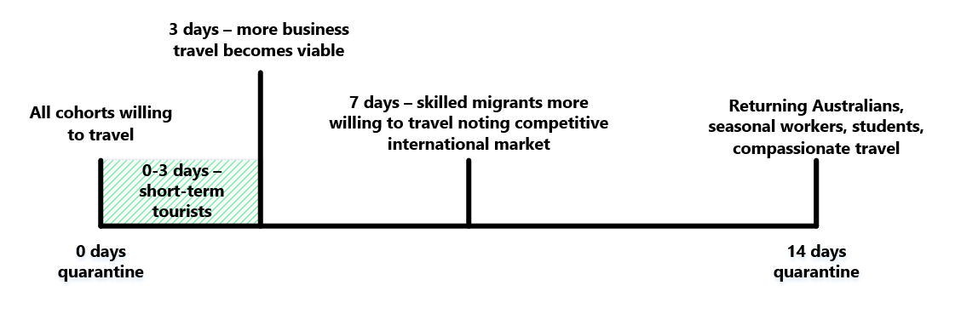
In this context, evidence about the duration of quarantine and its impact on transmission risk should be monitored with a view to reducing requirements as soon as is feasible.
The review heard from a number of parties about the importance of certainty about quarantine requirements to their decision making.

Emergency capacity
It will always be necessary to keep standing reserve capacity in order to respond to future variants of concern or new pandemics.
Purpose-built facilities represent the gold standard of quarantine and are an appropriate choice of location for high-risk travellers and emergency events. However, depending on the need for quarantine capacity, other quarantine options may also be appropriate, especially in an urgent situation. In these circumstances, hotel quarantine options could be sequentially be switched on, including for high-risk travellers.
Retaining the ability to re-activate hotel quarantine in urgent circumstances will be important to safeguard Australia’s future response to pandemics.
Monitoring variants of concern as part of pandemic management should ensure high-risk travellers are allocated to these purpose-built facilities.

Information sharing
Currently, there is no consistent national approach that tracks quarantine system capacity and usage. This presents challenges, such as setting incoming passenger caps, effective planning by jurisdictions, timely communication to airlines and giving certainty to individuals who want to travel to Australia.
This could be improved if there was a database that incorporates real-time quarantine logistics data across Australia. This could be linked with modelling the expected demand for quarantine facilities using historical and trend data. Modelling can then be used to inform risk assessments and the types of quarantine available to support individuals.
Modelling could also inform the appropriate level of incoming passenger arrivals caps. Future phases of the National Plan see a gradual restoration of inbound passenger caps. For example, in phase B measures may include restoring inbound passenger caps at previous levels for unvaccinated returning travellers and larger caps for vaccinated returning travellers.

Pre-arrival quarantine planning
Given increased capacity will put pressure on organisational capacity, the majority of quarantine planning will need to be completed before passengers arrive in Australia. Options to streamline or automate processes will need to be considered. Other countries, for example Canada, have such processes in place and we should draw from their experience in planning the Australian processes.
Jurisdictions currently have well established processes to assess exemptions or other passenger requirements. This includes processes to assess suitability of a passenger and their home for home quarantine arrangements. A key challenge will be the scalability of such processes.
Passenger pre-arrival information collected through the Australian Travel Declaration and the future Digital Passenger Declaration will be essential for jurisdictions in future phases of the National Plan.

Outbound travel
The rules surrounding outbound travel are relevant to consideration of Australian quarantine arrangements. That is because a significant amount of outbound travel relates to individuals who will subsequently wish to return to Australia. Currently, if you are an Australian citizen or a permanent resident you cannot leave Australia unless you have an exemption. The Commonwealth Government has already clarified that the current overseas outward travel restrictions related to COVID-19 will soon be removed, which will mean there will be no travel restrictions on entering or leaving Australia if you are a vaccinated Australian.
In phase C of the National Plan, measures include gradual reopening of outward international travel with safe countries. These measures will need to be considered together with anticipated quarantine arrangements for these passengers on return to Australia, and how they impact overall quarantine system capacity. Exemption processes will need to be updated to align with these approaches.

Airport limitations
Urgent work will need to be done to ensure appropriate arrangements at airports that can safely and efficiently manage increased volumes of travellers. To date, Australian international airports have adapted terminals and other facilities to handle incoming ‘red zone’ international passengers and separate them from ‘green zone’ passengers. Operation of a ‘red zone’ requires a range of measures and risk management practices including physical barriers to protect airport staff and travellers, PPE, special procedures to handle luggage, and marshalling of passengers.
Stakeholders including the Australian Airports Association and the management of major airports including Sydney, Melbourne and Brisbane have raised concerns that current configurations may not suffice with increased passenger volumes. Handling increased numbers of ‘red zone’ passengers may result in overcrowding, long wait times and infrastructure shortages. Ultimately, it will limit the overall volume of passengers able to be processed at international airports.
Significant planning and engagement, including with the aviation industry, will be required to balance increased capacity and health security requirements. The Board of Airline Representatives of Australia also advocates consultation with international airlines around operational requirements. Noting there will be limited capacity at airports to process ‘red zone’ passengers, a risk-based framework will be required to determine which passengers can proceed through airports as ‘red zone’ passengers versus ‘green zone’ passengers.
These issues will largely be short-term issues that are present through the first three phases of the National Plan. By phase D, most travellers will be fully vaccinated and will likely be treated as ‘green zone’ passengers, which means that logistic constraints at airports will be much easier to manage.

Travel pathways
Under a risk-based framework, international arrivals could be allocated to an appropriate pathway based on various risk factors. These risk assessments should determine how travellers are managed at the airport or port of arrival through to their quarantine requirements.
A stratified quarantine approach would create travel pathways that are available based on an assessment of every individual. In practice this will likely reduce to high and low-risk pathways.
Figure 26 shows possible traveller pathways based on two pathways. In future, this may reduce to one pathway, which would enable a return to standard travel arrangements in which there are not ‘red’ and ‘green’ pathways.
This example also includes an amber category for risk assessment. This represents the fact that there may still be more than two tiers of risk category in use even if there are only one or two (i.e. a high-risk / ‘red’ and a low-risk / ‘green’) travel pathways.
It also recognises that how travellers are categorised will change over time. Broadly, as Australia moves through the phases of the National Plan, there will be increased volumes of travellers going through the green travel pathway.
Figure 26 – Traveller pathways and risk assessment
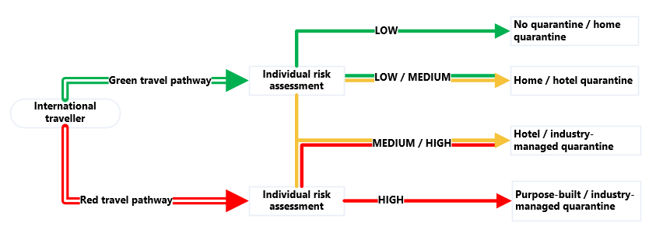

Specific cohorts
While the core of a risk-based framework will assess the transmission risk on an individual level, there may still need to be flexibility for specific cohorts. This may need to include consideration of different arrangements for unaccompanied minors, transit passengers, air crew, as well as the need for appropriate compassionate exemptions.
International passengers arriving into a state or territory other than their final destination will also need to be considered, including whether for Australian residents any domestic onward travel is permitted to facilitate home quarantine arrangements. Any exceptions to standard rules for these cohorts should be considered carefully in line with broader context, including the objectives of the quarantine system and clearly communicated to prospective travellers. In line with previous National Cabinet decisions, it is to be hoped that international travellers could undertake domestic onward travel with limited restrictions.

Domestic quarantine requirements
Jurisdictions also use quarantine extensively for domestic purposes. This includes interstate travellers quarantining in response to a jurisdiction’s domestic border restrictions. It also includes COVID-19 positive cases and close contacts quarantining to limit the spread of COVID-19 to the wider community. Each of these domestic scenarios presents a relative risk to jurisdictions who then determine requirements. Over time and as COVID-19 becomes more endemic, jurisdictions should determine the relative risk of interstate travellers and close contacts is sufficiently reduced to no longer require quarantine.

Industry-led solutions
While there will be a continuing need for government-managed quarantine facilities, industry-led quarantine solutions, where the private sector develops and implements quarantine arrangements, could support the future quarantine system to scale up and down. Private entities and industry groups are well-placed to deliver efficient, market-based quarantine options to satisfy their own commercial needs providing there is appropriate and adequate regulatory oversight and monitoring. The costs of offsetting the quarantine arrangements of temporary skilled migration for particular businesses or industries would also be best borne by those businesses.
Any industry-led approaches should be informed by previous pilots, including Queensland’s on-farm quarantine, South Australian and NSW international student quarantine arrangements, and Tasmania’s low-risk seasonal worker quarantine approach.
Ensuring that the learnings of the past 18 months in terms of quarantine provision are transferable and carry through to any new private sector quarantine arrangements will be crucial. There will remain a significant public health incentive for government action to ensure industry-led quarantine arrangements are safe and adequately manage risks, in line with government-led arrangements. Public health considerations will need to override some commercial incentives so that public health and the national interest are at the core of all quarantine systems both public and private.

Appropriate regulation
Industry-led quarantine arrangements will also need to be carefully regulated/supervised. This may demand the development of an accreditation scheme for industry-led quarantine arrangements and the establishment of an accreditation authority. It may also require regular audits or quality assurance checks of facilities to ensure ongoing compliance with expected quarantine requirements.
Creating efficient and effective rules will be critical for the private sector to deliver tailored, safe and fit-for-purpose quarantine. The rules and frameworks may also need to differ depending on the sophistication and size of the business involved. For instance, large corporations may have the logistics and workplace health and safety processes in place to operate their own quarantine systems. Smaller businesses may need to work together or could outsource their quarantine requirements to specialised firms.
These rules and regulations should also be proportionate to the broader context, including the phase of the National Plan and broader quarantine requirements. For example, in Phase D, where quarantine becomes the exception, the regulation for industry-led quarantine arrangements should be minimal.

Variants of concern
The quarantine system must be adaptable to react rapidly to the emergence of new variants of concern. A variant of concern is a variant of the virus SARS-CoV-2 that is designated as a variant of concern locally or by international bodies if there is evidence of epidemiological, pathological or immunological features of concern. In addition to variants of concern, the World Health Organisation and the Commonwealth Government also track ‘variants of interest’, which pose an emerging risk to global public health or are of regional interest to Australia. These currently include the variants Lambda and Mu, both first documented in South America. These variants of interest are not yet present in Australia, and while they are not designated as variants of concern, they still need to be carefully monitored. In its submission to this review, the Australian Medical Association (AMA) states that Australia needs to be preparing for another, more severe variant to emerge. Australia’s Communicable Diseases Genomics Network is keeping a watching brief and reporting regularly to the Commonwealth Government.
If new variants of concern are identified, decisions will need to be made on adapting the risk-based framework quickly to the new public health environment. This may require precautionary and more stringent quarantine requirements to be put in place for potentially short periods of time.
In these circumstances, the quarantine system would need to be able to scale up quickly to react to the heightened risk, including the potential increased transmissibility or detrimental change in COVID-19 epidemiology.
The best way to ensure this is possible is to retain purpose-built quarantine facilities and a standing reserve capacity within hotel quarantine facilities. To ensure this is possible, the review recommends that:
9 All governments should work together towards a future where quarantine requirements become the exception rather than the norm while ensuring managed quarantine can be scaled up quickly to meet future challenges including to prevent the introduction of new variants of concern.

Prevalence of COVID-19
In the current circumstances, in some jurisdictions, public health authorities are as concerned about those in quarantine being infected by quarantine workers as they are about quarantine workers being infected by those travellers in quarantine. This is the natural corollary of COVID-19 being more prevalent in some Australian states than in some overseas countries.
Currently, in phase A, international arrivals must complete 14 days mandatory quarantine even if they are fully vaccinated, have tested negative, and are coming from a nation with no COVID-19 cases. Local residents with the highest probability of transmitting COVID-19 –those have tested positive to COVID-19 – are only subject to home quarantine in many jurisdictions in Australia. In future phases, quarantine requirements should be less stringent and more consistent in line with a risk-based approach to quarantine.
In the latter stages of the National Plan it is arguable that it is the difference in prevalence between Australia and other countries that is most relevant to the use of quarantine. As Table 9 indicates, until vaccination is widely adopted around the world international travel is likely to be more limited if there is a differential in the background rate of COVID-19.
Table 9 – COVID-19 prevalence in Australia vs overseas
 |  | Prevalence in Australia
 |  | Low | High
Prevalence overseas | Low | Not relevant to risk assessment | Less travel because travellers from Australia will pose risks to other countries
 | High | Less travel because international arrivals will pose risks to Australia | Not relevant to risk assessment

International alignment of quarantine requirements
Australia has some of the most stringent quarantine requirements of any country, especially in regards to vaccinated travellers. Other comparable countries such as the United Kingdom and Singapore are moving quickly to modify their quarantine arrangements to allow quarantine-free travel for vaccinated travellers (see Attachment 6). As pointed out to the review by stakeholders, including the Business Council of Australia, stringent quarantine requirements will likely impede Australia’s ability to compete for skilled migrants.
As noted in section 4.7.3, the duration of quarantine and the requirements may also have significant impacts on business travel and tourism. Given the economic impacts of quarantine requirements, consideration should be given to how Australia’s quarantine requirements align with the requirements in comparable countries, particularly during the latter stages of the National Plan.

Health system capacity
Quarantine capacity and responses are not independent of health care system capacity. The quarantine system needs to be flexible and responsive to cater to the prevailing public health context. For example, health system capacity needs to be considered when applying the risk-based framework. This may include retaining some caps on arrivals if doing so would best support future high demand on health system capacity due to COVID-19 outbreaks particularly during the transition phases of the National Plan.
This is more likely to be necessary if international arrivals are still being quarantined in significant numbers. That is because managed quarantine requires a significant workforce to support clinical and logistical requirements. At times where domestic public health systems are under increased strain, it will be necessary to dedicate the health workforce to areas that can have the greatest impact, including testing, mass vaccination and treatment outside of the quarantine system.
However, if international arrivals are low-risk and do not need to be quarantined then adjustments to arrivals caps will not be necessary as these arrivals would have limited impacts on health system capacity.

5 Conclusion
Australia has had remarkable success in managing COVID-19, including the establishment of the initial managed quarantine system in a short period of time. The evolution of managed quarantine in Australia has been successful in many ways as outlined in parts 1, 2 and 3 of this report. As outlined in this report, and as agreed in the National Plan, Australia’s quarantine system needs to evolve so it remains fit-for-purpose as we move through the phases of the National Plan.
As detailed in this report, the context in which quarantine is now being used has changed. Up until now, travel from overseas or interstate has been used as a proxy to determine quarantine requirements. However, the environment we are now in is much more complex.
Vaccination rollout and uptake in Australia has gathered significant momentum while community transmission of COVID-19 is well-established in some parts of Australia. At the same time, travellers to Australia are also increasingly likely to have been vaccinated, and work is well advanced to enable travellers to be able to prove their vaccination status when entering Australia.
As this report details, while TTIQ remains a crucial part of managing COVID-19, the balance between each element has changed. Quarantine will continue to play an important role but should be seen as part of a broader mix of public health measures.
Quarantine itself should leverage a risk-based framework set out by the five COVID-19 quarantine principles. This approach should be applied consistently to international arrivals, interstate arrivals and local persons.
Governments must ensure quarantine requirements become the exception rather than the norm while still ensuring managed quarantine can be scaled up quickly to meet future challenges, including the possible emergence of new variants of concern.

Attachments
Attachment 1: Terms of reference
Attachment 2: Implementation of the first Review of Hotel Quarantine recommendations
Attachment 3: National Plan to Transition Australia’s National COVID-19 Response
Attachment 4: Transmission events
Attachment 5: Ventilation and airflow
Attachment 6: International experience
Attachment 7: AHPPC statements on quarantine
Attachment 8: The costs of quarantine
Attachment 9: Hierarchy of controls
Attachment 10: Customer experience in quarantine
Attachment 11: Testing arrangements
Attachment 12: Other risk mitigations
Attachment 13: Remote monitoring
Attachment 14: Vaccination certification and authentication
Attachment 15: Establishing a risk-based framework
Attachment 16: Cumulative effects of quarantine
Attachment 17: Vaccines

Attachment 1 Terms of reference
These terms of reference establish the Further Review of Quarantine Arrangements which follows the First National Review of Hotel Quarantine Arrangements published on 23 October 2020.
Since the First National Review, COVID-19 and the global pandemic has continued and intensified with new and more infectious variants of the SARS-CoV-2 virus challenging public health systems globally. More is known about the virus, new technologies have emerged and vaccination has begun globally and in Australia.
Quarantine continues to be an important tool in the management of COVID-19. The review will examine current settings in quarantine and opportunities for improvement.
The review will be led by the former Secretary of the Commonwealth Department of Health, Jane Halton AO PSM, with support provided by appropriate experts. The review will be conducted in consultation with states and territories and supported by a secretariat within the Department of the Prime Minister and Cabinet.
The Further Review will address:
- Implementation of recommendations from the First National Review
- Performance of current quarantine arrangements including evidence of community cases attributed to international travellers
- Changing capacity requirements related to changes in border restrictions
- Logistics arrangements, including transport to hotel quarantine
- Infection prevention and control including compliance and training of transport, clinical, hotel and security staff
- Use of testing regimes including compliance to support quarantine arrangements
- Any evidence from international models of quarantine including how quarantine models relate to the use of vaccines, testing and monitoring arrangements
- Any relationship between quarantine arrangements and incentives for individuals to be vaccinated
- Management of suspected and confirmed cases
- The characteristics and needs of current arrivals
- Provision and effectiveness of support services (medical, mental health, social services, financial support)
- Management of vulnerable people and cultural diversity
- Administrative arrangements

Attachment 2 Implementation of the first National Review of Hotel Quarantine recommendations
Completed | In progress | To be considered |  | ACT | NSW | NT | Qld | SA | Tas | Vic | WA
Recommendation 1.  States should embed end-to-end assurance mechanisms and look to continuously improve hotel quarantine to ensure that it is delivered consistent with good practice. |  | Suitable personnel with appropriate training engaged at facilities.
 |  | Security and video surveillance provided for transfers and at facilities.
 |  | Appropriate PPE training and practices in place end to end.
 |  | Assurance processes / audits conducted regularly to ensure appropriate use of PPE.
 |  | Arrivals, transfers and check-ins are well coordinated.
 |  | Facilities have good ventilation, provide access to fresh air and entertainment activities.
 |  | High quality meals are available.
 |  | Mental health screening and support available.
 |  | Feedback mechanisms in place to highlight potential areas for improvement.
Recommendation 2.  Information on the quarantine system should be easy to access by travellers in order to ensure their understanding of quarantine and to better psychologically prepare them for the experience. This should be provided across relevant Commonwealth/State and Territory websites. |  | Information provided on arrival in Australia in pamphlet form with QR codes.
 |  | Website information reviewed and updated regularly in a range of languages.
 |  | Information regarding psychological preparation should be online.
 |  | Information on mental health services provided online or to each individual.
Recommendation 3.  People in quarantine should have access to timely decision-making, review processes and complaints mechanisms, including pathways for escalation. |  | Complaints mechanisms are in place to address concerns
 |  | Information on review processes and complaints mechanisms are communicated to guests.

Recommendation 4.  Options for new models of quarantine should be developed for consideration by the National Cabinet including a risk assessment of these options and an analysis of traveller suitability. | ONGOING  This National Quarantine Review looks at a risk-based approach to quarantine in the context of the National Plan to transition Australia’s COVID-19 Response. The review will be delivered to the National Cabinet and will complement other relevant work commissioned by the National Cabinet, including state and territory home quarantine trials and further Doherty modelling.
Recommendation 5.  The National Cabinet should consider exempting low risk cohorts, such as travellers from New Zealand, from mandatory quarantine. | COMPLETED  Country risk assessments are underway. A travel bubble with New Zealand has been established and is under continuous monitoring. This monitoring process helped inform a recent pause in flights, demonstrating its effectiveness. Travel bubbles with other countries are being considered.
Recommendation 6.  The Australian Government should consider the establishment a national facility for quarantine to be used for emergency situations, emergency evacuations or urgent scalability. | COMPLETED  The Centre for National Resilience, Howard Springs has been successfully established through a bilateral agreement with the Northern Territory Government. The Australian Government has also entered into a Memorandum of Understanding with the Victorian Government to establish a dedicated quarantine facility in Victoria, with the Queensland Government to establish a quarantine facility in Brisbane, and with the Western Australian Government to establish a facility in Perth.

National facilities for quarantine
The Commonwealth Government expanded quarantine capacity by establishing the Centre for National Resilience, Howard Springs, through a bilateral agreement with the Northern Territory Government on 16 October 2020. Since May 2021, the Centre has been increasing capacity to support up to 2,000 returning Australians each fortnight. The Centre is separated into two sections to house both international and domestic arrivals.
The Commonwealth Government has also entered into Memoranda of Understanding with several state governments to establish dedicated quarantine facilities in those jurisdictions. This includes facilities in Victoria (Mickleham), Brisbane (Pinkenba) and Perth. The selection of each of these facilities has been on the basis of the key assessment criteria for Commonwealth partnership for stand-alone quarantine accommodation. These centres are intended to supplement existing hotel quarantine arrangements during the pandemic and be available to respond to future natural disasters or future health crises.

Travel bubble with New Zealand
In line with the first review recommendation to exempt low risk cohorts from mandatory quarantine, the Australian and New Zealand Governments created a ‘travel bubble’ between their jurisdictions. From 19 April 2021, the travel bubble has facilitated quarantine-free travel between the two countries. However, at 11 October 2021, quarantine-free travel is suspended between the two countries due to COVID-19 outbreaks in Australia.

End-to-end consideration
States have upgraded quarantine facilities and systems since the first review. In particular, the review has seen evidence that all states have adopted an end-to-end view of the quarantine process (i.e. from entry into Australia to post-discharge from quarantine) to include strong IPC measures at airports and in transport to and from quarantine facilities.

Customer experience
States have focussed on the customer experience, recognising the impact of 14 days of quarantine on the mental and physical health of individuals.

Continuous learning and process improvement
States have provided the review team evidence on how they have implemented continuous learning and process improvement. For example, in Victoria, CQV conducted a review to assess the airflow and ventilation in each of its hotels being used for quarantine accommodation against ventilation requirements. This was followed by remediation works and the implementation of other mitigation strategies to optimise the buildings for quarantine. Airflow and ventilation have also been assessed for quarantine transportation.
In response to the evolving risk profile of the pandemic, Victoria has also implemented a set of public health pillars. These include a policy of mandatory full vaccination seven days prior to presenting to work, digital pre-emptive contact mapping of the workforce to record household contact details, increased frequency of resident and staff testing, a workforce post-deployment regime, mandatory enhanced PPE in green zones (N95 and face shields) and enhanced contact tracing and staff furlough tracking capabilities.
The continuous process improvement is shared between jurisdictions at regular discussions of AHPPC that are supported by the Commonwealth Department of Health.

Attachment 3 National Plan to transition Australia’s National COVID-19 Response
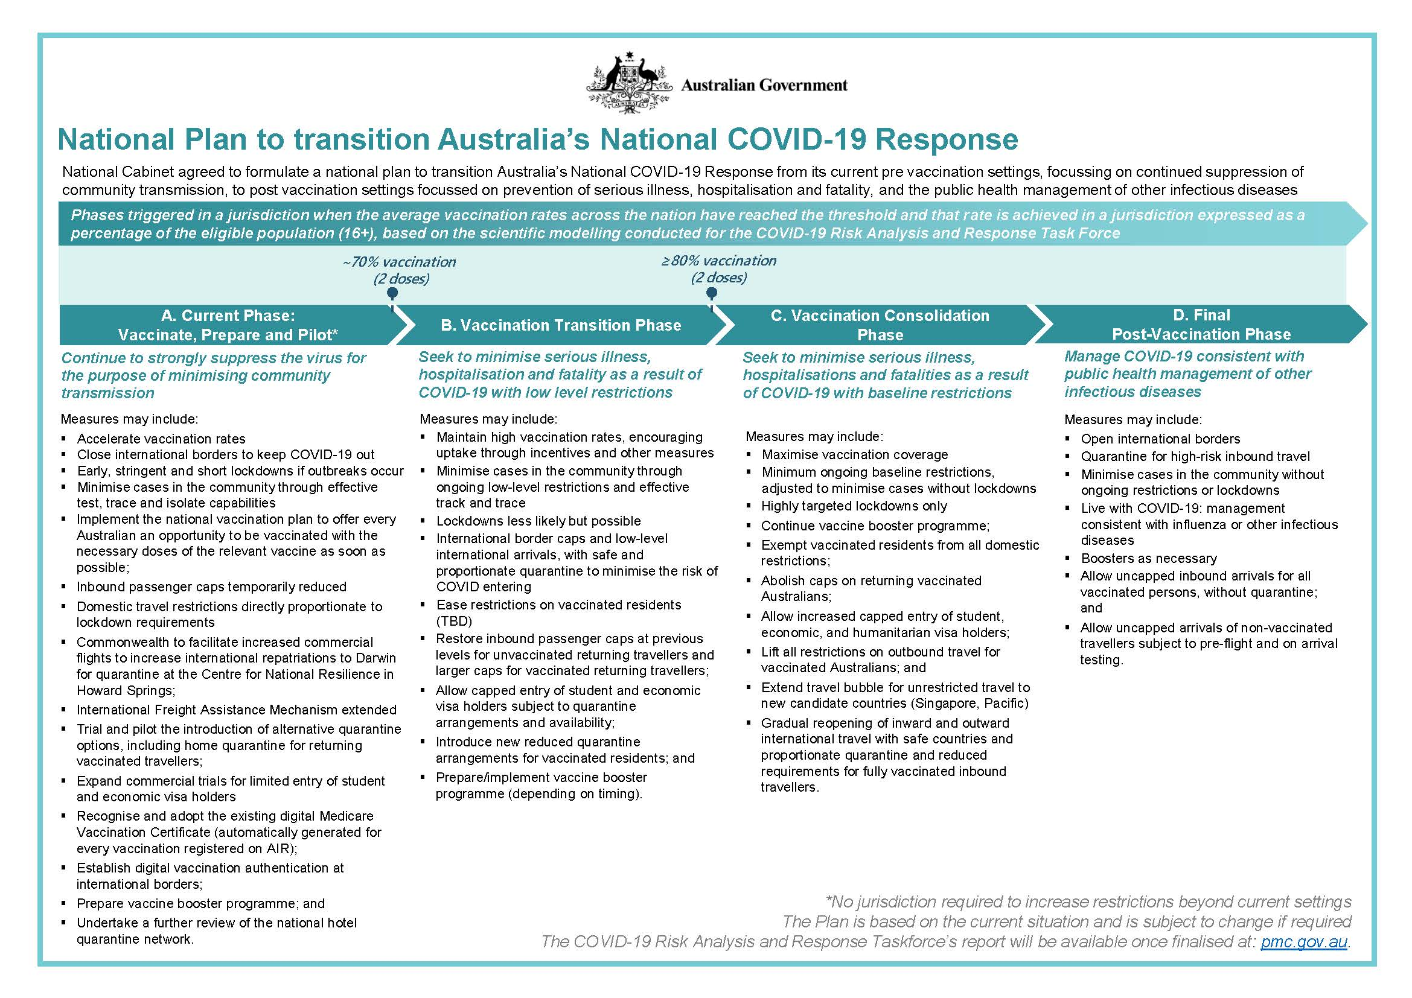

Attachment 4 Transmission events
As at 6 October 2021, 27 transmission events have been detected within mandatory quarantine facilities since the start of pandemic. This count includes locally acquired cases with epidemiological and genomic evidence to support transmission within the quarantine facility. This requires evidence of transmission from a returned traveller in a quarantine facility to another returned traveller in the same facility and/or a person who worked within the same quarantine facility at the same time as the case.
Event no. | State | Month and year | Variant of Concern (Yes/ No) | Detection and investigation |  | Lockdown |  | Extent of community transmission | Locally acquired cases in the community
 |  |  |  | First locally acquired case notified | Investigation findings | Area of lockdown | Period of lockdown (days)
1 | WA | Apr-20 | No | Quarantine worker | Breaches identified | N/A | - | Quarantine worker | -
2 | WA | May-20 | No | Quarantine worker | Breaches identified | N/A | - | Household of quarantine worker | -
3 | VIC | May-20 | No | Quarantine worker | Breaches identified | Hotspots then Metro Melbourne & Shire of Mitchell | 112 | Wider community | Second wave Vic
4 | VIC | Jun-20 | No | Quarantine worker | No breaches identified |  |  | Wider community | Second wave Vic
5 | NSW | Jul-20 | No | Returned traveller post quarantine | Unclear if acquired overseas or in hotel | N/A | - | Household of released traveller | -
6 | NSW | Aug-20 | No | Quarantine worker | No transmission route identified | N/A | - | Quarantine worker | -
7 | SA | Nov-20 | No | Household contact of quarantine worker | No transmission route identified | South Australia | 4 | Wider community | 31
8 | NSW | Dec-20 | No | Quarantine worker | - | N/A | - | Quarantine worker | -
9 | QLD | Jan-21 | Yes | Returned traveller in quarantine | No transmission route identified | Greater Brisbane | 3 | Household of released traveller | -
10 | VIC | Jan-21 | Yes | Returned traveller in quarantine | Hypothesised transmission during swabbing | N/A | - | No community cases | -
11 | VIC | Feb-21 | Yes | Quarantine worker | No transmission route identified | N/A | - | Quarantine worker | -
12 | WA | Jan-21 | Yes | Quarantine worker | Yes | Perth, Peel and South West | 5 | Quarantine worker | -
13 | VIC | Feb-21 | Yes | Quarantine worker | Nebuliser use | Victoria | 5 | Wider community | 21
14 | QLD | Mar-21 | Yes | Traveller in quarantine | No transmission route identified | Greater Brisbane | 3 | No community cases | -

Event no. | State | Month and year | Variant of Concern (Yes/ No) | Detection and investigation |  | Lockdown |  | Extent of community transmission
 |  |  |  | First locally acquired case notified | Investigation findings | Area of lockdown | Period of lockdown (days) |  | Locally acquired cases in the community
15 | NSW | Mar-21 | Yes | Quarantine worker | No transmission route identified | N/A | - | Quarantine worker | -
16 | WA | Apr-21 | Yes | Traveller in quarantine | No transmission route identified | Perth and Peel | 3 | Wider community | -
17 | NSW | Apr-21 | Yes | Traveller in quarantine | No transmission route identified | N/A | - | No community cases | -
18 | NSW | Apr-21 | Yes | Traveller in quarantine | No transmission route identified | N/A | - | No community cases | -
19 | WA | May-21 | No | Quarantine worker | No transmission route identified | N/A | - | Household of quarantine worker | -
20 | SA | May-21 | Yes | Returned traveller post quarantine | No transmission route identified | Vic and Greater Melbourne | 7 + 7 | Wider community | 94
21 | WA | Jun-21 | No | Returned traveller in quarantine | No transmission route identified | N/A | - | No community cases | -
22 | QLD | Jun-21 | Yes | Returned traveller post quarantine | Fomite Transmission | N/A | - | Wider community | 29
23 | QLD | Jun-21 | Yes | Returned traveller in quarantine | No transmission route identified | N/A | - | No community cases | -
24 | QLD | Jun-21 | Yes | Domestic traveller post quarantine | No transmission route identified | Greater Darwin, Alice Springs | Darwin - 5  Alice - 2 | Wider community | 19
25 | QLD | Jul-21 | Yes | Returned traveller post quarantine | No transmission route identified | N/A | - | Returned traveller detected in community | None yet identified - currently an active event
26 | NSW | Aug-21 |  | Traveller in quarantine | Under Investigation | N/A | - | - | None yet identified - currently an active event
27 | NSW | Sep-21 | Yes | Hotel security | Under investigation | N/A | - | No community cases | None yet identified – currently an active event
The transmission events in quarantine facilities resulted in varying extents of community transmission:
- Eight transmission events resulted in wider community transmission. These events often led to jurisdiction lockdowns. The outbreak in Victoria in mid-2020 was the result of two separate quarantine incursion events within a short period, prior to the program being reset under CQV;
- Six events involved no community transmission, as cases were limited to returned travellers in other hotel rooms and detected whilst still in quarantine; and
- Several events are still under investigation at the time of data collection.
For most events, no transmission route has been identified. The transmission events may have resulted from factors, or a combination of factors, including breaches in infection control practices and airflow, which may create an environment where there is potential for transmission.
This is despite extensive reviews into individual transmission events. For instance, the review team has reviewed documents that show how one jurisdiction conducts extensive reviews of transmission events to include a forensic/infection control investigation as well as a public health investigation. Forensic investigations include extensive review of closed circuit television (CCTV) footage while public health investigations include extensive testing of staff as well as urgent whole genome sequencing.
In some of these reviews, even where transmission appears to have occurred from specific individuals to one security guard and CCTV footage is reviewed thoroughly to review any potential interaction, reviews can only result in possible hypotheses regarding fomite transmission or an unreported opportunity for droplet or aerosol spread.
It is noteworthy that no transmission events have occurred in the Northern Territory’s Howard Springs facility, which provides accommodation in a non-hotel setting. Additionally, no transmission events have been detected stemming from home quarantine arrangements in the ACT, or any Special Health Accommodation in NSW, or from Tasmania’s hotel or home quarantine program.
Continuous improvements in quarantine have been made by jurisdictions with learnings from the extensive investigations into each transmission event.

Attachment 5 Ventilation and airflow
Since the first review, public health experts have gained significant experience in managing COVID-19 transmission. Based on that experience, governments and health authorities now acknowledge that while the virus spreads mainly between people in close contact and typically within one meter of each other (short-range), the virus can also remain suspended in the air and/or travel further than one metre (long-range). This is very relevant where areas are poorly ventilated and/or there are crowded indoor settings, where people tend to spend longer periods of time.
Recognising these later types of spread of COVID-19 (i.e. long-range), there has been a growing emphasis on ensuring appropriate room ventilation of potentially infected individuals. Decontamination of surfaces also remains important as people may also become infected by touching surfaces that have been contaminated (e.g. from doors or surfaces in hotel corridors) and then when touching their eyes, nose or mouth without cleaning their hands.
In several reviews conducted on quarantine arrangements in Australia, recommendations have focussed on ventilation and airflow considerations. This includes the Review of Management of Variants of Concern of COVID-19 in Hotel Quarantine Settings in Victoria. It also includes Western Australia’s Ventilation review of quarantine hotels, published on 28 April 2021. This review noted that ‘[i]deally accommodation rooms should be negative/neutral pressure to corridors to assist in containment of small droplets and aerosols within rooms.’
The AHPPC’s National Principles for Managed Quarantine outline that site selection should incorporate an environmental assessment of quarantine facilities, with consideration of airflow and ventilation, and introduction of additional controls to mitigate risk where relevant.
A basic principle that reduces the spread of viruses via air is to have rooms housing people potentially infected at negative pressure compared to corridors. The minimum turnover of fresh outside air per hour and the use of HEPA filters on air that is recirculated have also been examined.
Many jurisdictions have improved ventilation to minimise the indoor transmission of the virus. Tasmania, Victoria and Western Australia have all gone through a process to assess airflow and ventilation in each of their hotels used for quarantine. Where hotels have not met requirements, they have been discontinued from quarantine programs or mitigation strategies have been applied to optimise the facility.
There are variations in the mitigation strategies applied with regard to room spacing and keeping rooms at negative pressure. Victoria’s ventilation requirements require hotel rooms to be at negative pressure compared to the corridor. Strategies to achieve this include heating, ventilation and air conditioning (HVAC) remedial works, in addition to limiting hotel rooms to those with no balconies and sealable and non-opening windows. Ventilation standards, once in place, are routinely monitored.
Western Australia’s ventilation standards also require any previously openable windows to be closed and secured, so as to maintain consistent negative pressure in rooms relative to corridors at all times. Rooms that are identified as positive pressure are not used.
Western Australia also employs a ‘zipper model’ in hotels, even for rooms that are negatively pressured to the corridors. This means that opposite rooms in a corridor are not occupied at the same time, which reduces the risk of cross corridor transmission. In addition, cohorts are separated by a buffer room, high-risk rooms are removed from the available stock (end of corridor, front of lift etc.), and interconnecting rooms are only used for members of the same family. The zipper model comes with a significant reduction in room availability.
Victoria does not require a zipper model as all rooms are tested to ensure they are at negative pressure. However, efforts are made to choreograph door opening to shared corridors to minimise the risk that any doors into guest rooms are open at the same time.
NSW, Tasmania and Queensland also look to achieve negative pressure in rooms, relative to corridors. These states allow balconies and operable windows. Tasmania and Queensland have strict instructions for guests to close balconies and windows before opening the entrance door to the corridor.
The different approaches may all represent viable strategies to mitigate transmission risks but more research related to these various standards would support a more nationally consistent approach that could improve outcomes.
All jurisdictions have made efforts to minimise staff access to hotel floors and rooms to reduce episodes of doors opening in order to reduce transmission risk. Efforts have also been made to reduce the risk of people being in hotel corridors at the same time. This is commonly achieved through CCTV. CCTV can assist in monitoring guests opening doors for delivering at the optimal time. It can also replace the need for a static security guard: rather, security guards can rove or be placed in the optimal position for ventilation.

Attachment 6 International experience
Countries have had markedly different experiences throughout the COVID-19 pandemic. Table 10 sets out case and fatality rates for select countries.
Table 10 – Comparison of cases and fatality rates at 8 September 2021
Country | Population (million) | Total Cases | Total Deaths | Deaths per million
Argentina | 45.6 | 5,215,332 | 112,962 | 2,477
Australia | 25.8 | 68,042 | 1,066 | 41
Brazil | 214.0 | 20,928,008 | 584,421 | 2,731
Canada | 38.1 | 1,537,294 | 27,164 | 714
Colombia | 51.3 | 4,923,197 | 125,427 | 2,447
France | 67.6 | 6,944,797 | 115,846 | 1,714.6
Germany | 83.9 | 4,044,777 | 92,463 | 1,102
India | 1393.4 | 33,139,981 | 441,749 | 317
Indonesia | 276.4 | 4,147,365 | 137,782 | 499
Israel | 8.8 | 1,139,887 | 7,261 | 826
Italy | 60.4 | 4,585,423 | 129,707 | 2,149
Japan | 126.1 | 1,606,710 | 16,561 | 131
New Zealand | 4.9 | 3,848 | 27 | 6
Philippines | 111.0 | 2,134,005 | 34,672 | 312
Russia | 145.9 | 6,964,595 | 186,224 | 1,276
Singapore | 5.9 | 69,582 | 56 | 9
South Africa | 60.0 | 2,836,773 | 84,152 | 1,402
South Korea | 51.3 | 267,470 | 2,343 | 46
Spain | 46.7 | 4,898,258 | 85,147 | 1,822
Thailand | 70.0 | 1,322,519 | 13,511 | 193
Turkey | 85.0 | 6,566,538 | 58,913 | 693
Ukraine | 43.5 | 2,404,585 | 57,472 | 1,322
United Kingdom | 68.2 | 7,127,630 | 133,999 | 1,965
United States | 332.9 | 40,456,711 | 652,657 | 1,960
Vietnam | 98.2 | 563,676 | 14,135 | 144
Source: Oxford Martin School, ‘Our World in Data’, data set retrieved 10 September 2021, available at: https://ourworldindata.org/covid-deaths

Approaches to quarantine
A wide variety of approaches to quarantine have been implemented internationally. Australia is part of a small group of countries that have used hotel quarantine measures since the early stages of the pandemic. Other countries using hotel quarantine include New Zealand, Singapore, China and South Korea.
Vaccination has had an impact on countries’ approaches to border control and quarantine. Some countries, including Iceland, have reopened their borders to all vaccinated travellers, regardless of country of origin. In contrast, Japan does not distinguish between vaccinated and unvaccinated travellers – 14 days of self-isolation is required for most travellers.
Comparison of these arrangements is difficult because each country has faced unique public health challenges based on their own operational environment. What is clear is that each system appears to have different strengths and weaknesses, and Australia has done extraordinarily well under any comparison.

Risk-based approaches
Some countries have adopted risk-based approaches to quarantine. At 16 September 2021, this includes Canada, which utilises managed quarantine in very limited circumstances. All travellers, regardless of citizenship and vaccination status, must make suitable plans for home quarantine within their own means. For a quarantine plan to be considered suitable, it must meet specific criteria: a place where the traveller can stay for 14 days or possibly longer; have access to the necessities of life without leaving quarantine; can avoid contact with others who they did not travel with; and have no visits from family or guests. The Canadian guidelines are clear that an individual cannot quarantine in ‘group living environments’. A questionnaire is available on a Canadian Government website to assist travellers to assess if their quarantine plan meets the suitability criteria.
If a traveller cannot quarantine at home, it is their responsibility to make alternative arrangements, which could include quarantining with family or friends or paid accommodation. Travellers may be directed to a federal designated quarantine facility, but these are a last resort for travellers who have no options of meeting quarantine requirements by other means.
Fully vaccinated travellers are likely to be exempt from quarantine in Canada, but are still required to submit a quarantine plan in the event they fail the on-arrival testing requirements. Final determination of vaccination status is made at the border, based on assessment of documents. At ports of arrival and border crossings, border services officers are operating randomised testing arrangements. Randomised testing includes on-arrival testing, but does not require that travellers wait for results – they are able to travel to their final destination, including taking connecting flights. Travellers may also receive a home test kit to complete within 24 hours of entering Canada.
In Canada, vaccinated travellers must upload proof of vaccination in an app, ArriveCAN, within 72 hours of their travel. Only vaccines approved by the Canadian Government are accepted for this purpose, being Pfizer, Moderna, AstraZeneca and Johnson & Johnson.
Norway has also applied a risk-based approach to quarantine. Fully vaccinated travellers and travellers who have recovered from COVID-19 in the prior 6 months who also reside in the European Union, the European Economic Area or the Schengen Area are able to enter Norway with a valid EU Digital COVID Certificate or a valid Norwegian, Swedish, or Danish COVID-19 certificate with a QR code. If a traveller enters Norway this way, there is no requirement to quarantine, undergo any tests, or register on arrival.
Norway ranks the risk profiles of different countries in colour-coded tiers. If a person resides in a green area (lowest risk) or a country in most of Europe, they can also enter Norway without having to quarantine or take a test before arrival, although they will need to take a mandatory test at the border. For this to apply, the traveller needs to have stayed in a green area for the last 10 days prior to entering Norway.
In Hong Kong, global risk is assessed through analysis of a range of data points, including the rolling average number of cases in the past 14 days, and consideration of variants of concern.
The data in the global risk assessment are then used to place countries in five risk classifications. These categories then affect management of critical hazard control points, including individual quarantine arrangements. Whether an individual is vaccinated also affects the quarantine they are required to undertake.
For example, travellers from the ‘highest risk’ countries must undergo compulsory quarantine for 21 days in a designated quarantine hotel, undergo six tests during compulsory quarantine, undertake self-monitoring in the subsequent seven days and undergo compulsory testing on the 26th day after arrival in Hong Kong. This stringent quarantine requirement appears to have led to limited availability in quarantine facilities and high charges; reportedly one package costs HK$57,300 (about $10,000 AUD).

No managed quarantine
Most countries, including the United States and the majority of nations comprising the European Union, have not implemented a managed quarantine system as part of their pandemic response.
Instead, the United States has suspended entry and transit of non-citizens from certain COVID-19-affected countries. The United States also applies testing regimes, including pre-departure testing requirements. Additionally, the Centers for Disease Control and Prevention (CDC) recommend that unvaccinated individuals travelling to the United States from overseas are tested within three to five days of arrival and stay home for seven days post-travel. If they do not get tested, the recommendation is that they self-isolate for ten days. Self-isolation compliance is not monitored.

Attachment 7 AHPPC statements on quarantine to 16 September 2021
Quarantine principles
- 26 June 2020 – statement on hotel quarantine
  - Recommended that all international travellers continue to undertake 14 days quarantine in a supervised hotel.
  - Recommended that jurisdictions improve testing arrangements during hotel quarantine.
  - Acknowledged that hotel quarantine may not be sustainable in the long-term.

- 24 December 2020 – statement on Australia’s National Hotel Quarantine Principles
  - Provided nationally agreed guiding principles to set benchmarks for hotel quarantine programs.
  - The first version of the principles was based on the key findings of the first Halton review, the Finkel review and the Victorian COVID-19 Hotel Quarantine Inquiry.

- 7 June 2021 – statement on National Principles for Managed Quarantine
  - Encouraged all quarantine workers to be vaccinated and noted that jurisdictions may require vaccination.
  - Provided additional principles regarding governance: clear chains of command, cross agency coordination, mechanisms for escalation and enabling shared learnings.
  - Provided additional principles for IPC: comprehensive IPC training for all staff, minimising risk to all staff, fostering a culture of speaking up for safety.
  - Provided additional principles for site selection: environmental assessment, floor layout and wellbeing considerations.

- 7 July 2021 – statement on National Principles for Managed Quarantine
  - Updated principles to reflect statement of same date on testing travellers once they leave managed quarantine.

- 9 July 2021 – statement on National Principles for Infection Prevention and Control in Quarantine
  - Developed in consultation with ICEG to provide more comprehensive guidance on IPC practices in quarantine. Intended to complement national principles.
  - Provides detailed guiding principles on IPC matters including governance, PPE, airflow and ventilation, zoning facilities, and cleaning and disinfection.

- 2 September 2021 – statement on National Principles for Managed Quarantine
  - Updated to provide additional guidance on health, mental health and wellbeing of international arrivals and workers in quarantine programs.
Vaccination
- 29 June 2021 – statement on vaccinating and testing quarantine workers
  - Recommended mandatory vaccinations for all quarantine workers.
  - To be implemented under state and territory legislation.
Testing
- 29 June 2021 – statement on vaccinating and testing quarantine workers
  - Recommended daily testing requirements for all quarantine workers and those indirectly involved in quarantine.
  - To be implemented under state and territory legislation.

- 7 July 2021 – statement on testing travellers once they leave managed quarantine
  - Recommended all international travellers be tested on days 16 or 17 following quarantine, and whenever they have symptoms in the 14 days following quarantine.
  - To be implemented by states.
Cohorts
- 24 December 2020 - statement on mandatory quarantine for aircrew who are not local residents
  - Recommended mandatory 14 day managed quarantine for international aircrew. Prior to this, international air crew were eligible for exemptions and could quarantine at other locations including other hotels.

- 29 June 2021 – statement on minimising risk of transmission from high risk international travellers
  - Recommended accommodating domestic travellers separately from international travellers, ideally in different facilities.
  - This is to protect domestic travellers in quarantine from the higher risk of transmission from international travellers.
Alternative quarantine arrangements
- 9 July 2021 – statement on public health management of persons fully vaccinated against SARS-CoV-2
  - Recommended that modified quarantine arrangements involving a 14 day home quarantine period for vaccinated persons who have been in low/medium risk countries be used in a pilot.
  - Recommended risk stratification for selection to home quarantine.

Continuous improvement
- 14 April 2021 – statement on continuous learning in managed quarantine for international arrivals
  - Recommended a continuous improvement framework for quarantine, in line with National Hotel Quarantine Principles.
  - The framework includes checks, audits and reviews focusing on assuring compliance and regular review of managed quarantine by states.

Attachment 8 The costs of quarantine
In July 2020, the Prime Minister announced on behalf of the National Cabinet that states would move to towards a user-pays model for hotel quarantine.
At present, in all jurisdictions, most individuals and families contribute to the costs of their quarantine although this is only a portion of the total cost of providing quarantine.
Table 11 – Charging for quarantine by state
Jurisdiction | Cost
NSW, VIC,, SA, ACT | Travellers are charged $3,000 for one adult. Fees for additional occupants are:  - Additional adults in the same room or apartment: $1,000;  - Children under 18 years of age: $500 each; and  - Child under three years of age: no additional cost.
WA | Travellers are charged $2,520 for one adult. Fees for additional occupants are:  - Additional person (over six years of age) per room, per day: $60. This means that for two adults in one room, travellers are charged $3,360; and  - Child under six years of age: no additional cost.
QLD | Travellers are charged $3,220 for one adult. Fees for additional occupants are:  - Additional adults in the same room or apartment: $910;  - Children under 13 years of age: $455; and  - Child under three years of age: no additional cost.
TAS | Travellers are charged $2,800 for one adult. Fees for additional occupants are:  - Additional adults in the same room or apartment: $1,000;  - Children under 18 years of age: $500 each; and  - Child under three years of age: no additional cost.
NT | Travellers are charged $2,500 for one adult. A family rate of $5,000 applies for family groups of two or more people in shared accommodation.  People in mandatory supervised quarantine will also be subject to testing before exiting quarantine. If travellers refuse a test, they will be subject to an additional 10 days of quarantine at a cost of $1,750 for an individual or $3,500 for a family.

In most jurisdictions, costs are capped at 14 days. Travellers receive an invoice after their stay and are given 30 days to pay. Fee waivers and payment plans are available in all jurisdictions if travellers meet particular conditions.
Some states are facing issues with large volumes of unpaid quarantine bills. For example, the media reported in June 2021 that Queensland Health will engage private debt collectors to follow up unpaid invoices. At that time, only 44 per cent of approximately 30,000 invoices (worth a collective $87.7 million) had been paid either in full or in part, leaving over $52 million outstanding. Media reports have indicated that Revenue NSW figures from early 2021 showed debt recovery orders had been issued for 5,264 invoices covering 7,214 travellers.
Further, in February 2021, it was reported that the Victorian Government had yet to send an invoice to more than 16,000 returned travellers. This was due to delays in developing the systems required to support the hotel quarantine system in Victoria, which was overhauled in late 2020. The gaps included the billing system and finalising the processes for fee waivers and payment plans.
Table 11 does not set out the full cost to states and territories of an individual’s stay at a quarantine facility. Documents received by the review indicate that servicing one person in quarantine costs between $5,500 and $9,000 per person in some jurisdictions.
Media reporting indicates that the hotel quarantine system in Victoria cost $1.6 million per day between July 2020 and March 2021. In July 2020, the NSW Government indicated that it had spent $65 million in the first half of 2020 on quarantine accommodation.
The broader costs of quarantine go beyond the service costs of the facility. There are additional costs for the physical, regulatory, health and social infrastructure needed to maintain the hotel quarantine system, including nursing staff, hospital admissions, security, drivers, airport workers, policing costs and surge capacity within federal and state bureaucracies. For example, cost elements can include hotel contracts (including hotel staff, catering, and additional cleaning), quarantine workers, health-related contracts, transport and security and various infection prevention control initiatives.
In its submission to this review, Tourism Accommodation Australia (TAA), noted that its members (accommodation operators) are facing recruitment barriers to replace staff who exit the hotel quarantine programs. The TAA estimates that their industry lost half of its workforce during the pandemic. The submission also noted the costs associated with refurbishing rooms from a quarantine to a tourist standard, which will present upcoming challenges to the industry.

Attachment 9 Hierarchy of controls
The hierarchy of controls identifies the relative effectiveness of different measures to control the spread of viral infections (see Figure 27). The hierarchy of controls forms the basis for understanding Australia’s IPC framework.
Five components categorise the features of the hierarchy from most effective to least effective: elimination; substitution; engineering controls; administrative controls; and personal protective equipment.
Figure 27 – Hierarchy of controls
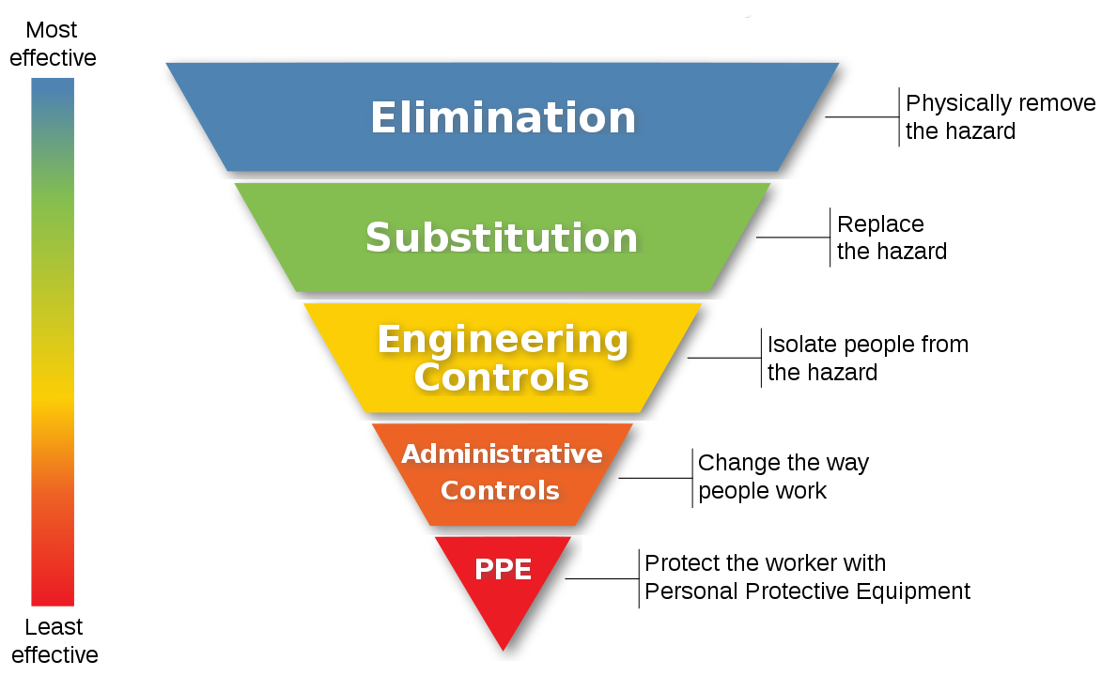
Source: United States Centers for Disease Control and Prevention and United States National Institute for Occupational Safety and Health
The Infection Control Expert Group (ICEG) provides guidance on how to use the hierarchy of controls to manage the risk of COVID-19 transmission. This includes guidance on applying the hierarchy of controls in health care, residential and quarantine settings. The ICEG advises the Australian Health Protection Principal Committee (AHPPC) and its other standing committees on infection prevention and control issues. Further information can be found on the Department of Health website.
All jurisdictions appear to implement some form of IPC framework based on the hierarchy of controls – seeking to eliminate risks where possible then working down the hierarchy of controls. The following diagram from South Australia shows how the hierarchy of control overlays the quarantine program in South Australia.

Figure 28 – Hierarchy of controls and the quarantine program in South Australia
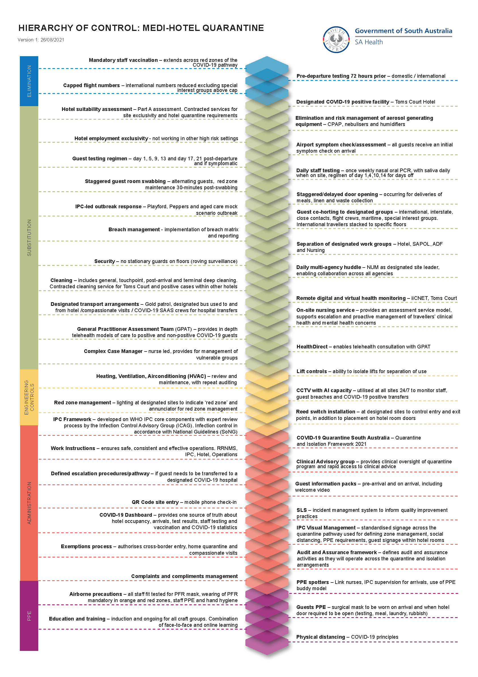

Attachment 10 Customer experience in quarantine

Figure 29 – International arrival journey through managed quarantine

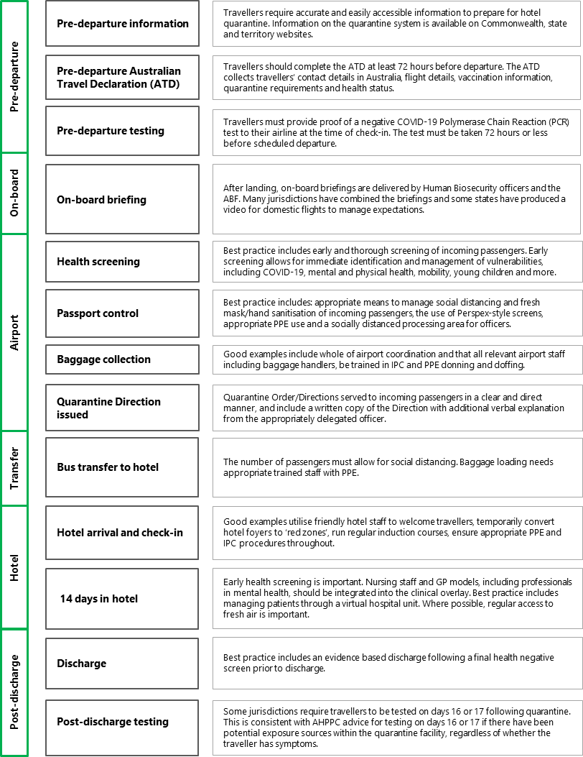

Customer surveys
This review has surveyed a number of people who have undertaken quarantine in Australia, including in hotels in Sydney, the Gold Coast, Cairns and the Centre for National Resilience (Howard Springs) in the Northern Territory. Feedback to the review indicates that while the quarantine experience is challenging, the conditions are acceptable.
In relation to information about quarantine, participants reported difficulty in understanding pre-arrival and quarantine requirements, as well as entry and exit exemptions. There was also some confusion about the similarities and differences in requirements between states. Most individuals indicated that they sought information about quarantine from friends, family and social media and not government websites, as these were not particularly accessible or comprehensive. Lack of targeted information for particular cohorts, including family groups, was highlighted.
The review also heard that some individuals found meeting Australia’s pre-departure PCR testing requirements a stressful process, as it was difficult to be confident that test results would be confirmed in time for travel.
Some participants expressed concern about infection prevention and control in the transit process from port of arrival to quarantine location. For example, some individuals explained that they were not appropriately distanced from other travellers or members of the public in the arrival terminal. Others were concerned that the health and law enforcement personnel that met and marshalled passengers on arrival were not wearing adequate PPE.
Individuals that had access to a balcony or openable window highlighted the benefit of fresh air during their quarantine period. Those that did not have access to fresh air suggested that this may have improved their wellbeing.
Beyond access to fresh air, most participants indicated that the health support (including mental health) provided during quarantine was adequate. It was widely reported that information relating to health and wellbeing support was provided at the outset of quarantine by authorities at the facility, and that this was supplemented with regular ‘check in’ calls during the quarantine period. Most individuals also acknowledged that they were satisfied with the quality of their accommodation and food quality.
Finally, most participants indicated that at the time of their arrival in Australia, they had a suitable location to undertake quarantine at home and that this would have been their preferred option. Some participants expressed frustration that they were not able to quarantine at home despite their fully vaccinated status and access to an appropriate space to quarantine at home.

Complaints to the Human Rights Commission & Commonwealth Ombudsman
Through consultation with the Australian Human Rights Commission (HRC) and the Commonwealth Ombudsman, this review has sought details regarding customer complaints about the quarantine experience. In the 2020-21 reporting period, the HRC received six complaints relating to hotel quarantine. The complaints relate to denial of exemptions from hotel quarantine, inappropriate facilities for people with physical disabilities, psychological disabilities not being accommodated, the requirement to wear masks and the requirement to undergo COVID-19 testing.
It is worth noting that the HRC received 855 complaints related to COVID-19 more generally during the 2020-21 reporting period. The majority of these were made under the Disability Discrimination Act 1992 and the Australian Human Rights Commission Act 1986 (AHRC Act). The most prevalent COVID-19-related complaints are concerned with mask wearing, vaccination and travel. The significant majority of complaints made under the AHRC Act related to travel caps on returning citizens and permanent residents, and travel bans on citizens and permanent residents in Australia.
Since the introduction of mandatory hotel quarantine in March 2020, the Commonwealth Ombudsman has registered 30 complaints. 17 of these were registered in 2021. Complaints related to quarantine conditions, including suitability for individuals with young children and mental health conditions, as well as quality of accommodation and treatment by staff. Complaints also related to concerns around the cost of quarantine for individuals and mandatory quarantine as a policy, including suggestion that fully vaccinated customers should not be required to undertake managed quarantine. These complaints are distinct from complaints made to state and territory ombudsmen and those made specifically against police.
Publicly available material suggests that a large volume of quarantine-related complaints have also been lodged with state and territory ombudsmen. For example, the NSW Ombudsman tabled a special report on COVID-19-related complaints in NSW Parliament in March 2021. The report indicated that of the 913 pandemic-related complaints made to the Ombudsman between January 2020 and January 2021, more than 500 concerned NSW’s police managed hotel quarantine program. Issues most often raised in these complaints and inquiries included the condition and cleanliness of the hotel facilities, food options and quality and inadequate support services.

Customer mental health and wellbeing

Pre-travel and screening
The first review also suggested that psychological preparedness is material in a person’s ability to cope and recommended that information on the quarantine system should be provided to travellers prior to the experience. The Commonwealth Department of Health has published two online guides to assist returning travellers with preparing for quarantine. These include information on what to expect on arrival and during transit to the quarantine facility, what to pack and important contacts. They also include advice on how to manage the limited space, how to stay connected to community and how to maintain wellbeing.
All jurisdictions now complete a mental health assessment as part of an initial health screening, either at the port of arrival or at the quarantine location or both. For example, in Victoria, as part of the nurse screening in the baggage collection area for airport arrivals, a brief mental health history is taken to determine the most appropriate hotel or hospital triage pathway. Community residents who are accommodated in hotel quarantine are required to have an Integrated Intake Assessment and Triage Service (IIATS) assessment which includes an assessment of their suitability for hotel quarantine. Local Public health units also undertake an assessment prior to referral to IIATS. There is a further mental health screen within a customer’s first 12 – 18 hours in quarantine, which includes requesting information on historical and current mental health professional involvement, medication and hospitalisation. A resident can then be referred for further mental health assessment and escalation if required.

Ongoing monitoring
During the quarantine period, mental health supports must maintain a customer’s mental health and wellbeing and identify and address more serious mental health challenges if they emerge. The first review observed that good practice includes assertive in-reach and assessment that does not rely on the traveller seeking support, and making treatment available to hotel quarantine guests. The first review also recommended daily follow up to identify emerging or escalating psychological distress.
Regular health and welfare checks are now conducted in every jurisdiction. For example, in NSW, following an initial assessment in the first 24 hours of quarantine, a daily check is completed by nursing staff, including specialist mental health nurses where required. This is completed via telehealth. If required, a face-to-face assessment can be completed by medical staff or psychologists at each quarantine facility. Individuals identified as requiring increased mental health support will have a management plan implemented and if required, can be transferred to a quarantine location where a balcony or fresh air is available.

Activities and entertainment
Regular activities and entertainment support a structured day, and in turn positive mental health and wellbeing. Since the first review, some jurisdictions have made comprehensive programs available to guests. For example, Western Australia has trialled and is now implementing a 14-day wellbeing program designed by health professionals to occupy and stimulate guests through the provision of therapeutic activities and wellbeing education. Guests are encouraged to use the program as a guide to keeping mentally and physically active during their stay. The program includes an activity menu of exercise, board games and puzzles, craft and self-care packages.
Further, as part of its welcome pack, Victoria includes a wellbeing brochure and information on a 14-day program of daily activities for both adults and children. The activities program is online and includes virtual tours, story times, games and online puzzles. Activity packs for both adults and children are also placed in rooms. The Wellbeing Victoria program, which includes a series of yoga and mindfulness videos, is also available to customers. Customers can also hire exercise and fitness equipment.

Wellbeing needs of particular cohorts
The first review notes that in good practice operations, assessment for other vulnerabilities, including addiction and disability, is undertaken during the initial health screening or shortly afterwards. For alcohol, nicotine and/or other drug issues, treatment plans and necessary supports for addictions should be implemented early to alleviate increased anxiety associated with withdrawal symptoms from dependency. This is relevant to the clinical overlay in the hotel quarantine system.
Some jurisdictions have adopted such assessments in their initial screenings. For example, Tasmania has a standard operating procedure for the identification of vulnerable people on arrival to hotel quarantine. Clinical staff located within the red zone undertake an assessment for vulnerabilities. If there is an immediate clinical concern, a decision will be made by the Nurse Coordinator to undertake a comprehensive face-to-face nursing assessment. Nursing staff are responsible for determining a suitable assessment pathway for everyone in quarantine. This includes the determination of requirement for increased observation, assessment and visual checks on at-risk persons or those with increased care needs.
For non-English speaking individuals or individuals with limited English, most jurisdictions offer interpreter services in their quarantine systems. For example, in the Northern Territory, government policy and legislation requires Northern Territory Health to ensure that people who cannot speak or speak limited English have access to interpreting services when significant decisions are concerned and when essential information is being communicated. Guidelines published by the Northern Territory Government make clear that at the Centre for National Resilience in Howard Springs, all staff working with residents are responsible for informing residents of interpreter services and providing them with the opportunity to access these services. Any requirement for interpreting must be noted in the person’s clinical record. The guidelines also suggest strategies for staff to assess whether an interpreter is required and how to access on-site and phone interpreters.

Attachment 11 Testing arrangements
Testing for infection is a fundamental component of the COVID-19 public health response. An effective testing regime provides assurance that infected individuals are diagnosed and isolated, while they remain infectious. It helps the quarantine system identify and isolate those who are positive and allows those who are negative to carry out their activities, after their 14 days of quarantine.

Testing regimes
All jurisdictions have testing regimes in place for international arrivals. Current national guidelines state that at a minimum, testing should occur on day 0-2 and then on day 10-14 of hotel quarantine, with results to be received prior to release from quarantine. Exact arrangements depend on state and territory protocols, with a number of jurisdictions conducting tests at a higher frequency.
The main change in testing since the first review is implementation of additional testing of international travellers once they leave quarantine. This follows AHPPC advice that all international travellers should get tested at days 16 or 17 following quarantine, if there has been potential exposure within the quarantine facility, regardless of whether they have symptoms. This has presented some challenges, such as when an arrival travels to a different state or territory from where they completed quarantine.
Some jurisdictions have designed their testing regime to fit their own circumstances. For example, the ACT has moved to a bespoke program for special purpose government flights due to low numbers of passengers arriving and the ability to manage daily testing of a small number of guests. In addition to routine nasal swab testing conducted on day 1, days 5 to 7, and days 12 to 13, guests undertake a daily saliva test. The rationale is that increased surveillance of guests will lead to earlier detection of positive cases, which can lead to further testing and treatment of staff.
Testing protocols have detected a number of positive COVID-19 cases in quarantine. Figure 30 depicts arrivals and positive COVID-19 cases in Victorian quarantine facilities.
Figure 30 – Air arrivals and positive COVID-19 cases in Victorian quarantine facilities (weekly)
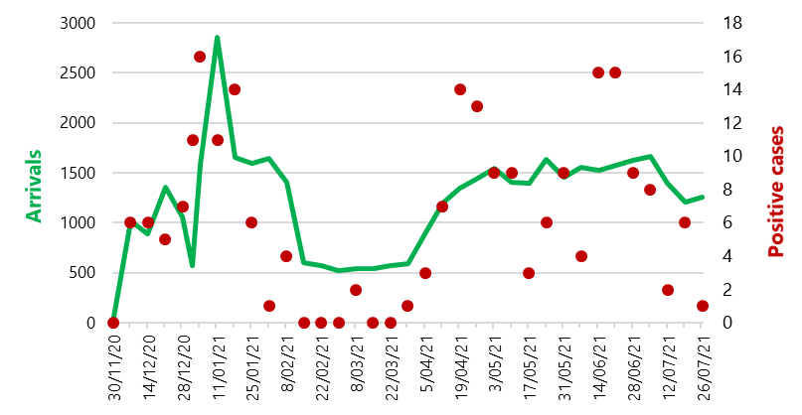
Source: Victorian Government - note: Green line represents air arrivals in Victoria and red markers represent number of positive cases

RT-PCR testing
The reverse transcription polymerase chain reaction (RT-PCR) diagnostic test is the current gold standard for confirming an acute SARS-CoV-2 infection in Australia and globally. It is the main testing modality used in quarantine. The RT-PCR test is highly sensitive and therefore used when there is a need to ensure that any testing accurately determines a person’s infection status and does not miss cases. In quarantine settings, RT-PCR testing is almost always performed in pathology laboratories. As a result, there is usually a minimum turnaround time of around six hours from time of collection before a result is available, but it is more often between 18 to 24 hours later.

Rapid antigen testing
Rapid antigen testing provides a means of diagnosing COVID-19 within 10-30 minutes. Rapid antigen testing is less sensitive to detecting COVID-19 compared with RT-PCR methods, especially in those without symptoms. In asymptomatic individuals, up to 50% of cases may be missed by rapid antigen tests. In those with symptoms, rapid antigen testing will likely still detect the virus in over 80% of cases and do so quicker than RT-PCR methods. This allows results to be available much more quickly at the collection site. Sensitivity can be increased by frequent and repeated testing of an individual, such as in a surveillance setting.
Another limitation of rapid antigen testing is that while the risk of false positivity is typically low, it will be more significant when the method is used to test populations with low COVID-19 prevalence. The impact of false positive results and how these are managed must be considered.
In some countries, rapid antigen testing kits are available over the counter and for purchase online, including home testing kits. The rapid turnaround and lower individual cost (compared to RT-PCR testing) means such approaches may prove useful in certain public health contexts and for screening purposes in high risk settings, and to better calibrate some risks.
While rapid antigen testing is yet to be widely used in Australia, it was announced in late September 2021 that at-home rapid antigen testing would be available from 1 November 2021, subject to individual tests being approved as safe and effective by the TGA. As at 28 September 2021, 33 tests have been approved by the TGA for use outside the home. It is anticipated that some of these will be approved for use in the home. Currently only a small number of rapid antigen tests included on the Australian Register of Therapeutic Goods (ARTG) are intended for use with saliva specimens. The majority are intended for use with a nasopharyngeal swab or for use with a nasal swab, and oropharyngeal swab. This may not be acceptable for frequent testing and would require repeat collection for confirmatory PCR testing.
The existing recommendation to use RT-PCR testing for confirmatory diagnostic testing with much higher sensitivity than rapid antigen testing is consistent with a suppression or elimination strategy as this will reduce the risk of positive cases being missed and so reduce the potential of leakage and community transmission. However, as the population is increasingly vaccinated and Australia enters into the others phases of the National Plan, opening up Australia’s borders further will require additional, faster and more efficient diagnostic techniques for identifying COVID-19 than just relying on PCR testing. This could include for initial screening during outbreaks, upon arrival at airports, clinics in remote locations, merchant and passenger ships, venues with high-transmission potential and screening within high-risk workplaces and quarantine facilities. However, it is important to note that a negative result on a rapid antigen test does not mean that a person does not have COVID-19. A negative rapid antigen test result suggests less infectious potential but does not exclude infectious potential.
For the quarantine system, the main applications of rapid antigen testing are likely to be as an initial screening tool for arrivals, during but not at the conclusion of home quarantine and for the regular screening of quarantine workers. Rapid antigen testing can work well as a screening tool when used frequently. Regular repeat testing of individuals improves collective sensitivity of this testing approach. Rapid antigen testing could also be incorporated into tiered testing regimes within the quarantine system in which high-risk individuals are subjected to more comprehensive and regular testing.
Rapid antigen testing played a role in the success of the Australian Olympic team’s travel to Tokyo in mid-2021. The team underwent quantitative salivary rapid antigen tests at the airport on arrival in Japan and then daily for their duration of stay in Japan. Athletes provided a saliva sample each day and test results were provided in about 30 minutes. This complemented use of rapid RT-PCR testing (described below) at the Australian Medical Headquarters in the Tokyo Olympic Village. These same rapid antigen tests have also been used by Japanese health authorities in community settings since August 2020 and in multiple European airports to screen individuals prior to air travel.

Rapid RT-PCR testing
Some jurisdictions are also using rapid RT-PCR or Nucleic Acid Amplification (NAA) point-of-care testing methods, which can yield results in 15 to 45 minutes. Rapid RT-PCR testing can be slightly less sensitive to detecting COVID-19 particularly if only one gene is used compared with laboratory-based RT-PCR testing where multiple genes are often looked for.
However, rapid RT-PCR testing has sensitivity close to laboratory-based RT-PCR testing. It has much higher sensitivity compared to rapid antigen testing. Rapid RT-PCR tests can be useful in particular circumstances where rapid results are needed but with a low probability that any positive case will be missed and where there may be logistical challenges with transporting samples from remote locations to laboratories.
Rapid RT-PCR testing is already a crucial part of NSW Health Pathology’s response to the pandemic. This mode of testing is conducted at 38 NSW Health Pathology laboratories and is used for high-risk, high-priority cases where an urgent diagnosis is needed. This includes the need to rapidly assess whether someone going to ICU is infected or not and can include the elderly, acutely unwell patients, those with pre-existing or chronic health conditions and some isolated communities depending on circumstances. Expanding use of rapid RT-PCR testing is an explicit part of NSW Health’s testing strategy going forward.
In-house rapid RT-PCR testing was used at the Australian Medical Headquarters in the Tokyo Olympic Village in mid-2021. This testing had a number of uses, including for screening Australian Olympic team members arriving in Tokyo from high-risk locations or those with confirmed or presumed exposure to COVID-19 in Tokyo.

Testing for COVID-19 in wastewater
Testing by RT-PCR methodology of on-board wastewater from lavatories on long-haul planes and ships could provide crucial warning about the presence of COVID-19 in inbound travellers. There is evidence that the virus is present in faecal matter very early in the infection in both symptomatic and asymptomatic individuals. Since early 2020, scientists at the Commonwealth Scientific and Industrial Research Organisation (CSIRO) have been working with airlines and transport companies to assess wastewater testing as a public health management tool. The results demonstrate that surveillance of wastewater from transport vessels with their own sanitation systems can be a complementary data source to assist in prioritising clinical testing and contact tracing among disembarking passengers.

New testing modalities
Testing technologies are advancing rapidly and numerous trials for different technologies are ongoing globally. Used as part of a comprehensive response strategy in Australia, these technologies may offer alternative efficient and complementary screening modalities in the future. More information on these emerging technologies can be found in the Commonwealth Department of Health’s Testing Framework for COVID-19 in Australia.

Testing of quarantine workers
Requirements around testing of quarantine workers differ across the jurisdictions. For example, in NSW, designated airport workers, quarantine workers and transportation providers must complete daily surveillance saliva testing when at work. If a non-negative surveillance test is returned, an urgent PCR test is completed.
In Victoria, all quarantine hotel workers must be tested on every day of on-site work. This includes one nasopharyngeal PCR testing per week and four saliva PCR testing per week in addition to temperature checks and attestations on entry. CQV frontline workforce are also encouraged to undertake voluntary testing on days off and remitted under the CQV Day-Off Voluntary Staff Testing Program.
In the Northern Territory, the testing regime for quarantine workers varies according to level of contact with individuals in quarantine, frequency of attendance at the quarantine facility and the nature of the staff member’s work. Those that are in daily or regular contact with individuals in quarantine are required to undertake a saliva PCR test every day they are at work with a nose and throat swab occurring every seven days.

Attachment 12 Other risk mitigations

Assurance mechanisms
The first review recommended that states embed end-to-end assurance mechanisms and look to continuously improve hotel quarantine to ensure that it is delivered consistent with good practice. This recommendation builds from an appreciation that transmission risks are present at every step of the quarantine journey and continuous monitoring and assurance measures are needed to ensure best practice in the quarantine system can mitigate these risks.
Since the first review, these mitigation processes have become even more important in line with the increased transmissibility of the Delta variant. In response, states have implemented several upgrades to their quarantine system to set up appropriate end-to-end assurance mechanisms.
Several jurisdictions, including Queensland, have publicly reported on transmission events from quarantine. Some of these reports relate to specific events whereas others relate to more general issues within quarantine. Other jurisdictions internally report on breaches of protocol that could result in a transmission event. Some jurisdictions, such as Victoria, conduct root-cause analysis of incidents. This approach defines the problem, determines root causes and then implements necessary solutions.

Regular audits
Site visits and audits provide assurance that staff are following all protocols. The review team has seen significant amounts of evidence that states are regularly conducting these visits and audits. These audits are conducted in line with agreed audit guidelines that have been agreed across agencies within individual jurisdictions. These include checklists – sometimes very detailed checklists – that relate to specific issues such as Infection Prevention and Control that include specific performance metrics (e.g. 100% of cleaning staff have been trained in PPE and optimal cleaning protocols).

Non-compliance with protocol
A well-functioning quarantine system should identify all instances of non-compliance with protocols, no matter how minor the non-compliance may seem. This will lead to a high number of reported incidents.
In one jurisdiction, in early 2021, breach reporting was streamlined and provided to a central area. This saw reports of non-compliance with protocol increase from 8 in February 2021 to 211 in July 2021. However, these significant numbers are not evidence of poor practice – instead they reflect a low reporting threshold and a positive reporting culture.
While the review team has not been able to verify all instances of breaches, this data appears to reflect much-improved reporting rather than more instances of non-compliance. For example, it includes instances where a guest has opened their door while not wearing a face mask while a security guard is in the corridor in full PPE more than five meters away.

Infection Prevention and Control
As noted in the first review, good hotel quarantine practice incorporates proper IPC practice throughout the entire process and at appropriate levels for the risks associated with each environment.
Since the first review, strong IPC practices are noted across all jurisdictions. This is especially important in the context of the highly transmissible Delta variant. Best practice IPC treats every traveller as if they have COVID-19 to prevent transmission.
At a national level, the AHPPC developed National Principles for Infection Prevention and Control in Quarantine. These were developed after considering reviews into managed quarantine and the causes of SARS-CoV-2 transmission events. The principles provide a basis to strive for national consistency across IPC aspects including PPE, airflow and ventilation, and managing high-risk individuals.
All jurisdictions now have IPC policies and frameworks for their quarantine systems and these appear to be supported by comprehensive IPC training and assurance mechanisms. Some jurisdictions also demonstrate additional monitoring of quarantine operations, including through audits and assurance processes conducted by external experts.
A number of jurisdictions are taking additional precautions to reduce the risk of transmission between staff. In addition to vaccination and testing requirements, some jurisdictions, including Western Australia, have implemented requirements for staff to work at a single quarantine site only.
Good IPC practices demonstrate several layers of information that can be accessed by staff. For example, NSW have a COVID-19 Infection Prevention and Control Manual for acute and non-acute healthcare settings that is over 200 pages long. This is then given more specificity with a 40-page manual that is specific to IPC in hotel quarantine settings. This guide includes simple diagrams to support staff working on hotel quarantine to understand their IPC requirements, including donning and doffing PPE. Then, this guide is supported by additional posters about mask wearing and PPE including eye protection.

End-to-end improvement
Good practice within quarantine systems considers the whole quarantine journey and seeks to mitigate risks at every step of the journey.
For example, jurisdictions such as NSW have implemented public health orders that apply to flight crew members and those who provide transportation services to international passengers or crew.
These public health orders are then backed up by guidelines to provide specific instructions to transportation providers. NSW also require transportation to be provided from a list of approved transport providers. This requirement has been in place since 28 June 2021. This is beneficial in that it ensures authorities can check that registered drivers have complied with requirements such as saliva testing and wearing correct PPE.
With the introduction of green zone flights between Australia and New Zealand, green and red zones have been created at international airports to ensure separation of passengers. To reduce transmission risk, air travellers arriving in Australia are processed through a red zone if they require quarantine or a green zone if they arrived on a quarantine-free flight. Red zone processing areas include physical barriers to protect staff and travellers, the use of appropriate PPE by staff, procedures around the handling of luggage, physical distancing measures and the strict marshalling of passengers through the building. Passengers are also usually required to undergo health screening in the terminal.
Thus far, green zone passengers have only included New Zealand arrivals, though this arrangement has been suspended due to ongoing COVID-19 outbreaks. As Australia progresses through the phases of the National Plan, it is anticipated that more countries will be listed as green zones and more passengers will be processed through green zones in airports. Ultimately, it is possible that as we move through the phases of the National Plan, all travellers will be processed through green zones unless there are specific increased risks coming from unvaccinated travellers from countries that have transmission of new COVID-19 variants of concern.

Attachment 13 Remote monitoring

Wearable technology
‘Wearable’ technologies include activity tracers, smartwatches and purpose-built devices. These technologies can support quarantine compliance by monitoring the movements of quarantined individuals and can also be employed for monitoring symptoms of COVID-19 infection. For example, Hong Kong has made use of a wrist band that connects to a smart phone device. The wrist band captures real-time GPS data on movements and monitors physiological data, including temperature, pulse, sleep and other vital signals to identify signs of COVID-19 in quarantined patients.
In a pilot scheme in north-west London, wearables collected vital signs of quarantining individuals before or after travelling abroad so medical staff could monitor whether they needed to be transferred to hospital.
Additionally, the Abu Dhabi Government in the United Arab Emirates is using electronic wristbands to monitor isolation of high-risk travellers. The device serves as a tracing and monitoring tool and is linked to the COVID-19 testing and tracing app, Al Hosn. The device is used to identify and track the geographical location of individuals in self-isolation. The wrist band is applied at Abu Dhabi International Airport on arrival, or at the Dubai-Abu Dhabi border if arriving from Dubai International Airport.

Mobile phones
Other forms of technology beyond wearables can also support quarantine compliance. This includes a range of new technologies. In some Australian jurisdictions, such as Western Australia and the Northern Territory, phone apps are already in use to conduct remote checks on people in quarantine. Both these jurisdictions use the G2G Now app, which is a tool that helps people subject to a quarantine or isolation direction show their compliance quickly and easily by performing in-app check-ins.
The app works by asking individuals to take a photo to verify their identity when a check-in request is sent. Check-in requests are sent at different times of the day. Individuals then have five minutes to check in. If they do not check in, a second request will be sent and if they fail to check in, they will receive a call to confirm their whereabouts. Completing a daily health questionnaire and registering COVID-19 tests and results is also a requirement for using G2G Now in Western Australia.
To support compliance in the South Australian home quarantine trial, authorities are using a mobile phone app that includes a facial verification service, geolocation functionality and a live ID check. During the trial, individuals will be contacted at random and required to verify their location within 15 minutes. The app also includes functionality for daily symptom checking, testing scheduling and support for the provision of mental health and other non-COVID health supports.
As part of the trial, a number of controls will be included to mitigate home quarantine risks:
- restricting the trial to participants who have travelled from lower risk countries,
- requiring participants to be fully vaccinated,
- testing on arrival at the airport along with an increased testing regimen,
- dedicated transport from the airport to the house,
- quarantine premises located within one hour of a tertiary hospital,
- random in-person compliance checks,
- a statutory declaration of understanding the requirements of quarantine, and
- non-compliance attracting monetary fines and transfer to a standard hotel quarantine facility.
Other approaches are in use overseas. For example, Taiwan has a monitoring system ‘digital fence’ where mobile phone coverage is used to triangulate the location of an individual’s mobile phone. Venturing too far from home triggers an alert system, which calls and messages the customer to ascertain their whereabouts. Israel adopted similar technology based on the Taiwan example, but this was only implemented as a trial and it appears that the use of mobile-phone location data to enforce quarantine was suspended in Israel on account of privacy concerns.
Technological solutions can help support compliance but they cannot function as standalone measures – some level of physical and human interaction is necessary to support compliance with quarantine. For example, enforcement measures cannot be purely digital. Local police may always need to enforce quarantine arrangements even where compliance is monitored digitally.

Attachment 14 Vaccination certification and authentication
Processes to certify the vaccination status of all travellers are needed to accurately assess individual risk. A digital approach to vaccination certification that can be recognised internationally would smooth the way for efficient movement between Australia and overseas countries. The assessment of each incoming traveller will need to account for the reliability of the vaccination certification of each traveller. Reliable assessment of vaccination certification is vital to enable appropriate risk assessments of travellers. Australia will also need to be able to recognise some vaccinations administered overseas and others that are not currently approved by the TGA.
The Commonwealth Government has developed a vaccination certificate to be used for international travel that meets the new standard developed by the International Civil Aviation Organisation and endorsed by the World Health Organisation. The certificate will be able to be used for international travel by anyone who has their COVID-19 vaccination details uploaded into the Australian Immunisation Register.
The certificates will be Visible Digital Seals (a QR barcode) that have the same data integrity and interoperability as a passport chip and are designed to work in digital wallets such as the International Air Transport Association (IATA) TravelPass app. IATA is a trade association of 290 of the world’s airlines.
In April 2021, IATA launched the IATA Travel Pass, a phone app that allows users to store verified COVID-19 test and vaccine status information. It has been reported that a number of countries and airlines are already trialling different functions of the IATA Travel Pass. Qantas confirmed in July 2021 that it will work with IATA to roll out use of the Travel Pass when regular international flights resume.
Work is underway to consider how Australian border systems will process health credentials such as vaccination certificates. Currently, self-declared, unverified vaccination information is being captured in part via the Australia Travel Declaration. However, Australia will establish the Digital Passenger Declaration (DPD) that will replace the physical incoming passenger card and the Australian Travel Declaration. The DPD will assist in processing health credentials at the border. The DPD will be capable of the digital collection of health-related information and provide the capacity to share digitally-verified COVID-19 vaccination details of international travellers with state and territory public health authorities.
The treatment of internationally administered COVID-19 vaccines is still under consideration though the TGA now recognises Coronavac (Sinovac) and Covishield (AstraZeneca/Serum Institute of India).

Attachment 15 Establishing a risk-based framework

Stratified approach to quarantine
The World Health Organisation notes that all appropriate measures should be put in place to limit the transmission of SARS-CoV-2 associated with international travel while ‘recognizing that even comprehensive public health measures adapted to the local epidemiological context and capacities can mitigate the risk substantially but cannot yield “zero risk”’.
Risk management assesses both the probability and impact of an event. The potential impact of every COVID-19 transmission event is high – as any transmission leads to the possibility for significantly more transmission and community outbreaks that, in turn, lead to higher morbidity and mortality in the communities affected. The probability of a transmission event will vary depending on some factors that are external to the quarantine system (for example, numbers coming into the quarantine system) as well as many factors that are part of the quarantine system (discussed in part two of this report).

Risk assessments
The core of a risk-based framework to quarantine is assessing each individual for the risk of transmitting COVID-19 that they present. This transmission risk can be seen as the aggregate of risk factors at different levels: from risks due to individual characteristics such as vaccination status, risks associated with country of travel origin and transit, as well as risks associated with transport and the proposed quarantine facility.
Each risk factor needs to be assessed so that travellers can be streamed into the setting best suited to manage that risk, with those settings ranging from no quarantine to quarantine in a managed setting with the highest level of controls.
The review team considers a risk framework across three simple measures is appropriate at this time. The example framework at Figure 31 stratifies risk elements into two categories: as low (‘green’) or high (‘red’).
Figure 31 – Risk framework
Measure | Green | Red
New variants of concern or other relevant factors in country of origin | No | Yes
Vaccination status | TGA approved / recognised vaccine | Not vaccinated or not approved vaccination
Home quarantine suitability (including transport) | Suitable | Not suitable
Although there are some exceptions (such as for medical treatment), the starting point for the standard traveller being able to enter Australia is a negative COVID-19 test so this has not been factored into the risk framework.

Country risk assessments
On 13 October 2020, the Australian Health Protection Principal Committee (AHPPC) agreed that the likelihood of seeding inbound international travellers depends on the individual’s country of origin and their travel history. AHPPC also agreed that quarantine should be applied according to an assessment of this risk.
Country risk assessments are conducted by the Commonwealth Department of Health, drawing on advice from the Department of Foreign Affairs and Trade and publicly available information published by authorities in the relevant country and international organisations including the WHO. Inputs to these assessments for a given country currently fall under three key headings: spread of cases, ability to detect cases and ability to manage cases.
To evaluate spread of cases, the Department of Health examines thresholds for notification of cases and patterns of transmission in a country. To evaluate a country’s ability to detect cases, national preparedness, testing and laboratory capacity and evidence of under-ascertainment are investigated. Finally, to evaluate a country’s ability to manage cases, public health restrictions, contact tracing, quarantine arrangements and hospital capacity, amongst other things, are scrutinised.
The Department of Health’s assessments also survey factors beyond those headings, including a country’s vaccine use and vaccination rates, domestic and international border restrictions imposed in that country, and the quality of publicly available news and information. These factors are analysed cumulatively to produce a recommendation, namely whether a country is classified as low risk (‘green’), medium risk (‘amber’) or high risk (‘red’). The assessments are presented to the CDNA Jurisdictional Executive Group for technical review and endorsement of the analysis and the risk rating outcome prior to being submitted to the Commonwealth’s Chief Medical Officer for endorsement and signature.
Australia already implements border controls stemming from country risk assessments and reports. This includes the two-way quarantine-free travel arrangement with New Zealand.
Australia has also imposed additional travel restrictions on travellers from certain countries for periods of time. For example, on 30 April 2021, the Commonwealth Government issued a temporary ban on all travellers who had visited India (where the Delta variant was first identified) in the preceding 14 days. This determination was repealed on 15 May 2021.
The international landscape, including COVID-19 prevalence and vaccination uptake overseas, will influence how risk assessments are conducted in the future. The risk framework must be flexible to account for new variables, including new variants.
Consideration should be given to the development of a country ‘alert’ system that identifies ‘high’ or ‘extreme’ risk countries. This would include countries in which a new variant of concern had emerged or where there were particular and highly significant COVID-19 outbreaks. Travellers from these countries could be subject to increased testing and quarantine requirements or even, in extreme circumstances, of temporary travel suspensions.

Attachment 16 Cumulative effects of travel restrictions and quarantine requirements

Impacts on the economy
The economic costs of quarantine are significant. The economic costs of all public health measures, including lockdowns, are more substantial again. Various entities have published estimates of these costs. The Victorian Treasury estimated Victoria’s two-week lockdown over May to June 2021 cost around $100 million per day. In July 2021, NSW Treasury estimated the cost to the NSW economy of the NSW lockdowns that commenced in June 2021 to be approximately $1.3 billion per week.
Analysis commissioned by the Business Council of Australia and published in July 2021 showed that the lockdowns in NSW, Victoria and South Australia that were ongoing at that time were costing $2.8 billion per week and impacting 1.6 million workers.
The Australian Bureau of Statistics has traced the impact of COVID-19 on the Australian economy between March 2020 and March 2021. Key statistics include:
- In the March 2020 quarter, underemployment hit an historic high of 13.8%, or 1.8 million people working reduced or zero hours for economic reasons. In terms of decreases in payroll jobs, the accommodation and food services industry was the hardest hit with a 35 per cent drop;
- In the June 2020 quarter, GDP fell by a record 7 per cent, the second quarter in a row of falls. 2 in 3 businesses reported decreased revenue compared to the same time in 2019. The most impacted industries were education and training, accommodation and food services and information media and telecommunications;
- In July 2020, almost half of businesses in Australia reported a fall in revenue over the prior month; and
- In the September 2020 quarter, tourism jobs reached their lowest number since 2013, down 15% from December 2019.

Tourism and international students
COVID-19 has had an uneven impact on the Australian community. For example, the pandemic has adversely impacted the international tourism and education sectors. Griffith University academics have quantified that Australia’s closed border is costing the economy $36.5 million every day in these two sectors alone. The closure of our international borders to foreign tourists has a knock-on impact on other sectors, including the accommodation and food services sectors.
Figure 32 – Tourism consumption in current price over time
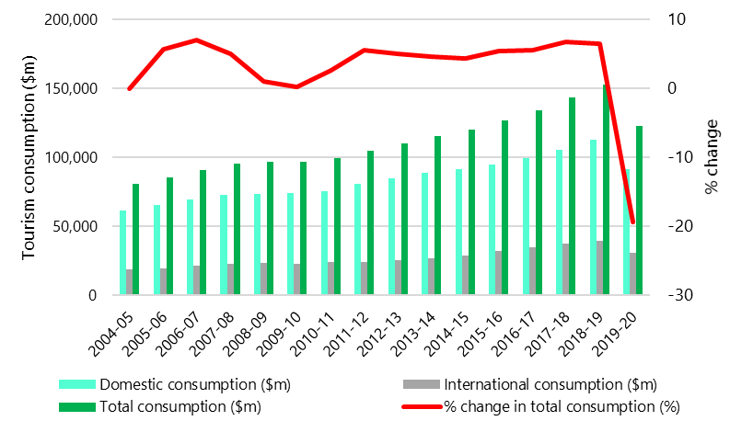
Source: Australian Bureau of Statistics Australian National Accounts: Tourism Satellite Account methodology, 2019-20 financial year

Impacts on society
In general terms, the pandemic has heightened risk factors commonly associated with poor social outcomes and community mental health. Quarantine, including the constraints of limited quarantine capacity, has added to this strain for many individuals and families.

Attachment 17 Vaccines
Vaccines are now widely accepted as the only means to protect large populations from infection. The efficacy of various vaccines suggests substantial relative risk reductions for all vaccines with approval from a reputable regulator. The ongoing roll-out of the COVID-19 pandemic vaccination program across Australia is a key part of minimising the risk of spread of COVID-19 and to keep the community safe.
The primary purpose of vaccination is to reduce the severe effects of a virus, including the likelihood of hospitalisation and death. The AstraZeneca-Oxford and Pfizer vaccines – the first two vaccines available in Australia – also reduce the likelihood of a vaccinated person infecting others, such as unvaccinated household members. Vaccination rates are critical to the success of the National Plan.
Vaccine hesitancy may constrain vaccination rates. In late July 2021, the Melbourne Institute Vaccine Hesitancy Report Card found that 12 per cent of Australian adults were unwilling to get vaccinated (down from 19 per cent in mid-May 2021). An ABS Survey from June 2021 found that the main reasons people may not get a vaccination were concerns related to potential side-effects and the effectiveness of the vaccine. These concerns should diminish over time, as the vaccine supply increases and more Australians are vaccinated with limited side-effects.
Vaccination rates and quarantine arrangements have impacts that flow both ways. Higher vaccination rates provide more potential to deploy risk-based modified quarantine. On the other hand, implementing differentiated quarantine arrangements may influence vaccination rates especially if vaccination is required to access less stringent quarantine arrangements.
COVID-19 vaccines authorized for use in Australia have all shown to have both efficacy and effectiveness against SARS-CoV-2 infections. Table 12 represents information compiled from a variety of studies on vaccine effectiveness, including vaccines that are not certified by the TGA.
Table 12 – Vaccine effectiveness – summary statistics
Vaccine | Against death | Against hospitalisation/ Severe disease | Against symptomatic infection | Against infection from COVID19 | Against infection from Delta VOC
AstraZeneca | Double dose: 100% | Double dose: 100%  Single dose: 92-94% | Double dose: 69-78%  Single dose: 50-68% | Single dose: 44% | Double dose: 60%  Single dose: 33-67%
Johnson & Johnson | - | - | - | Double dose: 77% | -
Moderna | - | Double dose: 92% | Single dose: 72% | Double dose: 86% | -
Pfizer/ BioNTech | Double dose: 91-100% | Double dose: 85-98%  Single dose: 85% | Double dose: 82-97%  Single dose:49-61% | Double dose: 63-95% | Double dose: 76%  Single dose: 72%
Sinovac | Double dose: 86-95% | Double dose: 86-91% | Double dose: 59% | Double dose: 60% | Double dose: 39-88%  Single dose: 33-56%
Sinopharm | - | - | Double dose: 90% | - | Double dose: 65.2%
Table adapted from aggregated information published in COVID-19 Weekly Vaccine updates produced on behalf of the Melbourne Children’s Campus at the University of Melbourne Medical School
Evidence about both the efficacy and effectiveness of vaccines against different strains of COVID-19 is still emerging. Given the possible emergence of new variants of concern, vaccine effectiveness needs to be assessed on a continuous basis. This monitoring process is complex and needs to account for a wide variety of regulator approvals, numerous studies and hundreds of vaccines. The World Health Organisation reports that 110 COVID-19 vaccines are in clinical development and a further 184 vaccines are in pre-clinical development.

Additional doses
On 23 September 2021, the Australian Technical Advisory Group on Immunisation (ATAGI) released a statement about the need for third and booster doses of COVID-19 vaccines. A third dose is an additional dose required as part of the primary course to reach an optimal level of protection. ATAGI anticipates that a relatively small cohort of individuals, such as those with severely immunocompromising conditions, are likely to require a third dose as part of their primary course of vaccination to ensure optimal vaccine effectiveness. ATAGI anticipates that additional booster doses for other populations may be required in the future.
Some countries, including the United States, have commenced making booster shots available for particular cohorts of vaccine recipients. In Israel, as of 1 October 2021, Israelis who received two vaccination doses six months ago but have not received a third will no longer be considered vaccinated for Green Pass purposes. The Green Pass grants vaccinated Israelis access to many public venues.
ATAGI is expecting to provide preliminary advice on the need and timing of additional doses in the broader population by the end of October 2021.

Throughout this report, ‘states’ is used synonymously with ‘jurisdictions’ and refers to all eight Australian states and territories.
Throughout this report, ‘public health direction’ refers to the range of statutory mechanisms used by states to impose requirements on all or part of the community.
Government of Western Australia ‘Review of Western Australia’s Hotel Quarantine Arrangements’, 26 February 2021, available at: https://www.wa.gov.au/government/announcements/review-of-western-australias-hotel-quarantine-arrangements
Victorian COVID-19 Hotel Quarantine Inquiry, ‘COVID-19 Hotel Quarantine Inquiry Final Report and Recommendations’, 21 December 2020, available at: https://www.quarantineinquiry.vic.gov.au/reports-0
Queensland Health and Queensland Police Service, ‘Joint Agency review of the COVID-19 infection of a hotel worker (Hotel Grand Chancellor)’, January 2021, available at: https://www.health.qld.gov.au/research-reports/reports/review-investigation/joint-qh-qps-review-covid-19-infection-hotel-grand-chancellor
Data provided by the Departments of Health and Australian Border Force.
Excluding air crew and flights from 19 April 2021 with New Zealand as a last port of call. Note that this does not represent exact numbers included in mandatory quarantine because, for example, it does not include exemptions provided by individual states.
Overseas acquired confirmed cases since 28 March 2020 as per notification received date. Excludes cases acquired at sea. The estimate represents overseas acquired confirmed cases that are linked to travel to Australia from international passenger air arrivals.
NSW Government, ‘COVID-19 (Coronavirus) statistics’, 5 September 2021, available at: https://www.health.nsw.gov.au/news/Pages/20210905_00.aspx
In part, this is likely to be explained by the increased transmissibility of the Delta variant.
A variant of concern means a variant of the virus SARS-CoV-2 that causes coronavirus disease 2019 (COVID-19) that is designated as a variant of concern if there is evidence of epidemiological, pathological or immunological features of concern. In Australia, variants of concern include the Delta, Kappa, Gamma, Beta and Alpha strains. See: Public Health Laboratory Network, ‘PHLN Statement on Reporting of SARS-COV-2 Variants of Concern and Interest’, 6 April 2021, available at: https://www.health.gov.au/sites/default/files/documents/2021/04/phln-statement-on-reporting-of-sars-cov-2-variants-of-concern-and-interest.pdf
This includes positive cases from both international arrivals as well as domestic quarantine.
This chart includes all air travellers, including crew and including travellers from New Zealand even when these travellers were not subject to mandatory quarantine.
Andrea Chai, ‘Australia’s closed border is costing the economy $36.5 million a day’, Griffith Asia Insights, 8 June 2021, available at: https://blogs.griffith.edu.au/asiainsights/australias-closed-border-is-costing-the-economy-36-5-million-a-day/
The ACT is one of the few jurisdictions with a large proportion of international arrivals undertaking home quarantine with 3051 between 1 March 2020 and 1 August 2021. A large proportion of these are diplomats and their families.
WHO, ‘Tracking SARS-CoV-2 variants’, retrieved 24 September 2021, available: https://www.who.int/en/activities/tracking-SARS-CoV-2-variants/
Ashley Hagen, ‘How Dangerous is the Delta Variant’, American Society for Microbiology, 30 July 2021, available: https://asm.org/Articles/2021/July/How-Dangerous-is-the-Delta-Variant-B-1-617-2
Government of the United Kingdom, ‘SPI-M-O Consensus Statement on COVID-19’, 2 June 2021, available:https://assets.publishing.service.gov.uk/government/uploads/system/uploads/attachment_data/file/993321/S1267_SPI-M-O_Consensus_Statement.pdf
Ashley Hagen, ‘How Dangerous is the Delta Variant’, American Society for Microbiology, 30 July 2021, available at: https://asm.org/Articles/2021/July/How-Dangerous-is-the-Delta-Variant-B-1-617-2
Emi Berry, ‘What we know about the SARS-CoV-2 Delta Variant’, UNSW Newsroom, 26 July 2021, available at: https://newsroom.unsw.edu.au/news/health/what-we-know-about-sars-cov-2-delta-variant
Zhang M, Xiao J, Deng A, Zhang Y, Zhuang Y, Hu T, et al. Transmission Dynamics of an Outbreak of the COVID-19 Delta Variant, Chinese Center for Disease Control and Prevention 2021: 3(27) available: http://weekly.chinacdc.cn/en/article/doi/10.46234/ccdcw2021.148.
Data download as at 3 September 2021, available at: https://covid19.who.int/info/
Data download as at 3 September 2021, available at: https://covid19.who.int/info/
Department of Health, COVID-19 Vaccine Roll-out, 10 October 2021, available at: https://www.health.gov.au/sites/default/files/documents/2021/10/covid-19-vaccine-rollout-update-10-october-2021.pdf
See for example, Lt Gen. Frewen testimony to the Senate Select Committee on COVID-19 on 28 September 2021, available at: https://parlinfo.aph.gov.au/parlInfo/download/committees/commsen/4b2c3ad5-0b12-4d32-b134-3a413c8ea8ef/toc_pdf/Senate%20Select%20Committee%20on%20COVID-19_2021_09_28_9144.pdf;fileType=application%2Fpdf#search=%22committees/commsen/4b2c3ad5-0b12-4d32-b134-3a413c8ea8ef/0000%22., The Guardian on 20 September, available at: https://www.health.gov.au/sites/default/files/documents/2021/09/covid-19-vaccine-rollout-update-29-september-2021.pdf and ABC news on 27 September 2021, available at: https://www.abc.net.au/news/2021-03-02/charting-australias-covid-vaccine-rollout/13197518#targets
Note this data is based on the total number of people who are fully vaccinated divided by the total population rather than the adult population and that the apparent spike in world vaccination rates in August 2021 relates to the inclusion of data from China.
Australian Bureau of Statistics, Population, https://www.abs.gov.au/statistics/people/population
Our World in Data, Share of the population fully vaccinated against COVID-19, https://ourworldindata.org/grapher/share-people-fully-vaccinated-covid?time=2020-12-27..2021-10-03
Covid-19 Data, COVID-19 in Australia, available: https://www.covid19data.com.au/
Vaccination status was self-reported by returning travellers and not verified.
While valuable modelling has been made available to the review team, the pandemic is changing rapidly and updated modelling, emerging real-world data and the experience of the home quarantine trials may provide additional insights on matters covered in this report.
For more information on the Burnet Institute’s COVID-19 modelling work, refer to a description of their ‘COVASIM’ model, available at: https://www.burnet.edu.au/projects/467_covasim_modelling_covid_19
Burnet Institute, 7 September 2021, available: https://www.burnet.edu.au/news/1506_initial_modelling_projections_for_second_epidemic_wave_in_sydney_nsw
Government of Australia, ‘National Plan to transition Australia’s National COVID-19 Response’, 30 July 2021, available at: https://www.pm.gov.au/sites/default/files/media/national-plan-to-transition-australias-national-covid-19-response-30-july-2021.pdf
Australian Department of Health, ‘AHPPC statement on national principles for managed quarantine’, 2 September 2021, available at: https://www.health.gov.au/news/ahppc-statement-on-national-principles-for-managed-quarantine-0
Australian Department of Health, ‘AHPPC statement on national principles for managed quarantine’, 2 September 2021, available at: https://www.health.gov.au/news/ahppc-statement-on-national-principles-for-managed-quarantine-0
Northern Territory Government, Centre for National Resilience Infection Prevention & Control SOP.
Victorian COVID-19 Hotel Quarantine Inquiry, ‘COVID-19 Hotel Quarantine Inquiry Final Report and Recommendations’, 21 December 2020, available at: https://www.quarantineinquiry.vic.gov.au/reports-0
AHPPC Statement on continuous learning in managed quarantine for international arrivals, 14 April 2021, https://www.health.gov.au/news/australian-health-protection-principal-committee-ahppc-statement-on-continuous-learning-in-managed-quarantine-for-international-arrivals
NSW Health, ‘Public health alert – COVID-19 case’, 16 June 2021, available at: https://www.health.nsw.gov.au/news/pages/20210616_01.aspx
Western Australia Department of Health, ‘Ventilation review of quarantine hotels, Summary Report’, April 2021, available at: https://www.wa.gov.au/sites/default/files/2021-04/2804-Ventilation-review-of-quarantine-hotels-Summary-report.pdf
Australian Department of Health, ‘Minister Hunt's Press Conference in Melbourne on 28 September 2021 with an update on the COVID-19 vaccination update, home testing from 1 November and child mental health support’, 28 September 2021, available at: https://www.health.gov.au/ministers/the-hon-greg-hunt-mp/media/minister-hunts-press-conference-in-melbourne-on-28-september-2021-with-an-update-on-the-covid-19-vaccination-update-home-testing-from-1-november-and-child-mental-health-support
Australian Department of Health, ‘Coronavirus Disease 2019’, available at: https://www1.health.gov.au/internet/main/publishing.nsf/Content/7A8654A8CB144F5FCA2584F8001F91E2/$File/COVID-19-SoNG-v4.7.pdf
Australian Department of Health, ‘AHPPC statement on testing travellers once they leave managed quarantine’, 7 July 2021, available at: https://www.health.gov.au/news/australian-health-protection-principal-committee-ahppc-statement-on-testing-travellers-once-they-leave-managed-quarantine
See for example: Joint agency review of the COVID-19 infection of a hotel worker (Hotel Grand Chancellor), 5 February 2021, available at: https://www.health.qld.gov.au/research-reports/reports/review-investigation/joint-qh-qps-review-covid-19-infection-hotel-grand-chancellor
Australian Department of Health, ‘AHPPC statement on national principles for infection prevention and control in quarantine’, 9 July 2021, available at: https://www.health.gov.au/news/australian-health-protection-principal-committee-ahppc-statement-on-national-principles-for-infection-prevention-and-control-in-quarantine
Queensland Government, Designated COVID-19 Hospital Network Direction (No. 3), available at: https://www.health.qld.gov.au/system-governance/legislation/cho-public-health-directions-under-expanded-public-health-act-powers/designated-covid-19-hospital-network-direction
Prime Minister of Australia Media Centre, ‘National Cabinet Statement’, 28 June 2021, available at: https://www.pm.gov.au/media/national-cabinet-statement-5
Fair Work Ombudsman, ‘COVID-19 vaccinations and the workplace’, retrieved 21 September 2021, available at: https://coronavirus.fairwork.gov.au/coronavirus-and-australian-workplace-laws/covid-19-vaccinations-and-the-workplace/covid-19-vaccinations-workplace-rights-and-obligations
Qantas Newsroom, ‘Qantas Group to require employees to be vaccinated against COVID-19’, 18 August 2021, available at: https://www.qantasnewsroom.com.au/media-releases/qantas-group-to-require-employees-to-be-vaccinated-against-covid-19/
WA Government, ‘Quarantine Centre Workers (Secondary Employment) Directions’, available at: https://www.wa.gov.au/government/publications/quarantine-centre-workers-secondary-employment-directions
Victoria Government, ‘Workplace (Additional Industry Obligations) Directions, available at: https://www.dhhs.vic.gov.au/victorias-restriction-levels-covid-19
NT Government, COVID-19 Directions (No. 12) 2021: Directions for Quarantine Workers, available at: https://coronavirus.nt.gov.au/__data/assets/pdf_file/0017/1019024/cho-directions-nr12-2021-directions-for-quarantine-workers.pdf
Victoria Government, ‘Workplace (Additional Industry Obligations) Directions, available at: https://www.dhhs.vic.gov.au/victorias-restriction-levels-covid-19
Government of Australia, ‘Stand-alone quarantine accommodation – key assessment criteria and health criteria’, available at: https://www.pm.gov.au/sites/default/files/files/commonwealth-key-assessment-criteria-quarantine-proposals.pdf
Each state provided separate information so that the time periods are different but the methodology used to collect this data and the specific exclusions is also likely to be different.
225,441 in police-managed hotels and a further 13,181 in Special Health Accommodation.
Victoria use a different methodology across two periods: 28 March – 31 July 2020 had 22,473 people that included international arrivals and frontline workers but excludes other community intakes accommodated over this period only, under various emergency accommodation programs. A different methodology was used from 1 August 2020 to 1 August 2021 in which 47,191 international and domestic individuals were quarantined.
Includes Howard Springs.
Australian Department of Health, ‘AHPPC Statement on hotel quarantine’, 26 June 2020, available at: https://www.health.gov.au/news/australian-health-protection-principal-committee-ahppc-statement-on-hotel-quarantine
Western Australia Government, ‘COVID-19 coronavirus: controlled border’, retrieved 10 September 2021, available at: https://www.wa.gov.au/organisation/covid-communications/covid-19-coronavirus-controlled-border#conditions-for-quarantine
Victoria Government, ‘Victorian travel permit system’, retrieved 10 September 2021, available at: https://www.coronavirus.vic.gov.au/victorian-travel-permit-system
Premier of Victoria, ‘Coronavirus restrictions to lift for regional Victoria’, 8 September 2021, available at: https://www.premier.vic.gov.au/coronavirus-restrictions-lift-regional-victoria-0
Premier of Victoria, ‘Pathway For Vaccinated Victorians To Come Back Home’, 23 September 2021, available at: https://www.premier.vic.gov.au/pathway-vaccinated-victorians-come-back-home
Use of Technology to Support Home Quarantine Direction, 11 September 2021, https://www.health.qld.gov.au/system-governance/legislation/cho-public-health-directions-under-expanded-public-health-act-powers/technology-support-home-quarantine-direction
Queensland Minister for Health and Ambulance Services, The Honourable Yvette D’Ath, 7 October 2021, available https://statements.qld.gov.au/statements/93440
Australian Department of Health, ‘Coronavirus (COVID-19) advice for international travellers’, retrieved 10 September 2021, available at: https://www.health.gov.au/news/health-alerts/novel-coronavirus-2019-ncov-health-alert/coronavirus-covid-19-travel-and-restrictions/coronavirus-covid-19-advice-for-international-travellers
Data provided by the Department of Home Affairs.
Australian Department of Health’ AHPPC statement on mandatory quarantine for aircrew who are not local residents’, 24 December 2020, available at: https://www.health.gov.au/news/australian-health-protection-principal-committee-ahppc-statement-on-mandatory-quarantine-for-aircrew-who-are-not-local-residents
NSW Health, ‘Quarantine and COVID-19 testing for international flight crew arriving in NSW’, 26 August 2021, available at: https://www.health.nsw.gov.au/Infectious/factsheets/Pages/quarantine-information-for-non-resident-flight-crew.aspx
Victorian Government, ‘Quarantine for international air crew’, retrieved 10 September 2021, available at: https://www.coronavirus.vic.gov.au/quarantine-international-aircrew
Queensland Government, ‘Quarantine and COVID-19 Testing for Air Crew’, retrieved 10 September 2021, available at: https://www.qld.gov.au/health/conditions/health-alerts/coronavirus-covid-19/current-status/public-health-directions/air-crew
NSW Health, ‘NSW Health air transportation guidelines’, retrieved 10 September 2021, available at: https://www.health.nsw.gov.au/Infectious/factsheets/Pages/air-transportation-guidelines.aspx#guidelines
Data provided by the Department of Home Affairs
Australian Department of Health, ‘Coronavirus (COVID-19) advice for international travellers’, retrieved 10 September 2021, available at: https://www.health.gov.au/news/health-alerts/novel-coronavirus-2019-ncov-health-alert/coronavirus-covid-19-travel-and-restrictions/coronavirus-covid-19-advice-for-international-travellers
Australian Government, ‘COVID-19 information for the maritime industry’, 12 February 2021, available at: https://www.health.gov.au/sites/default/files/documents/2021/02/coronavirus-covid-19-information-for-the-marine-industry.pdf
Australian Department of Foreign Affairs and Trade, ‘COVID-19 pandemic mandatory quarantine’, retrieved 10 September 2021, available at: https://www.dfat.gov.au/about-us/publications/corporate/protocol-guidelines/16-covid-19-pandemic-mandatory-quarantine
More information on Queensland’s requirements is available in Border Restrictions Direction (No. 47) under the Public Health Act 2005 (Qld) available at: https://www.health.qld.gov.au/system-governance/legislation/cho-public-health-directions-under-expanded-public-health-act-powers/border-restrictions
World Health Organization, ‘COVID-19 Dashboard’, retrieved 7 September 2021, available at: https://covid19.who.int/region/wpro/country/ws
QLD Government documents provided to this review.
QLD Government documents provided to this review.
Western Australia Government, ‘Seasonal worker flight for tourism hospitality’, 24 August 2021, available at: https://www.peel.wa.gov.au/seasonal-worker-flight-for-tourism-hospitality-24-august-2021/
Tasmanian Government, ‘Seasonal worker agreement extended with Victoria’, 7 September 2021, available at: http://www.premier.tas.gov.au/site_resources_2015/additional_releases/seasonal_worker_agreement_extended_with_victoria
Victorian Department of Health, ‘Review of Management of Variants of Concern of COVID-19 in Hotel Quarantine Settings’ (Chaired by Professor Allen Cheng), 12 March 2021, available at: https://www.vic.gov.au/sites/default/files/2021-03/Cheng-Review-Report-final.docx
QLD Government documents provided to this review.
Study International, ‘NSW pilot plan still on ice, says minister’, 29 July 2021, available at: https://www.studyinternational.com/news/nsw-pilot-schemes/
Stephanie Richards, ‘Overseas students on track for SA return as political leaders bicker’, InDaily, 28 July 2021, available at: https://indaily.com.au/news/2021/07/28/overseas-students-on-track-for-sa-return-as-political-leaders-bicker/
Victorian Government, International Student Arrivals Plan, 8 October 2021, available: https://www.coronavirus.vic.gov.au/international-student-arrivals-plan
Universities Australia submission to this review.
Department of Health, ‘Coronavirus (COVID-19) – Advice on mental health screening, assessment and support during COVID-19 quarantine’, 18 December 2020, available at: https://www.health.gov.au/resources/publications/coronavirus-covid-19-advice-on-mental-health-screening-assessment-and-support-during-covid-19-quarantine
Department of Health, COVID-19 vaccine rollout update – 10 October 2021, available at: https://www.health.gov.au/resources/publications/covid-19-vaccine-rollout-update-10-october-2021
Department of Health, Coronavirus (COVID-19) at a glance – 23 October 2020 https://www.health.gov.au/resources/publications/coronavirus-covid-19-at-a-glance-23-october-2020
Department of Health, Coronavirus (COVID-19) case numbers and statistics, available https://www.health.gov.au/news/health-alerts/novel-coronavirus-2019-ncov-health-alert/coronavirus-covid-19-case-numbers-and-statistics#total-covid19-cases-in-australia-by-source-of-infection
Ian Mackay (2020): The Swiss Cheese Respiratory Virus Defence. figshare. Figure. https://doi.org/10.6084/m9.figshare .13082618.v24
NSW Department of Health, COVID-19 in NSW - up to 8pm 3 October 2021, available at https://www.health.nsw.gov.au/Infectious/covid-19/Pages/stats-nsw.aspx accessed 5 October 2021.
Government of the United Kingdom, ‘Entering the UK’, accessed 8 October 2021, available at: https://www.gov.uk/uk-border-control
Department of Health: https://www.health.gov.au/news/health-alerts/novel-coronavirus-2019-ncov-health-alert/coronavirus-covid-19-restrictions/coronavirus-covid-19-advice-for-international-travellers/coronavirus-covid-19-faqs-international-travellers-to-australia
Department of Health: https://www.health.gov.au/initiatives-and-programs/covid-19-vaccines/getting-vaccinated-for-covid-19/why-should-i-get-vaccinated-for-covid-19
WHO: https://www.who.int/news-room/q-a-detail/coronavirus-disease-(covid-19)-vaccines?topicsurvey=v8kj13)&gclid=EAIaIQobChMIl8eVw-v_8gIVN51LBR2KFQX5EAAYASAAEgKex_D_BwE
Therapeutic Goods Administration : https://www.tga.gov.au/covid-19-vaccine-provisional-registrations
Therapeutic Goods Administration, TGA advice on recognition of COVID-19 vaccines not registered in Australia but used internationally, 1 October 2021, https://www.tga.gov.au/media-release/tga-advice-recognition-covid-19-vaccines-not-registered-australia-used-internationally
Therapeutic Goods Administration : https://www.tga.gov.au/list-countries-and-jurisdictions-determined-be-comparable-overseas-regulators-cors
Cheng, C., Zhang, D., Dang, D. et al, ‘The incubation period of COVID-19: a global meta-analysis of 53 studies and a Chinese observation study of 11 545 patients’ Infectious Diseases of Poverty 10, 119 (2021). https://doi.org/10.1186/s40249-021-00901-9
AHPPC, Statement on the utility of testing for COVID-19 to reduce the requirement for 14 days of quarantine, 16 May 2020, available: https://www.health.gov.au/news/australian-health-protection-principal-committee-ahppc-coronavirus-covid-19-statements-on-14-may-2020
Li, B. et al. Preprint at medRxiv, https://www.medrxiv.org/content/10.1101/2021.07.07.21260122v2
See for example: Burnet Institute, traQ Study: Transparent Risk Assessment of Quarantine, Final Report, November 2020, available here: https://burnet.edu.au/system/asset/file/4361/Final_Report_10November2020_Final.pdf
Doherty Institute, Interim Report on Work Package 3: Review border measures and arrivals pathways in context of revised risk tolerance, received by review on 6 October 2021.
NSW daily confirmed cases are collated from NSW health data and are available here: https://covidlive.com.au/report/daily-cases/nsw
Wells, C.R., Townsend, J.P., Pandey, A. et al. Optimal COVID-19 quarantine and testing strategies. Nat Commun 12, 356 (2021). https://doi.org/10.1038/s41467-020-20742-8. Also see, Peng B, Zhou W, Pettit RW, et al, Reducing COVID-19 quarantine with SARS-CoV-2 testing: a simulation stud, BMJ Open 2021;11:e050473. doi: 10.1136/bmjopen-2021-050473: https://bmjopen.bmj.com/content/11/7/e050473
Wells, C.R., Townsend, J.P., Pandey, A. et al. Optimal COVID-19 quarantine and testing strategies. Nat Commun 12, 356 (2021). https://doi.org/10.1038/s41467-020-20742-8.
Burnet Institute, traQ Study: Transparent Risk Assessment of Quarantine, Final Report, November 2020, available here: https://burnet.edu.au/system/asset/file/4361/Final_Report_10November2020_Final.pdf
Nelson EJ, McKune SL, Ryan KA, et al. SARS-CoV-2 Positivity on or After 9 Days Among Quarantined Student Contacts of Confirmed Cases. JAMA. 2021; 325(15):1561–1562. doi:10.1001/jama.2021.2392
She J, Liu L, Liu W. COVID-19 epidemic: Disease characteristics in children. J Med Virol. 2020;92(7):747-754. doi:10.1002/jmv.25807
Department of Health: https://www.health.gov.au/news/health-alerts/novel-coronavirus-2019-ncov-health-alert/coronavirus-covid-19-travel-and-restrictions/coronavirus-covid-19-advice-for-international-travellers
A negative rapid antigen test result suggests less infectious potential but does not exclude infectious potential.
R.K.Webster et al, How to improve adherence with quarantine: rapid review of the evidence, Public Health 182 (2020) P.164
South Australian Government, ‘Home quarantine trial for international arrivals’ media release, (15 September 2021), available at: https://www.premier.sa.gov.au/news/media-releases/news/home-quarantine-trial-for-international-arrivals
R.K.Webster et al, How to improve adherence with quarantine: rapid review of the evidence, Public Health 182 (2020) P.167
Australian Bureau of Statistics, 2016 Census of Population and Housing, available here: abs.gov.au/ausstats/abs@.nsf/Lookup/by%20Subject/2071.0~2016~Main%20Features~Apartment%20Living~20
Canadian Government, ‘Mandatory quarantine or isolation’, retrieved 16 September 2021, available at: https://travel.gc.ca/travel-covid/travel-restrictions/isolation
Canadian Government, ‘Mandatory quarantine or isolation’, retrieved 16 September 2021, available at: https://travel.gc.ca/travel-covid/travel-restrictions/isolation
The review team did not receive documents that enable a reliable estimate of total national quarantine capacity.
Prime Minister media release, Next steps to reopen to the world, 1 October 2021, available: https://www.pm.gov.au/media/next-steps-reopen-world
See National Cabinet Statement, 28 June 2021, https://www.pm.gov.au/media/national-cabinet-statement-5
See: Public Health Laboratory Network, ‘PHLN Statement on Reporting of SARS-COV-2 Variants of Concern and Interest’, 6 April 2021, available at: https://www.health.gov.au/sites/default/files/documents/2021/04/phln-statement-on-reporting-of-sars-cov-2-variants-of-concern-and-interest.pdf and Communicable Diseases Genomics Network, ‘Current Variants of Concern’, retrieved 10 September 2021, available at: https://www.cdgn.org.au/variants-of-concern
The Communicable Diseases Genomics Network (CDGN) Variant of Concern Taskforce is responsible for ongoing monitoring and surveillance of SARS-CoV-2 variants literature and global events to inform Australia’s national approach in detecting and reporting of Variants and Mutations of Concern (VOC, MOC), Variants Under Investigation (VUI) and Variants and Mutation of Interest (VOI, MOI).
World Health Organization, ‘Tracking SARS-CoV-2 variants’, retrieved 16 September 2021, available at: https://www.who.int/en/activities/tracking-SARS-CoV-2-variants/
Australian Government, ‘Stand-alone quarantine accommodation – key assessment criteria and health criteria’, accessed 30 September 2021, available at: https://www.pm.gov.au/sites/default/files/files/commonwealth-key-assessment-criteria-quarantine-proposals.pdf
Department of Health, Australia-New Zealand Green Zone, accessed 27 September 2021, available at: https://www.health.gov.au/news/health-alerts/novel-coronavirus-2019-ncov-health-alert/coronavirus-covid-19-travel-and-restrictions/coronavirus-covid-19-advice-for-international-travellers#travel-zones
World Health Organisation, ‘Coronavirus disease (COVID-19): How is it transmitted?’, 13 December 2020, available at: https://www.who.int/news-room/q-a-detail/coronavirus-disease-covid-19-how-is-it-transmitted
Western Australia Department of Health, ‘Ventilation review of quarantine hotels, Summary Report’, April 2021, available at: https://www.wa.gov.au/sites/default/files/2021-04/2804-Ventilation-review-of-quarantine-hotels-Summary-report.pdf
Canadian Government, ‘Mandatory quarantine or isolation’, retrieved 16 September 2021, available at: https://travel.gc.ca/travel-covid/travel-restrictions/isolation
Canadian Government, ‘Mandatory quarantine or isolation’, retrieved 16 September 2021, available at: https://travel.gc.ca/travel-covid/travel-restrictions/isolation
Government of Canada, ‘COVID-19: Assess your quarantine plan’, accessed 10 September 2021, available at: https://travel.gc.ca/travel-covid/travel-restrictions/isolation/quarantine-start
Government of Canada, ‘Mandatory quarantine or isolation’, accessed 10 September 2021, available at: https://travel.gc.ca/travel-covid/travel-restrictions/isolation#no-suitable-place
Government of Canada, ‘COVID-19 vaccinated travellers entering Canada’, accessed 10 September 2021, available at: https://travel.gc.ca/travel-covid/travel-restrictions/covid-vaccinated-travellers-entering-canada
Government of Norway, ‘Coronavirus and travelling to Norway’, accessed 20 September 2021, available at: https://www.visitnorway.com/plan-your-trip/coronavirus-and-travelling-to-norway/.
Government of Norway, ‘Coronavirus and travelling to Norway’, accessed 20 September 2021, available at: https://www.visitnorway.com/plan-your-trip/coronavirus-and-travelling-to-norway/.
Andrew Miller and Karina Powers, ‘Improving Australian quarantine – insights from Hong Kong’, 19 July 2021, available at: https://insightplus.mja.com.au/2021/26/improving-australian-quarantine-insights-from-hong-kong/
Andrew Miller and Karina Powers, ‘Improving Australian quarantine – insights from Hong Kong’, 19 July 2021, available at: https://insightplus.mja.com.au/2021/26/improving-australian-quarantine-insights-from-hong-kong/
South China Morning Post, ‘Coronavirus: Hong Kong’s 21-day quarantine bombshell triggers hotel scramble with availability all but wiped out until mid-September’, 20 August 2021, available at: https://www.scmp.com/news/hong-kong/health-environment/article/3145850/coronavirus-hong-kongs-21-day-quarantine
Centers for Disease Control and Prevention, ‘After International Travel’, accessed 25 August 2021, available at: https://www.cdc.gov/coronavirus/2019-ncov/travelers/after-travel-precautions.html
Note – this does not include the statements under ‘historical/archived statements’ on the AHPPC statements page of the Commonwealth Department of Health website: https://www.health.gov.au/committees-and-groups/australian-health-protection-principal-committee-ahppc
Prime Minister’s Media, ‘National Cabinet Statement’, 10 July 2020, available at: https://www.pm.gov.au/media/national-cabinet
NSW Government, ‘Fees and payment’, accessed 5 October 2021, available at: https://www.nsw.gov.au/quarantine/fees-and-payment
Victorian Government, ‘Hotel quarantine contribution fee’, retrieved 5 October 2021, available at: https://www.coronavirus.vic.gov.au/hotel-quarantine-contribution-fee
South Australian Government, ‘International arrivals – quarantine information’, retrieved October 2021, available at: https://www.covid-19.sa.gov.au/restrictions-and-responsibilities/international-arrivals
Public Health (Quarantine Fees) Determination 2020 (ACT)
Western Australia Government, ‘COVID-19 coronavirus: Paying for hotel quarantine in WA frequently asked questions’, retrieved 5 October 2021, available at: https://www.wa.gov.au/government/publications/covid-19-coronavirus-paying-hotel-quarantine-wa-frequently-asked-questions
Queensland Government, ‘Quarantine fees and payment’, retrieved 5 October 2021, available at: https://www.qld.gov.au/health/conditions/health-alerts/coronavirus-covid-19/protect-yourself-others/quarantine/fees-payment
Tasmanian Government, ‘Quarantine, isolation and stay at home directions’, retrieved 5 October 2021, available at: https://www.coronavirus.tas.gov.au/travellers-and-visitors/quarantine-isolation-and-stay-at-home-directions
Northern Territory Government, ‘Mandatory supervised quarantine fee’, retrieved 5 October 2021, available at: https://coronavirus.nt.gov.au/travel/quarantine/quarantine-fee#/who_can_i_contact_if_i_have_a_question_about_mandatory_supervised_quarantine_fees
Emilie Gramenz, ‘Queensland Health to call in debt collectors over millions in unpaid hotel COVID-19 quarantine bills’, ABC News, 23 June 2021, available at: https://www.abc.net.au/news/2021-06-23/qld-debt-collectors-called-hotel-quarantine-millions-owed-covid/100235882
Emilie Gramenz, ‘Queensland Health to call in debt collectors over millions in unpaid hotel COVID-19 quarantine bills’, ABC News, 23 June 2021, available at: https://www.abc.net.au/news/2021-06-23/qld-debt-collectors-called-hotel-quarantine-millions-owed-covid/100235882
Caitlin Fitzsimmons, ‘‘It’s not optional’: Debt collectors sent in for overdue quarantine hotel bills’, The Sydney Morning Herald, 21 February 2021, available at: https://www.smh.com.au/national/nsw/it-s-not-optional-debt-collectors-sent-in-for-overdue-quarantine-hotel-bills-20210219-p5747y.html
Michael Fowler, ‘Victorian government yet to send a hotel quarantine bill, with tens of millions owed’, The Age, 19 February 2021, available at: https://www.theage.com.au/national/victoria/victorian-government-yet-to-send-a-hotel-quarantine-bill-with-tens-of-millions-owed-20210219-p57447.html
Michael Fowler, ‘Victorian government yet to send a hotel quarantine bill, with tens of millions owed’, The Age, 19 February 2021, available at: https://www.theage.com.au/national/victoria/victorian-government-yet-to-send-a-hotel-quarantine-bill-with-tens-of-millions-owed-20210219-p57447.html
Michael Fowler, ‘Hotel quarantine costs $1.6m a day but no money for it in state budget’, The Age, 21 May 2021, available at: https://www.theage.com.au/politics/victoria/hotel-quarantine-costs-1-6m-a-day-but-no-money-for-it-in-state-budget-20210521-p57tzg.html
NSW Government, ‘NSW to charge returned international travellers for hotel quarantine’, 12 July 2020, available at: https://www.nsw.gov.au/media-releases/nsw-to-charge-returned-international-travellers-for-hotel-quarantine
Centers for Disease Control and Prevention, ‘Hierarchy of Controls’, accessed 30 September 2021, available at: https://www.cdc.gov/niosh/topics/hierarchy/default.html
Infection Control Expert Group Guidance, 2 July 2021, available at: https://www.health.gov.au/sites/default/files/documents/2021/07/minimising-the-risk-of-infectious-respiratory-disease-transmission-in-the-context-of-covid-19-the-hierarchy-of-controls.pdf
Infection Control Expert Group Guidance, 2 July 2021, available at: https://www.health.gov.au/sites/default/files/documents/2021/07/minimising-the-risk-of-infectious-respiratory-disease-transmission-in-the-context-of-covid-19-the-hierarchy-of-controls.pdf
Ombudsman NSW, ‘2020 hindsight: the first 12 months of the COVID-19 pandemic’, 22 March 2021, available at: https://www.ombo.nsw.gov.au/__data/assets/pdf_file/0017/115073/2020-hindsight_the-first-12-months-of-the-COVID-19_pandemic-Special-Report.pdf
Ombudsman NSW, ‘2020 hindsight: the first 12 months of the COVID-19 pandemic’, 22 March 2021, available at: https://www.ombo.nsw.gov.au/__data/assets/pdf_file/0017/115073/2020-hindsight_the-first-12-months-of-the-COVID-19_pandemic-Special-Report.pdf
Australian Government, ‘A guide to the final step in coming home: getting ready for quarantine’, retrieved 10 September 2021, available at: https://www.health.gov.au/sites/default/files/documents/2020/12/getting-ready-for-quarantine-a-guide-to-the-final-step-in-coming-home-a-guide-to-the-final-step-in-coming-home-part-1-before-you-depart.pdf.
COVID-19 Quarantine Victoria, ‘Resident Health & Wellbeing Journey – Quarantine Hotel’, August 2021.
NSW Government, ‘NSW Hotel Quarantine Recommendations Summary Report’, date unknown.
NSW Government, ‘NSW Hotel Quarantine Recommendations Summary Report’, date unknown.
Northern Territory Government, ‘Centre for National Resilience Interpreters’.
Northern Territory Government, ‘Centre for National Resilience Interpreters’.
Australian Department of Health, ‘Coronavirus Disease 2019’, available at: https://www1.health.gov.au/internet/main/publishing.nsf/Content/7A8654A8CB144F5FCA2584F8001F91E2/$File/COVID-19-SoNG-v4.7.pdf
Australian Department of Health, ‘AHPPC statement on testing travellers once they leave managed quarantine’, 7 July 2021, available at: https://www.health.gov.au/news/australian-health-protection-principal-committee-ahppc-statement-on-testing-travellers-once-they-leave-managed-quarantine
Australian Department of Health, ‘Minister Hunt's Press Conference in Melbourne on 28 September 2021 with an update on the COVID-19 vaccination update, home testing from 1 November and child mental health support’, 28 September 2021, available at: https://www.health.gov.au/ministers/the-hon-greg-hunt-mp/media/minister-hunts-press-conference-in-melbourne-on-28-september-2021-with-an-update-on-the-covid-19-vaccination-update-home-testing-from-1-november-and-child-mental-health-support
Australian Department of Health, ‘Minister Hunt's Press Conference in Melbourne on 28 September 2021 with an update on the COVID-19 vaccination update, home testing from 1 November and child mental health support’, 28 September 2021, available at: https://www.health.gov.au/ministers/the-hon-greg-hunt-mp/media/minister-hunts-press-conference-in-melbourne-on-28-september-2021-with-an-update-on-the-covid-19-vaccination-update-home-testing-from-1-november-and-child-mental-health-support
Centers for Disease Control and Prevention, ‘Testing Overview’, accessed 30 September 2021, available at: https://www.cdc.gov/coronavirus/2019-ncov/hcp/testing-overview.html
Centers for Disease Control and Prevention, ‘Testing Overview’, accessed 30 September 2021, available at: https://www.cdc.gov/coronavirus/2019-ncov/hcp/testing-overview.html
NSW Health, ‘NSW Health Pathology – diagnostic COVID-19 testing’, accessed 30 September 2021, available at: https://www.health.nsw.gov.au/Infectious/covid-19/Pages/pathology.aspx
NSW Health, ‘NSW Health Pathology – diagnostic COVID-19 testing’, accessed 30 September 2021, available at: https://www.health.nsw.gov.au/Infectious/covid-19/Pages/pathology.aspx
NSW Health Pathology ‘SARS-CoV-2 NAT Rapid’, accessed 30 September 2021, available at: https://www.pathology.health.nsw.gov.au/covid-19-info/sars-cov-2-nat-rapid
CSIRO, ‘Australian researchers track COVID-19 in wastewater from plane and cruise ship passengers’, 16 July 2020, available at: https://www.csiro.au/en/news/news-releases/2020/australian-researchers-track-covid-19-in-wastewater-from-plane-and-cruise-ship-passengers
Warish Ahmed et al, ‘Article Navigation Detection of SARS-CoV-2 RNA in commercial passenger aircraft and cruise ship wastewater: a surveillance tool for assessing the presence of COVID-19 infected travellers’, Journal of Travel Medicine, 14 July 2020, available at: https://academic.oup.com/jtm/article/27/5/taaa116/5871228
Australian Department of Health, ‘Testing Framework for COVID-19 in Australia’, accessed 30 September 2021, available at: https://www.health.gov.au/resources/publications/coronavirus-covid-19-testing-framework-for-covid-19-in-australia
Victorian Government, ‘Surveillance testing industry list’, available at: https://www.dhhs.vic.gov.au/surveillance-testing-industry-list-covid-19
Northern Territory Government, ‘COVID-19 Procedure for testing of quarantine workers as approved by the CHO’, available at: https://coronavirus.nt.gov.au/__data/assets/pdf_file/0018/1019025/procedure-for-covid-19-testing-of-quarantine-workers-as-authorised-by-the-cho.pdf
See for example: Joint agency review of the COVID-19 infection of a hotel worker (Hotel Grand Chancellor), 5 February 2021, available at: https://www.health.qld.gov.au/research-reports/reports/review-investigation/joint-qh-qps-review-covid-19-infection-hotel-grand-chancellor
Australian Department of Health, ‘AHPPC statement on national principles for infection prevention and control in quarantine’, 9 July 2021, available at: https://www.health.gov.au/news/australian-health-protection-principal-committee-ahppc-statement-on-national-principles-for-infection-prevention-and-control-in-quarantine
See for example: Public Health (COVID-19 Air Transportation Quarantine) Order (No 3) 2021 (NSW), available at: https://legislation.nsw.gov.au/file/Public%20Health%20(COVID-19%20Air%20Transportation%20Quarantine)%20Order%20(No%203)%202021.pdf
Brisbane Airport Corporation, Submission to Second National Review of Hotel Quarantine, August 2021.
Ates, H. C. et al, ‘Wearable devices for the detection of COVID-19’ Nature Electronics, 4(1) (2021) available at: https://www.nature.com/articles/s41928-020-00533-1
Nizar Al Bassam. et al, ‘IoT based wearable device to monitor the signs of quarantined remote patients of COVID-19’ Informatics in Medicine Unlocked, 24, (2021) available at: https://www.sciencedirect.com/science/article/pii/S2352914821000782
Best, J., ‘Wearable technology: covid-19 and the rise of remote clinical monitoring’, BMJ (2021), available at: https://www.bmj.com/content/372/bmj.n413
UAE Government, ‘Smart solutions to fight COVID-19’, retrieved 5 October 2021, available at: https://u.ae/en/information-and-services/justice-safety-and-the-law/handling-the-covid-19-outbreak/smart-solutions-to-fight-covid-19
Western Australia Department of the Premier and Cabinet, ‘COVID-19 coronavirus: G2G Now frequently asked questions’, retrieved 8 September 2021, available at: https://www.wa.gov.au/organisation/department-of-the-premier-and-cabinet/covid-19-coronavirus-g2g-now-frequently-asked-questions
BBC News, ‘Coronavirus: Israel halts police phone tracking over privacy concerns’, 23 April 2020, available at: https://www.bbc.com/news/technology-52395886
Graham Dunn, ‘More than 70 airlines trialling IATA Travel Pass’, FlightGlobal, 8 July 2021, available at: https://www.flightglobal.com/networks/more-than-70-airlines-trialling-iata-travel-pass/144506.article
Qantas Newsroom, ‘Digital Health Pass will be the ticket to fly for Qantas and Jetstar flights’, 29 July 2021, available at: https://www.qantasnewsroom.com.au/media-releases/digital-health-pass-will-be-the-ticket-to-fly-for-qantas-and-jetstar-flights/
Minister for Home Affairs Press Release, ‘Joint media release with the Hon Stuart Robert – New digital platform to support reopening of the international border’, 13 September 2021, available at: https://minister.homeaffairs.gov.au/KarenAndrews/Pages/new-digital-platform-to-support-reopening-of-the-international-border.aspx
World Health Organisation, Technical considerations for implementing a risk-based approach to international travel in the context of COVID-19, 2 July 2021, p.1 available: https://www.who.int/publications/i/item/WHO-2019-nCoV-Risk-based-international-travel-2021.1
NSW Government, ‘House Business Papers – 6948 – Treasurer – Greater Sydney Lockdowns’, 16 August 2021, available at: https://www.parliament.nsw.gov.au/lc/papers/pages/qanda-tracking-details.aspx?pk=88098
Business Council of Australia, ‘Be smarter about managing the virus’, July 2021, available at: https://d3n8a8pro7vhmx.cloudfront.net/bca/pages/6036/attachments/original/1627281173/BCA_Be_smarter_about_managing_the_virus_-_27_July_2021.pdf?1627281173
Australian Bureau of Statistics, ‘One year of COVID-19: Aussie jobs, business and the economy’
Andreas Chai, George Verikios and Tom Nik Verhelst, ‘Australia’s closed border is costing the economy $36.5 million a day’, The Conversation, 3 June 2021, available at: https://theconversation.com/australias-closed-border-is-costing-the-economy-36-5-million-a-day-160873
Piero Olliaro, Els Torreele and Michel Vaillant (2021), ‘COVID-19 vaccine efficacy and effectiveness—the elephant (not) in the room’ The Lancet Microbe. COVID-19 vaccine efficacy and effectiveness—the elephant (not) in the room - The Lancet Microbe
Harris, R. J., Hall, J. A., Zaidi, A., Andrews, N. J., Dunbar, J. K., & Dabrera, G. (2021). Impact of vaccination on household transmission of SARS-COV-2 in England. medRxiv. 35bf4bb1-6ade-d3eb-a39e-9c9b25a8122a (khub.net)
Melbourne Institute, Vaccine Hesitancy Tracker (2021), including data up to 7 August 2021, available: https://melbourneinstitute.unimelb.edu.au/publications/research-insights/ttpn/vaccination-report
Australian Bureau of Statistics, Household Impacts of COVID-19 Survey, released 14 July 2021, available here: https://www.abs.gov.au/statistics/people/people-and-communities/household-impacts-covid-19-survey/latest-release#covid-19-vaccination
Melbourne Children’s Campus, COVID-19 Weekly Vaccine Updates, Weekly Update Number 22, 12 August 2021, available at: https://medicine.unimelb.edu.au/__data/assets/pdf_file/0010/3882952/Melbourne-Childrens-Campus-Weekly-COVID-19-Vaccine-Updates-12-August-2021.pdf
World Health Organization, COVID-19 vaccine tracker and landscape, 13 August 2021, available at https://www.who.int/publications/m/item/draft-landscape-of-covid-19-candidate-vaccines
Australian Department of Health, ‘ATAGI statement about the need for additional doses of COVID-19 vaccines’, 23 September 2021, available at: https://www.health.gov.au/news/atagi-statement-about-the-need-for-additional-doses-of-covid-19-vaccines
Centers for Disease Control and Prevention, ‘Who is eligible for a COVID-19 vaccine booster shot?’, 30 September 2021, available at: https://www.cdc.gov/coronavirus/2019-ncov/vaccines/booster-shot.html
Government of Israel, ‘Green Pass Guidance’, accessed 5 October 2021, available at: https://corona.health.gov.il/en/directives/green-pass-info/

