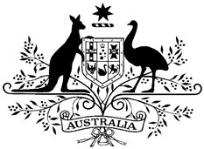

AUSTRALIAN NATIONAL ANTHEM

Australians all let us rejoice, For we are one and free;
We’ve golden soil and wealth for toil; Our home is girt by sea;
Our land abounds in nature’s gifts Of beauty rich and rare;
In history’s page, let every stage Advance Australia Fair.
In joyful strains then let us sing, Advance Australia Fair.

Beneath our radiant Southern Cross We’ll toil with hearts and hands;
To make this Commonwealth of ours Renowned of all the lands;
For those who’ve come across the seas We’ve boundless plains to share; With courage let us all combine
To Advance Australia Fair.
In joyful strains then let us sing, Advance Australia Fair.

1 January 2021

