Gender Balance on Australian Government Boards Report 2021-22

A report on the gender composition of Australian Government Boards

Office for Women

Contents

Foreword 2

Executive Summary 3

Current environment 3

International context 3

Parliament 4

Private sector 4

Government actions 4

Gender Balance on Australian Government Boards Data 5

Overall Government results 5

Portfolio results 5

New appointments 7

Chair and Deputy Chair Roles 8

External Nominations 10

Appendix A 13

Gender Balance on Australian Government Boards Report — guidelines 13

Scope of the reporting 13

Boards 13

Positions 14

Chair and Deputy Chair positions 14

New appointments 14

External nominations 14

© Commonwealth of Australia 2022 Gender Balance on Australian Government Boards Report 2021-22

ISSN 2652-5135

Copyright Notice

With the exception of the Commonwealth Coat of Arms, this work is licensed under a Creative Commons Attribution 4.0 International licence (CC BY 4.0) (https://creativecommons.org/licenses/by/4.0/).

Third party copyright

Wherever a third party holds copyright in this material, the copyright remains with that party. Their permission may be required to use the material. Please contact them directly.

Attribution

This publication should be attributed as follows:

© Commonwealth of Australia, Department of the Prime Minister and Cabinet.

Gender Balance on Australian Government Boards Report 2021-22.

Use of the Coat of Arms

The terms under which the Coat of Arms can be used are detailed on the following website: http://www.pmc.gov.au/government/its-honour

# Foreword

As the Minister for Finance, Women and the Public Service, I am pleased to present the *Gender Balance on Australian Government Boards Report 2021-22*.

In this reporting period, the Government has met the target of 50 per cent representation of women on Government Boards for the first time since the target was introduced.

The target was first met in December 2021, when women occupied 50.2 per cent of board positions. This has been further strengthened, with women now holding 51.4 per cent of Government board positions as of 30 June 2022. This is a milestone achievement and is significant when compared to 2016 when this number was only 40.5 per cent.

The latest results also show an increase in the representation of women in leadership positions, with women holding 41 per cent of Chair and Deputy Chair positions, at 30 June 2022. This is an increase of 1.9 percentage points from 30 June 2021.

The Government remains committed to the target of 50 per cent representation of women on Australian Government Boards and we will not rest on the progress made so far. There is still work to do to improve women’s representation in leadership positions, and to reach the target at portfolio and board level.

We also need to ensure greater diversity across board membership, including people with disability, people from culturally and linguistically diverse backgrounds and representation of First Nations people. Having diverse women in visible, influential and decision-making positions across all levels and sectors of society is vital to driving cultural change and ensuring diverse views and experiences are represented at decision-making tables.

The Government wants Australia to be a leader on gender equality. We are putting gender equality at the centre of decision making and will develop a National Strategy to Achieve Gender Equality to guide whole-of-government action toward achieving this goal. Equal representation on Government Boards – the very decision-making tables that help guide our policies – is a critical foundation to delivering on this ambition.

**Senator the Hon Katy Gallagher**  
Minister for Finance, Minister for Women and Minister for the Public Service

# Executive Summary

The *Gender Balance on Australian Government Boards Report*, prepared annually by the Office for Women, outlines performance against the Australian Government’s target for gender balance on Australian Government Boards.

On 1 July 2016, the Government committed to a target of women holding 50 per cent of Government board positions overall, and men and women each holding at least 40 per cent of positions on individual boards. This target replaced the previous gender diversity target of women holding 40 per cent of Australian Government Board positions overall.

In the 2021-22 Financial Year, the Australian Government has met its target of women holding 50 per cent of Government board positions. At 30 June 2022, women held 51.4 per cent across all Government board appointments, an increase of 1.8 percentage points from 30 June 2021.

Since the 2020-21 report, there has also been positive progress across other metrics:

* As at 30 June 2022, women held 41 per cent of Chair and Deputy Chair positions across Australian Government Boards, an increase of 1.9 percentage points since 30 June 2021.
* As at 30 June 2022, women made up 54.4 per cent of new appointments to Australian Government board positions, an increase of 2.2 percentage points since 30 June 2021.

However findings from the 2021-22 results have also highlighted where further effort is needed to achieve balanced gender representation.

* Of the 112 nominations for Government board positions by external organisations over 2021-2022, 46.4 per cent of nominees were women – a decrease of 3.6 percentage points from 2020-21.

Results in this report reflect the portfolio structure prior to the 2022 election. Post-election machinery of government changes will be reflected in the 2022-23 report.

The *Gender Balance on Australian Government Boards Report — Guidelines* determine the scope of reporting for portfolios (see Appendix A).

## Current environment

The labour force participation rate of women in Australia was at 62.3 per cent in August 2022.[1] Since 2013, women’s participation rate has increased from 58.9 per cent, an overall increase of 3.4 percentage points.[2] Yet women remain under-represented in senior leadership and management positions in virtually all sectors.

## International context

In the 2022 World Economic Forum Global Gender Gap Index, Australia ranked 43rd overall and 38th in Economic Participation and Opportunity.[3]

Achieving gender equality is an area of increasing focus for many nations. Although no country has yet achieved full gender parity, the top 10 economies have closed at least 80 per cent of their gender gaps, with Iceland (90.8 per cent) leading the global ranking. New Zealand ranked fourth on the Index in our region, closing 84.1 per cent of their gender gaps.[4]

## Parliament

Women make up 44.5 per cent of the 47th Australian Parliament and 43.5 per cent of Cabinet.[5] The Government has committed $5.0 million over five years from 2022-23, to fund organisations to equip and encourage more women across the political spectrum to run for public office at local, state and federal levels.

## Private sector

As at August 2022, women make up 24.3 per cent of board directors of Australia’s top

300 companies (ASX300).[6] A total of six boards in the ASX300 do not have any women, and a further 40 have Boards with only one female. The 2022 Chief Executive Women Senior Executive Census reported there are 18 female CEOs in the ASX300, and at the current rate of change it would take 100 years to achieve gender balance in CEO roles.[7]

## Government actions

The Government is committed to advancing gender equality as a national priority. Gender equality supports women and men to thrive, making our economy stronger, more inclusive and more sustainable.

Through the introduction of gender responsive budgeting, the Government is putting gender equality at the heart of policy and decision making.

The Government is also committed to restoring Australia’s leadership on gender equality by introducing a National Strategy to Achieve Gender Equality to guide work towards its goal of Australia being one of the most gender-equal countries in the world.

We have also established the Women’s Economic Equality Taskforce to provide independent advice to Government on a range of issues facing women in Australia. They will play a key role in informing the development of the National Strategy to Achieve Gender Equality.

The 2022-23 Budget together with the Women’s Budget Statement outlines the steps we are taking to drive meaningful change.

# Gender Balance on Australian Government Boards Data

## Overall Government results

At 30 June 2022, there were 335 Australian Government Boards with 2,214 filled positions. Women filled 51.4 per cent of all board positions (1,138 positions were filled by women).

This result is an increase of 1.8 percentage points since 30 June 2021 when women filled

49.6 per cent of Government board positions (1,149 of 2,315 filled positions).

Table 1 details the number of boards, number and percentage of occupied positions by gender, and the percentage point difference from the previous year, since 2016.

Table 1: Gender balance on Australian Government boards as at 30 June, from 2016 to 2022

| Year | Number of boards | Number of filled positions | Number of women | Number of men | Percentage of positions filled by women | Percentage point change since previous year |
| --- | --- | --- | --- | --- | --- | --- |
| 2022 | 335 | 2,214 | 1,138 | 1,076 | 51.4 | +1.8 |
| 2021 | 342 | 2,315 | 1,149 | 1,166 | 49.6 | +1.1 |
| 2020 | 343 | 2,489 | 1,206 | 1,283 | 48.5 | +0.6 |
| 2019 | 341 | 2,313 | 1,109 | 1,204 | 47.9 | +2.1 |
| 2018 | 339 | 2,530 | 1,158 | 1,372 | 45.8 | +3.1 |
| 2017 | 337 | 2,508 | 1,072 | 1,436 | 42.7 | +2.2 |
| 2016 | 332 | 2,351 | 953 | 1,395 | 40.5 | +1.4 |

## Portfolio results

At 30 June 2022, six out of 13 portfolios met or exceeded the 50 per cent gender diversity target:

* Social Services (including Services Australia)
* Health
* Attorney-General’s
* Education, Skills and Employment
* Foreign Affairs and Trade, and
* rime Minister and Cabinet.

Women held between 45 and 50 per cent of board positions in the remaining eight portfolios (see Figure 1 and Table 2).

Figure 1: Gender balance of overall Australian Government board positions as at 30 June 2020, by portfolio

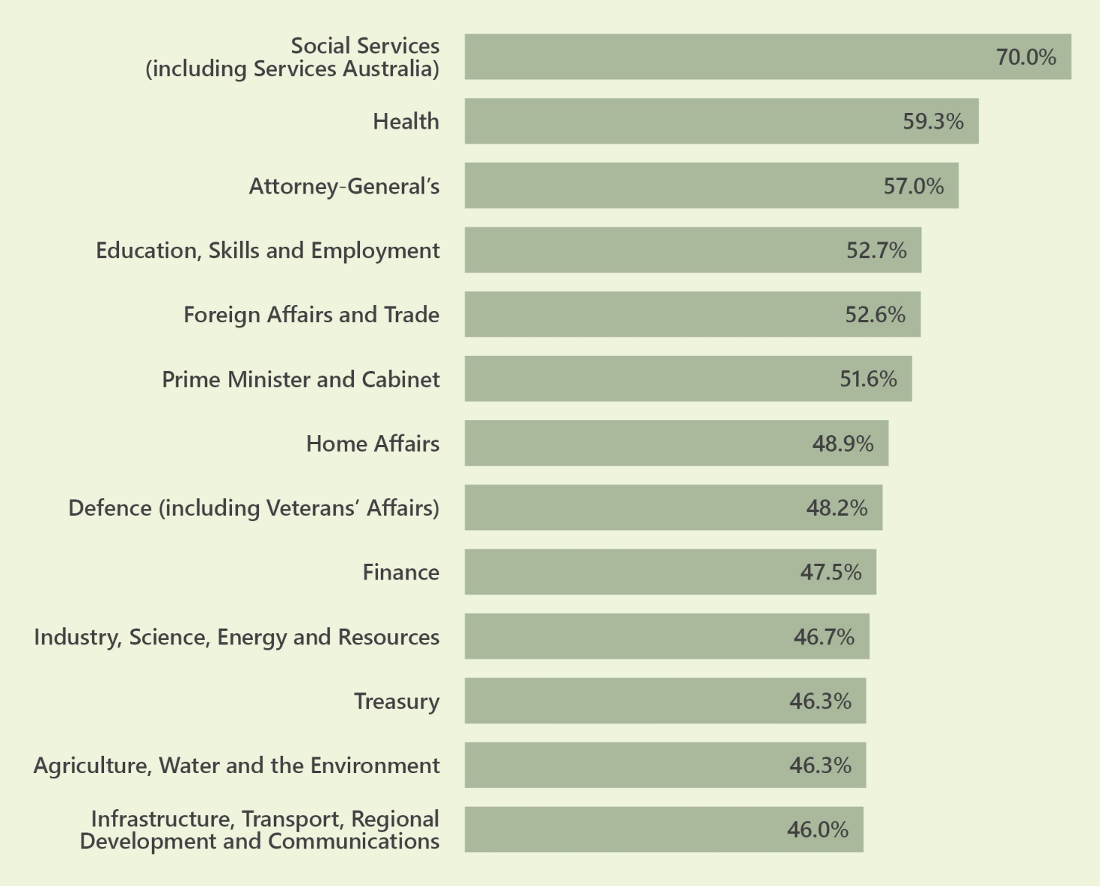

Table 2: Gender balance of overall Australian Government board positions as at 30 June 2022, by portfolio

| Portfolio | Number of Boards | Number of Filled Positions | Number of Women | Percentage of positions filled by women as at  30 June 2022 | Percentage of positions filled by women at  30 June 2021 | Percentage point difference from 30 June 2021 to 30 June 2022 |
| --- | --- | --- | --- | --- | --- | --- |
| Social Services (including Services Australia) | 5 | 30 | 21 | 70.0 | 69.4 | 0.6 |
| Health | 48 | 504 | 299 | 59.3 | 56.8 | 2.5 |
| Attorney-General's | 14 | 100 | 57 | 57.0 | 50.0 | 7.0 |
| Education, Skills and Employment | 20 | 131 | 69 | 52.7 | 51.8 | 0.9 |
| Foreign Affairs and Trade | 24 | 196 | 103 | 52.6 | 50.5 | 2.1 |
| Prime Minister and Cabinet | 15 | 91 | 47 | 51.6 | 50.9 | 0.7 |
| Home Affairs | 7 | 88 | 43 | 48.9 | 44.7 | 4.2 |
| Defence (including Veterans' Affairs) | 18 | 110 | 53 | 48.2 | 49.3 | -1.1 |
| Finance | 6 | 40 | 19 | 47.5 | 40.0 | 7.5 |
| Industry, Science, Energy and Resources | 27 | 165 | 77 | 46.7 | 52.6 | -5.9 |
| Treasury | 23 | 121 | 56 | 46.3 | 45.8 | 0.5 |
| Agriculture, Water and the Environment | 34 | 242 | 112 | 46.3 | 46.9 | -0.6 |
| Infrastructure, Transport, Regional Development and Communications | 94 | 396 | 182 | 46.0 | 41.4 | 4.6 |
| **TOTAL** | **335** | **2214** | **1138** | **51.4** | **49.6** | **1.8** |

## New appointments

New appointments are those appointments made over the 2021-22 financial year that were not reappointments of the same person to the same position.

Of the 682 new appointments made in 2021-22, 54.4 per cent of appointees were women. This is an increase of 2.2 percentage points since the last annual report when women comprised 52.2 per cent of new appointees.

Table 3 shows at 30 June 2022, in eight of 13 portfolios, women represented 50 per cent or more of new appointments.

Table 3: Gender balance of new appointments in 2021-22, by portfolio

| Portfolio | Number of new appointments | Number of women appointed | Percentage of new appointments who were women 1 July 2021 to  30 June 2022 |
| --- | --- | --- | --- |
| Finance | 6 | 6 | 100.0 |
| Attorney-General's | 39 | 27 | 69.2 |
| Foreign Affairs and Trade | 25 | 17 | 68.0 |
| Social Services (including Services Australia) | 6 | 4 | 66.7 |
| Health | 172 | 112 | 65.1 |
| Education, Skills and Employment | 46 | 26 | 56.5 |
| Prime Minister and Cabinet | 26 | 14 | 53.8 |
| Home Affairs | 21 | 11 | 52.4 |
| Agriculture, Water and the Environment | 63 | 31 | 49.2 |
| Infrastructure, Transport, Regional Development and Communications | 186 | 88 | 47.3 |
| Treasury | 33 | 15 | 45.5 |
| Defence (including Veterans' Affairs) | 23 | 9 | 39.1 |
| Industry, Science, Energy and Resources | 36 | 11 | 30.6 |
| **TOTAL** | **682** | **371** | **54.4** |

# Chair and Deputy Chair Roles

At 30 June 2022, women held 41 per cent of Chair and Deputy Chair positions across all Government Boards.

This result is 1.9 percentage points higher than the 30 June 2021 result, when women held 39.1 per cent of Chair and Deputy Chair positions.

Figure 2 details the portfolios results for the gender balance of Chair and Deputy Chair positions on 30 June 2022.

Figure 2: Gender balance of Chair and Deputy Chair positions as at 30 June 2022, by portfolio

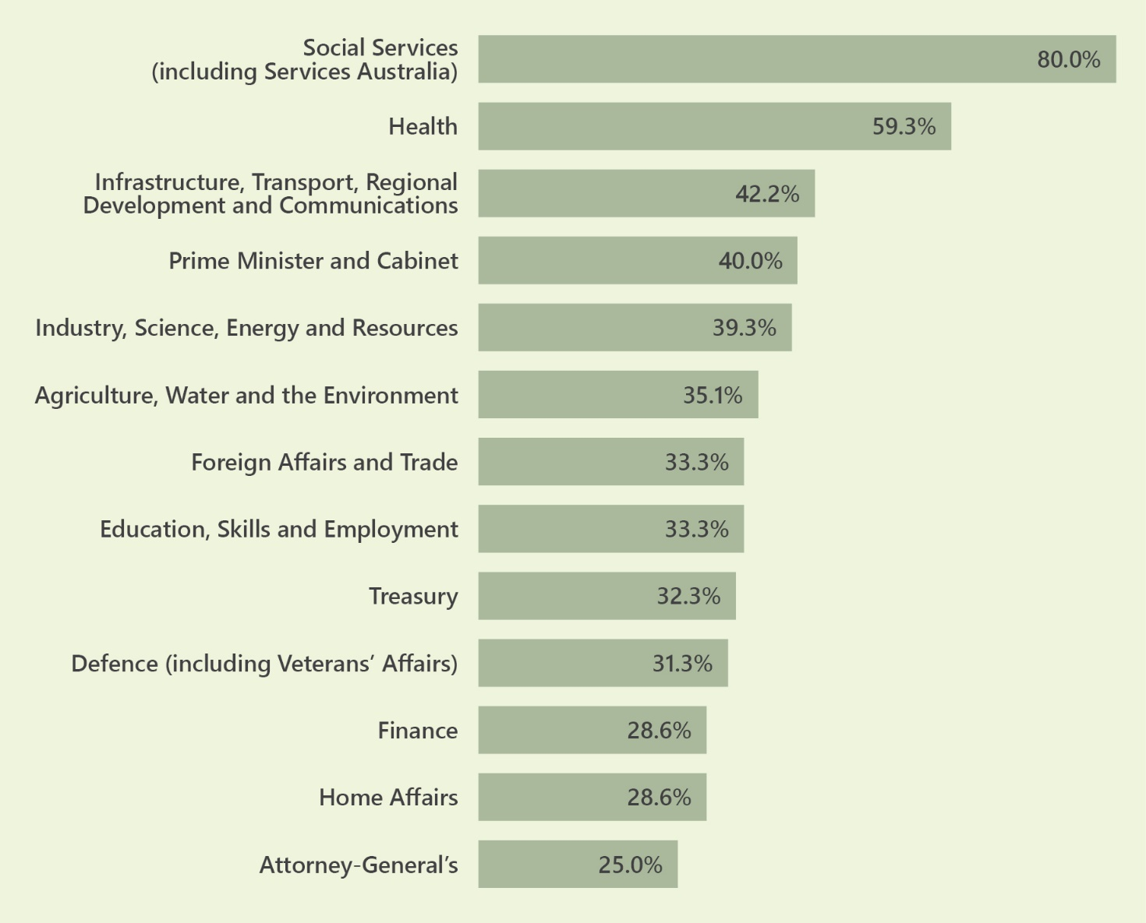

Table 4: Gender balance of Chair and Deputy Chair positions as at 30 June 2022, by portfolio

| Portfolio | Number of boards | Number of filled Chair and Deputy Chair positions | Number of Chair and Deputy Chair positions filled by women | Percentage of Chair and Deputy Chair positions filled by women, as at  30 June 2022 | Percentage point difference from 30 June 2021 to 30 June 2022 |
| --- | --- | --- | --- | --- | --- |
| Agriculture, Water and the Environment | 34 | 37 | 13 | 35.1 | 5.4 |
| Attorney-General's | 8 | 8 | 2 | 25.0 | 8.3 |
| Defence (including Veterans' Affairs) | 14 | 16 | 5 | 31.3 | -8.8 |
| Education, Skills and Employment | 20 | 21 | 7 | 33.3 | -13.8 |
| Finance | 6 | 7 | 2 | 28.6 | -21.4 |
| Foreign Affairs and Trade | 24 | 24 | 8 | 33.3 | -9.6 |
| Health | 48 | 54 | 32 | 59.3 | 12.6 |
| Home Affairs | 7 | 7 | 2 | 28.6 | 6.4 |
| Industry, Science, Energy and Resources | 27 | 28 | 11 | 39.3 | 1.4 |
| Infrastructure, Transport, Regional Development and Communications | 94 | 147 | 62 | 42.2 | 3.4 |
| Prime Minister and Cabinet | 15 | 20 | 8 | 40.0 | -1.2 |
| Social Services (including Services Australia) | 5 | 5 | 4 | 80.0 | -20.0 |
| Treasury | 21 | 31 | 10 | 32.3 | 5.6 |
| **TOTAL** | **323** | **405** | **166** | **41.0** | **1.8** |

# External Nominations

An external nomination is one which is made by a person or organisation who is not the Minister responsible for approving the appointment, or a member of their department. This may include, for example, a state or territory government or non-government body, and extends to appointment processes where it is either legislated or accepted practice for nominations to be provided to the Minister.

While all nominations are reported, not all nominations made by external bodies resulted in the appointment of the nominee. For example, multiple nominations may be received for the same vacancy.

In 2021-22, 52 of the 112 external nominations (equivalent to 46.4 per cent) received for gender balance appointments were for women (see Table 5).

Table 5: External nominations for board positions received in 2021-22, by nominating organisation

| Nominating Organisation | Number of nominations given | Number of women nominated | Percentage of nominees who were women |
| --- | --- | --- | --- |
| New South Wales Government | 26 | 10 | 38% |
| Queensland Government | 15 | 7 | 47% |
| South Australian Government | 1 | 0 | 0% |
| Australian Capital Territory Government | 4 | 3 | 75% |
| Western Australian Government | 7 | 2 | 29% |
| Tasmanian Government | 2 | 0 | 0% |
| Northern Territory Government | 2 | 2 | 100% |
| Victorian Government | 4 | 2 | 50% |
| Premier of South Australia | 1 | 1 | 100% |
| Australian Strategic Policy Institute Council | 1 | 0 | 0% |
| National Farmers’ Federation | 1 | 0 | 0% |
| Business Council of Australia | 3 | 0 | 0% |
| SA Arid Lands Landscape Board | 1 | 0 | 0% |
| Northern Land Council | 1 | 0 | 0% |
| QLD Government - Department of Regional Development, Manufacturing and Water | 1 | 1 | 100% |
| Australian Industry Group | 2 | 2 | 100% |
| Desert Channels QLD Group | 2 | 1 | 50% |
| The United Ngunnawal Elders Council | 1 | 1 | 100% |
| Northern Territory Stolen Generations Aboriginal Corporation | 1 | 1 | 100% |
| Australian Conservation Foundation | 1 | 0 | 0% |
| QLD Conservation Council, Arid Lands Environment Centre | 1 | 0 | 0% |
| The Healing Foundation | 2 | 1 | 50% |
| New Zealand Minister | 1 | 1 | 100% |
| Australian Institute of Marine and Power Engineers and the Australian Maritime Officers Union | 1 | 0 | 0% |
| National Catholic Education Commission | 1 | 0 | 0% |
| Law Council of Australia | 1 | 0 | 0% |
| Australian Resources & Energy Employer Association | 1 | 1 | 100% |
| Master Builders Australia | 1 | 1 | 100% |
| Maritime Industry Australia Limited | 1 | 1 | 100% |
| Pharmaceutical Society of Australia | 1 | 1 | 100% |
| Mining and Energy Union | 1 | 0 | 0% |
| Institute of Public Accountants | 1 | 1 | 100% |
| ACT and NSW Stolen Generations Council | 1 | 1 | 100% |
| Australian Chamber of Commerce and Industry | 1 | 0 | 0% |
| Australian Council of Trade Unions | 7 | 3 | 43% |
| Central Australian Aboriginal Congress Link-Up Service | 1 | 1 | 100% |
| Chartered Accountants Australia and New Zealand (CA ANZ) | 6 | 2 | 33% |
| Certified Practicing Accountants Australia | 4 | 3 | 75% |
| Global Compact Network Australia | 1 | 1 | 100% |
| Defence Minister | 1 | 0 | 0% |
| **TOTAL** | **112** | **52** | **46.4%** |

# Appendix A

## Gender Balance on Australian Government Boards Report — guidelines

The Australian Government has committed to a gender diversity target of women holding 50 per cent of Government board positions overall, and women and men each holding at least 40 per cent of positions at the individual board level. These targets took effect from 1 July 2016.

To track progress towards these targets, each year the Office for Women publishes a Gender Balance report on the Department of the Prime Minister and Cabinet website. In addition to reporting on the overall Government result, the report covers portfolio results, new appointments to Australian Government Boards, Chair and Deputy Chair positions and candidates nominated for Australian Government board positions by external organisations.

## Scope of the reporting

### Boards

Some Australian Government Boards are not within the scope of the Gender Balance report. To fall within scope, a board must meet two conditions.

*Condition one:* The board must be either:

* a body covered by the Public Governance, Performance and Accountability Act 2013 (PGPA Act) (a Flipchart and further information can be found at [https://www.finance.gov.au/government/managing-commonwealth-resources/structure-australian-government-public-sector/pgpa-act-flipchart- list)](https://www.finance.gov.au/government/managing-commonwealth-resources/structure-australian-government-public-sector/pgpa-act-flipchart-%20%20list))
* a ministerial advisory committee
* a review committee, whose appointments are made by a Minister or the Cabinet
* a Commonwealth statutory authority.

*Condition Two:* At least one appointment to the board must be approved by particular representatives of the Australian Government. These are limited to:

* the Prime Minister
* one or more Commonwealth Ministers
* the Governor-General in Council
* the Cabinet.

Boards which fall outside the scope of gender balance reporting include Royal Commissions, Commonwealth Courts and tribunals.

### Positions

Gender balance data is reported on a positions basis. Not all positions are within the scope of the Gender Balance report. Reporting does not include positions which are:

* elected with no formal Government approval
* nominated by a third party with no formal Government approval (these positions are captured in external nominations data only, see below)
* of a particular office-holder to a particular board or committee, as required by legislation
* (e.g. a Minister serving as the Chair of a board)
* for employees engaged under the Public Service Act 1999 or other enabling legislation for purposes beyond serving on a Commonwealth decision-making or advisory board, committee, council or similar (e.g. ex officio appointments of senior public servants), or acting appointments of six months or less.

Where a board has a mixture of in-scope and out-of-scope positions, the board and its in-scope positions are included in the Gender Balance report. Out-of-scope are do not contribute to the number of filled positions or to the gender balance report.

## Chair and Deputy Chair positions

Board members with Chair or Deputy Chair positions, or their functional equivalents, contribute towards this metric. Equivalent roles can include, for example, Chief or Deputy Chief Convenors and Commissioners.

## New appointments

New appointments are appointments made over the 2019-20 financial year, which fulfil all of the criteria above but do not require the successful candidate to have been formally working in the role at 30 June 2020. Reappointments do not contribute towards the new appointments metric, only to the overall gender balance metric and Chair and Deputy Chair gender balance metrics.

## External nominations

External nominations include, but are not limited to, nominations made by a state or territory government, the Senate or House of Representatives, an overseas Government, or a non-Government body. This includes appointment processes where it is either legislated or accepted practice for nominations to be provided to a Minister.

External nominations do not include nominations made by a Minister’s department, the relevant board or its Chair, or by two or more Ministers where one is the relevant portfolio Minister.

Both successful and unsuccessful nominations are within the scope of the Gender Balance report.

**Endnotes**

1. [Gender indicators | Australian Bureau of Statistics (abs.gov.au)](https://intranet.ssp.pmc.gov.au/COM/Documents/abs.gov.au)
2. *Australian Bureau of Statistics, Labour Force Australia, June 2013, ABS cat. no. 6202.0, ABS, Canberra 2013*
3. Global index [WEF_GGGR_2022.pdf (weforum.org)](https://intranet.ssp.pmc.gov.au/COM/Documents/weforum.org)
4. Global index [WEF_GGGR_2022.pdf (weforum.org)](https://intranet.ssp.pmc.gov.au/COM/Documents/weforum.org)
5. [Statistical Information (aph.gov.au)](https://intranet.ssp.pmc.gov.au/COM/Documents/aph.gov.au)
6. *Quarterly Gender Diversity Report, Australian Institute of Company Directors June-August 2022*
7. *Chief Executive Women Senior Executive Census 2022*