Putting people at the heart of policy
November 2026

About BETA

Who we are
Good policy starts with understanding people. The Behavioural Economics Team of the Australian Government (BETA) helps Australian Government departments and agencies understand how people interact with policies and programs, so they can be improved to better fit Australians’ needs.
By better appreciating where people are coming from, and where they want to go, we can design government policies, programs and services to align with people – rather than expecting people to change. This means understanding how people actually behave, not how we think or assume they should act.
Drawing on a broad range of fields – psychology, economics, sociology, neuroscience, anthropology and others – we design interventions grounded in an understanding of human behaviour and respecting people’s autonomy, interests and preferences. We also test our interventions to see what works, ensuring the Government is investing in policies and services that work and improve the lives of Australians.
To learn more about BETA, please visit our website: https://www.pmc.gov.au/beta

Contents
Our story 3
Our impact 7
Our lessons learned 12
Our future 18
References 19

Executive summary
For the last decade, the Behavioural Economics Team of the Australian Government (BETA), in the Department of the Prime Minister and Cabinet, has been putting Australians at the heart of public policy design and delivery. We have helped the Australian Public Service (APS) and policymakers understand the experience of Australians, design and test evidence-informed solutions, and evaluate how interventions are working in the real world.
We have helped to rigorously test policy ideas. BETA’s trials show that its interventions typically lead to an extra 10 to 20 people out of every 1,000 taking the action they wanted to take, compared with what would have happened without the intervention. These small but important improvements accumulate into significant societal benefits. More broadly, BETA has had direct impacts across sectors, improving outcomes in many areas of Australians’ lives. We have:
- helped Australians prosper – supporting consumers to engage with markets and systems are designed around how people actually behave
- improved government services – making them more streamlined, responsive and respectful
- supported Australians’ wellbeing – helping to build resilience and prevent harms, from the domains of health to security
- made life easier for Australians – reducing complexity in government processes, helping people navigate time pressures and competing demands
- supported a more inclusive and productive workforce – helping businesses develop more inclusive and productive workforces and workplaces
- built APS capability – sharing skills, tools and lessons learned so more policies and people can benefit from a behavioural lens and evidence-informed policy.
As we look to the future, we are building on the key lessons we have learned.
- Good public policy starts with understanding people – doing research with Australians and understanding their contexts remains critical.
- Evidence provides more certainty and better outcomes – understanding Australians’ experiences and testing interventions helps effectively identify what works and why.
- Rigour and relevance go together – high-quality, ethical research must be designed to meet the unique needs of the policy process.
- Behavioural science is a tool for everyone – with opportunities for teams across governments to use existing tools in their work or seek specialised support.
The challenges facing Australians will continue to evolve, and so too will the policy landscape. As we look to the future, BETA will continue to look for opportunities to improve the lives of Australians, working with the people affected by government policies and services. We will continue to evolve our methods and capabilities, including by integrating techniques that help us engage effectively throughout the policy cycle, look for opportunities to leverage existing data assets, and keep our finger on the pulse of emerging technologies and their interplay with human behaviour and research.

Our story
The idea was simple: put real people, their decisions, experiences and behaviours at the heart of public policy. Since 2016, when the Behavioural Economics Team of the Australian Government (BETA) was established, this is exactly what we have done.

BETA’s mission
To improve the lives of Australians by generating and applying evidence from the behavioural and social sciences to find solutions to complex policy problems.

BETA’s objectives
- Conduct research to better understand how people interact with policies and programs.
- Design and test evidence-based solutions.
- Evaluate and measure the impact of programs and changes (including randomised controlled trials).
- Uplift APS capability to apply evidence from the behavioural and social sciences to policy.
Located within the Department of the Prime Minister and Cabinet, we have worked on over 150 projects with our partners across the Australian Public Service (APS) and published over 56 reports. This genuine collaboration of policy, subject matter and research expertise has ensured our insights are both rigorous and directly relevant, helping translate evidence into practical policy outcomes.

Forming a broader perspective
BETA now works across the whole policy cycle, from helping policymakers understand a problem to designing and testing potential solutions (Figure 1). We have helped partners better understand the broader context of an issue, recognise trade-offs and consider their next steps.

BETA works across the policy cycle
Identify issues​ – orient policymakers’ attention to issues people are experiencing.​
Analysis​ – help understand the drivers of policy problems using exploratory research.​
Design​ – design and test potential policy options and interventions to build the evidence base.​
Implementation​ – advise on and test details about how policy and program decisions are implemented in practice.​
Evaluation – evaluate policies or programs we’ve helped design, or that focus on human behaviour.​
Figure 1 A behavioural lens through the policy cycle
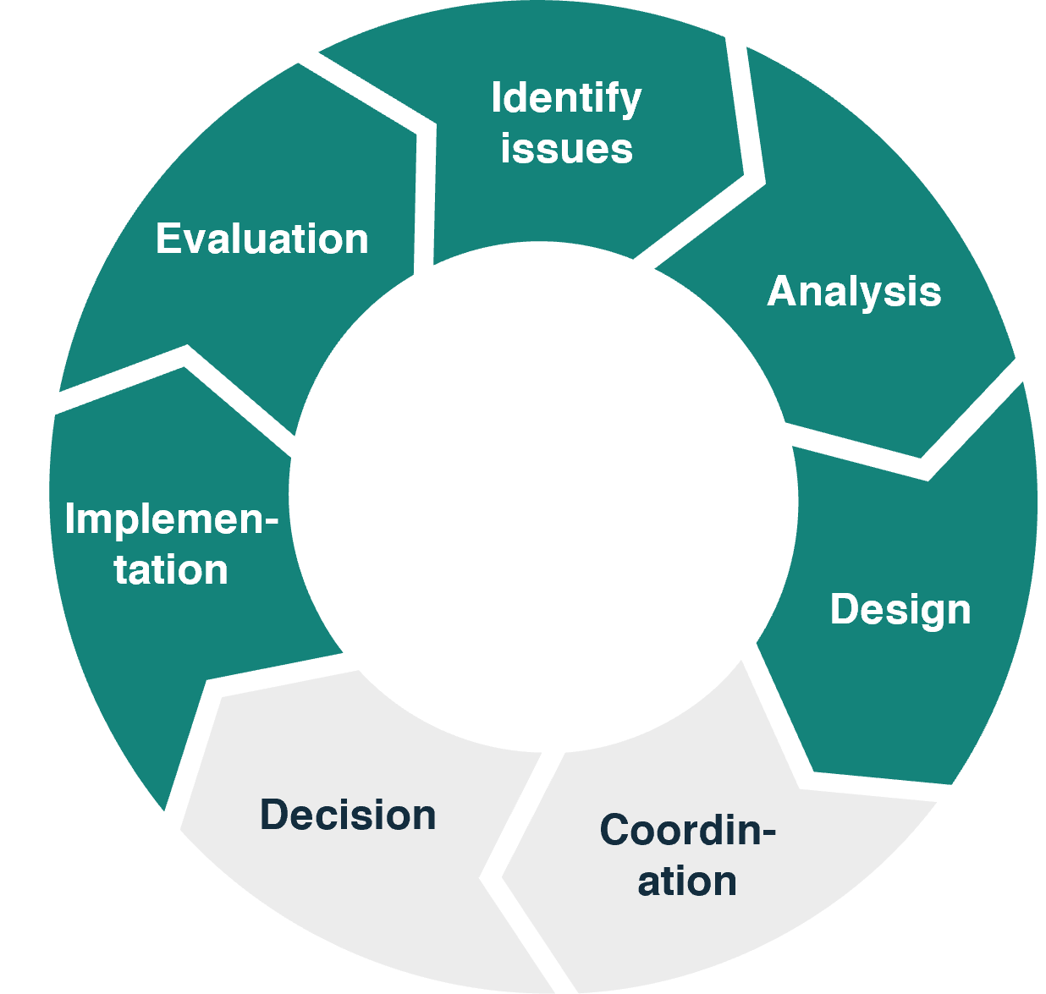
To do this we, alongside the field of behavioural public policy, have had to mature over time.
We started by building a foundation by rigorously testing ideas, contributing to the use of Randomised Controlled Trials (RCTs) across a wide range of public policy areas (Rehill et al. 2025). Across a decade of RCTs, our interventions have had a positive impact on the lives of Australians. BETA’s trials show that its interventions typically lead to an extra 10 to 20 people out of every 1,000 taking the action they wanted to take, compared with what would have happened without the intervention. This aligns with international evidence (Kaiser 2025, Mertens 2022). Behavioural interventions in real-world settings usually result in small but reliable improvements. When applied to a country, these small changes can help a lot of people, accumulating into significant societal benefits (BETA 2026b).
Our skillset has broadened over time (Figure 2) to help answer different policy and research questions across the policy cycle. Exploratory research techniques ensure we’re speaking with and including the voices of everyday Australians and an understanding of what may work for the development of new policies and programs. Impact evaluation, including RCTs, remain critical tools for understanding policies and programs already in effect and where there could be opportunities for improvement.
Figure 2 Broadened our skillset
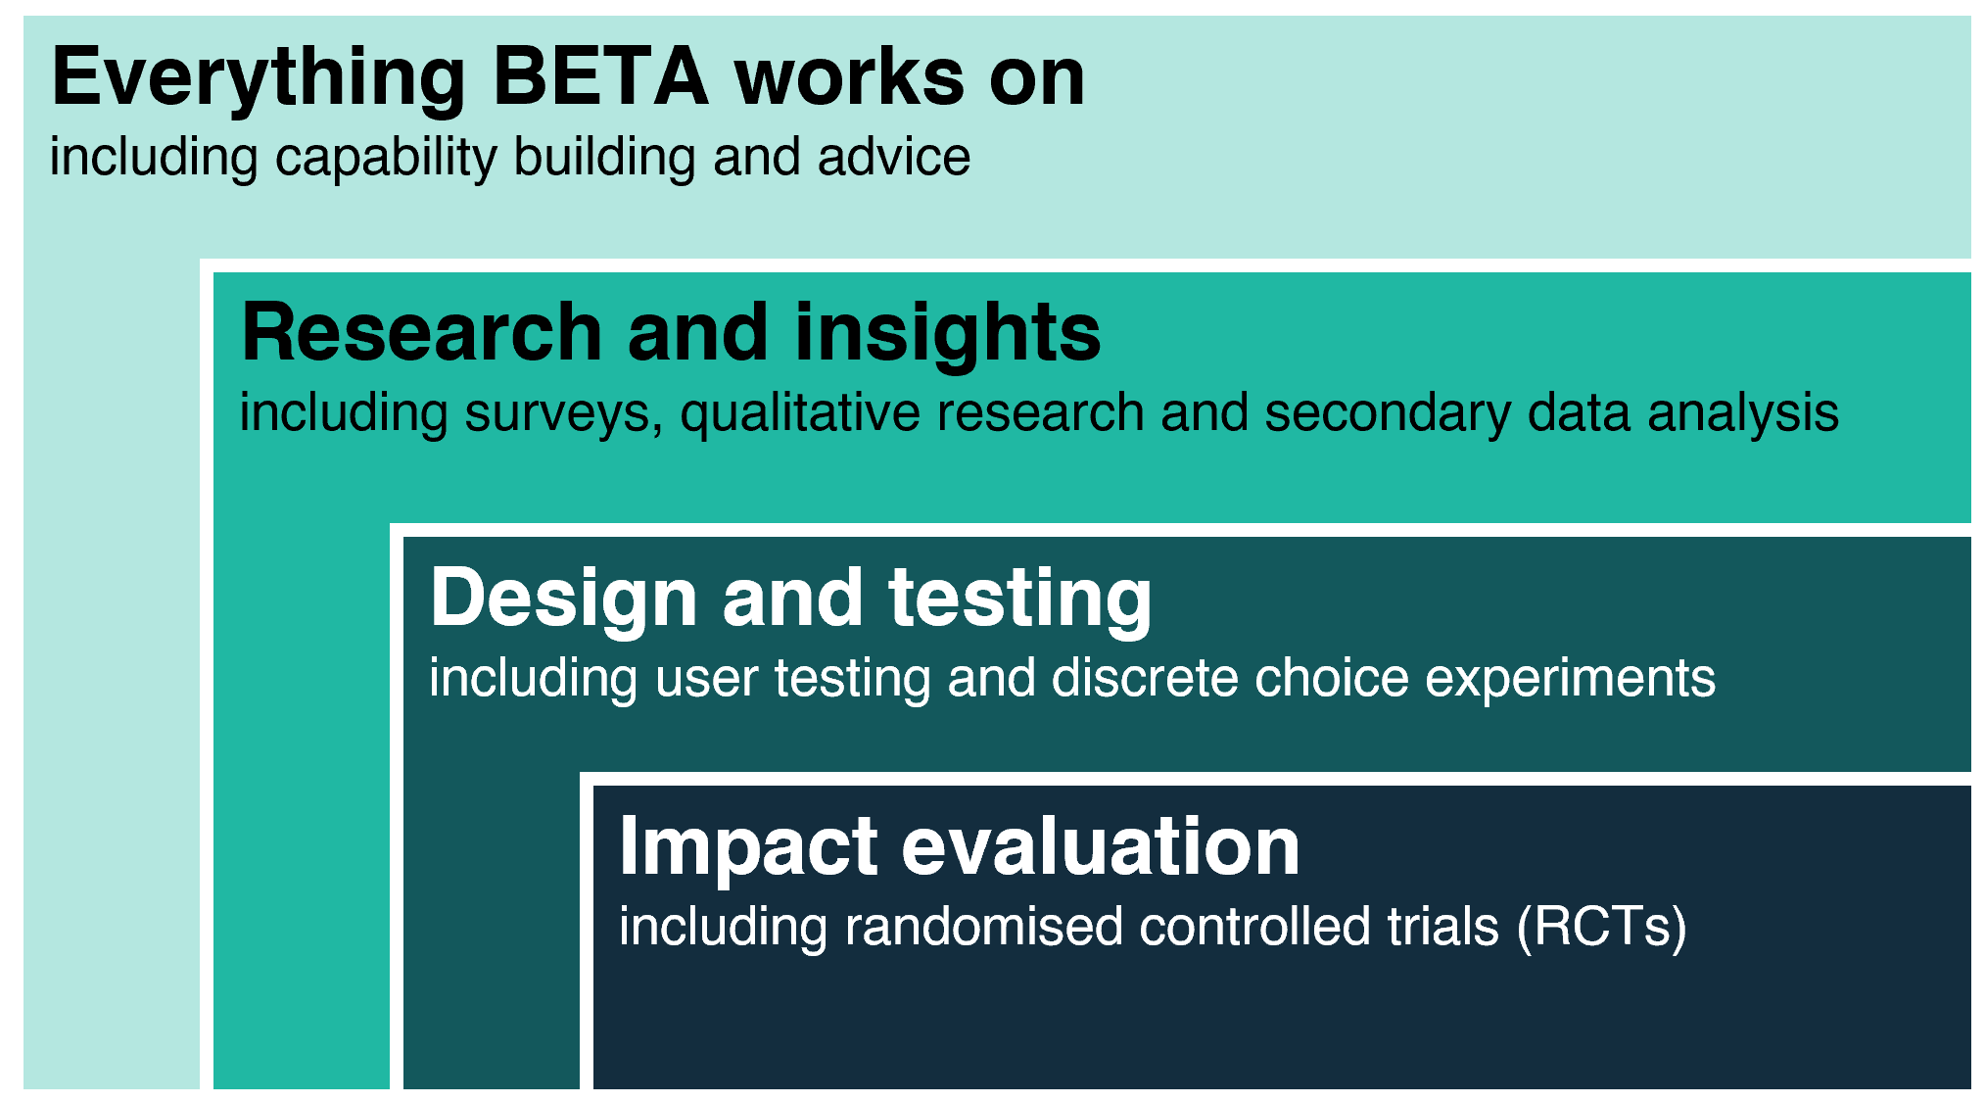

A proven track record
Ten years on, BETA has demonstrated the value behavioural science brings to public policy. We’ve helped government make better, evidence-informed decisions that have delivered improvements to Australian lives by putting people at the heart of policy.
This impact report is supported by two supplementary documents:
- 10 years of BETA: Case studies – a curated collection of case studies summarising some of our key work with our APS partners
- 10 years of BETA: Meta-analysis of our behavioural trials – a technical appendix detailing what we have learned from BETA’s behavioural trials
This report and its supplementary documents can be found on the BETA website alongside our full catalogue of publications.

Our impact
BETA’s work with partners has supported Australians in their interactions with government, businesses and employers. We’ve helped make parts of life easier for Australians, saved them money, and improved their health and wellbeing.
Figure 3 BETA's impacts
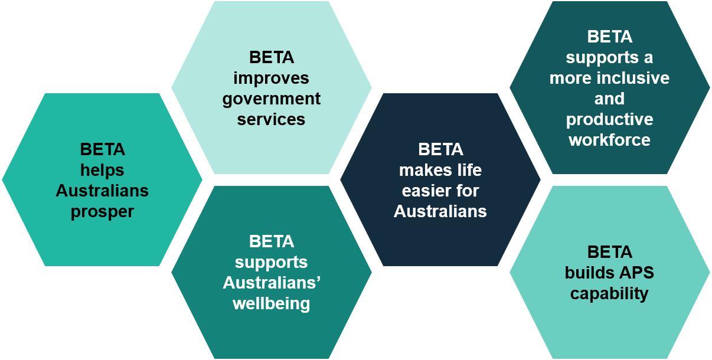
Within government, our research has enabled more informed decision making. This impact stretches from working with agencies to develop new evidence and insights to support policy conversations, creating tools for Australians to use in the real world, and inspiring new ways to tackle problems. Our review of BETA case studies shows that the tangible impact of our work can either happen quickly or develop slowly from a steady accumulation of evidence and advice over time.
Further, by driving an Australian policymaking capability and culture that is curious and deeply informed by the experiences of Australians, we have made a difference beyond the issues we’ve directly advised on. We’ve heard from our APS partners that they:
- no longer see complex problems as inevitable, but instead lean in to find root causes and ask what they could do differently to support better outcomes
- think more creatively about how alternate data sources could help them better understand their policy area
- have broadened their conception of who their stakeholders are and are now thinking about new ways to listen and communicate.

BETA helps Australians prosper
Australians are saving money thanks to BETA’s advice and testing. Much of our work has focused on empowering consumers to engage with markets more effectively, and identified where supply-side interventions can better support consumer outcomes.
Many of the markets Australians must navigate can be confusing and overwhelming. Often, consumers are presented with a multitude of complex products with different features and attributes. Relevant information may be obfuscated by poor design, and other times practices appear to be purposefully designed to deceive consumers.
BETA has helped policymakers and regulators understand the challenges and harms consumers experience when shopping for particular products or services. We’ve found areas where government intervention can be effective in supporting consumers to find the best deal for their personal circumstances. This means helping consumers get the right information, in the right way, and at the right time.
With the Australian Energy Regulator, we designed a message to go on energy bills to let people know if they could get a better offer with their current retailer, with potential household savings of $291 per year on average. Read more at p. 4, 10 years of BETA: Case studies.
In other cases, our work challenged the assumption that providing information, no matter how well designed, would not be sufficient to address market asymmetries, highlighting where supply-side interventions may be needed.
We’ve seen the dynamic ways market players anticipate and respond to government action. Market interventions and regulation need to be carefully designed to ensure they are resilient to motivated interpretations and changing contexts.

More BETA work in 10 years of BETA: Case studies
Helping Australians avoid junk insurance, p. 6.
Saving Australians money on foreign exchange, p. 8.

BETA improves government services
When government processes are streamlined, responsive and respectful – they save everyone time, help to ensure services are delivered where needed, and help build trust in the fairness and efficacy of systems.
Working with Services Australia, BETA helped shift stigma in government services from being an abstract societal problem to an issue that government agencies can actively address through service design and delivery. Read more at p. 11, 10 years of BETA: Case studies.
BETA has helped government agencies adopt a more user-centred perspective when designing interactions with their services. We’ve helped service owners analyse the causes of complaints and poor outcomes, often revealing how a specific touchpoint, such as a form, is just one part of a longer process and broader relationship between a person and the services they use.
Form-a-Palooza, an event held by BETA in 2019 with 38 agencies, helped to mainstream a customer-focused mindset across the APS by making behavioural insights tangible and practical. Read more at p. 13, 10 years of BETA: Case studies.
We’ve worked in partnership with agencies to improve how they engage with their customers, leading to more efficient service delivery and improved outcomes for individuals.

More BETA work in 10 years of BETA: Case studies
Minimising errors when registering personal property, p. 15.
Supporting people and businesses to adopt a new process, p. 17.
Encouraging farmers to share their stories with government, p. 19.

BETA supports Australians’ wellbeing
Our work has touched on all themes of Australia’s national wellbeing framework, Measuring what matters, helping to reduce risk, build resilience and protect Australians from harm, across domains including physical and mental health, cyber security and climate change.
BETA’s research on the benefits of paid family and domestic violence (FDV) leave brought victim-survivors’ stories into policy discussions. Our work provided evidence for the Independent Review on FDV leave and informed the actions Australian Government agencies have taken. Read more at p. 22, 10 years of BETA: Case studies.
BETA’s research has helped policymakers understand Australians’ lived experiences, enabling more considered, targeted and effective policy interventions. Understanding how different people experience barriers and enablers to accessing the various factors that contribute to wellbeing, can help uncover and address gaps in systems and structures that may not produce equitable outcomes across society.

More BETA work in 10 years of BETA: Case studies
Helping online gamblers moderate their betting, p. 24.
Encouraging organ donation, p. 27.
Informing pandemic responses by understanding real-time behaviours, p. 29.
Understanding the barriers to sustainable household choices, p. 31.
Testing options to encourage home energy upgrades, p. 34.

BETA makes life easier for Australians
Australians have busy lives, juggling multiple goals and competing priorities day to day. People do not have the time or energy to fully research every single decision they need to make.
BETA’s hotel quarantine guide, one component of the Australian Government’s effort to address the psychological effects of quarantine, was downloaded over 55,000 times. The guide received positive feedback, including positive comments from travellers on social media. Read more at p. 37, 10 years of BETA: Case studies.
It’s more effective to design systems that understand people and go with the flow of human intuition, than to expect every individual to understand every system and process they need to interact with. Government can work towards meeting people where they are, ensuring processes are easy and don’t add unnecessary friction. BETA has a large body of work focusing on making systems and processes easier to navigate, to help Australians find the outcome that best fits their family or business a little quicker.

More BETA work in 10 years of BETA: Case studies
Enabling consumers to choose cyber secure devices, p. 39.
Clarifying what internet plan is best for your household, p. 41.

BETA supports a more inclusive and productive workforce
BETA’s research has helped businesses and workers develop the labour force and workplaces that are more safe, inclusive and productive. Barriers, frictions and concerns in the way the labour force and workplaces operate, from recruitment to retention, can impose financial and psychological costs on both employers and workers, hampering wellbeing and economic productivity.
In partnership with Home Affairs, BETA developed guidance to support cyber security employers to change their recruitment processes, making them more welcoming and inclusive for all Australians. This has the potential benefits of broadening the talent pool, helping all Australians access employment opportunities, and boosting productivity through better job matching. Read more at p. 44, 10 years of BETA: Case studies.
We have helped match Australians’ skills with employers’ needs. If people are in a rewarding role aligned with their skillset and lifestyle, they are generally have higher job satisfaction (Farooqui & Nagendra 2014).
BETA and Workplace Gender Equality Agency (WGEA) developed an engaging and user-friendly tool which has given employers the confidence and knowledge to take action to help improve the gender pay gap in their organisation. Read more at p. 46, 10 years of BETA: Case studies.
We have also developed tools to support equality and diversity in the workforce. Inclusive workplaces support better job matching, enhancing both the psychological, social and financial wellbeing of individuals (Puig-Barrachina 2020; Mackey 2024).

More BETA work in 10 years of BETA: Case studies
Supporting people to return to work after an injury or illness, p. 48.
Helping to ensure polling venues are staffed at the next election, p. 51.

BETA builds APS capability
Our impact goes beyond the policy issues we’ve worked on. Helping everyone in the APS think about people and evidence in their own roles has been a consistent part of BETA’s mission. Over the past decade, we have trained more than 15,000 public servants through workshops, eLearning and events to adopt a behavioural lens in their own work. Our flagship conference, BI Connect, is free to attend by professionals and the Australian public and attracts over 1,000 participants annually.
BETA has also provided hands-on support through collaborating on projects, coaching and developing a network of behavioural insights practitioners across more than 25 government agencies. This ecosystem approach ensures that behavioural science expertise can be fostered throughout government.
We have also shared our expertise in survey design, research ethics and randomised evaluations – tools essential to the work of evidence-informed policy.

Our resources
- Behaviour Discovery Tool
- eLearning modules
- Improving government forms better practice guide
- Practical guide to survey development

Our lessons learned
From our last decade of work, covering hundreds of policy issues, we have identified 4 key takeaways for supporting and strengthening evidence-informed policymaking (Figure 4).
Figure 4 Key lessons learned
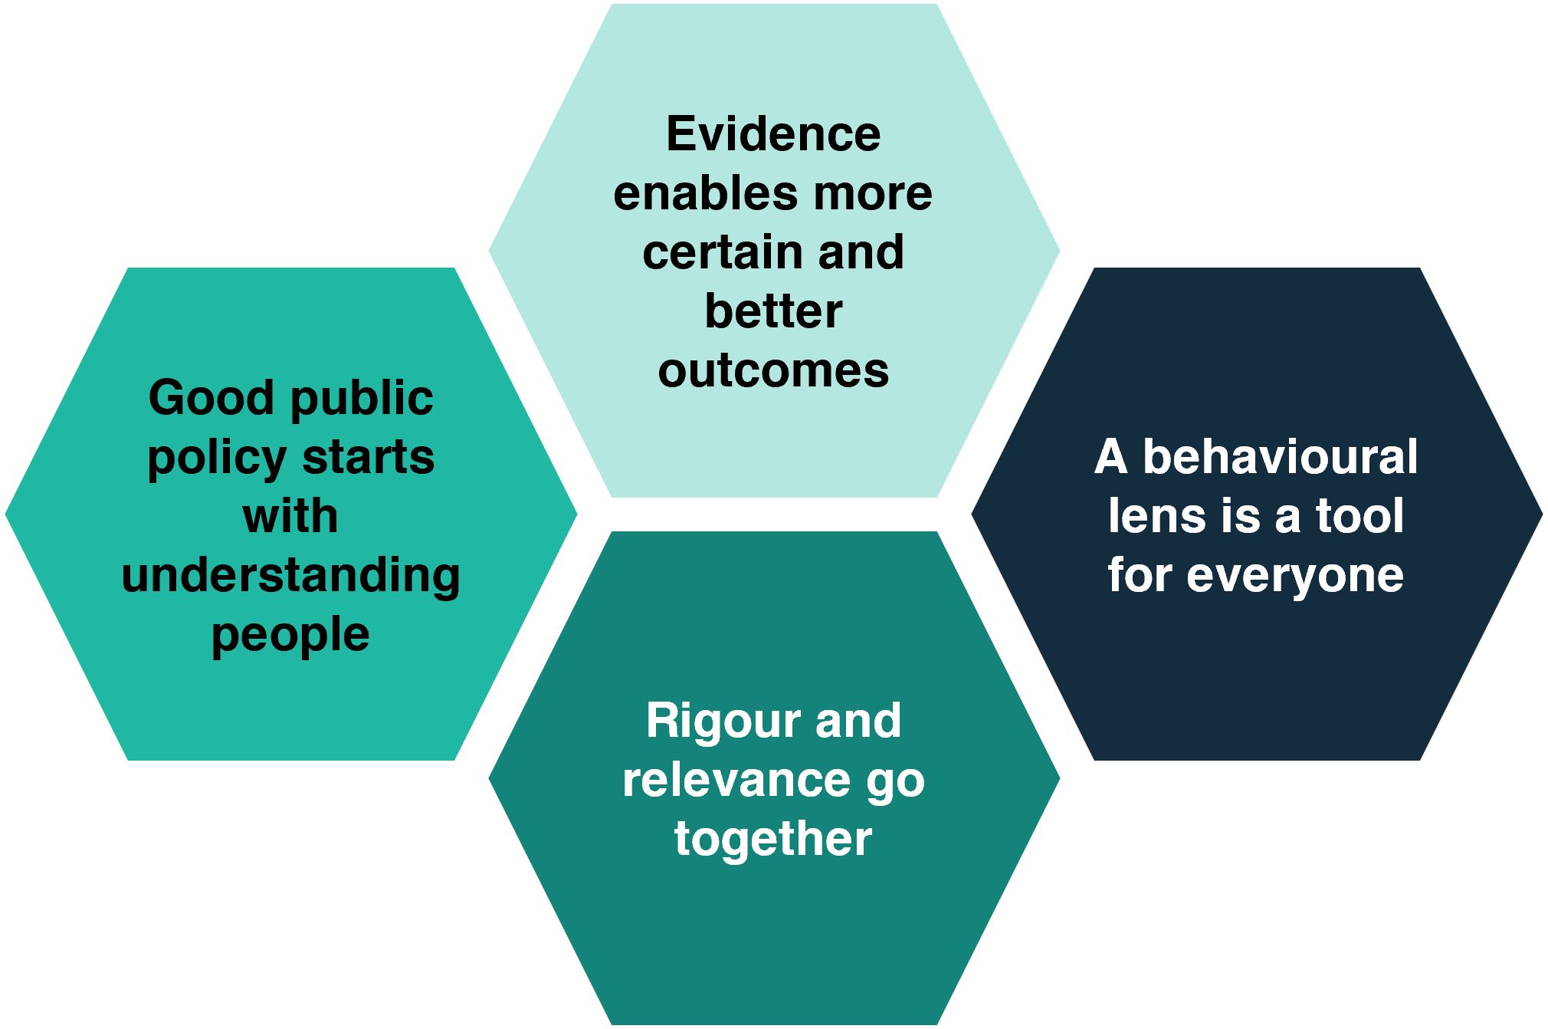

Good public policy starts with understanding people
When policymakers take time to understand human behaviour, appreciate individual contexts and respect people’s expertise on their own lives, they can design policies, programs and services that align with people, rather than expecting people to adjust to systems. The objective of this analysis is not to tell people what to do, but to create conditions in which people can easily make decisions that work for them.
An investment in evidence is essential. Mistakenly believing that we’re on the right track with a policy approach, or that a problem is solved, can be more costly than being sent back to the drawing board.

Ask real people how they think and behave
We want to understand how people actually behave, not how we think people might or should behave. When policymakers consider an issue, it can be easy to assume the people affected are equally invested in the topic with enough time and energy to carefully consider the choices available to them.
Australians are busy – what people prioritise and how they handle competing trade-offs across each choice and decision is unique. Taking the time to consult Australians, as experts in their own lives, can reveal unanticipated complexities and interdependencies. It can highlight what people actually want to do, what’s stopping them and how they want to be helped.
With these insights, we can help to create well-designed supports and systems that enable Australians to navigate complex choices for themselves, their family and their community in a way that respects their agency.
For example, BETA’s research helped prioritise efforts to increase the widespread disclosure of Home Energy Ratings. People told us it was important for them to know a home’s energy rating at the point of sale (86%) and lease (75%). The NSW and Australian governments have since trialled ways home energy ratings can be used and shared during the sale or lease of a property. Read more at p. 34, 10 years of BETA: Case studies.
To ensure we hear from genuine humans, not fabricated responses from artificial intelligence (AI), BETA is moving towards offline verification of our online survey respondents, exploring where we can use administrative data analysis and where possible face to face conversations with people.

Understand people’s context
Designing effective policy requires us to understand the broader context in which people are making decisions. Focusing only on a single task or process gives you an incomplete understanding. It’s important to recognise outcomes are not only shaped by individuals’ decisions, but the broad context they are operating in, including the influences of other people, the design of relevant systems and historical factors.
BETA’s work with the Aged Care Quality and Safety Commission (the Commission) was an example of understanding behaviour in context. To promote aged care safety, aged care providers are required to report serious incidents to the Commission. However, many aged care providers do not report incidents, and others report low-quality information, making investigations and regulatory responses difficult and time consuming for the Commission. Taking a contextual approach, we did not assume that aged care providers were intentionally not complying with the obligations to report serious incidents occurring in care. We spent time observing both providers completing reports and Commission staff assessing them and making regulatory decisions. We found that many of the barriers to accurate, timely reporting stemmed from the design of the reporting process itself. Overly complex legal language in the form created uncertainty, information was requested in ways that did not always align with providers' workflows, and key concepts were interpreted differently by providers and regulators.
Redesigning the process around the needs of both users and the Commission has the potential to reduce regulatory burden while improving the quality and usefulness of the information collected.

Pick the right tool
Viewing policy problems through a behavioural lens helps policymakers select the right tool, or range of tools, for achieving meaningful and sustained change. Crucially, this doesn't always mean a 'behavioural tool'. Understanding people’s behaviour and context can help determine when an individual-level intervention is appropriate, or when more systemic or structural changes (or a combination) are required.
We have seen time and again that research and testing can yield surprising insights that reveal and challenge assumptions.
For example, in our Prompting for a better deal: Understanding and overcoming barriers to financial product switching work we were initially asked to design a prompt to encourage people to switch mortgages and savings accounts. However, with the support of the Treasury, we used a mixed-methods approach to test both prompt designs and explore consumer experiences with switching products. This approach gave us richer and more nuanced findings.
We found that while a well-designed prompt could draw initial attention to the option and benefit of switching, perceived and actual frictions in the switching journey may influence the consumer’s decision whether to ultimately switch products.

Evidence enables more certain and better outcomes
Research can be a valuable tool to help policy advisers better understand a policy issue, its root cause and impacts on Australians, test assumptions, and work out what is more likely to work ahead of implementation.

Reduce uncertainty and test assumptions
Exploratory research and testing can help reduce some of the uncertainties and risks associated with a new intervention. It helps the new policy approaches to be:
- more certain – learning about the real-world consequences of options helps test assumptions that have been made. Even well-considered ideas might not actually work in practice, and the range of results BETA has seen in our trials and the insights from our exploratory research underscore this (BETA 2026b). Our analysis suggests that behavioural interventions cannot be assumed to work equally well across all settings, there is a need to test solutions with people within the specific policy context as a cost-effective way to deliver policy.
- more effective – appreciating the full context of a problem means complexities and challenges can be identified early and better managed in policy design
- more efficient – research helps dedicate limited government resources to policies with the greatest likelihood of success.
Armed with a deeper understanding of the problem and clearer answers on what works, policy advisers can then be more certain about recommending evidence-based options – including exploring and backing in new and innovative policy approaches. Similarly, decision makers can be more confident that the advice they receive is sound and will stand up to scrutiny.
For example, BETA partnered with the Interim Aviation Consumer Ombuds Scheme to build a foundational knowledge-base of Australian aviation consumers’ attitudes, experiences, behaviours and their understanding of consumer rights. This helped inform the design of the new Aviation Consumer Ombuds Scheme.
Read more: Preparing for take-off: Survey of Australians’ air travel behaviour, experiences and attitudes.

Rigour and relevance go together
A tension often exists between producing high-quality insights with research rigour, and producing them at a speed that ensures the evidence is relevant to decision making. For teams generating and applying evidence to policy, getting both right is important to building trust and ensuring the work is useful.

Be ethical
Trust is built when governments make decisions based on evidence and give people a voice in decision making (OECD 2026). Engaging directly with Australians to understand their experiences and views is a key component of applied behavioural science. When working with people, it is important to consider and apply appropriate ethical principles and processes. While BETA obtains ethics approval for all primary research activities through an independent Human Research Ethics Committee, the principles of the National Health and Medical Research Council (NHMRC) National Statement on Ethical Conduct in Human Research 2025 is an important and useful resource to consider for the spectrum of public consultation and engagement activities.
Key ethical principles which can be applied to any engagement with people include:
- considering the merit and integrity of activities – engagement and activities must be worthwhile and justifiable by potential benefit
- ensuring justice – treat people with fairness, ensure there is no unfair burden for participating in activities, and a fair distribution of benefits
- actively doing good (that is, ‘beneficence’) – potential harms should be minimised, and likely benefits must justify any risks of harm or discomfort to participants
- giving respect – recognise the intrinsic value of human beings.
Fundamentally, this means ensuring research and engagement activities with people should have a clear benefit, treat people fairly, minimise risks and respect everyone involved.

Be timely
To be useful for public policy, evidence must be targeted and timely. Data collection and analysis must be tailored to the research aims and the time and resources available. Behavioural science researchers and policy advisers can take steps to work together effectively to identify timely, useful and cost-effectively research activities that can help design evidence-informed policy solutions. These approaches can include but are not limited to:
- where possible, policy advisers engaging with researchers early. Even if it's unclear whether there will be space for research, having researchers involved in the conversation will mean they can jump in quickly when needed and opens the possibility for new evidence to be generated earlier in the policy cycle
- researchers being flexible and pragmatic in their research approach. This includes picking the research method that is the best fit for the question being asked, the point in the policy cycle, and the time and resources available
- researchers, particularly those housed in or alongside policy teams, proactively preparing material on cross-cutting, perennial or emerging policies issues to support timely responses as issues arise.
For example, BETA’s proactive survey High-impact decisions that reduce household emissions in 2023 laid the groundwork for subsequent projects in the energy and environment policy space.
Identifying early the limitations of research is also an important role for researchers. Rushed or poor-quality research can be worse than no research and has the potential to be harmful. Knowing when to not do primary research and recognising and communicating methodological limitations and findings is important to ensure evidence brought to decision-makers is sounds and can be interpreted accurately.

Translate evidence for policy
High-quality research alone is not enough for applied researchers. The value and impact of evidence often relies on how well it can be translated into insights that are actionable or can inform decision making. This requires an understand of existing policy processes and practices and the ability to effectively communicate what research findings fundamentally mean for policy design. These skills can be built by having diverse teams, including those with policy backgrounds, as well as actively upskilling in this area through development and experience.

A behavioural lens is a tool for everyone
Behavioural science specialists can draw on their expertise of behavioural science and research methodologies to provide robust evidence-based advice and rigorous research. However, there are easy and accessible resources that can help all public advisors think about what drives people’s choices and gather evidence to understand the impact of policy proposals in their day-to-day work.

Take simple steps
Broadening your perspective and bringing in a behavioural lens does not always mean taking on a large research project. Simple tools can help to quickly reframe a problem, ask new questions, imagine alternative solutions, and to deliver a policy intervention more effectively. BETA’s Behaviour Discovery Tool lets policy advisors assess whether behavioural insights may be able to help with a specific policy matter and provides simple, practical next steps which can be easily applied.

Other resources
Sludge Toolkit – developed by the NSW Behavioural Insights Unit, this toolkit helps make services easier for customers to find and use.
WISER framework – developed by BETA, this framework helps you write easy and effective forms.

Follow best practice
Thinking about affected people and evidence is a core part of best-practice policy development. Putting Australians, their behaviours, experiences and context at the heart of policy development helps to clarify intended policy outcomes, build an evidence base, design alternative policy options, ensure solutions work in practice, and measure their real-world impact. A behavioural approach also complements other initiatives and frameworks which encourage a people-centred, evidence-informed culture across the APS.

Learn with BETA
BETA is here to help apply a behavioural lens to your work. We try to make it as easy as possible for policy advisors to understand how to apply behavioural science in their own roles.
You can learn with BETA by:
- accessing our range of resources which include guides on form and survey design, and eLearning courses on how to apply a behavioural lens to public policy analysis and to run a behavioural science project
- drawing on the learnings and insights shared in our published reports
- joining our Behavioural Insights Practitioners Network for Commonwealth government employees
- attending our annual public conference, BI Connect, which brings together the best minds in applied behavioural science and public policy.

Ask BETA for help
For specialist and technical advice or collaborating on specific research projects, BETA is here to help the APS tackle policy issues and delivery challenges. We can provide a range of services, from specialist tailored advice to conducting bespoke primary research designed to fit your needs and developing evidence-based interventions which deliver better outcomes for Australians.

Looking ahead
The challenges facing Australians are changing, and BETA will continue to evolve our methods and capabilities to meet them. For example, this may include:
- deepening insights earlier in the policy cycle – where relevant and practical, using more techniques from across disciplines, such as the social sciences, psychology, data science to help gain even deeper insights from the outset of the policy design process
- leveraging existing data – considering the opportunities to make better use of what data the government already has, researchers could help policy advisers better understand enduring and emerging policy problems, adding novel behavioural insight in the policy process
- working with emerging technologies – the increased uptake of artificial intelligence has a number of implications for applied research – how we design and conduct research how we think about AI interaction with people and their decision making.
We remain committed to improving the lives of Australia by generating and applying robust evidence. We look forward to continuing to support Commonwealth entities and collaborating with academia and industry to tackle these new challenges head on and keep Australians’ experiences – how they think and feel – at the heart of Australian public policy.

References
BETA (2026a) 10 years of BETA: Case studies, Department of the Prime Minister and Cabinet.
BETA (2026b) 10 years of BETA: Meta-analysis of our behavioural trials, Department of the Prime Minister and Cabinet.
Farooqui S & Nagendra A (2014) The Impact of Person Organization Fit on Job Satisfaction and Performance of the Employees, Procedia Economics and Finance, accessed 12 October 2026.
Kaiser T, Kloidt J, Mata J and Hertwig R (2025) A meta-meta-analysis of behavior change interventions: Two tales of behavior change, CESifo Working Paper No. 11863, CESifo, accessed 12 October 2026.
Mackey W (2024), Labour market matching across skills and regions in Australia, The Department of the Treasury, accessed 24 September 2026.
Mertens S, Herberz M, Hahnel UJJ and Brosch T (2022) The effectiveness of nudging: a meta-analysis of choice architecture interventions across behavioral domains, Proceedings of the National Academy of Sciences, 119(1):e2107346118, accessed 12 October 2026.
NHMRC (National Health and Medical Research Council) (2025), National statement on ethical conduct in human research, NHMRC website, accessed 24 September 2026.
OECD (Organisation for Economic Co-operation and Development) (2026), OECD Survey on Drivers of Trust in Public Institutions 2026 Results: Navigating Rising Expectations and New Horizons, OECD website, accessed 25 September 2026.
Puig-Barrachina V, Giró P, Artazcoz L, Bartoll X, Cortés-Franch I, Fernández A, González-Marín P & Borrell C (2020), The impact of Active Labour Market Policies on health outcomes: a scoping review, European Journal of Public Health, vol. 30, no. 1, pp. 36-42, accessed 24 September 2026.
Rehill P, Slaven E, Greenwell H, Bowers P, Copley S & Williams E (2025), Randomised trials in Australian public policy: a review, Australian Centre for Evaluation, The Department of the Treasury, accessed 25 September 2026.

Tell us how you’re using this report via a short survey below:


Other uses
Enquiries regarding this license and any other use of this document are welcome at:
Executive Director
Behavioural Economics Team of the Australian Government
Department of the Prime Minister and Cabinet
1 National Circuit
Barton ACT 2600
Email: beta@pmc.gov.au
The views expressed in this paper are those of the authors and do not necessarily reflect those of the Department of the Prime Minister and Cabinet or the Australian Government.

Report team
Staff who contributed to the report were: Ruisi Chen, Cale Hubble, Josefine Lederer, Dr Thomas Valentini, Dr Angela Bender, Dr Bethany Jones and Madelaine Magi-Prowse

Acknowledgments
Our deepest gratitude to all of BETA’s project partners who have collaborated with us over the last ten years. Their subject matter expertise, curiosity and openness have been critical to driving applied behavioural public policy, and ensuring BETA’s research ultimately improves the lives of Australians.
Many thanks to the past and present members of BETA’s Academic Advisory Panel for their support and guidance: Professor Nicholas Biddle, Distinguished Professor Bronwyn Carlson, Professor Swee-Hoon Chuah, Professor Uwe Dulleck, Professor Michael J. Hiscox, Professor Jolanda Jetten, Professor Ben Newell, Professor Kate Reynolds, and Professor Robert Slonim.
Finally, thank-you to the past and present staff of BETA who have contributed to the past decade of work by bringing deep expertise, dedication and a commitment to doing research to help Australians. At time of publication BETA’s staff include: Joanna Abhayaratna (Executive Director), Carissa Adams, Katie Anderson-Kelly, Dr Angela Bender,
Laura Bennetts-Kneebone, Dr Annalese Bolton, Dr Jacqui Brewer, Abigail Chan, Ruisi Chen, Riley Childs, Dr Aurore Chow, Lindsey Cuthbertson, Rachelle Damm, Anton J Falez,
Shae Ffrench, Lachlan Gault, Nicholas Hilderson, Dr Julia Hinsliff, Cale Hubble,
Dr Bethany Jones, Dr Su Mon Kyaw-Myint, Josefine Lederer, Dr Dana Leidl,
Madelaine Magi-Prowse, Connor Morrison, Haris Rao, Michael Ridgway, Andrei Turenko,
Phi Vu, Dr Thomas Valentini, Parima Vyas, Dr Hanne M Watkins.

Use of Artificial Intelligence (AI)
During the preparation of this work, the author(s) used Microsoft 365 Copilot Chat (various versions between June and September 2026) to provide alternative wording for sentences, check spelling and grammar. After using this tool the author(s) reviewed and edited the content and assume full responsibility for the content of the paper.
ISBN 978-1-925365-93-1 10 years of BETA: Putting people at the heart of policy

Copyright Notice
With the exception of the Commonwealth Coat of Arms, this work is licensed under a Creative Commons Attribution 4.0 International license (CC BY 4.0) (https://creativecommons.org/licenses/by/4.0/)


Third party copyright
Wherever a third party holds copyright in this material, the copyright remains with that party. Their permission may be required to use the material. Please contact them directly.

Attribution
This publication should be attributed as follows:
© Commonwealth of Australia, Department of the Prime Minister and Cabinet, 10 years of BETA: Putting people at the heart of policy, 2026.

Use of the Coat of Arms
The terms under which the Coat of Arms can be used are detailed on the following website: https://pmc.gov.au/cca

Behavioural Economics Team
of the Australian Government
General enquiries beta@pmc.gov.au
Media enquiries media@pmc.gov.au
Find out more www.pmc.gov.au/BETA

See 10 Years of BETA: Meta-analysis of our behavioural trials for details of the meta-analysis of BETA's 10 years of RCTs. Meta-analysis combines results from multiple studies to estimate an overall average intervention effect.
‘Behavioural trials’ refer to instances where we tested an intervention designed by BETA
National Statement on Ethical Conduct in Human Research 2025 pp. 11-12.

