Case studies
November 2026

About BETA

Who we are
Good policy starts with understanding people. The Behavioural Economics Team of the Australian Government (BETA) helps Australian Government departments and agencies understand how people interact with policies and programs, so they can be improved to better fit Australians’ needs.
By better appreciating where people are coming from, and where they want to go, we can design government policies, programs and services to align with people – rather than expecting people to change. This means understanding how people actually behave, not how we think or assume they should act.
Drawing on a broad range of fields – psychology, economics, sociology, neuroscience, anthropology and others – we design interventions grounded in an understanding of human behaviour and respecting people’s autonomy, interests and preferences. We also test our interventions to see what works, ensuring the Government is investing in policies and services that work and improve the lives of Australians.
To learn more about BETA, please visit our website: https://www.pmc.gov.au/beta

Contents
BETA helps Australians prosper 3
BETA improves government services 10
BETA supports Australians’ wellbeing 21
BETA makes life easier for Australians 36
BETA supports a more inclusive and productive workforce 43
BETA builds APS capability 53


BETA helps Australians prosper

Empowering consumers to get a better energy deal

Policy context
To get the best energy deal, consumers need to walk away from their current more expensive plans. But many consumers never switch. Shopping around takes a lot of time and effort, especially when energy plans are complex, retailers bundle products and services together, and there’s an overwhelming number of choices and options. Australians who don’t actively switch energy plans are the most likely to be on plans that cost them hundreds of dollars more each year than the more competitive options – even from their own retailer.

What we did
Improving the energy market has been one of BETA’s longest workstreams – we began testing consumer fact sheets for the Australian Energy Regulator (AER) in 2017. In 2021, we tested a message the AER could put on energy bills telling people how much they could save by switching to their retailer’s cheapest plan. The message also encouraged them to compare to other retailers by visiting Energy Made Easy, a government comparison website that we helped redesign to make it easier to use. We tested our proposed bill and website changes using survey experiments with over 15,000 Australians, then evaluated them as they were rolled out in practice.

What we found
Our early testing found that switching plans was not top of mind for most people when thinking about ways to save money or reduce their energy costs – most people thought about cutting down on their energy use. But seeing a ‘better offer message’ on a bill made people 2 to 3 times more likely to consider switching plans.
On the Energy Made Easy website, we found consumers who choose to search using their National Metering Identifier number were able to more easily access accurate search results of all the best value energy plans, so we recommended making that the default search option. We also found that people were reluctant to switch if they couldn’t see how their own retailer compared. Showing people how much they could save made them more confident.
‘This research shows design principles work, with plain language, logical structures and visual cues improving customer understanding and supporting informed decision-making.’
AER Retail Guidelines, Notice of Draft Instrument (2026)

Impact
Hundreds of thousands of Australians are saving money on their energy thanks to the changes BETA designed and tested. After the better offer message became mandatory on bills in 2023, 8 out of 10 households in the National Energy Market received a message telling them they could save by switching to a cheaper plan with their current retailer. Potential savings with the same retailer were $291 per year on average for households. Over 2024 to 2025, the proportion of residential customers on their retailer’s best offer increased from 19% to 27%.
Some households took the additional step of visiting Energy Made Easy. One in 5 searches in 2024 came from people who visited the site after seeing the message on their bill – around 200,000 people. And people got more out of the website while there: because it was now easier to do, the number of people choosing to use their National Metering Identifier number to search for energy plans increased by more than 25 percentage points, and there was a three-fold increase in the number of people completing a search and perusing plan details.
Figure 1 The better offer message boosted the proportion of Energy Made Easy users who came to the website because they saw a message on their bill
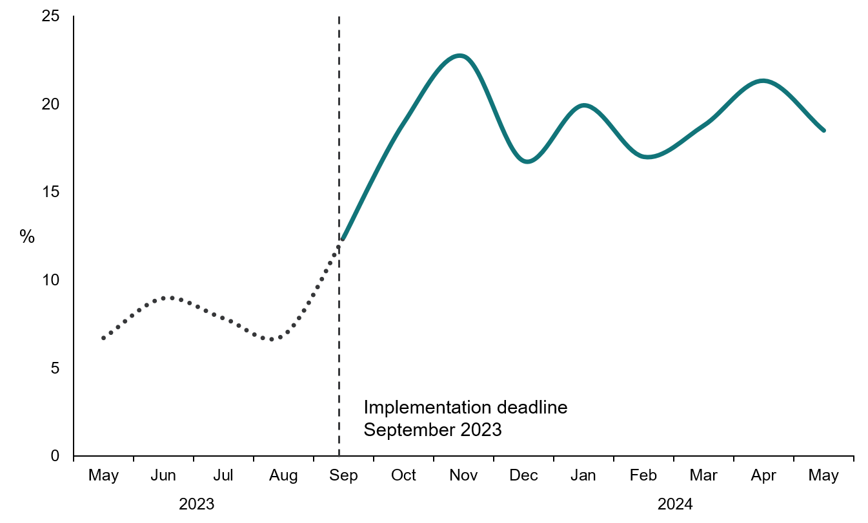
Read the report: Better Bills impact report
Read the report: Empowered to switch: Energy made easier
Read our blog: Energy made easier: Helping consumers switch energy plans

Helping Australians avoid junk insurance

Policy context
The Australian Securities and Investments Commission (ASIC) was concerned about add-on insurance. ASIC had found that insurance offered as an ‘extra’ to the main purchase (for example, consumer credit insurance sold with a loan) was often sold using high-pressure sales tactics, while providing poor value for money. The Financial Services Royal Commission (2017) shared these concerns and recommended a deferred sales model, intended to give consumers space to consider add-on insurance purchases separately from the purchase of the main product. New legislation in 2020 introduced a four-day deferred sales period and empowered ASIC to specify the details of an information statement that providers of add-on insurance must give to consumers at the start of this period. ASIC wanted to know how the statement given during this time could best help consumers. So, they partnered with BETA to design an effective information statement and to test several potential features.

What we did
In 2020, BETA undertook consumer testing with 6,243 Australians. We measured what effect seeing an information statement had on people’s decision to buy add-on insurance in a hypothetical online shopping scenario (involving buying a phone, buying flights, or getting a loan). We also tested how different design and information features influenced consumers’ decisions.
Figure 2 Information statement tested with consumers
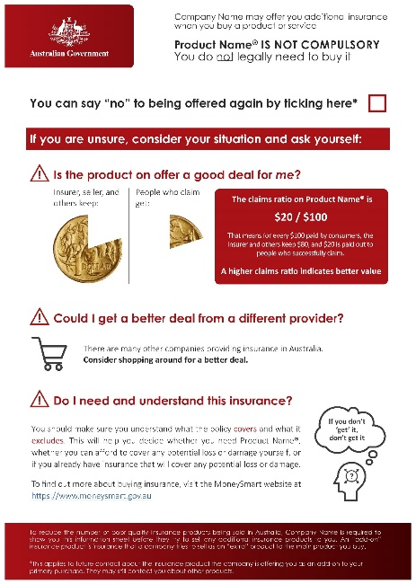

What we found
People who saw an information statement were 24% less likely to purchase add-on insurance, compared to those who did not see a statement. Our designs were all effective: we found no evidence that specific features of the statement, such as the colour or including a claims ratio, had any additional effect on helping consumers to reject poor-value add-on insurance.

Impact
BETA and ASIC’s collaboration has helped ensure Australian consumers receive helpful information about add-on insurance at a critical point in their decision-making. Insights from BETA’s work informed the development of ASIC’s mandatory information statement, which includes several key elements that consumers found helpful in our testing (such as the prominent heading, ‘You can say no’).
The information statement, coupled with the mandated time-lag between the product purchase and add-on insurance sale, helps empower consumers to decide to not purchase products that are not right for them. The deferred sales model is likely to be one of the factors driving the dramatic shrinking of the consumer credit insurance market in recent years.
Read the report: Supporting consumer decision-making about add-on insurance
Read our blog: Slow down, shop around: supporting decision-making about add-on insurance

Saving Australians money on foreign exchange

Policy context
Australians transfer tens of billions of dollars to family and friends overseas each year. But international money transfer (IMT) services can be confusing. IMT calculators differ from provider to provider, making it hard for Australians to pick which provider is offering them the best deal.

What we did
Looking to increase competition and value for Australians, the Australian Competition and Consumer Commission (ACCC) asked BETA in 2023 for help testing potential changes to IMT calculators. We designed 7 alternative calculators to address the issues identified in earlier ACCC qualitative research. Then we ran online survey experiments with over 5,600 Australians to test which of the 7 calculators made it easiest for Australians to spot the best value offer.

What we found
If you can, change the world to suit people, rather than trying to change people to suit the world. BETA’s testing found that people naturally make the best choices when the decision is set up to match their heuristics.
When we showed people calculators resembling those in use in the market, people only picked the best-value option about 47% of the time. This jumped up to 85% accuracy when we showed people sets of calculators that consistently subtracted fees. When fees are consistently subtracted, people can rely on the amount received by the recipient – a common heuristic – to accurately guide them to the highest value offer.
BETA’s research also challenged the common assumption that simply giving consumers more information helps them make better decisions. We found that showing consumers information about the mark-up on the mid-market IMT rate did not help – people rated this as one of the most confusing aspects of our calculator designs. This is why we test.
Figure 3 One of the calculators BETA tested
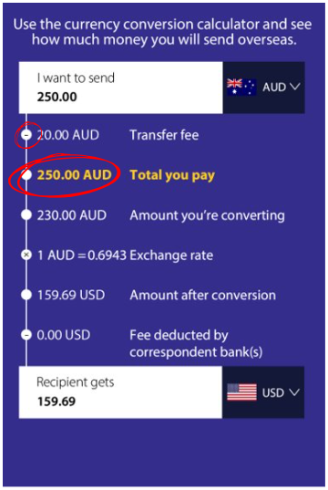

Impact
Better calculators make it easier for Australians to send as much as they can to their friends and family overseas. In 2024 the ACCC updated their best practice guidance for IMT suppliers to draw on BETA’s results – including a recommendation to subtract fees. The ACCC estimated that these improvements could save consumers $200 million every year. The clarity and insights this trial gave to the ACCC has also inspired them to continue incorporating more testing and evaluation in their work.
Read the report: Increasing transparency of online foreign exchange calculators

BETA improves government services

Reducing stigma and promoting dignity in government service delivery

Policy context
Australians should feel safe and comfortable to seek government support. But Royal Commissions`` have heard from people who both anticipate and experience stigma when accessing government services. Customers can feel judged, distrusted and unfairly treated by systems intended to support them, contributing to reduced uptake, poorer wellbeing, and disengagement from assistance.

What we did
In 2024, it remained unclear to some agencies how government services stigma was established, driven and perpetuated, making it hard for agencies to know how to respond. With contributions from Services Australia, BETA conducted a literature review on the drivers and impacts of government services stigma, as well as potential intervention points. We distilled the literature into a one-page framework tailored to the Australian context, with advice on where evidence-informed interventions to promote customer dignity would be most feasible and impactful.
Figure 4 BETA’s report includes a one-page guide for reducing stigma
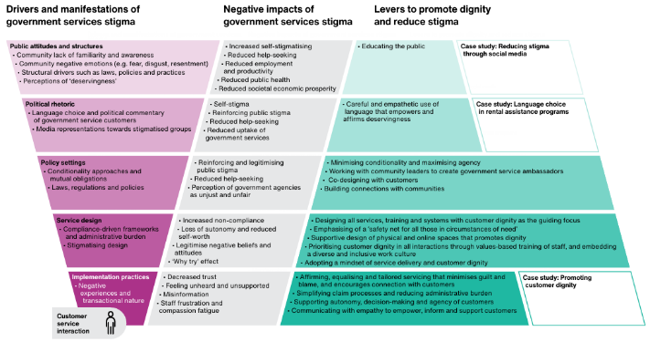

What we found
Stigma in government services is driven by public attitudes, political rhetoric, policy settings and service design choices. Stigma commonly manifests through compliance-focused approaches, conditionality, administrative burden and stigmatising language. Experiences of stigma contribute to customers internalising stigma, apathy, reduced help-seeking and intentional non-compliance. These experiences also contribute to broader impacts on employment, health and economic outcomes.
While many structural drivers of stigma sit outside agencies’ control, service design and delivery choices can either reinforce or reduce stigma. Agencies can focus on promoting customer dignity as a more accessible way to operationalise reducing stigma. Approaches that are associated with reduced stigma include:
- using non-stigmatising language
- creating supportive spaces (both welcoming physical settings and accessible online experiences)
- emphasising universality where possible, or framing a service as a safety net available to anyone who may find themselves in need of support
- adopting service-oriented (rather than purely compliance‑driven) approaches.

Impact
BETA’s work repositioned stigma as a service design and delivery issue that agencies can actively address, rather than an abstract societal problem beyond their influence. The reframe from ‘reducing stigma’ to ‘promoting dignity’ made it more concrete and actionable, enabling agencies to identify changes they could make to support respectful interactions.
As a result of BETA’s work, the APS Experience Design Principles explicitly call for physical and digital spaces that promote dignity and reduce stigma. The principles advise APS staff to empower and respect customers by prioritising their needs, promoting compassion, and minimising power differentials between government and customers.
Services Australia is working to embed the principles into their organisational strategy and assurance processes. They have developed a Customer Experience Standard as a tool to explicitly guide initiatives to embed the principles in service design. Project teams are now tracking how their work is embedding the principles.
Read the report: Stigma in government services literature review
Read our blog: Stigma in government services

Making government forms easier for everyone

Policy context
Forms are a major way that Australians interact with government every day. When they’re well designed, forms save people time, make it easier for people to access services and entitlements, build trust in government and free up public resources. Unfortunately, not every form tells this story. Since BETA's inception, agencies have frequently sought our advice on improving forms and customer interactions. In 2019, we decided to tackle forms head-on with an ambitious, APS-wide capability-building effort.

What we did
BETA held ‘Form-a-Palooza’ on 28 June 2019, inspired by a similar event hosted by the Mayor of Washington, DC in 2017. More than 200 APS staff from 38 agencies participated, creating one of the earliest large-scale opportunities for public servants to apply behavioural insights to a practical service design challenge. At the event we launched BETA’s own five-step framework for how to improve forms, called ‘WISER’ (Who, Introduction, Structure, Expression, Repeat).
APS agencies nominated forms to be worked on at Form-a-Palooza. Trained facilitators guided groups of participants in using WISER to review each of the 5 selected forms, which included forms about child support, aged care, veterans and scams.
Figure 5 The WISER framework in use
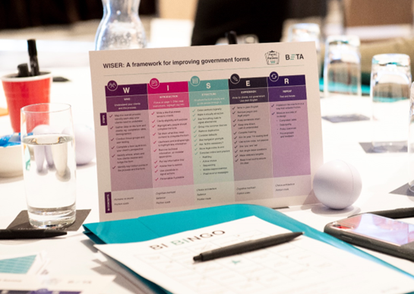

Impact
Form-a-Palooza helped to mainstream a customer-focused mindset across the APS by making behavioural insights tangible and practical. The event built attendees’ capability and reoriented them towards users’ perspectives. BETA’s WISER guidance remains a go-to resource for APS form development with over 1000 website downloads.
‘I still rave about Form-a-palooza as one of the most useful events I have ever attended. These days I find, download and share the resources created from that event with colleagues, new starters, business areas and service designers every time we encounter a problem with a form (and that’s a lot).’
Mia Richter, Department of Home Affairs, February 2026
Feedback from participants on the day was overwhelmingly positive: one form owner said it was the best thing their department had ever participated in. BETA also synthesised attendees’ feedback into over 60 actionable recommendations for the form owners, many of which were taken forward in later updates to the forms. These practical and tangible changes have made it easier for Australians to engage with government.
Read the WISER guide

Minimising errors when registering personal property

Policy context
Governments contribute to economic growth by ensuring the systems, rules and safeguards are in place for fair and transparent commerce. The Personal Property Securities Register (PPSR) supports secured lending, helping people and businesses protect their security interests and make informed purchasing decisions. Users register security interests on the PPSR by completing an online form managed by the Australian Financial Security Authority (AFSA).
AFSA commissioned BETA to understand why some businesses were creating inaccurate registrations. Even a small mistake could make a registration ineffective, potentially affecting a person's or business's legal rights and exposing them to financial risk. This could be particularly problematic for small businesses, which may be more vulnerable to financial losses.

What we did
In 2019, we interviewed personal property securities lawyers and advisers, small and large businesses, and AFSA’s Service Centre staff. We also analysed 2.7 million registrations and provided AFSA with recommendations to improve the registration process.
AFSA implemented changes they expected to benefit infrequent users without impacting regular users, such as adding a visual depiction of the process. There were 2 recommendations AFSA were less sure about and wanted us to test further through randomised controlled trials:
- A new layout with error-warning prompts. We introduced a more intuitive way for users to identify the grantor. We also added 5 customised prompts that appeared when the user appeared to make a mistake.
- A new review step. We required users to confirm details about themselves, the property being registered and the grantor. And we introduced a new pop-up alerting users that incorrectly completed registrations may not be effective.
Figure 6 BETA tested error-specific, customised prompts
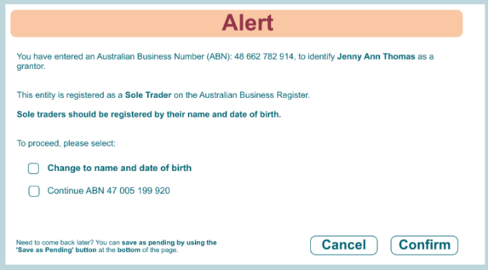

What we found
The best results came from simple changes that provided the right information just when the user needed it. The new layout and prompts almost halved the number of incorrect registrations: around 22% of registrations completed using the existing process contained errors, compared with 13% of transactions completed using the redesigned page. But introducing a review step did not reduce the rate of incorrect registrations.
Figure 7 The new layout and prompts halved errors
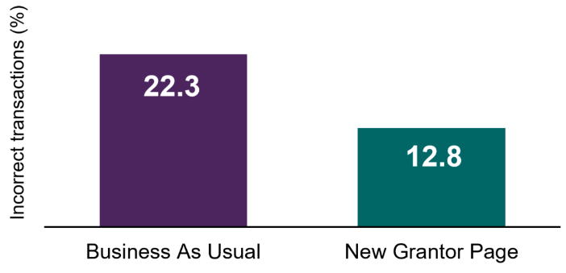

Impact
Based on BETA’s work, AFSA updated key elements of the registration process, including simplifying language, explaining key concepts and improving the layout, to help users complete registrations accurately and confidently. After the new layout and prompts were rolled out to all users in July 2022, AFSA saw the most common errors reduce by half.
AFSA’s use of BETA’s research to assist users helped them win a Merit Award from the International Association of Commercial Administrators. The project continues to support AFSA’s efforts to become a more evidence- and data-driven organisation.
Read the evaluation report: Introducing behavioural insights to the Personal Property Securities Register
Read the research report: Applying behavioural insights to the Personal Property Securities Register

Supporting people and businesses to adopt a new process

Policy context
Australian veterans with a service-related injury or condition may be eligible for Government-funded at-home support such as cleaning, shopping or gardening. In 2024, the Department of Veterans’ Affairs (DVA) was seeing increasing demand for these household services, leading to a backlog of invoices awaiting processing and payment. To make this process more efficient, DVA decided to transition all household services invoices to its online Provider Upload Page (PUP).

What we did
To help household services providers and clients adapt to the new process, DVA asked BETA to apply a behavioural science lens to their transition and communication approach. We suggested DVA:
- Reduce friction points and barriers (such as difficult-to-understand text) in the new portal
- Invest time to train DVA staff who play a supporting role
- Extend the timeline to allow greater lead time between communication and implementation
- Front-end communication as much as possible to help providers and clients prepare and increase the number of reminders about the upcoming change.
Figure 8 DVA’s online document upload service
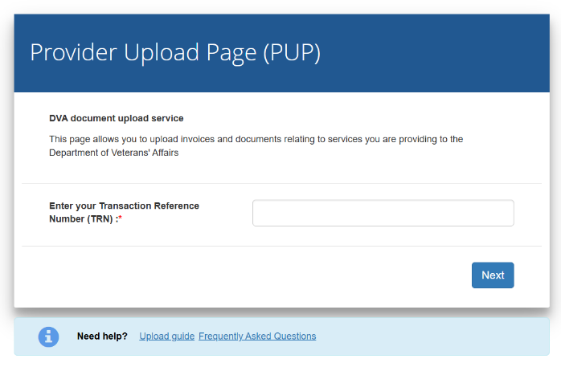

Impact
DVA oversaw a smooth and supported transition to the new process, which enabled them to eliminate the backlog of household services invoices. In particular, BETA’s advice to provide greater time for early communication and engagement was key to the success of the transition. Working with BETA has supported a change in mindset for our partner teams in DVA. It encouraged them to continue focusing on identifying and addressing root causes for provider behaviours and considering what needs to change in their communications. This proactive, curious and people-centred approach is a great example of behavioural public policy in practice.

Encouraging farmers to share their stories with government

Policy context
Every year, thousands of farmers sit down with researchers from the Australian Bureau of Agricultural and Resource Economics and Sciences (ABARES) to share details about their farm’s performance in the previous year. These surveys have been running for 70 years, producing a rich and valuable data asset that enables government to make careful, informed decisions about issues affecting our agricultural industries.
However, ABARES has experienced a decline in the number of farmers agreeing to participate, making it harder for them to produce reliable insights for decision-makers in government and industry. The overall response rate steadily fell from 84% in 2018 to 51% in 2024, driven largely by an increase in refusals. In 2025, ABARES came to BETA for advice on how they might turn this trend around.

What we found
ABARES was facing a challenge also seen by other survey organisations: participation rates are declining as people are asked to complete more surveys than ever before. This means there is rarely a single cause, or a simple solution, when response rates fall.
Within this broader context, BETA found opportunities to improve the effectiveness of how ABARES was engaging with farms to participate in the survey. ABARES’ initial approach letters were formal and difficult to understand, and they did not make the benefits of participation salient to farmers. We also noted that other government surveys generally invested more in incentivising participation, and that their surveys were significantly shorter. We suggested that ABARES adopt a more personable tone in their communications, reduce jargon and address common questions upfront – including in an attached brochure explaining how the data is used and why it is important. We also suggested modest rewards for participating, such as gift cards or a prize draw.

Impact
More farmers are starting to give ABARES their time again, meaning government and industry decision makers can have more confidence in ABARES’ data and insights. BETA’s advice supported ABARES’ efforts to address the decline in farmers participating. ABARES’ survey collectors conducting interviews found farmers to be more engaged than previous years. ABARES’ 2025 surveys saw a modest increase in the response rate (up 1 percentage point on the year before), driven partly by fewer eligible farmers refusing requests to participate (down 2 percentage points).
Figure 9 ABARES’ new leaflet for potential respondents
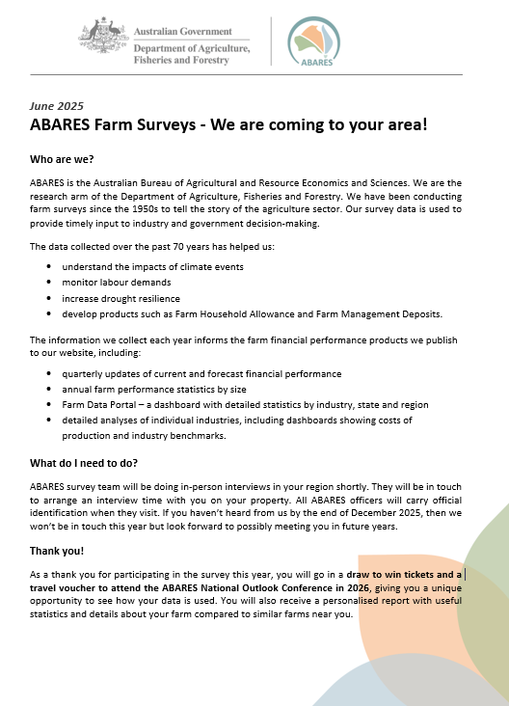
ABARES immediately applied many of BETA’s suggestions to their 2025 surveys. They refreshed their approach letters, emphasising the value of participation using simple language and a friendly tone, and included an accompanying leaflet answering common questions. ABARES also put respondents in a draw to win tickets and a travel voucher to attend the ABARES National Outlook Conference in 2026. The farmers who attended were enthusiastic about seeing how their data was used and went home knowing that their voices mattered.

BETA supports Australians’ wellbeing

Enabling victim-survivors to get the support they need

Policy context
Family and domestic violence (FDV) can have far-ranging impacts across all aspects of victim-survivors’ lives – including their work. In 2023, new legislation commenced giving Australian employees access to 10 days paid FDV leave, enabling victim-survivors to make arrangements for their safety and access services such as police, medical and legal support without sacrificing income.

What we did
In 2024, the Department of Employment and Workplace Relations (DEWR) asked BETA to conduct qualitative and quantitative research to understand the impacts of the new paid FDV leave provisions on employees and employers, to inform an independent statutory review by Flinders University. BETA conducted interviews and surveys with both victim-survivors and employers. We researched key areas such as attitudes and awareness, uptake, barriers and challenges, impacts, understanding and views of leave parameters and other supports. We also ran an online experiment to test if teaching Australian workers about the new legislation could help reduce workplace stigma and discrimination.

What we found
We discovered that the leave was indeed supporting victim-survivors in crisis and had strong support from both victim-survivors and employers. Uptake was low, but those who had used it saw profound benefits. In the words of one victim-survivor, ‘this leave has given us the job security and also given us confidence that despite whatever we are going through as victims, that the government is offering us support.’ And our experiment suggested that the existence of the entitlement may help reduce workplace stigma: workers who read about the entitlement evaluated a fictional victim-survivor’s work performance more positively.
BETA identified several opportunities to strengthen the leave’s impact, such as promoting existing supports and resources for employers and managers, reducing barriers associated with providing evidence, and raising awareness (particularly for casual employees).

Impact
BETA brought victim-survivors’ stories into policy discussions, directly informing the actions Australian Government agencies have taken. BETA’s research was the main evidence base for the Independent Review into paid FDV leave, which reaffirmed many of the issues we had identified. The Government agreed to all the Independent Review’s recommendations and is now implementing them. For example, agencies have produced better resources for small businesses and improved guidance for casual workers to address the confusion and misconceptions BETA uncovered on who can access paid FDV leave. Following the review, the Fair Work Ombudsman also undertook awareness-raising activities about the entitlement, including a number of social media posts (between November 2024 and October 2025) that made over 6.3 million impressions.
Figure 10 Social media post from the Fair Work Ombudsman
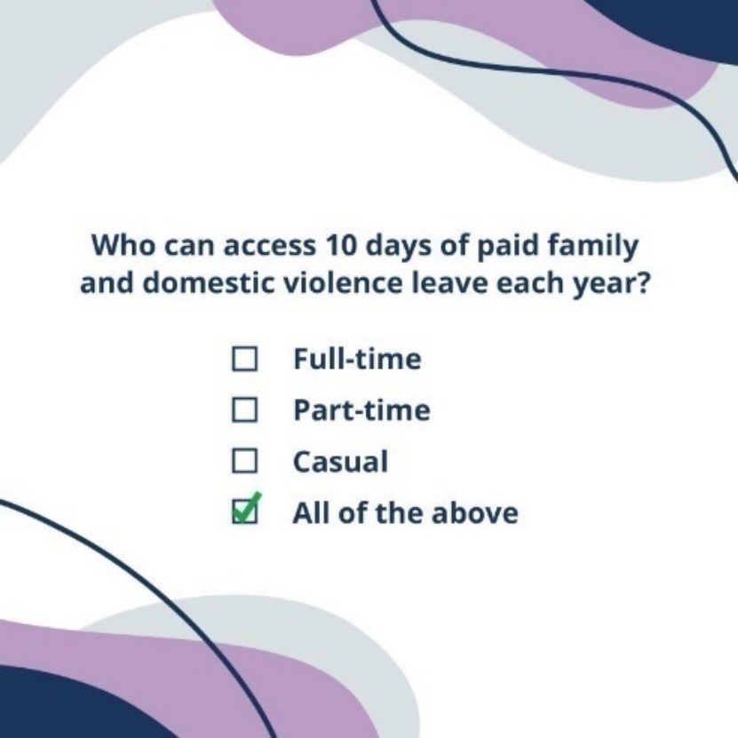
BETA’s research has also been a key input into the more recent Review of the Closing Loopholes Acts, which included paid FDV leave.
Beyond paid FDV leave, seeing the unique insights from BETA’s primary research and testing has encouraged policymakers in DEWR to bolster their research and data capability, look beyond their usual data sources, and interrogate problems in new ways.
Read the report: Paid family and domestic violence leave
Read our blog: Supporting victim-survivors: The power of the paid family and domestic violence leave entitlement to create more compassionate workplaces

Helping online gamblers moderate their betting

Policy context
Rates of online gambling have increased over the past decade. It is also associated with high rates of risky gambling for those who bet online on sports or races at least monthly. Easy, unlimited access through mobile devices can lead to excessive spending and harmful consequences. In 2018, all Australian jurisdictions agreed on a national consumer protection framework for online wagering. The framework called on state and territory governments to mandate that gambling providers give consumers regular activity statements detailing their spend, wins and losses. Crucially, the framework called for trialling and testing specific features of these statements. The Department of Social Services commissioned BETA to do this testing.

What we did
In 2020, BETA designed 2 prototype statements using different features, drawing on previous literature, the expertise of our Academic Advisory Panel, and new user research (interviews, focus groups and eye-tracking). To test our designs, we then built a simulated horse racing platform that mimicked real online wagering (without using real money).
Figure 11 Activity statement tested with consumers
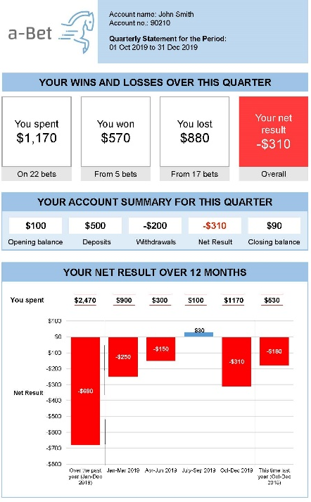

What we found
Our activity statements both reduced betting and were welcomed by users. Statements that included a graph reduced amounts bet by about 8%. And 9 in 10 of the online wagering consumers in our study said they would like to receive the statements in real life. BIT found similar results in the United Kingdom when they tested an adapted version of our statement with a simulated poker machine.
‘I think this is a good reality check for people as a few dollars here and there mean not much, but when you see these big numbers they really stand out and make you question your behaviours.’
Online wagering consumer in BETA’s research

Impact
Online wagering consumers across Australia are now receiving activity statements informed by BETA’s work, helping them monitor their betting and make informed decisions. Activity statements were made mandatory across Australia in 2022, with BETA’s best-performing design promoted as a preferred example of good practice. In 2024, the Victorian Government updated their guidance to ensure that activity statements stick more closely and consistently to BETA’s design.
Academic survey research in 2024 suggests the statements are making a difference. About 6 in 10 online wagering consumers reported opening their statements at least sometimes. Of those who opened them, 18% reported that they decreased their gambling.
Read the report: Applying behavioural insights to online wagering
Read our blog: Behavioural insights help people to bet within their budget

Encouraging organ donation

Policy context
Thousands of Australians are on a waitlist for an organ transplant every year. But while 4 in 5 Australians support donation, in 2021 only 1 in 3 have actually registered to be a donor. Registering has a direct impact on increasing the number of organ donors: 8 out of 10 families say yes to donation when their relative was a registered donor, compared to 6 in 10 when they otherwise know the relative wanted to donate, and 4 in 10 when the family is unaware. In 2021, the Organ and Tissue Authority (OTA) was concerned that young adults had even lower registration rates. The OTA wanted to better understand young adults’ perspectives and experiences, to inform their annual DonateLife Week awareness campaign.

What we did
BETA discussed organ donation with small groups of young adults. Then we tested 3 messages in an online survey experiment with 762 young adults to see which led to the biggest increase in intentions to register as a donor.

What we found
Focus on what people do, not just what they say. While many young adults liked messages that incorporated humour (‘Know that your heart will go on’), our survey experiment found the most effective message was one that emphasised ease of access (‘Registering is easy and only takes one minute’). Young adults don’t expect registration to be easy. BETA’s research found that dispelling this misapprehension could boost registration rates. We also found that many young adults would welcome being prompted to register as a part of other government processes, such as through Medicare.
Figure 12 BETA’s message is still in use on donatelife.gov.au


Impact
The messages BETA tested have been so successful that the OTA is still using them today.
The OTA incorporated BETA’s findings into their 2021 DonateLife Week campaign, alongside a refreshed brand, compelling call to action, and strategic partnerships to reach Australians who have no or low awareness about organ donation registration. This comprehensive campaign saw almost 110,000 new registrations, an increase of 95% on 2020 results. Almost 22,000 of these new registrations were young adults (a 78% growth on the previous year).
A subsequent DonateLife campaign in 2021 and 2022 focused on public bathrooms also used messages drawing on BETA’s research. An evaluation found that these advertisements created high recall, strong message comprehension and meaningful engagement – especially for younger adults.
Read the report: Improving organ donor registration among young adults
Read our blog: How we used behavioural insights to encourage organ and tissue donor registration among young adults

Informing pandemic responses by understanding real-time behaviours

Policy context
COVID-19 triggered a time of high uncertainty for Australians and policy makers. Australians were suddenly asked to rapidly change their behaviour to slow the spread of the virus and reduce pressure on our health system. BETA identified the need for real-time behavioural data to enable the government to make responsive decisions informed by an accurate picture of what people were doing and why.

What we did
In March 2020, BETA quickly designed and launched a weekly survey – the COVID-19 Barometer. Each week we asked a new sample of 2,000 Australians about their behaviours and attitudes in response to the pandemic, with a particular focus on protective health behaviours like social distancing. We rapidly analysed the responses to ensure timely delivery of insights and their policy implications. We ran the survey between March and June 2020, when we handed it over to the Department of Health.

What we found
We found that protective behaviours slowly decreased as the initial wave subsided and the perceived threat within the community diminished. Compliance was higher when people understood the benefits, trusted authorities, perceived COVID-19 as a threat, saw others complying, and faced fewer barriers to action. The Barometer also identified differences across population groups and emerging misconceptions about COVID-19, enabling BETA to provide timely advice to decision makers on targeted communication approaches and areas where additional public information was needed.
Figure 13 Compliance with protective behaviours early in the COVID-19 pandemic
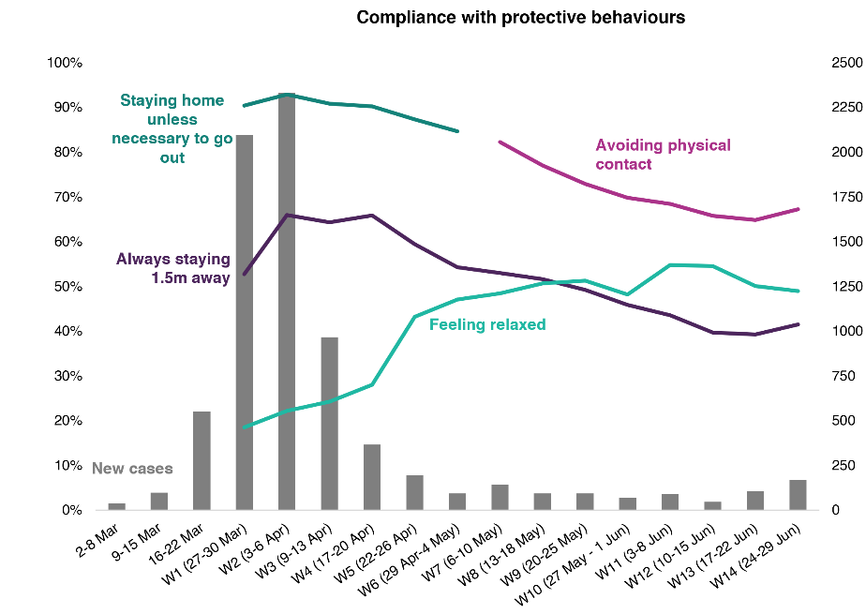

Impact
BETA’s survey data was incorporated into the epidemiological models developed by the Doherty Institute, the Melbourne School of Population and Global Health, and their collaborators. Outputs from these models went to the Prime Minister, National Cabinet and other bodies, and were a key input into policymakers’ decisions around pandemic response measures. Australians’ ability and willingness to stay distant from others (among other protective health behaviours) was a major driver of the spread of COVID-19. BETA’s initiative reduced the guesswork for government by shedding light on what people were doing, and why, enabling informed and responsive decision-making.

Understanding the barriers to sustainable household choices

Policy context
Behaviour change at the individual and household level will help accelerate Australia’s progress towards our legislated target of Net Zero emissions by 2050. In Australia, residential buildings account for more than 10% of total carbon emissions. Among the actions individuals can take to limit their own emissions, home upgrades are some of the most impactful. High-impact home upgrades – like heat pump technology, insulation, solar panels and electric vehicles – have the co-benefit of reducing bills and making homes more comfortable to live in. But in 2023, we found that much of the existing literature on the contribution of households to Net Zero focused on lower-impact habitual behaviours (like recycling).

What we did
In consultation with the Department of Climate Change, Energy, the Environment and Water and the Australian Energy Regulator, BETA proactively surveyed almost 5,000 Australians about how they made home energy upgrade decisions. We used descriptive statistics, regression and qualitative analyses to understand different cohorts’ capability, opportunity and motivation to make different home upgrades.

What we found
Financial motivations and barriers dominated home upgrade decisions. Those who could afford to make upgrades were primarily motivated by long-term cost savings, while those with financial constraints were locked out of the decision to make upgrades. In particular, the significant upfront cost was one important reason home upgrades were not more common. People often weigh present costs more highly than future benefits. Looking specifically at batteries, we found that while 39% of houses had rooftop solar, only 7% had connected a battery – with cost being the most common reason for not doing so.
Figure 14 In 2023, reasons to install solar were broadening, but cost savings remained most important
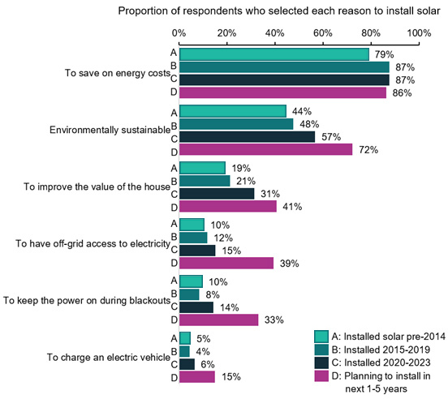

Impact
BETA’s survey results have helped the government make well-informed, effective decisions about demand-side emissions reduction policies. In particular, BETA’s findings formed part of the evidence base for the Cheaper Home Batteries Program. Under the program, Australian households, businesses and community organisations can get a discount of around 30% on the upfront cost of installing a range of small-scale battery systems. This directly tackles one of the major barriers identified in our survey. Since launching in mid-2025, the program has helped install hundreds of thousands of new batteries. Emerging evidence suggests that the rapid uptake of batteries is saving participating households money on their bills, and also helping to reduce wholesale energy prices by reducing evening demand on the grid.`
The survey was also a springboard for subsequent BETA projects on barriers to electric vehicles and home energy upgrades (see case study on home upgrades).
Read the report: High-impact decisions that reduce household emissions
Download the survey data

Testing options to encourage home energy upgrades

Policy context
An energy-efficient home can help households reduce both their energy bills and Australia’s carbon emissions, while improving their comfort. But a home’s energy efficiency is often invisible to potential buyers or renters. If buyers could tell up front how cold their new home would be in winter, would they value and act on that information? Consumer research in 2022 suggested that most Australians would support mandatory disclosure – making a home’s energy efficiency public at the point of sale or lease – as is required in the Australian Capital Territory.

What we did
In 2024, BETA partnered with the Department of Climate Change, Energy, the Environment and Water to design and test ways to inform homeowners, buyers and renters about home energy efficiency that might encourage homeowners to take action to upgrade their home. Using hypothetical scenarios in a survey with 13,797 Australians, we compared 5 different policy interventions.
Figure 15 Real estate listing used in BETA's testing
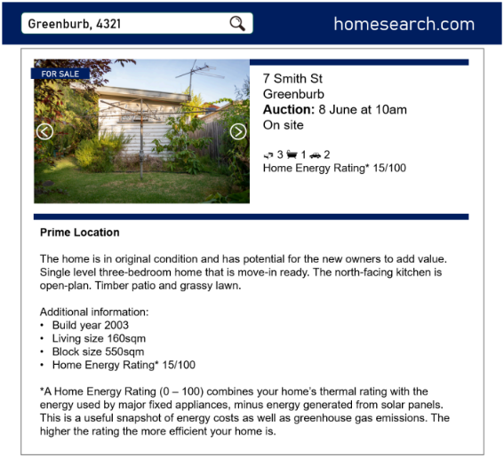

What we found
Of the policy interventions tested, mandatory disclosure saw the most compelling findings. Survey participants said it was important to know a home’s energy rating at the point of sale (86%) and lease (75%). In our hypothetical scenarios, respondents told they were ‘buyers’ were more likely to inspect homes where the listing displayed high home energy ratings. Mandatory disclosure was more effective than voluntary disclosure at assisting buyers to choose better performing homes. Similarly, respondents told they were ‘sellers’ were more inclined to prioritise energy efficiency upgrades when they understood it would be mandatory to disclose home energy ratings on the listing.

Impact
BETA’s research helped policymakers prioritise their time and effort on encouraging the widespread disclosure of Home Energy Ratings. The second version of the national Home Energy Ratings Disclosure Framework cited BETA’s findings in detail (alongside other research) to demonstrate how disclosure reduces information asymmetry in the real estate market and helps people pick more efficient homes. Agreed to by Commonwealth, state and territory energy ministers, the framework provides a consistent approach for how home energy ratings can be communicated, while still recognising that state and territory governments set the rules and requirements for how home energy ratings are disclosed in their jurisdiction.
The NSW and Australian governments have gone on to trial how a home energy rating can be used and shared during the sale or lease of a property. Findings from the trial will inform the NSW Government about when to transition to mandatory disclosure.
Read the report: Home energy upgrades: empowering homeowners to make informed decisions

BETA makes life easier for Australians

Helping people prepare for hotel quarantine

Policy context
During the height of the COVID-19 pandemic, Australia’s hotel quarantine program played an important role in keeping Australia safe. But quarantine could be a challenging experience. The October 2020 National Review of Hotel Quarantine identified that some travellers were not psychologically prepared for hotel quarantine. It suggested the Australian Government could do more to support people’s wellbeing, including by giving travellers better information about quarantine ahead of time. At the time, BETA considered the available information was difficult to navigate, provided too late, and not designed to prepare travellers for the actual experience of a prolonged period inside.

What we did
In late 2020, BETA developed a practical guide for returning travellers to help them safely and effectively quarantine. The information supported travellers’ wellbeing with practical advice and ideas. For example, the guide advised travellers how they could manage the limited space, stay connected to community, and maintain their wellbeing.
In developing the guide we consulted a wide range of stakeholders, including hotel quarantine facility managers, psychologists and government agencies. We also user-tested the products with travellers who had recently undergone quarantine to check the products were useful and hit the right tone.
Figure 16 Front page of the guide
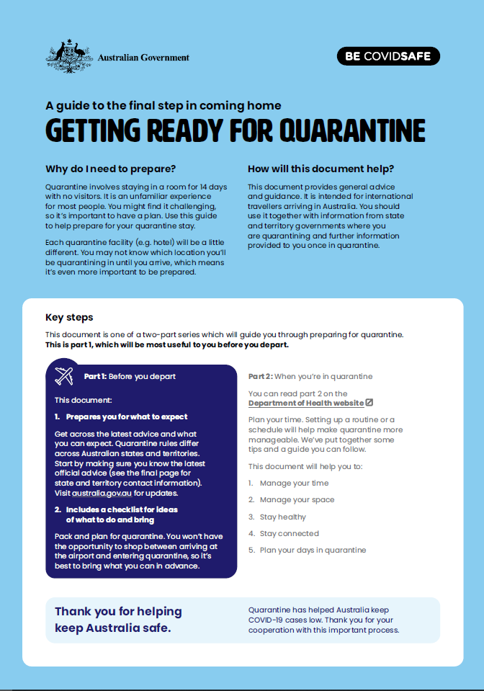

Impact
Tens of thousands of Australians used BETA’s advice to prepare for and manage their time quarantine. Ultimately, BETA’s guide was downloaded over 55,000 times. It received positive feedback, including positive comments from travellers on social media.
The guide was available on the then Department of Health website from December 2020. It was promoted via Smartraveller and in emails to registered Australians interested in returning. A year later, the October 2021 National Review of Quarantine noted that governments had taken steps to address the psychological effects of quarantine, with BETA’s guide as one component.
In 2021 the Department of Foreign Affairs and Trade (DFAT) asked BETA to adapt the guide for incoming seasonal workers. Our tailored version was provided to DFAT posts and distributed in hard copy to workers before they arrived in Australia.

Enabling consumers to choose cyber secure devices

Policy context
Australians are buying more and more smart devices, from smart light bulbs to smart kettles. Being connected to the internet or a home Wi-Fi network brings extra functionality – but also cyber security risks. Consumers can protect themselves by purchasing more secure devices, but even well-intentioned consumers may have difficulty making accurate comparisons based on complex or inaccessible security information. Under the Cyber Security Strategy 2020, the Australian Government committed to exploring the additional steps needed to better inform consumers of the cyber security of consumer connectable products. This was aimed at empowering consumers to make more informed purchasing decisions, while also incentivising manufacturers to lift baseline levels of device security.

What we did
In 2021, the Department of Home Affairs asked BETA to explore the likely effectiveness of a cyber security label for consumer devices in Australia. This would make clear whether a label would materially influence consumer choices once factors such as price and product features were taken into account. BETA conducted a discrete choice experiment, which allowed us to measure the relative impact of a label on people’s choices in a hypothetical shopping scenario.

What we found
BETA found consumers were more likely to purchase labelled over unlabelled products. In our online set-up, the presence of a cyber security label on a product made Australians up to 19 percentage points more likely to buy that product. Consumers also differentiated between different levels of security, preferring more highly rated products.
Figure 17 Example label used in a pilot of the Scheme from September 2026
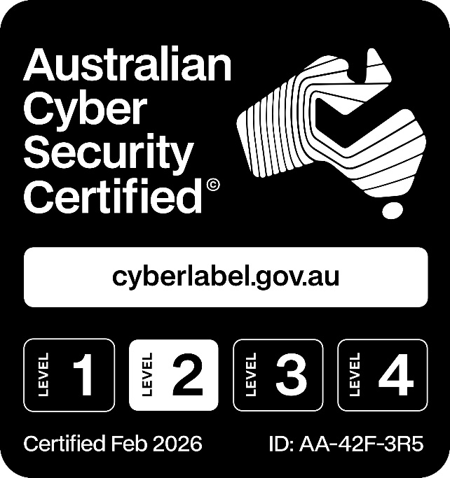

Impact
BETA’s research contributed to the evidence base for introducing a voluntary cyber security labelling scheme for consumer devices, which the government is now co-designing with a peak industry body – the Connected Technology Alliance – as a key initiative under the 2023-2030 Australian Cyber Security Strategy. BETA’s findings were cited as key evidence of the benefits of the scheme.
With the average Australian household having a growing number of connected devices – over 25 in one estimate – the scope and potential benefits of a cyber security label are broad. A well-designed label, backed by reliable certification, will be critical to the scheme’s success. Since our first project, BETA has conducted further surveys and interviews exploring how Australian consumers consider cyber security in smart device purchases and how a cyber security label could support their decision-making. Our continued expert advice to the Department of Home Affairs and the Connected Technology Alliance has helped ensure that consumer behaviour and usability considerations remain central to the scheme’s design.
Read the report: Helping consumers choose cyber secure smart devices

Clarifying what internet plan is best for your household

Policy context
Australians often face challenges comparing between phone and internet service providers. During the rollout of the National Broadband Network (NBN), research by the Australian Communications and Media Authority (ACMA) found that consumers were finding it very hard to understand which NBN service plan would be right for their needs. There was also confusion about important differences between their existing service and how a new NBN service would work, adding an extra challenge to moving to the NBN smoothly.
To address this problem, the ACMA created new consumer information rules that required providers to have more useful and standardised information available about NBN plans. While these changes significantly helped consumers to understand and choose the right plan for them, the ACMA noticed that there were inconsistencies in the way the information was presented between providers. Information was also not being shown as clearly as it could be, posing difficulties for Australians to make an informed choice when moving to the NBN.

What we did
In 2019, the ACMA asked BETA to develop a better practice guide for how providers should display plan information to make households’ choices easier. BETA’s specific, practical guidance helped providers follow ACMA’s new consumer information rules, including the requirement for a Key Facts Sheet explaining the different internet plans offered.
BETA’s guide outlined how to best present NBN information and gave a detailed breakdown on the behavioural science principles underpinning our advice. The guide also included an example of how a Key Facts Sheet could be designed to communicate the most important information to Australian consumers.
Figure 18 BETA’s example of a consumer-friendly Key Facts Sheet
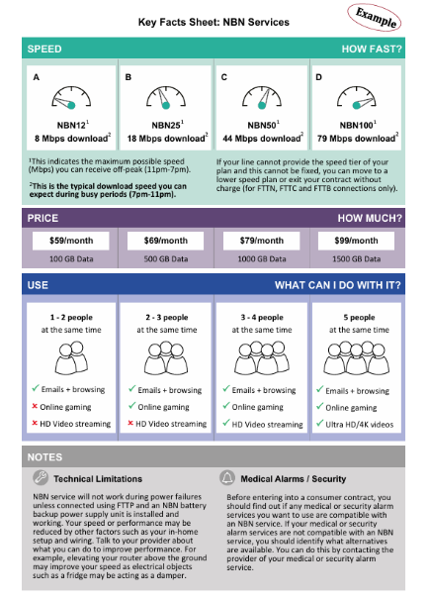

Impact
Where providers have put BETA’s advice into action in the presentation of NBN Key Fact Sheets, this is likely to have made it easier for Australian households to understand and choose the most suitable plan for them. Many providers used the example design or incorporated key elements. While telco plans have changed over the years, ACMA’s consumer-focused Key Facts Sheet requirements remain in place, helping to ensure that providers continue to give consumers the information they need to make informed choices. BETA’s better practice guide remains relevant to helping to make this information easier for consumers to understand. The Key Facts Sheet was particularly important during the COVID-19 pandemic, helping households easily switch to bigger plans if they suddenly had higher internet needs.
Read the guide: A better practice guide for NBN providers

BETA supports a more inclusive and productive workforce

Helping cyber businesses access diverse applicants

Policy context
Cyber attacks on Australian households and businesses are increasingly common, with the Australian Signals Directorate receiving an average of one cybercrime report every 6 minutes. To protect Australians, we need a robust and capable cyber security workforce, full of talented people bringing different perspectives, skills and experiences. But the sector experiences persistent workforce shortages and a lack of representation from certain cohorts. Women make up only 17% of the cyber workforce, highlighting an opportunity to expand participation and access to talent. The Government’s 2023-2030 Australian Cyber Security Strategy set out a number of actions to help grow and diversify the workforce.

What we found
The way cyber security employers design and advertise roles can inadvertently discourage suitable applicants. In 2021, BETA identified job ads as a potential barrier in focus groups with people who were considering a mid-career transition into cyber security. Then in 2023 we analysed 12 million online Australian job ads, working with the Department of Industry, Science and Resources and Jobs and Skills Australia. We found cyber job advertisements often included language that connotes masculine stereotypes (like ‘dominate’), long lists of required skills, and limited references to flexible work arrangements. Cyber security used the most masculine language of any occupation we analysed, and only 1% of cyber security job ads mentioned the availability of flexible work (compared to 5% across all occupations).

What we did
Building on our research, in 2025 BETA partnered with the Department of Home Affairs, cyber security professionals and subject matter experts to develop a practical guide to inclusive recruitment for cyber security employers, with a particular focus on women, First Nations and neurodivergent applicants.
Figure 19 BETA’s guide
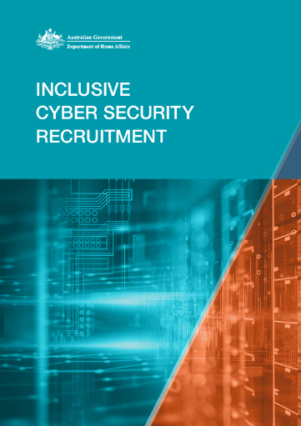

Impact
BETA’s guidance is supporting cyber security employers to make tangible changes to their recruitment processes, making them more welcoming and inclusive for all Australians. More inclusive recruitment has a triple benefit of potentially: broadening the talent pool available to employers; helping all Australians access employment opportunities in a fast-growing sector; and boosting economic productivity through better job matching. Early feedback on the guide from industry participants has been positive.
Since its publication by the Department of Home Affairs in October 2025, BETA’s inclusive recruitment guidance has been downloaded over 255 times.
Read the guide: Inclusive Cyber Security Recruitment Guidance

Advising organisations on how to reduce their gender pay gaps

Policy context
Women continue to earn less than men in Australia, despite improvements over the last decade. Employers play an important role in tackling the enduring gender pay gap. To promote accountability, accelerate action and foster transparency, Australian organisations with 100 or more employees are required to annually report their gender equality data to the Workplace Gender Equality Agency (WGEA). WGEA uses this information to publish employers’ gender pay gaps, workforce demographics and workplace policies.
But these reporting requirements only go so far. Of the 7,414 Australian organisations who reported to WGEA in 2024, 1 in 3 had not yet analysed the causes of their gender pay gap. And of those who had done this analysis, a quarter had not yet taken any further steps in response. From our previous interviews with employers, BETA also knew there was a cohort that recognised they had a problem but needed help with how to address it.

What we did
To help employers act on their gender pay gaps, WGEA partnered with BETA to develop an online Action Planning Tool (APT). Launched in May 2024, the APT bridges the gap between measuring progress and taking action by suggesting evidence-informed actions tailored to the user’s organisation. After launch, BETA evaluated the APT by analysing user data, and interviewing organisations and WGEA staff members.
Figure 20 WGEA has promoted the tool on social media
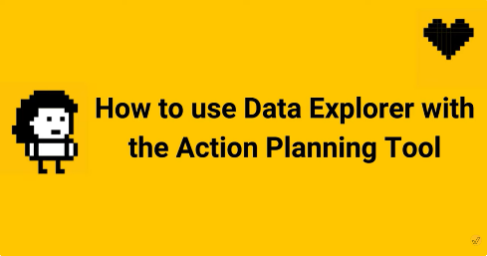

What we found
The APT is user-friendly and is helping organisations feel more confident in reducing their gender pay gaps. Of users who provided voluntary feedback at the end of the tool, 77% said their confidence had increased, 74% reported they learnt something new, and 82% agreed the recommended actions were relevant to their organisation.
‘Our team went, ‘Oh, this is great, it’s telling us how to help us.’ Like we didn’t have to sit around a table and think, ‘How are we going to do this…’’
Employer representative in BETA's research

Impact
BETA and WGEA’s work making an engaging and user-friendly tool has given employers the confidence they need on how they could take action to improve the gender pay gap in their organisation. Multiple organisations we interviewed said the APT’s recommended actions informed their planning for future activities. The APT continues to be an essential part of WGEA’s resources for organisations to reduce their gender pay gaps. Updates to the APT drawing on BETA’s evaluation have further enhanced its useability, with feedback continuing to show positive impacts on users’ confidence and learning.
The APT complements WGEA’s other resources and support, as well as more recent reforms requiring large employers to set gender equality targets, and report on progress towards them. Together, these initiatives are encouraging practical changes in workplaces across the country.
Read the report: Developing the Workplace Gender Equality Agency’s Action Planning Tool
Read our blog: Helping organisations reduce their gender pay gap
See the tool

Supporting people to return to work after an injury or illness

Policy context
Workers often find returning to work after an illness or injury to be complex and challenging. This hampers Australia’s economic productivity and exacerbates financial, social and health difficulties for workers and their families. In 2022, Safe Work Australia (SWA) estimated that Australia’s economy would be $28.6 billion larger each year, with 185,500 more jobs created, if we had no work-related injuries and illnesses.

What we did
In 2018, BETA conducted a literature review for the Department of Education that found early and sustained support from a worker’s supervisor was critical. BETA designed and tested a suite of materials guiding Australian Public Service supervisors through the journey of welcoming a worker back.
In 2021, SWA partnered with BETA to tailor these materials for supervisors in small and medium enterprises (SMEs). We undertook stakeholder consultation, data analysis, and user testing interviews with 12 supervisors in SMEs.
Figure 21 Guide for supervisors
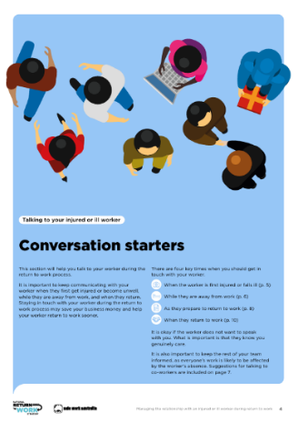

What we found
Supervisors in SMEs emphasised the importance of making the materials available right when a worker is injured or falls ill, enabling them to revisit the guidance throughout the return-to-work process.
‘I like the document…it’s nice, simple, laid out all the way through…it’s a nice checklist to help you work through what you’re doing.’
Supervisor in BETA’s research

Impact
BETA produced tangible, practical tools that are making a difference for Australian workers and SMEs. SWA’s social media posts received strong engagement statistics, and the guide has been downloaded over 5,600 times. In the 2025 mid-term review of the National Return to Work Strategy 2020-2030, industry stakeholders appreciated the accessible and evidence-based resources that SWA had delivered for SMEs.
‘These resources have been useful in training and providing guidance to employees and return-to-work coordinators, contributing to success in return to work rates and reducing recovery timeframes.’
Employer representative quoted in Safe Work Australia's Mid-term review of the National Return to Work Strategy (2025)
Through the project, SWA saw the value of using lived experience research to inform the design of practical guidance and tools. SWA later developed an accompanying return to work plan template and guide. SWA led the work themselves, using a similar evidence-informed and user-centred approach, with BETA providing supporting advice and further user testing. This demonstrated a lasting capability uplift, with SWA applying behavioural and research methods independently in subsequent work.
Read the report: Helping small business supervisors support workers to return to the workplace
Read the guide: Managing the relationship with an injured or ill worker during return to work - A guide for supervisors in small and medium businesses

Helping to ensure polling venues are staffed at the next election

Policy context
Democracy takes work. To ensure millions of Australians can cast their vote in each federal election, the Australian Electoral Commission (AEC) needs to hire and train up to 100,000 polling officials in urban, regional and remote areas across Australia. And the AEC only gets about 5 weeks’ notice.
To make this process easier and more secure, the AEC implemented a new online employment system in 2024. All previous polling officials needed to re-register in the new system if they wanted to work at upcoming electoral events. Because an election can be called at any time, the AEC wanted to maximise early re-registrations.

What we did
The AEC planned waves of bulk emails to people registered in the previous system encouraging them to register with the new system. They asked BETA for high-level advice on these email communications to support greater engagement from users.
The AEC had proposed using 5 email waves using an increasingly urgent tone. We recommended they instead develop 2 waves of email communications, following up with SMS and phone calls – starting with the most urgent tone and then focusing on particular drivers and barriers to re-registering. We expected that people who had not re-registered by the later communications may need a reminder, or they may need more convincing to re-register. We also shared good practice principles for email design, such as keeping each message as simple as possible and including a direct call to action.
Figure 22 BETA gave the AEC example emails
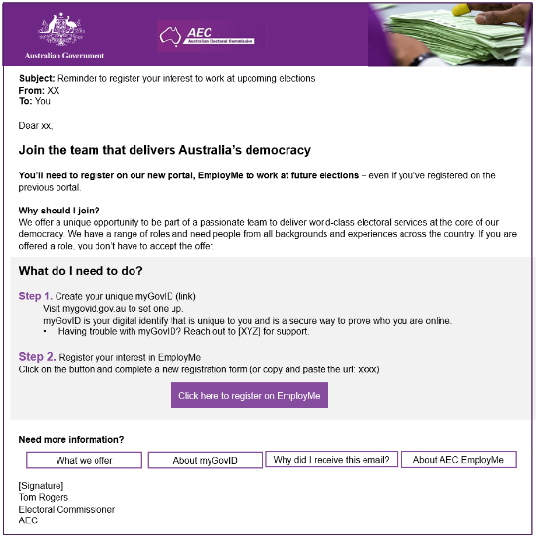

Impact
BETA’s advice helped the AEC secure the workforce it needed to successfully deliver recent electoral events. The communications were rolled out across Australia and approximately one third of the people on the old system re-registered. This was without an upcoming election, and therefore no immediate driver to re-register. Also, the AEC expected that a number of people would never re-register, as the previous register had been open for 14 years and people needed to actively opt-out.
The AEC closely followed BETA’s suggested approach. They piloted the communications with 1,000 people in Tasmania and found 98% thought the emails were easy to read, 95% thought that they clearly explained what action they needed to take, and 90% thought that they had a friendly tone. Furthermore, 90% considered re-registration important, indicating that the email had conveyed clearly why they should act. A total of 89% of people who received the email during the trial went on to register in the new employment system.

BETA builds APS capability

A tool that helps discover the behaviours within your policy problem

Context
Human behaviour underpins much of government work, from policy design to program delivery and beyond. When a program is not working as intended, or a new policy is being considered, it often helps to think systematically about the groups of people affected, how they are currently affected by policy settings, and what might be driving their behaviour. But it’s not always clear how a policy officer should start.

What we did
In 2019, BETA developed an online Behaviour Discovery Tool that applies a structured approach to help policy officers apply a behavioural lens to their work. In less than 10 minutes, the tool:
- breaks down a broader policy problem into a subset of behaviours
- provides tips to better understand people’s behaviours
- outlines behaviourally informed approaches that could support the delivery of a policy or program.

Impact
The tool has helped thousands of people view their work from a behavioural perspective. Since its launch in December 2019, over 7,500 people have interacted with the tool and over 1,500 users have rated the tool, with 83% reporting a positive experience.
Early feedback on the tool highlights several ways it helps policy officers work through policy problems, including challenging assumptions about how people are currently affected by an issue, breaking down complexity, generating new ideas, and guiding people with practical steps and advice, both throughout the tool itself and in a report at the end.
‘It is helpful for questioning assumptions you yourself may have about a policy problem and starting the thinking process.’
User quote, 2020
‘I liked how it broke down all the complex parts of policy development in a very clear way.’
User quote, 2020
‘I liked how the suggestions and questions included practical examples.
I like that I was able to go back and adjust my answers in response to new thoughts and ideas sparked by the tool.’
User quote, 2020
The tool has also attracted international attention, with the Welsh and Spanish governments developing their own versions of the BETA tool.
Use the Behaviour Discovery Tool

Showcasing Australian behavioural public policy

What we did
Since 2020, BETA has hosted an annual conference on behavioural insights (BI) for public policy: BI Connect. This free event features presentations and discussions with behavioural science academics, experts and practitioners from across Australia and the world. BI Connect shares knowledge and builds interest in behavioural insights across the Australian Public Service (APS), as well as strengthening connections with academia and the broader field of behavioural public policy.
The inaugural BI Connect explored the application of behavioural insights to COVID-19. It highlighted the importance of a people-centred and evidence-informed approach in the rapid policy development and program delivery during the pandemic. Since then, BI Connect programming has included presentations reflecting current and best practice research, with a focus on how behavioural insights can be applied to public policy to improve outcomes for Australians.

Impact
BI Connect has become a popular event for behavioural science practitioners, policy makers, enthusiastic champions and those who are curious or want to learn about behavioural sciences. Attracting over 390 registrations in its first year, the event has developed a strong following, reaching 1,220 registrations in 2025. Feedback from participants indicates we are successfully building knowledge of, and interest in, behavioural insights across the APS through BI Connect.
‘The chance to hear from other BI practitioners and about relevant research – there aren't many forums where you get to hear from a diverse range of speakers like for BI Connect.’
2021 attendee
‘It was a great event and I’m glad it was virtual, which enabled a lot more attendees to participate. The content was really interesting and informative.’
2025 attendee
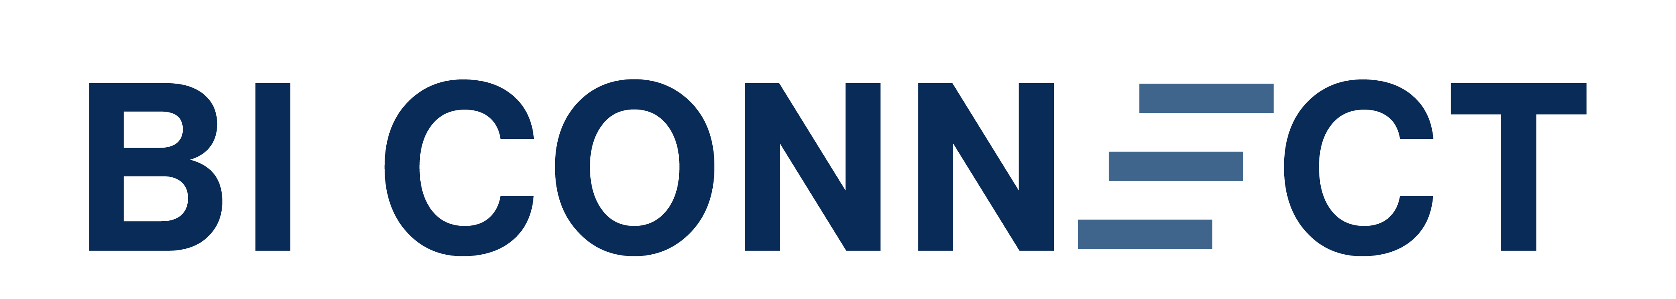
Watch, listen or read recordings of past BI Connect conference sessions

Making behavioural insights and evaluation accessible for everyone

Context
To help embed the use of behavioural insights across the APS, BETA developed a suite of online courses and resources that provide practical guidance on applying behavioural insights to public policy and using evaluation methods.

What we did
Our first course, Behavioural Insights for Public Policy, introduces the core concepts of behavioural insights and explores how they can be applied in a government context. Our 4D (Discover, Diagnose, Design, Deliver) Framework course then takes learners through the four stages of a behavioural insights project, providing practical guidance on putting behavioural insights into action.
BETA also developed a course on randomisation as part of the Evaluation skills for public servants program available through the APS Academy. This program helps policy officers to build the skills and knowledge needed to understand, design and undertake robust evaluations.
In 2024, BETA wrote the Pragmatic and better practice survey guide to support policy officers develop effective surveys, especially when they have limited resources and time. The guide aims to increase understanding of key concepts in survey research and assist policy officers in developing better surveys. Following release of the guide, BETA developed an online face-to-screen course, focussing on survey question development. The course has also been tailored to learning and development professionals to improve their evaluation surveys.

Impact
Since BETA released its first online course in 2019, more than 3,500 APS staff have enrolled in our courses. While BETA continues to deliver live training sessions, these online courses provide a cost-effective, accessible and on-demand learning option, enabling policy officers across Australia to develop an understanding of behavioural insights and evaluation, and apply these approaches to their work.
For our survey guide specifically, feedback has been positive:
‘I thought working through the survey was helpful. It was good to be practical.’
‘Exercises were really well developed so that we could practice what we learned as we were exposed to it. The whole course was really well presented and materials will be useful to refer back to.’
Survey content user, 2025
Learn with us: Explore our free online courses and recourse
Read the Survey Guide

Tell us how you’re using this report via a short survey below:
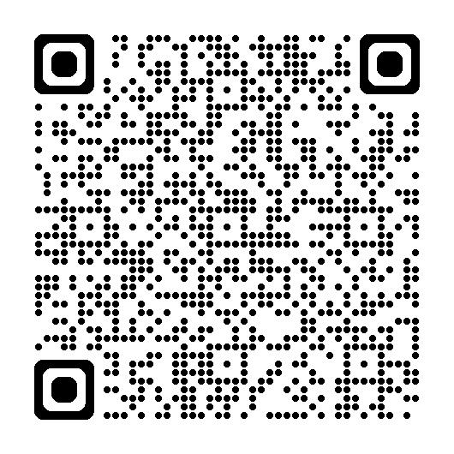

Other uses
Enquiries regarding this license and any other use of this document are welcome at:
Executive Director
Behavioural Economics Team of the Australian Government
Department of the Prime Minister and Cabinet
1 National Circuit
Barton ACT 2600
Email: beta@pmc.gov.au
The views expressed in this paper are those of the authors and do not necessarily reflect those of the Department of the Prime Minister and Cabinet or the Australian Government.

Use of Artificial Intelligence (AI)
During the preparation of this work, the author(s) used Microsoft 365 Copilot Chat (various versions between June and September 2026) to provide alternative wording for sentences, check spelling and grammar. After using this tool the author(s) reviewed and edited the content and assume full responsibility for the content of the paper.

ISBN 978-1-925365-94-8 10 years of BETA: Case studies, 2026

Copyright Notice
With the exception of the Commonwealth Coat of Arms, this work is licensed under a Creative Commons Attribution 4.0 International license (CC BY 4.0) (https://creativecommons.org/licenses/by/4.0/)


Third party copyright
Wherever a third party holds copyright in this material, the copyright remains with that party. Their permission may be required to use the material. Please contact them directly.

Attribution
This publication should be attributed as follows:
© Commonwealth of Australia, Department of the Prime Minister and Cabinet, 10 years of BETA: Case studies, 2026.

Use of the Coat of Arms
The terms under which the Coat of Arms can be used are detailed on the following website: https://pmc.gov.au/cca

Behavioural Economics Team
of the Australian Government
General enquiries beta@pmc.gov.au
Media enquiries media@pmc.gov.au
Find out more www.pmc.gov.au/BETA

ACCC (Australian Competition & Consumer Commission) (2025), Inquiry into the National Electricity Market, ACCC, accessed 7 October 2026.
BETA (2021), Improving energy bills: final report, BETA, accessed 7 October 2026.
ACCC (Australian Competition & Consumer Commission) (2025), Inquiry into the National Electricity Market report - December 2025, ACCC, accessed 7 October 2026.
A pop-up survey on the website asked users, ‘What brought you to Energy Made Easy today? Select all that apply’. This chart shows the proportion of respondents who selected ‘Mentioned on my electricity bill or gas bill’.
ASIC (Australian Securities and Investments Commission) (2021), Attachment 1 to RG 275 Compliant form for hard copy provision of Customer Information, ASIC, accessed 7 October 2026.
ASIC analysis of APRA insurance performance statistics database.
ACCC (Australian Competition and Consumer Commission) (2024), Best practice guidance for foreign cash and international money transfer services, ACCC, accessed 7 October 2026.
Royal Commission into the Robodebt Scheme (2023), Report of the Royal Commission into the Robodebt Scheme, Royal Commission into the Robodebt Scheme, accessed 7 October 2026.
Royal Commission into Violence, Abuse, Neglect and Exploitation of People with a Disability (2023), Final report, Royal Commission into Violence, Abuse, Neglect and Exploitation of People with a Disability, accessed 7/10/2026.
Royal Commission into Defence and Veteran Suicide (2022), Final Report, Royal Commission into Defence and Veteran Suicide, accessed 7/10/2026.
ABARES (Australian Bureau of Agricultural and Resource Economics and Sciences) (2026), Farm surveys definitions and methods, Department of Agriculture, Department of Agriculture Fisheries and Forestry website, accessed 7 October 2026.
DEWR (Department of Employment and Workplace Relations) (2026), Closing Loopholes Review final report, DEWR, accessed 7 October 2026.
Suomi A, Hahn M and Biddle N (2025) Gambling participation in Australia 2025: Trends over time, and profiles associated with online gambling and gambling harm, POLIS: The Centre for Social Policy Research, Australian National University, accessed 7 October 2026.
AIFS (Australian Institute of Family Studies) (2023), Regular online bettors in Australia, 2023, AIFS, accessed 7 October 2026.
DSS (Department of Social Services) (2022), National Consumer Protection Framework for Online Wagering in Australia - National Policy Statement, DSS, accessed 7 October 2026.
BIT (The Behavioural Insights Team) (2023), How do activity statements impact gambling behaviour? Results deck, BIT, accessed 7 October 2026.
DSS (Department of Social Services) (2024), Activity statement measure: prototype, DSS, accessed 7 October 2026.
VGCCC (Victorian Gambling and Casino Control Commission) (2024), Wagering account holders to be better informed under clearer, fairer player activity statements, VGCCC website, accessed 7 October 2026.
Gainsbury SM, Chandrakumar D and Heirene RM (2025) Use and impact of government-mandated activity statements for online gambling in Australia, Harm Reduction Journal 22, 44, accessed 7 October 2026.
OTA (Organ and Tissue Authority) (2021), Donation and transplantation data, DonateLife website, accessed 2021.
Ratcliff S (2022), DonateLife Narrowcast Messaging Evaluation: Year 1 | Final Report, Convenience Advertising, accessed 7 October 2026.
Shearer F, Adeshina A, Dawson P, Golding N, Hao T, Hyndman RJ, Moss R, O’Hara-Wild M, Price D, Ryan G, Senior K, Tobin R, Wood J and McCaw J (2023), Series of weekly COVID-19 epidemic situational assessment reports submitted to the Australian Government Department of Health Office of Health Protection from April 2020 to December 2023, The University of Melbourne Figshare, accessed 7 October 2026.
Golding N, Price DJ, Ryan G., McVernon J, McCaw JM, Shearer FM (2023), A modelling approach to estimate the transmissibility of SARS-CoV-2 during periods of high, low, and zero case incidence, eLife 12:e78089, accessed 7 October 2026.
DCCEEW (Department of Climate Change, Energy, the Environment and Water) (2023), Residential buildings data, DCCEEW website, accessed in 2023.
ACCC (Australian Competition and Consumer Commission) (2025), Inquiry into the National Electricity Market report - July 2025, ACCC, accessed 7 October 2026.
AEMO (Australian Energy Market Operator) (2026), Quarterly Energy Dynamics Q2 2026, AEMO, accessed 7 October 2026.
AER (Australian Energy Regulator) (20 August 2026), Renewables and battery growth ease pressure in wholesale electricity market [media release], AER, accessed 7 October 2026.
Jones H, Polidaros H and Stolper D (2022), Energy Efficient Housing Research, SEC Newgate Australia, accessed 8 October 2026.
Australian Government (2024), Home Energy Ratings Disclosure Framework Version 2, Australian Government, accessed 7 October 2026.
NSW DCCEEW (Department of Climate Change, Energy, the Environment and Water) (2025), Home Energy Ratings, NSW Climate and Energy Action, accessed 8 October 2026.
DHDA (Department of Health, Disability and Ageing) (2020), National review of hotel quarantine, DHDA, accessed 7 October 2026.
DPM&C (Department of the Prime Minister and Cabinet) (2021) National review of quarantine, DPM&C, Australian Government, accessed 7 October 2026.
Department of Home Affairs (2026), Mandatory security standards and industry-led voluntary cyber security labelling scheme for consumer-grade smart devices, Department of Home Affairs, accessed 7 October 2026.
Telsyte (20 March 2024), Australia’s smart home market set to crack $2.5B, driven by AI, energy savings and security [media release], Telsyte, accessed 7 October 2026.
NBN (National Broadband Network) (26 March 2025), Average NBN network downloads to double and popular new tech to drive more growth [media release], NBN, accessed 7 October 2026.
ACMA (Australian Communications and Media Authority) (2019), Action on telco safegaurds: July to September 2018, ACMA website, accessed 7 October 2026.
Marles R and Burke T (14 October 2025), Annual cyber threat report highlights persistent threat to individuals and across the Australian economy [media release], Australian Government, accessed 7 October 2026.
Commonwealth of Australia (2026), Budget 2026-27 - Women’s Budget Statement, Commonwealth of Australia, accessed 7 October 2026.
Deloitte (2022), Safer, healthier, wealthier: The economic value of reducing work-related injuries and illnesses, Deloitte, accessed 7 October 2026.
Safe Work Australia (2023), Guide: Developing a return to work plan: A guide and template, Safe Work Australia, accessed 7 October 2026.

