

Prompting for a better deal
Understanding and overcoming barriers to financial product switching

Updated June 2026

Other uses
Enquiries regarding this license and any other use of this document are welcome at:
Managing Director
Behavioural Economics Team of the Australian Government
Department of the Prime Minister and Cabinet
1 National Circuit
Barton ACT 2600
Email: beta@pmc.gov.au
The views expressed in this paper are those of the authors and do not necessarily reflect those of the Department of the Prime Minister and Cabinet or the Australian Government.
Tell us how you are using this report


Research team
Current and former staff who contributed to the report were: Luzian Ong, Dr Dana Leidl, Carissa Adams, Lachlan Gault, Dr Su Mon Kyaw-Myint, Dr Angela Bender, Michael Ridgway, Bradon Suter, Abi Chan, Josefine Lederer, Riley Childs, Emma Summerhayes, Nicholas Hilderson, Phi Vu, Haris Rao, Dr Loren Willis, Dr Aurore Chow, Dr Bethany Jones and Madelaine Magi-Prowse.

Acknowledgments
Thank you to the Treasury for their support and valuable contribution in making this project happen. Thank you to the ASIC Moneysmart team for their contribution to this project as well as the bank whom we partnered with and the bank employees for their work on this project. Thank you to Professor Michael Hiscox who advised on this project.
The trials were pre-registered on the American Economic Association registry:
https://www.socialscienceregistry.org/trials/15045
https://www.socialscienceregistry.org/trials/15747
https://www.socialscienceregistry.org/trials/17265
registry.org/trials/17265

Who?

Who are we?
We are the Behavioural Economics Team of the Australian Government, BETA. We are the Australian Government’s first central unit applying behavioural economics to improve public policy, programs and processes.
We use behavioural economics, science and psychology to improve policy outcomes. Our mission is to advance the wellbeing of Australians through the application and rigorous evaluation of behavioural insights to public policy and administration.

What is behavioural economics?
Economics has traditionally assumed people always make decisions in their best interests. Behavioural economics challenges this view by providing a more realistic model of human behaviour. It recognises we are systematically biased (for example, we tend to satisfy our present self rather than planning for the future) and can make decisions that conflict with our own interests.

What are behavioural insights and how are they useful for policy design?
Behavioural insights apply behavioural economics concepts to the real world by drawing on empirically-tested results. These new tools can inform the design of government interventions to improve the welfare of citizens.
Rather than expect citizens to be optimal decision makers, drawing on behavioural insights ensures policy makers will design policies that go with the grain of human behaviour. For example, citizens may struggle to make choices in their own best interests, such as saving more money. Policy makers can apply behavioural insights that preserve freedom, but encourage a different choice – by helping citizens to set a plan to save regularly.

Contents

Executive summary 4
Context 6
What we did 8
Findings: Rapid literature scan 14
Findings: Home loans 16
Findings: Savings 29
Discussion and conclusions 36
Appendix A: Methodology 40
Appendix B: Prompt text 44
References 46

Executive summary
The Government is looking at ways to create a more dynamic, diverse and resilient Australian banking sector, including through more choice, lower prices and better services.
The Behavioural Economics Team of the Australian Government (BETA) conducted a suite of research activities in partnership with the Department of the Treasury (Treasury) to explore how to help consumers get a better deal on their banking products, including finding and switching to better offers. BETA’s research tests the effectiveness of consumer prompts and unpacks the barriers and enablers for consumers in switching products.

What we found
Well-designed prompts could encourage some cohorts of savings account and home loan consumers to engage in the market
- Prompts may benefit consumers who have not considered switching. In 2 survey experiment randomised controlled trials (RCT), prompts were found to be effective in directing consumers’ attention to market engagement.
- Detailed prompts that compare your rate to the market are more likely to encourage consideration of switching compared to a simple prompt.
- Prominent and personalised prompts can encourage consumer action. Well-designed prompts can encourage consumers to contact their bank for a better deal.
Frictions in the journey to get a better deal mean that motivated consumers may still not switch
- The volume and complexity of choice make it difficult to identify the best home loan or savings account. Comparing saving accounts had the added difficulty of comparing conditional interest requirements.
- Existing supports for engaging the market are not meeting the needs of home loan and savings account consumers with comparison websites and mortgage brokers not always trusted or used.
- High administrative burden, effort, time and financial cost deter home loan consumers from switching.
- Savings account consumers who have not switched were deterred by the expectation of effort and time involved. However, those who recently opened an account generally found it easy.

What this means for policy

If mandated, how prompts are regulated matters
Across 4 trials, the prompts had varying effects on encouraging consumer engagement. Prompts that capture attention and demonstrate the benefit of switching have the best chance of success. To do this, prompts should be placed prominently, and personalised to consumers. We have also identified additional features that we recommend should be tailored, tested and monitored by those who deliver prompts, including timing and channel of delivery. Given the diversity in consumers, products, and banks and lenders, it is unlikely there will be a ‘one-size-fits-all’ prompt that would be appropriate for all consumers, however adhering to overarching principles in prompt design such as those outlined above, coupled with ongoing testing and monitoring by those delivering the prompt to demonstrate effectiveness may yield positive results.

More is needed to support consumers to get a better deal
Going forward, initiatives beyond prompts are needed to support consumer switching. Further consideration is needed to ensure initiatives are suitable in the current regulatory landscape, and are accompanied by careful evidence-based design and delivery to achieve the best effect.
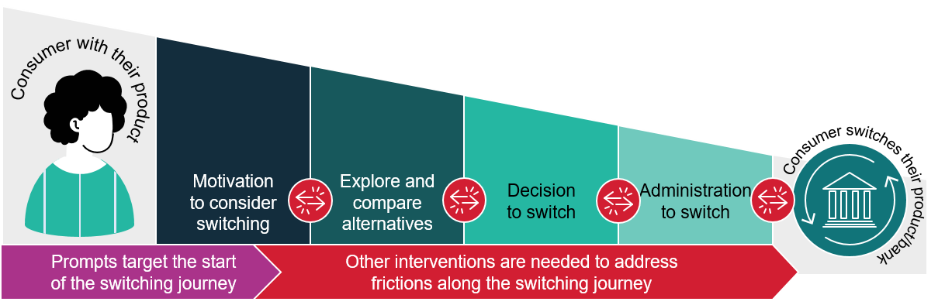
Figure 1: A simplified switching journey: prompts target the start of the switching journey and other interventions are needed to address frictions along the journey

Context

Policy background
The Australian Competition and Consumer Commission (ACCC) recently released 2 inquiries relating to retail banking products – the Home Loan Price Inquiry (2020) and the Retail Deposits Inquiry (2023). Despite the financial benefits that can result from switching products, the reports found a lack of consumer engagement in home loan and savings account markets. For both these financial products, the ACCC recommend that banks and lenders should directly prompt their consumers to engage in the market to get a better deal.

Project scope
The Department of the Treasury (Treasury) partnered with the Behavioural Economics Team of the Australian Government (BETA) to undertake a suite of research activities to (1) understand the utility of prompting consumers, (2) understand the barriers and enablers consumers experience when switching or repricing. The findings of these research activities will support Treasury’s advice on achieving better outcomes for Australian consumers.

Terminology used in this report
Switching refers to moving a financial product to a different one, either with the same bank ('internal switch) or to another bank ('external switch').
Market engagement refers to consumers' action to search for a better deal or to switch.
Refinancing is the process of taking out a new home loan to replace an existing one, with the same or different lender.
Repricing is the process of requesting or negotiating with your current lender to get a reduced interest rate on your existing home loan.

What we did
We completed a series of 5 research activities to understand consumer experiences and test prompts. These activities are outlined below and the full methodology including limitations can be found in the Appendix.

We conducted a rapid and targeted literature scan to gather learnings about prompts
We conducted a rapid and targeted scan of existing literature on the use of prompts in the retail banking and home loans sectors.

We interviewed and surveyed consumers to understand the switching journey, and why people do or don’t switch
- In an online survey, we surveyed 5,843 people about their banking products and experience. Participants answered questions about their home loan or savings account, including about their switching and repricing behaviour.
- We conducted 28 semi-structured in-depth interviews with consumers (20 home loan and 8 savings account consumers) who had and had not switched their products in the last 3 years, and consumers who had received a reprice on their home loan. During the interviews, we asked questions about their experiences of considering switching and subsequent decisions to switch or not.
- Over a 5-week period, 80 people who visited the Australian Securities and Investment Commission (ASIC)’s Moneysmart webpages about home loans (e.g. the ‘mortgage calculator’) answered a 3-item pop-up about their home loan interest rate.

We used 2 survey experiment randomised controlled trials (RCTs) to test if prompts can direct attention to market engagement
In 2 online studies, one about home loans and one about savings accounts, participants read a vignette about a hypothetical friend who wants to improve their finances. For each study, we randomly assigned participants to see a mocked up, fake banking app screen with one of 3 messages: a control message, a simple prompt or detailed prompt. See Figure 2 for screens and Figure 3 for prompts used in each RCT. Refer to Appendix B for text-only versions of the prompts.
We asked participants to recommend actions to improve their friend’s finances. We quantified how many participants made recommendations for the character to engage in the home loan market (e.g. ‘switch mortgage’, ‘see what other home loans are available’, ‘get a better savings account interest rate’, ‘visit Moneysmart’) and compared these between groups.
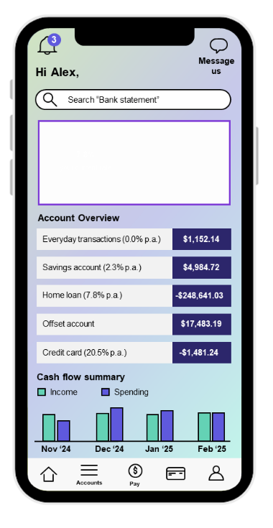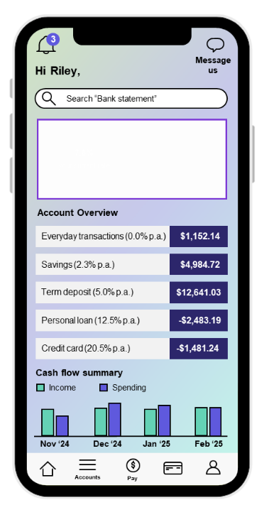
Figure 2: Banking app screen used in home loan survey experiment RCT (left) and in the savings survey experiment RCT (right)
Figure 3: The prompt text used for each condition in home loan survey experiment RCT (left) and in the savings survey experiment RCT (right)

We ran a field RCT to test whether a prompt could encourage disengaged consumers to contact their bank
In collaboration with an Australian bank, we tested whether a prompt delivered in the bank’s smartphone app could encourage disengaged consumers to contact the bank about repricing their loan. We randomly assigned consumers of the bank to either see a prompt in their banking app (Figure 4) or not see a prompt. We compared the 2 groups to see if the prompt increased the number of people calling the bank about their loan.
Figure 4: Wireframe of the first field RCT prompt

We ran a second field RCT to test whether ‘enhanced’ prompts could encourage disengaged consumers to contact their bank
Building on our first field RCT we developed an ‘enhanced’ prompt and tested whether it would encourage disengaged consumers to contact the bank about repricing their home loan. Taking learnings from our first field RCT and survey experiments, the prompt was more prominent, personalised and delivered in multiple channels (see Table 1).
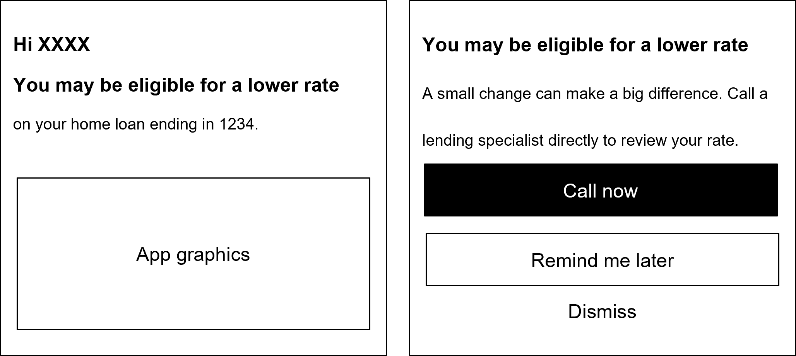
Figure 5: Wireframe for the second field RCT smartphone app prompt. ‘1234’ refers to the final 4 digits of the consumers home loan
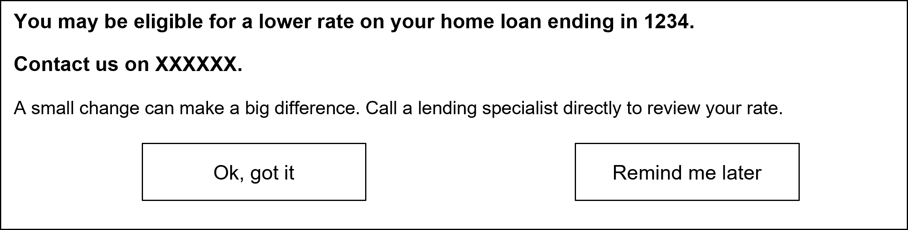
Figure 6: Wireframe for the second field RCT online platform prompt. The ‘XXXXXX’ represents the phone number for the bank’s mortgage area
Table 1: Differences in prompt design and delivery between the first and second field RCTs
Element | First field RCT | Second field RCT
Channel | Single channel (smartphone app) | Multi-channel (smartphone app and online portal)
Prominence | Located at the bottom of the app (visible only when scrolled to) | Located at the top of the app (visible on opening)
Personalisation | No personalisation | Included reference to specific loan (‘…your home loan ending in 1234’)

Findings: Rapid literature scan
Before undertaking additional research, we conducted a rapid and targeted scan of past literature on the use of prompts in the retail banking and home loans sectors. Key takeaways of this scan are detailed below.

Financial decision making is complex
Making decisions about financial products, even the most familiar ones like a savings account, can be complex. Weighing up and comparing multiple options and features, considering different dependencies, understanding trade-offs and dealing with different types of uncertainty is required alongside other decision and life events – all of which divert consumers’ limited attention and add to their cognitive load. This makes it very hard, sometimes near impossible, to make ‘optimal’ decisions (ASIC 2019). In this environment consumers may use a range of decision-making techniques including to satisfice (i.e. accept a ‘good enough’ rather than ‘best’ option) or disengage from the market (i.e. ‘inertia’).

Financial benefits of switching are hard to calculate and not immediate, and switching costs are high
The financial benefits experienced by switching are typically delayed, and the ‘costs’ - financial, administrative, and cognitive – are often large and upfront (ACCC 2020). In the face of the perceived (and actual) difficulty of switching, consumers tend to defer decisions, often indefinitely (Iyengar and Lepper 2000) – even where substantial savings are available (Barr et al. 2008).

Prompts can act as a trigger point to help overcome consumer inertia and limited attention
Retail banking products, like home loans and savings accounts, typically lack a natural ‘trigger point’ that requires action and draws consumers attention to fees and features and encourage consideration of alternative options (Hartfree et al. 2016). For many consumers, once they make a choice, inertia or inattention takes over. Consumers default to remaining with their current financial product, even if it is not in their best financial interests. Prompts are a relatively cost effective intervention, which can provide recipients with timely and targeted information to encourage market engagement. Recent research suggests prompts effectively increase consumer search and switching behaviour in financial markets by 2 to 3 percentage points on average (Vasas 2022).

Optimising prompt design may improve effectiveness but there are limitations
Putting prompts in a prominent location can help capture attention (e.g. Adams et al. 2021), but there is inconclusive evidence about the value of using behavioural insights techniques in prompt wording (such as loss or gain framing; Adams et al. 2015; Adams et al. 2021; Byrne et al. 2022). However, prompts (and other forms of consumer information) still have to compete for consumer attention and can fail when they are ignored, overlooked, misremembered or misunderstood. Their effectiveness is also influenced by other factors in the ‘choice architecture’ or environment in which the consumer is making decisions including advertising, sales pitches, communication channel, timing etc. (ASIC 2019, Marlin and Magi-Prowse 2022).

Making switching easier may be more impactful
Even if it overcomes these limitations, a prompt alone only directs attention towards switching. Switching financial products can be complex and friction-heavy. Reducing frictions in subsequent steps required to switch may have a greater effect on actual consumer behaviour than a prompt or access to information.

Findings: Home loans
Summary
While home loan consumers may benefit from prompts, consumers may need additional support to complete the complex, time consuming and uncertain process of getting a better home loan rate.
Prompts that are prominent, with a clear call to action and are personalised with interest rate comparisons may help consumers by calling their attention to availability of a better deal. However, frictions throughout the switching process may deter consumers.
Consumers may benefit from additional demand and supply side interventions which address the subsequent frictions we identified in the switching journey.

Prompts target the start of the switching or repricing journey for home loan consumers
Interviewing home loan consumers helped us understand the steps involved in the switching and repricing journey. At best, a prompt can trigger a consumer to consider switching or repricing (see Figure 7 for a simplified consumer journey). To get a better deal, consumers must still overcome other frictions and barriers at each subsequent step of the journey, which in reality is often in a nonlinear fashion.
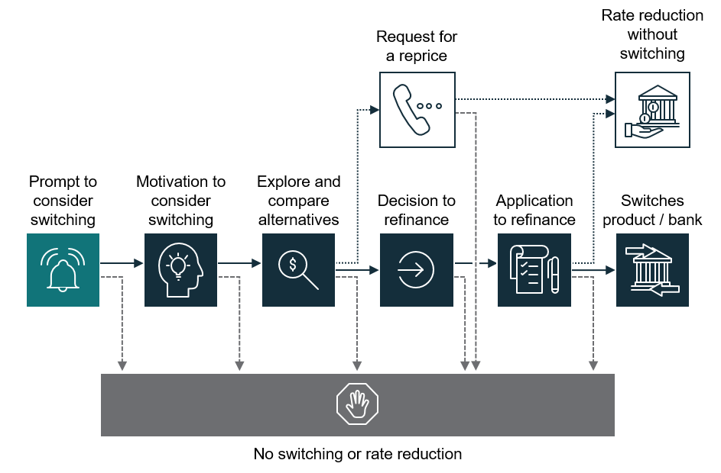
Figure 7: Simplified consumer journey to switch or reprice a home loan

Prompts may help consumers consider market engagement
Given prompts may act as a trigger to start the switching or repricing journey, they may be beneficial for those who have not considered switching or repricing in the past. Just under a third of our survey participants, who had not refinanced in the past 3 years, had not thought of refinancing, or had thought about it but had not looked into it (13% and 15% respectively). Similarly, for interview participants who had not refinanced in the last 3 years, some home owners hadn’t encountered a natural prompt to assess the competitiveness of their loan, and weren’t sure of their interest rate and how it compared to the market.
‘I don’t tend of pay too much attention to what the tiny little variable [interest rate] is, because I’m not someone who stresses about those sort of things … I can’t remember my interest rate, I think it’s maybe 5% or something, I can’t remember.’
Interviewee #19, home loan, has not refinanced recently

Prompts can direct attention to market engagement and switching
Our survey experiment RCTs tested whether simple or detailed prompts, delivered in a mocked up, fake banking app, captured and directed attention to switching or repricing home loans. Prompts were tested in a hypothetical scenario, see section What we did or Appendix for details on the methodology.
We found prompts were effective in directing attention to market engagement, and that a detailed prompt was more effective than a simple prompt. The simple prompt resulted in a 16 percentage point increase in market engagement recommendations, and the detail prompt was associated with a 49 percentage point increase in market engagement recommendations. These differences were all statistically significant (Figure 8).
Source: Home loan survey, ‘After looking at Alex's banking app screen below, what are some of the actions you suggest that he takes to improve his financial position?’ Free text coded blind binary as engagement or no engagement in response. N = 4,500.
Figure 8: Participants who saw a simple or detailed prompt were more likely to recommend market engagement than those who saw the control message
Participants who saw a simple or detailed prompt were more likely to recommend market engagement than those who saw the control message.
Most participants also found the prompts easy to understand. 88% of participants who saw the simple prompt, and 91% of participants who saw the detailed prompt, said the prompt was easy or very easy to understand (see Figure 9).
Source: Home loan survey, ‘How easy or difficult is this message to understand?’, N = 4,500.
Figure 9: Participants found the prompts easy to understand

A suboptimal prompt does not encourage market engagement
In the first field RCT, we randomly assigned consumers of the bank to either receive a prompt encouraging them to call the bank, or not receive a prompt. The prompt included a stock image and the text ‘Interested in reducing your mortgage payments? Check whether you can get a lower interest on your home loan’, and was located underneath a main menu selection of app features. Consumers needed to scroll down the page past the menu to come across the prompt.
We compared the proportion of consumers who contacted the bank in the trial period (Figure 10). While consumers who received the prompt had slightly higher contact rates (2.9%) compared to those who did not receive a prompt (2.7%), this difference was not statistically significant.
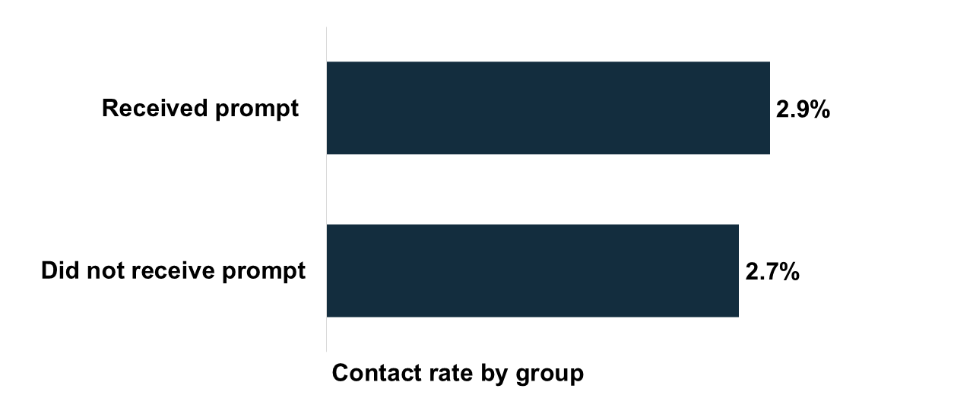
Source: First field RCT primary outcome, percentage of clusters with at least one person who contacted the bank at T1. N= 11,922 loan clusters, with n=5,961 per condition.
Figure 10: There was no significant difference between treatment and control in contacting the bank during the trial period

Prominent and personalised prompts can encourage some consumers to contact their bank
Our second field RCT tested a more prominent, personalised and multi-channel prompt. Consumers who received the prompt had a higher contact rate compared to those who did not receive a prompt (7.2% compared to 4.8%). This difference was statistically significant (Figure 11).
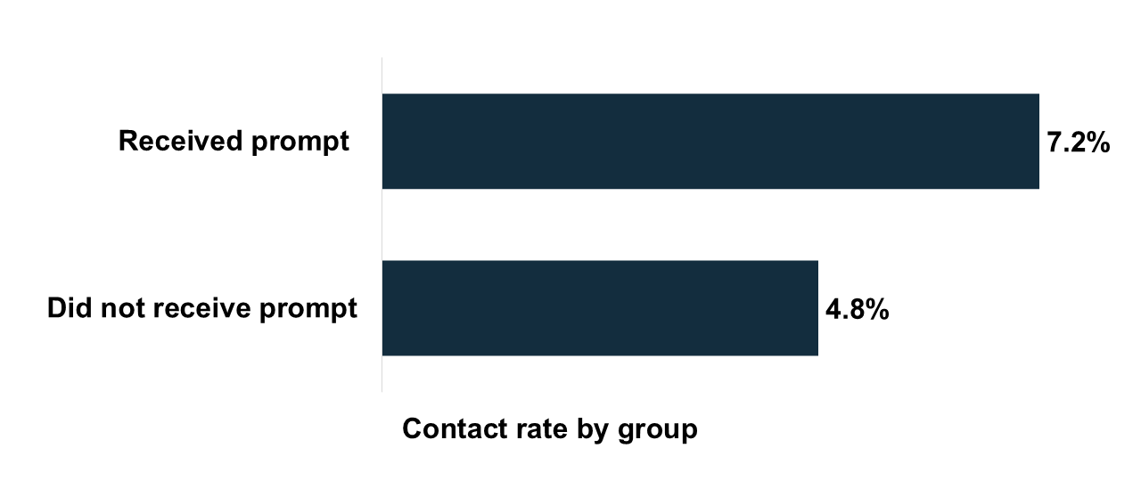
Source: Second field RCT primary outcome, percentage of individuals with at least one contact with the bank at T1. N = 12,701 individuals with n= 6,334 control and n= 6,367 intervention.
Figure 11: There was a significant difference between the treatment and control group contact rates during the trial period
Although the prompt was effective, the increase in contact rates was relatively small (2.4 percentage points). There are several reasons why consumers may not have made contact. Consumers may be on, or perceived they were on, a suitable interest rate or simply not had the time or energy to engage. Our trial showed that prompts can encourage some disengaged consumers to engage with their bank but do have limitations.

Only some consumers got a better deal
Not all consumers who made contact in the trial got a better deal. For repricing, prompts rely on consumers making contact, asking for a better rate and then a bank decision on whether the consumer can receive a reprice. Consumers in the trial were identified by the bank as being eligible for a lower rate (providing they called and asked). Despite this there were still modest numbers of consumers who received a discount (Figure 12).
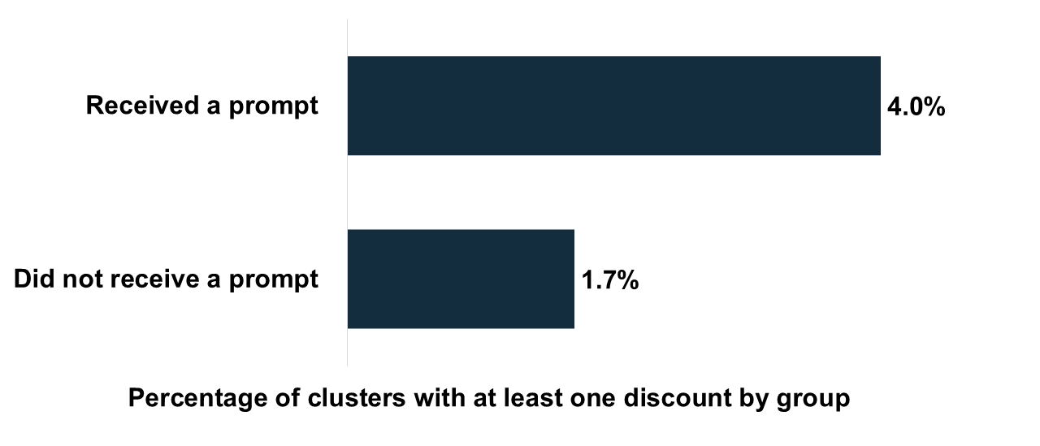
Source: Second field RCT secondary outcome, percentage of clusters with at least loan with a discount at T1. N=10,419 clusters with n=5,209 clusters in the control and n=5,210 clusters in the treatment.
Figure 12: Percentage of clusters with at least one loan receiving a discount by group.

The effectiveness of prompts is determined by design features
Across our survey experiment RCT and field RCTs, we had mixed results: prompts in our survey experiment RCT were effective at directing attention to market engagement, but the prompt in our first field RCT was not effective at encouraging consumers to call their bank. By contrast the enhanced prompt in our second field RCT was effective at encouraging consumer contact. We attribute some of the differences in the RCTs’ effectiveness to how the prompts were designed and delivered.
We have identified the following features which may impact prompt effectiveness: prominence and placement, a clear call to action and personalisation.

Prominence and placement
Prompts need to be delivered in a location prominent enough to capture attention. Placement of the prompts used in the survey experiment RCT, and second field RCT were prominent, at the top of the banking app screen. This made them difficult to miss. On the other hand, the prompt used in the first field RCT was only visible if a consumer scrolled down in their bank app home screen (with amount of required scrolling varying between individual consumers and the accounts and services available on their app). This was identified as a constraint of the first field RCT prompt in the bank’s post-trial user testing.

Personalisation creates a clear call to action
Personalising the prompt with the user’s interest rate or home loan details communicates that the prompt is specific to their circumstances, reducing the likelihood of its dismissal as general information or marketing. The detailed prompt tested in the survey experiment RCT was significantly more effective than the simple prompt.
In contrast, the poor performing prompt used in the first field RCT contained more generic messaging. Moreover, the bank’s user research post-trial found that the use of stock imagery in the first field RCT prompt contributed to the perception that the prompt was marketing. This suggests consumers consciously or unconsciously dismiss material they perceive as irrelevant or as marketing material.
Our interview findings lend further support to a need for personalisation in various ways. Among survey participants who had not refinanced in the last 3 years, 11% were unsure of their interest rate, and 17% were not sure whether they could get a better rate or not (see Figure 13 and Figure 14).
Source: Home loan survey, participants with loans originating more than 3 years ago who had not refinanced in the last 3 years, ‘Which best describes you in relation to the interest rate for [your home loan/current largest residential home loan]?’ N =1,590. Some percentages might not add to 100 due to rounding and a small amount of missing data.
Figure 13: Non-switchers awareness of their home loan interest rate
Source: Home loan survey, participants with loans originating more than 3 years ago who had not refinanced in the last 3 years, ‘Which of the following best describes your view of the interest rate on this loan?’, N =1,590. Some percentages might not add to 100 due to rounding and a small amount of missing data.
Figure 14: Non-switchers view of their home loan interest rate
Other consumers we interviewed had considered switching, but believed that switching would not result in a significant financial benefit. Consumers believed that they were already on the best rate, or that were not substantial differences between different banks. Almost half (46%) of survey participants who had not refinanced in the last 3 years thought they were on close to the best rate.
‘I feel like all banks are in the same ballpark of interest rates … if someone opened up a bank and it had an interest rate of 2%, I'm sure I'd soon hear about it and everyone would go there.’
Interviewee #3, home loan, has not refinanced recently
Answers to the Moneysmart questionnaire also support a need for personalisation. We asked respondents what would help them get a better interest rate on their mortgage, responses selected with moderate frequency were ‘information on how my interest rate compares to other rates’ and ‘information on the potential savings if I switch to a better interest rate’.

Prompts don’t address challenges in the switching journey
Summary
Prompts may kick off action but the journey to a better deal is not linear and consumers face challenges along the way.
Engaging with the market to find a better deal can be complicated and consumers find it difficult to identify the ‘best’ option. The volume and complexity of products contributes to information overload, and a lack of certainty can halt decision making and action. Current supports for engaging the market (e.g. comparison websites and mortgage brokers) are valued, but contribute to uncertainty for some.
Refinancing can be complex and friction-heavy. Consumers have to weigh up the time, administrative and financial costs of switching with the potential savings. At each stage, personal and systemic barriers and frictions contribute to consumers delaying, disengaging, or settling for a suboptimal deal. Consumers’ perceptions of the effort and time involved also deter them from commencing the switching journey.
Consumers who do try to improve their interest rate might have a suboptimal outcome. Although a reprice can be the best outcome for consumers, in some cases consumers may seek or settle for a reprice to avoid the administrative burden, cost, time and effort of refinancing. Consumers can also be reluctant to move away from a familiar bank, even if it means they might not get the best deal.
Most survey participants who had refinanced recently found it easy to identify a loan to switch to (72%), and to apply for the loan (75%). On the other hand, interviews discussed each step of the refinancing process and surfaced specific barriers and frictions throughout the switching journey. Interview participants who had not refinanced also cited anticipation of challenges and complexity as a deterrence to refinancing.

Information overload makes it hard to take action
To identify an optimal loan to switch to, a consumer must understand and compare a large number of products and their features. Interest rate is an important criterion for selecting a home loan. In our survey sample, most people considered interest rate (85%) and for the majority of the sample (66%), interest rate was the most important factor in selecting their current loan. But consumers also consider product features, the lender, and practicalities like the amount the lender is willing to lend, fees and charges, as well as cashbacks and other incentives. Consumers must evaluate and compare products and their features both within lenders and compare those features across lenders.
Consumers we interviewed felt overwhelmed by the amount of information they needed to sift through, and were often uncertain about which options were best. Those who used individual banks’ websites to compare options shared that they found the amount and type of information provided by banks to be inconsistent and different between providers. They thought while some banks were transparent and had a clear summary of the fees, rates and conditions of their loan products, other banks were not.
‘The level of information that banks provide upfront drastically varies between providers. Some are extremely upfront, with the terms and conditions and limitations and things like that, and others you have to really dig into the detail. ’
Interviewee #14, home loan, has refinanced recently
Consumers who had been interested in switching but had not switched, shared that the lack of certainty led them to stay where they were. Consumers wanted to make sure they had put careful consideration into switching their home loan before they took action. This could lead them to engage with the market multiple times over a prolonged period, using a combination of different research strategies (e.g. bank and comparison websites, talking to friends and family) before they would switch.

Consumers value comparison websites but some find current formats harassing and untrustworthy
For many consumers interviewed, comparison websites were generally helpful, making it easier to compare options, select a product without the need for expert assistance, and gain exposure to banks that they might not have considered. In our snapshot of Moneysmart users, when asked what would help you get a better interest rate, a ‘trusted mortgage comparison website’ was the second most selected option.
In contrast, some consumers were hesitant to use comparison websites. Some had experienced persistent marketing after using comparison sites which made them unlikely to engage with private comparison websites in the future. Consumers also thought comparison sites had missing details or failed to cover all banks, making them an untrustworthy resource.
‘When you’re looking at things like “Compare the market” and “iSelect”, they’re paid by people to bring up their products. They don’t include everyone. So I’m not really prepared to use those.’
Interviewee #12, home loan, has repriced recently

Mortgage brokers are helpful for inexperienced switchers, but not all consumers believe they are being offered the best deal
Using a mortgage broker to assist in the switching process is common. Over half (57%) of participants surveyed who had recently refinanced had used a mortgage broker to switch. Interviewees who had used a mortgage broker had mixed experiences. First homebuyers and those who had not refinanced before saw mortgage brokers as a helpful resource to sift through the complex choice environment, and present them with limited and ranked options.
However, interviewees who felt more confident in their ability to switch, particularly those who had switched in the past, thought mortgage brokers could be an unnecessary intermediary who added to the administrative load of switching. Some consumers also viewed mortgage brokers as driven by commissions from banks, rather than consumers’ interests.
‘…you have to be sure that [mortgage brokers are] acting in your best interest. Because sometimes there can be a conflict of interest, where they might push a product they are getting a higher commission or trailing commission for.’
Interviewee #1, home loan, has not refinanced recently

The time, effort and financial cost of switching can outweigh the savings
Administrative burden was a common barrier to interviewees taking action to switch. For survey participants who had not refinanced, and did not think they are on the best rate, 42% said this was because they had not gotten around to getting a better rate, and a further 10% said it was because they did not think it was worth the time and effort to get a better rate. In our Moneysmart snapshot, the most common support identified that would assist participants to gain a better interest rate, was ‘fewer administration requirements to refinance.’
For survey participants who had refinanced in the last 3 years and found applying for the home loan difficult, many identified their source of difficulty as the administration involved, including the paper work (91%), locating the necessary documents (52%) and finding the time to do the application (41%). Interviewees shared that, even if they might improve their finances if they switched, the savings were not significant enough that the effort and time involved was worth it.
Both consumers who had switched, and those who had not, shared that the cost of switching was a key consideration when deciding whether to switch, particularly when cashback deals were not available. In our Moneysmart snapshot, ‘lower fees to refinance’ was the third most frequently selected support that would help them get a better deal.
‘The cost of getting out of some of those loans ends up meaning you [can be] locked in a bit.’
Interviewee #15, home loan, has refinanced recently
Consumers interviewed also seemed unaware of the exact costs of switching. Some consumers recognised the benefits of switching in the long-term, but this did not outweigh the short-term costs of switching. Other consumers were focused on the short-term costs, and seemed less aware of the long-term financial benefits of each small rate reduction.
Cashback promotions – which partially or completely offset costs associated with refinancing – increased interviewed consumers’ motivation to switch. In the survey, cashbacks and other incentives were a contributing factor to why 22% of consumers selected the loan they did.

Changing circumstances impact switching
Consumers may want to switch and begin to take action, but then delay or give up on switching due to changing personal or financial circumstances. In interviews, consumers said their new circumstances made it harder for them to switch, or other priorities distracted them from the switching process.
Conversely, changing life circumstances also triggered considering and taking action to switch (see Figure 15). Changing life circumstances, like renovations, purchasing a new property or the birth of a child contributed to consumers’ desire for monetary savings and/or a need to access equity. Ending a fixed-interest rate period on their current loan was also a common trigger.
Source: Home loan survey, respondents with loans older than 3 years who had refinanced in the last 3 years, answers to ‘What made you think of refinancing?’, 2309 observations from N = 716 participants. Percentages sum to greater than 100 due to multiple selections.
Figure 15: Triggers to think about refinancing
Consumers interviewed shared that an environmental trigger sometimes led them to consider switching (e.g. a financial product advertisement or a news media report on interest rates changing). Among survey participants who had refinanced recently, the most common trigger was hearing about interest rate changes (36%).
‘A prompt for me to reinforce [wanting to switch] was hearing from the media that everyone should “compare, compare, compare”.’
Interviewee #31⁴, home loan, has refinanced recently
From the interviews, real and perceived local and global volatilities contributed to consumers’ decisions to delay or not switch. Some interviewees wanted to sit tight where they were, and just wait to see how things turned out, before they took action to switch.

Consumers see their financial circumstances as a barrier to switching
Participants in both the survey and interviews said their financial circumstances, such as low or inconsistent income, are barriers to switching. In some cases, a drop in income since taking out their loan was a practical barrier to refinancing with a different bank given they could not demonstrate serviceability with their reduced income. Financial circumstances also contributed to thinking it was too great a risk to switch, when they were uncertain about whether switching would result in a worse outcome, like losing their loan and subsequently their home. Those we interviewed said they feared if they tried to switch, this might draw their current bank’s attention and lead them to conclude they could not service their loan. Some survey participants thought their financial circumstances made them and their loan undesirable to new lenders.
‘We are too old to [refinance].’
‘No other bank lends to a disability pensioner.’
Survey responses to ‘Why have you decided not to refinance, or decided you don’t need to?’, ‘Other – please specify’

Some consumers may settle for a reprice to avoid refinancing
These barriers to both engaging and switching can lead consumers to seek a less effortful and burdensome option, such as requesting a reprice. In our survey sample, repricing is more common than refinancing: 56% of respondents had asked for a reprice on their current largest residential mortgage in the last 3 years, compared to 37% who had refinanced in the same period. We asked survey participants why they had repriced but not refinanced in the last 3 years, and only 20% said it was because the savings were similar. The most common response was that it is easier and/or lower or no fees (41%).
Consumers often seek a reprice as a first step before they consider switching. From the survey, most people (72%) who had refinanced in the last 3 years had also asked for a rate reprice in the same period. There may sometimes a trade-off between the low time and effort involved in a rate reprice compared to the financial benefits of switching. For some consumers, accepting a reprice as an alternative to switching can offer financial benefits that are equal or better than what is available in the market, avoiding the need to refinance.⁶ However, for other consumers, the repriced rate is less than what is available on the market.

Consumers can be reluctant to switch from a familiar and well-known bank
Consumers rely heavily on the reputation, trust and familiarity of banks when they are making a decision about switching. Several consumers said that they either decided to stay where they were, or switch to a familiar bank even if they were aware of cheaper options out there. Consumers believed that online only or ‘neobanks’ tend to have lower interest rates than larger banks. Despite this, consumers seemed to prefer a familiar bank, even if it meant they might not get the best deal.
‘It gets overwhelming [when choosing a loan]. Because they are advertising a really good rate, but I don’t know them from a bar of soap, and nobody I speak to has ever heard of them either. You tend to sort of go, “no, thank you”.’
Interviewee #13, home loan, has refinanced recently
Some consumers interviewed shared that they preferred to remain with a well-known bank, even if it meant they would have a higher interest rate, purely because they trusted the lender and felt that their money was safer there. Survey results reinforce this finding: 33% of participants selected their loan because of the ease or convenience of the lender, 34% because of the reputation of the lender, and 30% due to having past experience with the lender.

Findings: Savings
Summary
Similar to our findings for home loan prompts, prompts to encourage consumers to seek a better interest rate on their savings account may be effective if they are prominent, personalised and informative.
Savings account consumers face fewer frictions than home loan consumers when opening a new account. Despite this, they would also benefit from additional support to choose the best product, consolidate their savings into the highest earning account and, where applicable, meet the conditions to earn bonus interest. Consumers may also benefit from supply side intervention that identifies consumers who are not obtaining bonus interest and actively supports them to move to a more suitable product.

Prompts may increase savings account consumers’ awareness of their account interest rate
We asked survey participants about their savings account with the highest balance. More than a quarter of participants were unsure of the interest rate on their main savings account (28%), and 26% were unsure if they could get a better interest rate or not (Figure 16 and Figure 17 respectively). We also asked participants about account features and awareness, and 22% of survey participants who were on an introductory interest rate period were not sure when it ended.
Source: Savings account survey, ‘Which best describes you in relation to the interest rate for [main savings account]?’, N = 2,682. Percentages might not add to 100 due to rounding or a small amount of missing data.
Figure 16: Awareness of savings account interest rate on participant’s main savings account

Source: Savings account survey, ‘Which of the following best describes your view of the interest rate on [main savings account]?,’ N = 2,682. Percentages might not add to 100 due to rounding or a small amount of missing data.
Figure 17: Views of the interest rate on participant’s main savings account
When survey consumers who reported not being on the best deal were asked why they have not taken steps to get a better deal, the most common response was they ‘just haven’t gotten around to it’ (39%), followed by ‘I haven’t thought of it’ (19%). As such, prompts may be beneficial to draw savings account consumers’ attention to their current interest rate and encourage them to consider switching if it is not competitive.

Prompts about savings account interest rates are also effective in directing attention to market engagement
As with the home loan survey, we also used a survey experiment RCT to see if a prompt drew attention to market engagement and was understood by savings account consumers (see What we did and Appendix for methods).
We found prompts were effective in directing attention to market engagement. A detailed prompt, which included a benchmark competitive comparison interest rate, was significantly more effective than a simple prompt. We found the simple prompt resulted in a 12 percentage point increase in market engagement recommendations, and the detailed prompt was associated with a 23 percentage point increase in market engagement recommendations (see Figure 18).
Source: Saving account survey, ‘After looking at Riley’s banking app screen below, what are some of the actions you suggest that he takes to improve his financial position?’, free text coded blind binary as engagement or no engagement in response. Estimate of effect size relative to control, N = 5,231.
Figure18: Participants who saw either a simple or a detailed prompt were significantly more likely to recommend engaging in the market to their hypothetical friend, compared to those who received the generic control message.
Most participants also found the prompts easy to understand (82% in the ‘detailed prompt’ condition, and 83% in the ‘simple prompt’ condition; Figure 19).
Source: Savings survey, ‘How easy or difficult is this message to understand?’, N = 5,231.
Figure 19: Participants found the prompts easy to understand

The switching experience for savings account consumers has important differences to home loan switching
Switching a home loan is generally a one-to-one swap between establishing a new loan and discharging an existing loan. Savings accounts are a type of financial product that allow consumers ‘switch’ their savings account through product usage rather than product holding (Productivity Commission 2018). Consumers can readily open new accounts without closing their existing account or fully switching their usage to the new account.

Consumers hold multiple accounts and open on an as needed basis
Consumers we interviewed shared they tended to open new accounts when needed, often resulting over time in them having different accounts with different interest rates and purposes spread out across multiple banks.
‘If you’re saving up for a holiday, you can just open another account. If you’re saving up for a different thing, you can just have another account. It’s very easy.’
Interviewee #21, savings account, has not switched accounts recently
Most consumers we surveyed reported that when they opened a savings account in the last 3 years, they did not close their previously existing bank account. For 60% of participants, this new account was used in addition to their other accounts. Less than a quarter (23%) closed their old account after opening a new one, while a smaller proportion (16%) kept but stopped using their old account after opening their new one.
These survey findings align with interview findings, where consumers shared their experiences of retaining their previous account when they opened a new savings account with either their current bank or different bank. Reasons for keeping multiple accounts open included:
- Access: Either to minimise a perceived risks of losing access to funds (e.g.in the face of a bank collapse of cyber-attack); or to restrict the consumers own access (e.g. avoid impulse buying).
- Loyalty: A sense of trust and loyalty to their existing bank.
- Time to build trust: A need for time to build trust with, or ‘test’, their new bank
- A method to divvy up funds: Using different accounts to assist with their mental categorisation of funds (e.g. holidays, bills, long term savings etc.). Among survey participants, 24% of participants who recently opened a new account did so to organise money and accounts into different categories.
- Avoiding administrative burden: Like having to redirect established in-coming payments (e.g. salary) and set up new out-going payments (e.g. automatic scheduled payments).
‘I’ve still got everything going out and coming in from my old bank account, because that’s been there for a very long time ... I think changing it to a different account would take me a lot of time to go re-set everything up.’
Interviewee #21, savings account, has not switched accounts recently
The tendency to hold multiple accounts for different purposes may inadvertently result in reduced interest earnings for consumers. When these accounts had different interest rates, not pooling all available savings into the highest interest savings account may mean that some consumers miss out on interest earnings, or find it more difficult to meet bonus interest rate requirements each month.

Consumers found it easy to open a new account
Once consumers decided to open a new savings account, the actual process was straightforward and easy for many consumers. Unlike refinancing a home loan, opening a new savings account rarely incurs a cost. In the absence of fees, there is no financial hurdle that discourages people from switching.
Consumers interviewed reported that opening up a new savings account was typically both quick and easy. They shared that the ability to open the account online with minimal to no assistance from staff, and with few administration or identification requirements, made switching to a new bank both accessible and easy.
Consumers found it particularly easy to open a new bank account with their existing bank. Some of those we interviewed stated they could do this with a few clicks.
Opening a bank account with a new bank was seen to be slightly more effortful than with their current bank, as there was additional need to prove their identify. Despite this, switching a savings account to a new bank was still seen as far simpler and less time consuming, compared to what home loan consumers shared during their interviews about switching their home loan.

But consumers who have not switched may expect this process to be harder
However, interviewees, who had not opened a new account recently, expected switching to be time-consuming and administratively burdensome. This made them hesitant to open or switch savings accounts, because of the perceived time and effort they believed it would involve.
‘In the year 2025, I’m thinking a lot [of opening an account] could be done online. So I don’t think that have to go back to square one, where I’d need to go in a branch like I’d had to do with my current bank all those years ago. But I think there may be more vigorous identification processes. The forms would take longer to fill out because I’m a new consumer… I expect the process would take longer. But if I had to do it now [and] had no choice, I’d be confident enough in my digital ability to do so.’
Interviewee #33, savings account, has not switched accounts recently

While opening a new account is easy, choosing the ‘right’ account can be challenging

Conditional interest rules add complexity to finding the right product
When selecting an account to maximise their interest rate, consumers may consider ‘conditional interest rate’ accounts, which add complexity when comparing different accounts. Conditional interest rates are often higher than interest rates available for accounts without conditional interest, and, in our sample, conditional interest rates were common.
The requirements to earn bonus interest vary between accounts and banks. Consumers interviewed shared that this variability increased the complexity of consumers’ decision-making process. This was likely because it was harder for consumers to identify which was the best option for them.
‘Comparing the different options is quite confusing because of all the [conditional interest requirements]. You have to “put a dollar in”, “take a dollar out”, “it’s got to be higher than the last month”…Where I got stitched up with one bank, is that it’s got to be a higher [balance] than the last month, but the [balance] doesn’t include the interest earned. And I thought, “well, if I’d earned the interest, the balance has gone up, I am good”. But no, you actually have to add [more money] above the interest [earned]. And that to me, was totally confusing.’
Interviewee #24, savings account, switched accounts recently
Some of the consumers we interviewed also reported that, while they thought they understood the conditions of a savings account, they had lost money because they had misunderstood the conditions. Although 75% of surveyed consumers who had a conditional interest savings were certain they knew the criteria to receive the bonus interest, 35% reported not meeting the criteria monthly. Given the complexity of conditional interest criteria, some consumers interviewed avoided them. These consumers were prepared to accept a savings account with a non-conditional lower interest rate, to avoid needing to meet the requirements for conditional interest.
‘I lost hundreds of dollars because, for whatever reason, I didn’t meet the criteria [for the conditional high interest rate] for a month. So then I started shopping around … And that’s when I moved [to a non-conditional high interest account] with a different bank, because they didn’t have those hurdles.’
Interviewee #25, savings account, switched accounts recently

The volume of accounts to choose from is also a challenge
During interviews, consumers shared how researching the best option was high effort. Consumers generally found it easy to find a savings account that met their needs, but difficult to identify which was the best savings account for their circumstances that would maximise their interest earning potential.
Many consumers tended to start with identifying options on a search engine (e.g. Google) by typing in search terms such as ‘high interest savings account’, before going onto each individual bank website to find one that met their needs. Savings account consumers appeared to weigh the opinions of friends, family, trusted advisers, or recommendations on forums more heavily than home loan consumers, who were more likely to rely on comparison website, mortgage brokers, or their own research.
Consumers interviewed also discussed how, compared to other types of products, existing comparison websites did not meet their needs for savings accounts, referencing the complexities relating to conditional interest rates and the desire for the websites to compare on more features than just the interest rate. Similar to home loan consumers, consumers shared that they felt that comparison websites for savings accounts did not share all available options, and that sponsored products appeared higher on the list of products, with some products not appearing at all.

Discussion and conclusions
Summary
Our research found consumers face supply and demand side frictions when engaging in the market and switching. Anticipation and experience of these frictions also deters consumers from engaging with the market to begin with.
Prompts may play a ‘light touch’ role in encouraging consumer switching. Their efficacy will depend on how they are designed and delivered. Overall, they should be prominent and personalised. Future research may also wish to explore the impacts of prompt timing, messages related to costs or savings, and communicating ease (where appropriate). It is unlikely there will be a ‘one-size-fits-all’ prompt that would be appropriate for all consumers, however adhering to overarching principles in prompt design, such as those outlined, coupled with testing and monitoring by those delivering the prompt may yield positive results.
Prompts will not address the subsequent frictions our research found consumers experience throughout the switching journey for both products.
There may be opportunities to explore additional supply and demand side interventions, complementary to prompts, which address the subsequent frictions consumer may experience. These additional interventions may be particularly important for those currently experiencing vulnerability.
The ACCC’s Home Loan Price Inquiry (2020) and Retail Deposits Inquiry (2023) recommended that banks and lenders should directly prompt their consumers to engage in the market to get a better deal.
Our findings suggest that well designed and delivered prompts may encourage consumers to consider product switching, but consumers must still overcome frictions and barriers in this process to get a better deal.

Implications of our findings for prompt design
We tested 6 different prompts across 2 survey experiment RCTs and 2 field RCTs. We found design matters. A generic prompt, not prominent to consumers, did not have any effect on behaviour (first field RCT) while a more prominent, personalised prompt was effective in the second field RCT. Across the survey experiment RCTs, we also found a detailed prompt outperformed the simple prompt in both experiments. Our findings were consistent with our literature scan and suggest the following factors are important to consider in prompt design:
- Personalisation: Our interview and survey findings support ACCC’s overall recommendation that a prompt for home loan consumers should include a ‘compelling and personalised communication of the potential benefits of switching’. The survey experiment RCTs give strong experimental evidence that personalised, visible prompts will encourage people to find a better deal. We found a prompt that included an interest rate comparison was significantly more effective than stating that there could be a financial benefit of switching. The generic prompt used in the first field RCT was not effective. The second field RCT included a small amount of personalisation and was effective in encouraging some consumer contact. The prompts for retail deposits consumers recommended by ACCC (2020) are intended to highlight consumers’ own interest rates and encourage them to consider alternatives. Our survey experiment RCT findings suggested that additionally including a benchmark interest rate would make a prompt more effective.
- Prominence: Our findings highlighted that the prompt must be prominent. Minimally, a prompt must be located where a user will see it and be conspicuous enough to capture attention. The prompt used in the first field RCT was ineffective and was only visible if a consumer scrolled down in their smartphone app home screen. The prompt in the second field RCT was prominently located at the top of the smartphone app and on the bank’s online platform.
Across all research activities there were features we were unable to test. This was due to a range of factors including feasibility within the different research activity timeframes and, where relevant, operational considerations. Where appropriate, we recommend further consideration and ideally testing be done for the following features:
- Presenting costs: ACCC (2020) noted that consideration should be given to if and how refinancing costs are presented in a prompt to home loan consumers. In general, the financial savings for refinancing are realised over time, and the fees associated are large and upfront. This makes it challenging to weigh up if switching is financially ‘worth it’. The prompts we tested did not mention cost or savings. Including the costs or savings in a prompt may help consumers evaluate if refinancing is worthwhile, but they should be presented so they can be fairly weighed up against savings. It may be helpful to frame the cost of switching as a long-term gain, or present a ‘break-even’ point at which costs are covered by savings.
- Timing of the prompt: The timing of prompt’s delivery can affect their efficacy (e.g. Adams 2015). Testing this was out of scope for our research, but we did find that the most common environmental prompt for recent refinancers in our survey was ‘hearing about interest rate changes’. There may be various time points that would be appropriate, including before or after a rate change, or at a specific and consistent time of year (ACCC 2020; Adams et al. 2021). Our research also found that life changes such as renovations, birth of a child, and purchasing property where natural trigger points for switching which could be leveraged. The most appropriate times may also vary for different consumers or cohorts. It is recommended that timing is considered and ideally tested and tailored to the consumers being targeted. It should also be noted for savings accounts, the newly effective 2025 Banking Code of Practice, requires signatories to communicate interest rate changes ‘as soon as reasonably possible, but no later than the date of the change’ directly to consumers.
- Communicating ease for switching savings accounts but not home loans: In our research, interviewees who had recently opened a savings account found it straightforward. However, interviewees who had not recently opened an account were deterred by the anticipated administration. Prompts to savings consumers could emphasise the ease of opening accounts, and support consumers with guidance of how to open a new account. Conversely, we do not recommend this messaging for prompts related to home loan switching, as we did hear about the genuine administration burden of refinancing. Without materially making home loan switching easier, prompts with an ‘ease’ message will not be effective.
- Channel of prompt delivery: In our research, the prompts were tested in a banking app (real and hypothetical). In reality, consumers have diverse preferences and behaviours for engaging with their bank or lender. ACCC (2020) recommends that prompts be delivered how consumers receive their annual statements, but separate to these. A multi-channel approach (i.e. app notification, and email) could help account for varied channel preference and access between consumers; and for those who access multiple channels, repetition across channels may reinforce the message and increase action.
Given the diversity in consumers, products, and banks and lenders (including how they operate and engage with consumers) we suggest it is unlikely there is a ‘one-size-fits-all’ prompt that would be effective for all consumers. However, prompts that adhere to overarching design principles, such as those described above, coupled with testing and monitoring by those delivering the prompt may yield positive results.

Other frictions in the switching journey may limit prompt effectiveness
After receiving a prompt, frictions in the switching journey mean that motivated consumers may still not switch or may end up with a suboptimal outcome.
In both sectors, the volume and complexity of choices make it difficult to choose the best home loan or savings account to switch to. In the case of home loans, overwhelm and uncertainty can delay and halt decision making and action. The administrative burden, time and financial costs of refinancing, makes it hard to determine if potential savings from switching are ‘worth it’. Some consumers who do decide to seek a lower interest rate may settle for a less competitive reprice on their existing loan, or a less competitive offer from a familiar bank, rather than seeking out the best option.
For savings accounts, opening an account is straightforward, but consumers who have not opened one recently are deterred by perception of difficulty. Fully switching accounts (i.e. transferring full use from the existing to the new account) carries an administrative burden. Consumers maintain multiple accounts to avoid this administrative burden, and this may inadvertently reduce their interest earnings.
There may be different opportunities to address some of these frictions with both demand and supply side interventions that complement the use of prompts.

Appendix A: Methodology

Summary of research program
Our research program included 5 activities (Table 2). This appendix provides an overview of all activities. For more details, see accompanying Technical Report.
Table 2: Summary of research aims and activities
Research aims | Research activities
Understand the utility of prompting consumers to get a better deal on their products | - 2 field randomised controlled trials (RCTs) in collaboration with an Australian bank  - 2 survey experiment RCTs with home loan and savings account consumers
Understand the barriers and enablers consumers experience when getting a better deal | - A survey of 5,843 home loan and savings account consumers  - Interviews with 20 home loan and 8 savings account consumers  - A 3-item survey of 80 MoneySmart.gov.au users with home loans

Overall considerations and limitations
- We partnered with an Australian bank to test the impact of prompts on consumers in 2 field RCTs. The location, prominence, appearance and wording of the prompt was determined by operational factors and what the bank considered feasible within the project timeframe. As a result, the prompt design and delivery, especially in the first RCT, was not optimal.
- Both field RCTs focused on a specific cohort of the bank’s home loan consumers and explored the act of repricing rather than switching. Other types of consumers may respond differently to the prompts tested. The steps required to ask and receive a reprice are also different to switching.
- Consistent with common survey practice, we used online survey panels to procure most of our research participants. While these panels are large and diverse, they only include individuals who are digitally literate, read and write fluent English and are willing to participate in online research.
- In our interviews and survey, we asked people why they had not switched products and their views about their current interest rates. We only know participants’ subjective view of the competitiveness of their rate, but do not know participants’ actual interest rate or availability of suitable products.
- We made a typographical error in the savings online experiment. To account for this, we reran the experiment with additional participants and combined the results meta-analytically. See Technical Report for explanation.

Research activities
Box 1: About randomised controlled trials (RCTs)
In this research, we used randomised controlled trials (RCTs) to test the impact of a prompt. RCTs work by randomly separating people into 2 or more groups, in a manner similar to allocating people to groups by flipping a coin. People in the ‘treatment’ groups are assigned to receive an intervention, while people in the ‘control’ group are not. The control group receives either the ‘business as usual’ experience or nothing. On average, the difference in outcomes between people in the groups reflected the effect caused by the intervention.

2 field randomised controlled trials (RCTs) in collaboration with an Australian bank
Our first field RCT tested whether a prompt could encourage disengaged consumers to contact the bank. We randomly assigned consumers of the bank to either see a prompt in their banking app (n = 7,589) or not see a prompt (n = 7,622). The prompt was located underneath a main menu selection of app features consumers can explore. To come across the prompt, consumers needed to scroll down the page past this menu selection. The prompt consisted of a stock image of a middle-aged person in a relaxed posture, holding a phone to their ear smiling, and text that read 'Interested in reducing your mortgage payments? Check whether you can get a lower interest rate on your home loan.' The prompt was displayed on the bank’s smartphone app for a week. After 2 weeks, we compared the proportion of consumers who contacted the bank in the trial period.
We conducted a second field RCT to test whether an enhanced prompt could encourage disengaged consumers to contact the bank. We randomly assigned consumers to either see a multi-channel prompt (smartphone app and online platform) (n = 6,367) or not see a prompt (n = 6,334). The prompt was prominently located at the top of the app and within the online platform. The prompt included text that read ‘You may be eligible for a lower rate on your home loan ending in 1234’ (‘1234 represented the consumers last 4 digits of their home loan). The prompt was displayed for approximately 2 weeks unless dismissed or the ‘remind me later’ tile was clicked. We compared the proportion of consumers who contacted the bank’s mortgage line during the trial period.

Two survey experiment RCTs with home loan and savings account consumers
All participants had either a current home loan or savings account, and were directed to either a home loan (N = 4,500) or savings survey (N = 5,231). Participants read a vignette about a friend who wants to improve their finances. We randomly assigned participants to see a banking app screen with one of 3 messages: a control message, a simple prompt or detailed prompt.
We asked participants to recommend actions for the character to take to improve their finances. We analysed if people who received a detailed or simple prompt were more likely to recommend engaging with the market (e.g. ‘get a better home loan interest rate’ in the home loan RCT or ‘get a better savings account interest rate’ in the savings account RCT) than those that received the control message.
All recommendations were coded without the coders knowing what treatment participants had received (blind coded), and used binary scoring to indicate whether their recommendations included a suggestion to engage with the market.
We also conducted sub-group analyses to understand if the prompt was more effective for different cohorts (e.g. those that had switched recently). We did not find any differences.
For full trial details, see Technical Report.

A survey of 5,843 home loan and savings account consumers
After the survey experiment RCT, we randomly allocated participants to a longer experiences survey, or a brief survey. In the longer survey, participants answered questions about their home loan or savings account, including their past switching experiences, and in the case of home loans, asking for a reprice. Most of the home loan sample owned a single residential property (82%), and participants with more than one loan answered questions about their current largest residential home loan. The home loan sample included a mix of loan ages, including those with loans older than 10 years (28%) or new loans (under 3 years; 18%). About a third (37%) of the sample had refinanced in the last 3 years, and about half (56%) had asked for a reprice in the last 3 years.
The savings account participants answered questions about their savings account with the largest balance. For most participants (64%), they had opened this account more than 3 years ago and the median balance is $10,000.
The sample had an even gender split (51% women). The home loan sample was predominantly middle aged (58% between 35 and 54 years); the savings sample was more evenly spread across ages, with a skew to older aged (26% aged 65+). Participants were concentrated on the east coast of Australia (70% in New South Wales, Victoria or Queensland) and in major cities (79% of savings account sample and 83% of home loan sample), and 94% of the sample spoke English as their main language at home.

Interviews with 20 home loan and 8 savings account consumers
We conducted semi-structured in-depth interviews to understand why consumers do and do not switch financial products. We recruited consumers whose products was older than 1 year. We recruited home loan consumers who had a variable interest rate home loan that was older than 1 year, and the savings account cohorts answered questions about their main interest earning bank account older than 1 year.
We interviewed participants over online video. We asked consumers who had switched in the last 3 years about their switching experience. We asked consumers who had not switched in the last 3 years about their banking product, any experiences they had of considering switching, and why they had not switched. Finally, we interviewed home loan consumers who had received a reprice on their home loan in the last 3 years to understand repricing experiences and the relationship between repricing and switching.
Table 3: Number of semi-structured interviews per sub-cohort
Cohort | Home loan consumers | Savings account consumers
Switched | 8 | 4^
Not switched | 8 | 4
Repriced | 4# | -
Note: ^Because people commonly open new savings account without closing their existing account, we considered someone had ‘switched’ their savings account if they had opened a new account and moved money into it. #This reprice could be lender or consumer initiated.
Across the sample, we had an approximately even gender spit (54% women), and an age range of 29-66 years (median age of 43). Participants mostly lived on the east coast (85% in NSW, Vic and Qld) and 43% lived in regional or remote locations. The longest standing home loan was 25 years (median age 6.5), and savings accounts ranged from 1-36 years old (median age 7.5).

A 3-item survey of 80 Moneysmart.gov.au users with home loans
We conducted a brief survey of Moneysmart.gov.au users to capture the views of engaged consumers. Over a 5-week period, we invited users of Moneysmart’s home loan webpages to complete a 3-item survey about their home loan interest rate. Respondents were obtained via a convenience sample of all those who clicked on a pop-up and answered the questions. Participation was voluntary, and respondents did not receive reimbursement for participating. We excluded participants who did not have a home loan (14 responses) or who did not answer any questions (10 responses) from analysis. Responses from the remaining 80 participants are included in this report.

Appendix B: Prompt text

Home loan survey experiment RCT prompts

Control condition
Check out our great range of products!
We have a wide range of products to suit your financial needs.
Visit banking.com.au/all-products for more information.
Eligibility requirements may apply

Simple prompt
A lower interest rate will save you money on your home loan
Visit moneysmart.gov.au/mortgagecalculator to see how much you could save with a lower interest rate.
This information is required by the Australian Government

Detailed prompt
Your home loan interest rate is higher than average
7.8% your current rate
6.5% average rate for similar home loans
Visit moneysmart.gov.au/mortgagecalculator to see how much you could save with a lower interest rate.
This information is required by the Australian Government.

Savings survey experiment RCT prompts

Control condition
Check out our great range of products!
We have a wide range of products to suit your financial needs.
Visit banking.com.au/all-products for more information.
Eligibility requirements may apply.

Simple prompt
Grow your savings with a higher interest rate
Visit moneysmart.gov.au to check if you are getting the best interest rate for your savings.
This information is required by the Australian Government.

Detailed prompt
Grow your savings with a higher interest rate
A competitive savings account will offer an interest rate of 4% or higher.
Visit moneysmart.gov.au to check if you are getting the best interest rate for your savings.
This information is required by the Australian Government.

References
Adams P, Hunt S, Smart L and Zaliauskas R (2015) ‘Stimulating Interest: Reminding Savers to Act When Rates Decrease’, Financial Conduct Authority, Occasional Paper No. 7.
Adams P, Hunt S, Palmer C, and Zaliauskas R (2021) ‘Testing the effectiveness of consumer financial disclosure: Experimental evidence from savings accounts’, Journal of Financial Economics, 141(1): 122-147.
ACCC (Australian Competition and Consumer Commission) (2020) ‘Home loan price inquiry: Final report’.
ACCC (2023) ‘Retail deposits inquiry: Final report’.
ASIC (Australian Securities and Investments Commission) (2019) Report REP 632 Disclosure: Why it shouldn't be the default (asic.gov.au)
Bristow M (5 September 2023), ‘Which Banks Are Scrapping Their Cashback Offers? And Who Is Still Offering Them?’, RateCity News Release, accessed 31 July 2025.
Byrne S, Devine K and McCarthy Y (2022) ‘Interrupting inertia: evidence from a mortgage refinancing field trial’, No. 9/EL/22. Central Bank of Ireland.
BIT (Behavioural Insights Team) (2016) ‘Applying behavioural insights to regulated markets’.
Hartfree Y, Evans J, Kempson E, and Finney A (2016) ‘Personal current account switching: why don't more people switch and what could encourage them to do so?’, Personal Finance Research Centre, University of Bristol.
Iyengar SS and Lepper MR (2000) ‘When choice is demotivating: Can one desire too much of a good thing?’. Journal of personality and social psychology, 79(6):995-1006.
List JA (2022) The voltage effect: How to make good ideas great and great ideas scale, Crown Currency.
Marlin C and Magi-Prowse M (2022) ‘Helping or harming? How behavioural levers can influence people’s financial outcomes’. The Behavioural Economics Guide.
Productivity Commission (2018) ‘Competition in the Australian Financial System’. Report no. 89, Canberra.
Vasas Z (2022) ‘Do nudges increase consumer search and switching? Evidence from financial markets’, Behavioural Public Policy, 7(3):808–824.

© Commonwealth of Australia 2025
ISBN 978-1-925365-80-1 Prompting for a better deal: Understanding and overcoming barriers to financial product switching (Updated 2026)

Copyright Notice
With the exception of the Commonwealth Coat of Arms, this work is licensed under a Creative Commons Attribution 4.0 International license (CC BY 4.0) (https://creativecommons.org/licenses/by/4.0/)


Third party copyright
Wherever a third party holds copyright in this material, the copyright remains with that party. Their permission may be required to use the material. Please contact them directly.

Attribution
This publication should be attributed as follows:
© Commonwealth of Australia, Department of the Prime Minister and Cabinet, Prompting for a better deal: Understanding and overcoming barriers to financial product switching (Updated 2026)

Use of the Coat of Arms
The terms under which the Coat of Arms can be used are detailed on the following website: https://pmc.gov.au/cca


Behavioural Economics Team
of the Australian Government
General enquiries beta@pmc.gov.au
Media enquiries media@pmc.gov.au
Find out more www.pmc.gov.au/beta

Per in-confidence arrangements, we have withheld the name of the bank.
The first and second field RCTs included both immediate and follow-up outcome measures. Follow-ups are reported in the technical appendix.
However, it was recognised that most of these trials were not powered to allow for all treatments to be compared to each other (to determine which had the highest impact).
For example, nudges that reduced the hassle factor (by reducing consumers’ administrative burdens) had an average impact on switching of 9 percentage points in field trials, compared to the prompt impact of 2 to 3 percentage points on average (Vasas 2022).
Clustering ensured that all people sharing a given loan either all received an intervention, or none of them did. This approach aimed to also prevent spill overs, where people on the same loan are randomised to the intervention and to control, and prevent people being randomised more than once.
Another explanation is that in 'real life' (i.e. in the first field RCT) people are less likely to perform a behaviour when nudged as they have other priorities at the time of the nudge, unlike paid respondents in a survey (as in the survey experiment RCT i.e. ‘the voltage effect’, List 2021). However, given the size of the effect in the survey experiment RCT, and the lack of prominence of the first field RCT prompt, we conclude overall that a prominently placed, well-designed prompt may impact switching behaviour a ‘real-life’ setting.
These were the fourth and seventh most selected responses.
Participants selected their loan based on its features like offset account (40%), redraw facility (28%), or packaged products (11%). Participants also took into account the lender: with 33% selecting their loan because of the ease or convenience of the lender, the reputation of the lender (34%) or past experience with the lender (30%). Practical considerations like the amount the bank was willing to lend was a selection criteria for 21% of participants, as were the fees and charges of refinancing for 26% of participants. A cashback or other incentive was a factor for 22% of participants.
For example, time and effort may be required to find and provide personal identification, proof of income, employment details, estimated living expenses, details of existing liabilities, current home loan details, property details (including an updated property valuation), savings and assets, as well as reasons for refinancing.
Fees may include discharge fees, switching fees, application fees, break fees (for fixed rate loans), stamp duty, property valuation fees, legal fees etc.
This included retirees, people on parental leave, people whose income has otherwise dropped, business owners and sole traders with fluctuating income
A lender can also offer a reprice without the consumer requesting one, such as when attempting to retain a consumer once they have commenced switching (ACCC 2020).
These are factors that contributed to loan selection in a multiple response question.
This explicitly excluded home loan redraw or offset accounts, term deposits, or direct investment accounts. The median balance was $10,000.
We had 2 waves of data collection and employed multiple analytical strategies to ensure robust inference. To compare the simple prompt to control, we used a meta-analytic combination of wave-specific effects. To compare the detailed prompt to control, we used a pooled analysis comparing treatment 2 (wave 2 only) against combined control data (wave 1 + wave 2). See Technical Report for further explanation.
An exception to this pattern of ‘switching’ is when consumers had an exceptionally poor experience with the bank which leads them to no longer want to associate with them.
‘Conditional’ or ‘bonus’ interest rates are a higher interest rate which is applied when a consumer meets specific conditions, such as depositing a certain amount of money each month, completing a certain number of transactions, growing the balance of the account, and/or not withdrawing money.
In our survey, 57% of participants had a bonus interest rate for their main savings account.
Note our research did not compare all 6 prompts to each other. Here, we synthesised findings from the different research components, rather than make statistical comparisons.
ACCC (2020) outlined several options for displaying the benefit include a dollar figure of savings. We did not test all options.
Waived fee and cashback promotions offset refinancing fees and make it easier for consumers to compare between their existing product and an alternative without needing to take into account switching costs. However, these promotions are typically offered to attract consumers when market competition is already high (e.g. see Bristow 2023).
The trial cohort were consumers with home loans who had not requested or received an additional discount on their variable rate loan in the past 3 years, and who met several other eligibility criteria determined by the bank.
We compared contact for any purpose (not just requesting a reprice) as our primary outcome measure. We also compared the interest rates between groups to see if the consumers who received the prompt where more likely to have their rate reduced over the trial period, but did not find any differences (see Technical Report for full trial analysis).
The inclusion and exclusion criteria were based on the first field RCT. Consumers who received a prompt in the first trial were excluded. See technical appendix for full inclusions and exclusions.
This explicitly excluded home loan redraw or offset accounts, term deposits, or direct investment accounts.

