
Paid Parental Leave decisions
The role of forms and websites
March 2026

Other uses
Enquiries regarding this license and any other use of this document are welcome at:
Managing Director
Behavioural Economics Team of the Australian Government
Department of the Prime Minister and Cabinet
1 National Circuit
Barton ACT 2600
Email: beta@pmc.gov.au
The views expressed in this paper are those of the authors and do not necessarily reflect those of the Department of the Prime Minister and Cabinet or the Australian Government.

Research team
BETA staff who contributed to this project were Shae Ffrench, Cale Hubble, Nicholas Hilderson, Hanne M Watkins, Luke Jamieson-Rogers, Abi Chan and Josefine Lederer.

Acknowledgments
Thank you to the Department of Social Services and Services Australia for their support and valuable contribution in making this project happen. In particular, special thanks to Leigh Allison, Matt McNeil, Leigh Stuckey, Suzie Holmes, Madeleine Gollan, Agnieszka Nelson and Amanda Kennedy for their work on this project. Thank you also to Professor Nicholas Biddle for his support in setting up the survey experiment.
The trial was pre-registered on the American Economic Association registry:
https://www.socialscienceregistry.org/trials/13157

Who?

Who are we?
We are the Behavioural Economics Team of the Australian Government, or BETA. We are the Australian Government’s first central unit applying behavioural economics to improve public policy, programs and processes.
We use behavioural economics, science and psychology to improve policy outcomes. Our mission is to advance the wellbeing of Australians through the application and rigorous evaluation of behavioural insights to public policy and administration.

What is behavioural economics?
Economics has traditionally assumed people always make decisions in their best interests. Behavioural economics challenges this view by providing a more realistic model of human behaviour. It recognises we are systematically biased (for example, we tend to satisfy our present self rather than planning for the future) and can make decisions that conflict with our own interests.

What are behavioural insights and how are they useful for policy design?
Behavioural insights apply behavioural economics concepts to the real world by drawing on empirically-tested results. These new tools can inform the design of government interventions to improve the welfare of citizens.
Rather than expect citizens to be optimal decision makers, drawing on behavioural insights ensures policy makers will design policies that go with the grain of human behaviour. For example, citizens may struggle to make choices in their own best interests, such as saving more money. Policy makers can apply behavioural insights that preserve freedom, but encourage a different choice – by helping citizens to set a plan to save regularly.

Contents
Executive summary 4
Why? 5
What we did 11
What we found 16
Limitations 33
Discussion and conclusion 34
References 38
Appendix A: Interview guide 41
Appendix B: Webpages shown to participants 46
Appendix C: Technical details 60

Executive summary
In 2023 the Australian Government reformed the Paid Parental Leave (PPL) scheme to make it more flexible and gender neutral. A key objective of the reforms was to encourage parents to share care. The decision about dividing caring responsibilities is subject to a range of factors, including finances, availability of leave, social norms, and parents’ preferences. In this project, we explored how forms and websites support parents’ intentions to share their parental leave entitlements.
We interviewed 24 new and soon-to-be parents (from 15 families), to understand how parents engage with Services Australia’s PPL website and claim form. Our interviews revealed:
- Decision-making on PPL was influenced by the enduring norm that mothers are the ‘primary carers’. Although fathers are becoming more involved in child care, the mother taking the majority of the parental leave pay is the default, even when parents intend to share care.
- Most parents indicated the mother would take 70-90 days of the 100 day entitlement. This was largely driven by individual preferences and expectations that the mother will require more time – for recovery, breastfeeding and bonding.
- Complexities and safeguards in the claim process. The new birth mother ‘approval’ process and the lack of a direct question in the claim form about how families would like to share their entitlement were a source of confusion, potentially presenting a barrier to fathers taking up more than the minimum 10 days of leave.
Through a survey of 1,500 people conducted by the Australian National University to evaluate the expanded PPL scheme, we found that – compared with the current form – making the option to share days more salient and mentioning the purpose of the PPL scheme encourages fathers to claim more days. We did not find any influence on mothers’ claims.
Our study also found that employers are a trusted source of guidance generally about parental leave, and play a significant role in setting expectations for caring arrangements. Misconceptions exist about the difference between employer-funded and government-funded PPL. For example, that parents are entitled to take one type of leave, or that PPL is funded by the employer. This may be resulting in some employers not offering their own parental leave, instead relying solely on the government PPL scheme.
Overall, our research suggests that government policies, and the ways these are communicated and implemented, can both reflect and influence broader social norms – with both then informing individuals’ choices. As such, seemingly minor changes to the wording and structure of government websites and forms can reduce confusion and broaden care options for parents. Minimising confusing and biased language, while maintaining consistency with the underlying legislation, could encourage fathers and partners to take parental leave and support gender equality.

Why?

In 2023 the Government reformed the Paid Parental Leave scheme
Government-funded Paid Parental Leave (PPL) was introduced in Australia in 2011 to provide financial support – Parental Leave Pay (PLP) – for eligible working parents to take time off after the birth (or adoption) of a child (DSS 2024). While the 18-week PLP payment was available for the primary carer – who could be either the mother or the father of the child – the vast majority of recipients were women (Baird and Hill 2022). A separate 2-week payment, called Dad and Partner Pay, was introduced in 2013 (Buckmaster n.d.).
From 1 July 2023, PLP and Dad and Partner Pay were combined into a single 20-week payment., The payment can be shared between parents, with 2 weeks reserved for each parent as a ‘use it or lose it’ component of the payment. Parents also have more flexibility in how they take their PLP days: rather than being required to take some or all PLP in a single block, the PLP can be taken in single days (including weekends) until the child is two years old. All payments under the PPL scheme can now be received on days when parents are on paid leave from work (not just unpaid leave, which was the case for Dad and Partner Pay). Previously, the birth parent must have claimed PLP before the other parent could claim, but from 1 July 2023 either parent may claim PLP first.

The reforms introduced a range of important structural changes including increasing flexibility and promoting gender equality
When PPL was first introduced in 2011, the objectives were to provide financial support to primary carers (mainly birth mothers) taking time off work to care for children. The financial support aimed to allow these parents to take time off work, enhance health and development of birth mothers and children, encourage women’s workforce participation and promote equality between men and women. Consistent with this focus, paid maternity leave has a number of benefits: it improves health outcomes for mothers and children and increases the mother’s likelihood of returning to work (for reviews see Khan 2020, Navarro-Rosenblatt and Garmendia 2018, WGEA 2017, and for specific Australian findings see Broadway et al. 2015, 2016). In Australia, evidence from an independent PPL evaluation for 2010-2014 also found that PPL increased women’s return to work one year after the birth of a baby, with a larger impact for those on lower incomes (Martin et al. 2014).
When Dad and Partner Pay was introduced in 2013, the PPL scheme retained its original objectives, while also aiming to further promote equality between men and women by providing a payment specifically for fathers and partners to encourage them to take more leave. Recent reforms in 2023 were another step in this direction, putting mothers and fathers on a more equal footing with respect to Parental Leave Pay.
The revised PPL scheme further signals that taking time out of the paid workforce to care for a child is part of the usual course of life and work for both parents, and aims to increase the time that fathers and partners take off work; to create further opportunities for fathers and partners to bond with their child; and to allow fathers and partners to take a greater share of caring responsibilities and support mothers from the beginning. This aligns with key outcomes the government is advancing under Working for Women: A Strategy for Gender Equality, particularly narrowing the gender gap in use of and access to paid parental leave. In her Second Reading speech, previous Minister for Social Services the Hon Amanda Rishworth MP noted that the reform:
‘…introduces a range of important structural changes to modernise the Paid Parental Leave scheme to ensure it better meets the needs of Australian families. (…) The new legislation will give more families access to the government payments, provides parents more flexibility in how they take leave, and encourages them to share care to support gender equality.’

Having fathers involved early in a child's life has a range of benefits
One motivation for this renewed focus on gender equality is that paternity leave also has a range of benefits – both for the father and the child/family. First, reserving some leave exclusively for fathers increases the time they take off work around the birth of a child (Patnaik 2019, and for summaries see e.g. Cools, Fiva and Kirkebøen 2015, Duvander and Johansson 2019). Even if the father is not the sole carer of the newborn during that time, he is available to care for both the child and the mother, which in turn has positive impacts on child and maternal health, such as reducing maternal postpartum complications (Persson and Rossin-Slater 2022) and increasing breastfeeding (Flacking et al. 2010).
During their leave, fathers may also become more familiar with childcare, developing greater skills and confidence, and ultimately increasing their willingness to engage in childcare in the future (Reich, Boll, and Leppin 2012; Patnaik 2019). One study found that when part of the paid parental leave was reserved for fathers, days of sick leave to care for a child were more equally shared between mothers and fathers up to 12 years later (Duvander and Johansson 2019). In addition, longitudinal and cross-sectional studies show that fathers who take leave are more likely to also be involved in childcare-related tasks such as feeding, bathing and nappy changing (Huerta et al. 2014), including being more engaged later in the child’s life (Petts and Knoester 2018). Positive involvement by fathers is in turn associated with children’s early learning (McWayne et al. 2013) and with less problem behaviour among preschool children (Zhang et al. 2019). Evidence that parental leave can have a causal effect on school performance is mixed and may only hold for some cohorts (e.g. Cools et al. 2015). Research shows that involved fathers also benefit, including experiencing increased happiness, fewer mental and physical health problems, increased productivity at work and lower likelihood of abusing drugs (Behson and Robbins 2016).
Other studies have found that paternity leave can reduce conflict over division of household labour and increase the equality of some household chores (Kotsadam and Finseraas 2011), and that in families in which the father takes parental leave around the birth of the child, the father spends more (and the mother less) time on housework up to 4 years later (Patnaik 2019). In 2022, men spent an average of 12.8 hours on housework, the same amount of time as they were spending in 2002. Women, comparatively, spent an average of 18.4 hours a week on a housework (Wilkins, Botha, Laβ and Peyton 2024).
There is less research on the longer-term impact of paternity leave partly because this type of leave is less widely available and has been available for shorter periods of time. In a recent review, Khan (2020) estimates the effects of introducing parental leave may only be observed after a couple of years, as awareness and uptake increases over time. However, evidence from Sweden suggests that over time, norms around parental leave and caring responsibilities can shift to the point where ‘it would be very strange if your [male] colleague at work did not go on leave. He would get questions of “why, what is wrong?”’ (Swedish expert, cited in Aidukaite and Telisauskaite-Cekanavice 2020).
Policy is only the first step. For the benefits of paternity leave to be realised, the implementation and uptake plays a critical role as well. Lithuania and Sweden have similar leave policy settings, but uptake is much lower in Lithuania (Aidukaite and Telisauskaite-Cekanavice 2020) – probably due to a combination of differences in social norms, culture and implementation details. For example (and as discussed in further detail later), people’s awareness and understanding of the policy, the complexity of the information and the defaults communicated by the claims process, may all contribute to reduce the uptake of parental leave by fathers and others.

Uptake of parental leave by fathers and partners has historically been low, but is growing
A recent report by the Australian Institute of Family Studies estimates that 40% of eligible fathers made use of Dad and Partner Pay under the previous scheme, with the vast majority taking the payment in the first two months following the child’s birth (Baxter, Budinski and Stevens 2024). The same report estimated that 74% of eligible mothers made use of Paid Parental Leave. While this report may have overestimated the absolute number of eligible parents (meaning that it underestimated the proportion of the eligible parents taking the entitlement), it still demonstrates a large gap in uptake between eligible mothers and fathers. In 2022-23, fathers and partners accounted for 34% of total government-funded parental leave payment recipients.
While around 68% of Australian private sector employers offer some kind of paid parental leave, only 17% of paid primary carer’s leave (or unlabelled leave) is taken by men (WGEA Gender Equality Scorecard 2023-24). Men are more likely to take secondary carer leave (than women; WGEA 2018) but this type of leave is usually less generous (an average of 3 paid weeks of leave, compared to 12 for primary carer’s or unlabelled parental leave, WGEA Gender Equality Scorecard 2022-23). In 2017 the Australian Bureau of Statistics (ABS) reported that 30% of fathers working in the private sector took parental leave, compared to 72% of mothers (ABS 2017).
These numbers do not capture the possibility that fathers are taking other types of leave in order to care for their child – for example annual leave, personal leave or unpaid leave. As a result, they may underestimate the amount of time fathers spend at home with their newborn. Overall however, it is clear that men are taking overall less parental leave than women and under the previous scheme were less likely to take up the government-funded parental leave they were entitled to. Now that fathers and partners are able to access PLP at the same time as paid leave from work, if this low uptake continues families will neither receive the full financial support available to them nor experience the benefits of more gender-balanced childcare.

The decision about dividing caring responsibilities in families is subject to a range of factors
Factors influencing a family’s decision about caring arrangements can be divided into policy-level, organisation-level and family-level factors (Duffy et al. 2020). Government entitlements at the policy level interact with the organisation level (such as communication of which entitlements are available from the workplace, accessibility and flexibility of entitlements, workplace culture and norms), while other government policy levers such as the interaction of the tax and transfer system and child care subsidies can influence a family’s workforce participation decision-making (Clarke 2024). For the purposes of this report we focus primarily on the circumstances and decision-making of the family.
At the family level, key factors to consider are the household and individual financial circumstances and leave entitlements (which interact with the policy and organisation levels). But decisions are also likely to be influenced by – for example – the family composition, whether (formal or informal) early childhood education and care is available, social norms or discrimination within the workplace and society more broadly, and the parents’ preferences (Aidukaite and Telisauskaite-Cekanavice 2020; Pizarro and Gartzia 2024; although see Bahar, Bradshaw, Deutscher and Montaigne 2023, on ‘preferences’). To preview one of the findings from our interviews, we also heard that a number of parents focused on the mother’s and baby’s health and wellbeing. In these respects, decision-making within a family involves balancing similar aims to the PPL scheme more generally at the policy level: supporting maternal and child health, pursuing both parents’ wishes and goals, managing return to work, and finding a work-life balance.

Implementation details might interact with pre-existing social norms and expectations to inform decisions about care
Each family’s unique circumstances will inform their intentions about taking government- funded PPL. But the specifics of the implementation of the payment (how it is presented and accessed) may inform parents’ actual decision-making once they engage with the system. In this project, we focused on key aspects of the PPL scheme’s implementation which may present barriers to shared decision-making or discourage fathers and partners from accessing PPL. These aspects may come into play throughout the process: when an individual (or a family) is gathering inputs to their decision-making; during their decision-making; and then lastly when they try to act on their decisions. Families’ touchpoints with the PPL scheme – reviewed below – represent opportunities for the government to help couples make informed choices about what is best for their family, and ensure that the objectives of the scheme are borne out in its implementation. They were therefore the focus of our research project.
- Social norms around gender, caring and shared decision-making: Perceptions that caring responsibilities are ‘women’s work’ (Australian Institute of Family Studies 2019) and perceptions that women are more ‘expert’ at child care than men (see Cox 2021 for a review) may contribute to unequal division of childcare and caring duties. These social gender norms can be reflected, reinforced, or challenged by the way information is presented in government materials, including the Services Australia PPL website and PLP claim form.
- Parents’ awareness and understanding of the Paid Parental Leave scheme: A lack of awareness about PPL entitlements – and how employer-funded and government-funded PLP interact – has been identified as a barrier to uptake by fathers and partners (Wood and Emslie 2021). While this could present a barrier to mothers claiming PLP as well, in the current context it seems more likely to affect fathers and partners, as it is their entitlements that are affected the most by the reforms to the PPL scheme.
- The complexity of the Parental Leave Pay claim process: Applying for Parental Leave Pay can be a challenging administrative task for many parents and may present a barrier to uptake (Wood and Emslie 2021). The process requires parents to coordinate with their employer (including requesting that the employer register for the scheme if they haven’t already), compile a range of supporting documents and submit an online claim through myGov. Further, while either parent can claim PLP first, the 2023 reforms introduced a new process whereby the birth mother must provide approval for another parent to claim PLP. This process is intended to ‘mitigate the risk that fathers or partners may take PLP against the wishes of a birth parent, including as a form of coercive control or financial abuse’ (DSS 2023, p 5). Protections afforded to the birth mother are thus balanced against the ease of claiming. We were interested in better understanding this balance, including whether the additional steps could introduce opportunities for confusion or mistakes, or reinforce gendered norms around childcare (as they may communicate the idea that the birth mother is the ‘default’ carer, responsible for decisions about PLP and leave).
- Choice architecture and defaults: In addition to social norms around the ‘default’ carer, the claim process may also communicate defaults through the wording of specific questions. For example, asking ‘if’ a birth mother would like to share her PLP days sends a different message than asking ‘how’ a couple would like to share the days. Defaults matter because people often ‘go with the flow’ or use the default as a reference point for their decision (Jachimowicz et al. 2019).
In our research we investigated these barriers in more depth, hearing from new and expectant parents how they interpreted and engaged with Services Australia’s PPL website content and claim form. We also conducted a survey experiment to specifically assess the impact of a question in the claim form asking how couples would like to allocate PLP days between them.

What we did
In early 2024, BETA partnered with Services Australia and the Department of Social Services (DSS) to review Services Australia’s public-facing materials about PPL – that is, relevant sections of the website and the PLP claim form. This was around 6 months after the reforms had come into effect on 1 July 2023, and parents could claim 100 PLP days with 10 days reserved for either parent. The aim of the research was to identify ways in which the materials could be updated to support gender equality through shared decision-making and encourage more fathers and partners to take up PLP. We undertook user testing of the materials, as well as a survey experiment aimed at determining the potential impact of a specific update to the PLP claim form.

We spoke to 24 new and soon-to-be parents from across Australia
We recruited new and soon-to-be parents using an online research platform called Askable, and invited 6 individuals and 9 couples to participate in user testing, for a total of 24 participants. The couples and individuals we interviewed included a mix of metro and regional residents, both native and non-native English speakers, and both first-time parents and those who had previously claimed PLP. However, all participants were in a traditional family arrangement consisting of a birth mother and biological father. Other family dynamics, such as parents adopting a child, or single parents, were outside the scope of the current research. Everyone we spoke to was either expecting a child in the next few months or had had a child within the past 12 months. Thus, the changes to the PPL scheme were highly relevant to them, and many participants had done extensive research into the scheme on Services Australia’s website prior to the interviews. A few participants also had older children and could therefore compare the previous scheme to the current scheme.

We conducted user testing to understand how parents engage with Services Australia’s parental leave website and claim form
The user testing consisted of 60 to 90 minute semi-structured video interviews with new and soon-to-be parents. Overall, the primary aim of the interviews was to gain insights into how people were understanding and engaging with the materials, in order to suggest updates which could facilitate couples’ shared decision-making and encourage more fathers and partners to take PLP.
Interviews started with a few questions about the participants’ family circumstances and their current awareness of the PPL scheme to understand their context and build rapport. We then asked them to view sections of the Services Australia PPL website while sharing their screen, and we asked them questions about (for example) what they found most useful about the website, if anything was confusing to them, and what they would click on next. (See Appendix B for specific sections of the website we focused on, and full interview guide.) Next, participants completed a ‘mock-up’ of sections of the Parental Leave Pay claim form – again while sharing their screen – and we solicited feedback on specific aspects of the form (see Appendices A and B for details).

Conducting two rounds of user testing allowed us to test both current and revised materials
We conducted two rounds of user testing. In the first round we spoke to 6 couples and 4 individuals, who gave their initial impressions and feedback on the website and claim form in its current form (at the time of the interviews in January 2024). We then created new (offline) versions of the Services Australia website, which we revised based on participants’ feedback. We also revised our mock-up of the claim form. In the second round, we interviewed a mix of participants – 2 individuals and 2 couples we had already spoken to in the first round, as well as 2 new individuals and 3 new couples – and gathered their impressions and feedback on the updated website and claim form.

We conducted an in-depth analysis of the broader themes emerging in the interviews
When analysing the findings from the user testing, our focus was initially narrow: we drew on the user testing primarily to recommend specific updates to the website and claim form which could make the communications clearer and more gender neutral, support shared decision-making, encourage greater uptake of PLP by fathers and partners, and reduce complexity and confusion for parents. However, because of the semi-structured and relatively ‘open’ nature of the interviews, we also learnt more about new parents’ views on parental leave, shared care and parenting more generally, with additional potential implications for policy and implementation. In order to provide a more comprehensive overview of these broader findings from the interviews, we therefore undertook a second, more in-depth round of thematic analysis. One researcher developed a code book based on the interview guide and coded most of the interviews. A second researcher coded the remainder of the interviews, and the broader research team collaborated to integrate the codes, synthesise insights and structure themes.

A survey experiment provided additional insight into the impact of potential revisions to the claim form
While user testing and interviews can provide rich insights into people’s experiences with the PPL website and claim form, they cannot directly test the impact of different aspects of the form on people’s choices. To quantitatively measure the extent to which question framing and language can affect parents’ decisions about allocating PLP days in their family, we also undertook a survey experiment. We were particularly interested in whether the allocation of PLP days between parents would change if the claim form asked parents how they want to share their leave, in contrast to asking only how many days each individual wants to claim. That is, can making the question an active choice about sharing increase the number of PLP days claimed by (or allocated to) fathers and partners?
In an essay discussing when policy-makers should rely on defaults versus active choices, Sunstein (2017) argues that in domains that people understand well, where their situations and needs are diverse, and where it’s hard for policy makers to determine the most ‘accurate’ (or optimal) default, presenting people with an active choice may be the better option. The domain of planning and sharing parental leave and PLP days arguably fits these criteria.

In the survey experiment, participants completed a hypothetical scenario
As part of DSS’s Phase 1 Evaluation of the Paid Parental Leave Scheme, 1,523 participants were recruited to participate in an online survey. The sample consisted of 614 men and 901 women, all between the ages of 18 to 44. There were also 8 participants who identified as non-binary, who used another term, or who declined to respond. For the purposes of this project, they were grouped with women. All participants were either recently eligible for PPL, currently eligible, or potentially eligible in the future. BETA’s survey experiment was appended to the end of this survey.
The survey experiment consisted of a single scenario describing a couple who are expecting a child. Participants were asked to imagine being in the mother’s or father’s role (depending on the participant’s gender) and completing the PLP claim form (see Box 1).
Box 1: Parental leave claiming scenario used in survey experiment
Nadia and Alan are expecting their first child in the next three months. They are both excited to be parents and are looking forward to caring for their child. They both earn $70,000 per year but do not have access to paid parental leave from their employers.
Now imagine you are Alan/Nadia. [Name displayed depended on gender of participant.]
You are applying for Parental Leave Pay through Services Australia’s online form. You plan to finalise the Parental Leave Pay claim now.
[On the subsequent pages, a myGov header was displayed to remind participants they were responding to a hypothetical claim form.]
Participants were then randomly assigned to one of three groups. In the Business as Usual (BAU) group, they saw information about PLP and claim questions as they are currently presented in the claim form (shortened slightly, see Figure 1). In the two Treatment groups they saw revised versions of the information and the question. The revised versions used an active sharing format that asked the participant to indicate how they would like to share the PLP days in their family (rather than asking only how many days they would individually like to claim; see Figure 2). In Treatment 2 we also included additional text summarising the purpose of the PPL scheme (see Figure 2). We then compared the responses of the three groups, to see which resulted in a higher number of days being claimed by (or allocated to) the father and mother in the scenario.
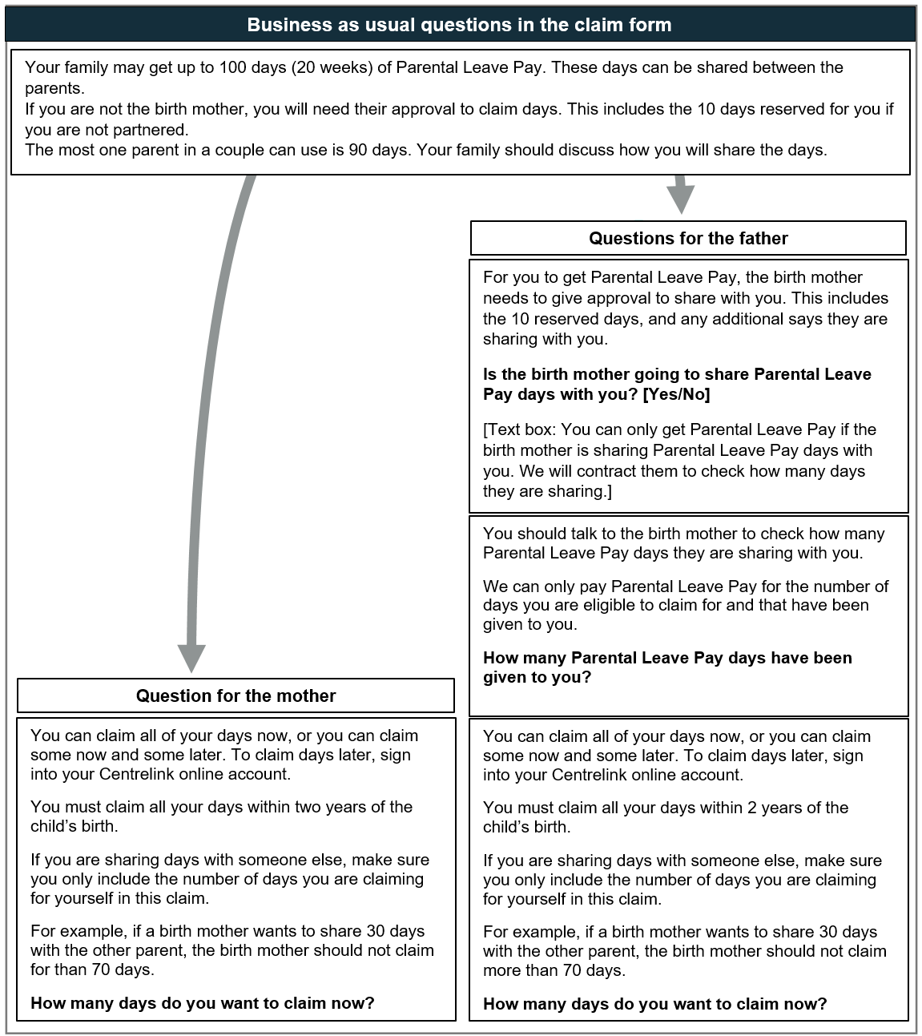Figure 1. The claiming questions shown to the BAU group in the survey experiment, showing the additional questions for fathers. Each question was shown on a new screen. The text was based on the text in the current Services Australia claim form at the time, edited slightly for brevity.
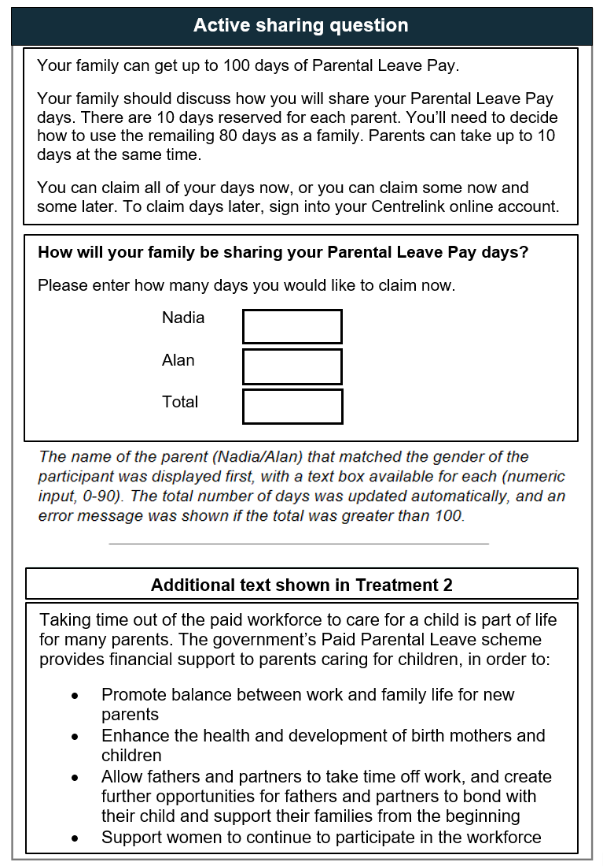
Figure 2. The active sharing question used in the two treatment groups, as well as the additional text summarising the rationale for offering PLP. This text was shown to participants in Treatment 2, before they completed the active sharing question.

What we found
In short…
Our interviews revealed new parents’ family circumstances, their understanding of the PPL scheme, and their views on parental leave (in particular, shared care).
Social norms around gender and child care form part of the social context in which parents start to consider applying for PLP. Although fathers are becoming more involved in child care (and the parents we spoke to appreciated the way the PPL scheme recognises this as well), the norm that ‘mothers are primary carers’ appeared to influence our participants’ decisions about their family’s caring arrangements.
While the parents we spoke to sought help and advice from a range of people while learning about and claiming PLP, employers and managers were a common source of trusted guidance about parental leave (both government-funded and employer-provided). At the same time, the difference between employer-funded and government-funded parental leave was a key element of confusion identified in interviews. In many couples, fathers had jobs which offered less leave or flexibility than mothers, and this also appeared to influence their decisions about who would take leave when.
Learning about the leave options and entitlements, and deciding how to allocate leave and PLP days as a family, was an iterative process for the parents we spoke to. Most parents in our study agreed on a 90:10 split (or close to it), a choice that was influenced both by the perception that the mother would ‘obviously’ have more child care duties (including breastfeeding), and by the way government websites communicate that the birth mother ‘controls’ the leave.
Once parents are claiming PLP, aspects of the online form – including the birth mother approval process – may present a barrier to uptake due to their complexity. For example, a question about ‘when will the child come into your care’ tripped up many fathers (who naturally saw themselves as becoming carers as soon as the child was born).
In a survey experiment with around 1,500 people (who were recently, currently, or potentially eligible for PLP), we found that asking how they would like to claim their PLP days in a way that makes the sharing of days between parents more salient, alongside a reminder of the purpose of the PPL scheme, encourages fathers to claim 3 more PLP days than the current form. We did not find any effect of the active sharing question on mothers’ claims. Overall, most participants in the survey experiment – regardless of what question they saw – allocated the majority of the PLP days to the mother. Around a quarter of both men and women allocated the same number of days to mothers and fathers (such as 50:50 or 40:40).

Overview
Our interview findings highlight the ways in which a family’s circumstances and decision-making, and broader social norms, interact with – and can be reinforced or challenged by – the details of how the PPL scheme is implemented and presented to parents through Services Australia’s website and claim form.
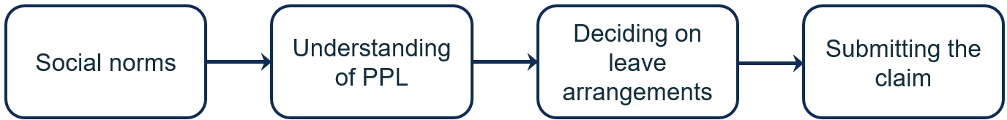
Figure 3. Subheadings in this section follow parents’ journey to claiming PLP
The structure of this section follows the process of parents’ interaction with the PPL scheme:
- Social norms around gender, caring and shared decision-making are part of the social context in which parents start to consider applying for PLP.
- As parents begin to gather information to inform their decision, their awareness and understanding of the specifics of the PPL scheme increases (but new confusions may also be introduced).
- Once they have made a decision about how to divide their PLP days and begin to apply, the PLP claim process itself may hinder or help them in acting on their decision.
- In particular, defaults communicated by the online materials and the way choices are presented through the questions in the form may inform the family’s final leave and PLP days allocations.

Social norms around gender, caring and shared decision-making
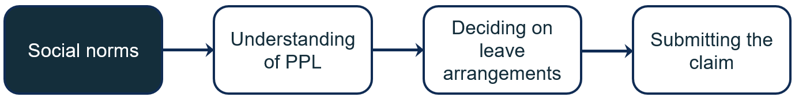
Figure 4. Social norms influence how parents approach the PPL scheme

The norm that ‘mothers are primary carers’ influenced participants’ decisions about their family’s caring arrangements
Consistent with research reviewed earlier in this report, most participants in our study expressed the norm that the mother is or would be the new baby’s primary carer (even though they didn’t tend to use the phrase ‘primary carer’). This norm appeared to influence their decisions about sharing leave (and PLP days), and was expressed as something that didn’t need discussion: it was ‘obvious’. For example, participants made comments like ‘obviously, we figured [mother] would have the majority of the days’ (Couple 8, expecting first child) or ‘I [mother] would obviously be the primary carer’ (Female 3, expecting first child).
For many there was a clear rationale behind this prioritisation: the mother and child’s health. A focus on (breast) feeding was evident in the comments made by both mothers and fathers, such as:
At the end of the day she’s going to be the one who is feeding the baby, and that’s more important than anything.
– Couple 6, expecting first child
Basically the mum is more important. She needs to feed the baby.
– Couple 12, expecting second child
While the parents we spoke to talked about ‘feeding the baby’ rather than ‘breastfeeding’, from context it seems likely that they were mostly referring to breastfeeding. Some also expressed the mothers’ priority more broadly, for example saying ‘obviously the mum will have more duties than the dad’ (Couple 25, second child recently born) or emphasising that it was important to recover after giving birth: ‘[parental leave] gives parents … especially the primary carer or the person who has given birth … time to recover from the childbirth’ (Couple 11, first child recently born).

Fathers are becoming more involved in child care, and participants appreciated the way the PPL scheme recognises this as well
At the same time, parents emphasised the importance of the father in caring for the newborn and the mother. A few participants commented on this directly: ‘We want [father] to be as involved as possible at the very start because obviously newborns are hard work’ (Couple 8, expecting first child); ‘[If] your wife is going to be exhausted … you need to be helping at home’ (Couple 6, expecting first child).
The role of the father was particularly salient when we asked parents to reflect on why the government might offer PPL. Many parents acknowledged and appreciated that norms around child care and parental leave are changing and that fathers are taking on a more active role in caring for their children.
Prior to, I don't know, the last 10 years, the fathers didn't get [leave]. It was all about the females, which I understand, but now, the government's actually realising that there's two parents, mothers and fathers, they're both on the same page, so they should be treated equally. Which is good.
– Male 21, expecting third child
Father: ‘When the government comes in and [introduces] leave even for the dad, I think it's good … it helps in the bonding between the father and the child and also it is of benefit to the women.’
Mother: ‘Yeah, because we are able to concentrate on our work and careers as well.’
– Couple 19, expecting second child
‘You know if the guy wants to take more time off … to stay home with the child they can … both parents have a good opportunity to decide what they wanna do with those days and how it will work for [them]’
– Couple 6, expecting first child

Government policies can both reflect and influence social norms
As we observed among participants in our study, gendered norms about child care continue to play a role in allocation of parental leave and PLP days in families. Social norms are complex, and tend to change only gradually (Harper, Marcus, George, D’Angelo and Samman 2020). The norm that mothers are primary carers appears to be already shifting, and a single policy change is unlikely to drastically accelerate that process. However, our research suggests that government policies, and the way these are communicated, can both reflect and – over time – influence broader social norms. Services Australia’s online materials about PPL and the PLP claim process, can support the gender equality objectives of the PPL scheme by using gender-neutral language, signalling that taking time out of the paid workforce to care for a child is part of the usual course of life and work for both parents, and providing concrete examples of parents sharing leave and PLP days. This approach is underpinned by Working for Women, which outlines the Australian Government’s commitment to narrowing the gender gap in use of and access to paid parental leave.

Awareness and understanding of the PPL scheme
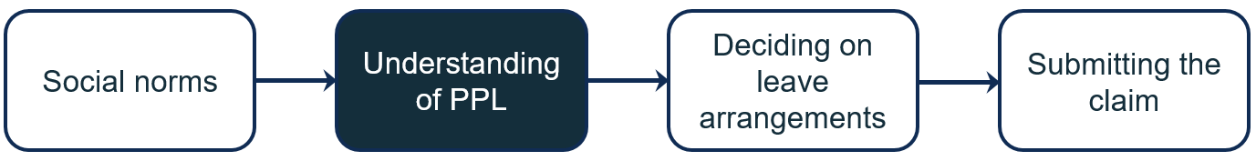
Figure 5. Understanding of PPL was informed by Services Australia’s website
During interviews we asked participants general questions about what they know about the Paid Parental Leave scheme, and asked them how they would go about learning more (including who they would usually talk to). In order to gather information on the PPL entitlement and the claim process, almost everyone conducted an internet search for information, often citing Services Australia or Centrelink as their first points of reference. Managers and employers were also frequently mentioned as an early contact point – not just for information about the employer’s policies, but also in relation to broader questions about (government-funded) parental leave. Finally, some of our participants reached out to friends or family who had completed the PLP claim forms previously.

Most couples began their online search by reviewing eligibility criteria
Almost all participants were easily able to navigate the Services Australia website and appreciated the comprehensiveness of the information available there. Parents wanted to feel fully informed, but seemed to simplify the task by focusing on questions that seemed most relevant to them: usually ‘Am I eligible?’ and ‘How do I apply?’ For example, the Australian citizens we spoke to mostly didn't bother reading the residency requirements for PPL. On the other hand, for those with Permanent Residency (or New Zealanders), the residency requirements were a key piece of information.
Overall, the website is well set up to help people navigate to the key pieces of information (such as with hyperlinks), including the income test, the work test, and so on. However, some of the pages could be restructured to make it easier for parents to quickly answer their key questions about eligibility. For example, two participants incorrectly believed that they were not eligible for PPL due to the individual income test, despite being eligible according to the family income test. Highlighting the (broader) family income test rather than the individual income test would guide parents to the right answer more quickly.

Employers and managers were a key source of guidance for participants
Almost all participants knew whether their employer offered parental leave or not, even if they were sometimes unsure about the details (such as the number of weeks or conditions of the leave). In general, participants seemed confident that their employer (sometimes HR within their company) would be able and willing to help them understand their options, and seemed comfortable approaching them with their initial questions.
We've got … all the policy and procedures and so on clearly communicated on our internal websites. And I mean, you can speak to your managers if you don't understand a particular policy or a particular detail. … We definitely have the support and the people and the team around us to help us – help me – understand it.
– Female 2, expecting second child
A few participants talked about preparing for conversations with their employer by first reading up on their entitlements – either through internal company policies or through government websites (such as the 'for employers' pages on Services Australia's PPL pages). This highlights the important role employers play in ensuring parents are aware of their leave entitlements, and encouraging uptake of parental leave – both paid and unpaid, employer-provided and government-funded. Recognising this role, Services Australia provides an Employer Toolkit, explaining the scheme and outlining what is required of the employer. This toolkit was out of scope for the present project, but may present an opportunity to further emphasise changing norms around child care and encourage greater involvement by fathers and partners.

Many were confused about PLP and employer-provided parental leave
Although employers were a trusted source of information and guidance, many of the people we spoke to were confused or mistaken in some respect about the relationship between government-funded and employer-provided parental leave.
A few people misunderstood the distinction between employer-provided paid parental leave and the legal entitlement that employers 'keep your job for you' (that is, allow you to take unpaid leave) for up to 12 months if you are taking leave to care for a child.
A second confusion, common among those who had not previously claimed PLP, was not realising that government-funded and employer-provided leave were two separate things.
What's the difference between PLP and the employer’s parental leave? My assumption is that they're the same thing. But I'm getting the sense that it's not the same thing.
– Female 2, expecting second child
This particular confusion may derive partly from the fact that government-funded leave is paid to individuals through their employer (through their regular pay cycle).
Sometimes with policies that come out of a larger organisation it's unclear who on the back end is actually paying for the pieces. … Now that we've had a look at it, it's actually quite unclear as to whether it's covered by Services Australia, or whether it's covered by your employer.
– Couple 7, expecting first child
Finally, many participants were surprised to learn they could claim PLP days as well as employer-funded leave – and in particular, that they could claim them both simultaneously (that is, receiving PLP on days when they are on paid leave, as well as unpaid leave, from their employer).
These confusions about the relationship between government- and employer-provided parental leave pay appeared equally common among men and women we spoke to, and are unlikely to disproportionately affect the allocation of the shared leave days to fathers. However, clarifying this distinction earlier on Services Australia’s website may help new parents prepare for conversations with their employer (which, as we heard, many people did early in the process), and enable them to make full use of the leave and payments available to them.

Planning and (ongoing) decision-making
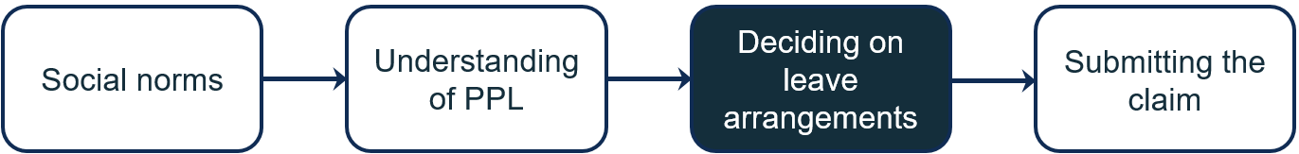
Figure 6. Parents’ decision-making is collaborative and iterative

Researching and deciding is an iterative process
During interviews we asked parents how they approached decisions about leave (both government-funded and employer-provided) – such as when they would take it, how much each parent would take, and what their caring arrangements would look like. Most of the parents we spoke to were still in the discussion and decision-making phase, and all recognised that any plan would need to be flexible and potentially change depending on the newborn child’s needs. They therefore appreciated the increased flexibility of the new PPL scheme, and were reassured by online messages saying they could change their nominated days.
I actually changed my parental leave. When I originally applied [for PLP], I was gonna be taking leave until February. And then during my leave, I decided I wanted to return to work early. So I had to go and adjust it.
– Couple 11, expecting second child
Couples often reported that they had each reviewed Services Australia’s website separately, and had done independent research, before coming together to discuss how to arrange their leave, including their PLP days. One couple mentioned that there were specific details of the reformed scheme that prompted them to consider how they wanted to take leave:
… realising that we could both take leave [PLP days] at the same time – that got us talking about, yeah, what do we wanna do? And then I guess the reading started our conversations, because we didn't know anything prior [to that].
– Couple 6, expecting first child
Similarly, hyperlinked phrases on the website and in the claim form helped parents double-check what they were eligible for and whether there was additional information they needed in order to complete their claim.
I would have [read this] before applying, or if during the form I was like ‘ohh, I forgot what that was,’ I'll go [and click on the hyperlink].
– Couple 11, expecting second child
So it's good that they've given us more blurbs in this section during the [claim form]. I think it's just a good refresher (…) for me or for anyone who isn't familiar or just forgotten about the details.
– Female 2, expecting second child

The Services Australia website communicates that the mother ‘controls’ the leave
Parents’ iterative decision-making process means that information on government websites may frame and inform their decision-making in these early stages. During interviews, this was particularly clear on the ‘Sharing your payment’ page, which describes how the birth mother ‘can choose to share some or all of your Parental Leave Pay’ (emphasis added). Reading this page, parents reflected (and reflected on) the idea that the mother ‘controls’ the PLP days:
“If you're the birth mother, you can choose to share.” Okay, so the mothers have control.
– Female 10, expecting third child
So it's up to the birth mother to, I guess, carry all the responsibility of the days and then share or not share.
– Male 7, expecting first child
We saw some evidence that this sense of control or responsibility could reduce fathers’ engagement with the process. One expectant father we spoke to initially indicated that he would be in charge of the paperwork, in an attempt to reduce the administrative burden on his partner. However, reading the ‘Sharing your payment’ page, he started to change his mind:
Given the nature of the birth mother, having the authority on this system to approve [the leave], I think it would actually make more sense to have the birth mother actually make the claim.
– Male 7, expecting first child
Some fathers found the birth mother approval process surprising, and questioned what it meant for their relationship and ability to take leave. For example, one father summarised his role in the claim process by saying (laughing), ‘So it says, ummm ... that I need to be nice to her’ (Couple 6, expecting first child). Another couple thought through the steps involved, including the separate forms for the mother and father:
Mother: ‘I would also have to put the claim through my profile. To get you that approval ID.’
Father: [laughing] ‘To give me the time off.’
– Couple 7, expecting first child
While it is an intentional policy choice to require that birth mothers approve the number of PLP days claimed by the other person, this reaction suggests that some of the language used to describe this arrangement may be subtly disempowering fathers from engaging in the decision-making, and potentially the leave-taking. The PLP website could instead emphasise the shared nature of the entitlement, such as by moving the ‘Sharing your payment’ page earlier in the hierarchy of pages (or linking to it earlier), and altering some of the language on the page.
In the second round of user testing we showed participants a revised mock-up of the ‘Sharing your payment’ page which placed greater emphasis on the shared ownership of PPL, and provided examples. Reviewing the revised page, participants focused more on the shared decision of how to allocate the PLP days, and what this would look like in practice. This suggests that these changes could help shape how participants approach the conversation about sharing caring responsibilities.
So, in short, everything looks pretty legit and balanced for both parents to be on the same side, on the same page, very much.
– Couple 6R, expecting first child
That's pretty clear because it tells you for the first 10 days, both of us can claim at the same time, but apart from that, we have to separate into different times.
– Couple 12, expecting second child
That said, one couple in the second round of user testing believed that if the government was going to truly allow parents to allocate the leave in a way that suited them, either parent should be able to take the full 100 days:
So if it's true sharing, and the dad needed to go to work, then [he could] give up the two weeks and the mum will get 20 weeks, dad will get 0. So that's considered sharing if the parents agree. Or if the mum wants to go to work, the mum is making more money, then the mum will get zero, the dad will stay at home and get 20 weeks. So that's considered, like, true sharing.
– Couple 25, second child recently born

Most parents agreed the mother would have the majority of the days
As discussed in the section on social norms, most couples took it for granted that the mother would be in charge of the bulk of the child care, at least initially, with the father in a supporting role. In our interviews, this assumption was also carried through to how they allocated the leave, with most parents reporting that the mother would likely have 90 days, and the father just the 10 reserved for him. A few who were still undecided said things like ‘for this exercise, let’s start with 50:50’, and a few mothers also joked that if they could take the full 100 days for themselves they would. Parents asked for more examples of the types of arrangements others have decided on, and seemed open to the idea of more equal sharing, if they could see ‘how it would work’:
[Like] I said before, giving some examples of “how it works” … would have been good … Can I take 2 days this week and the missus takes 3 [etc]? Or does she take the first 10 weeks? Then I take the next 10. Or does she take five weeks? Then I take 5, she takes 5, I take 5. [I have] a lot of questions about that.
– Male 4, expecting first child
Other factors that were relevant in the couples’ conversations about how to share the leave included whether their employers offered unpaid or paid parental leave, the availability of other types of leave (such as personal leave or annual leave), and how to schedule leave-taking around practical constraints – such as if one parent did shift work or could work from home.
Surprisingly, financial considerations were mentioned by only a few of our participants. Instead, the 90:10 default appeared to be driven more by social norms around caring roles and relative employment flexibility (see below). These norms are not challenged by the Services Australia website, and parents reading the website continued to highlight a 90:10 split as the ‘generic’ option (more on this below). This is consistent with research demonstrating that even in couples where the mother earns more, she is more likely to take parental leave from her work than her partner (Bahar, Bradshaw, Deutscher and Montaigne 2023). Some couples also commented that as they shared finances, the payment for either parent would arrive in a shared bank account, and so exactly how they shared the payment was less relevant than determining how best to schedule their leave days.
I mean, the money's coming to our family as a whole. So whether it goes to my husband or whether it goes to me, it's still the same money.
– Female 9, first child recently born

Fathers make decisions based on their job’s entitlements, flexibility and culture
Many fathers cited job considerations as the reason why they couldn't or didn't take on more of the leave (both paid and unpaid leave from their employer, and PLP days). Some participants referred to practical differences between their jobs in terms of available leave or relative flexibility. One mother said that it was easier for her partner – a builder – to go back to work, while for her – working in HR – there was a lot more to catch up on.
In other cases, interviewees’ references to the father’s employer implied gendered norms in the workplace around appropriate caring responsibilities for the father. Some shared that their workplaces were more male-dominated, with one father who worked in logistics stating:
Put it this way, it's a little more sort of a male focus I think … Umm, you know, they're firms that are run by older men.
– Male 7, expecting first child
One father who had not applied for PPL following the birth of his older child reported that his employer at the time had directly discouraged him from taking leave:
In my case my employer is a bit strict, so when I informed him … [he] said not to proceed with application.
– Male 10, expecting second child
It’s not clear whether this father took leave but didn’t receive PLP, or whether he didn’t take leave at all. While this is a single case – and most of our participants had supportive employers – it is a reminder of the influential role employers play in shaping parents’ understanding of and decisions around parental leave options.

Social norms, apparent defaults, and examples give parents shortcuts through a complex decision
Parents are juggling a range of considerations – employer entitlements, their preferences, child well-being, both parents’ schedules, finances, and more – when deciding how to allocate leave between them. Despite these considerations varying widely among our participants, most decided that the mother would take the majority of the leave. This appeared to be driven partly by an expectation that the mother would ‘obviously’ undertake the majority of the child care, including feeding the baby – a social norm that in turn was reflected in the way the leave was described on the ‘Sharing your payment’ webpage, and reinforced by the fathers’ workplaces. The complexity of the decision may be encouraging people to rely on ‘rules of thumb’ or what seems to be the default.
So you know … the ratio is 90 to 10, but you can work out a different ratio.
– Female 10, expecting third child
Similarly, almost all our participants mentioned that they found examples useful, and that they would benefit from more examples. Some participants explicitly asked for examples of how to share the leave. This provides an opportunity for the websites to highlight alternatives to the ‘default’ 90:10 split, and encourage parents to consider a more equal allocation.
You know, on that page where it emphasises that there is a pool of 100 days to draw from for both the mother and the father (…) it would be good to see – just for relativity, you know – a link to ‘this is how some families have chosen to allocate their days.’
– Couple 7, expecting first child
It would be good to have a couple of scenarios. Single – claiming 20 weeks, in this example claiming 10-10, then – just checking my assumption – the generic one would be the mum taking 18 and the dad taking 2.
– Couple 25, second child recently born
Participants also used examples to check that they understood the information on the website, and they found this reassuring. They also appreciated additional visual elements – such as graphics and videos – to support their understanding.
Given the complexity of the decision-making environment, individuals and couples may also benefit from an interactive planning tool to support arranging leave and caring (including considerations of dates, income, and the couple’s preferences). Such a tool could help simplify a complex family and financial planning process and provide examples, supporting families to share decision-making and plan their leave. It could also clarify aspects of the process that are currently confusing (like the interaction between employer-provided leave and PLP).

Submitting the online claim
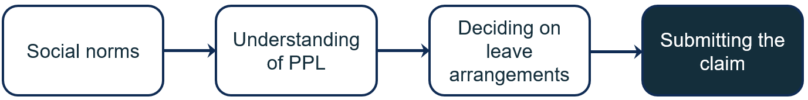
Figure 7. Attempting to submit a claim can lead to further questions and further research
After reviewing the website with participants, our interviews turned to the sections of the online claim form that were relevant to caring arrangements.
Overall, participants said that they found the PPL claim form comparable in complexity and difficulty to other Services Australia forms (that they may have completed in the past). Most questions were clear and easy to answer. Where questions were confusing, participants were usually able to complete them by ‘muddling through’: having a guess at the right answer, reading the help text or following hyperlinks to further information, or even coming back to the question later. This approach was facilitated by the structure of the online form, the way it automatically saves information, and the reminders (throughout the form) that changes could be made later. Participants especially appreciated the fact that they would be able to log in and flexibly manage their PLP days later, as uncertainty and change are a common feature of life with a newborn.
We kind of fumble our way through. … And we contemplated calling [Centrelink], then we're like “How long are we gonna be on hold?” So we would kind of be like, OK, we'll just do this form. We tried to read through it several times and then we're like, OK, we'll just do it and we'll see what happens at the end of it.
– Couple 9, first child recently born
However, some features of the claim form were particularly likely to create confusion among the participants we spoke to, and could contribute to lower uptake of leave by fathers and partners. These features include the approval process, the two forms (one for each parent), and several questions about dates. In addition to generally confusing some participants, these features may further reinforce social norms around the birth mother’s primary care role. We discuss them in turn below.

The complex steps of the birth mother approval process may be a barrier to uptake
If both parents want to claim PLP, both parents must submit an online claim form through myGov, and the birth mother must give approval to share PLP days with the other parent’s claim (including the 10 reserved days). This approval mechanism through the birth mother is legislated, and is intended to mitigate the risk that fathers or partners may take PLP against the wishes of a birth parent, as a form of protection for mothers experiencing domestic violence or coercive control. Our research did not assess whether or how the approval mechanism helps mothers in these situations.
We did find, however, that the approval process’s multiple steps increased the potential for confusion among parents, and strongly reinforced the social norm of the mother being the primary carer. Some participants questioned the reasoning behind the approval step, believing that simply reporting how many days they (each) wanted to claim would be sufficient:
I would suppose that when you put that in ‘how many days are you gonna take,’ that's your way of giving approval to the other, for Centrelink. To say that you're happy for the other person to take the rest of the days.
– Couple 6, expecting first child
I knew that we could split it however you wanted to. But [what I was confused about] was actually just getting to that step of like being able to share and approve it and have it all sorted [in the form].
– Female 3, expecting first child
These additional steps add further opportunities for confusion and mistakes to an already complex process. Given the extra steps are only triggered once another person (who is not the birth mother) attempts to claim PLP, they could have the effect of giving fathers more opportunities than mothers to drop out of the process, whether due to errors, forgetfulness, procrastination, or even a decision that it’s not worth continuing (though note that we did not observe this drop-out directly as part of the user testing, because parents were asked to complete the whole mock form). To reduce confusion, Services Australia could consider simplifying the approval process, or including additional context or reasoning in the form for why the birth mother’s approval is required (that is, instances of violence, coercive control or separation). This could help parents better understand the purpose and rationale behind the process. However, the effect of the current approval process and any changes to it would need to be carefully monitored. Services Australia could also consider additional supports for victim-survivors, including, for example, proactively following up with mothers who reject their partner’s PLP claim, to provide them with information about domestic violence support services or other support they may need.

Some parents were confused by the process involving two forms with overlapping questions
Some of our participants found the form straightforward, including the approval process. These participants interpreted the Approval ID as a method for Centrelink to match the two carers (and claims) together, while also allowing them to confirm that they had both agreed on the allocation of the days. A couple of participants also thought this process might make sense in circumstances where the parents were separated.
Obviously the mother’s gonna be the primary carer of the child at birth, and (…) if there was a divorce or a separation or something, you have to approve that 10 days to be put through to the father.
– Couple 8, expecting first child
Father: ‘It does seem a bit backwards to have me do a form and [her to do a form] where we could just do one (…)’
Mother: ‘Yeah, but [the Approval ID] just allows if you are in a separated circumstance or (…)’
Father: ‘But if you're just in a normal family unit, this is all you have to do here.’
– Couple 9, first child recently born
That said, while most people we spoke to understood that both parents would need to submit a form, some were frustrated with having to repeat so much information. Others, upon seeing the same questions again, worried that they had made a mistake and were accidentally submitting a whole new claim. One couple thought the mother’s claim was sufficient for them both, only discovering that the father would have to claim separately when they received the notification that they had been approved – but only for 90 days.
It wasn't until after we had got the email to say “your application has been approved” and I actually read the letter that it says “[to get] the other 10 days, your partner must apply”. I just thought we put like, [his] name and details in, so we were like, OK, obviously that's gonna go to both of us.
– Couple 8, expecting first child
Father: ‘It was a bit cumbersome and like I know that you might be just double-checking information, but it did seem like OK, well, am I doing this right?’
Mother: ‘Yeah, we were questioning if it was a whole new application because of how much was involved.’
– Couple 9, first child recently born
Overall, the user experience may be improved by Services Australia conducting a ‘question audit’: considering what information needs to be collected, for what purpose, and whether there would be a way to create a simpler PLP claim form suitable for the majority of applicants (‘filtering’ people with less common caring arrangements into a more extensive form earlier in the process).
An alternative approach would be to create the option of a single form per child that allows parents to jointly apply for PLP. Offering couples the option of jointly applying for PLP would signal a clear departure from the previous process, help establish a new social norm for sharing care of a child, and encourage families to explicitly discuss their caring arrangements as they complete the form together. (Individuals would still need the option to file separately if they prefer to, or if this better suits their circumstances, such as separated parents or single parents.) Any proposed revisions to the form process and design would need to carefully consider the impacts on parents experiencing family and domestic violence (see comments about approval process above).

A question about ‘when will the child come into your care’ tripped up many fathers
For Centrelink purposes, it's important to know that the person claiming PPL is caring for the child on the days they are receiving the payment (rather than working, for example, or doing something else while the child is in childcare). For this reason, the claim form asks when the claimant would like the PLP days to start, and whether they would be caring for the child on the days they are claiming PLP. The current scheme allows for a child to have multiple carers on the same day (and for parents to claim 10 PLP days simultaneously) and therefore no longer defines a 'primary' carer. Despite these changes, the claim form still also asks biological fathers when the child will come into their care (or when the child did come into their care, if the child has already been born).
This question was often confusing to fathers, as it seemed to imply that they were not a carer from the child’s date of birth. Within the context of the claim form, many assumed it meant 'from which date would you like to be paid'; but that question is asked directly elsewhere in the form, and is asked of both parents.
As this question caused some parents to pause and second-guess themselves, and isn’t necessary for determining eligibility for PLP for biological fathers (given that other questions provide the required information), it is an example of the type of question that could be removed from the form in order to simplify it (as discussed above).
When will you become the carer – when will the child come into your care – when it's born. But then – is it the day that I want to take? Yeah, that you're gonna be paid for? On a second [read], is this a trick question?
– Male 8, expecting first child
When did [child] come into your care? So, I think that it may not be relevant, because if I'm the biological parent, he came into my care the day that he was born. I was not expecting a question of that kind. And I think that it is aimed at adoptive parents.
– Male 10, first child recently born
Father: ‘Wouldn't this be the same day [i.e. birth date] though?’
Mother: ‘Yeah but it depends which days you're taking – I think the day you become the carer is the first day that you're aiming to take off. So since we are both submitting the form, my day might be different to [yours].’
– Couple 7, expecting first child
This question could still be retained for non-birthing parents who are adoptive parents (as noted by one of our participants as well), gaining parents in a surrogacy arrangement, or people claiming PLP in exceptional circumstances, as these claimants are only eligible for PLP after the child has come into their care (which may not be on the same day as the child’s birth date).

The role of how choices are presented
Parents may turn to social norms and apparent defaults when navigating a complex decision. In addition to a default or ‘typical’ allocation of leave being communicated through information about PPL emphasising the mother’s control of the leave, defaults can potentially come through in the wording of specific questions in the claim form.

We tested how a new sharing question might affect a father’s leave allocation
Asking ‘if’ a birth mother would like to share her PLP days sends a different message than asking ‘how’ a couple would like to share the days. We designed a survey experiment to test the following: would an active sharing question – asking ‘how would you like to share your family's Parental Leave Pay Days?’ – help couples enact their intentions to share care, compared to the current framing in the PLP claim form? We asked participants to consider a hypothetical scenario in which they were an expectant mother or father (depending on the gender of the participant), claiming PLP online. We randomly assigned participants to either see the 'business as usual' (BAU) claim form, or one of two active sharing questions. We then tracked how many days each group allocated to the father and mother (see further details in the 'What we did' section).

The active choice question did not affect women’s allocation to mothers
Women in the BAU group were asked 'how many days do you want to claim now'. They claimed on average 60 days for themselves. In the two treatment groups, they were asked how they would like to share their family’s leave between the mother and the father (the same question as men; see Figure 2). In these groups, women claimed on average 61 and 62 days for themselves, which was not significantly different from the BAU condition (see Figure 8).

Men allocated more days to the father in the treatment groups than in the BAU
Male participants responded to the hypothetical scenario 'on behalf of' the father. For those in the BAU group, this meant they were presented with a brief overview of the PPL scheme and how the sharing of PLP days works, then asked a series of questions – consistent with Services Australia's current claim form – before being asked ‘how many days would you like to claim now’. As can be seen in Figure 9, fathers claimed on average 21 days for themselves in this BAU group.
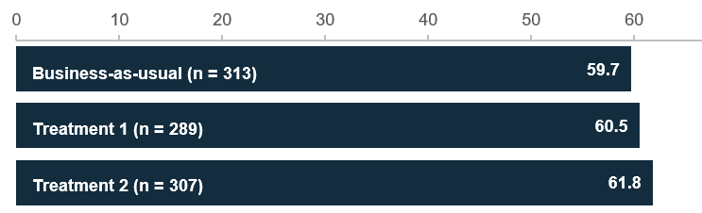
Figure 8. Number of days allocated to the mother, by women
In the two treatment groups, participants were provided the same background information about PPL (reworded slightly on the basis of user testing), but the question asked them to allocate leave to both the mother and the father in the scenario (active sharing, see Figure 2). Treatment 2 was the same as Treatment 1, except for the addition of a short paragraph about the purpose of the PPL scheme (for example, to promote balance between work and family life for new parents; see Figure 2).
In the treatment groups, men claimed on average claimed 23 and 25 days for themselves, respectively. The difference between Treatment 2 and BAU was statistically significant (p = .03), but the difference between Treatment 1 and BAU was not (p = .12). Men in Treatment 2 claimed on average 3.3 more days for the father than those in the BAU group.
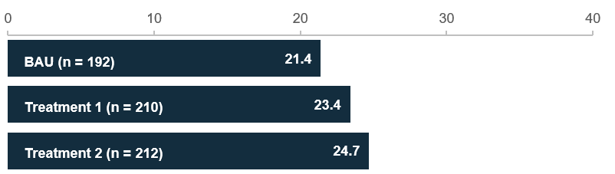
Figure 9. Number of days allocated to the father, by men

Both men and women tended to allocate more leave to the mother
In the treatment groups, both men and women were asked to allocate days to both mothers and fathers (that is, to themselves and to the other parent). This allowed us to examine the total number of days allocated, and to directly compare men’s and women’s allocations. Most participants allocated the full 100 days (60%), but a sizable minority allocated only 80 days (21%) or fewer (17%). This could be because they were imagining keeping some days 'in reserve' to allocate later.
On average, in the treatment groups, women allocated 4.0 days more to the mother than men did, and men allocated 2.6 days more to the father than women did. However, the majority of both men (68%) and women (73%) allocated more days to the mother than to the father. Around a quarter of all participants allocated the exact same number of days to both parents (men: 26%, women: 25%). Only 2% of women and 6% of men allocated more days to the father than to the mother. This is consistent with what we heard in user testing. See Figure 10 for the full distribution of responses.
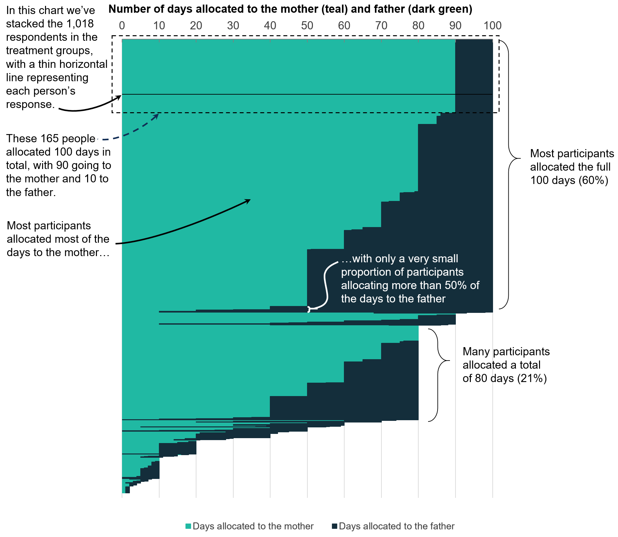
Figure 10. Number of days allocated to mothers and fathers by participants in the treatment groups

During user testing, parents found the ‘active sharing’ question easy to complete
During the first round of user testing, parents completed a mock-up of the BAU claim form. The questions about ‘how many days would you like to claim now’ (and, for fathers, ‘how many days have been given to you’) were generally straightforward for parents to complete. When confusion arose, it was usually for one of two reasons:
- Parents sometimes reacted to the word ‘now’ by saying that since the child hadn’t been born yet, they didn’t want to claim any days now. This confusion was allayed by reminders (in the help text) that parents can update their dates later (by logging in to myGov), and by subsequent questions asking parents to nominate which specific day they wanted their PLP days to start (which must be after the expected date of birth).
- Mothers were sometimes unsure whether they should claim 100 or 90 days – incorrectly reasoning that if they were in charge of sharing the days, they should first claim 100 days, and then give the 10 reserved days (or more) to the father afterwards.
In the second round of user testing, we showed parents an active sharing question, similar to the one used in the survey experiment. As the active sharing question asks parents to allocate days to both the mother and father at the same time, it avoids this second confusion – the parent can be confident that they are indicating that they would like to use the full 100 days overall, while at the same time only claiming a smaller number of days for themselves. The parents we spoke to also found this format intuitive and easy to understand, and appreciated that it ‘did the maths’ for them. While the active sharing question we tested did not make a distinction between how many days the parents would like to claim now, versus later, parents still had the ability to log into myGov and update their PLP days.

Changes to the claim form could contribute to couples’ broader conversations
In sum, we did not see an impact of the 'active sharing' question on allocation of days to fathers overall. However, male participants given an active sharing question did allocate slightly more days to themselves (the father), on average, when they were also reminded about the purposes of the leave. These fathers saw a brief paragraph highlighting the purpose of the PPL scheme, including to ‘allow father and partners to take time off work, and create further opportunities for fathers and partners to bond with their child’. In addition to the changed question framing, the explicit reminder of a father’s role in child care might have contributed to this group’s slightly higher allocations to fathers.
While the survey used a hypothetical and circumscribed scenario to elicit allocation decisions, in the real world – as we heard during user testing – accessing and filling in the form is often an iterative process. Information included on the Services Australia website and in the claim form itself can prompt and inform conversations among couples about specific aspects of how they arrange their leave. A couple’s broader considerations (social norms, finances, healthcare needs and so on) may ultimately swamp any direct impact from questions in the form. But the results from the survey experiment suggest that reminding fathers about their role in child care, and highlighting the relative allocation going to them and their partner, may prompt men to consider taking a few more days leave – potentially informing the conversation they have with their partner, and helping the couple make an active, informed choice that is right for their family.

Limitations

User testing interviews
In this study, we spoke to a small sample size of 24 expectant or recent parents (from 15 families) about their experience of, and decision-making around, parental leave. Insights from the interviews suggest ways in which government materials could further encourage fathers and partners to take leave. However, the parents we spoke to – while facing different circumstances – represent only a specific subset of all parents in Australia: heterosexual couples who were raising their child(ren) together.
As we didn't conduct user testing with people in less common caring arrangements – for example, adoptive parents, divorced or step-parents, those who experienced a medically complicated pregnancy or birth, LGBTQIA+ couples, or those in surrogacy arrangements – the results cannot speak to how the materials work for them. Future research could be conducted with these cohorts as well, in particular to inform any changes to Services Australia’s materials that involve the trade-off between making the form easy and short for parents in the most common circumstances, versus ensuring it captures all relevant information from parents in the full range of circumstances.

Survey experiment
Similarly, while the survey experiment was completed by a larger sample, the scenario also focused on a heterosexual couple, and provided relatively little information about their circumstances. Further limitations of the survey experiment include:
- Participants made the decision and answered the questions alone, whereas a key feature of real decision-making about PPL is that it usually involves both parents.
- Although we asked participants to ‘imagine’ that they were in the position of the mother or father in the scenario, they were still in essence making the decision for someone else, in a way that differs from the real-life decision.
- In the real world, parents can update how and when they take their leave after the claim has been approved, including allocating more days to the mother or father as needed. In the scenario, by contrast, participants weren’t able to revise their responses later.
These limitations are a function of the somewhat abstract set-up of the survey experiment, and are unlikely to bias the internal validity of the study – that is, the finding that men claimed 3 more days when given additional information and an active sharing question, in this specific experimental scenario. However, they reduce the external validity of the result, in that they limit our confidence in whether we would observe a similar effect if the active sharing question was implemented in the actual claim form.

Discussion and conclusion

The claim form and website are important – in the context of much broader cultural norms
Parents are juggling many factors when deciding how to care for their new child and manage their parental leave. These factors include what they feel will be best for the child and birth mother, what leave they have available from their workplaces (including both annual and parental leave), and what they are eligible for under the Paid Parental Leave scheme. Similarly, the PPL scheme has multiple goals, and policy makers face challenging trade-offs when designing policy that balances these goals.
Our research suggests that the implementation of the scheme also matters: Services Australia’s website has an important role to play in prompting and informing conversations about shared care among new parents. Our user testing suggests that the website and form (as they stood at the time this research was conducted) reinforced the norm of mother as primary carer (despite not using the language of ‘primary carer’), contributing to a perception that the 'default' split of PLP is around 90 days to the birth mother, and 10 for the father. The reformed scheme and its yearly updates to the entitlement present an opportunity to move away from this default in the communication materials, such that the implementation of the scheme more strongly supports gender equality in leave and child care. This can help support implementation of Working for Women, particularly in relation to changing gender norms and narrowing the gender gap in use of and access to paid parental leave.
However, our user testing also highlighted that gendered norms around child care – that the mother would ‘obviously’ have the primary carer role – exist outside the form and the website. Larger cultural shifts, including in male-dominated workplaces – which have already begun – are likely required to encourage greater gender equality in child care. This includes addressing workplace discrimination and assumed norms around male caregiving, and ensuring that men’s take up of paid parental leave and taking of flexible work is normalised in workplaces and promoted as a supported entitlement.

Employers have an important role to play
The financial support provided by the PPL scheme is intended to complement and supplement existing entitlements to paid or unpaid leave in connection with the birth or adoption of a child. While the present project didn’t focus on employer-provided parental leave (or other types of leave) directly, it was an important factor in parents’ considerations. We uncovered significant confusion about the relationship between government-funded and employer-provided parental leave pay: for example, whether they were the same thing, whether they could be taken at the same time, and how unpaid and paid leave entitlements provided by their workplace influenced the eligibility for PLP. Further, the men we spoke to appeared to be more likely to believe they didn’t have parental leave entitlements through their work, or that their employer would not be supportive of them taking leave.
This suggests employers can play a role both in offering equal paid parental leave for all parents, and in encouraging more men to take parental leave. The availability of employer-provided parental leave benefits is increasing (WGEA 2024). The government could continue to encourage employers to offer gender-equal parental leave benefits through leading by example – for example offering gender-equal parental leave in Enterprise Agreements – and recognising those who demonstrate best practice. Good practice guides such as those available from the Fair Work Ombudsman (FWO) and WGEA could be updated to highlight new features of the government’s PPL scheme (especially the ability to take both types of leave at the same time). On a smaller scale, the Services Australia website can support parents’ understanding of their entitlements by clarifying the distinction between employer-provided and government-funded parental leave, and linking to the relevant FWO webpages about leave entitlements, in order to help new parents prepare for conversations with their employer, and enable them to make full use of the leave and payments available to them.

If fathers claim more PLP days, fewer days are available to the mother
As the total number of PLP days available is fixed (though increasing every year up until 2026), any days a father claims – above the reserved period – are days that are not available to the mother. While fathers claiming more days would contribute to more equal allocation of PLP, there may also be trade-offs.
First, if the father earns more than the mother and takes unpaid leave from work during his PLP days, couples may end up in a less optimal financial situation (than if the mother had taken the PLP days). Couples may still choose this arrangement if it makes sense given their values, preferences and practical arrangements. And trade-offs between money and caring are already being made, given the frequency at which mothers with higher incomes than their partners are choosing to take unpaid leave or work part-time (Bahar et al. 2023). As noted by some of the parents we spoke to, many couples share finances, and thus the exact distribution of the payment was less relevant than the distribution of leave days. In any case, there may be a financial incentive for fathers to take at least 10 PLP days, given that parents can now take paid leave from their employer (if they have access to this) and receive PLP at the same time.
Second, if the father takes more PLP days and – as a result – the mother not only claims less PLP days but also goes back to work earlier (because the father is more involved in child care), one concern might be that it would over time reduce rates of breastfeeding and have impacts on child and maternal health. The World Health Organisation recommends exclusive breastfeeding for 6 months. In 2011, the average duration of parental leave for women in Australia who had gone back to work was 7 months (Ulker and Guven 2011). Government-funded PLP was at that time only available for 18 weeks, so mothers were already supplementing with other types of (paid or unpaid) leave. As leave entitlements have increased in the 14 years since 2011, it is likely that the current average duration of the women’s time off from work is higher. It thus seems unlikely that having fathers claim a few more PLP days – or even weeks – will decrease the woman’s availability to breastfeed to less than the recommended 6 months.
The reforms to the PPL scheme noted that the original intent of the leave entitlements – to support maternal and child health (including breastfeeding) – would need to be monitored and maintained as these changes are introduced. Monitoring these possible financial and health impacts as parents become more familiar with the reformed PPL scheme could help determine how families are managing the trade-offs and making decisions for their family.

Parents should be supported to make a choice that works for their family
With social norms shifting towards more gender-equal parenting, parents may choose a more equal allocation of PLP days and child care, even if it means their household having a lower overall income, or the mother going back to work sooner. Services Australia’s online materials about PPL and the PLP claim process can support parents to make their own informed decision about these trade-offs by using gender-neutral language, signalling that taking time out of the paid workforce to care for a child is part of the usual course of life and work for both parents, and providing examples of parents sharing leave in a range of ways. Individuals and couples may also benefit from an interactive ‘planning tool’ that helps them schedule their leave and caring (including considerations of dates, income, and the couple’s preferences). Such a tool could help simplify a complex family and financial planning process, supporting families to reach an arrangement that works for them. It could also help clarify aspects of the process that are currently confusing, like the interaction between employer-provided leave and PLP.

Further research may help disentangle the influence of social norms from the influence of the PLP claim form and website
As mentioned in the ‘Limitations’ section, the present research involved couples in heterosexual relationships who were caring for (or planning to care for) their children together. While this is the most common family configuration (ABS 2021), the PLP claim form is currently designed to capture all the required information from parents in all circumstances. Despite the use of conditional questions and ‘branches’ in the form – intended to ensure parents are only asked the questions that are relevant to them – the process is complex and long. These frictions in the process may present a barrier to parents claiming PLP – and may have a bigger impact on parents who are less motivated. Despite fathers becoming more involved in child care in recent years, a couple may be less motivated to complete a father’s claim process if he is taking fewer days than the mother (or only the reserved days) and the effort to complete the claim is seen as ‘not worth the hassle’. This in turn means that any continual improvements to the claim form (to the extent possible within the legislation) – for example the removal of unnecessary questions, streamlining of the form’s logic, and ensuring the birth mother approval process is as straightforward as possible – may also have a larger impact on fathers’ claims, and contribute to greater gender equality in a couple’s allocation of days.
As highlighted in this report, it can be hard to disentangle the influence of the claim form and website from the influence of broader social norms. However, in addition to speaking to parents in less common circumstances (as suggested in the ‘Limitations’ section), future research could also examine additional changes to the claim form and website alongside shifts in how couples are allocating their days over time. This real-world, longitudinal monitoring may enable greater understanding of how the claim form and website contributes to parents’ decision-making, and informs their allocation of PLP days to mothers and fathers.

References
Australian Bureau of Statistics (ABS) (2021) Household and families: Census, ABS Website, accessed 21 July 2025.
Aidukaite J and Telisauskaite-Cekanavice D (2020) ‘The Father’s Role in Child Care: Parental Leave Policies in Lithuania and Sweden’, Social Inclusion, 8(4):81–91.
Bahar E, Bradshaw N, Deutscher N and Montaigne M (2023) Children and the Gender Earnings Gap: Evidence for Australia Treasury Working Paper, The Treasury, Australian Government, accessed December 2024.
Baird M and Hill E (2022) Next steps for paid parental leave in Australia, report to the Australian Government, Department of the Prime Minister and Cabinet, The University of Sydney.
Baxter J, Budinski M and Stevens E (2024) Take-up of Parental Leave Pay and Dad and Partner Pay among Australian parents: Analysis using the Person Level Integrated Data Asset Australian Institute of Family Studies, Australian Institute of Family Studies, Australian Government, accessed December 2024.
Broadway B, Kalb G, Kuehnle D and Maeder M (2015) ‘The effect of paid parental leave on child health in Australia (No. 8978)’ [PDF 176 KB]. IZA Discussion Papers, accessed July 2025.
Broadway B, Kalb G, McVicar D and Martin B (2016) The impact of paid parental leave on labour supply and employment outcomes (No. 9801) [PDF 1654 KB], IZA Discussion Papers, accessed July 2025.
Buckmaster L (n.d.) Comparing the Paid Parental Leave schemes, Parliament of Australia, Australian Government, accessed July 2025.
Clarke E (16 August 2024) ‘Lower child care costs are just the beginning’ e61 INSTITUTE, accessed July 2025.
Cools S, Fiva JH and Kirkebøen LJ (2015) Causal effects of paternity leave on children and parents. The Scandinavian Journal of Economics, 117(3), 801-828.
Department of Social Services (DSS) (2023) Submission to Community Affairs Legislation Committee [PDF 2414 KB], Parliament of Australia, Australian Government, accessed July 2025.
Cox C (2021) An integrative review of fathers' needs during the transition to fatherhood: Implications for perinatal education [PDF 619 KB] [honours thesis], Portland State University.
Duffy S, Van Esch P and Yousef M (2020) ‘Increasing parental leave uptake: A systems social marketing approach’, Australasian Marketing Journal, 28 (2), 110–118.
Duvander AZ and Johansson M (2019) ‘Does fathers’ care spill over? Evaluating reforms in the Swedish parental leave program.’ Feminist Economics, 25(2), 67-89.
Flacking R, Dykes F and Ewald U (2010) The influence of fathers’ socioeconomic status and paternity leave on breastfeeding duration: a population-based cohort study. Scandinavian Journal of Public Health, 38(4), 337-343.
Harper C, Marcus R, George R, D’Angelo S and Samman E (2020) Gender, power and progress: How norms change’. ALiGN, accessed July 2025.
Huerta MC, Adema W, Baxter J, Han, WJ, Lausten M, Lee R and Waldfoge J (2014) Fathers' leave and fathers' involvement: Evidence from four OECD countries. European Journal of Social Security, 16(4), 308-346.
Jachimowicz JM, Duncan S, Weber EU and Johnson EJ (2019) When and why defaults influence decisions: A meta-analysis of default effects. Behavioural Public Policy, 3(2), 159-186.
Khan MS (2020) Paid family leave and children health outcomes in OECD countries. Children and Youth Services Review, 116.
Kotsadam A and Finseraas H (2011) The state intervenes in the battle of the sexes: Causal effects of paternity leave. Social Science Research, 40(6), 1611-1622.
Martin B, Baird M, Brady M, Broadway B, Hewitt B, Kalb G, Strazdins L, Tomaszewski W, Zardoroznyj M, Janeen B, Chen R, Foley M, McVicar D, Whitehouse G and Xiang N (2014) PPL Evaluation: Final Report, report to the Australian Government, Department of Social Services, The University of Queensland.
McWayne C, Downer JT, Campos R and Harris RD (2013) Father involvement during early childhood and its association with children's early learning: A meta-analysis. Early Education & Development, 24(6), 898-922.
Navarro-Rosenblatt D and Garmendia ML (2018) .Maternity leave and its impact on breastfeeding: a review of the literature. Breastfeeding Medicine, 13(9), 589-597.
Patnaik A (2019) Reserving time for daddy: The consequences of fathers’ quotas. Journal of Labor Economics, 37(4), 1009-1059.
Persson P and Rossin-Slater M (2019). When dad can stay home: fathers' workplace flexibility and maternal health (No. w25902), National Bureau of Economic Research, accessed July 2025.
Petts RJ and Knoester C (2018) Paternity leave‐taking and father engagement. Journal of Marriage and Family, 80(5), 1144-1162.
Pizarro,J and Gartzia L (2023) Paternity leave: A systematic review and directions for research. Human Resource Management Review, 101.
Reich N, Boll C and Leppin JS (2012) Fathers' childcare and parental leave policies: Evidence from Western European Countries and Canada (No. 115) [PDF 419 KB], HWWI research paper, accessed July 2025.
Wilkins R, Botha F, Laß I and Peyton K (2024) The Household, Income and Labour Dynamics in Australia Survey: Selected Findings from Waves 1 to 22 [PDF 13,300 KB], Melbourne Institute of Applied Economic and Social Research, The University of Melbourne, accessed July 2025.
Workplace Gender Equality Agency (WGEA) (2017) Towards gender balanced parental leave: Australian and international trends, Australian Government.
Workplace Gender Equality Agency (WGEA) (2023). WGEA Gender Equality Scorecard: Key results from the Workplace Gender Equality Agency’s Employer Census 2022–23 [PDF 1,632 KB], Australian Government.
Workplace Gender Equality Agency (WGEA) (2024) WGEA Gender Equality Scorecard: Key results from the Workplace Gender Equality Agency’s Employer Census 2023–24, Australian Government.
Wood D and Emslie O (2021) Dad days: How more gender-equal parental leave could improve the lives of Australian families, Grattan Institute, accessed July 2025.
Zhang J, Liu Y and Hu T (2021) A meta-analysis of the relationship between father involvement and problem behaviour among preschool children, Early Child Development and Care, 191(11), 1802-1824.

Appendix A:
Interview guide

PPL user testing: Interview guide
[The interview guide began with an outline of who were were talking to and general background on the purpose of the interviews. These have been omitted for brevity. The interview guide below is for Round 1 of interviews. The Round 2 discussion guide was similar. The introduction was shortened for repeat participants, and we added text to emphasise that we were asking participants to review documents that we had revised, i.e. not current Services Australia documents.]

Interviewer notes:
- This discussion guide outlines the topics to be covered in the interviews. It is not intended to be prescriptive or used verbatim. Interviewers are to encourage an open, participant-led conversation and avoid a ‘question-and-answer’ type format.
- Interviewers should take a neutral approach to discussing paid parental leave.
- If possible, mirror the natural language used by participants. Interviewers should also adapt questions, language and tone for participants as required.
- Note for Interviewers: Throughout the template are notes for the Interviewers, such as topics to probe if not raised naturally by participants.

Interview Discussion Template – First Round Interviews

Welcome; introduction to the project; ethics, privacy, recording
[Omitted for brevity]

Introduction – 5 min (individuals/couples)
Objective: Open the dialogue and build rapport
Note for interviewers: This section is focused on building rapport with participants. Steer away from specifics of pregnancy, child birth/difficulties parenting a new born. For couples, you may need to direction questions to both participants if one of the couple talks more.
- Background on individual/couple (work, family, living arrangements etc.)
- Future plans for parenthood (for expectant/trying parents)
- Background on children (for current parents)
(Example prompts:)
- ‘Tell us a bit about yourself and your family?’
- ‘How old are your kids?’
- ‘What do you do for work?’
(If the participant gets upset about something, or needs to vent:)
- ‘That sounds really tough, I’m sorry to hear that.’
- ‘Do you want to take a break?’ or ‘Are you okay to continue?’
(Their wellbeing is more important than having our research questions answered! You can ‘steer them away’ from difficult topics by avoiding asking follow-up questions (and many people will steer themselves away) but if somebody has something they need to share we should try to give them the space for that.)

Awareness of PPL – 5 min (individuals), 10 min (couples)
Objective: To understand what the couple/individual currently know about PPL/Parental Leave Pay, and whether they will apply or have applied. If they have applied, we’ll also ask a bit about how they found the application process. As part of this discussion, we’ll also learn more about their current sharing arrangements, and how the family came to this decision.
Note for Interviewers: Remember to approach this in a neutral manner. Participants’ leave decisions are a personal decision, involving many trade-offs that are specific to their circumstance.
- ‘Have you heard about the Paid Parental Leave scheme or Parental Leave Pay before?’ ‘And have you heard about any changes to the scheme recently?’
Note for Interviewers: If the participant believes something incorrect about PPL (whether confidently or not, and regardless of whether they ask you about it), try to avoid correcting them. Could say things like:
- ‘I understand this is confusing, sorry, that’s why we’re doing this research.’
- ‘It might be worth checking whether that information is provided somewhere else on the webpage before you apply.’
- ‘I’m not sure – unfortunately we don’t have time to go digging for the answer right now, but you could look it up later.’
- (‘Could you tell us what you’ve heard about it?’)
  - Specifics to prompt for:
    - Eligibility requirements (such as working in the past but not while taking the leave; caring for the child while taking the leave)
    - Number of days per parent
    - Ability to take days at the same time as the other parent
    - Interaction with employer leave (such as ability to receive PLP while on annual leave)
- (If they know about it but haven’t applied yet:)
  - ‘Do you think you will apply? How will you make the decision to apply or not?’
  - ‘Would you both be taking leave?’
  - ‘Have you thought/talked about how you would divide the parental leave days between you?’
- (If they know about it but have decided not to apply:)
  - ‘How did you decide not to apply? Was there something specific that prevented you from applying?’
- (If they have applied:)
  - ‘How did you decide on your family’s caring arrangements? Did you both take leave?’
  - ‘How did you find the process of applying?’
  - (Note: If their child is born before July 2023, they would have applied using the old process. Might be worth reminding them that for this project, we’re focusing on the revised scheme, and therefore the website content and application form will look a bit different.)
- Where do you go for information on things like this?
  - (Specifics to prompt for:) talking to colleagues, manager, HR people at work, family, friends, do they go online (which flows into the next section…)

Website Content PPL – 15 min (individuals), 20 min (couples)
Objective: Observe how people interact with the website content, elicit comments on ease of use, understanding, would they use the website.
Note for Interviewer: Direct questions to both members in the couple. For this section, the participant will need to share their screen. Make sure you’re familiar with how screen sharing works in Teams before you get to this section!
- ‘Great, now let’s have a look at the information available online about Paid Parental Leave and Parental Leave Pay. Could you please share your screen?’
- ‘Could you please navigate to where you would find information on Paid Parental Leave?’
  - ‘You can use Google to search for the information.’
  - ‘What link would you click first?’
Note for Interviewers: The participant(s) might end up at one of the pages hyperlinked below. In that case, you can start at that page. Depending on the timing, you might not get time to go through all pages. Just pick one to start with, and make a note to make sure to cover all pages across the 10 interviews.
- ‘Now I would like to spend some time getting [both] your views on the Services Australia website content. We don’t have time to go through the entire website, so could you please navigate to the link that I just shared?’
- (Share one of the links:)
  - https://www.servicesaustralia.gov.au/sharing-your-parental-leave-pay-for-child-born-or-adopted-from-1-july-2023?context=64479
  - https://www.servicesaustralia.gov.au/parental-leave-pay-for-child-born-or-adopted-from-1-july-2023
  - https://www.servicesaustralia.gov.au/how-to-claim-parental-leave-pay-for-child-born-or-adopted-from-1-july-2023?context=64479
- ‘I am going to just let you read this page. As you read, could you please let us know your thoughts about the content as you go? Or if it is easier for you, you are welcome to read it all at once, and let us know when you are done.’
- ‘As I said before, any feedback will be helpful to make the website more useful, so please feel free to be frank in providing your views.’
(Potential prompt for couple:)
- ‘You don’t have to agree on everything. We’re interested in both your perspectives.’
(Potential probes:)
- ‘Could you describe in your own words what this page is trying to communicate?’
- ‘Did anything stand out to you as being particularly useful/relevant?’
- ‘Did anything seem out of place or not relevant to you? Confusing?’
- ‘Was there any unnecessary information?’
- ‘Do you have any questions that weren’t answered? Was there anything missing you think should be included?’
- ‘After reading this, what would you do next?’ [In order to apply for Parental Leave Pay]
Note for interviewers: Repeat with next hyperlink if there is time.

Form Content PPL – 25 min (individuals), 50 min (couples)
Objective: Observe how people interact with the form content, elicit comments on ease of use, understanding, would they use the form.
- ‘Now I would like to spend some time getting [both] your views on the Parental Leave Pay application form. We don’t have time to go through the entire form, but I have just posted a link to a mocked up version of the form.’
Note for Interviewers: Make sure participant is aware that this is a mock form only. We’ve cut some questions, in order to focus only on what’s most relevant. In real life, this form also allows you to apply for Family Tax Benefit B, and possibly other payments as well, but we won’t focus on that.
Note for Interviewers: Ask the participant how they would approach it IRL. If they say the mum would do the form first, take her through the corresponding flow; if they say the dad/partner would do the form first, take them through the corresponding flow. (In both cases, the other parent can provide comments along the way as well.) If it looks like everyone is saying the mum would do it first, we could start asking the dads/partners to do their form first anyway.
- ‘I will ask you to go through the sections of the form together, and pause at some key points to ask more specific questions. If anything is confusing, please pause and let me know, and if anything stands out as helpful or relevant, please let me know that too.’
Note for Interviewers: There are essentially four ‘paths’ through the form:
- Birth mother – expecting a child
- Birth mother – child already born
- Partner – expecting a child
- Partner – child already born
- Please make sure the note-taker is clear on which one we’re going through. It’s important that we cover all four, across the 10 interviews.
(Potential probes – don’t use these on all questions, just pause where the participant seems confused)
- In your own words, what did you think this question meant?
- How did you find the process of coming to your answer – was this difficult? Easy? Would you need any further information to answer this question?
- Did anything stand out to you as being particularly useful/relevant?
- Did anything seem out of place or not relevant to you? Confusing?
- Was there anything missing you think should be included?
- Why did you come to that decision?

Wrap up – 5 to 10 minutes
Objective: Wrap up, answer any questions, ask if they’d like to be contacted for Round 2.
- ‘Thank you for providing your feedback on the form and materials. This is the end of the session. (You can stop sharing your screen.)’
- ‘Just one last question: is there anything you would like to add to what you have said here today? Anything you feel we’ve missed?’
- ‘And do you have any questions for me?’
- ‘The next steps for us now are to revise the website and the form on the basis of your feedback, and the feedback from other people who we’re interviewing. We might not be able to address all your comments, as it depends on what other people say as well, but we’ll do our best.’
[During the first round of interviews, we asked people whether they would be interested in being contacted to participate in the second round as well.]
[Thank them again and close.]

Appendix B:
Webpages shown to participants
As these pages have been updated since we conducted our research, we include screenshots below. Participants were asked to share screen and navigate using hyperlinks and menus as they would ‘normally’.
In Round 2 of interviews we made ‘mock up’ versions of the websites that were edited based on feedback from Round 1. These edited versions were not live, and the interviewer therefore shared screen with the participant to show them the webpages, and asked them what they would click on.

Home / Raising kids / Having a baby / Top payments / Parental Leave Pay / Parental Leave Pay for a child born or adopted from 1 July 2023

Parental Leave Pay for a child born or adopted from 1 July 2023
A payment for up to 100 days, or 20 weeks, while you care for a child born or adopted from 1 July 2023.
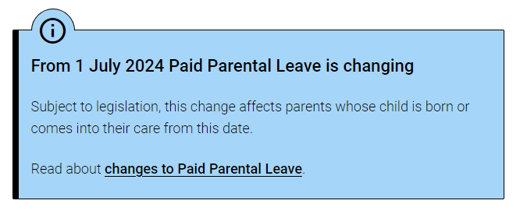
To get this payment all of the following must apply. You must:
- be caring for a child who is born or adopted from 1 July 2023
- have met the income test
- not be working on your Parental Leave Pay days, except for allowable reasons
- have met the work test
- meet the residency rules
- have registered or applied to register your child’s birth with your state or territory birth registry, if they’re a newborn.
There are additional requirements to get Parental Leave Pay. Read more about who can get it.
You must also claim Parental Leave Pay within the claiming timeframes.
Watch our video about Parental Leave Pay.
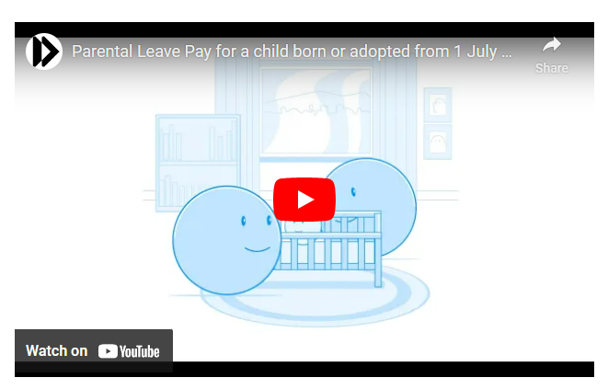
Transcript | Watch on YouTube
If you’re an employer, read more about the Paid Parental Leave scheme for employers and how to help your employees.
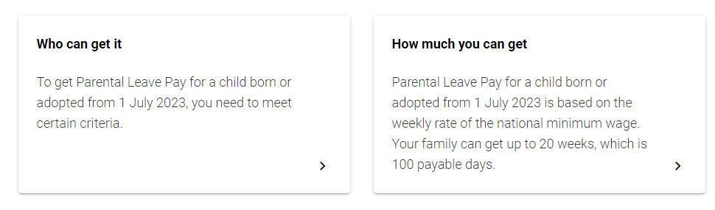
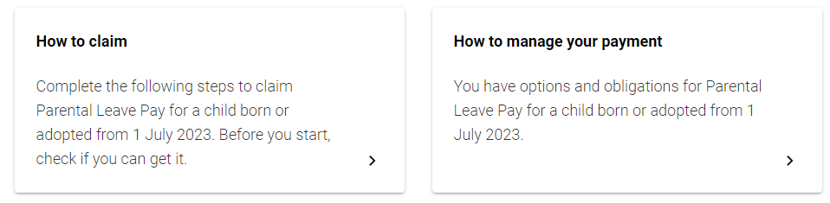

Home / Raising kids / Having a baby / Top payments / Parental Leave Pay / Parental Leave Pay for a child born or adopted from 1 July 2023 / How to claim

How to claim
Complete the following steps to claim Parental Leave Pay for a child born or adopted from 1 July 2023. Before you start, check if you can get it.

Parental Leave Pay is up to 100 days, or 20 weeks based on a 5 day work week. You can claim up to 3 months before the birth or adoption of your child.
If you’re the first person to claim for your child, you must claim within 52 weeks of their birth or adoption.
If someone else has already claimed for your child, you have 2 years to make a claim. You must use all the Parental Leave Pay days within 2 years of your child’s birth or adoption.
We won’t pay you before the birth or adoption of your child. Before your payment can start, you need to do both of the following:
- make a claim
- provide all supporting documents including proof of birth or adoption.

Steps to claim Parental Leave Pay
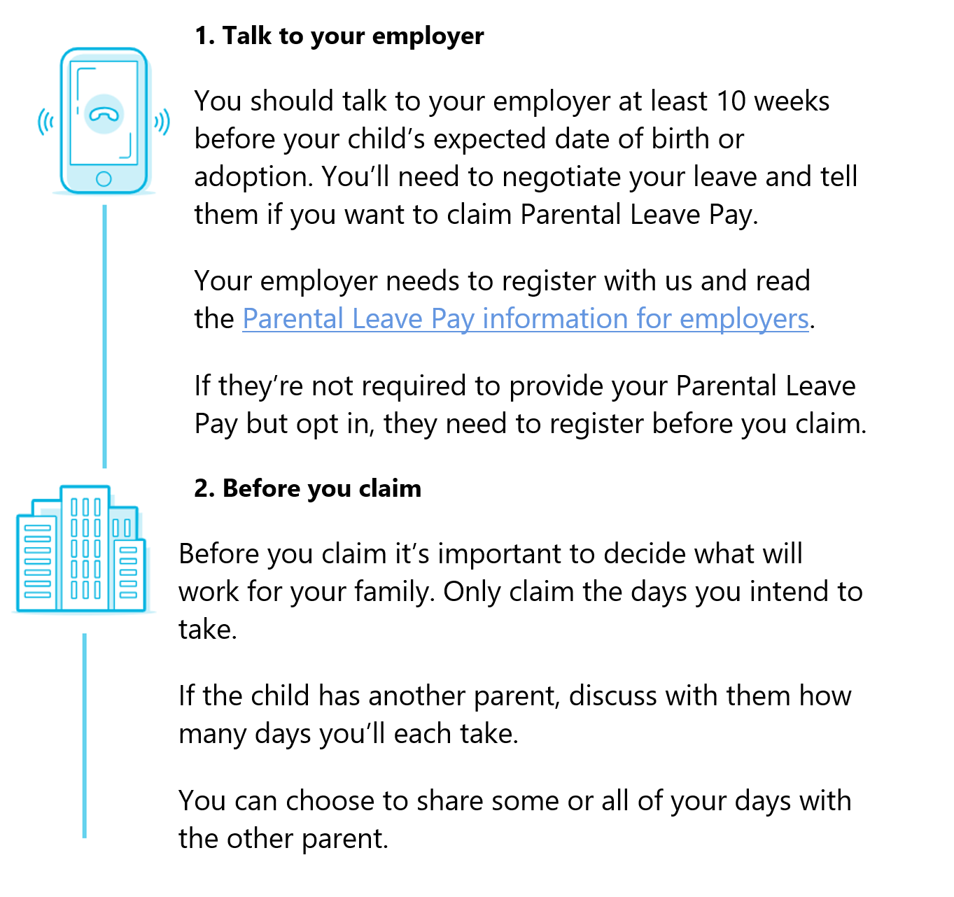
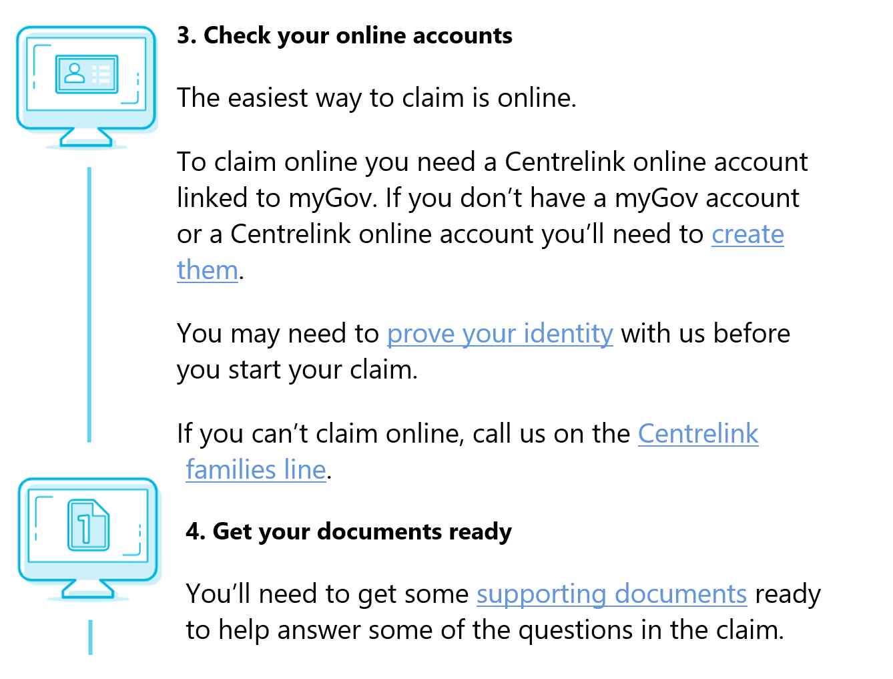
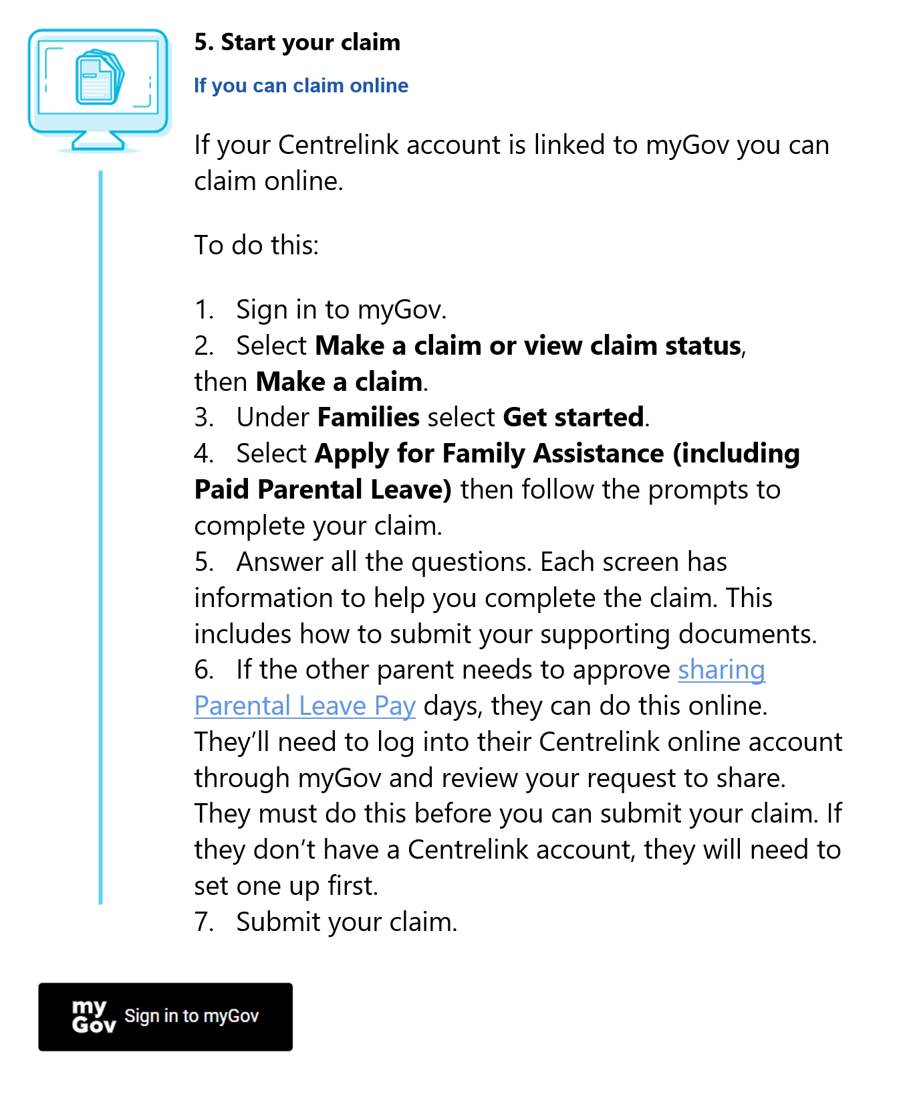

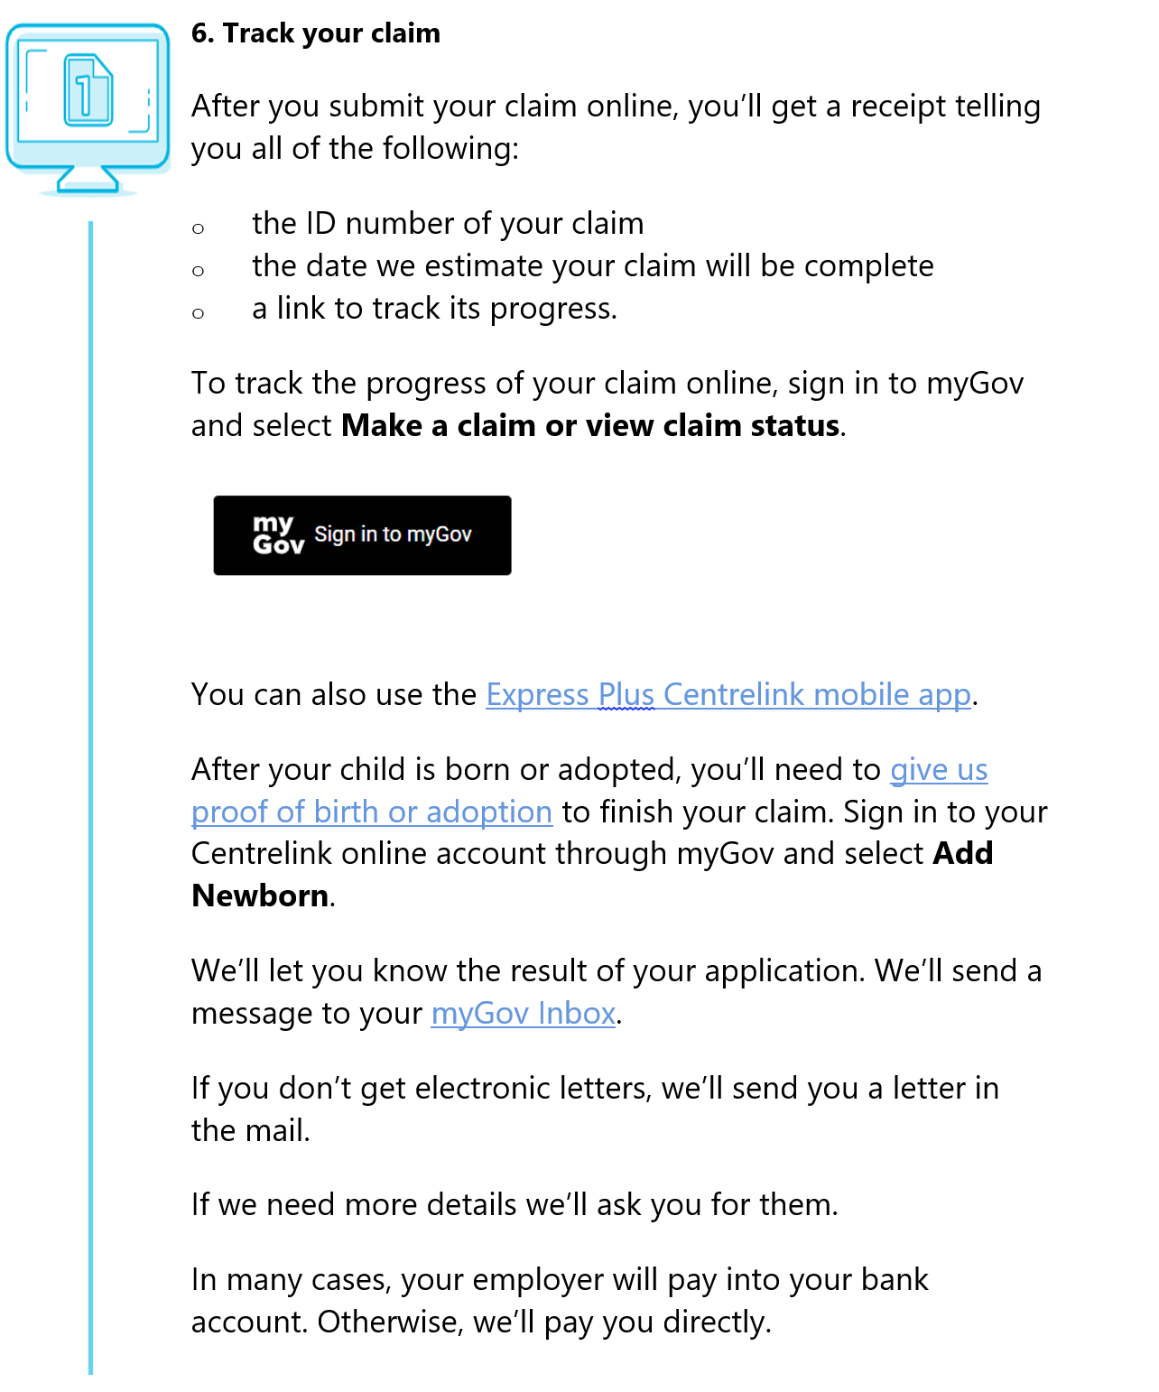
If you think we’ve made a mistake you can ask us to review our decision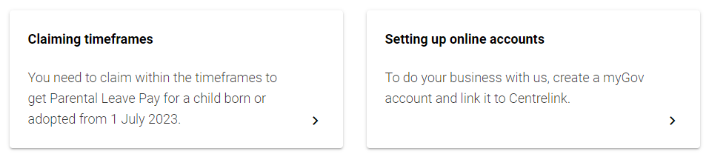
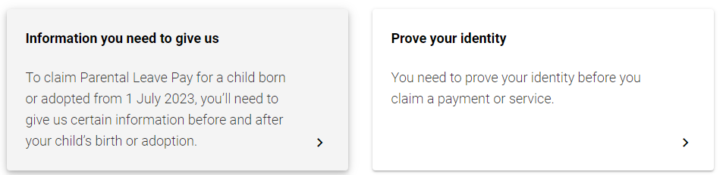
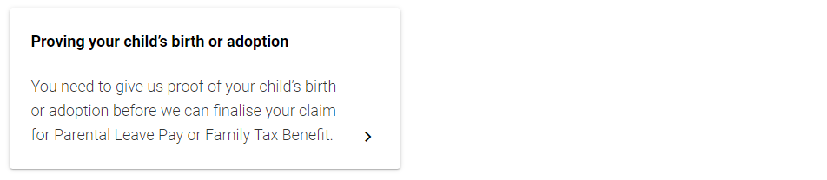
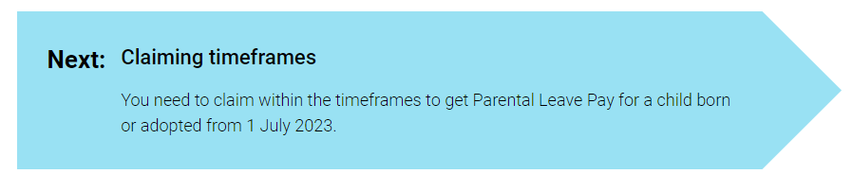

Home / Raising kids / Having a baby / Top payments / Parental Leave Pay / Parental Leave Pay for a child born or adopted from 1 July 2023 / Who can get it / Sharing your payment

Sharing your payment
You may share some or all of your Parental Leave Pay for a child born or adopted from 1 July 2023 with another parent.

On this page
- Information for birth mothers
- Information for the first adoptive parent or first gaining parent in a surrogacy arrangement
- Information for other parents
- Information if you’re caring for a child under exceptional circumstances
Your family can get up to 100 days of Parental Leave Pay. You can choose to share either some or all of the Parental Leave Pay days. The most one parent in a couple can use is 90 days. Each parent can even take up to 10 days at the same time. There are some exemptions to these limits.

Information for birth mothers
If you’re the birth mother you can choose to share some or all of your Parental Leave Pay with the other parent.
If you have a partner, part of Parental Leave Pay will be reserved to share with them. To get the full 100 days, both parents need to claim and be eligible. The most one parent in a couple can use is 90 days. If only one parent in the couple is eligible, the 90 day limit still applies.
If you’re a single parent, you can still share your days with the other parent. If you choose not to, you can get the full 100 days of Parental Leave Pay.

Understand the rules
You can give approval to share some or all of the days with the other parent. If you choose to share your days, you must meet the work test for the other parent to be eligible, even if you don’t claim any days for yourself.
When the other parent claims Parental Leave Pay, we’ll send a task to your Centrelink online account through myGov. You’ll need to complete the task to confirm if you give approval to share Parental Leave Pay. The other parent can only claim the number of days you’ve approved to share with them.
When you claim, make sure to only include the number of days you’re claiming for yourself. If you’re sharing days with the other parent, this should not exceed the maximum number of days. For example, if you want to share 30 days with the other parent, you can’t claim more than 70 days for yourself.

Information for the first adoptive parent or first gaining parent in a surrogacy arrangement
If you’re the first adoptive parent, you can choose to share Parental Leave Pay with the other adoptive parent. First adoptive parent means you’re the first adoptive parent of the child to claim Parental Leave Pay.
If you’re the first parent gaining the child in a surrogacy arrangement to claim, you can choose to share Parental Leave Pay with the other gaining parent.
If you have a partner, part of Parental Leave Pay will be reserved to share with them. To get the full 100 days, both parents need to claim and be eligible. The most one parent in a couple can use is 90 days. If only one parent in the couple is eligible, the 90 day limit still applies.
If you’re a single parent, you can still share your days with the other parent. If you choose not to, you can get the full 100 days of Parental Leave Pay.

Understand the rules
You can give approval to share some or all of the days with the other parent.
To share Parental Leave Pay, if your partner isn’t listed on the adoption or surrogacy papers, then both you and they must meet the work test. This means if you don’t meet the work test, they won’t be eligible.
When the other parent claims Parental Leave Pay, we’ll send a task to your Centrelink online account through myGov. You’ll need to complete the task to confirm if you give approval to share Parental Leave Pay. They can only claim the number of days you’ve approved to share with them.
When you claim, make sure to only include the number of days you’re claiming for yourself. If you’re sharing days with the other parent, this should not exceed the maximum number of days. For example, if you want to share 30 days with the other parent, you can’t claim more than 70 days for yourself

Information for other parents
If you’re not the birth mother, first adoptive parent or first gaining parent in a surrogacy arrangement, to claim Parental Leave Pay you must be one of the following:
- the partner of the birth mother
- the child’s biological father
- the partner of the child’s biological father
- the partner of an adoptive parent
- partner of the gaining parent in a surrogacy arrangement.
Both you and the birth mother must meet the work test if you’re any of the following:
- the birth mother’s partner
- the biological father
- the biological father’s partner.
This means if you meet the work test but they don’t, you won’t be eligible.
Both you, and the first adoptive parent or first gaining parent in a surrogacy arrangement, must meet the work test. This is if you’re the partner of either the adoptive parent or the gaining parent but aren’t on the adoption or surrogacy papers. This means if you meet the work test but they don’t, you won’t be eligible.
If you have a partner, part of your Parental Leave Pay will be reserved to share with them. To get the full 100 days, both parents need to claim and be eligible. The most one parent can use is 90 days. If only one parent in the couple is eligible, the 90 day limit still applies.
If you’re single, the birth mother or first adoptive parent can choose to give you either:
- some of their Parental Leave Pay days
- all 100 Parental Leave Pay days.
The birth mother or first adoptive parent must first give approval to share any Parental Leave Pay days with you. You should discuss with them the number of days you’ll both take. When you claim Parental Leave Pay, we’ll send a task to the other parent’s Centrelink online account through myGov. They’ll need to complete the task to confirm if they give approval to share Parental Leave Pay. You can only claim the number of days they’ve approved to share with you.

Information if you’re caring for a child under exceptional circumstances
You may get Parental Leave Pay if you’re caring for a child under exceptional circumstances. If you’re the first person to claim for the child, you can choose to share Parental Leave Pay with your partner. If you choose not to, you can get the full 100 days of Parental Leave Pay.

Understand the rules
You can give approval to share Parental Leave Pay with your partner.
When your partner claims Parental Leave Pay, we’ll send a task to your Centrelink online account through myGov. You’ll need to complete the task to confirm if you give approval to share Parental Leave Pay. They can only claim the number of days you’ve approved to share with them.
When you claim, make sure to only include the number of days you’re claiming for yourself. If you’re sharing days with the other parent, this should not exceed the maximum number of days. For example, if you want to share 30 days with the other parent, you can’t claim more than 70 days for yourself.
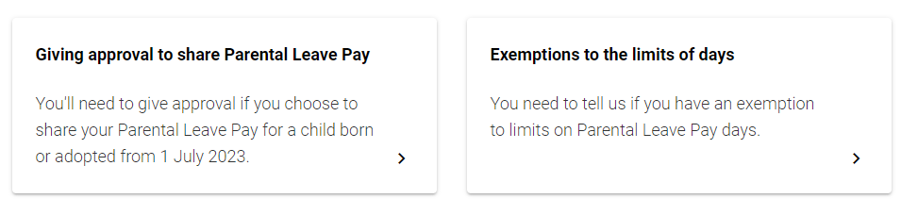
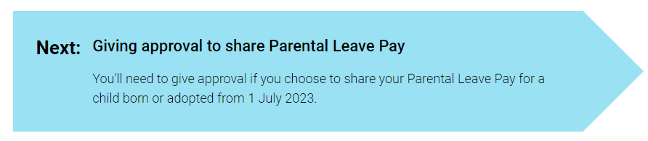

Appendix C:
Technical details

Pre-registration, pre-analysis plan and ethics
The trial was publicly pre-registered on the American Economic Association’s Social Science Registry (AEARCTR-0013157). The registration was completed after we commenced data collection, but prior to analysing the data.
The analysis of the RCT data is consistent with the pre-analysis plan. However, we did conduct additional exploratory analyses which are reported here and in the main report. All exploratory analyses are clearly designated. The pre-analysis plan is available on the BETA website.
The ethical aspects of the research were reviewed and approved by the Australian National University Human Research Ethics Committee (Protocol 2021/430), as the survey was conducted and administered by the ANU.

Population and sampling
Participants were recruited by an online survey panel provider procured by ANU. Sampling was non-probability based, and the survey was delivered online using the panel provider’s online survey software. The survey panel provider also randomly assigned participants to conditions (stratified by gender).
Participants were adults (aged 18 to 44) in Australia. Sampling quotas were applied to the following variables:
- Participant gender – 50-50 for each gender.
- Whether participants have had a child – 50-50 for having a child and not having a child.
However, the final sample had significantly more women than men (see Table 1 below). There was also a large amount of missing data on the question about whether an individual had a child or not, with the vast majority of participants (for whom data was available) indicating that they have at least one child (see Table 1).

Sample size and power
As we were relying on an existing survey, our sample size was fixed at 1,500 participants. The final sample size was 1,523. As our designed included one control and two treatment groups, each group had roughly 500 participants (see Table 1 below). We used an alpha level of 5% and 95% power to calculate our power. Based on a simulated power analysis with 500 participants in each arm, we estimated that we would be powered to detect an effect of 2 days difference between the control and either one of the treatment groups. This represents an average treatment effect across gender. A simulated power analysis was used due to the complexity around simulating stratification and differential treatment effect across genders.
Table 1. Sample characteristics across the three groups
Characteristic | Value | BAU | Treatment 1 | Treatment 2
N | Number of participants | 505 | 499 | 519
Gender | Male | 192 (38%) | 210 (42%) | 212 (41%)
Gender | Not male | 313 (62%) | 289 (58%) | 307 (58%)
Age | 18-24 years | 20 (4%) | 22 (4%) | 29 (6%)
Age | 25-34 years | 166 (33%) | 176 (35%) | 152 (29%)
Age | 35-44 years | 319 (63%) | 301 (60%) | 338 (65%)
Number of children• | None | 13 (3%) | 15 (3%) | 18 (4%)
Number of children | One | 82 (16%) | 96 (19%) | 105 (20%)
Number of children | Two | 118 (23%) | 131 (26%) | 130 (25%)
Number of children | Three or more | 42 (8%) | 28 (6%) | 28 (5%)
Note: • There was a large amount of missing data for the ‘number of children’ question.

Intervention
As described in the main report, the survey experiment involved a hypothetical scenario in which participants were asked to imagine that they were part of a couple who were expecting a child together. Participants were asked to imagine being in the mother’s or father’s role (depending on the participant’s gender) and completing the PLP claim form.
Participants were then randomly assigned to one of three groups. In the Business as Usual (BAU) group, they saw information about PLP and claim questions as they are currently presented in the claim form (shortened slightly). In the two Treatment groups they saw a revised version of the information and the question. The revised version used an ‘active sharing’ format that asked the participants to indicate how they would like to share the leave in their family (rather than asking only how many days they would individually like to claim). In Treatment 2 we also included additional text summarising the purpose of parental leave. See Figures 1 and 2 in the main report for further details.

Outcome measures

Primary outcome
At an individual level, the primary outcome was the number of PPL days allocated by participants to the father in the vignette. Each parent could be allocated a minimum of 0 days and a maximum of 90 days, which was consistent with the current entitlement when we conducted the study. (The number of available days has since been increased. In some exceptional circumstances – outside the scope of the present study – a parent may be entitled to claim the full 100 days.)
In the BAU condition, true to the current birth-mother claim form, participants who were allocated to the birth-mother control condition were only asked how many days they wished to claim for themselves. Therefore, for this condition, we calculated the number of days allocated to the father by subtracting the birth-mother’s claim from 100 (the total maximum number of days). This calculation method was chosen as it maximised our external validity, since it reflects the current PPL claim form.
Unfortunately, as summarised below and in the main report, the total number of days allocated by participants was often less than the full 100 day entitlement. As a result, our way of calculating the outcome measure for women represents a large overestimate of the number of days women in the BAU condition would allocate to fathers. In the main report, we therefore focus on an analysis of men and women separately (and how much they allocate to the father and mother, respectively), and report the planned primary analysis in a footnote. Full details are provided below.
As an additional outcome measure for exploratory analysis, we also recorded the time it took participants to complete the PLP questions.

Hypotheses
We had two primary hypotheses and one secondary hypothesis. We planned to combine data from both genders, but include gender as a covariate (see further details in Method of analysis section).

Primary hypothesis
H1 – T1 > C: Treatment 1, compared with the control condition, will increase the number of Paid Parental Leave days that participants allocate to the father in the vignette.
H2 – T2 > C: Treatment 2, compared with the control condition, will increase the number of Paid Parental Leave days that participants allocate to the father in the vignette.

Secondary hypothesis
SH3 – T2 > T1: Treatment 2, compared with Treatment 1, will increase the number of Paid Parental Leave days that participants allocate to the father in the vignette.

Exploratory analyses
We also planned to examine the distribution of leave allocation in the treatment conditions compared with the control condition. In addition, we tested whether there was a difference in leave allocation depending on participant gender. Finally, we considered exploring whether the median time to complete the questions differed by treatment arm. However, on reflection, this last analysis seemed less useful given that men in the control condition responded to two more questions than the men and women in the other conditions, making their responses slower for that reason and hard to interpret.

Method of analysis
We cleaned and analysed the data using R 4.4.3 (R Core Team 2022). We did not analyse the data until after collection was complete. Consistent with the analysis plan, we used ordinary least squares regression with HC2 robust standard errors. We included two covariates in the initial analysis – gender and number of children. Gender was a binary variable, mean-centred. Number of children was treated as a numeric variable, also mean-centred. The treatment group was entered into the model as a vector of treatment indicators. However, due to missing data and a large interaction effect of gender, later analyses drop these covariates (see full details below).

Statistical tables

Overall analyses
Our pre-registered primary analysis tested the impact of the treatment on the allocation of leave to the father, including number of children and gender as covariates (mean-centred). Results are included in Table 2. We specified a directional hypothesis, and report single sided- p-values.
Table 2. Primary RCT analysis
Treatment | Means | Estimate | Standard error | 95% Confidence Interval | p-value
BAU | 30.6 | na | na | na | na
T1 | 21.3 | -9.3 | 1.8 | (-12.16 - Inf) | 1.0
T2 | 22.1 | -8.5 | 1.7 | (-11.35 - Inf) | 1.0
OLS model adjusted for: gender (binary) and number of children (numeric; both mean centred). HC2 robust standard errors. One-sided test for treatment > control. Number of observations = 803.
These results are in the opposite direction to expected, and not statistically significant.
We unexpectedly had a lot of missing data on the ‘number of children’ covariate. We therefore ran the analysis excluding this covariate as well. Results are included in Table 3.
Table 3. Follow-up RCT analysis without ‘number of children’ as a covariate
Treatment | Means | Estimate | Standard error | 95% Confidence Interval | p-value
BAU | 32.7 | na | na | na | na
T1 | 22.2 | -10.5 | 1.3 | (-12.63 - Inf) | 1.0
T2 | 22.9 | -9.8 | 1.3 | (-11.93 - Inf) | 1.0
OLS model adjusted for: gender (binary; mean centred). HC2 robust standard errors. One-sided test for treatment > control. Number of observations = 1,516.
The results were largely similar, and for both analyses we observed a large interaction between treatment allocation and gender – as can be seen in the table of marginal means (Table 4), below. This interaction was unexpected: we did not expect women to allocate more days to the father in the BAU compared to the treatment conditions.
Table 4. Adjusted marginal means, primary RCT analysis
Condition | Days allocated by men | Days allocated by women
BAU | 20.6 | 37.4
T1 | 24.5 | 19.2
T2 | 25.3 | 19.9
Note: Marginal means created using the regression described in Table 2.
We therefore conducted follow-up analyses for men and women separately. These analyses were planned, as exploratory analyses.

Analysis of male participants only
As summarised in the main body of the report, men in the BAU condition were asked a series of questions (consistent with Services Australia’s current form). These questions were: Is the birth mother going to share Parental Leave Pay days with you? [If yes]: How many days have been given to you? How many days do you want to claim now?
However, 52 men in the control condition who answered no to the first question, were nonetheless asked the last question (the main outcome variable, about how many days they would like to claim). As summarised in the main report, we analysed their data in three different ways.
First, we included their data (that is, their responses to the question about how many days they want to claim now), as summarised in Table 5. For this analysis we did not include number of children as a covariate, due to all the missing data.
Table 5. Male participants only, full sample, days allocated to the father
Treatment | Means | Estimate | Standard error | 95% Confidence Interval | p-value
BAU | 21.4 | na | na | na | na
T1 | 23.4 | 2.0 | 1.7 | (-0.85 - Inf) | 0.12
T2 | 24.7 | 3.3 | 1.8 | (0.36 - Inf) | 0.03
OLS model. HC2 robust standard errors. One-sided test for treatment > control. Number of observations = 607.
The two treatment conditions were not significantly different, F(1, 604) = 0.59, p = 0.48.
The results are largely similar if we exclude the 52 participants instead, see Table 6.
Table 6. Male participants only, 52 participants excluded, days allocated to the father
Treatment | Means | Estimate | Standard error | 95% Confidence Interval | p-value
BAU | 20.7 | na | na | na | na
T1 | 23.4 | 2.8 | 1.5 | (-0.30 - Inf) | 0.07
T2 | 24.7 | 4.0 | 2.1 | (0.92 - Inf) | 0.02
OLS model. HC2 robust standard errors. One-sided test for treatment > control. Number of observations = 555.
Finally, we also considered the results with these participants’ values set to 0 (as arguably they should have been, if they said ‘no, the birth mother is not sharing’). On this analysis, the BAU condition was – as expected – significantly different to treatment conditions.
Table 7. Male participants only, 52 data points set to 0, days allocated to the father
Treatment | Means | Estimate | Standard error | 95% Confidence Interval | p-value
BAU | 14.8 | na | na | na | na
T1 | 23.4 | 8.7 | 1.7 | (5.81 - Inf) | < 0.001
T2 | 24.7 | 9.9 | 1.7 | (7.03 - Inf) | < 0.001
OLS model. HC2 robust standard errors. One-sided test for treatment > control. Number of observations = 607.

Analysis of female participants only
Our pre-registered outcome measure was number of days allocated to the father. However, as described in the main report and the pre-analysis plan, women in the control conditions were only asked how many days they wanted to claim (for themselves, that is, the mother). For each woman we therefore imputed the number of days allocated to the father, by subtracting the mother’s allocation from 100. The results of this imputed analysis are included in Table 8 below.
Table 8. Female participants only, days allocated to the father (using imputed values in BAU)
Treatment | Means | Estimate | Standard error | 95% Confidence Interval | p-value
BAU | 40.3 | na | na | na | na
T1 | 21.3 | -19.0 | 1.8 | (-21.94 - Inf) | 1.0
T2 | 21.6 | -18.7 | 1.8 | (-21.59 - Inf) | 1.0
OLS model. HC2 robust standard errors. One-sided test for treatment > control. Number of observations = 909.
The imputation was based on the assumption that participants would allocate a total of 100 days. However, while most did (as reported in the main report), a large proportion did not; leading to an average total of closer to 80 rather than 100. This means that the 40 days was a large over-estimate. In the main report, we therefore summarise the results of the number of days women allocated to the mother, instead (see Table 9 below).
Table 9. Female participants only, days allocated to the mother
Treatment | Means | Estimate | Standard error | 95% Confidence Interval | p-value
BAU | 59.7 | na | na | na | na
T1 | 60.5 | 0.9 | 2.2 | (-2.74 - Inf) | 0.35
T2 | 61.8 | 2.1 | 2.1 | (-1.43 - Inf) | 0.16
OLS model. HC2 robust standard errors. One-sided test for treatment > control. Number of observations = 909.
We did not find an impact of the treatment condition on women’s allocation to mothers. Nor did the allocation differ between T1 and T2, F(1, 906) = 0.31, p = 0.58.

Comparing allocations by male and female participants
In the main report, we analyse just the data from the two treatment conditions, in order to compare allocations by men and women to dads vs mums. Results of these analyses are included below.
Table 10. Allocation to fathers, by men and women
Gender | Means | Estimate | Standard error | 95% Confidence Interval | p-value
Not male | 21.5 | na | na | na | na
Male | 24.0 | 2.6 | 1.1 | (0.43 - 4.7) | 0.02
OLS model. HC2 robust standard errors. One-sided test for treatment > control. Number of observations = 1,018.
Table 11. Allocation to mothers, by men and women
Gender | Means | Estimate | Standard error | 95% Confidence Interval | p-value
Not male | 61.2 | na | na | na | na
Male | 57.2 | -4.0 | 1.7 | (-7.41 - -0.59) | < .001
OLS model. HC2 robust standard errors. One-sided test for treatment > control. Number of observations = 1,018.
As mentioned in the main report, women tended to allocate about 4 days more to mothers than men did, and men tended to allocate about 2 days more to fathers than women did.

© Commonwealth of Australia 2026
ISBN 978-1-925365-76-4 Paid Parental Leave decisions: The role of forms and websites (PDF)

Copyright Notice
With the exception of the Commonwealth Coat of Arms, this work is licensed under a Creative Commons Attribution 4.0 International license (CC BY 4.0) (https://creativecommons.org/licenses/by/4.0/)


Third party copyright
Wherever a third party holds copyright in this material, the copyright remains with that party. Their permission may be required to use the material. Please contact them directly.

Attribution
This publication should be attributed as follows:
© Commonwealth of Australia, Department of the Prime Minister and Cabinet, Paid Parental Leave decisions: The role of forms and websites

Use of the Coat of Arms
The terms under which the Coat of Arms can be used are detailed on the following website: https://pmc.gov.au/cca


Behavioural Economics Team
of the Australian Government
Tell us how you’re using this report.

General enquiries beta@pmc.gov.au
Media enquiries media@pmc.gov.au
Find out more www.pmc.gov.au/beta

For simplicity, in this report we’ll refer to ‘the birth of a child’. However, Parental Leave Pay is also available for eligible parents of an adopted child, or for eligible people who are caring for a child under exceptional circumstances.
The 20 weeks is equal to 100 days, based on a 5-day work week.
From 1 July 2024, the number of weeks available will increase by 2 weeks every year to a maximum of 26 weeks from 1 July 2026.
Before the reform, Parental Leave Pay could be claimed while on unpaid or paid leave from work; but Dad and Partner Pay could only be claimed while on unpaid leave.
The birth mother must still approve the number of days that can be claimed by the other parent. More on this below.
The emphasis of the reforms is on fathers and partners. Not to exclude the importance of other people in a mother and child’s life, for simplicity we’ll just say ‘fathers’ in this report. This is also consistent with the research we conducted, which included only couples in a heterosexual relationship.
Note, the sick-leave days were more equally distributed primarily because mothers took fewer days following the reform. The researchers explain that this unexpected pattern could be due to the particular type of sick-leave they were studying: a government subsidised leave-entitlement, which men may have been more reluctant to claim. They suggest men were making up for the decrease in the woman's sick-leave by taking their own annual or personal leave.
An earlier report by the Grattan Institute estimates that in 2017-18, around 25% of all new fathers made use of the government-funded Dad and Partner Pay (Wood and Emslie 2021). The discrepancy in the estimates is likely mostly due to differences in the methods used for analysis, rather than reflecting an increase in uptake between the time when the reports were written. The Grattan report also mentions that fathers and partners were also able to access Parental Leave Pay by having some days transferred to them from the primary carer. Uptake of this method was very low (Wood and Emslie 2021).
For example, see Baxter and colleagues (2024) for their choice of inclusion criteria: ‘it is likely this included some who did not satisfy the work test’ footnote 4, page 5.
Calculated by dividing number of Dad and Partner Pay recipients by total number of government-funded parental leave recipients (Dad and Partner Pay plus Parental Leave Pay), although some PLP claimants may have been fathers/partners rather than mothers. Dataset available at data.gov.au: Expanded DSS Benefit and Payment Recipient Demographics - June 2023.
This represents a slight increase since 2022-23, when 63% of private sector employers offered paid parental leave, and 14% of the paid primary carer’s leave was taken by men (WGEA 2023).
All the participating parents were partnered, but some of them attended the interview alone.
We created a mock-up of the claim form – rather than asking participants to complete the actual form during the interview – because completing only a mock-up preserved participants’ privacy (i.e. interviewers couldn’t view their myGov account) and the mock-up could skip sections of the claim form that were less relevant to the present research.
The purpose of the survey was to provide insights into the likely behavioural responses of Australians of childbearing age to alternative PPL policy scenarios, and to help inform the wider evaluation methodology. It included a range of questions about participants’ circumstances (such as their marital status and number of children), behaviour (such as what kind of leave they took when their most recent child was born), and opinion (such as whether they supported the leave entitlements being extended). The total sample size was larger, but only 1,523 completed the survey experiment that we report on here. These participants were recruited from a non-probability based sample, so any generalisations to the population as a whole should be treated with caution.
While the parents we spoke to talked about ‘feeding the baby’ rather than ‘breastfeeding’, from context it seems likely that they were mostly referring to breastfeeding.
See full Discussion Guide in Appendix A. Example questions included: Have you heard about the Paid Parental Leave scheme before? Have you heard about any changes to the scheme recently? Where do you go for information on things like this? Now let’s have a look at information available online [while screen sharing] – could you please navigate to where you would find information on parental leave?
Occasionally they also visited other government websites, such as the Fair Work Ombudsman or DSS.
See Fair Work Act 2009, Section 70: Entitlement to unpaid parental leave; and the National Employment Standards: https://www.fwc.gov.au/work-conditions/minimum-wages-and-conditions/national-employment-standards
This process is intended to ‘mitigate the risk that fathers or partners may take PLP against the wishes of a birth parent, including as a form of coercive control or financial abuse’ (DSS 2023, p 5).
This participant refers to ‘this example’ because they were at the time looking at an example that the researchers had generated, showing a couple sharing leave with both the mother and father taking 10 weeks.
When the father completes the form, he is asked whether the birth mother is sharing PLP days with him (and if so, how many he has been given). If he answers ‘no’, he is asked additional questions to determine whether he may nonetheless be eligible to claim PLP days, e.g. due to exceptional circumstances. If he answers yes, later in the claim process he is asked additional questions to connect his claim to the birth mother’s (as the ‘approval giver’). First, he can request an ‘Approval ID’ from the birth mother, which she would have received if she has already completed a claim. Second, he is asked for details about the birth mother, including name, address, phone number, and Customer Reference Number. Once he submits his claim, the birth mother receives an ‘approval task’ through myGov, and can choose to approve or reject the request.
We had originally intended to analyse responses from both male and female participants together. However, when planning the analysis for female participants we made an incorrect assumption which made the results hard to interpret (see further details below). We therefore present the analyses for male and female participants separately. These analyses should be considered exploratory.
Our original plan was to analyse the days allocated to the father by both male and female participants. In the treatment groups, women allocated on average 21 and 22 days to the father (slightly fewer days than men did). However, in the BAU group, they were only asked about their own claim, not about the father's allocation. In order to calculate how many days were ‘allocated’ to the father in this group (i.e. to calculate our outcome measure), we planned to subtract the mother's claim from 100 (the full entitlement), reasoning that whatever she didn't claim for herself would go to the father. In the BAU condition, women claimed 60 days for the mother on average; we might assume that they intended the full remainder (40 days) to be allocated to the father. But when we look at common allocation patterns in the treatment groups (see the following section) it is clear that this assumption was not warranted, as the total number of days participants allocated was often less than the full 100 day entitlement. We are therefore not able to say how many days women in the BAU group truly intended the father to take, making our planned analysis impossible.
The questions were: Is the birth mother going to share Parental Leave Pay days with you? How many days have been given to you? How many days do you want to claim now? (See Figure 1.) In the current form, fathers are also asked a set of questions about medical complications surrounding the birth, to determine whether they are eligible for additional concurrent days.
Treatment 2 and Treatment 1 were not different from each other either, p = .48.
This analysis included a subset of 52 men in the BAU group who said the mother was not going to share her days with them. Due to a mistake in the survey programming, these men were nonetheless asked 'how many days do you want to claim now?' Given that these men appeared to give genuine responses and we were unable to exclude a similar subset from the treatment groups, we included their responses in the analysis. If we instead exclude these men from the analyses, the average number of days claimed in the BAU condition was 20.7. The difference between Treatment 2 and BAU is still significant (p = .02), and Treatment 1 and BAU are still not different to each other (p = .07).
The remaining 2% allocated between 80 and 100 days. For these analyses we combine the data from the two treatment groups.
We also showed participants a version of the active sharing question that asked them to input the number of days using a slider, which could be moved to the left or right to indicate more days to the mother or father respectively. Almost no participants preferred this presentation format, although this could have been partly due to the limitations of the software we were using, which made the slider more ‘clunky’ to use than the text boxes.
Resources for employers to support gender best practice in the workplace are available on the Workplace Gender Equality Agency’s website.
From February 2027, APS employees who are primary or secondary caregivers will both have access to 18 weeks of paid parental leave, as per the APS-wide Enterprise Agreement.
And this number will increase as the number of use-it-or-lose-it days for each parent increases.
While outside the scope of the present report, finding ways of supporting women to continue to breastfeed after returning to work is another way of minimising potential harms from this trade-off. For example, raisingchildren.net.au suggests continuing to breastfeed before and/or after work, and the Australian Breastfeeding Association publicly recognises organisations that have been awarded a Breastfeeding Friendly Workplace Best Practice standard.
At the time of writing, there were 10 days reserved for each parent. As this number increases to 15 (from 1 July 2025) and 20 (from 1 July 2026), the motivation to claim may also increase.
Changes to simplifying the legislation may also be an option, but this was outside the scope of the present project.

