Pre-analysis plan:

PPL Survey Experiment

Policy Problem
Following recent government updates to the Paid Parental Leave (PPL) scheme, BETA has been commissioned to review sections of the Services Australia PPL website content and online claim form. The overarching goal of this project was to investigate how Services Australia’s public-facing PPL communications and claim forms could be updated to encourage greater allocation of PPL to fathers and partners. An additional goal was to increase the clarity of these materials so that families are better placed to make informed decisions about a shared caring arrangement that suits them.
Increasing the time that fathers and partners take off work around the time of a child’s birth is a key objective of the expanded PPL scheme. Greater involvement of fathers and partners in early childcare has been linked to a range of positive outcomes for the child, the mother, and the family – but uptake of parental leave by fathers and partners in Australia has historically been low. In November 2022, BETA provided initial advice to the Women’s Economic Equality Taskforce on the behavioural considerations for the implementation of the new PPL scheme, with a particular focus on encouraging greater uptake by fathers and partners. The present project builds on that advice.
So far, BETA has conducted primary research and reviewed existing behavioural literature. Our findings suggest that the gendered phrasing used throughout the website and claim form can lead to the misunderstanding that a birth-mother ‘owns’ the parental leave and has the option of ‘giving’ it to the father. In addition, the lack of clarity in the website and claim form means many are unaware of the flexibility of the scheme. These barriers, amongst others, may reduce the allocation of leave to fathers and partners. Therefore, in our proposed revisions to the website and claim form, we aimed to present the PPL information in a way that is neutral, easy to understand, and emphasises the importance of shared decision-making. The current survey experiment will be used to evaluate whether the updates we have made to the PPL claim form could lead to greater allocation of PPL to fathers and partners.
BETA is conducting this experiment with the Department of Social Services (DSS), as part of their Phase 1 Evaluation of the PPL scheme. BETA’s survey experiment will sit in a broader survey being run by the Australian National University (ANU) for DSS. The project as a whole is a collaboration between Services Australia and BETA, with DSS as a key stakeholder.

Trial Aim
The aim of the trial is to determine whether revisions to the PPL claim form questions increase the number of Parental Leave Pay (PLP) days allocated to fathers and partners. We will look at two changes: an active choice condition and the active choice condition plus information on the benefits of fathers and partners using PLP.

Design
The research consists of a stratified 3-arm randomised controlled trial (RCT) embedded in a survey. All participants will be presented with a vignette which describes a couple who are in the process of deciding how they will share their 100 PPL days. They will be asked to complete a section of the PLP claim form as if they were one member of the couple (differing depending on their gender). Participants will be stratified by gender and simple randomisation will be applied within each strata to present participants with either the control condition, Treatment 1, or Treatment 2 (see Figure 1).
Each of these conditions asks participant to enter how they wish to allocate the couple’s PPL days. However, the phrasing of the question differs and so does the body text (preamble). The control condition represents the existing leave allocation section of the PPL claim form, while the treatment conditions are two redesigned gender-neutral versions. We will be comparing the number of PPL days that participants in each condition allocate to the father in the vignette.
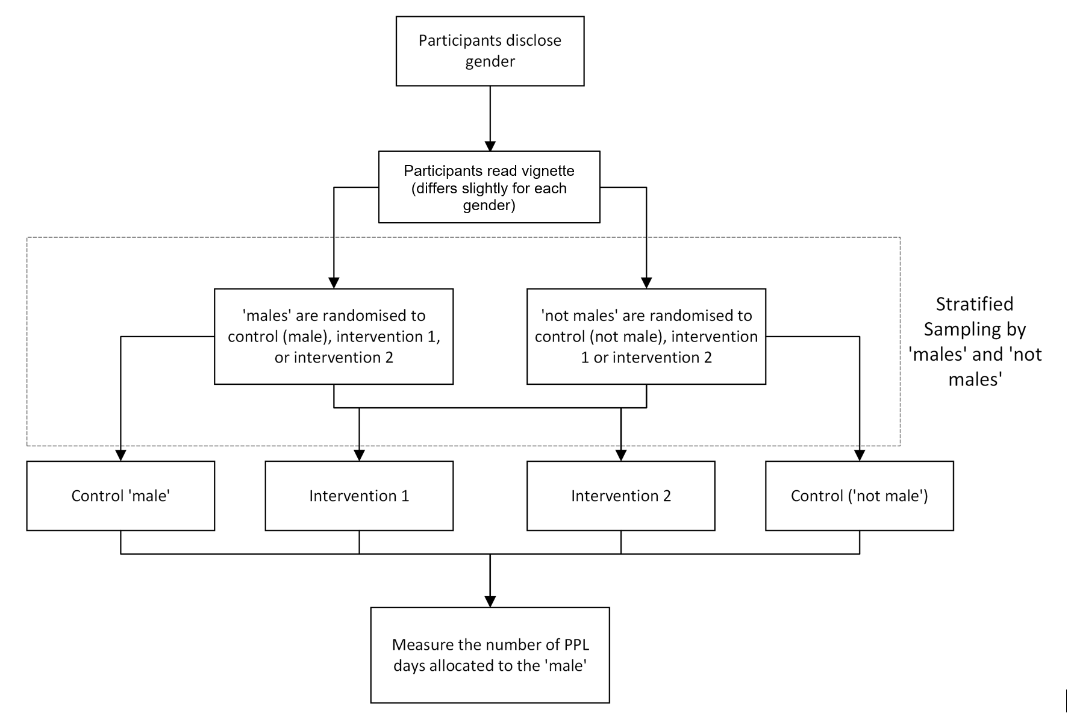
- The flow of participants through the experiment.

Gender Stratification
We will stratify the experiment by participant gender, with a ‘male’ strata (people that identify as male) and a ‘not male’ strata (people that identify as female, or non-binary). This is driven by several considerations:
    - In the current online PPL form (represented by the control condition) different content is presented to the birth mother compared with her partner (usually the biological father). Stratification allows us to present the relevant version to each participant in the control condition depending on their gender. In addition, we can balance each gender across our three treatments.
    - Given the historically low uptake of PPL by fathers, as well as our primary research findings (the current qualitative research), we believe there may be gender differences in how individuals allocate leave. Therefore, stratification by gender will increase the power of our experiment, since the gender of participants may be prognostic of our findings.
    - We split the strata into male and not male, since men benefit from the patriarchy in ways that both women and non-binary people do not. Due to these benefits, those who are ‘males’ are likely to be systematically different from those who are ‘not males’. We note that the sample will only include a small number of non-binary individuals.

Interventions
This trial consists of two treatment arms and one control group. We will be simulating the decision to share the 100 days of government-provided PPL that the couple in our vignette is entitled to. More detail on each arm is presented below.

Control
The control condition will simulate the current online PPL form. In the current form, birth mothers and their partners see different information and different questions when they are choosing how much leave to claim. The birth mother is asked how many leave days out of the 100 they wish to claim. Meanwhile, the partner is asked if the birth mother will be sharing any leave days with them and, if yes, how many days. They are then asked how many days they wish to claim. See the Appendix for the full text and questions for the control condition.

Treatment 1 – Active Choice
In this condition, participants will be required to make an active choice when deciding how they want to allocate their PPL. The active choice condition aims to make the choice architecture around the question of leave allocation between partners as neutral as possible. We removed the current framing which implies that the birth mother ‘owns’ the leave and can ‘give’ it to her partner. Instead, the active choice form is gender neutral and participants are asked how the couple will be sharing their Parental Leave Pay days. They must then enter the number of days allocated to each partner (and the total number of days they wish to claim as a couple must add up to less than 100). We believe these changes will result in an increased allocation of PPL to fathers and partners. See the Appendix for the exact text of the Treatment 1 condition.

Treatment 2 – Active Choice + PPL information
In this condition, participants will be presented with the ‘active choice’ condition, as described above, as well as information on the benefits of dividing PLP between parents. By including this information, we hope to further encourage fathers and partners to take up PPL. This was supported by our user testing, which found that the information presented in the current claim form influences how people approach the decision of how to share their leave. See the Appendix for the exact text of the Treatment 2 condition.

Outcome measures

Primary Outcome
At an individual level, the primary outcome will be the number of PPL days allocated by participants to the father in the vignette. Under the current PPL scheme, 100 days of leave are allocated to each couple (although this depends on their exact circumstances), including 10 days reserved expressly for each partner. Due to the ‘use it or lose it’ design of the scheme, a parent will lose the 10 days reserved for them unless they are claimed. Therefore, in our experiment, each partner can be allocated a minimum of 0 days and a maximum of 90 days.
We note that, true to the current birth-mother claim form, those allocated to the birth-mother control condition are only asked how many days they wish to claim for themselves. Therefore, for this condition, we will calculate the number of days allocated to the father by subtracting the birth-mother’s claim from 100 (the total maximum number of days). This calculation method maximises our external validity, since it reflects the current PPL claim form. In addition, it will provide the most conservative estimate as regards our hypotheses.
As an additional outcome measure for exploratory analysis, we will also record the time it takes participants to complete the questions.

Population and sample selection
Participants will be recruited by an online survey panel provider, and sampling will be non-probability based. This survey will be delivered online using the panel provider’s online survey software.
Participants will be adults (aged 18 to 44) in Australia and the sample distribution will otherwise reflect population demographics. Sampling quotas will be applied to the following variables:
    - Participant gender – 50-50 for each gender.
    - Whether participants have had a child – 50-50 for having a child and not having a child.

Hypotheses
For this analysis we have two primary hypotheses and one secondary hypothesis. We also have a range of exploratory analyses planned. We would combine data from both genders but include gender as a covariate (see further details in Method of Analysis section).

Primary Hypothesis
H1 – T1 > C: That Treatment 1, compared with the control condition, will increase the number of Paid Parental Leave days that participants allocate to the father in the vignette.
H2 – T2 > C: That Treatment 2, compared with the control condition, will increase the number of Paid Parental Leave days that participants allocate to the father in the vignette.

Secondary Hypothesis
SH3 – T2 > T1: That treatment 2, compared with Treatment 1, will increase the number of Paid Parental Leave days that participants allocate to the father in the vignette.

Exploratory Analyses
We will also examine the distribution of leave allocation in the treatment conditions compared with the control condition. In addition, we will test whether there is a difference in leave allocation depending on participant gender, and whether the median time to complete the questions differs by treatment arms. Finally, we may conduct additional subgroup analyses based on age, income, whether the participant has a child, or other – for exploratory purposes.

Randomisation
Randomisation will occur at the individual level and be stratified by participants’ gender. It will be implemented within the survey using the randomisation functionality designed by the survey panel provider. Participants will first share their demographics, including their gender, and will then be randomised with equal probability using a simple random sampling method to one of the three arms.

Sample Size and Power
As we are relying on an existing survey, our sample size is fixed at 1,500 participants. Our design includes two treatment groups and one control so each group will have roughly 500 participants.
We will use a conventional alpha level of 5% but aim for 95% power. These values entail type I and type II error rates of 5%. We have chosen these parameters because the intervention is low risk and it would be equally harmful to reject a possible real effect as accept a possibly spurious one.
Based on a simulated power analysis, given we will have 500 participants in each arm, we will be powered for a minimal detectable effect of 2 days. Note this represents an average treatment effect across gender of 2 days. A simulated power analysis was used due to the complexity around simulating stratification and differential treatment effect across genders.

Method of analysis
The principal analysis of the effect of the intervention will consist of a covariate-adjusted comparison of our primary outcome. This estimate, confidence intervals and p-values will be derived from a linear regression model using robust (HC2) standard errors and with the following specification:
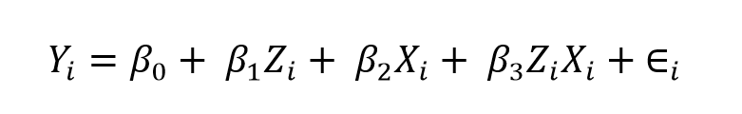
Where is an index for each individual in the trial, Υ is the individuals score on the comparison task as a proportion, β₀ is the intercept, Ζ is a vector indicating treatment vs control, β₁ is a vector of coefficients representing the average treatment effect for the two interventions relative to control, Χ is a vector of the covariates, and ΖΧ is the interaction of the treatment indicator vector with the mean centred covariate indicator vector and  is the individual error term.
For Hypothesis 1, we will use β₁₁ (the vector in the first position) to measure the average treatment effect for treatment 1. For Hypothesis 2, we will use β₁₂ (the vector in the second position) to measure the average treatment effect for treatment 2. For Hypothesis 3 we will use an F-Test to determine whether the coefficients for each treatment are equal.

Covariates
There will be two covariates in this study:
    - The gender of participants – gender may influence the outcome. In addition, the sample is stratified by gender and the control condition will differ according to gender, so this needs to be accounted for in the design.
    - Whether participants have had a child before - we believe this could be prognostic of our findings since a person’s understanding and experience of claiming PPL will depend on whether they have had a child. We believe they are likely to have systematically different attitudes compared with childless participants.

Trial threats
We identified some possible threats to the internal and external validity and reliability of our experiment, although these are mainly a trade-off for the limitations in the feasibility and timeline of this project.
The placement of our survey experiment, within a larger survey, may undermine its validity and reliability. For example, the survey as a whole will contain several other vignettes so participants may accidently conflate these when responding to our vignette. In addition, our survey experiment is positioned at the end of the survey, so participants may experience fatigue.
The content presented in the previous sections of the survey may also provide participants with an above average understanding of PPL. Although this may threaten the external validity of our findings, it may also reflect reality, since soon-to-be parents would probably research the PPL scheme before claiming leave.
We also expect that some participants will “speed” through the survey or answer at random, especially since they will be compensated by the survey provider for participating. The survey provider has already replaced 15 participants who had not completed the survey or had completed it extremely quickly.
We are not planning to exclude any further participants, so speedsters and other ‘noise’ in responses may impact our ability to detect an effect. We may conduct robustness checks by excluding participants who answer survey questions in a logically inconsistent way, and by reviewing open-ended responses for nonsense data.
In terms of the specific ways in which a vignette study limits the external validity of the study, the key differences from the ‘real world’ include:
    - In the vignette, participants are making their decision alone, whereas a key feature of real decision-making about PPL is that it usually involves both parents.
    - Parents can claim PPL up to 3 months before the birth of their child, but are able to update how and when they take their leave after the claim has been approved. In the vignette, by contrast, participants can’t revise their responses later.
    - Although we’ve asked participants to ‘imagine’ that they are in the position of the couple in the vignette, they are still in essence making a decision for someone else, which may systematically differ from the decision that would ultimately make for themselves in a real case.

Interpretation and reporting
For our primary hypotheses, we will use null hypothesis statistical testing in order to facilitate decision making about whether to treat an effect as real. However, we will also make use of non-significant primary analyses and exploratory analyses in order to provide context and to highlight interesting avenues for further research. We will clearly delineate these analyses when communicating findings.
For reporting, treatment effects, standard errors, and confidence intervals will be presented as a difference in terms of the number of days. Absolute p-values will be reported. We will provide these outputs for all three hypotheses.

Pre-analysis plan commitments
- We will be transparent about, and provide justification for, any deviations (additions or omissions) from this plan.
- The survey was launched and data collection completed before we had finalised this pre-analysis plan, however we had not yet analysed the data.

Appendix A
This document sets out the vignette and the different experiment conditions for BETA’s survey experiment. These questions would be included in DSS’s Phase 1 Evaluation survey. The objective of this survey experiment is to explore if changes to the framing of shared care questions has any impact on the shared care decisions that parents make.

Experiment Conditions
Participants in the experiment will read a vignette about a typical couple expecting their first child. Respondents will be asked to respond as though they were answering the form as this couple. Some respondents will see the shared cared questions as they are currently in the online form, this will act as a control group for the experiment. Other respondents will be randomly assigned to see one of the other two versions of the shared care questions designed by BETA. Table 1 below details the sections seen by participants based on gender and their random allocation to treatment or control. We expect the questions to take no longer than 3 minutes for any individual.

- Condition of the experiment and which page people see.
Condition | Pages Shown
Control – Birth Mother | Page A
Control – Partner | Page B
Treatment 1 – Active Choice | Page C
Treatment 2 – PPL Information + Active Choice | Page D

Vignette
Page 1:
Almost done, we just have a couple final questions for you.
Earlier in the survey you were asked to imagine yourself in a particular scenario and answer questions as if you were that person. The next question you will see is similar to this, however it is a new situation we want you to picture yourself in, so please read the scenario and questions carefully.
Page 2:
Nadia and Alan are expecting their first child in the next three months. They are both excited to be parents and are looking forward to caring for their child. They both earn $70,000 per year but do not have access to paid parental leave from their employers.
Now imagine you are [Alan-Nadia – men see Alan, women see Nadia, other genders randomised]. You are applying for Parental Leave Pay through Services Australia’s online form. You plan to finalise the Parental Leave Pay claim now. Could you please complete the following question[s – men see s]?

Page A: Control Mother – How many days would you like to claim
Your family may get up to 100 days (20 weeks) of Parental Leave Pay. These days can be shared between the parents.
If you are not the birth mother, you will need their approval to claim days. This includes the 10 days reserved for you if you are partnered.
The most one parent in a couple can use is 90 days. Your family should discuss how you will share the days.
You can claim all of your days now, or you can claim some now and some later. To claim days later, sign into your Centrelink online account.
You must claim all your days within 2 years of the child’s birth.
If you are sharing days with someone else, make sure you only include the number of days you are claiming for yourself in this claim.
For example, if a birth mother wants to share 30 days with the other parent, the birth mother should not claim more than 70 days.
Question | Response
How many days do you want to claim now? | Numeric [0-90]

Remember you are answering this question as Nadia.

Page B: Control Father – Did you want to share leave
Your family may get up to 100 days (20 weeks) of Parental Leave Pay. These days can be shared between the parents.
If you are not the birth mother, you will need their approval to claim days. This includes the 10 days reserved for you if you are partnered.
The most one parent in a couple can use is 90 days. Your family should discuss how you will share the days.
For you to get Parental Leave Pay, the birth mother needs to give approval to share with you. This includes the 10 reserved days, and any additional days they are sharing with you.
Question | Response
Is the birth mother going to share Parental Leave Pay days with you? | Yes/No
[Info box] You can only get Parental Leave Pay if the birth mother is sharing Parental Leave Pay days with you. We will contact them to check how many days they are sharing.

Control Father – How many days have been shared with you
[Question pops up if they click Yes to above.]
You should talk to the birth mother to check how many Parental Leave Pay days they are sharing with you.
We can only pay Parental Leave Pay for the number of days you are eligible to claim for and that have been given to you.
Question | Response
How many Parental Leave Pay days have been given to you? | Numeric [0-90]
[Next page]
You can claim all of your days now, or you can claim some now and some later. To claim days later, sign into your Centrelink online account.
You must claim all your days within 2 years of the child’s birth.
If you are sharing days with someone else, make sure you only include the number of days you are claiming for yourself in this claim.
For example, if a birth mother wants to share 30 days with the other parent, the birth mother should not claim more than 70 days.
Question | Response
How many days do you want to claim now? | Numeric [0-90]

Remember you are answering this question as Alan.

Page C: Treatment 1 – Active choice condition
Your family can get up to 100 days of Parental Leave Pay.
Your family should discuss how you will share your Parental Leave Pay days. There are 10 days reserved for each parent. You’ll need to decide how to use the remaining 80 days as a family. Parents can take up to 10 days at the same time.
You can claim all of your days now, or you can claim some now and some later. To claim days later, sign into your Centrelink online account.
Question | Response
How will your family be sharing your Parental Leave Pay days?  Please enter how many days you would like to claim now.  [Alan/Nadia (biological father/birth mother)]: ________ Days  [Alan/Nadia (biological father/birth mother)]: ________ Days  Total: ________ Days | Two numeric inputs, one for birth mother and one for the partner, with a ‘total’ automatically reflecting what is entered above.  Errors if the total leave division is over 100, and if one person in the couple has more than 90 days.  Force response to put a number of days between 0-90.  The person completing the form is completing it first.

Remember you are answering this question as [Alan-Nadia].

Page D: Treatment 2 – PPL Information + Active Choice
Taking time out of the paid workforce to care for a child is part of life for many parents. The government’s Paid Parental Leave scheme provides financial support to parents caring for children, in order to:
- Promote balance between work and family life for new parents
- Enhance the health and development of birth mothers and children
- Allow fathers and partners to take time off work, and create further opportunities for fathers and partners to bond with their child and support their families from the beginning
- Support women to continue to participate in the workforce

Your family can get up to 100 days of Parental Leave Pay.
Your family should discuss how you will share your Parental Leave Pay days. There are 10 days reserved for each parent. You’ll need to decide how to use the remaining 80 days as a family. Parents can take up to 10 days at the same time.
You can claim all of your days now, or you can claim some now and some later. To claim days later, sign into your Centrelink online account.

Question | Response
How will your family be sharing your Parental Leave Pay days?  Please enter how many days you would like to claim now.  [Alan/Nadia (biological father/birth mother)]: ________ Days  [Alan/Nadia (biological father/birth mother)]: ________ Days  Total: ________ Days | Two numeric inputs, one for birth mother and one for the partner, with a ‘total’ automatically reflecting what is entered above.  Errors if the total leave division is over 100, and if one person in the couple has more than 90 days.  Force response to put a number of days between 0-90.  The person completing the form is completing it first.

Remember you are answering this question as [Alan-Nadia].

