Standard timeframes for Legislative Projects
The purpose of this document is to establish a high-level, consistent understanding across Commonwealth agencies about the investment of time necessary to complete a legislative project.
This document outlines the broad steps involved in the development of a legislative project and the approximate time you need to allow for each step. There are different timeframes for small/medium and large projects, with commentary included about the variables that will impact planning at each stage.
You are encouraged to use the Legislation Development Plan when developing a specific timeline for your project.
If you are required to complete a project in a timeframe substantially more compressed than the timing outlined in this document, you will need to consult with:
- The Office of Parliamentary Counsel (OPC)
- The Australian Government Solicitor (AGS)
- The Department of the Prime Minister and Cabinet (PM&C), Parliamentary Affairs and Legislation Section
- Any other stakeholder departments, agencies or states or territories
to develop an achievable compressed timeline tailored to your project. A compressed timeframe will give rise to risks that require active management through collaboration.
Alongside this document, you should review the Legislation Handbook, OPC’s drafting services: a guide for clients, OPC’s Timeframes for the Development of Bills, PM&C’s Legislation Development Plan Template and OPC’s Reducing Complexity in Legislation when determining your specific timeline.

Figure 1: Small/medium size legislation projects – moderate complexity
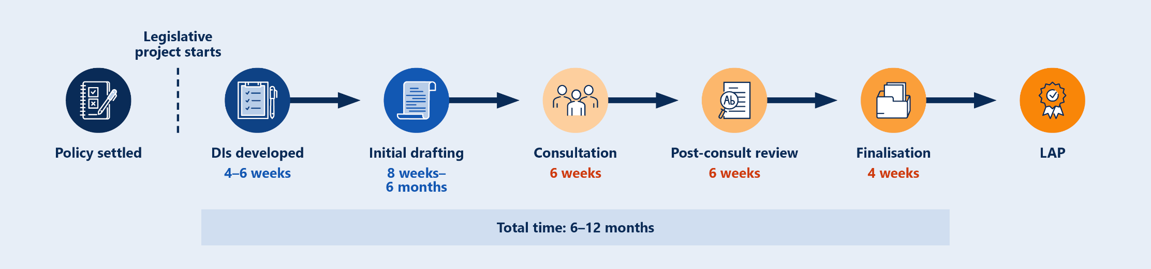
Figure 2: Large size legislation projects – moderate/high complexity
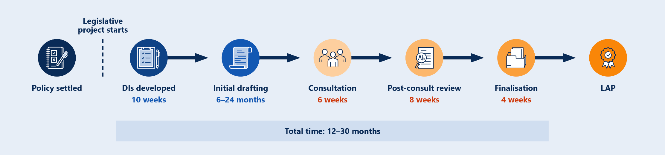

Summary of steps in legislative process



Policy settled
After receiving policy authority, you need to settle policy specifics to a level of detail necessary to draft a Bill.
The time involved in this step will depend on the policy’s relative priority, complexity, sensitivity, resourcing available and the capacity of other stakeholders you need to consult. Public consultation or discussions with states and territories will increase the amount of time needed to settle the details.
Engage AGS early on the legislative implementation of the policy. Engage with OIA to discuss policy impact assessment requirements.
This stage ends once you can say policy is settled to an extent that quality drafting instructions can be developed. This is usually when all elements in the policy checklist are covered, and all fields in the standard drafting instructions template can be filled in.


DIs developed
Develop drafting instructions to implement the settled policy in the standard drafting instructions template or another template agreed by OPC.
Consult with:
- AGS
- Any agencies that will administer the new law
- Departments that administer legislation you wish to amend.
Gaps in policy and instructions will cause inefficiencies in drafting and put your timeframes at risk.
You will need to be able to give a detailed explanation of your policy, the legislative framework, and why and how the law needs to be changed to implement your policy.
For further detail see OPC’s Guide for Clients and Chapter 5 of the Legislation Handbook.


Initial Drafting
When developing draft legislation, OPC will manage resources in line with priorities set by PBC. Refer to OPC’s Timeframes for the development of Bills to work out more exact timing.
OPC will prepare draft bills for comment and ask questions about your policy. Prompt responses to OPC’s comments will progress the project.
You may want to consult with:
- AGS – to manage legal issues identified
- Any agencies that will administer the new law.
Start drafting explanatory materials once drafting instructions are with OPC (see Chapter 7 of the Legislation Handbook). If consulting, allow for time at this stage to seek approval of an exposure draft. From this stage to finalisation, you generally will need to bid across at least 2 sitting periods.
For further detail about the drafting process see Chapter 6 of the Legislation Handbook.


Consultation
Exposure draft consultation will require the approval of Cabinet or the Prime Minister – see paragraph 3.7(k) of the Legislation Handbook. This timeframe assumes 2 weeks to seek approval and 4 weeks for consultation.
You should be clear on your legislation bid and drafting instructions that you intend to conduct exposure draft consultation, and what the purpose of the consultation will be.
Consultation should generally not be less than a month. You will need to carefully consider the appropriate timeframe for you and your stakeholders and factor that into your project plan.
If you expect substantial feedback you may wish to build in extra weeks for reviewing feedback after consultation closes.
For further detail about consultation on legislation, see paragraphs 1.4 to 1.9 of the Legislation Handbook.
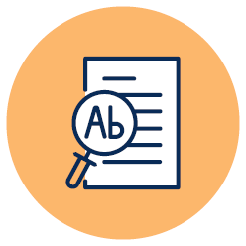

Post-consult Review
When conducting post-consult review you are considering and incorporating feedback received to date in supplementary instructions to OPC.
You may wish to arrange final advice from AGS about any issues flagged in the policy and how they are dealt with in the Bill.
You will also be finishing your Explanatory Memorandum and drafting the necessary speeches and documents for introduction. You will need more time in this phase if you expect your policy will change as a result of consultation on an exposure draft. The likelihood of this risk will need to be considered in developing the overall timeline.


Finalisation
When finalising your legislation you will need to secure approvals in time for your Legislation Approval Process (LAP) date:
- Minister’s text approval of the Bill and Explanatory Memorandum
- Additional policy authority (if needed)
- Text approval from other ministers or departments (if needed)
- Any other authority – depending on what this is, this may impact your timing, for example, approvals from states and territories can take months.
All documents will need to be finalised and ready for introduction before LAP.
See Chapter 3 of the Legislation Handbook for further details about Policy Approval, and Chapter 8 for further details about LAP.


LAP
Your Bill is ready for introduction once it has been approved through LAP. The ultimate date for introduction will be determined by ministers.
See section 1 of Appendix G of the Legislation Handbook for a list of documents your department needs to lodge with the Parliamentary Affairs and Legislation Section in PM&C for LAP. OPC will lodge the Bill.
You will need to arrange for the printing and tabling of the explanatory memorandum. OPC will arrange the printing and tabling of the Bill. See section 2 of Appendix G of the Legislation Handbook for an outline of tabling requirements.
Contact Parliamentary Affairs and Legislation Section in PM&C if you have any questions.

