

A Tool for Action
Developing the Workplace Gender Equality Agency’s Action Planning Tool
December 2025

Other uses
Enquiries regarding this license and any other use of this document are welcome at:
Managing Director
Behavioural Economics Team of the Australian Government
Department of the Prime Minister and Cabinet
1 National Circuit
Barton ACT 2600
Email: beta@pmc.gov.au
The views expressed in this paper are those of the authors and do not necessarily reflect those of the Department of the Prime Minister and Cabinet or the Australian Government.
Tell us how you are using this report


Research team
BETA staff who contributed to this report are Abigail Chan, Riley Childs, Lindsey Cuthbertson and Loren Willis. Current and former BETA staff who designed and developed the Action Planning Tool are Carissa Adams, Abigail Chan, Ruisi Chen, Aurore Chow, Andrew Pfeiffer and Loren Willis.

Acknowledgments
Thank you to the Workplace Gender Equality Agency and their Capacity Building Team for their support and valuable contribution in making this project happen. In particular, special thanks to Elyse Lane, Lachlan Smith and Anna Stathopoulos for their work on this project.

Who?

Who are we?
We are the Behavioural Economics Team of the Australian Government, or BETA. We are the Australian Government’s first central unit applying behavioural economics to improve public policy, programs and processes.
We use behavioural economics, science and psychology to improve policy outcomes. Our mission is to advance the wellbeing of Australians through the application and rigorous evaluation of behavioural insights to public policy and administration.

What is behavioural economics?
Economics has traditionally assumed people always make decisions in their best interests. Behavioural economics challenges this view by providing a more realistic model of human behaviour. It recognises we are systematically biased (for example, we tend to satisfy our present self rather than planning for the future) and can make decisions that conflict with our own interests.

What are behavioural insights and how are they useful for policy design?
Behavioural insights apply behavioural economics concepts to the real world by drawing on empirically-tested results. These new tools can inform the design of government interventions to improve the welfare of citizens.
Rather than expect citizens to be optimal decision makers, drawing on behavioural insights ensures policy makers will design policies that go with the grain of human behaviour. For example, citizens may struggle to make choices in their own best interests, such as saving more money. Policy makers can apply behavioural insights that preserve freedom, but encourage a different choice – by helping citizens to set a plan to save regularly.

Contents
Executive summary 4
Why 5
What we did 6
APT usage insights 9
Organisation interview insights 17
WGEA interview insights 23
Discussion and conclusion 25
References 27

Executive summary
As the gender pay gap in Australia persists, with women earning 78c on average for every $1 a man makes, more needs to be done to improve workplace gender equality (WGEA, 2024). Of the 7,414 Australian organisations who reported gender pay gap data to the Workplace Gender Equality Agency (WGEA) in 2024, 32% of employers had not conducted a gender pay gap analysis – and of the 68% who had, 25% did not take any further steps to reduce their gender pay gaps (WGEA, 2024).
BETA partnered with WGEA to develop an online, behaviourally-informed Action Planning Tool (APT). The APT’s personalised design aimed to increase confidence, build knowledge and support action within organisations to reduce their gender pay gaps and complement existing WGEA resources. WGEA launched the APT in May 2024. BETA then evaluated the APT by analysing user data, and interviewing organisations and WGEA staff members.

The APT increased user confidence to address organisational gender pay gaps
The APT helped organisations feel more confident in reducing their gender pay gaps, with 77% of respondents saying their confidence had increased after using the APT. A majority of users (74%) also reported they learnt something new about how to reduce their organisation’s gender pay gap after completing the APT.

The intention-action gap between receiving and implementing APT recommended actions remained
There was still an intention-action gap between increased confidence and implementing the APT’s recommended actions. While the organisations we interviewed were taking actions to address their gender pay gaps, these actions were not directly in response to the APT’s personalised recommendations. However, multiple organisations said the APT’s recommended actions informed planning activities and future activities, meaning it might be too early in the lifespan of the APT to fully appreciate its impact.
The Workplace Gender Equality Amendment (Setting Gender Equality Targets) Act 2024, which requires relevant employers to select and meet gender equality targets, was legislated since these interviews took place and may help address this intention-action gap.

Improvements could be made to future versions of the APT
The APT user experience was positive, but completion rates could improve. Greater promotion of its location and value to organisations could increase its reach and impact. There is scope to improve the support provided by the APT, from autofill functionality to a refinement of the actions and information provided to users after completion. Encouraging reporting organisations to complete the APT prior to WGEA consultations as a standard practice could also assist in achieving greater value.

Why
Australian organisations of over 100 employees are required to annually report their gender pay gaps to WGEA. WGEA publishes this data on their Data Explorer in line with the Workplace Gender Equality Amendment (Closing the Gender Pay Gap) Bill 2023 (Office of Parliamentary Counsel, 2025). The aim of publicly sharing the data is to encourage better and quicker action to reduce gender pay gaps (WGEA, 2025).
Australia’s average total remuneration gender pay gap remains above 20%, equating to a yearly difference of $28,425 (WGEA, 2024).
It is possible there is an intention-action gap between identifying gender pay gaps and taking action to reduce them. Based on reporting figures from the 2024 Scorecard for relevant Australian organisations (with over 100 employees):
- Around 2,300 Australian employers have not completed a gender pay gap analysis
- Around 1,760 Australian employers have not taken further action to reduce their gender pay gap after completing a gender pay gap analysis (WGEA, 2024).
Initial qualitative research conducted by BETA into the employer experience of addressing gender pay gaps, identified two common barriers to taking action:
- Difficulty identifying the cause of “hot spots” contributing the most to organisational gender pay gaps
- A lack of resources to identify specific actions to address these gender pay gap hot spots.
The research also identified a common group of organisations who have identified gender pay gaps, accepted responsibility for addressing them, and want to take action but need guidance on how to do so.

What we did
BETA developed the APT in partnership with WGEA. The APT aimed to bridge the intention-action gap and provide organisations with personalised guidance to address gender pay gaps.
The APT has 3 sections:
- input – users enter their organisational data from the WGEA data explorer (or a more up-to-date source if one exists in their organisation) into the APT.
- diagnose – the APT identifies “hot spots” or common causes for the organisation’s gender pay gap based on the data provided by the user. The APT also acknowledges key areas where organisations were meeting recommended requirements.
- action – the APT provides relevant recommended actions and resources based on the hot spots identified to help the user reduce their gender pay gap.
These personalised recommended actions are categorised into three colour-coded levels:
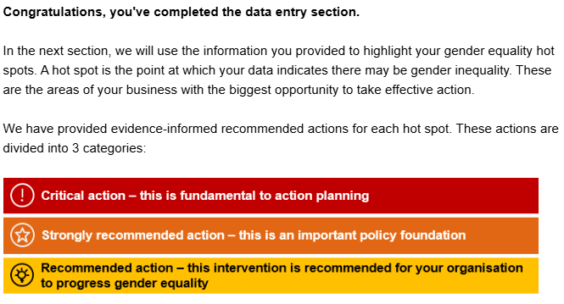
Source: WGEA APT
Figure 1: The 3 categories of APT personalised recommended actions
The APT takes users through each recommended action in detail, which includes an overview of the action and links to further resources. Users can then select what actions they see as their organisation’s highest priorities and request an email summary or PDF of their recommended actions.
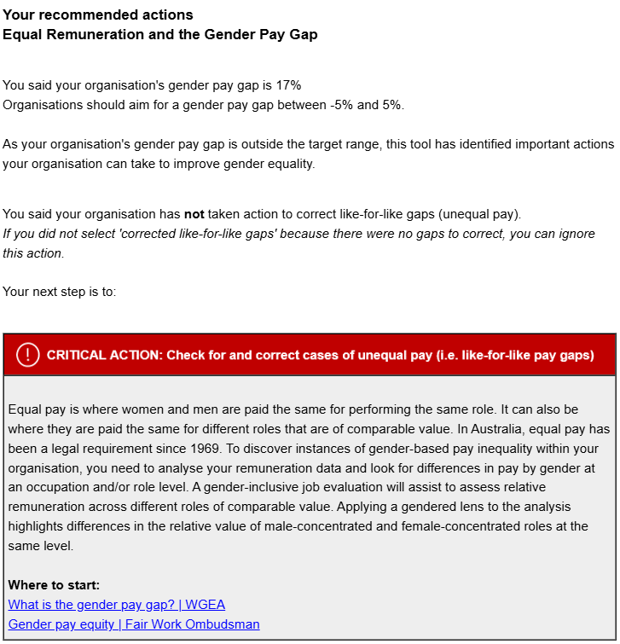
Source: WGEA APT
Figure 2: An example of the APT’s recommended actions based on users’ gender pay gap responses
The APT was underpinned by behavioural insights (BI) using the EAST Framework (BIT, 2024). EAST is an evidence-based approach to supporting behaviour by making actions easy, attractive, social and timely. BETA’s focus was to make the APT user experience, and responding to recommended actions, both easy and attractive.
For example, we made the APT ‘easy’ by:
- Providing clear instructions and links to the WGEA Data Explorer to reduce user frictions.
- Including a screener question on whether a user’s organisation is a relevant, reporting employer to increase completion by the target population and reduce confusion over the purpose of the APT.
- Providing an APT post-completion email which included a behavioural to-do checklist suggesting effective next steps.
We made the APT recommended action ‘attractive’ by:
- Personalising the actions based on the organisational data entered at the start of the tool.
- Creating a hierarchy of actions using colour, icons and categories to draw attention, convey critical information and help with comprehension.
- Asking users to select the recommended actions they see as the highest priorities for their organisations, to help prioritise next steps.
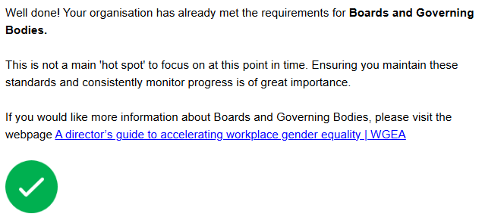
Source: WGEA APT
Figure 3: The APT also recognises where a user’s organisation is doing well in relation to their gender pay gap
Users could leave feedback at the end of the APT and opt in to a follow-up interview to provide insights on whether their organisation implemented recommended actions.

APT usage insights

Who used the APT
A total of 498 users accessed the APT during the data collection period from launch (31st May 2024) until the end of BETA hosting the APT (14th Jan 2025). 186 users (37%) completed and 312 users (63%) partially completed the APT. The majority of users who partially completed the APT did not progress any further after viewing or completing the opening APT page. The opening page explained the purpose of the tool, asked whether the user’s organisation is a “relevant employer” (of more than 100 employees) and some additional questions about the user’s organisation.
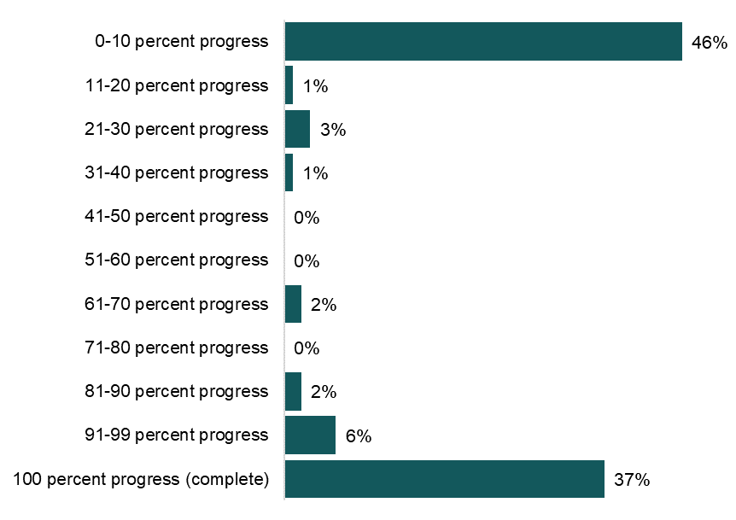
Source: WGEA APT (n=498, 186 completed users; 312 partially completed users). The “0-10” column represents users who did not progress past the APT “screener” page.
Figure 4: Progress of all APT users
The majority of APT users worked in human resources/diversity and inclusion roles, and most users were based in Australia (96% in Australia, 4% outside of Australia).
- most popular APT recommended actions which were selected as highest priority by users
APT user roles | Total APT users | Actual APT completions
Executive | 55 | 20
Human Resources and/or Diversity and Inclusion | 356 | 152
Finance | 12 | 2
WGEA Reporting Contact | 27 | 13
Consultant | 18 | 6
Other | 42 | 8
Source: WGEA APT (n=498) – users could select more than one category
The top 3 industries that used the APT were professional, scientific and technical services, financial and insurance services, and health care and social assistance. This trend was the same for both partial and full completions of the APT.
- most popular APT recommended actions which were selected as highest priority by users
APT user’s organisational industries | Partial completions | Actual completions
Professional, scientific and technical services | 30 | 39
Financial and insurance services | 31 | 31
Health care and social assistance | 28 | 19
Public administration and safety | 29 | 8
Manufacturing | 25 | 9
Education and training | 14 | 15
Other services | 19 | 10
Mining | 16 | 8
Construction | 17 | 6
Information media and telecommunications | 10 | 8
Transport, postal and warehousing | 12 | 6
Agriculture, forestry and fishing | 11 | 5
Retail trade | 8 | 6
Accommodation and food services | 10 | 2
Wholesale trade | 7 | 3
Electricity, gas, water and waste | 6 | 3
Administrative and support services | 5 | 2
Arts and recreation services | 2 | 3
Rental, hiring and real estate services | 0 | 1
Source: WGEA APT (n=468)
APT users also provided information on their organisation’s gender pay gap and actions taken to reduce it. The average gender pay gap of APT users’ organisations was 17.3%. The majority of organisations had both undertaken a payroll analysis and taken action in response. The APT data also identified an intention-action gap, with 29% of organisations not taking action after undertaking a payroll analysis.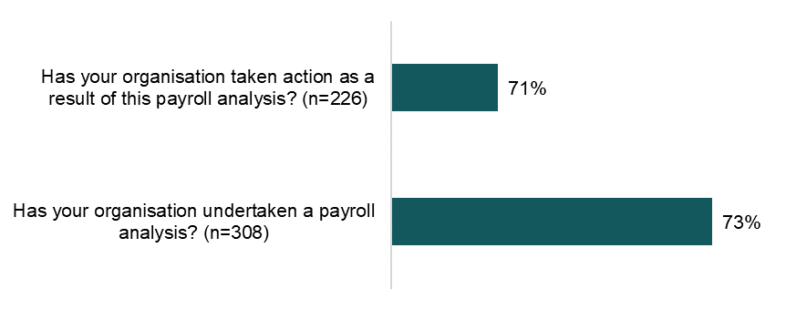
Source: WGEA APT
Figure 5: Percentage of users’ organisations that have undertaken a payroll analysis and taken action

APT users reported a positive user experience

There was an optional feedback form at the end of the APT. Those who responded to these questions found the APT easy to use, and the APT’s recommended actions both helpful and relevant to their organisations.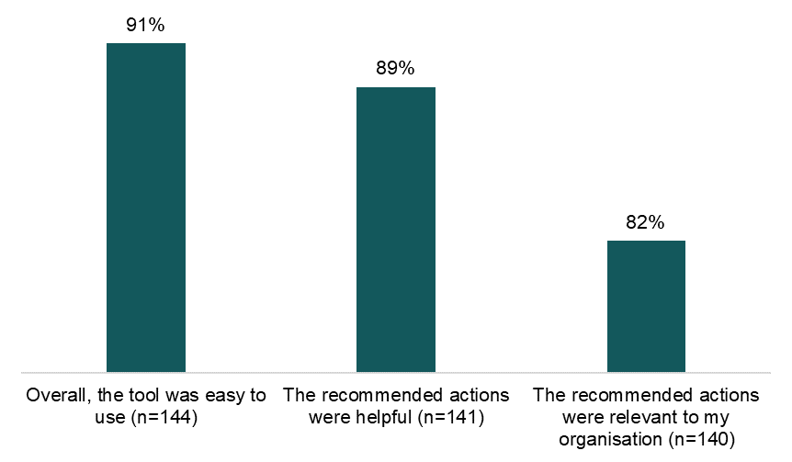
Source: WGEA APT. Percentages refer to net satisfaction which is the proportion of respondents answering satisfied or very satisfied.
Figure 6: How the APT reported their user experience (net)
The APT also asked users how it impacted their knowledge and confidence to take action to reduce their gender pay gaps, and the responses were positive.
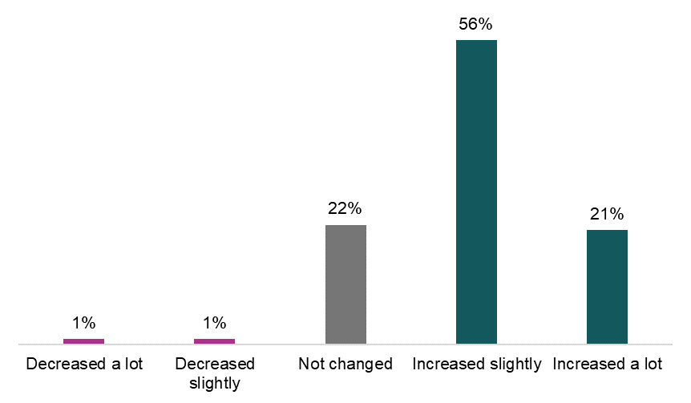

Source: WGEA APT (n=115)
Figure 7: User responses on how the APT impacted users’ confidence in how to reduce their organisational gender pay gaps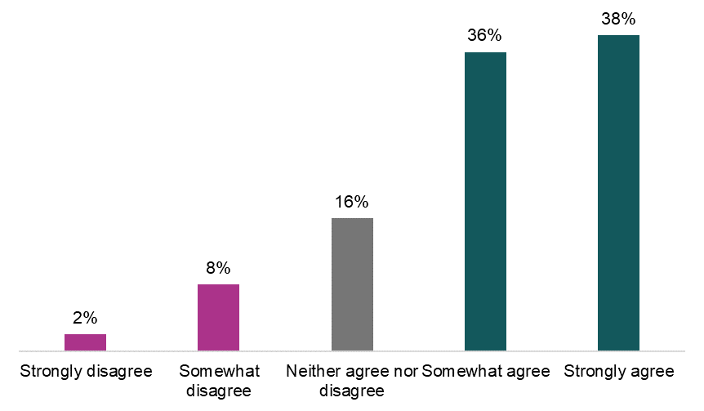
Source: WGEA APT (n=119)
Figure 8: User responses when asked to agree/disagree on whether they learnt something new about how to reduce their organisation’s gender pay gap
A majority of users also demonstrated an intention to implementing at least one of the APT’s recommended actions within the 6 months after using it.
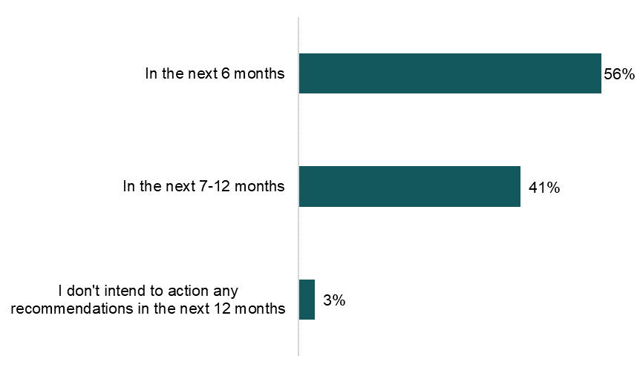
Source: WGEA APT (n=133)
Figure 9: APT users’ intentions towards implementing at least one of their recommended actions after using the APT
Users could select which recommended actions they saw as their highest priority. Table 1 outlines the 10 recommended actions selected most often as high priority.
- most popular APT recommended actions which were selected as highest priority by users
APT recommended action | Number of times recommended action selected as highest priority by users
Use talent and succession planning frameworks to improve your gender workforce composition (strongly recommended action | 17
Develop and deploy a universal, gender informed parental leave policy and return to work program (strongly recommended action) | 12
Apply a gender lens to exit processes (recommended action) | 10
Embed an opt-out approach to parental leave for all parents (strongly recommended action) | 10
Undertake a gender pay gap analysis (critical action) | 9
Undertake a gender impact assessment (GIA) of your remuneration policy | 9
Use job redesign to deepen your recruitment candidate pool (strongly recommended action | 9
Undertake a gender impact assessment of your recruitment and promotion policies (strongly recommended action) | 9
Increase part-time job-share work options for all staff (recommended action) | 9
Check for and correct cases of unequal pay (critical action) | 7
Source: WGEA APT
A total of 154 users requested a personalised email summary of their recommended actions.

Users suggested tangible improvements to the APT
Twenty-four users left open text feedback on their experience, with a mixture of positive and negative feedback. Several users described the APT as an excellent tool and very useful, while others perceived the recommended actions to be generic and generating ‘a lot of actions for a small HR team to do’. Suggested APT improvements focused on 2 key areas:

- Better interaction between the APT and the WGEA data explorer:
- ‘Automating the report from our existing data will help to streamline this process’
- ‘It would be fantastic if future iterations of this tool allowed you to input your company name and it automatically pull through your results’
- ‘Data needs to be pulled directly from the online explorer.’

- Increased resources to support action and evaluation:
- Providing a ‘more realistic scale where our organisations sit against other competitions/in the industry’
- ‘Can we use this tool to look back at previous years so we can track how we're progressing?’
- Including a draft template ‘so that the recommendations can be transferred into actions, measures, timeframes and responsibilities’.

Organisation interview insights
BETA interviewed 5 organisations from different industries who opted into the APT follow-up after completing to tool, to help understand how the APT was supporting organisations to address their gender pay gaps in practice.

Feedback on the APT

Users saw initial value in using the APT
Participants recognised the value in using the APT as both an easy entry point to the resources offered by WGEA and a way to understand complex information in a straightforward manner.
‘WGEA, their website has so many resources. So it is really great. But there's so much there. So I think what attracted me to the action planning tool was actually going, "OK, rather than me looking through all of the criteria and all of those resources, I'll give this a go ... as a guide as to where we're sitting”’.
Organisation interview, information media and telecommunications industry

Using the APT was generally a positive experience

Participants generally reported a positive user experience with entering their data and accessing results in the APT. One participant said completing the APT showed it was well- designed, ‘because generally, if it's really clunky and I can't use it, I give up’.
Participants reported mixed experiences entering the WGEA data explorer information into the APT. In some instances, it was a positive addition to the user experience because participants didn’t have to locate the data. Adding the WGEA data explorer information into the APT also prompted users to check for errors and allowed for a clearer connection between the organisations data and the recommended actions.
Having our submission and … our actual data that we submitted was really useful and being able to just bring that across ... I actually think doing it that way allowed me to think about it a little bit as well ... rather than it just sort of spitting something out at the end … which I couldn't sort of trace the threads to.
Organisational participant, construction industry
In other instances, participants noted difficulties with inputting information from the WGEA data explorer into the APT due to different language between the WGEA data explorer and the APT.
‘[We had to] come back to our responses and then go, “Oh, does that align?”… just seemed to me to be slightly different wording, if you like. Or the way that was presented, like, it just wasn't a one for one – “Oh yep, we answered 20% and there's 20%”, you know what I mean?’
Organisational participant, information media and telecommunications industry

The APT could be clearer on next steps
There was a general lack of clarity towards the end of the APT when participants received their personalised results, especially with the various summary formats available (on screen, via email or PDF). There was generally a preference for the more “durable” PDF format, but some participants either did not realise a PDF was available, were confused about how to access it, or didn’t understand whether it contained the same information as the on-screen results.
‘It's just that visual – kind of telling you, yes, it's ready. As opposed to [the PDF] just pops on the screen and you can't save it anywhere or you've got to save it at that point in time.’
Organisational participant, professional, scientific and technical services industry
Next steps for organisations could be clearer. The email summary was recommended to be more instructive and guidance on how often the APT should be revisited.
‘OK, we've submitted all the data and then I was like, ‘Oh there was an email from WGEA you can go and do this now’. But it just didn't feel as, you know, ‘now that you've submitted your data, go away and do this because it would be really useful’, and I think it could just be a little bit more forthright about it.’
Organisational participant, construction industry

‘I hadn't really thought of the next step of the action planning tool. So for example, is that something that … the agency would recommend I do again in 6 or 12 months…’
Organisational participant, information media and telecommunications industry

The APT recommended actions might have contributed to information overload
Some participants described experiencing information overload when reviewing their recommended actions, which in some cases seemed to cause disengagement or a delay in reviewing them. The information overload related to the volume and visual presentation of the recommended actions, and the supporting information for each one.
I suppose what I loved was that each recommended action had some explanatory information and some embedded links. But I've got to say, as one person working in this space, my ability to read all of those links is going to be impossible.
Organisational interview, professional, scientific and technical services industry
Several participants suggested future improvements to the structure of recommended actions to reduce information overload, including:
- an interactive sorting/filtering feature for the traffic light system
- redesigning the recommendation email to highlight the single most important action, followed by a more condensed list of recommended actions
- categorising recommended actions by an additional dimension of the anticipated complexity/simplicity of actioning it.

Greater personalisation of APT recommended actions was suggested for future iterations of the tool
Most participants were supportive of the personalisation of the APT’s recommended actions. Some positively described seeing recommended actions they expected, as it was ‘reassuring’ and ‘good to get confirmation’ their organisation is heading in the right direction. Only one participant expressed scepticism about the validity of the personalised recommended actions provided for their organisation, it is possible this stemmed from user error (e.g. answering a previous question incorrectly).
The ability to further personalise the tool would be beneficial. Participants felt the APT could better account for the specific circumstances of their respective industries or capture additional gender equality work undertaken by an organisation, such as leadership programs. Participants reported that the APT failed to capture the nuance of their organisational structure because WGEA definitions (especially employee classifications) do not map appropriately onto their structure, making recommended actions less reliable and useful. Participants also suggested having sector benchmarks attached to their recommended actions for easier comparisons.
These insights demonstrate the disclaimer on the APT landing page advising its limitations (see Figure 12) may not be achieving its intended purpose. Users may not have either read this prior to use or did not recall reading it during our interviews.
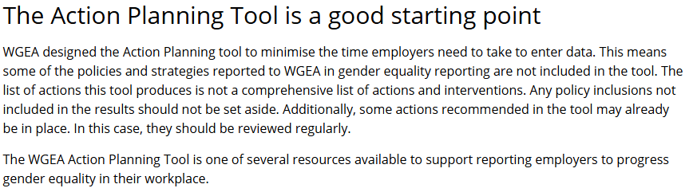
Source: WGEA APT landing page
Figure 13: Disclaimer on the APT outlining its limitations

The APT and environmental facilitators drove change

Receiving APT recommended actions were a trigger for organisational conversations
Most participants saw the recommended actions as a starting point for more detailed action planning, consultation and engagement. One participant described how the ‘traffic light’ system applied to recommended actions assisted with this behaviour.
‘So I went, “OK, so I know what I've to do in regards to these kind of 3 things – like these kind of colours. OK, if it's red, well, that's what we're going to start on straight away”’.
Organisational interview, professional, scientific and technical services industry
Participants identified that, in the first instance, the recommended actions were used by the organisation’s subject matter experts (HR staff, D&I professionals, etc.), then they triggered early conversations with leadership, while the planning for action came later.
‘…our team went, “oh, this is great, it's telling us how to help us”. Like we didn't have to sit around a table and think, “how are we going to do this”…’
Organisational participant, professional, scientific and technical services industry
The APT recommended actions helped structure gender equality conversations. They also appeared to be well-received by leadership.
‘It was a great two-way conversation and [the Chief Executive Officer] knows that the team is not big enough to do all the things that have come up on this.’
Organisational interview, health care and social assistance industry

‘At that [board] meeting, I [sought] endorsement for our gender equality strategy … I was kind of able to overlay that current strategy with our actions with what the tool was telling me.’
Organisational interview, professional, scientific and technical services industry
Another participant framed addressing the APT recommended actions alongside other gender pay gap initiatives as an opportunity to seek further investment in resourcing.

Changing environments are making actions easier
Several participants outlined how factors outside their organisations, such as WGEA reporting and media coverage, were supporting actions to reduce gender pay gaps.
When describing the reasons for recent actions addressing family and domestic violence being some of the easiest to implement, they said:
‘With all of the media attention since earlier this year on [family and domestic violence], more public discourse … just actually our employees [are] more aware so they were warmer … sometimes it's timing, the stars align. So that's been good just to say, “we can talk about this stuff in the workplace.”’
Organisational interview, information media and telecommunications industry
Another said leadership support for addressing organisational gender pay gaps is increasing due to WGEA reporting requirements.
‘In the past there may have been a degree of complacency around gender equality because the firm had made quite a lot of progress in a short period of time. The board can see now through WGEA’s increased mandate, I suppose, through changes to the legislation, that this is something that they need to be engaged in.’
Organisational interview, professional, scientific and technical services industry

Organisational barriers slowed progress on implementing APT recommended actions
Participants identified implementation barriers when first reviewing their APT recommended actions. Although the recommended actions often prompted new conversation, some perceived barriers to action included a lack of resourcing, existing organisational culture and infrastructure, and pushback leadership.

A lack of dedicated resourcing reduced momentum
A recurring theme among participants was a lack of resourcing, including budget, time and staffing, which impacted efforts to change gender pay gaps. The responsibility of addressing their gender pay gap might be one component of their broader role or relatively small HR teams might not feel they have the capacity to address all the APT recommended actions.
‘… So you're only picking it up, you know, now and then…I'm not able to spend that much time on it, to be honest … it'll ebb and flow where yes, I have some time for projects. So I will pick it up and spend a couple of hours, but yeah, that doesn't happen that often.’
Organisational interview, information media and telecommunications industry

‘We have [over 1,000] staff. We have an HR team of 4 people. Two do only recruitment, two do HR. There is no way we could do 20 actions. There's way too many there.’
Organisational interview, health care and social assistance industry

‘There is a lot of action points here. We don't have a WGEA officer within the business to drive this.’
Organisational interview, health care and social assistance industry
One participant spoke about a lack of corporate expertise or support resulting in reduced momentum to drive organisational change and address recommended actions.
‘In terms of how things are going from a D&I [diversity and inclusion] perspective, I am at the moment in very much a business as usual kind of mentality … But we're not in what I would call a building phase right now, we're just in a maintaining phase. So … some of the things I would say we are already doing or had prioritised to do, some of the things we won't do … at least not in the next 12 to 18 months.’
Organisational interview, professional, scientific and technical services industry

Existing organisational culture and infrastructure can hinder change
Organisations’ unique culture and existing infrastructure presented as a barrier, particularly when the recommended actions to address the gender pay gap clashed with an organisation’s underlying business model, such as a focus on profit. Several participants identified paid parental leave as a difficult recommendation to action due to financial pressures and increased costs.
‘… It would have quite significant cost implications because 45% of our workforce are Gen Y and so they're in the key parenting time frames.’
Organisational interview, professional, scientific and technical services industry

‘Interestingly enough, not many males pick up on parental leave and we don't offer paid parental leave with a company of about 80% of women who are of that age bracket. That would be extremely expensive for a private company. And aged care really operates on small margins.’
Organisational interview, health care and social assistance industry
‘… The nature of our workforce is that we have three times as many male, generally male employees taking partner parental leave. So if we were to shift that [paid parental leave] into a much bigger employer-paid entitlement, it just wouldn't get over the line in terms of costs.’
Organisational interview, information media and telecommunications industry
One participant outlined how they used their APT recommended actions to develop a phased action plan with a 3-year timeframe to continue gradual change and bring staff on a longer journey, which included establishing working groups and committees focusing on gender equity. They reflected that even though the action plan took a long-term approach to addressing their organisation’s gender pay gap, it could not be something that ‘could just be taken and run with’ in their organisation.
‘There's going to be a 6-to-12 month process of foundation building where we'll use some of these [recommended actions] but we also need to do a lot of education and discussions about issues and challenges. And not just pay equity. This is also a little bit about respect and equity and unconscious bias and all of those other things…’
Organisational interview, construction industry

‘Undertake a gender impact assessment – that can be really simple and we could do that up front. But when we start to say, “embed a skills based assessment” – those two things aren't … always equal and not easily done. So I've created a business transformation piece … used the action plan to inform, which has been really helpful in that.’
Organisational interview, construction industry

Leadership might have other priorities to focus on
Several participants observed leaders having to balance support for new gender policies with broader organisational outcomes. At times this resulted in low leadership appetite for change and trade-offs on which recommended actions to action, if any. For example, one participant’s organisation had worked on addressing their board’s gender compositions over the last 18 months, but while there was still work to go, they felt this past progress would impact leadership support for ongoing efforts.
‘If I went to our CEO and said, ‘we need to have another bite at this’, I think [they would] just say, “I can't. I just can't.”’
Organisational interview, professional, scientific and technical services industry
One participant acknowledged their organisation was not prioritising identifying and addressing organisational sexual harassment risk profile due to both a lack of resourcing and expertise, and the view it was not currently a top priority for management.
‘… with the sexual harassment … not enough top priority for management and also again just a lack of internal expertise … and maybe this touches just as much on WHS, but yeah, just doing that really good look at our risk profile for sexual harassment. That's another thing which is … always in the back of your head.’
Organisational interview, information media and telecommunications industry

WGEA interview insights
BETA interviewed 4 WGEA staff members on how the APT has impacted their work since its launch.

The APT was useful to assist with referrals and strengthen engagements with organisations
WGEA staff saw the APT as an important part of their engagement with organisations who are required to report to WGEA. They generally saw the value of referring organisations to the APT in two key ways:
- saving WGEA staff time and resources
- providing depth and personalisation to organisations.
WGEA staff aimed to build a ‘base knowledge of gender pay gaps’ through engagements with organisations before referral to the APT. The APT was seen as useful in the “second step” of the engagement process, especially for those in the earlier stages of taking action.
The APT allowed staff to use advisory sessions with organisations to focus on priorities and next steps as it ‘reduces the need to ask a lot of probing questions’. It was also ‘a really helpful starting point’ for staff’s own thinking about developing recommended actions for organisations.
‘We can kind of say: ‘before you come to the session, have you done a gender pay gap analysis? If not, please do it and then use the action planning tool and come to us with those actions in mind.’
WGEA staff member
WGEA staff saw referring to APT results as a useful behaviour for engaging with organisations. For one staff member, inputting an organisation’s publicly available data explorer results into the preview version of the APT was a way to ‘get my brain going in terms of what to suggest to them and where to start’.
‘There's been one or 2 times where I’ve been on a call and just said … “give me 2 minutes, I'll just pop this into this tool we've got and let you know what it thinks.”’
WGEA staff member
The APT also provides organisations with a level of personalisation a WGEA staff member felt they would be unable to match in a single advisory session given they ‘do not have the resources to be doing that diagnosis’.
‘It's a lot less manual work on my end … it's kind of standardised it a bit as well, because again it's more consistency in terms of what suggestions we make and how those conversations go.’
WGEA staff member
Another staff member felt positively about the ability of the APT to improve the nature and sentiment of organisations’ engagement with WGEA:
‘[It’s] something that we can give back to them [and] use that data that [they’ve] painstakingly collected.’
WGEA staff member
In addition to being used in advisory consultations, one WGEA staff member found the APT compliments other engagement activities, such as master classes, in which integration of the APT has ‘completely changed the format of it’. They also reported the APT is an effective way of addressing the ‘stress’ and ‘information overload’ organisations may feel when coming into a master class.

APT visibility could be improved to increase impact
WGEA staff observed organisations would often contact WGEA because of the gender pay gap publication and seek advice to reduce their gender pay gaps without first using the APT, suggesting a lack of awareness about the tool's existence or purpose among potential users.
‘The second one [round of data publication] was, “OK, how do I deal with this?” So a lot of times they reach out because they don't know the action planning tool is there.’
WGEA staff member

‘I think this tool is so underutilised – I think we need to promote it properly and we just haven't because we've had quite a year. There's been a lot of other stuff that's taken precedent, but it sits there, it's on the website. I know the comms team want to promote it and I do think particularly if this next piece of legislation passes, it's going to play a really important role. It just hasn't been promoted enough.’
WGEA staff member
Several WGEA staff members also observed the APT could be better located on the WGEA website to increase usage, as organisations were generally struggling to find the resources they need without guidance from WGEA staff. WGEA staff believed building the APT’s visibility within reporting organisations could streamline the engagement process, and deliver earlier, impactful conversations as a result.

Discussion and conclusion

The APT increased confidence and knowledge to decrease gender pay gaps, but the intention-action gap remained
The APT appeared to fulfil its main goal to support organisations to address their gender pay gaps. Users reported increased confidence, overall capability building and that the recommended actions were helpful and relevant were evidence of the APT’s positive impact.
Multiple organisational participants outlined how the recommended actions were informing their planning activities and future actions. However, none of the interview participants had implemented their APT recommended actions (unless they were already underway prior to using the APT). APT recommended actions did not translate into organisational action because of resourcing, culture and leadership. It is possible it is still too early in the lifespan of the APT to fully appreciate its impact.
Introducing an ongoing evaluation as a regular part of WGEA’s business could provide a long-term approach to measuring the impact of the APT and determine any causal links between the APT and changes in organisational gender pay gaps.

The APT is a valuable tool, but greater promotion could increase its use
While there was positive feedback on the APT user experience, a greater promotion of its location on the WGEA website and value to organisations could help increase usage rates. More consideration could be given to when the APT is promoted and when organisations will be most receptive to using it, such as reporting cycles or during other engagements with WGEA.
The recent passage of the Workplace Gender Equality Amendment (Setting Gender Equality Targets) Act 2025 requires organisations who directly employ 500 or more people to select and commit to achieve 3 gender equality targets. Organisations can select these targets from a menu of 19 options and must meet or demonstrate improvement against these targets over a 3-year period. The APT may be a valuable tool for WGEA promote to make this process easier for organisations to navigate and decide upon their gender equality targets.

Improvements to the tool and ongoing support could be provided to reduce intention-action gaps
While organisations described the APT as easy to use, both interview participants and open-ended APT feedback also suggested future improvements to the tool itself, relating to greater synchronisation with the WGEA data explorer and decreasing the number of recommended actions to reduce information overload. Reducing unnecessary information or steps in a process can reduce the gap between a person’s intentions and their actual actions.
Participants also called for further support with addressing their respective pay gaps, particularly when staff time and resourcing was limited. There were several suggestions from organisations to address this, including providing templates and clear instructions on how to implement recommended actions.

Limitations
There are limitations to the insights identified in this report. The small sample size of our interviews means these insights should not be generalised, despite our 5 participant interviews working across 4 industries. These limitations due to small sample size also apply to WGEA staff insights.
The nature of the evaluation (interviews and APT data analysis) is also a limitation to be conscious of, as it does not involve either a randomised controlled trial or real world experiment. It is difficult to know whether completing the APT has a causal impact on reducing organisational gender pay gaps as a result. Evaluating the APT in a continual and longitudinal way should help WGEA gain a greater understanding of the APT’s impact on helping organisations reduce their gender pay gaps.

References
Australian Government, Workplace Gender Equality (Gender Equality Targets) Instrument 2025 - Federal Register of Legislation, Australian Government, accessed 2 September 2025.
BIT (Behavioural Insights Team) EAST Four simple ways to apply behavioural insights Revised and updated edition, BIT, accessed 7 February 2025
Office of Parliamentary Counsel (2025) Federal Register of Legislation - Workplace Gender Equality Act 2012, Australian Government, accessed 14 February 2025.
WGEA (Workplace Gender Equality Agency) (20 November 2024) WGEA Gender Equality Scorecard 2023-24, Workplace Gender Equality Agency, accessed 6 January 2025.
WGEA (Workplace Gender Equality Agency) WGEA Action Planning Tool | Create a gender equality action plan, Workplace Gender Equality Agency, accessed 4 February 2025.
WGEA (Workplace Gender Equality Agency) WGEA Legislation | WGEA, Workplace Gender Equality Agency, accessed 2 September 2025.
WGEA (Workplace Gender Equality Agency) Gender Equality Targets: Frequently Asked Questions | WGEA, Workplace Gender Equality Agency, accessed 2 September 2025.

© Commonwealth of Australia 2025
ISBN XXX-X-XXXXXX-XX-X A Tool for Action – Reporting on the Workplace Gender Equality Agency’s Action Planning Tool

Copyright Notice
With the exception of the Commonwealth Coat of Arms, this work is licensed under a Creative Commons Attribution 4.0 International license (CC BY 4.0) (https://creativecommons.org/licenses/by/4.0/)


Third party copyright
Wherever a third party holds copyright in this material, the copyright remains with that party. Their permission may be required to use the material. Please contact them directly.

Attribution
This publication should be attributed as follows:
© Commonwealth of Australia, Department of the Prime Minister and Cabinet, A Tool for Action – Reporting on the Workplace Gender Equality Agency’s Action Planning Tool

Use of the Coat of Arms
The terms under which the Coat of Arms can be used are detailed on the following website: https://pmc.gov.au/cca

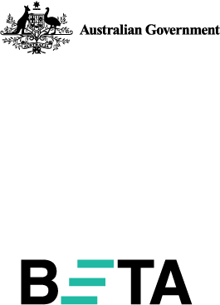
Behavioural Economics Team
of the Australian Government
General enquiries beta@pmc.gov.au
Media enquiries media@pmc.gov.au
Find out more www.pmc.gov.au/beta

The APT was refined with both internal user testing, with WGEA staff, and external user testing with nine organisations, to ensure the needs of the target population were being met.
APT usage insights incorporate both partial and complete responses. Response statistics for each element of the APT differ as a result.
“The Workplace Gender Equality Agency (WGEA) has partnered with the Behavioural Economics Team of the Australian Government (BETA) to create an action planning tool to assist employers to develop and implement their gender equality action plan”…” The tool is designed for employers reporting to WGEA under The Workplace Gender Equality Act 2012 (Act).” (WGEA, 2024).
The results for “Progress of all APT users” figure equal 98% due to rounding.
The results for “the recommended actions were helpful” question equal 101% due to rounding.
This feedback on auto-populating responses from the data explorer was provided despite the inability to do so being clearly articulated on the APT landing page.
In this instance, the participant’s people and culture manager and senior sponsor for diversity and inclusion had left in the 6 months prior to our interview
The Workplace Gender Equality Amendment (Setting Gender Equality Targets) Act 2024 was passed in March 2025.

