# After the employee returns: Conversation starter

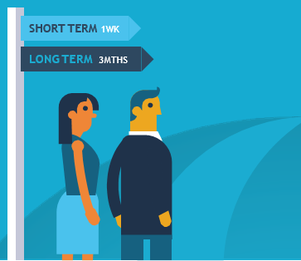This tool aims to assist you in your conversations with your injured/ill employee.

## Within the first week of return

* Be positive: Start out by mentioning that you are happy to have them back.
* Actively listen and flag that the important thing is making sure their return to work is sustainable.
* Mention that you are there to support them in their recovery at work.
* Chat with them about any important information or activities that might have happened while they were away.
* Be careful not to suggest their absence was a big burden on the team.
* Talk about how you, the employee and RCM can work together to support a sustainable return to work.
* Consider what a sustainable return to work looks like and whether it includes a gradual return to work.
* Ask whether the workplace accommodations and suitable duties arrangements have been helpful.
* Think about how progress will be measured and acknowledge that it will not necessarily be linear.
* Schedule catch-ups to check that the return to work is progressing well.

## Within three months of return

* Stay positive: think about ways that the employee has adapted to their new working arrangements.
* Highlight your commitment to a flexible approach: health and what your employee can do will change over time. Plans and support set up in the first week may not be what they need after a few weeks or months.
* Talk about progress towards sustainable return to work goals.
* Ask whether the workplace accommodations and suitable duties arrangements have been helpful.