

Home energy upgrades
Empowering homeowners to make informed decisions
December 2024

Other uses
Enquiries regarding this license and any other use of this document are welcome at:
Managing Director
Behavioural Economics Team of the Australian Government
Department of the Prime Minister and Cabinet
1 National Circuit
Barton ACT 2600
Email: beta@pmc.gov.au
The views expressed in this paper are those of the authors and do not necessarily reflect those of the Department of the Prime Minister and Cabinet or the Australian Government.
Tell us how you’re using this report
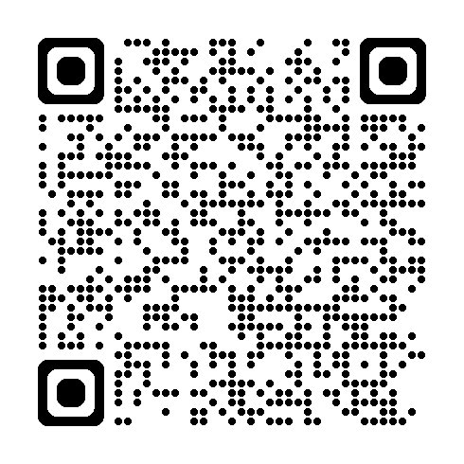
Research team
Laura Bennetts Kneebone was the principal investigator for this project. Other (current and former) staff who contributed to the report were: Ruisi Chen, Michael Ridgway, Parima Vyas, Dr Belinda Xie, Dr Angela Bender, Nicholas Hilderson, Dr Su-Mon Kyaw-Myint, Alexander Tashevski-Beckwith, Katie Anderson-Kelly, Dr Bethany Jones and Dr Jacqui Brewer.

Acknowledgments
Thank you to the Commonwealth Department of Climate Change, Energy, the Environment and Water. In particular, special thanks to the Behavioural Science Unit and the Disclosure Framework Team for their support and valuable contributions in making this project happen.
The trial was pre-registered on the BETA website and the American Economic Association registry:
https://behaviouraleconomics.pmc.gov.au/projects/home-energy-upgrades
https://www.socialscienceregistry.org/trials/13623

Who?

Who are we?
We are the Behavioural Economics Team of the Australian Government, or BETA. We are the Australian Government’s first central unit applying behavioural economics to improve public policy, programs and processes.
We use behavioural economics, science and psychology to improve policy outcomes. Our mission is to advance the wellbeing of Australians through the application and rigorous evaluation of behavioural insights to public policy and administration.

What is behavioural economics?
Economics has traditionally assumed people always make decisions in their best interests. Behavioural economics challenges this view by providing a more realistic model of human behaviour. It recognises we are systematically biased (for example, we tend to satisfy our present self rather than planning for the future) and can make decisions that conflict with our own interests.

What are behavioural insights and how are they useful for policy design?
Behavioural insights apply behavioural economics concepts to the real world by drawing on empirically-tested results. These new tools can inform the design of government interventions to improve the welfare of citizens.
Rather than expect citizens to be optimal decision makers, drawing on behavioural insights ensures policy makers will design policies that go with the grain of human behaviour. For example, citizens may struggle to make choices in their own best interests, such as saving more money. Policy makers can apply behavioural insights that preserve freedom, but encourage a different choice – by helping citizens to set a plan to save regularly.

Contents
Executive summary 4
Why? 6
What we did 10
Disclosure of Home Energy Ratings 13
Home Energy Ratings and certificate advice 27
Decision support for consumers 32
Interpretation of results 41
Appendices 44
References 74

Executive summary
Making home energy upgrades can reduce the running cost and greenhouse gas emissions of a home, while increasing the comfort for occupants. Most Australian homes were built before minimum energy efficiency requirements were introduced nationally in 2003 (Australian Building Codes Board 2024). Identifying the most suitable and cost effective home energy upgrade can be complex, with uncertainty leading to inaction.
BETA partnered with the Commonwealth Department of Climate Change, Energy, the Environment and Water (DCCEEW) to design and test interventions which empower homeowners to take action to upgrade their home’s energy performance. BETA tested five policy interventions using survey experiments with 13,797 Australians to find out what works.

What works
Mandatory disclosure of Home Energy Ratings
- Most Australians said it is important to know the Home Energy Rating for a potential property at the point of sale (86%) and at the point of lease (75%).
- Australians were more likely to choose to inspect homes with high energy ratings when disclosure of ratings was mandatory
- When choosing from a range of different home upgrades prior to listing a property for sale, sellers were more likely to choose upgrades that improved the energy rating when told that it was mandatory to disclose the rating in the real estate listing.
- Advice on a standard home energy assessment certificate prompted 6 in 10 people to choose to make a permanent home energy upgrade. Prioritising specific upgrade options and offering small incentives did not impact this choice.
Decision support resources for consumers
- A text prompt with a link to YourHome.gov.au encouraged 2.4% of Australians to seek more information on home energy upgrades, this is a strong response rate for a prompt.
- Current homeowners said the most helpful kinds of home upgrade resources would be: information about rebates and government assistance; cost and savings calculators; and assistance choosing the right upgrade.
- An online decision support tool increased homeowner’s confidence in their upgrade decisions, but decreased their interest in a professional home energy assessment. It did not change their underlying intention to make upgrades to their home in the next year.
This research provides robust evidence that introducing mandatory energy rating disclosure at the point of sale and lease across Australian states and territories is likely to positively impact buyer and seller behaviour. The evidence shows that the right choice environment can empower consumers when they are buying, renting or a selling a home and appropriate resources can support them to make informed home energy upgrade decisions.

Why?

Policy context
Residential buildings are responsible for more than 10% of total carbon emissions in Australia (Residential buildings - DCCEEW). While new houses must meet a minimum Home Energy Rating or equivalent, most Australian housing stock was built before the introduction of national minimum energy efficiency requirements in 2003. Reducing emissions from Australian homes is an important part of the national plan (Trajectory for Low Energy Buildings - DCCEEW) that sets a path towards zero energy and low carbon buildings.
In this project we wanted to understand how to support homeowners, home buyers and landlords to make informed energy decisions for their home, so it uses less energy to cool, heat and operate. These decisions can include installing energy efficient appliances, making improvements to their home’s thermal performance, or installing solar panels and battery storage systems. These household decisions not only reduce Australia’s combined greenhouse gas emissions, but also save homeowners money and improve the comfort of their homes.
In Australia, except for the Australian Capital Territory (ACT), there is no requirement for the energy performance ratings of homes to be disclosed when selling or leasing a home. This means most homebuyers and renters cannot easily compare homes by their energy performance.
Work is underway on the Home Energy Ratings Disclosure Framework (Disclosure Framework), which sets out a national approach to assessing and disclosing the energy performance of homes. This framework aims to help consumers access consistent and reliable home energy performance information when they need it. It provides information that encourages improvements in Australia's residential building stock. The parameters in the Disclosure Framework can be adapted and implemented by state and territory governments. The Disclosure Framework Version 1 was published by the Energy and Climate Change Ministerial Council (ECMC) in July 2024. It covers ratings for single dwellings. Version 2 is scheduled to be considered by ECMC in late 2024. It covers ratings for apartments, apartment buildings and a number of other disclosure parameters.
DCCEEW intends to use behavioural insights to inform the development and improve the implementation and success of the Disclosure Framework, and residential building disclosure scheme/s. It will also use these behavioural insights to inform the Nationwide House Energy Rating Scheme (NatHERS) and existing consumer guidance resources, such as YourHome.gov.au.

Project Scope
This project involved testing interventions designed to empower homeowners to upgrade the energy performance of their home. BETA’s Towards Net Zero survey research (2023) identified a range of behavioural enablers and barriers to making home energy upgrade decisions, and this project tested interventions designed to address them.
We focused on encouraging a wide range of high impact energy upgrades that would stay with the home for many years, such as an energy efficient heat pump hot water system. These upgrades may have a higher upfront cost than other less energy efficient alternatives, but lead to sustained reductions in a home’s energy use. This reduces energy bills and household emissions without daily, habitual effort from individuals.
The project targeted homeowners of existing freestanding houses and townhouses, including owner occupiers, owner investors and prospective homeowners. This group is most likely to have the opportunity to make and implement an upgrade decision and were covered by the Disclosure Framework Version 1. Renters who need permission from landlords, and apartments that share physical infrastructure and services, are yet to be covered by the Disclosure Framework.
Homes built before minimum energy efficiency requirements were introduced nationally (2003) are likely to benefit most from making home energy upgrades, including:
- Upgrading the thermal properties of the home e.g. adding insulation
- Replacing old, fixed appliances with efficient options e.g. hot water system
- Adding solar panels and battery storage to make and store electricity.
This research focused on the ideal consumer journey for an individual looking to make home upgrades (Figure 1). In particular, how individuals might interact with government services, regulations and resources.
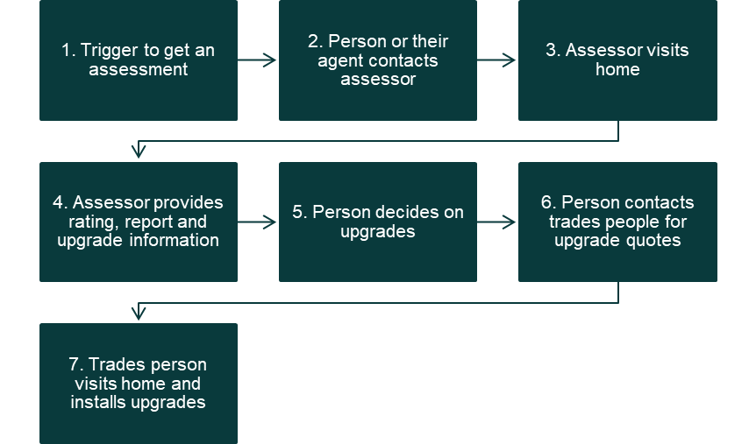

Figure 1. Indicative consumer journey from trigger events to the installation of home energy upgrades
We wanted to look at multiple points along the home upgrades user journey. Firstly, we wanted to better understand the triggers of disclosure of Home Energy Ratings at the point of sale and lease. Would consumers care? Would they understand this information? Would they act on it? Secondly, we wanted to explore how to best present home energy upgrade advice on a home energy assessment certificate. Could the advice be presented in a way to improve its impact? Lastly, we considered the potential for decision support resources. How could people be encouraged to consider upgrades? What might help them to see the upgrades progress through to completion?

Insights from existing literature: behavioural barriers and enablers
Many factors influence the decision to make home energy upgrades. We looked at Australian and international literature to understand what drives people to allocate money, effort and time to make a home upgrade, how people choose which upgrade to do, and what barriers they may encounter.
Below is a summary of the high-level insights. For the full literature review refer to the separate Home Upgrades Technical Appendix, Appendix H.

Much of the problem is invisible
Awareness is a critical pre-condition for action. Interventions should focus on high impact actions and assume low rates of awareness of existing home energy performance. Decision tools, home energy assessments, efficiency labelling and robust rules of thumb could all help build awareness and make the energy consumption of homes more visible.
International literature shows mandatory disclosure of Home Energy Ratings is much more effective than voluntary disclosure at making home energy performance visible.

Uncertainty and indecision often leads to inaction, confidence is key
Confidence is a key precursor to action and motivates behaviour change. Interventions should test ways to build confidence in making home energy upgrade decisions.

People are overloaded by complex, difficult tasks
Interventions should consider individual appetite to put time and energy into an upgrade decision. People who are already time poor and overloaded with information are more likely to take advantage of options that have supported decision making or are easier to implement.

People struggle to align costs and expected benefits with their household budget
People often weigh present costs more highly than future benefits. Interventions should be clear about the relative impact of different upgrade options, offering higher and lower cost options. As each choice carries an opportunity cost, interventions should identify whether an upgrade will ‘pay for itself’ and ideally offer options to reduce the upfront expense.

Benefits of home upgrades can be bundled
People often perceive bundled benefits as offering greater value than individual benefits. Interventions should communicate the broad benefits from any energy upgrade decision, including financial, comfort and environmental. For example, homeowners may choose double glazed windows to block noise as well as to keep the house warmer in winter and reduce energy bills.

People are more open to change during key trigger points
Interventions are most effective when they coincide with existing trigger events, such has buying or selling a house, moving home, making renovations or when an existing appliance needs replacement. Embedding information about home energy performance into a larger change event may be more helpful for decision making and lead to action.

What we did

Methodology

A hypothesis for behaviour change
Making a home energy upgrade is not a single action. Consumers face a wide range of options and decisions at each step in the process. This can be overwhelming to navigate when paired with a lack of knowledge and a human preference for the status quo – making no changes or opting for a like-for-like replacement. We designed behavioural interventions that addressed many points in the home upgrades journey, including making Home Energy Ratings more visible, simplifying how information is presented and creating supports for decision making.

Key research questions
Disclosure of Home Energy Ratings
Does mandatory disclosure of Home Energy Ratings influence choice of house?
Does mandatory disclosure of Home Energy Ratings lead to home energy upgrades?
Home Energy Ratings and certificate advice
Can advice on a Home Energy Rating certificate support greater upgrade action and how?
Decision support for consumers
How can government resources best support home upgrade decisions?
Would prompts attract people to view home upgrade resources on a government website?
To test respondent behaviour, we used hypothetical scenarios that emulated the following experiences:
- Picking a property to inspect from a set of online search results
- Choosing a preferred upgrade for a property when presented with incomplete information on a real estate listing or detailed information on a Home Energy Rating certificate
- Using resources such as an online decision support tool
- Seeing a prompt with a clickable link to information.

Hypothetical scenarios allow us to understand the preferences and behaviour of all respondents, even if they cannot make home energy upgrades decisions in the real world due to individual circumstances.

Survey sample
We ran a national survey from 16 to 28 May 2024 with a sample of 13,797 survey respondents representative of Australia by age, gender and location (for demographics see Appendix 2). Respondents were recruited through two online survey panels, each respondent received a small monetary incentive to complete a 10 minute online survey using the Qualtrics platform. Respondents had to be based in Australia and over 18 years of age to participate.

Survey flow
To better understand the link between consumer knowledge and intention with their actual behaviour. Our survey contained five experiments, with respondents taking part in three (Figure 2). 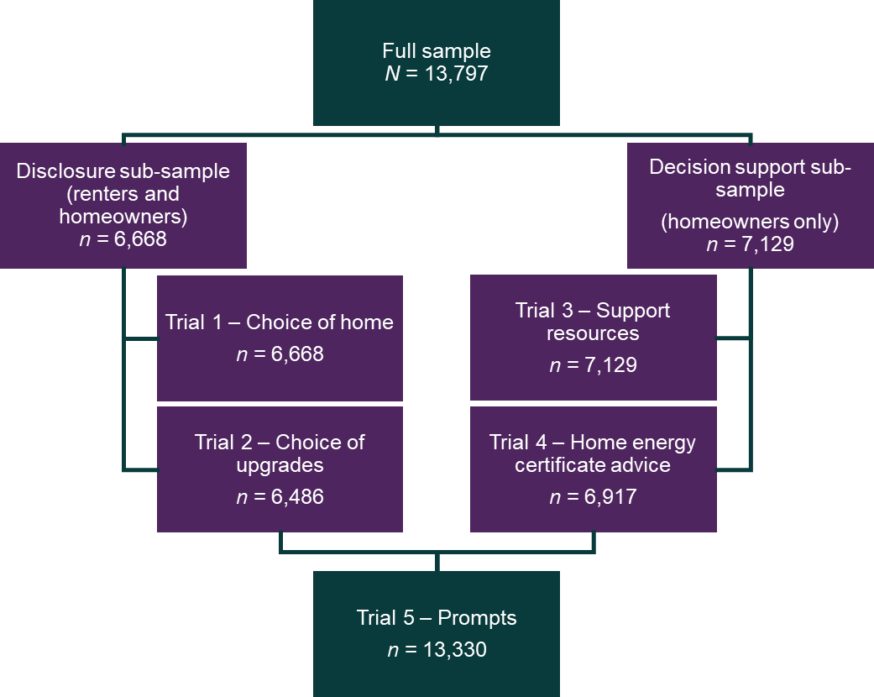

Figure 2. We used sub-samples to investigate four of our five research questions
Around half of respondents saw trials in the disclosure stream. This was a blended group of homeowners and renters living in different house types. With this group we tested the impacts of mandatory disclosure of Home Energy Ratings on respondents’ choice of house (Trial 1) and choice of upgrades (Trial 2).
The other half of the sample saw trials in the decision support stream. This was only comprised of homeowners living in freestanding homes. They were shown resources to support homeowners to make upgrade decisions in their home (Trial 3) and Home Energy Rating certificates (Trial 4).
Respondents were also asked a short series of survey questions relevant to the trials they had seen. This was to better understand their thoughts and perspectives around home energy upgrades.
At the end of the survey, all respondents saw a prompt to visit a government website (Trial 5).
Results from these five trials will be discussed in three separate sections: disclosure; certificate advice; and decision support.

Randomised controlled trials
Our survey experiments were randomised controlled trials (RCTs). This allowed us to control for known variables such as home ownership status, and reduce the bias of unknown variables, such as motivation to make upgrades.
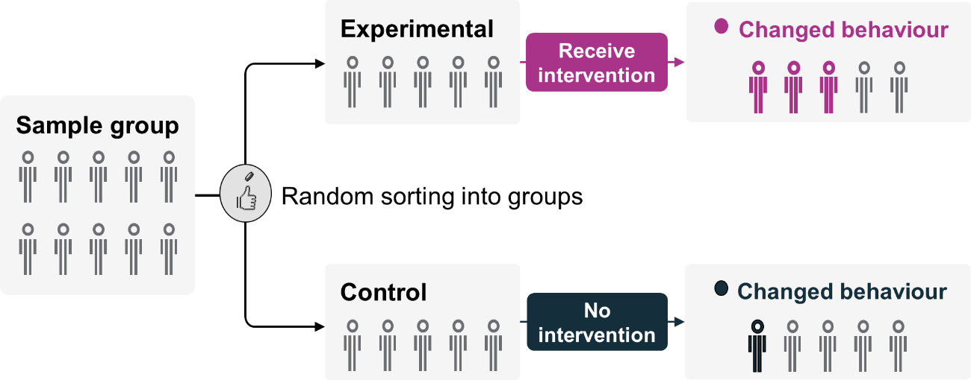

Figure 3. Example of randomisation in RCTs
Source: Adapted from Haynes et al 2012, ‘Test, Learn, Adapt: Developing Public Policy with Randomised Controlled Trials’.
While no single piece of research can prove cause and effect, RCTs can provide robust evidence for policy and decision makers, and compliment other forms of research when looking at a complex issue. This rigorous tool helps us understand if an intervention achieves its intended policy outcome and allows us to look for adverse outcomes or make clear when an intervention has no effect.
In survey experiments, respondents are presented with hypothetical scenarios. While this methodology provides strong evidence for the direction of an effect, the size of an effect in the real world may be smaller or bigger depending on many other factors.
For full trial details, please refer to the Home Upgrades Technical Appendix.

Disclosure of Home Energy Ratings

Key insights for policymakers
- The disclosure of Home Energy Ratings impacts consumer decision making. The mandatory disclosure group helped buyers exercise their choice better than the voluntary disclosure group.
- Respondents were more likely to inspect more energy efficient homes when Home Energy Ratings for all properties were disclosed.
- Respondents in the voluntary disclosure group overestimated the Home Energy Rating of ‘unrated’ properties more than those in the mandatory disclosure group.
- The majority of respondents said it is important to know the Home Energy Rating for a potential property at the point of sale (86%) and at the point of lease (75%).
- Disclosing a Home Energy Rating on a real estate listing encouraged both buyers and sellers to choose a home energy upgrade over other home upgrades.
- Sellers who were told they would have to disclose a Home Energy Rating on a real estate listing, were significantly more likely to make energy upgrades to a property prior to sale.
- 9 out of 10 respondents said it is useful to know your Home Energy Rating before choosing home upgrades.

Context
Around 2 in 3 Australian homes were built before the introduction of national minimum energy requirements introduced in 2003 (Australian Bureau of Statistics 2001/2002 and 2021/2022). This means many Australian homes are hot in summer, cold in winter and may require cooling and heating throughout much of the year to maintain comfort. With the ACT being the only jurisdiction in Australia to have a mandatory disclosure scheme, the energy performance of a home is invisible to most Australian consumers. Most evidence for mandatory disclosure comes from international literature or the ACT. This was an opportunity to add to the literature with contemporary and nationally representative evidence, the data has the potential to inform decision making for Australian policymakers.
A review of international disclosure schemes (Frederiks and Romanach 2023) showed disclosure of Home Energy Ratings can influence the real-world behaviour of consumers and can drive demand for more energy efficient housing. International literature has shown mandatory disclosure schemes are more effective at reducing information asymmetry in the real estate market than voluntary disclosure schemes. However, existing evidence for the effectiveness of a disclosure scheme in Australia is limited.
Without disclosure of home energy performance, it is difficult for Australian home buyers to know the energy performance, energy costs or greenhouse emissions of a home. Based on the international evidence, the disclosure of a home’s energy performance at the point of sale or lease could help buyers and renters make more informed decisions. Additionally, this could incentivise owner occupiers and owner investors to prioritise home energy upgrades when making alterations or renovations to their home.
In their review, Frederiks and Romanach (2023) pointed to two different types of feedback underpinning a disclosure scheme:
- Comparative feedback, such as browsing the search results of a real estate website, compares one property with other similar properties in the same location. This can help buyers and renters factor Home Energy Ratings into their decision when choosing a home to buy or lease.
- Personal feedback, such as a detailed real estate listing, provides clear and specific information about an individual property. This can help homeowners, owner investors and buyers to identify and prioritise which potential home upgrade may be best suited to their home.

What we did
We ran two trials to understand the impact of mandatory disclosure on respondents’ choice of house and choice of home upgrades. Respondents were randomised into either the voluntary disclosure or mandatory disclosure group for both trials (Figure 4). In the choice of house trial, all respondents were asked to play the role of a buyer choosing which properties to inspect. In Trial 1 – Choice of upgrades, respondents were randomised into two further groups, and asked to imagine they were buying the property to live in or intending to sell the property.
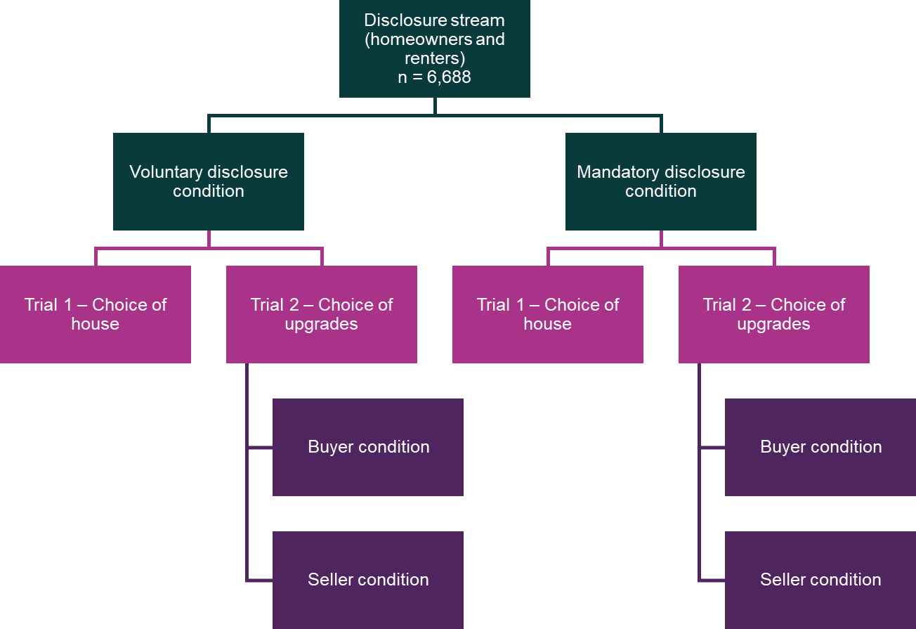

Figure 4. Respondent flow chart for the disclosure stream trials

Trial 1: Does mandatory disclosure of Home Energy Ratings influence choice of house?
We wanted to find out if providing a Home Energy Rating on real estate search results would affect the type of homes respondents chose to inspect. Most people search for properties online. Real estate websites allow users to shortlist properties they want to inspect by filtering properties based on key criteria, such as location, price and number of bedrooms. We were interested in whether respondents would use Home Energy Ratings to prioritise which properties they wanted to inspect, and whether mandatory provision of Home Energy Ratings would be more effective than voluntary provision of ratings. Typically, in a voluntary scheme only highly rated homes would include ratings on advertising materials, sellers tend not to disclose poor ratings, if they know the ratings at all (COAG Energy Council, 2019).
Trial 1 was a randomised control trial and discrete choice experiment (DCE), with respondents randomised into one of the two disclosure groups. Respondents were shown 8 pairs of houses with varying features and were asked to choose a house they would inspect, or not to inspect either house. Those in the mandatory disclosure group saw both high and low Home Energy Ratings on all homes, while those in the voluntary disclosure group only saw Home Energy Ratings for high rated homes and N/A for others.
Each house in the DCE had a range of features, such as number of bedrooms, bathrooms, indoor and outdoor features that were randomised each time. Respondents were told they had filtered the search by location for 3 or 4 bedroom freestanding homes within their budget, so they could freely choose any property based on preference.

Trial 1 findings
Finding: Respondents were more likely to inspect energy efficient homes in the mandatory disclosure groups.
Respondents were more likely to choose to inspect homes rated 50/100 or higher when they could see the ratings for all properties (Figure 5). Almost 3 in 4 respondents in the mandatory disclosure group chose high rated homes when given the option of a high rated and low rated home. In the voluntary disclosure group respondents could choose between a high rated or unrated home, and this was less effective.
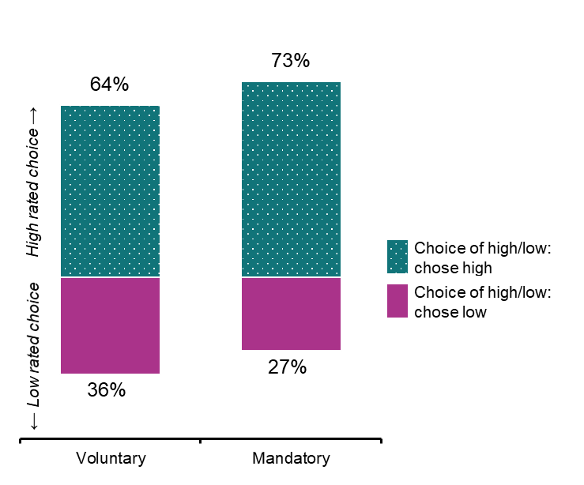

Figure 5. Respondents were more likely to choose a high rated home if they were in the mandatory disclosure group
n = 6,349, based on 25,010 observations (varying but up to 8 choices per respondent)
We found being able to see both high and low ratings (mandatory disclosure group) was more effective at assisting respondents to choose more efficient homes than only seeing properties with high ratings or unrated (voluntary disclosure group). Homes in the mandatory disclosure group were rated in increments of 20, between 0/100 and 100/100. In the voluntary disclosure group, the ratings of homes under 60/100 were not displayed, instead they were classed as ‘unrated’.
Homes with a Home Energy Rating of 100/100 were the most likely to be inspected. Respondents were less likely to inspect homes with lower ratings or no ratings (Figure 6). Each decrease in the rating reduced the likelihood of respondents choosing the property to inspect. Analysis showed respondents did not assume that unrated properties would have a low rating, unrated properties were treated as if they had a rating of approximately 50/100.
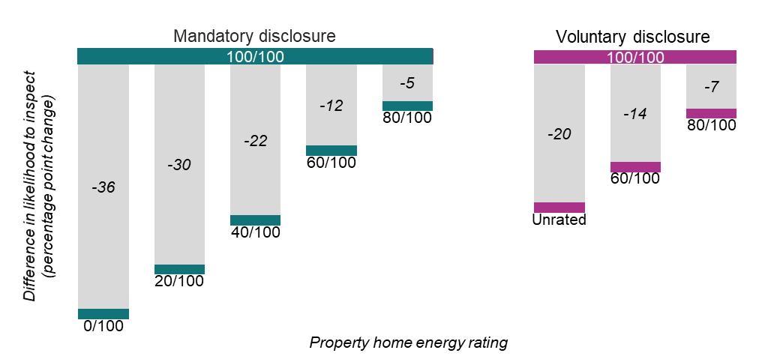

Figure 6. Compared to a home rated 100/100, respondents were less likely to choose to inspect homes with lower ratings
Additionally, respondents were more willing to inspect homes with high energy ratings even if they were listed with a higher price. Respondents valued a 20 point increase in Home Energy Rating more than a spare bedroom, hardwood floors, built in wardrobes, a large veranda or an established garden. A 40 point increase in Home Energy Rating was valued almost as much as a second bathroom (Figure 7).
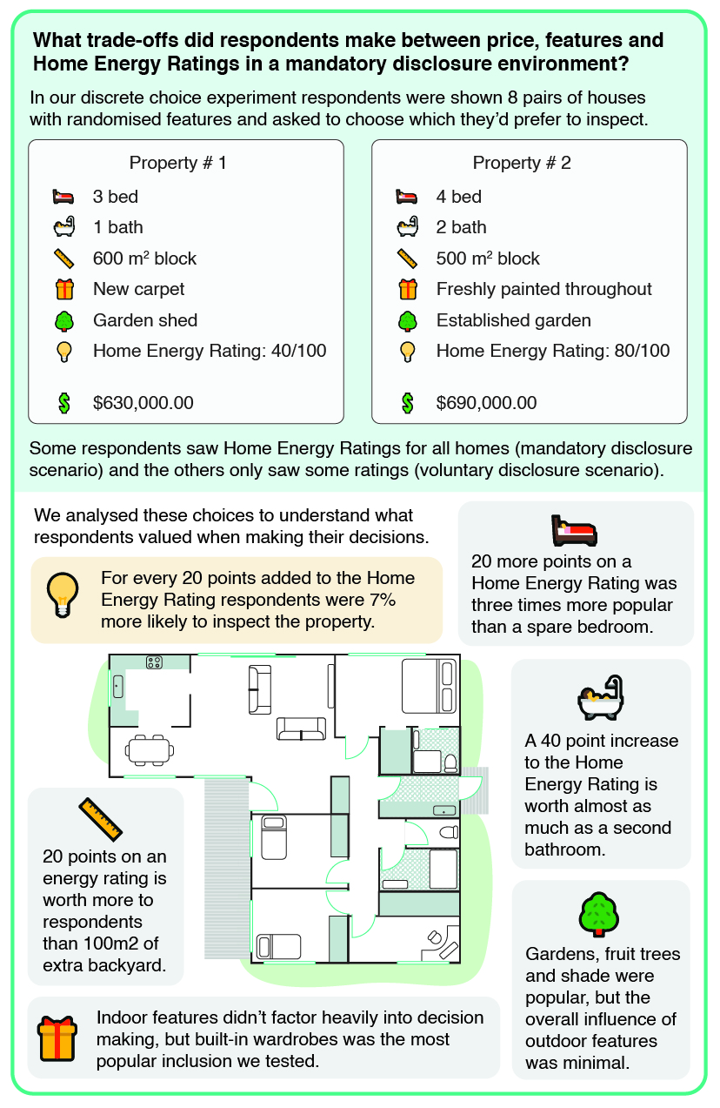

Figure 7. Our discrete choice experiment revealed respondents' preferences for different features of a home, including the impact of Home Energy Ratings
Long image description: What trade-offs did respondents make between price, features and Home Energy Ratings in a mandatory disclosure environment? In our discrete choice experiment respondents were shown 8 pairs of houses with randomised features and asked to choose which they’d prefer to inspect. Example pair: Property #1 with 3 bed, 1 bath, 600m block, new carpet, garden shed, Home Energy Rating of 40/100 and $630,000.00. Property #2 with 4 bed, 2 bath, 500m block, freshly painted throughout, established garden, Home Energy Rating 80/100 and $690,000.00. We analysed these choices to understand what respondents valued when making their decisions with a stylised floor plan for a house. For every 20 points added to the Home Energy Rating respondents were 7% more likely to inspect the property. 20 points on a Home Energy Rating was three times more popular than a spare bedroom. 20 points on an energy rating is worth more to respondents than 100m of extra backyard. A 40 point increase to the Home Energy Rating is worth almost as much as a second bathroom. Indoor features don’t actor heavily into decision making, but built-in wardrobes was the most inclusion we tested. Fruit trees and shade were popular, but the overall influence of outdoor features was minimal.
Figures 5 – 7 should not be interpreted as predictions or the effect of mandatory disclosure on the Australian housing market. In the survey experiment, half of the homes were displayed with high ratings and half with low ratings or unrated. The actual distribution of ratings in the Australian housing market will not look like this and will change over time, as new builds must comply with minimum energy efficiency requirements. However, the mandatory disclosure of Home Energy Ratings makes comparison between homes easier and allows people to exercise their preference for higher rated homes.
Finding: Respondents overestimate Home Energy Ratings of unrated properties.
All respondents in the disclosure stream, both mandatory disclosure and voluntary disclosure groups, saw a short series of survey questions after they had completed both Trial 1 and Trial 2.
We asked respondents to give the likely rating of an unrated home. On average, respondents perceived unrated homes as if they had an approximate rating of 50/100. Those assigned to the mandatory disclosure group estimated a lower average rating (48/100) than those in the voluntary disclosure group (55/100). However, both groups assumed that the average home would have a rating in the region of 50/100. This is likely an overestimate of the average rating for Australian homes, as the stringency requirement of 60/100 was only introduced to the National Construction Code in 2022.
Buyers of homes without an energy rating are at high risk of underestimating the future energy costs of their home. Unplanned future costs could include high energy bills, needing to replace ageing appliances and needing to add thermal comfort upgrades, such as insulation.
This effect of this misperception can be greatly reduced in a mandatory disclosure scheme where consumers receive more accurate and complete information. They would not have to guess the Home Energy Rating of their potential purchase. This provides us with robust evidence, highlighting the importance of mandatory energy rating disclosure at the point of sale and lease across Australian states and territories.
Respondents were asked for reasons a property listing may not show an energy rating. Most respondents said the likely reason was due to the property having a bad rating.
‘That it’s not a great rating so would be 50 or below and not willing to promote that.’
– Respondent in the voluntary disclosure group
‘It’s outdated or the energy rating is really bad.’
– Respondent in the mandatory disclosure group
Other respondents did not attribute the reason for a property listing not showing an energy rating to a bad rating. For the voluntary disclosure group the most common other reason for not showing an energy rating was because the property had not been rated. Whereas those in the mandatory disclosure group said that they were not sure why it was unrated.
‘They haven’t been officially checked.’
– Respondent in the voluntary disclosure group
‘I have no idea.’
– Respondent in the mandatory disclosure group
See the Appendix 2 for qualitative analysis details.
Not only do Home Energy Ratings influence choice of house, but they also provide a piece of information consumers want and value. When asked, 86% of respondents said it is important to see Home Energy Ratings when buying and 75% said it was important when renting. Except for the ACT, this information is not available by default to Australians when buying or leasing a property. A mandatory disclosure scheme would reduce this information vacuum in the housing market.

Trial 2: Does mandatory disclosure of Home Energy Ratings lead to home energy upgrades?
We wanted to find out if providing Home Energy Ratings on a real estate listing would influence respondents to choose upgrades likely to improve the energy performance of a home. Due to differing motivations, we hypothesised the effect of information was likely to be different between buyers and sellers. We expected a seller would focus on improvements likely to add value, while a buyer would prioritise their future comfort and reduction in energy costs. We were interested in whether the timely provision of a rating, at a point in time when someone was choosing an upgrade or renovation, would be used to inform the upgrade choice or ignored.
In Trial 2, respondents were shown a detailed real estate listing as either a buyer or a seller. Those randomised into the mandatory disclosure group saw a property with a Home Energy Rating of 15/100. Those in the voluntary disclosure group saw the same real estate listing without any Home Energy Rating disclosed. Respondents were randomised into two roles and told they were either a:
- ‘buyer’ who will move into this house in 6 months, or
- ‘seller’ who will sell this house in 6 months.
Respondents were presented with a list of 12 upgrades and asked to pick 3 upgrades they would make before they move in or put the property on the market. The list included:
- Home energy performance upgrades (e.g. roof insulation, rooftop solar panels to generate power), and
- Non-energy related upgrades (e.g. repaint interior walls, freestanding wood fireplace in the lounge).
Finally, respondents were asked to prioritise a single upgrade decision.

Table 1. Respondents randomised into a 2x2 factorial design were shown one of four possible scenarios
Respondent role | Voluntary disclosure | Mandatory disclosure
Buyer condition  Respondents were asked to imagine they have just purchased the house and will move into it in 6 months. | Buyers are not provided home energy performance information in the real estate listing for their home. | Buyers are provided home energy performance information in the real estate listing for their home.
Seller condition  Respondents were asked to imagine they are planning to sell this house in 6 months. | Sellers are not provided home energy performance information in the real estate listing for their home. | Sellers are provided home energy performance information in the real estate listing for their home and are told it's mandatory to display the energy rating on the property listing.

Trial 2 findings
Finding: Disclosing a Home Energy Rating on a real estate listing encouraged both buyers and sellers to choose an energy upgrade over other upgrades.
We found disclosure of a Home Energy Rating for a property influenced the upgrade decision of both buyers and sellers. Figure 8 shows the mandatory disclosure group that saw the Home Energy Rating was 6 percentage points more likely to choose an energy upgrade. After viewing the detailed real estate listing, those who saw a low Home Energy Rating disclosed on the listing were more likely to select one of the four ‘energy upgrades’ from the list, and less likely to select one of the non-energy related upgrades (e.g. fresh coat of paint throughout).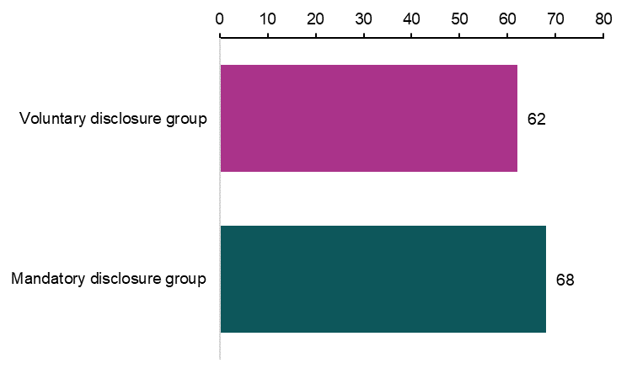

Figure 8. When asked to prioritise a single home upgrade, disclosure of a Home Energy Rating increased the percentage of respondents choosing an energy upgrade

As shown in Figure 9, respondents randomised into the buyer group were more likely to choose an energy upgrade compared to respondents in the seller group. However, sellers in the mandatory disclosure group were 11 percentage points more likely to make energy upgrades if they were told they had a low Home Energy Rating.
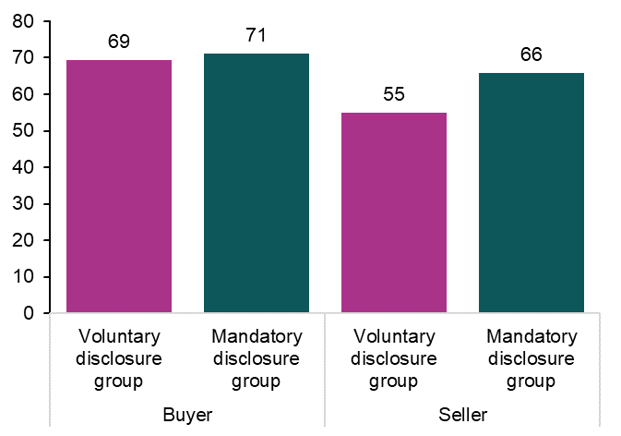

Figure 9. The biggest impact of mandatory disclosure was on sellers’ upgrade choices

Respondents were presented with a list of common upgrades they could apply to their home within a similar price range (Figure 10). Regardless of the group, solar panels were the most popular upgrade option (31%). However, some non-energy upgrades differed significantly with sellers more than twice as likely to repaint the interior as buyers.
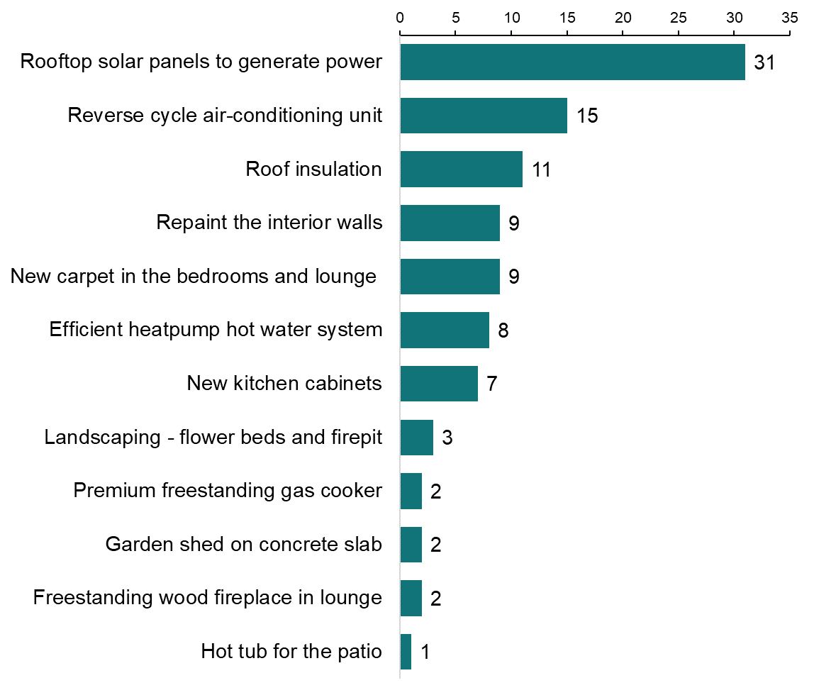

Figure 10. Solar panels were the most popular upgrade in all groups (percent who selected each option as the priority upgrade across all groups)

Figure 11 shows that for respondents in the voluntary disclosure group, buyers were more likely to choose solar panels than sellers. In the mandatory disclosure group, respondents were just as likely to choose solar panels regardless of whether they were asked to be a buyer or seller.
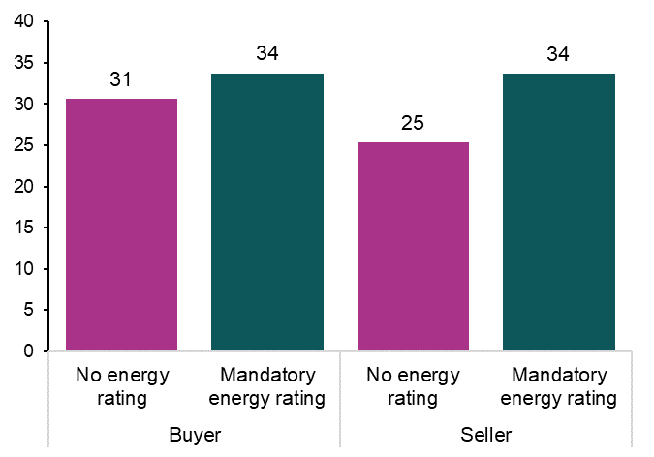

Figure 11. Respondents were more likely to choose solar panels as their preferred upgrade if the home’s poor energy rating was disclosed on the property listing
We further explored the decision making process for respondents using free text responses. Two main themes emerged for both disclosure groups, comfort and economic benefits.
Economic benefits included both reduction in energy bills and improvements to the value of the house. For example, a fresh coat of paint was seen as a cheap way to make a big visual difference and increase the value of the home, and getting solar panels was chosen in order to reduce the cost of energy bills by generating free energy and exporting energy to the grid.
‘It will probably have the most impact overall visually on potential buyers.’
  - Respondent in the mandatory disclosure group who chose repaint the interior walls
‘To assist with electricity bills and hopefully save money towards more upgrades.’
  - Respondent in the voluntary disclosure group who chose rooftop solar panels to generate power
Other than solar panels, the appeal of home energy upgrades was a mix of both economic benefits and comfort. For example, roof insulation was seen as both important to cost saving (reducing heating and cooling needs) and comfort (keeping internal temperature stable). While 9 out of 10 respondents (91% in the seller group and 92% in the buyer group) said it is useful to know your Home Energy Rating before choosing home upgrades, when asked to explain their choice of upgrade, the free text responses revealed differences in decision making between the voluntary and mandatory disclosure group. Respondents in the voluntary disclosure group were more likely to focus on the visual aspects of the home (looking clean, fresh and renewed). In the mandatory disclosure group respondents were more likely to mention the long-term comfort and energy savings of their home.
‘Makes it look warmer, and cleaner.’
  - Respondent in the voluntary disclosure group who chose new carpet in the bedrooms and lounge
‘Hot water is a year round expense that could use the most efficiency improvement.’
  - Respondent in the mandatory disclosure group who chose an efficient heatpump hot water system
See the Appendix 2 for qualitative analysis details.
Seller choices were more closely aligned with buyer choices in the mandatory disclosure group (Figure 9). Sellers may prioritise the features of a house they think is most appealing to potential buyers. If buyers do not know the Home Energy Rating of a house, a seller may be less likely to improve this feature and instead focus on visible features, such as repainting the house.

Home Energy Ratings and certificate advice

Key insights for policymakers
- Advice on a basic certificate prompted 6 in 10 people to choose an upgrade action.
- Offering an incentive of a free home energy re-assessment was not effective at encouraging respondents to choose an upgrade action.
- Visually highlighting upgrade actions into a ‘Top 3’ priority upgrade box did not impact the upgrade decision of respondents.
- Providing practical information on certificates (or links to this information) may be more successful in empowering people to make upgrade choices on top of a simple recommendation (see Decision support for consumers).

Context
Homeowners often don’t know their home’s energy performance. They may experience discomfort in a house that gets too hot in summer and too cold in winter with high energy bills, but may not know what changes will improve their comfort and budget.
A report prepared for the NSW Government (Boulet et al. 2023) conducted a scan of initiatives designed to encourage energy efficiency retrofits in NSW. The scan noted emphasis is currently placed on providing information to homeowners through self-assessment tools, with limited use of professional assessors to assist households. The report recommended future efforts focus more on professional assessments, because accredited assessors can influence change in their role as ‘trusted intermediaries, based on their objective assessment of the house and the targeted recommendations they make’.
International examples of home energy certificates range from long and detailed to short and simple. Past insights from behavioural science cautions against providing people with a long list of potential upgrades as that may result in choice overload (Chernev 2015). The struggle to choose between options may result in indecision, which may delay or prevent a decision. The evidence for this is mixed, but the number of choices is likely to matter. To contribute to this design process, we considered ways to prioritise and incentivise actions and chose to test a simple ‘Top 3’ prioritisation. Although a home assessment is useful to inform any choice of upgrades, there is a risk the assessment will only take place after upgrades are done in order to get a final rating immediately prior to sale. Additionally, the cost of an assessment may be too expensive before or after making upgrades. We tested the impact of an incentive offering a free re-assessment within 18 months of the first assessment to encourage respondents to act on the advice.

What we did
We asked homeowners to imagine their house is 30 years old and seems quite cold in winter and warm in summer, their bills are high, and they have money put aside for home improvements. We then asked them to look at a mock Home Energy Rating certificate and imagine it was an assessment for a house they have just bought and moved into.
A front page (Figure 12) showed respondents the whole of home and thermal ratings for their home. Some respondents saw a version advertising an incentive on the first page, which promised a re-assessment within 18 months at no extra cost.
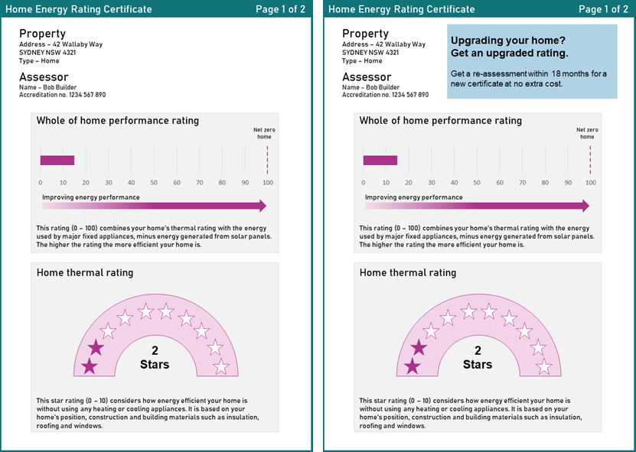

Figure 12. Page 1 of the certificate with and without the incentive message
The second page of the certificate (Figure 13) suggested four energy saving tips and eleven upgrade options. The second page tested four different interventions. One group saw a basic version and the other three groups saw a version which showed a heading with one of three different prioritisation messages:
- Top 3 upgrades with best value for money
- Top 3 recommendations from your assessor
- Top 3 upgrades to improve your Home Energy Rating.
For full sized versions of all certificates, see Appendix 4.
They were asked to click the action on the certificate they were most likely to take. They could choose to adopt one of the energy saving tips or make one of the upgrades.
We measured if respondents were more likely to choose an upgrade over a tip by adding an incentive message and/or different prioritisation message.

What we found
Finding: Providing home upgrade advice on a basic certificate was quite effective with 6 in 10 respondents choosing a home energy upgrade over a cheaper energy saving tip. However, the incentive we offered, and the prioritisation, had no impact on upgrade decisions.

Table 2. Respondents top 3 preferences for each certificate tested
Rank | Control | Assessor’s picks | Value for money | Impact on Home Energy Rating | Rank | All certificates
1 | Close the curtains (11%) | Close the curtains (13%) | Close the curtains (11%) | Close the curtains (11%) | 1 | Closing the curtains (11%)
2 | Install solar panels (10%) | Upgrade ceiling insulation  (9%) | Upgrade ceiling insulation  (10%) | Upgrade ceiling insulation  (10 %) | 2 | Upgrade ceiling insulation (9%)
3 | Seal draughts (10%) | Install solar panels (8%) | Seal draughts (10%) | Install solar panels (9%) | 3 | Seal draughts (9%)
3 | Seal draughts (10%) | Install solar panels (8%) | Seal draughts (10%) | Install solar panels (9%) | 4 | Install solar panels (8%)

Looking at the heat map patterns (Figure 13, and Appendix 4) it is possible that cognitive biases may be influencing respondents’ choice. There appears to be a pattern of picking the first item on a list (the primacy effect) and the last item on a list (the recency effect), which may be because these are the easiest items for respondents to remember. However, this interpretation is not supported by respondents’ free text responses.
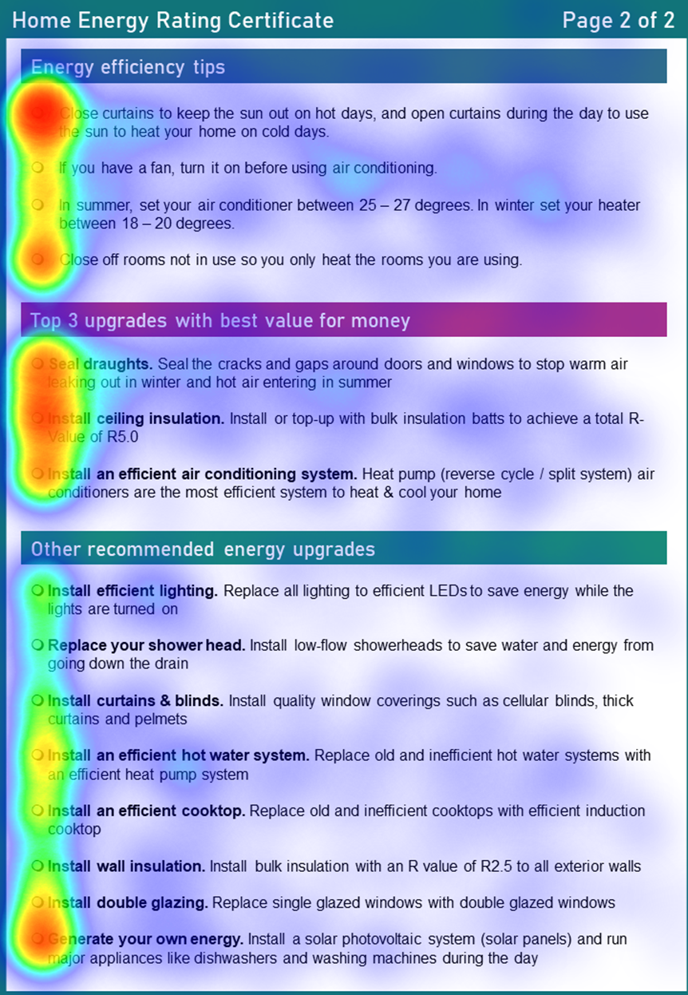

Figure 13. Heat map of page 2 of a certificate with both prioritisation and messaging
For full sized heat maps of all certificates see Appendix 4.

When we asked respondents to explain their choice, the most common responses was they were:
- Choosing the action they thought would save them the most money.
- Choosing the action easiest to implement.
- Choosing something that needed replacing in their own home.
- Very few respondents said they did not know why they chose the option or they picked an action because the activity required them to.
These results suggests respondents brought in their existing knowledge and preferences about what they would ideally like to have in their own home, in real life, as in the following examples.
‘Probably the cheapest upgrade that would have some effect straight away. If I could do the other ones like install efficient lighting and insulation I would, but it doesn’t fit my current budget.’
– Respondent who chose the ‘Install curtains & blinds’ upgrade action.
‘Most other things are already happening in my home.’
– Respondent who chose the ‘Close curtains’ energy efficiency tip.
Past research has shown sorting and prioritising complex information can simplify decision making, for example when choosing a superannuation plan (BETA 2022c). However, these choice architecture features may not be influential when consumers have strong personal preferences or prior knowledge. This may be because the benefits of some products (superannuation plans) have specific desired benefits and/or people have somewhat limited experience about superannuation plans to draw upon, whereas the benefits of home energy upgrades are varied and depend on individual circumstance, preference, and environment and/or people have some prior knowledge or experience to draw upon.

Decision support for consumers

Key insights for policymakers
- Prompts to visit YourHome.gov.au were effective at driving information seeking behaviour for 2.4% of survey respondents, but the precise wording of the message did not make a significant difference.
- Respondents were most interested in information about current government rebates and subsidies (48%), cost and savings calculators (42%) and in help choosing the right upgrade for their home (30%).
- An online home upgrades decision tool increased people’s confidence to plan upgrades, which is a predictor of action. People who used the tool were less interested in getting a professional home energy assessment, and more likely to say they knew exactly which upgrades they wanted to make.

Context
When planning home energy upgrades, the decision making process can be complex and difficult to navigate. Information can often be technical, making it difficult for consumers to make informed choices. Given consumers typically have limited time and cognitive resources, knowing which upgrade is right for their situation and who is a reliable source of information, can be time consuming and disruptive.
Professional home energy assessments can support homeowners on this journey, but the space on a certificate is limited. Information on a Home Energy Rating certificate could be supplemented by online resources. Additionally, many people will undertake upgrades without going through a professional home energy assessment process, and can also benefit from the same online resources.
Governments use prompts to encourage people to take or consider actions that can benefit them. A short message on government communication (letter, email, SMS) can be a cost effective behavioural intervention to create interest in home energy assessments, upgrades and support the consumer journey with targeted resources.

What we did

Testing prompts to visit YourHome.gov.au
At the end of our survey, we showed all respondents a message encouraging them to click on a link to more information about home energy upgrades. We trialled four different messages (Table 2) to determine whether they encouraged click-through to the YourHome.gov.au website. We measured the proportion of respondents who clicked-through, to test which prompt message was most effective. Survey respondents could easily click a ‘Next’ button to complete the survey, like how people can ignore prompts in real life.

Table 3. Respondents were shown one of four messages
Message number | Messages used in prompts trial
1 | Simple message – through inattention or cognitive load, people may not realise that an opportunity is available. A simple message makes it salient.  Start your home energy efficiency journey here: YourHome.gov.au
2 | Future savings – to address misperceptions or present bias of how costly it is to upgrade.  You can’t change what you’ve already spent on energy bills, but you can change what they will cost you in future.  Visit YourHome.gov.au to see how you can upgrade your home.
3 | Trigger event – status quo bias can cause people to make no changes or avoid taking action. People are more open to change during key trigger points, making interventions timely and targeted.  Planning your next renovation?  A renovation offers an opportunity to improve your home energy efficiency.  Find out how at YourHome.gov.au
4 | Home energy assessment – to identify issues that are otherwise invisible, overcoming information gaps.  Is something sapping your home’s energy?  Find out more about your home with a Home Energy Rating assessment.  Visit YourHome.gov.au

Web resources to support upgrade decisions
A decision support tool can provide personalised information without an energy assessment. People may not want a professional energy assessment, an online decision tool becomes useful because it can empower consumers:
- Who do not want the hassle or cost of an on-site visit (BIT 2023)
- Who lack home upgrade information in an easily understandable format (Duah and Syal 2016).
We tested whether decision and process supports could make people more likely to plan home upgrades and whether a decision support tool made people more interested in getting a professional home energy assessment. Additionally, given confidence is a key precursor to action, we wanted to understand if different support options could increase respondent confidence. We anticipated by coupling a decision resource with links to personalised recommendations and resources, we could reduce some of the complexity in home upgrade choices. We built a basic online decision support tool and tested a web page design that offered a range of support options, to see which would be valued and whether a perception that the supports existed, might increase intention to make an upgrade.
We trialled a decision support tool (Appendix 5, Figure 24) and a mock web page (Appendix 5, Figure 25) containing a menu directing respondents to a range of resources.
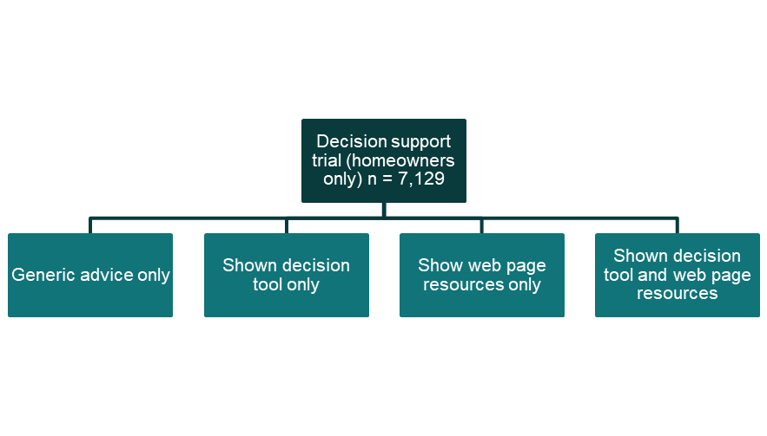

Figure 14. Respondents in Trial 5 were randomised into one of four groups

What we found
Finding: Prompts were effective at driving information seeking behaviour, with 2.4% of respondents clicking on the link to YourHome.gov.au
For this trial we were interested in understanding which messages would perform the best and what the baseline response rate would be like – as we are measuring a real behaviour here as opposed to an intention or a hypothetical. There was no statistically significant difference in impact between the four messages trialled and the simple message performed best by a small margin.
As shown in Figure 15, a simple message was as effective as a message targeting a specific problem or misperception. This may be due to respondents clicking on the link being primed by having completed a survey about energy efficiency upgrades. Placing the message in unexpected contexts where people are not already thinking about their home energy use may impact the effectiveness of the prompt.
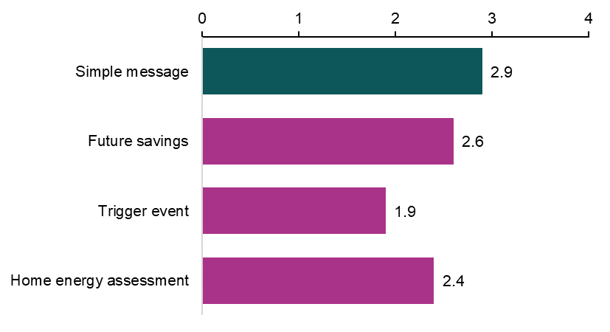

Figure 15. Prompts were effective at driving information seeking but no message performed significantly better than another
The click-through rate in this trial was higher than anticipated. Previous work undertaken by BETA found click-through rates were 1.8% for BETA’s organ donation prompts trial (BETA 2022a) and 0.03 to 0.09% for the Stay Smart Online email trial (BETA 2022b).
Findings from this trial indicate simple prompts can be utilised as a low cost measure to nudge homeowners towards government support. For example, if presented on rates notices, home energy certificates, or through other government communications, a prompt could complement existing advertising.
Simple prompts like those tested above – if presented on rates notices, home energy certificates, or through other government communications – could complement existing advertising. However, driving traffic to a government website will be most valuable if the content of the website is optimised. In Trial 3 we looked at the types of web content that would best support home energy upgrade decisions.
Finding: Respondents were most interested in information about rebates and government assistance, cost and savings calculators and help with choosing the right upgrade.
Respondents were shown a mock webpage that presented them with a menu of 9 different resources. They were asked to click on up to 5 of their preferred resources (Figure 16). Seeing the webpage did not increase respondents’ intention to make an upgrade to their own home in the next year, but revealed the types of information they were most interested in. Respondents were most likely to click on the following 3 categories:
- Rebates and government assistance (48%)
- Cost and savings calculators (42%)
- Choosing the right upgrade (30%).
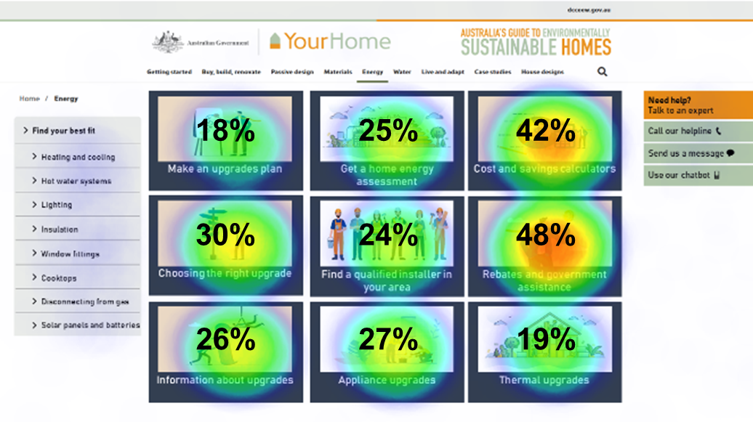

Figure 16. Heat map of which resources respondents felt would be most helpful
Note: Respondents were asked to pick up to 5 of their preferred resources, % don’t add to 100.
For full size web page see Appendix 5, Figure 25.
Not only did respondents state explicitly they would value assistance in choosing the right upgrade (30% clicked on this resource), but many respondents actually got to test the prototype we had built. The decision tool asked homeowners to respond to quiz style questions about heating, cooling, appliances, insulation and glazing in their current home. After answering the questions, they saw a traffic light report. A red traffic light in a particular domain (e.g. hot water system) indicated that an upgrade would be likely to be very beneficial (for example, extremely old appliances or homes without insulation). A yellow light was used to indicate a promising area for future action, and a green light indicated an area of high efficiency.
Finding: A home upgrade decision tool did not increase respondents’ intention to make home upgrades, but it did increase their confidence in choosing and planning upgrades.
The two-minute quiz/decision tool was not powerful enough to convince respondents to make upgrades in the following year, if they did not already intend to. The proportion intending to make upgrades (around half) was the same in the group that tested the personalised decision tool, as it was in the group that skipped the tool and saw a generic list of advice. However, as shown in Figure 17 the decision tool boosted respondents’ confidence by 5 percentage points compared to generic home energy upgrade advice, for both planning upgrades and knowing which upgrades to make.

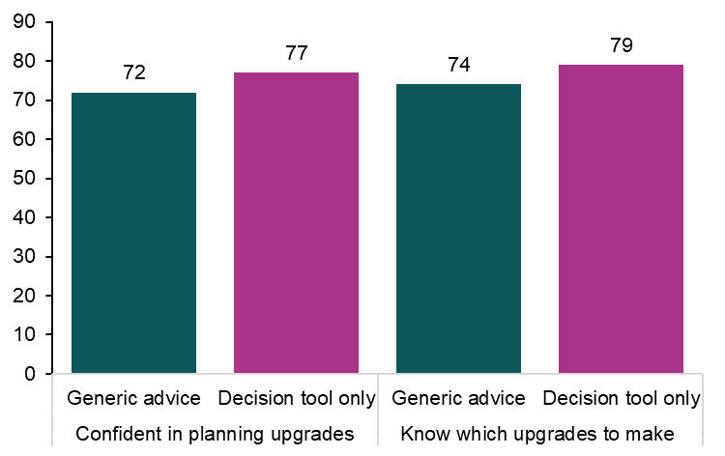

Figure 17. Respondents who used the decision tool were more confident in choosing and planning upgrades
BETA’s survey of Australian households conducted in 2023 found consistent links between respondents’ confidence and actual behaviour. Respondents who were very confident they knew which actions most limit greenhouse gas emissions, were more likely to have already made an upgrade.

While a decision tool increased respondents’ confidence in their ability to plan and choose a home energy upgrade (Figure 17), the tool decreased respondent interest in getting a professional home energy assessment (Figure 18).
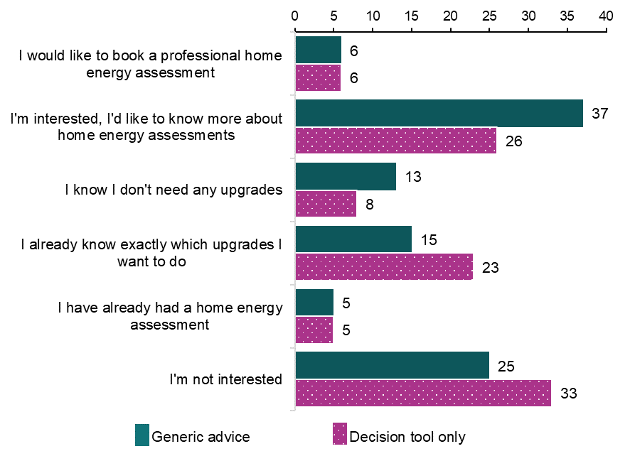

Figure 18. The decision tool made respondents more confident that they know which upgrades to do, but less interested in booking a home energy assessment
Future iterations of the tool could specifically recommend a professional home energy assessment to people who may benefit most. Professional home energy assessments and online decision tools do not need to compete, as they are likely to be useful in different ways. A decision tool is a free and instant resource for consumers to increase their knowledge and confidence. This could be most beneficial to individuals who do not have the time, cannot afford, or do not want a professional home energy assessment. A professional home energy assessment provides comprehensive advice that may be most helpful to individuals who need to make multiple upgrades, want more certainty that their choice in upgrade will lead to improvement in their home’s energy performance, or want to advertise the Home Energy Rating of their property at the point of sale or lease.

Attitudes to home energy upgrades
In addition to the survey experiments conducted, we asked some more traditional survey questions and qualitative questions about preferences and attitudes to home energy upgrades, and events that might trigger homeowners to undertake upgrades.
Finding: 1 in 2 homeowners said they were thinking about making a home energy upgrade in the next year.
A nudge can be most effective when timed well or with a change event. It was important for us to understand when people might make upgrades or what events are likely to trigger change.
We asked respondents when they would be most likely to make home energy upgrades. The most common responses were:
- Don’t know (24%)
- Several years after buying the home (23%)
- After living in the home for a year (16%).
The free text responses to this question helped us explore why many people didn’t know when they might make home energy upgrades. Respondents’ responses talking about timing fell into two broad categories:
- When they could afford to make an upgrade
- When the upgrade was needed, for example if a major appliance broke and needed replacement.
We also asked which events are likely to prompt them to consider home energy upgrades. Respondents described the following events:
- Experiencing discomfort in the home (38%)
- When major appliances break down (36%)
- Getting a higher than expected energy bill (26%)
- When they can access more money through a cash windfall (26%)
- Government rebates (25%).
Additionally, understanding why people may be unlikely to make a home upgrade in the next year was also important. The most common themes in these free text responses were:
They had already completed upgrades or had just done an upgrade.
‘Upgrades already done.’
They were facing a hard barrier to making upgrades.
‘I don't have money to make upgrades.’
‘Not allowed due to body corporate.’
They only recently moved in or will soon be moving out of the home.
‘Only bought and moved in recently so want to identify what is the biggest needs first.’
‘Planning to sell in the next year.’
The house doesn’t need upgrades.
‘House has only been built in 2016 to highest insulation standards.’
Or they have low trust in or difficulty finding installers or tradespeople.
‘Can't be bothered and wouldn't trust the installers.’
Over half (51%) of homeowners said they were likely or very likely to make a home energy upgrade in their current home in the next year. This finding highlights the need to support consumers to increase their knowledge and confidence, converting intention into action.

Interpretation of results
In this section, we will explore the findings and opportunities for them to have policy impact.

Disclosure of Home Energy Ratings
Mandatory disclosure of Home Energy Ratings increased the selection of energy efficient homes (by 4.2 percentage points in Trial 1).
Mandatory disclosure also made people more likely to choose home energy upgrades over a general home upgrade (by 6 percentage points in Trial 2) and was more influential on people selling homes than people buying them.
Mandatory disclosure also made people more likely to choose home energy upgrades over a general home upgrade (by 6 percentage points in Trial 2) and was more influential on people selling homes than people buying them.
These findings were statistically significant. This indicates a mandatory disclosure scheme is likely to support consumers to make home energy upgrades and exercise their preference for more energy efficient homes in practice.
While mandatory disclosure is likely to result in consumers choosing more energy efficient houses and increases the uptake of home energy upgrades in the real world, our methodology cannot determine the size of this change. Real life brings greater complexity, such as the availability and location of housing, which can interfere with the effectiveness of interventions. But real life also brings a higher level of personal investment in the outcome and consumers may pay more attention when their own physical and financial wellbeing is involved. Therefore, while we can anticipate the direction of behaviour change, the change may be bigger or smaller in practice.
Future research could explore and measure the size of these changes in the real world through field trials or other evaluation methods.

Home Energy Ratings and certificate advice
Our testing of interventions on the Home Energy Rating certificate to increase home energy upgrade behaviour made no significant difference. However, null findings are valuable as they help rule out interventions that are unlikely to be effective, which can drive better resource allocation and save money in the long-run. The light-touch nudges we trialled – prioritising three actions and offering a small incentive to make upgrades – did not improve upon the effectiveness of a basic certificate.
Observing the impact of receiving a personalised Home Energy Rating certificate on contemporary Australian households would establish a baseline from which improvements could be trialled and measured. The number of households making energy upgrades, the type of upgrades selected, the time taken to make the upgrades and the resulting change to energy consumption, could constitute robust baseline measures of impact. Further qualitative research with Australian homeowners could help identify and prioritise the best types of supports.
Supports could be financial in nature, for example loans, subsidies and rebates. Other options could be to provide cost and savings calculators, avenues to seek independent professional advice, and more comprehensive online resources or a bundle of several of these. Inclusion of metrics specific to an advised action on certificates, for example upfront cost, potential savings and an improvement to a Home Energy Rating, could also assist people to make informed decisions. Further research could help understand which types of information and supports could be prioritised.

Decision support for consumers
The online decision tool increased confidence to plan and choose upgrades but had no impact on intention to make an upgrade. Additionally, the decision tool reduced interest in home energy assessments. These findings suggest the decision tool may be useful to support consumers’ increase their confidence as they initially make plans to upgrade their home.
Similarly, the mock web page of resources did not increase intention to make upgrades, but if developed to include resources that were identified in the survey as valuable supports, it could still be effective at supporting people with the process.
A website could easily be adapted to triage people to information about assessments or to a decision tool depending on their personal preferences. Follow-up surveys that ask whether people proceeded with the upgrade after using the tool, could help gauge the actual size of the effect.
The prompt messages did encourage 2.4% of survey respondents to explore the YourHome.gov.au website, but no message tested stood out relative to any other message as more effective. Multiple pathways encouraging people to access government support and resources, can make it easier for people to get the information they need when they are ready for it. For example on website links on home assessments, bills, and in response to internet searches.
While a prompt may not necessarily prepare people to make energy performance upgrades or replace appliances with more efficient options if they are not already intending to, but this could be a promising area to explore further, to prevent people making automatic, unconsidered, like-for-like replacements.

Strong evidence of positive benefits
In a survey experiment, the goal is to make the experiment as realistic as possible within many constraints, for example, time, technology, cost and ethics. Within this context, the online survey we ran was a good fit for the materials and behaviours we chose to test:
- Searching and comparing real estate and choosing which properties to visit in person, occurs almost completely online in most parts of Australia
- A building report / home energy assessment certificate is likely to arrive via email
- Opening a government email and seeing embedded links to other information, is now more common than receiving a paper-based letter
- Using a DIY decision tool is very similar to responding to a social media quiz or to entering the funnel in a comparison website
- Viewing a landing page for a website and clicking on the zones you wish to view is common, everyday behaviour.
Using a large online panel of paid respondents gave us access to a diverse cross-section of Australians. This enabled us to target certain questions to current homeowners, and other questions to a broader group including renters, people in apartments and people in freestanding homes. People responded to the survey for a small paid incentive, not because they were especially interested in the subject matter or knowledgeable about home upgrades or energy. This was helpful in checking that designs can be understood by non-specialist audiences.
BETA used mixed research methods for this research. The survey experiment findings were strongly reinforced with the survey self-report data and the free text responses to open-ended questions. This can help us to interpret the experimental findings and to understand why things may or may not have been effective, and respondents’ thought process as they made their selections. These elements together with disclosure of our pre-registered pre-analysis plan (see technical appendix for these details), indicate a high standard of evidence that can identify causation.
This research has identified strong evidence of positive benefits to Australians and the environment through the broader implementation of mandatory disclosure of Home Energy Ratings. This research has also identified modest evidence in favour of improving online resources (decision tools, interactive information about costs, savings, and rebates) and of using prompts to encourage people to use those resources.
Surveys and survey experiments are a step towards building robust evidence-based policy. Piloting future interventions to support households and building evaluation into the implementation process of ratings schemes would be a valuable extension to this research.

Appendices

Appendix 1 – Summary of experimental findings

Trial 1
Hypothesis 1. Mandatory disclosure will increase the selection of homes with high Home Energy Ratings relative to voluntary disclosure.
There was a statistically significant difference of 4.2 percentage points between the mandatory and voluntary disclosure groups.
Hypothesis 2. Mandatory disclosure will lead to a higher ranking of importance and a higher proportion of respondents stating that Home Energy Rating is important, relative to voluntary disclosure.
Respondents who experienced in the mandatory disclosure group ranked Home Energy Ratings more highly than those in the voluntary disclosure group (average ranking was 3.1 compared to 2.7 out of 8, statistically significant.
Hypothesis 3. For the average rating of unrated homes, mandatory and voluntary disclosure arms will differ.
Estimates of the probable ratings for unrated homes differed by 7.7 points (out of 100). Unrated homes were rated lower in the mandatory disclosure group (statistically significant).

Trial 2
Hypothesis 1. The mandatory disclosure arm will increase the proportion of home energy upgrades selected relative to voluntary disclosure.
Selection of home energy upgrades was 6 percentage points higher (statistically significant) in the mandatory disclosure group than in the voluntary disclosure group.
Hypothesis 2. There will be a difference between buyers and sellers in the proportion of home energy upgrades selected.
Respondents assigned to the ‘buyer’ role were 10 percentage points more likely to choose an energy upgrade than ‘sellers’ (statistically significant). But ‘sellers’ were more influenced by mandatory disclosure.

Trial 3
Hypothesis 1. The decision support tool will perform better than the control at increasing the (a) intention of respondents to make home upgrades and (b) their confidence to plan and choose upgrades, relative to the control group.
There were no statistically significant differences between respondents self-rated likelihood to undertake an energy upgrade this year in the different groups.
The decision tool improved self-rated confidence compared to the control group (statistically significant).
Hypothesis 2. The web page of resource links will perform better than the control at increasing the (a) intention of respondents to make home upgrades and (b) their confidence to plan and choose upgrades, relative to the control group.
There were no statistically significant differences between respondents self-rated likelihood to undertake an energy upgrade this year or improvement to confidence in the different groups.
Hypothesis 3. The decision support tool and the web page of resource links presented together will perform better than the control at increasing the (a) intention of respondents to make home upgrades and (b) their confidence to plan and choose upgrades, relative to the control group.
There were no statistically significant differences between respondents self-rated likelihood to undertake an energy upgrade this year or improvement to confidence in the different groups.

Trial 4
Hypothesis 1 – 4. The incentives and/or prioritisation will each increase the selection of home upgrades relative to control.
The incentives and the prioritisation made no statistically significant difference relative to the control.

Trial 5
Hypothesis 1 – 3. The prompt messages will each increase the proportion of clicks relative to the control group.
There were no statistically significant differences between the control and behaviourally informed prompt messages tested.

Appendix 2 – Survey results

Demographics

Table 4. How do you describe your gender?
Gender | n | %
Woman or female | 7392 | 53.58
Man or male | 6348 | 46.01
Non-binary | 36 | 0.26
I use a different term | 8 | 0.06
Prefer not to answer | 13 | 0.09
N = 13,797

Table 5. Please select your age bracket?
Age | n | %
18 - 24 | 1112 | 8.06
25 - 34 | 2893 | 20.97
35 - 44 | 2650 | 19.21
45 - 54 | 2104 | 15.25
55 - 64 | 1913 | 13.87
65 - 74 | 2079 | 15.07
75+ | 1046 | 7.58
N = 13,797

Table 6. Where do you live?
State | n | %
Australian Capital Territory | 268 | 1.94
New South Wales | 4141 | 30.01
Northern Territory | 55 | 0.40
Queensland | 2809 | 20.36
South Australia | 1256 | 9.10
Tasmania | 346 | 2.51
Victoria | 3635 | 26.35
Western Australia | 1285 | 9.31
Other Territories | 2 | 0.01
N = 13,797

Table 7. Do you live in a capital city or another part of the state?
Location | n | %
State/territory capital city | 8146 | 59.04
Regional city | 3317 | 24.04
A town | 1947 | 14.11
Out of town (e.g. living on a rural property) | 387 | 2.80
N = 13,797

Table 8. What type of building do you live in?
Building type | n | %
Separate house | 9587 | 69.49
Semi-detached, row or terrace house or townhouse | 1637 | 11.86
Flat or apartment | 2376 | 17.22
Other type of home (please specify) | 197 | 1.43
N = 13,797

Table 9. What is the highest level of education that you have completed?
Education | n | %
Year 10 or below | 1277 | 9.26
Year 11 or equivalent | 466 | 3.38
Year 12 or equivalent | 2239 | 16.23
A trade, technical certificate or diploma | 4099 | 29.71
An undergraduate university degree | 3688 | 26.73
Postgraduate qualifications | 2021 | 14.65
Did not answer | 7 | 0.05
N = 13,797

Table 10. Given your current needs and financial responsibilities, would you say your are:
Financial comfort | n | %
Very comfortable | 1056 | 7.65
Reasonably comfortable | 4919 | 35.65
Just getting along | 5130 | 37.18
Struggling | 2454 | 17.79
Prefer not to say | 61 | 0.44
Did not answer | 177 | 1.28
N = 13,797

Table 11. In the last 12 months, did any of the following happen to you because of a shortage of money?
Financial hardship | n | %
Asked for financial help from friends or family | 2622 | 19.07
Could not pay electricity, gas or telephone bills on time | 2070 | 15.06
Pawned or sold something | 1986 | 14.44
Went without meals | 1762 | 12.82
Was unable to heat home | 1260 | 9.16
Could not pay the mortgage or rent on time | 1152 | 8.38
Asked for help from welfare / community organisations | 953 | 6.93
None of these | 7842 | 57.04
Prefer not to say | 298 | 2.17
n = 13,749

Table 12. How many people live in your household?
Household size | n | %
1 (only me) | 2531 | 18.34
2 | 4962 | 35.96
3 | 2690 | 19.50
4 | 2362 | 17.12
5 | 843 | 6.11
6 | 268 | 1.94
7 or more | 127 | 0.92
Did not answer | 14 | 0.10
N = 13,797

Table 13. Is English the main language you speak at home?
English at home | n | %
Yes | 12702 | 92.06
No | 1029 | 7.46
Did not answer | 66 | 0.48
N = 13,797

Survey questions

Table 14. Do you own the home you live in?
Home ownership | n | %
Own outright (without a mortgage) | 4422 | 32.05
Own with a mortgage | 4358 | 31.59
Rent | 4414 | 31.99
Other tenure type | 603 | 4.37
N = 13,797

Table 15. Upgrades to own home and why
Own property upgrades | Upgrades made since owning the property  (n) | Upgrades made since owning the property  (%) | Upgrade undertaken to reduce energy use or bills  (n) | Upgrade undertaken to reduce energy use or bills  (%)
Installed or replaced insulation | 1371 | 19.92 | 767 | 55.94
Replaced single glazed windows with double or triple glazed | 458 | 6.66 | 256 | 55.90
Replaced hot water system | 2596 | 37.73 | 885 | 34.09
Replaced or installed heating or cooling system | 2256 | 32.79 | 860 | 38.12
Replaced cooktop or oven | 2293 | 33.32 | 509 | 22.20
Replaced external walls | 243 | 3.53 | 87 | 35.80
Replaced roof | 632 | 9.18 | 167 | 26.42
Installed or replaced rooftop solar panels or battery | 2179 | 31.67 | 1697 | 77.88
Installed EV charging point | 227 | 3.30 | 111 | 48.90
Installed curtains or blinds on windows | 3129 | 45.47 | 1285 | 41.07
Draught proofed house | 1101 | 16.00 | 652 | 59.22
Installed home energy monitor | 494 | 7.18 | 272 | 55.06
None of these | 1343 | 19.52 | - | -
n = 6,881
Questions: ‘Thinking about your own home, have you made any of the following upgrades to your home since owning it?’, and ‘Were any of the upgrades to your home undertaken in order to reduce energy use or energy bills? Please select all upgrades which were at least partially undertaken in order to reduce energy use. If none, simply move to the next question.’

Table 16. Do you own a residential investment property that you currently, or intend to, rent out to tenants?
Owns investment property | n | %
Yes, more than one | 562 | 8.13
Yes, one | 915 | 13.23
No | 5433 | 78.58
Did not answer | 4 | 0.06
n = 6,914

Table 17. Upgrades to investment property and why
Investment property upgrades | Upgrade undertaken to reduce energy use or bills  (n) | Upgrades made since owning the property  (%) | Upgrade undertaken to reduce energy use or bills  (n) | Upgrade undertaken to reduce energy use or bills  (%)
Installed or replaced insulation | 222 | 15.07 | 104 | 46.85
Replaced single glazed windows with double or triple glazed | 135 | 9.16 | 64 | 47.41
Replaced hot water system | 372 | 25.25 | 129 | 34.68
Replaced or installed heating or cooling system | 339 | 23.01 | 145 | 42.77
Replaced cooktop or oven | 349 | 23.69 | 106 | 30.37
Replaced external walls | 113 | 7.67 | 49 | 43.36
Replaced roof | 142 | 9.64 | 49 | 34.51
Installed or replaced rooftop solar panels or battery | 223 | 15.14 | 136 | 60.99
Installed EV charging point | 114 | 7.74 | 64 | 56.14
Installed curtains or blinds on windows | 398 | 27.02 | 162 | 40.70
Draught proofed house | 175 | 11.88 | 78 | 44.57
Installed home energy monitor | 147 | 9.98 | 65 | 44.22
None of these | 376 | 25.53 | - | -
n = 1,473
Questions: ‘Have you made any of the following upgrades to your investment property? (Select all that apply)’ and ‘Were any of the upgrades to your investment property undertaken in order to reduce energy use or energy bills? Please select all upgrades which were at least partially undertaken in order to reduce energy use. If none, simply move to the next question.’

Table 18. In general, when do you think you would be most likely to make upgrades to your home's energy efficiency?
When to upgrade | n | %
Every year or two | 231 | 13.40%
Immediately after buying the home | 204 | 11.83%
After living in the home for a year | 274 | 15.89%
Several years after buying the home | 393 | 22.80%
Many years after buying the home | 186 | 10.79%
Just before selling the home | 38 | 2.20%
Never | 85 | 4.93%
Don't know | 424 | 24.59%
Other | 41 | 2.38%
n = 1,724

Table 19. In general, which events do you think are likely to prompt you to consider upgrades to your home energy efficiency?
Prompting event | n | %
Experiencing discomfort living in the home | 643 | 38.34%
In response to major appliances breaking down | 615 | 36.67%
Higher than expected energy bills | 436 | 26.00%
Receiving a tax refund, a pay rise or other cash windfall | 426 | 25.40%
Government rebates or subsidies for home energy upgrades | 425 | 25.34%
Making major renovations to the property | 291 | 17.35%
Before putting it up for sale | 238 | 14.19%
Before moving in | 221 | 13.18%
In response to a recommendation to do so | 131 | 7.81%
None of these | 242 | 14.43%
Other | 16 | 0.95%
n =1,677

Table 20. In general, what would prompt you to find out whether you could benefit from energy efficiency upgrades? (Select all that apply)
Prompt message | n | %
A message included with your energy bill (with a QR code & link) | 549 | 32.29%
A message in myGov | 378 | 22.24%
Item on TV, radio, newspapers or news sites | 368 | 21.65%
A message printed on your rates notice (with a QR code & link) | 339 | 19.94%
An SMS message from the Government | 256 | 15.06%
A message printed on your tax return notice (with a QR code & link) | 117 | 6.88%
A message accompanying your mortgage statement | 113 | 6.65%
I don’t want to be prompted | 497 | 29.24%
Other | 45 | 2.65%
n =1,700

Table 21. How important to you are the following factors when considering energy efficiency upgrades to your home?
Important factors | % | n | row n
Upfront cost | 90.98% | 1382 | 1519
Improve comfort | 90.56% | 1420 | 1568
Bill savings | 90.42% | 1454 | 1608
Ease of installation | 88.02% | 1337 | 1519
Decision process | 86.81% | 1343 | 1547
Improve appliance efficiency | 86.42% | 1355 | 1568
Payback period | 86.26% | 1425 | 1652
Government rebates | 86.19% | 1361 | 1579
Improve value of home | 81.76% | 1295 | 1584
Time to make the upgrade | 78.54% | 1277 | 1626
Sustainability | 72.00% | 1139 | 1582
Able to do it yourself (DIY) | 58.78% | 927 | 1577
Financing | 48.68% | 776 | 1594
Row n = from 1,519 to 1,652. Respondents only rated 4 factors each due to the length of the survey. The 4 factors shown were randomised from the full list of 13 factors.

Table 22. Have you ever had a home energy assessment?
Had home energy assessment | n | %
Yes | 233 | 13.76%
I have considered it, but not had an assessment done | 175 | 10.34%
No | 1205 | 71.18%
Don't know | 80 | 4.73%
n =1,693

Table 23. Do you think a home energy assessment would save you money?
Assessment would save money | n | %
Yes, a lot | 183 | 10.73%
Yes, a bit | 614 | 35.99%
No | 387 | 22.68%
Not sure | 522 | 30.60%
n =1,706

Qualitative analysis
For survey questions that prompted a free-text response, we analysed responses using a grounded theory approach. We used the TextIQ function within Qualtrics to iteratively code free-text responses into common categories. We also manually coded the responses to capture any missing categories that weren’t identified by TextIQ. We then manually analysed categories of responses for common themes to complement quantitative findings from the survey.

Summary tables for free text analysis
As part of Trial 2 – Choice of upgrade, respondents were asked to pick 3 upgrades from a list of 12 choices as part of a hypothetical scenario. They were then told their budget has taken and hit and could now only afford a single upgrade. Respondents were asked to reason why they had chosen their single upgrade in a free text question.

Table 24. What is the main reason behind your choice of 'Repaint interior walls'?
Theme | Voluntary disclosure group | Mandatory disclosure group
Attractive to buyers | 16% | 11%
Increases comfort | 8% | 10%
Like the look and feel | 59% | 50%
Quick and cheap to do | 11% | 7%
Other (including nil or nonsense response) | 12% | 24%
Note: Does not add to 100% because one free text response can correspond to multiple themes. Voluntary disclosure responses = 347, Mandatory disclosure responses = 245

Table 25. What is the main reason behind your choice of 'New kitchen cabinets'?
Theme | Voluntary disclosure group | Mandatory disclosure group
Attractive to buyers | 21% | 13%
Quick and cheap to do | 3% | 2%
Functional feature | 28% | 33%
Like the look and feel | 21% | 25%
Other (including nil or nonsense response) | 27% | 29%
Note: Does not add to 100% because one free text response can correspond to multiple themes. Voluntary disclosure responses = 245, Mandatory disclosure responses = 212

Table 26. What is the main reason behind your choice of 'New carpet in the bedrooms and lounge'?
Theme | Voluntary disclosure group | Mandatory disclosure group
Attractive to buyers | 15% | 14%
Quick and cheap to do | 4% | 2%
Functional feature | 17% | 22%
Like the look and feel | 36% | 38%
Other (including nil or nonsense response) | 28% | 28%
Note: Does not add to 100% because one free text response can correspond to multiple themes. Voluntary disclosure responses = 332, Mandatory disclosure responses = 291

Table 27. What is the main reason behind your choice of 'Landscaping - flower beds and firepit'?
Theme | Voluntary disclosure group | Mandatory disclosure group
Attractive to buyers | 23% | 23%
Functional feature | 14% | 9%
Like the look and feel | 31% | 24%
Other (including nil or nonsense response) | 20% | 45%
Note: Does not add to 100% because one free text response can correspond to multiple themes. Voluntary disclosure responses = 96, Mandatory disclosure responses = 80

Table 28. What is the main reason behind your choice of 'Premium freestanding gas cooker'?
Theme | Voluntary disclosure group | Mandatory disclosure group
Functional feature | 41% | 42%
I like or want it | 18% | 11%
Saves on costs | 7% | 6%
Attractive to buyers | 3% | 0%
Other (including nil or nonsense response) | 31% | 42%
Note: Does not add to 100% because one free text response can correspond to multiple themes. Voluntary disclosure responses = 61, Mandatory disclosure responses = 53

Table 29. What is the main reason behind your choice of 'Hot tub for the patio'?
Theme | Voluntary disclosure group | Mandatory disclosure group
Functional feature | 27% | 24%
I like or want it | 39% | 29%
Other (including nil or nonsense response) | 30% | 47%
Note: Does not add to 100% because one free text response can correspond to multiple themes. Voluntary disclosure responses = 44, Mandatory disclosure responses = 49

Table 30. What is the main reason behind your choice of 'Garden shed on concrete slab'?
Theme | Voluntary disclosure group | Mandatory disclosure group
Functional feature | 34% | 28%
I like or want it | 15% | 26%
For an activity or hobby | 11% | 7%
Quick and cheap to do | 3% | 2%
Other (including nil or nonsense response) | 38% | 39%
Note: Does not add to 100% because one free text response can correspond to multiple themes. Voluntary disclosure responses = 65, Mandatory disclosure responses = 54

Table 31. What is the main reason behind your choice of 'Freestanding wood fireplace in lounge'?
Theme | Voluntary disclosure group | Mandatory disclosure group
Saves on costs | 11% | 5%
Functional feature | 41% | 45%
I like the look and feel | 16% | 18%
Other (including nil or nonsense response) | 34% | 32%
Note: Does not add to 100% because one free text response can correspond to multiple themes. Voluntary disclosure responses = 56, Mandatory disclosure responses = 56

Table 32. What is the main reason behind your choice of 'Roof insulation'?
Theme | Voluntary disclosure group | Mandatory disclosure group
Saves on costs | 17% | 16%
Saves on energy use | 12% | 17%
Better for the environment | 1% | 0%
Health & wellness | 2% | 0%
It’s an essential feature | 13% | 4%
Comfort (staying warm and cool) | 49% | 41%
Other (including nil or nonsense response) | 24% | 22%
Note: Does not add to 100% because one free text response can correspond to multiple themes. Voluntary disclosure responses = 334, Mandatory disclosure responses = 391

Table 33. What is the main reason behind your choice of 'Energy efficient heatpump hot water system'?
Theme | Voluntary disclosure group | Mandatory disclosure group
Saves on costs | 16% | 13%
Saves on energy use | 8% | 10%
Better for the environment | 2% | 1%
Hot water used daily | 29% | 22%
It’s an essential feature | 31% | 25%
It needs replacing | 0% | 1%
Other (including nil or nonsense response) | 23% | 28%
Note: Does not add to 100% because one free text response can correspond to multiple themes. Voluntary disclosure responses = 254, Mandatory disclosure responses = 282

Table 34. What is the main reason behind your choice of 'Rooftop solar panels to generate power'?
Theme | Voluntary disclosure group | Mandatory disclosure group
Saves on costs | 55% | 52%
Comfort (run heating and cooling) | 1% | 1%
Saves on energy use | 16% | 20%
Better for the environment | 6% | 6%
Other (including nil or nonsense response) | 22% | 22%
Note: Does not add to 100% because one free text response can correspond to multiple themes. Voluntary disclosure responses = 918, Mandatory disclosure responses = 1,096

Table 35. What is the main reason behind your choice of 'Reverse cycle air-conditioning unit'?
Theme | Voluntary disclosure group | Mandatory disclosure group
Saves on costs | 2% | 3%
Saves on energy use | 3% | 4%
Better for the environment | 0% | 0%
Health & wellness | 1% | 1%
Comfort (staying warm and cool) | 62% | 58%
Other (including nil or nonsense response) | 32% | 33%
Note: Does not add to 100% because one free text response can correspond to multiple themes. Voluntary disclosure responses = 530, Mandatory disclosure responses = 455

At the end of the disclosure stream (Trial 1 and Trial 2), respondents were asked a short series of survey questions related to the Home Energy Ratings and their disclosure. This included one question with a free text response option.

Table 36. What do you think are the most likely reasons for a property listing to show no energy rating?
Theme | Voluntary disclosure group | Mandatory disclosure group
House has a low rating | 33% | 36%
House has not been rated | 23% | 19%
House is missing features (e.g. old house, no solar panels, no insulation) | 14% | 13%
Seller preference | 8% | 7%
Showing a rating might turn away buyers | 4% | 5%
To hide the rating | 4% | 3%
Showing a rating might impact property price | 3% | 4%
Not aware they can, or have to, show a rating | 2% | 3%
High cost to get a rating | 1% | 1%
Not listed on advertising material | 1% | 1%
Showing a rating might turn away renters | 1% | 1%
House has a high rating | 1% | 0%
Not sure | 18% | 20%
Other (nil or nonsense responses) | 18% | 18%
Note: Does not add to 100% because one free text response can correspond to multiple themes. Voluntary disclosure responses = 3,023, Mandatory disclosure responses = 3,012.

Appendix 3 – Disclosure of Home Energy Ratings
Not all choices in the Discrete Choice Experiment were genuine choices between high and low rated homes. Some choices were between two high rated homes and two low rated homes as all homes were randomised.

Table 37. Only genuine choice (2 and 3) were shown in Figure 5 of the report
 | Respondent choice | Voluntary  (n) | Mandatory  (n)
1 | Chose high rated home - both homes were high rated | 5,761 | 5,473
2 | Chose high rated home over low rated home | 7,849 | 9,223
3 | Chose low rated home over high rated home | 4,452 | 3,486
4 | Chose low rated home - both homes low rated or unrated | 5,487 | 5,045
5 | Chose neither property | 2,996 | 3,245
 | Totals | 26,545 | 26,472
n = 6,668, based on 53,017 observations (~ 8 choices per respondent).
Table 36 shows the number of respondents choosing high rated and low rated homes in the discrete choice experiment. Respondents could choose 1 of 2 properties or neither. In around half of cases, both properties presented were low rated or high rated. In the main RCT analysis, choices for a high rated home (line 1 or 2) were treated as the numerator, and all other choices (lines 3-5) were included in the denominator.

Table 38. Respondent choice of home when presented with a genuine choice between high and low rated homes
Respondent choice | Voluntary  (n) | Mandatory  (n) | Voluntary  (%) | Mandatory  (%)
Chose low rated home over high rated home | 4,452 | 3,486 | 36% | 27%
Chose high rated home over low rated home | 7,849 | 9,223 | 64% | 73%
Totals | 12,301 | 12,709 | 100% | 100%
n = 6,349, based on 25,010 observations (~ 8 choices per respondent). Table 37 shows the number of respondents choosing a high rated (60-100/100) or low rated home (0-40/100) when given a genuine choice between a high rated and low rated home.

Table 39. Respondent choice of home: all choice scenarios
Choice | Voluntary  (n) | Mandatory  (n) | Voluntary  (%) | Mandatory  (%)
Chose neither property | 2,996 | 3,245 | 11% | 12%
Chose low rated home - both homes low/unrated | 5,487 | 5,045 | 21% | 19%
Chose low rated home over high rated home | 4,452 | 3,486 | 17% | 13%
Chose high rated home over low rated home | 7,849 | 9,223 | 30% | 35%
Chose high rated home - both homes were high rated | 5,761 | 5,473 | 22% | 21%
Totals | 26,545 | 26,472 | 100% | 100%
n = 6,668, based on 53,017 observations (~ 8 choices per respondent).
Table 38 shows the number of respondent choices for all choice combinations.
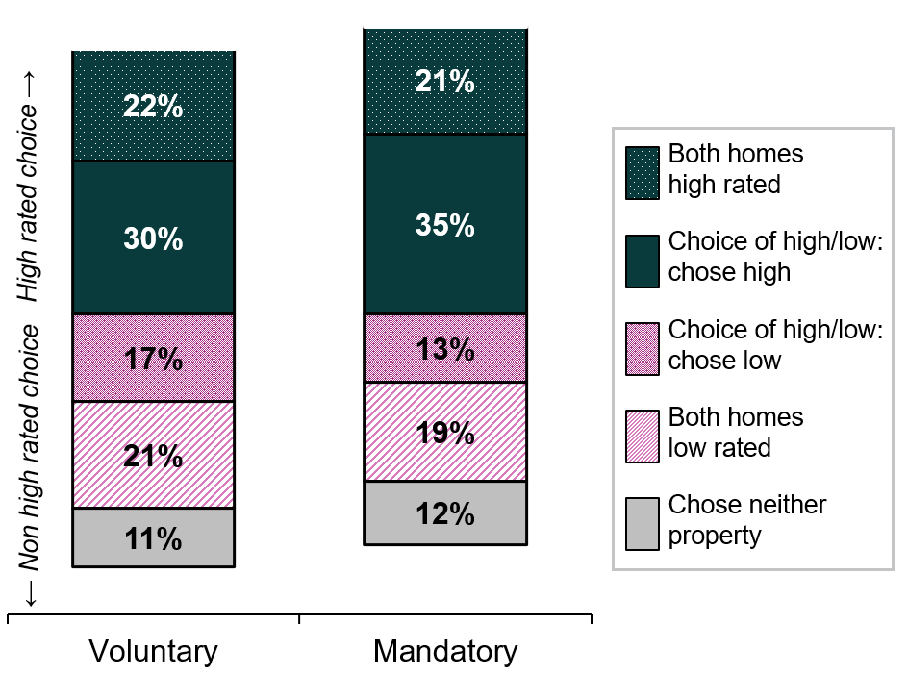

Figure 19. Respondents were more likely to choose to inspect a home with a high energy rating, this effect was stronger in the mandatory disclosure group
n = 6,668, based on 53,017 observations (~8 choices per respondent).

Appendix 4 – Home Energy Ratings and certificate advice

Heat maps of Home Energy Rating Certificates
In the Home Energy Rating Certificate trial, the contents and order of actions on page 2 remained consistent across all four certificates. The only changes were the addition of a pink ‘Top 3’ box and the message inside the pink box.
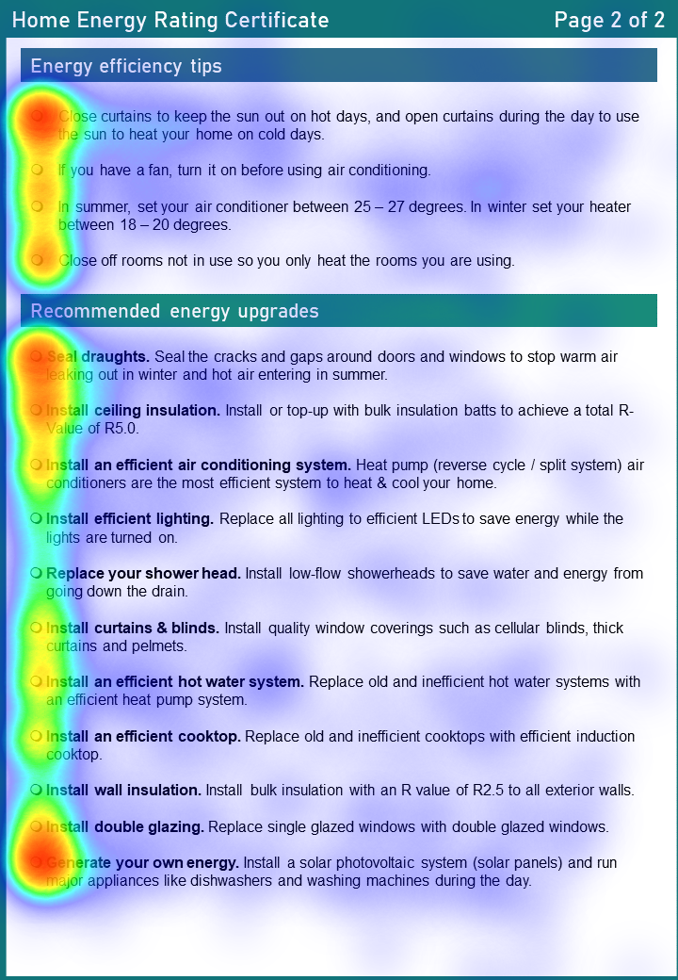

Figure 20. Heat map for control certificate with no prioritisation
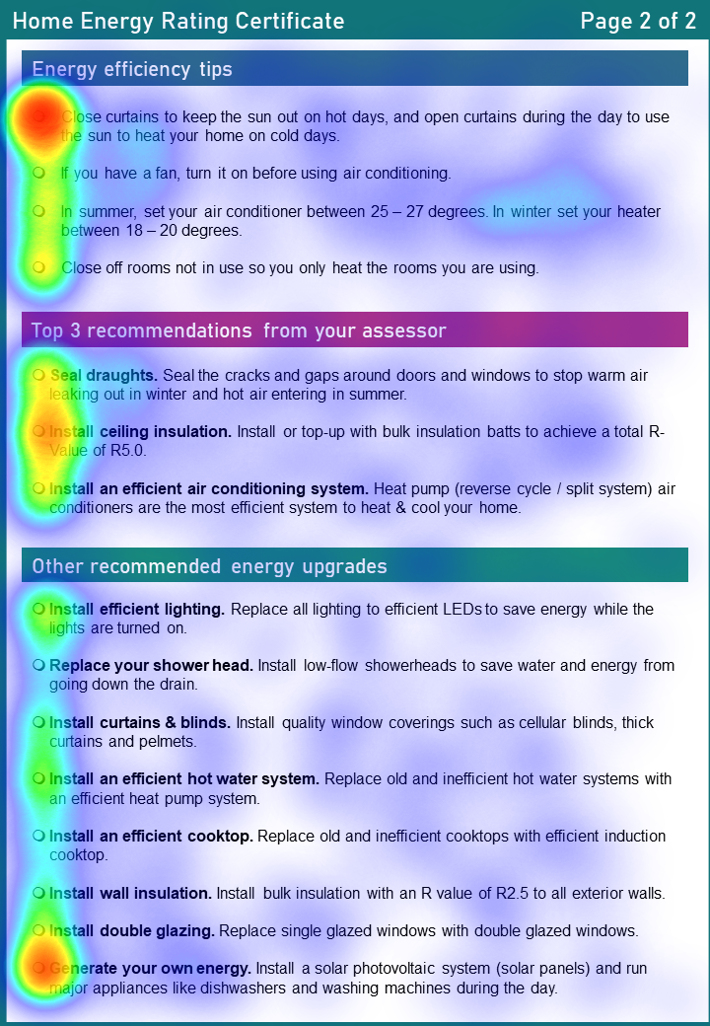

Figure 21. Heat map for Top 3 recommendations from your assessor
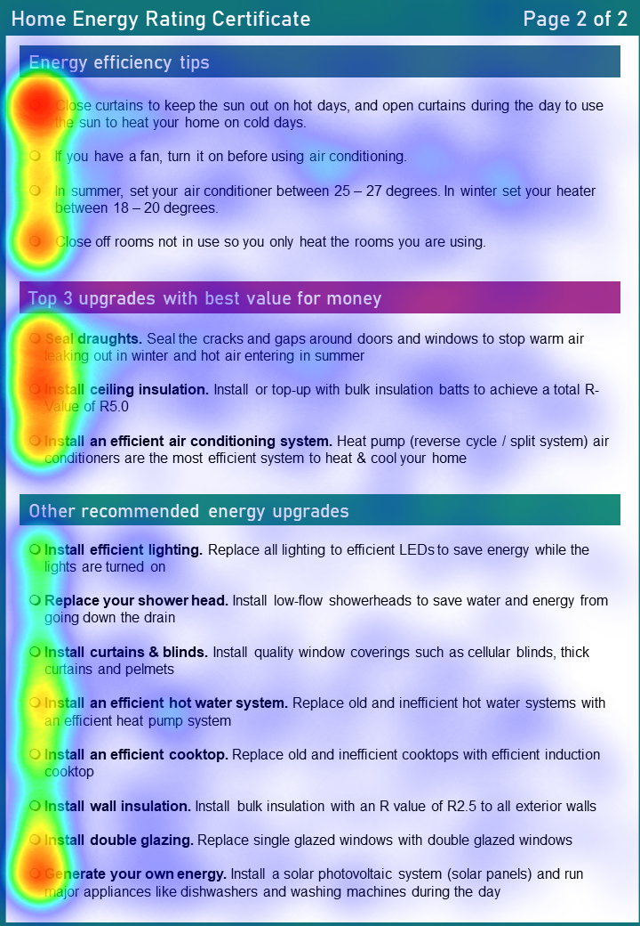

Figure 22. Heat map for Top 3 upgrades with best value for money
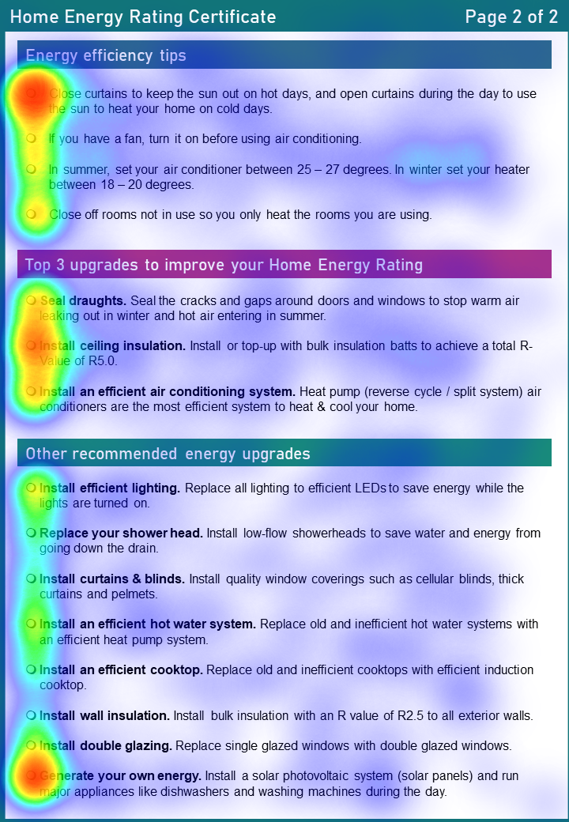

Figure 23. Heat map for Top 3 upgrades to improve your Home Energy Rating

Appendix 5 – Decision support for consumers
In the decision support trial, respondents were shown generic information only, a decision tool only (Figure 25), a web page of resources only (Figure 26), or the decision tool and webpage of resources. The decision tool was a minimum viable product created by BETA and hosted in Qualtrics to support the survey experiment. The mock web page of resources was designed to resemble the YourHome.gov.au website to support realism in a hypothetical scenario. The web page does not exist and was designed to understand what resources consumers are interested in.


Figure 24. QR code to view the mock decision tool
Link to decision tool: https://youropinion.au1.qualtrics.com/jfe/form/SV_ewVQC1SqOEQ1RZk

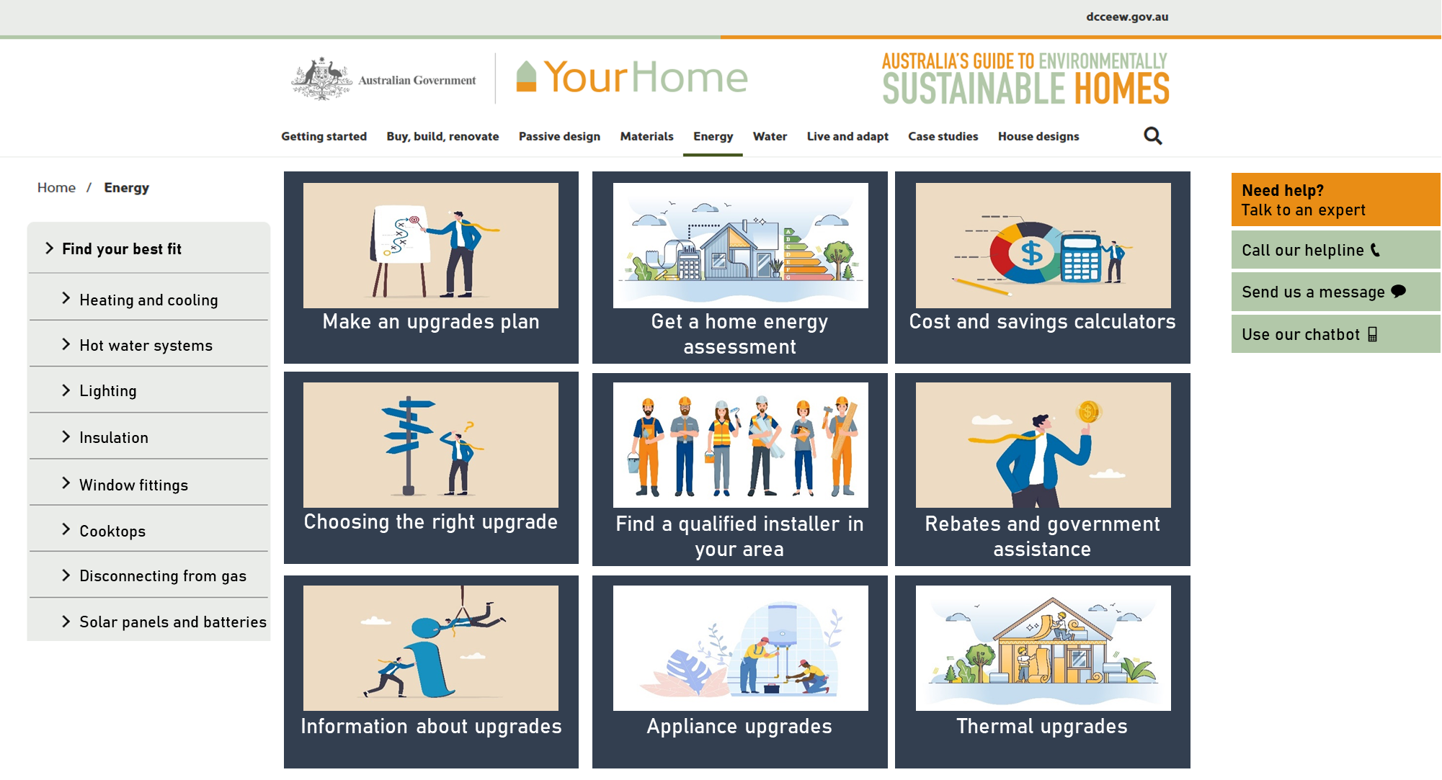Figure 25. Mock web page of resources

References
Australian Building Codes Board (2024) Housing energy efficiency handbook. Housing energy efficiency handbook (abcb,gov.au)
Australian Bureau of Statistics (2001/2002) Australia 2001 Census All persons QuickStats. 2001 Australia, Census All persons QuickStats (abs.gov.au)
Australian Bureau of Statistics (2021/2022) Housing: Census. Housing: Census, 2021 (abs.gov.au)
BETA, Department of the Prime Minister and Cabinet, Commonwealth of Australia (2023). Towards Net Zero survey research
BETA, Department of the Prime Minister and Cabinet, Commonwealth of Australia (2022a). Improving organ donor registration among young adults. Improving organ donor registration (pmc.gov.au)
BETA, Department of the Prime Minister and Cabinet, Commonwealth of Australia (2022b). Stay smart: helping consumers choose cyber secure smart devices. Stay smart (pmc.gov.au)
BETA, Department of the Prime Minister and Cabinet, Commonwealth of Australia (2022c). YourSuper Comparison Tool: results from a survey and two survey experiments. YourSuper Comparison Tool (pmc.gov.au)
Behavioural Insights Team UK, Sustainable Energy Authority of Ireland (2023) Promoting retrofitting among homeowners in Ireland through a behavioural lens: Evidence review and policy recommendations. Promoting retrofitting among homeowners in Ireland (seai.ie)
Boulet, M., Hatty, M., and Lauren, N. (2023). Intervention report: Encouraging householders to include energy efficiency upgrades in retrofits. Prepared for the NSW Office of Energy and Climate Change. BehaviourWorks Australia, Monash Sustainable Development Institute, Monash University, Australia
Chernev, A., Böckenholt, U., and Goodman, J. (2015) Choice overload: A conceptual review and meta-analysis. Journal of Consumer Psychology, Volume 25, Issue 2, 2015, Pages 333-358, ISSN 1057-7408, doi:doi.org/10.1016/j.jcps.2014.08.002.
Commonwealth Department of Climate Change, Energy, the Environment and Water (2023) Trajectory for Low Energy Buildings (update). Trajectory for Low Energy Buildings (dcceew.gov.au)
Duah, D. and Syal, M. (2016) Intelligent decision support system for home energy retrofit adoption. International Journal of Sustainable Built Environment, 5(2):620-634, doi:doi.org/10.1016/j.ijsbe.2016.05.003.
Frederiks, E. R. and Romanach, L. M. (2023) Residential energy efficiency disclosure: Key insights from the international literature to incentivise behaviour change. CSIRO, Australia.

© Commonwealth of Australia 2024
ISBN 978-1-925365-67-2 Home Energy Upgrades: Empowering homeowners to make informed decisions

Copyright Notice
With the exception of the Commonwealth Coat of Arms, this work is licensed under a Creative Commons Attribution 4.0 International license (CC BY 4.0) (https://creativecommons.org/licenses/by/4.0/)


Third party copyright
Wherever a third party holds copyright in this material, the copyright remains with that party. Their permission may be required to use the material. Please contact them directly.

Attribution
This publication should be attributed as follows:
© Commonwealth of Australia, Department of the Prime Minister and Cabinet, Home Energy Upgrades: Empowering homeowners to make informed decisions

Use of the Coat of Arms
The terms under which the Coat of Arms can be used are detailed on the following website: https://pmc.gov.au/cca

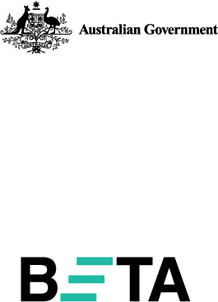
Behavioural Economics Team
of the Australian Government
General enquiries beta@pmc.gov.au
Media enquiries media@pmc.gov.au
Find out more www.pmc.gov.au/beta
Tell us how you’re using this report

