# Pre-analysis plan: Increasing Diversity Identification Trial

## Policy problem

In partnership with the Australian Public Service Commission, BETA is exploring ways to increase rates of disability identification in the Australian Public Service (APS) agency HR systems.

In 2022, BETA conducted a desktop review and qualitative research to identify the drivers and barriers to people sharing personal information with their agency. The research revealed that how employers ask for diversity data can impact how comfortable and willing staff are to identify in HR systems.

A large APS Agency is planning to send a reminder email to staff to update their diversity information in June 2023. This presents an opportunity to trial and test the effect of different email reminders on diversity identification, including disability identification.

## Trial Aim

The aim of the trial is to test the effect of three different behaviourally informed emails against attention control which is standard, information only BAU email.

## Design

The trial will consist of a four-arm parallel trial. The APS agency staff (population section for more information) will receive one of 4 emails to encourage them to update their diversity status information in SAP (agency’s HR system).

The emails were sent out on 28 June 2023 and the trial data was extracted on 13 July 2023.

## Outcome measures

### Primary outcome measures

The denominator for primary outcome measures will be the number of people randomised into the trial. All primary outcome measures will be binary variables where 0 = No/missing (no diversity indicator) and 1 = Yes (diversity indicator).

1. Proportion of staff reporting as having a disability (disability = Yes)
2. Other diversity status. This will capture diversity status other than disability. It will be the proportion of APS Agency staff who indicated on the agency’s HR system as either:
   1. LGBTIQ+ (LGBTQ+ = Yes) or
   2. Neurodivergent (Neurodivergent = Yes) or
   3. First Nations (First Nations = Yes) or
   4. Non-English speaking background (NESB) (NESB = Yes)

### Secondary outcome measures

1. Proportion of missing data on all diversity variables. This will examine whether APS Agency staff go and update their diversity status after the trial emails. This will consist of all responses other than yes or no. Individual proportion will be created to determine proportion missing per person (out of 5 diversity indicators). This means if a person has two missing data out of 5 diversity indicators, they will get a score of 0.4. Individual level outcomes will be averaged within each arm of the trial to obtain the average proportion of missing data by arm. This will provide a measure of engagement from the reminder emails.
2. Proportion of diversity characteristics changed with responses changed from “Choose Not to Give” to either ‘Yes’ or ‘No’. Each person will be recorded a change if they change from ‘Choose Not to Give” to either ‘Yes’ or ‘No’. So each person will have a change score created out of the five diversity indicators. They will get a score of 0.2 if they made this change for 1 out of 5 diversity indicators. Individual level outcomes will be averaged within each arm of the trial to obtain the average proportion of people who made this change by arm.

## Interventions

APS Agency staff will be randomly allocated into one of the four groups below and BETA will compare the outcome variables for each group to determine the impact of the intervention. All emails used in the trial are provided in Appendix 1.

1. **Simplified BAU T1+email (attention control)**

This email provides a basic reminder and simple information about the need to update ones details in the HR System.

1. **‘Make it Easy’ email (treatment group 1)**

This email highlights the ease of updating demographic data. This draws on the EAST principle ([The Behavioural Insights Team](https://www.bi.team/publications/east-four-simple-ways-to-apply-behavioural-insights/)) of ‘Make it Easy’, where removing small frictions that make a task seem challenging or effortful, can increase uptake of a behaviour.

1. **‘Make it Attractive’ email (treatment group 2)**

This email is designed to attract peoples’ attention and make updating details appear more rewarding (by highlighting the benefits of keeping HR System information up-to date).

1. **‘Make it Social’ email (treatment group 3)**

This email highlights how the APS Agency is progressing towards a more diverse and inclusive workplace. This draws on the EAST principle of ‘Make it Social’, which recognises that humans are positively influenced by those around them and are encouraged by the behaviour of others, particular in uncertain situations.

This email will graphically show how more staff are reporting in the APS Agency HR system than ever before. This information will act as a call to action and could reflect that trust in the agency is growing over time. The graph is also visually stimulating, novel and demonstrates how the APS Agency is using staff data, which could encourage more staff to identify in the HR system.

## Hypotheses

Each of these hypotheses make use of disjunction tests that will be conducted as a pair of one-sided tests using the model specified below. If any of the constituent tests are significant we will reject the joint null hypothesis that the intervention is no better than control. We will adjust p-values using Holm’s correction to account for multiple tests.

### Hypothesis 1

Those receiving the ‘Easy’ email will have a higher proportion of people declaring diversity status compared to the attention control group (BAU email).

* Percent declaring disability status in Treatment 1 (Easy email) >   
  Percent declaring disability status in attention control, or
* Percent declaring ‘other diversity’ status in Treatment 1 (Easy email) > Percent declaring ‘other diversity’ status in attention control

### Hypothesis 2

Those receiving the ‘Attractive’ email will have a higher proportion of people declaring their diversity status compared to the attention control (BAU email).

* Percent declaring disability status in Treatment 2 (Attractive email) >   
  Percent declaring disability status in attention control, or
* Percent declaring ‘other diversity’ status in Treatment 2 (Attractive email) > Percent declaring ‘other diversity’ status in attention control

### Hypothesis 3

Those receiving the ‘Social’ email will have a higher proportion of people declaring their diversity status compared to the attention control group. This includes the following:

* Percent declaring disability status in Treatment 3 (Social email) >   
  Percent declaring disability status in attention control, or
* Percent declaring ‘other diversity’ status in Treatment 3 (Social email) > Percent declaring ‘other diversity’ status in attention control

## Population and sample selection

The emails will be sent to the entire APS Agency staff from SES Band 3 level down to APS, graduate and intern levels. We will include ongoing and non-ongoing staff. Causal staff will be excluded from the trial.

### Exclusion criteria

Those on long-term leave such as maternity leave for the entire trial period will be excluded. Casual staff and those who have left the APS Agency during the trial period are also excluded from the trial.

## Sample size and power calculations

For this trial, the sample size is fixed because it is the number of staff employed by the APS Agency. There were 20,754 employees on the day of randomisation (27 June 2023). When we did power calculations, we assumed a sample size of 19,000.

This meant a sample size of approximately 4700 participants per arm, equal allocation across 4 arms. With a familywise alpha of 0.1 and 80% power, the minimum detectable effect size will be 0.0438 (cohen’s h[1]). Assuming the global diversity rate in the control group is 54.2% (based on historical APS Agency data), we will be able to detect an increase of 2.2 percentage point increase in the treatment group. Assuming the disability identification rate in the control group is 5.0% (based on historical data), we will be able to detect 1.0 percentage point difference in disability identification rates.

We chose a familywise alpha of 0.1 as the intervention is low risk and low cost. Baseline data shows that changes in disability proportion could be small so alpha of 0.1 will allow us to detect a 1 percentage point difference in disability identification.

## Randomisation

Randomisation will occur at the individual level. The APS Agency will provide staff list with de-identified staff IDs. They will then be randomised into 4 arms using complete randomisation using the randomizer package in R.

## Method of analysis

The main analysis of the effect of the interventions will consist of a covariate adjusted comparison of our two primary outcomes. The covariate included will be baseline diversity status and baseline disability status respectively, depending on the outcome measure for the analysis. This estimate, confidence intervals and p-values will be derived from a linear regression model using robust (HC2) standard errors and with the following specification:

Y subscript i equals beta subscript zero plus beta subscript one Z subscript i plus beta subscript 2 X subscript i plus beta subscript three Z subscript i X subscript i plus epsilon subscript i

Where

* *i* is an index for each individual in the trial
* *Y* isbinary variable (whether or not identified as having one or more of the diversity groups or whether or not identified as having a disability)
* beta subscript zero is the intercept
* *Z* is either a vector of four treatment assignment indicators
* beta subscript 1 is a vector of coefficients representing the average treatment effect for the intervention/s relative to control
* *X* is a mean-centred covariate
* *ZX* is the interaction of the treatment indicator vector with the mean-centred covariate
* epsilon is the individual error term.

As we only have directional hypotheses, all will be tested with a single sided t-test.

We may also conduct exploratory analyses investigating the impact of the interventions on disability identification in particular. We may also explore subgroups such as differences in the responses of workers at different levels of the organisation. If leave indicator data is available, we may also calculate complier average causal effect (CACE).

### Covariates

We will adjust for a single pre-trial covariate by including it in in our regression analyses. It will be pre-trial diversity status or pre-trial disability status.

## Trial threats

Given this is a short trial (in field for 3 weeks), we do not think there will be a huge risk of attrition (people leaving the APS Agency after being enrolled in the trial). Staff who have left the APS Agency during the trial period are excluded from the trial.

Staff may talk to each other about different emails they received but we do not think it will be a significant issue. We expect the spillover rate would be the same across all four groups due to randomisation.

We note that the trial occurred at the end of Financial Year which is a very busy year for APS Agency staff. The trial period also coincided with school holidays which meant parents with school-aged children are likely to take time off. On the day the email was sent, over a third of staff were on leave. If leave indicator data is available, we will calculate complier average causal effect (CACE) as exploratory analysis.

## Interpretation and reporting

For our primary hypotheses, we will use null hypothesis statistical testing to determine whether to treat the effect observed as real. We will also discuss practical significance, in additional to statistical significance.

We will accept that the intervention (treatment emails) work if any of the primary outcomes are statistically significant. Therefore, we will adjust alpha using the Holm method[2].

We will also make use of non-significant primary analyses, subgroup analyses in order to provide context and to highlight interesting avenues for further research. We will clearly delineate these analyses when communicating findings.

For reporting, all group proportions will be transformed to percentages. Treatment effects, standard errors, and confidence intervals will be presented as percentage point differences. Absolute p-values will be reported. We will provide these outputs for all primary hypotheses and any pre-specified secondary analyses.

## Pre-analysis plan commitments

We have two standard commitments:

* ‘No trial data have been collected/no analysis has been undertaken prior to the completion of this pre-analysis plan.’
* ‘We will be transparent about, and provide justification for, any deviations (additions or omissions) from this plan.’

## Appendix 1. Emails used in the trial

### Attention Control email

This image is a screenshot of the simple email. It reads: Update your personal details in mySAP now; All staff. We are committed to fostering a diverse and inclusive work environment that reflects the community we serve. The diversity of our staff is one of our greatest assets – it helps us to be more innovative, productive, and to deliver better outcomes for our clients. Staff diversity information is necessary to understand the needs of our workforce. Review your mySAP equity and diversity details to ensure they remain current and correct. Accurate SAP data will help influence our workplace and drive improvements to the staff experience. We are asking all staff to review their mySAP Inclusion and Diversity details, even if you don’t identify with any of the diversity characteristics listed. Updating your details
Check your mySAP profile Equity and Diversity details are current and correct, and update if needed. For further information, access instructions on [agency internal system]. [Name]; [Position]; [Agency HR team]; [Agency]

### Make it Easy email (treatment group 1)

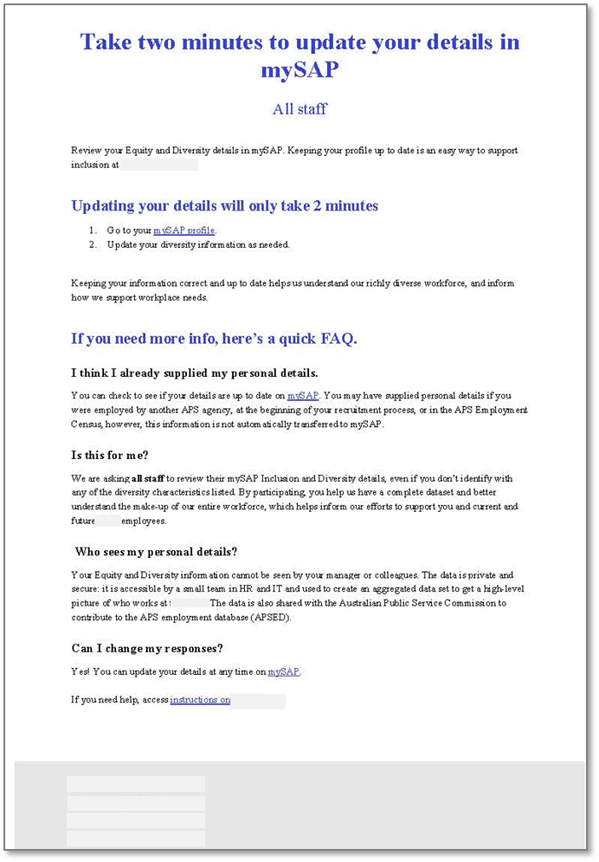

### Make it Attractive email (treatment group 2)

Screen shot of the attractive email. The email reads: Update your mySAP details to shape [agency] inclusion initiatives, All staff/
mySAP Equity and Diversity details are used to design programs and policies to support new and current [agency] employees. Our [agency diversity strategy] is developed using staff demographic information, and supports staff through initiatives such as: improving disability awareness and confidence of managers and senior leaders through training, manager guidance and events; providing development opportunities for culturally and linguistically diverse staff, such as network sponsored training initiatives; establishing the [agency] Gender Equality staff network; delivering leadership and career development programs for Aboriginal and Torres Strait Islander staff
To ensure we have a complete picture of [agency’s] workforce, we are asking all staff to update their mySAP profile. Will you help by making sure your details are correct? Yes, I’d like to support inclusion at the [agency]. Go to your mySAP profile. Update your diversity information as needed. Not yet, I need more information. I think I already supplied my personal details. You can check to see if your details are up to date on mySAP. You may have already supplied details if you were employed by another APS agency, at the beginning of your recruitment process, or in the APS Employment Census, however, this information is not automatically transferred to mySAP. Is this for me? We are asking all staff to review their mySAP Equity and Diversity details, even if you don’t identify with any of the diversity characteristics listed. By participating, you help us have a complete dataset and better understand the make-up of our entire workforce and helps inform our efforts to support you, current and new [agency] employees. 
Who sees my personal details? Your Equity and Diversity information cannot be seen by your manager or colleagues. The data private and secure: it is accessible by a small team in HR and IT and used to create an aggregated data set to get a high-level picture of who works at the [agency]. The data is also shared with the Australian Public Service Commission to contribute to the APS employment database (APSED).
Can I change my responses? Yes! You can update your details at any time on mySAP. If you need help, access instructions on [agency internal system]. [Name]; [Position]; [Agency HR team]; [Agency]

### Make it Social email (treatment group 3)

Screenshot of the social email. The email reads: Diversity is growing at [Agency] All staff. Did you know we use mySAP Equity and Diversity details to track our progress toward internal and external benchmarks? This helps ensure we are reflecting the diverse community we represent. An image of a graph showing the percentage of staff with 1 or more diversity characteristic recorded in HR system between 2015 and 2023. This graph shows sharing of diversity information in mySAP has been steadily growing over the last few years. Now, a third of the workforce identifies with at least one diversity characteristic, compared to a quarter in 2015. We are asking all staff to review their mySAP Equity and Diversity details to ensure they remain current and correct. Updating your details: Go to your mySAP profile. Update your diversity information as needed. More information about mySAP data: I think I already supplied my personal details. You can check to see if your details are up to date on mySAP. You may have already supplied your personal details if you were employed by another APS agency, at the beginning of your recruitment process, or in the APS Employee Census, however, this information is not automatically transferred to mySAP. Is this for me? 
We are asking all staff to review their mySAP Equity and Diversity details, even if you don’t identify with any of the diversity characteristics listed. By participating, you help us have a complete dataset and better understand the make-up of our entire workforce and helps inform our efforts to support you, current and new [agency] employees. Who sees my personal details? Your Equity and Diversity information cannot be seen by your manager or colleagues. The data is private and secure: it is accessible by a small team in HR and IT and used to create an aggregated data set to get a high-level picture of who works at the [agency]. The data is also shared with the Australian Public Service Commission to contribute to the APS employment database (APSED). Can I change my responses? Yes! You can update your details at any time on mySAP. If you need help, access instructions on [website]
 
[Name]
[Position]
[Agency HR team]
[Agency]

1. Cohen, J. (1988). Differences between Proportions. Statistical Power Analysis for the Behavioural Sciences. New York, Routledge**:** 181.
2. Rubin, Mark, When to Adjust Alpha During Multiple Testing: A Consideration of Disjunction, Conjunction, and Individual Testing (August 13, 2021). Rubin, M. (2021). When to adjust alpha during multiple testing: A consideration of disjunction, conjunction, and individual testing. Synthese. https://doi.org/10.1007/s11229-021-03276-4, Available at SSRN: <https://ssrn.com/abstract=3904565>